handlingWindows.cy.js – New tabs / windows
File | cypress/e2e/handlingWindows.cy.js
Website used | https://the-internet.herokuapp.com/windows
Run status | Approach 2 runs. Approach 1 is it.skip.
Concepts | target attribute, .invoke('removeAttr','target'), .prop('href'), cy.go('back'), Same-domain limit

1. What this file does
Cypress cannot switch to a second browser tab. These two approaches avoid opening a new tab at all so the test can continue in the same one.

2. The code (screenshots)
Keep this next to the file in VS Code. Line numbers match the real file.
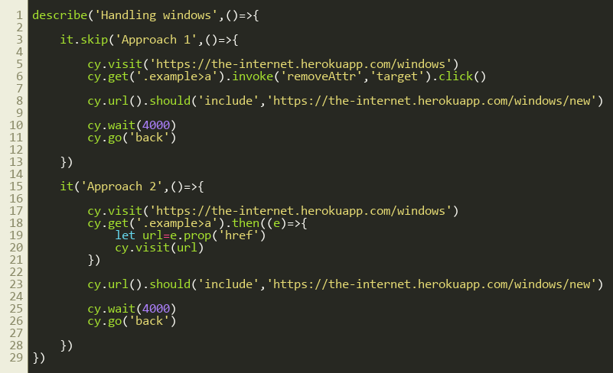
Lines 1–29

3. Step by step: what happens
Look for this in the code | What it does
Approach 1 (skipped) | cy.get('.example>a').invoke('removeAttr','target').click() removes target="_blank" from the link, so clicking opens the page in the same tab. Then check the URL and cy.go('back').
Approach 2 (active) | Read the link's href with .then(e => e.prop('href')) and open it with cy.visit(url). No click at all.
cy.url().should('include', ...) | Verifies we reached the new page.
cy.wait(4000) and cy.go('back') | A pause so we can see the page, and then browser Back.

4. Concepts involved
Concept | Meaning
target attribute | target="_blank" is what makes a link open in a new tab.
.invoke('removeAttr','target') | Calls the jQuery removeAttr function on the link.
.prop('href') | Reads a property of a jQuery element.
cy.go('back') | Browser Back button.
Same-domain limit | Approach 2 works only when the new page is on the same domain as the first.

5. How it is implemented
Both approaches change HOW we get to the new page rather than switching tabs.

6. Why it is useful
This is the standard workaround for Cypress's single-tab limitation.

7. Things to watch out for
- If the link opens another domain, visit() may need cy.origin().

