hooks&tags.cy.js – Hooks (before, after, beforeEach, afterEach)
File | cypress/e2e/hooks&tags.cy.js
Website used | None. The tests only write log messages with cy.log().
Run status | Runs. No browser page is opened.
Concepts | Mocha hooks, Execution order, cy.log(), Scope

1. What this file does
Demonstrates the four Mocha hooks and the order in which they run around three tests. Each hook and test just prints a message so I can see the order in the Cypress command log.

2. The code (screenshots)
Keep this next to the file in VS Code. Line numbers match the real file.
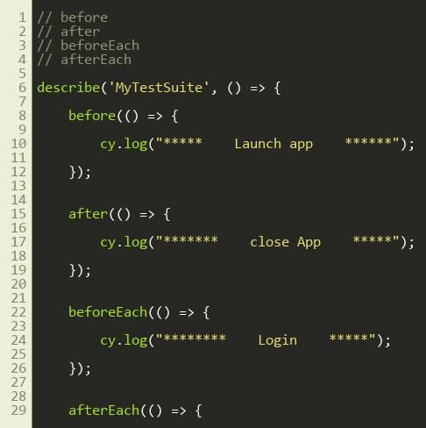
Lines 1–30
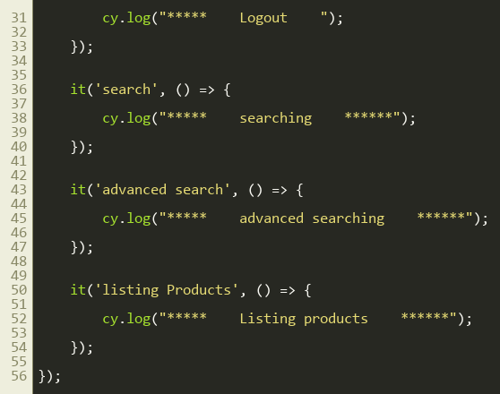
Lines 31–56

3. Step by step: what happens
Look for this in the code | What it does
before() | Runs ONCE before all tests. Logs 'Launch app'.
after() | Runs ONCE after all tests. Logs 'close App'.
beforeEach() | Runs before EVERY test. Logs 'Login'.
afterEach() | Runs after EVERY test. Logs 'Logout'.
it('search'), it('advanced search'), it('listing Products') | Three tests that only log what they are doing.

4. Concepts involved
Concept | Meaning
Mocha hooks | before, after, beforeEach, afterEach.
Execution order | Launch app > (Login > test > Logout) x 3 > close App.
cy.log() | Prints a message in the command log in the runner.
Scope | Hooks only apply to the tests inside the same describe block.

5. How it is implemented
The hooks are written inside the describe block. Cypress calls them at the right moment automatically; they are never called by hand.

6. Why it is useful
Avoids repeating setup such as login in every test and guarantees cleanup such as logout. beforeEach is the usual place for cy.visit() and login.

7. Things to watch out for
- The filename mentions 'tags' but this file only covers hooks. Tags (like @smoke) need the @cypress/grep plugin.
- it.only and it.skip are the simple built-in ways to choose which tests run.

