iFrames.cy.js – Working inside an iframe (3 approaches)
File | cypress/e2e/iFrames.cy.js
Website used | https://the-internet.herokuapp.com/iframe (TinyMCE editor)
Run status | Runs. All three tests do the same job in different ways.
Concepts | .its('0.contentDocument.body'), .should('be.visible'), .then(cy.wrap), Custom command, Plugin

1. What this file does
An iframe is a page inside another page, and cy.get() cannot reach inside it directly. Each test clears the editor inside the iframe, types text, selects it and clicks the Bold button (which is in the main page).

2. The code (screenshots)
Keep this next to the file in VS Code. Line numbers match the real file.
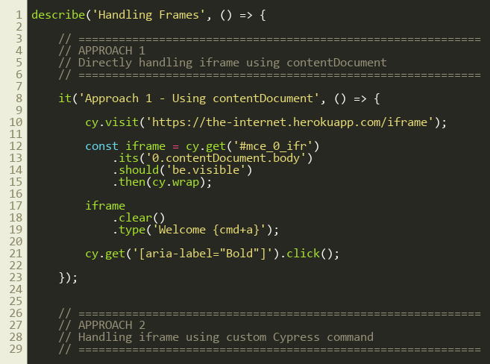
Lines 1–30
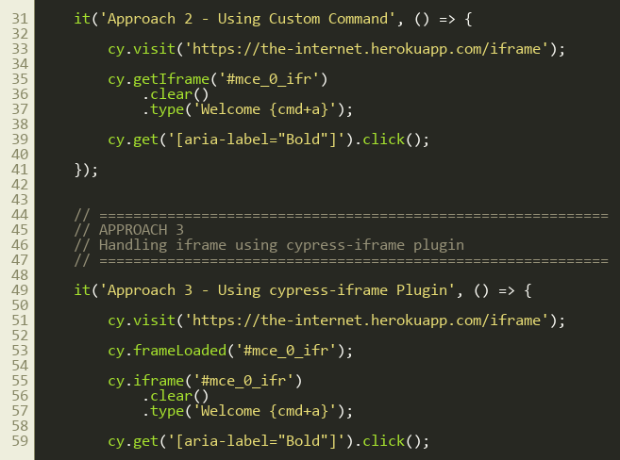
Lines 31–60
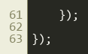
Lines 61–63

3. Step by step: what happens
Look for this in the code | What it does
Approach 1 – contentDocument | cy.get('#mce_0_ifr').its('0.contentDocument.body').should('be.visible').then(cy.wrap) digs into the iframe's document and wraps its body so Cypress commands work on it.
Approach 2 – custom command | Same code packaged as cy.getIframe('#mce_0_ifr') in cypress/support/commands.js, so tests stay short.
Approach 3 – plugin | cy.frameLoaded('#mce_0_ifr') waits for the iframe, and cy.iframe('#mce_0_ifr') returns its body. Comes from cypress-iframe.
.clear().type('Welcome {cmd+a}') | Empties the editor, types Welcome and presses select-all.
cy.get('[aria-label="Bold"]').click() | The Bold button lives outside the iframe, so a normal cy.get works.

4. Concepts involved
Concept | Meaning
.its('0.contentDocument.body') | Reads nested properties: first element > inner document > body.
.should('be.visible') | Makes Cypress wait until the iframe has loaded.
.then(cy.wrap) | Turns the plain DOM element into a Cypress chain.
Custom command | Cypress.Commands.add('getIframe', ...) in support/commands.js.
Plugin | cypress-iframe gives cy.frameLoaded() and cy.iframe().

5. How it is implemented
The progression is: raw code, then a reusable command, then a plugin. The plugin version is the cleanest.

6. Why it is useful
Iframes are common (editors, payment forms, ads). This file shows three ways, from basic to reusable.

7. Things to watch out for
- {cmd+a} is the Mac shortcut. On Windows use {ctrl+a}.

