implicitAssertions.cy.js – Implicit assertions (.should / .and)
File | cypress/e2e/implicitAssertions.cy.js
Website used | https://opensource-demo.orangehrmlive.com/web/index.php/auth/login
Run status | Runs. Only the last two commands are active; the rest are commented examples kept for reference.
Concepts | Implicit assertion, Auto-retry, Common chainers, Chaining

1. What this file does
Shows the built-in way of checking things in Cypress: chain .should() or .and() onto a command. Most examples are commented out as a reference list; the active part types a username and checks the input's value.

2. The code (screenshots)
Keep this next to the file in VS Code. Line numbers match the real file.
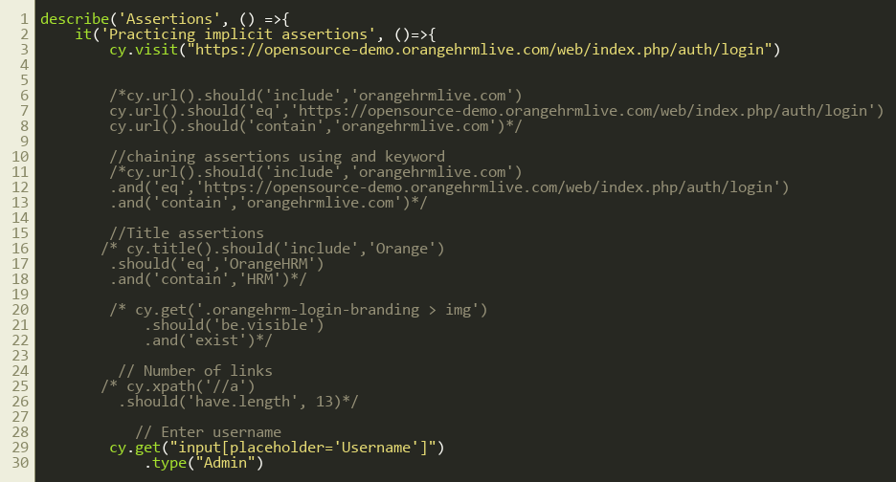
Lines 1–30
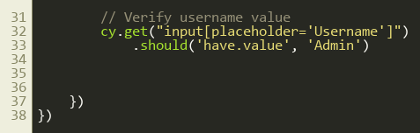
Lines 31–39

3. Step by step: what happens
Look for this in the code | What it does
cy.visit(login page) | Opens the OrangeHRM login page.
Commented: cy.url().should('include', ...) | Checks the URL contains some text. Variants use 'eq' (exact) and 'contain'.
Commented: .should(...).and(...).and(...) | Chains several checks on the same subject. .and() is just another name for .should().
Commented: cy.title().should('include','Orange') | Checks the page title.
Commented: .should('be.visible').and('exist') | Checks the logo is in the DOM and shown.
Commented: cy.xpath('//a').should('have.length', 13) | Counts the links on the page.
cy.get("input[placeholder='Username']").type("Admin") | Types Admin into the Username box.
.should('have.value', 'Admin') | Checks the input's value is now Admin. Inputs hold a value, not text.

4. Concepts involved
Concept | Meaning
Implicit assertion | An assertion attached directly to a Cypress command with .should() or .and().
Auto-retry | Cypress keeps re-running the command and the assertion together until they pass or the 4 second timeout is reached. No manual waits needed.
Common chainers | be.visible, exist, have.length, have.value, include, contain, eq, have.text.
Chaining | Several .and() calls can follow one command, so the subject is fetched once.

5. How it is implemented
The assertion is part of the chain, so there is no separate variable or callback. Compare this to explicitAssertions_*.cy.js, where we pull the value out first.

6. Why it is useful
This is the preferred way to assert in Cypress: short, readable and automatically retried, so it handles slow-loading pages.

7. Things to watch out for
- Use have.value for input fields and have.text / contain.text for normal elements.
- Remove the comment markers to try each example one by one.

