myFirstTest.cy.js – My first Cypress test
File | cypress/e2e/myFirstTest.cy.js
Website used | https://www.saucedemo.com/
Run status | Both tests run (no it.only / it.skip). The second test is MEANT to fail.
Concepts | describe / it, cy.visit(url), cy.title(), .should('eq', value), Positive vs negative test

1. What this file does
The smallest possible Cypress test. It opens a website and checks that the page title is what we expect. The file has one passing test and one deliberately failing test so I can see what pass and fail look like.

2. The code (screenshots)
Keep this next to the file in VS Code. Line numbers match the real file.
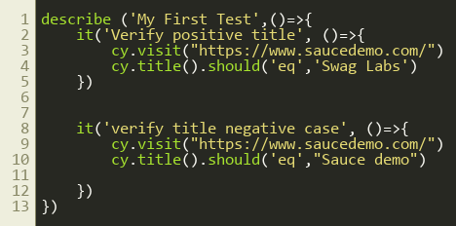
Lines 1–13

3. Step by step: what happens
Look for this in the code | What it does
describe('My First Test', ...) | Creates a test suite, a group that holds the two tests below.
it('Verify positive title') | Test 1. Opens saucedemo.com with cy.visit(), reads the page title with cy.title() and asserts it equals 'Swag Labs'. It passes.
it('verify title negative case') | Test 2. Same steps but expects 'Sauce demo', which is wrong. Cypress retries for 4 seconds, then fails with 'expected Swag Labs to equal Sauce demo'. This is a negative test written on purpose.

4. Concepts involved
Concept | Meaning
describe / it | Mocha structure. describe = suite, it = one test case.
cy.visit(url) | Opens a page and waits for it to load.
cy.title() | Reads the <title> of the current page.
.should('eq', value) | An implicit assertion. 'eq' means exactly equal. It retries automatically until it passes or times out.
Positive vs negative test | A positive test checks that correct things work. A negative test checks what happens with wrong data or wrong expectations.

5. How it is implemented
Every Cypress test follows the same shape: visit a page, do something (or read something), assert something. This file has the minimum version of that shape.

6. Why it is useful
It is the best file to copy when starting a new test. The failing test also shows the red error message and how Cypress compares expected and actual values.

7. Things to watch out for
- Each test starts with a clean browser, so each test must call cy.visit() itself.
- The second test failing is expected. Do not 'fix' it unless you want a green run.

