paginition.cy.js – Tables and pagination
File | cypress/e2e/paginition.cy.js
Website used | http://localhost:8080/admin/ (local OpenCart admin, Customers list)
Run status | Only the Pagination test runs (it.only). Needs OpenCart running on localhost:8080. The file name has a typo (pagination).
Concepts | beforeEach hook, Table selectors, .each(), .within(), String handling, Loops with Cypress

1. What this file does
Works with an HTML table: counting rows and columns, reading one cell, reading every cell on a page and looping through every page of a paginated list while logging each email.

2. The code (screenshots)
Keep this next to the file in VS Code. Line numbers match the real file.
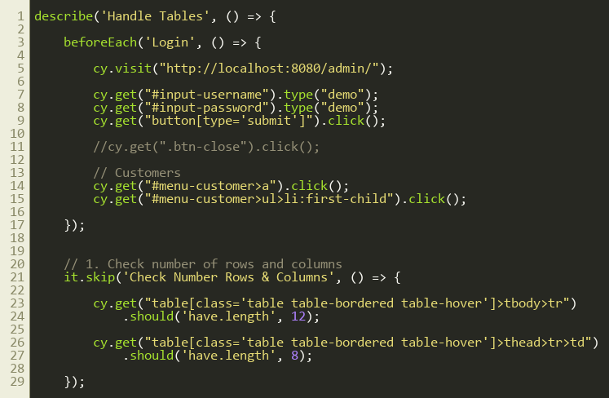
Lines 1–30
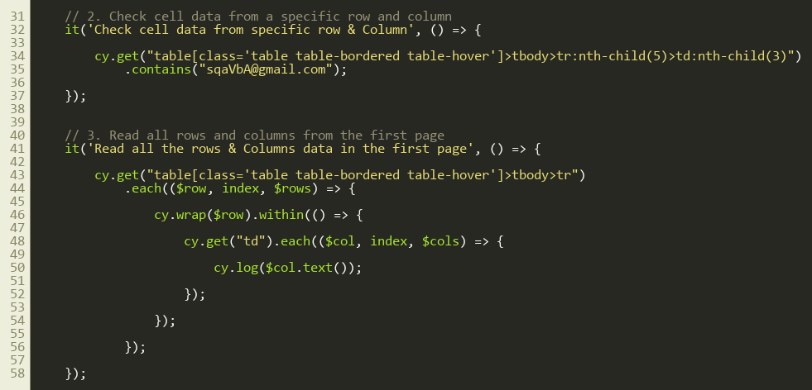
Lines 31–60
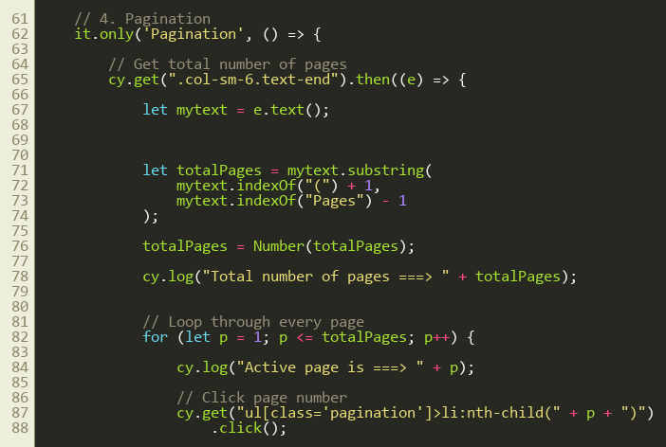
Lines 61–90
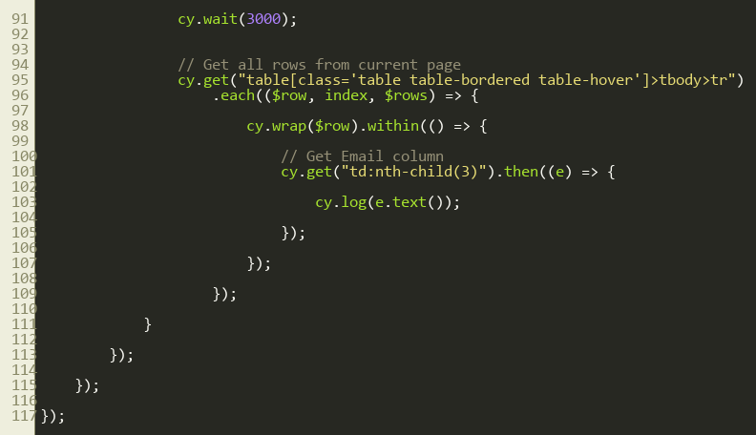
Lines 91–117

3. Step by step: what happens
Look for this in the code | What it does
beforeEach: Login | Before every test: open admin, type demo/demo, click submit, expand the Customers menu and open the Customers list.
1. Check rows and columns (skipped) | tbody>tr should have length 12 and thead>tr>td length 8.
2. Check one cell | tbody>tr:nth-child(5)>td:nth-child(3) is 5th row, 3rd column; .contains('...') checks its text.
3. Read the whole first page | Outer .each() loops rows. cy.wrap($row).within(...) limits the search to that row. Inner .each() on td logs each cell.
4. Pagination (active) | Reads text like 'Showing 1 to 10 of 100 (10 Pages)', extracts the number with substring() and indexOf(), converts it with Number(), then a for loop clicks page 1 to N and logs every row's email column.

4. Concepts involved
Concept | Meaning
beforeEach hook | Shared login for every test.
Table selectors | tbody>tr, td:nth-child(n).
.each() | Loops through elements.
.within() | Restricts cy.get to inside one element.
String handling | substring, indexOf and Number in plain JavaScript inside .then().
Loops with Cypress | A normal for loop works because Cypress queues the commands.

5. How it is implemented
Read the page-count text first, then iterate pages. Inside each page, iterate rows and then cells.

6. Why it is useful
Tables with pagination are common, and this pattern validates data across all pages.

7. Things to watch out for
- li:nth-child(p) assumes page 1 is the first li and numbers follow in order. Pagination with Next or '...' buttons can break it.
- cy.wait(3000) after each page click is a hard wait; waiting for the table to change is more reliable.

