radioButtons.cy.js – Radio buttons
File | cypress/e2e/radioButtons.cy.js
Website used | https://qaplayground.com/practice/radio-checkbox
Run status | Runs.
Concepts | .check() on a radio, Mutual exclusion, .uncheck()

1. What this file does
Selects the 'business' plan radio button, confirms it is selected, and confirms the 'pro' plan is not.

2. The code (screenshots)
Keep this next to the file in VS Code. Line numbers match the real file.
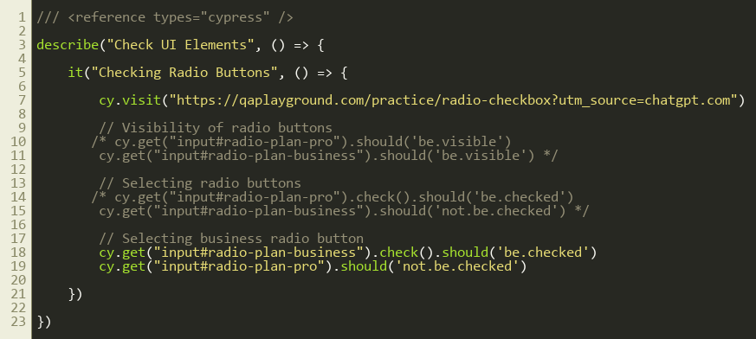
Lines 1–23

3. Step by step: what happens
Look for this in the code | What it does
cy.visit(...) | Opens the practice page.
Commented: visibility checks | Examples of should('be.visible') for each radio.
cy.get("input#radio-plan-business").check().should('be.checked') | Selects the business radio and verifies it is on.
cy.get("input#radio-plan-pro").should('not.be.checked') | Radios in one group exclude each other, so pro must be off.

4. Concepts involved
Concept | Meaning
.check() on a radio | Selects it.
Mutual exclusion | Choosing one radio in a group clears the others, which we verify with not.be.checked.
.uncheck() | Only works for checkboxes, not for radios.

5. How it is implemented
Locate each radio by its unique id (input#radio-plan-business), act on one and assert on the other.

6. Why it is useful
Verifying both the chosen and the not-chosen options proves the group behaves correctly.

7. Things to watch out for
- The ?utm_source=chatgpt.com part of the URL is only a tracking parameter and can be removed.

