xPath.cy.js – Finding elements with XPath
File | cypress/e2e/xPath.cy.js
Website used | https://tutorialsninja.com/demo/
Run status | Runs. Needs the cypress-xpath plugin (loaded in cypress/support/e2e.js). No assertion.
Concepts | XPath, cypress-xpath plugin, CSS vs XPath

1. What this file does
The same search scenario as cssSelectors.cy.js, but the elements are located using XPath instead of CSS.

2. The code (screenshots)
Keep this next to the file in VS Code. Line numbers match the real file.
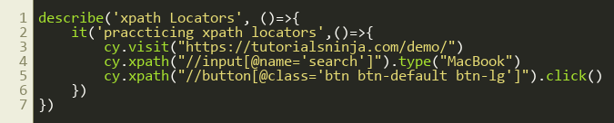
Lines 1–7

3. Step by step: what happens
Look for this in the code | What it does
cy.visit(...) | Opens the demo shop.
cy.xpath("//input[@name='search']").type("MacBook") | // = look anywhere on the page, input = tag, [@name='search'] = attribute filter. Types into that box.
cy.xpath("//button[@class='btn btn-default btn-lg']").click() | Finds the search button by its class attribute and clicks it.

4. Concepts involved
Concept | Meaning
XPath | A query language for the page structure: //tag[@attribute='value'].
cypress-xpath plugin | Cypress has no cy.xpath() by default. The plugin adds it. It is enabled globally with require('cypress-xpath') in support/e2e.js.
CSS vs XPath | CSS is simpler and faster. XPath can find an element by its text (//a[text()='Login']) and can move UP to a parent (/..), which CSS cannot.

5. How it is implemented
Because the plugin is required in the support file, no import is needed in this spec. If the plugin is missing, the error is 'cy.xpath is not a function'.

6. Why it is useful
Gives me a second locating strategy for cases where CSS is not enough, such as finding by visible text or navigating to a parent.

7. Things to watch out for
- Use CSS first; switch to XPath only when needed.
- Absolute XPaths like /html/body/div[2]/... break easily. Prefer relative ones starting with //.

