**CSE 573 SEMANTIC WEB MINING**

**Mid-Term Exam - FALL 2023**

**400 Points (40% of course grade)**

**October 16th, 2023**

1. Take-home and open note exam.
2. This is an **individual work exam,** and **you cannot work in groups**.
3. **PLEASE WRITE YOUR NAME and ASUID on top of each exam sheet!**

**Exam Submission Instructions**: You can (1) type your answers into this word document and convert it to PDF, or (2) write down your answers on plain papers, scan and upload them as a PDF at **Canvas > Assignments > Mid-Term Exam. DUE: October 16, 2023, 11:59pm** (by mid-night tonight).

**Duration**: The exam should take only about 75 minutes but I am giving you plenty extra time to work on it, convert or scan it as a single PDF document and submit it at Canvas.

**Academic Integrity**: All students in this class are subject to ASU’s Academic Integrity Policy and you should acquaint yourselves with its content and requirements, including a strict prohibition against working together or copying from each other and plagiarism. All violations will be reported to the Dean’s office, who maintain records of all offenses.

If you have any questions my SkypeID is **hdavulcu**. You can also call me at my cell phone **(602) 386.6565** until mid-night tonight. Best of Luck!

**GRADING**

* The exam is worth 400 points.
* This exam is 5 pages and 10 questions in 4 parts.

***PART I: Semantic Web Languages* [100 points]**

**1. Translate the HTML information below into an XML object. [30 pts]**

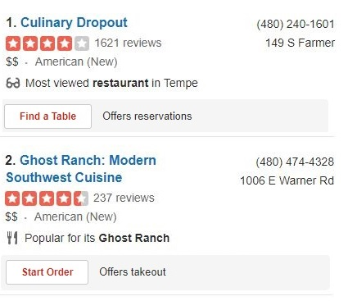

**2. Draw the graph representation for above XML object and its lower bound schema. [40 pts]**

**3. Translate following XML-QL with Regular Path Expressions into an English query. [30 pts]**

**SELECT R.telephone**

**FROM Yelp.restaurant R**

**WHERE R.takeout=true**

***PART II: Frequent Item-Sets and Association Rules* [100 points]**

**4. Apply the APRIORI algorithm assuming required minimum support at 40% (4 out of 10) to the following set of 10 transactions involving items {A, B, C, D, E, F, G}.**

**T1={A,B,C} T6={B, C, D, E}**

**T2={A,F,G} T7={E, F}**

**T3={B,C,G} T8={B, C, F, G}**

**T4={A, B, C, F} T9={B,C, F, G}**

**T5={B, C} T10={B, C, G}**

**Show how Apriori’s level-wise Item Set Generation algorithm works for the above example. Indicate what candidate itemsets will be generated in each pass, and which remain in the candidate set after pruning. [50 points]**

**5. Generate association rules with support of 40% and confidence of 100%. [50 points]**

***PART III: Clustering* [100 points]**

**6. You want to cluster following 7 observations into 3 clusters using the K-Means clustering algorithm. Assume that after the first iteration clusters C1, C2, C3 has following members:  
  
C1: {(2,2), (4,4), (6,6)}  
  
C2: {(0,4), (4,0)}  
  
C3: {(5,5), (9,9)}  
  
What will be the cluster centroids if you want to proceed to the second iteration? [40 pts]**

**C1: (__, __); C2:(__,__), C3:(__,__)**

**7. What will be the clusters for the second iteration? [60 points]**

**C1: { }  
  
C2: { }   
  
C3: { }**

***PART IV: Web Ranking* [100 points]**

***8. A directed network N has vertices {A, B, C} and edges (A🡪 B), (B🡪 B), (B 🡪 C), (C 🡪 A).***

***i. Draw the network N and write down its transpose, column-normalized transition matrix M for the calculation of simplified PageRank. [30 points]***

***9. Is M an irreducible matrix? Explain why? [30 points]***

***10. Show the evolution of the initial page-rank vector x = <xA, xB, xC> = <1, 1, 1> until the simplified PageRank algorithm with Power Method converges. [40 points]***

|  |  |  |  |
| --- | --- | --- | --- |
| ***iteration*** | ***XA*** | ***XB*** | ***XC*** |
| ***0*** |  |  |  |
| ***1*** |  |  |  |
| ***2*** |  |  |  |
| ***3*** |  |  |  |
| ***4*** |  |  |  |
| ***5*** |  |  |  |
| ***6*** |  |  |  |
| ***7*** |  |  |  |

**Hint.** Replace ***x*** by the product **M *x*** until page rankings converge.