1. Which answer option is a correct statement about the following ASP program (in **Problem 1**)?

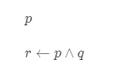

This ASP program has exactly 2 stable models.

This ASP program is a definite program.

This ASP program is NOT a positive program.

This ASP program is unsatisfiable under propositional logic.

2. Which answer option is a correct statement about the following ASP program (in **Problem 2**)?

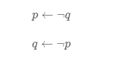

This ASP program is a definite program.

This ASP program has exactly 2 stable models.

This ASP program is a positive program.

This ASP program has no stable model but is satisfiable under propositional logic.

1. Which answer option is a correct statement about the following ASP program (in **Problem 3**)?

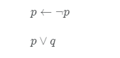

The critical part of the propositional rule in the ASP program is the “p” in the body of the first rule.

This ASP program has exactly 1 stable model and is satisfiable under propositional logic.

This ASP program has exactly 2 stable models.

This ASP program is a definite program.