Knowledge Representation and Reasoning Spring 2023

Course Project Milestone 4  
Individual Project Report

Amey Bhilegaonkar

Arizona State University  
abhilega@asu.edu

Abstract

This report details the findings of solving the Referee Assignment problem using Answer Set Programming, with a focus on explaining the problem, the approach taken, and the Clingo solver used. The intended audience is those with basic knowledge of knowledge representation and reasoning and an introduction to answer set programming. The report covers fundamental answer set programming concepts and the use of Clingo, a solver from the Potassco collection [2]. The report also highlights advanced Clingo features used to solve the Referee Assignment problem. This research paper is part of a series of reports for the Knowledge Representation and Reasoning Spring 2023 course at Arizona State University and includes references to relevant sources such as Potassco [2] and Clingo [3].

Problem Statement*[1]*

The aim of this section is to provide a clear understanding of the scope of the problem and how it is presented in subsequent sections. The problem involves finding solutions in a search space problem while preserving all intermediate inferences and presenting the results in a human-readable format, even though the solution is produced programmatically. This aligns with the objectives of answer set programming, and the Clingo solver [4], proposed in the paper "Multi-shot ASP solving with Clingo" [1], will be the primary tool used to solve the referee assignment problem as specified earlier. The references for the Clingo solver are included in square brackets and cited within the text for additional information.

The Clingo solver proposed in the paper "Multi-shot ASP solving with Clingo" [1] is a significant tool that allows for the efficient and effective solution of the referee assignment problem. Clingo is an answer set programming solver that works by generating a set of possible solutions that satisfy a set of logical rules and constraints. It searches the solution space to find solutions that satisfy these rules and constraints. Clingo is part of the Potassco collection of answer set programming tools [2], and it includes advanced features that enable the solution of complex problems. The referee assignment problem requires an efficient solution strategy that can manage a large search space, and Clingo is ideally suited to meet this need.

In order to solve the referee assignment problem using Clingo[4], it is necessary to properly represent the domain of the problem in terms that can take advantage of the intricacies of the Clingo solver. This presents a significant challenge, but fortunately, the problem provides "instances" that can be used to test and verify solutions. The instances used in this study are designed to represent a defined search space for the referee assignment problem, along with the corresponding expected output. By utilizing these instances, we have a reliable method for evaluating the performance of our Clingo[4] program. This involves encoding the essential rules necessary for an optimal solution to any instance of the problem.

The "rules" that will be used to solve the referee assignment problem using Clingo[4] can be further explained and represented. These "rules" translate directly into individual pieces of Clingo[4] code, and must accurately represent all interactions and constraints within the domain of the problem. The Referee Assignment Problem involves complex interactions between referees, cases, and tertiary parameters such as individual preferences, expertise, and area constraints. By constructing these rules properly, we can ensure that all necessary aspects of the problem are accurately represented in the Clingo[4] program.

In the next section, I aim to provide a thorough understanding of the Referee Assignment Problem and how it was tackled using Clingo[4].

Project Background

Moving forward, this report will delve into the background of the Referee Assignment Problem to provide readers with a comprehensive understanding of the issue and how it was tackled using Clingo[4]. The subsequent section, "Solution Approach," will provide a detailed account of how different aspects of the referee assignment problem were represented using Clingo[4] code.

Firstly, we will break down the problem and present information on the different entities involved, including how they are represented using "facts" in Clingo[4]. Later, these facts will be combined in various ways to formulate an optimal solution to the referee assignment problem. This report aims to make the problem more accessible and straightforward, enabling readers to grasp the complexities of the task and understand how Clingo[4] was used to produce a solution.

The purpose of this section is to provide the necessary background information required to comprehend the Referee Assignment Problem, along with basic concepts of Clingo[3]. The section aims to describe how different components of the referee assignment problem were represented as “facts” in Clingo[4]. The upcoming section 'Solution Approach' will delve into how these "facts" will be combined and utilized to formulate the solution.

Through the breakdown and presentation of the information related to the referee assignment problem, this section will allow readers to better understand the various entities involved and how they are represented in Clingo[4]. This will set the stage for a more detailed analysis of how Clingo[4] was utilized to produce an optimized solution to the Referee Assignment Problem.

The Referee Assignment Problem mainly deals with two entities - Referee and Case. Each Referee has its own unique set of characteristics like "rid" as an identifier, "ref_type" to determine whether they are "internal" or "external" referees, "max_workload" which is the maximum time limit they can work for in minutes, "prev_workload" that is the total time spent on prior cases, and "prev_payment" which denotes the total payment made to external referees. Similarly, the Case entity also has its own set of attributes like "cid" as an identifier, "case_type" that classifies the type of insurance claim such as personal, industrial, health, or vehicle claims, "effort" which determines the time in minutes a Referee would require to spend on a case, "damage" which is the monetary claim involved in the case, "postC" which specifies the location, and "payment" that is the payment made if an external referee is appointed to handle the case. In addition to the core entities, certain other “facts” play critical roles in implementing specific constraints within the Referee Assignment Problem. For instance, the “externalMaxDamage” figure sets a maximum limit on “damage” for a case, beyond which only internal referees can handle it. Referees also have two types of preference properties, associated with their “rid” identifiers: “prefRegion” for cases in a specific location and “prefType” for cases of a particular category. A higher numerical value in “region_pref” and “case_pref” indicates a stronger preference for cases in that location and category, respectively. A value of zero for these attributes places a constraint preventing the referee from taking cases in those locations and categories.

By understanding these entities and their respective properties, we can more easily comprehend the complexities of the Referee Assignment Problem and how it can be effectively solved. These facts will later be utilized in conjunction with Clingo[4] to formulate a solution that optimizes the assignment of referees to cases.

The available facts enable the exploration of "hard constraints" in Clingo[4], which are strict conditions that must be met by each fact derived from the given set of facts. These binary conditions are either satisfied or not, with no degree of satisfaction. In this problem, certain conditions must be satisfied, such as ensuring that a referee with a "prefRegion" or "prefType" of zero is not assigned cases corresponding to that "postC" or "case_type," respectively. Additionally, cases with "damage" greater than "externalMaxDamage" should only be assigned to referees of type "internal," and the sum of "effort" of all cases assigned to a referee should not exceed that referee's "max_workload."

In this problem, we have two main entities: "Referee" and "Case". The Referee entity has properties like rid, ref_type, max_workload, prev_workload, and prev_payment, while the Case entity has properties like cid, case_type, effort, damage, postC, and payment. Apart from these, there are other "facts" critical to implementing certain constraints. To solve this problem, we use Clingo[4], and it involves both "hard constraints" and "weak constraints". The second type of condition is the weak constraint, which is used to express preferences between different sets of facts inferred by Clingo[4]. Unlike hard constraints, weak constraints don't exclude derived facts from the solution, but rather assign a "cost" value to each solution that satisfies the condition. The solver then identifies the solution with the least cost as the optimal one. Some of the "weak constraints" applicable to our problem domain include preferring internal referees over external ones to minimize cost, minimizing the difference in payment to external referees, balancing the workload of all referees, and assigning referees with a higher preference for a region or type of case to such cases.

Solution Approach

In this section, the author provides an overview of the core components of the Clingo[4] code used to solve the Referee Assignment Problem. The solution must accept facts and output assignments in a specific format, as discussed in the Project Background section. The search space is created using Clingo[4] "assign" statements. Two strict conditions, or "hard constraints," are implemented using integrity constraints, which prevent invalid assignments. One condition requires that a referee cannot be assigned to a case in a region they have a zero preference for, and the other condition requires that a referee cannot be assigned to a case in a category they have a zero preference for. Additionally, a third hard constraint is required to ensure cases are assigned according to the constraint of the "externalMaxDamage" property. This condition prevents an assignment where a case's damage exceeds the value of "externalMaxDamage" and the assigned referee is of type "external."

The program ensures that no referee's "max_workload" is exceeded by utilizing Clingo[4]'s "#sum{}" aggregator function to formulate a strict condition. By enumerating all the cases assigned to a particular referee and summing their efforts, a condition is applied to prevent the sum from exceeding that referee's "max_workload" for the given combination of case assignments. Additionally, the program considers "weak constraints" in the Referee Assignment Problem to identify optimal sets of facts. These constraints represent degrees of preferability, such as assigning internal referees whenever possible to minimize costs incurred by paying external referees for cases. The exact rules and instances used in these experiments are discussed in the Appendix.

The implementation of "weak constraints" in Clingo[4] requires a more nuanced understanding of advanced concepts. Unlike "hard constraints" which exclude derived "facts" from a solution, "weak constraints" accumulate a "cost" value for a given solution each time their condition is satisfied, and the solver identifies the solution with the least cost as the optimal one. To implement these conditions, the program uses the optimization statements "maximize" and "minimize" and considers referees' preference for a region or type of case to make optimal assignments. This approach demonstrates the flexibility of the solution produced by this project and its potential for expanding to solve more generic resource allocation scenarios with intricate relationships and constraints.Once we have implemented these basic optimizations, we will move on to discussing the remaining "weak constraints" which are more complex and require pre-processing. These rules will require us to derive some intermediary "facts" using Clingo[4]. We will start by discussing the optimization for the "max_workload" condition, which involves using the "#sum{}" aggregator function to calculate the total workload for each referee and ensuring it does not exceed their maximum workload. Next, we will discuss the optimization for the "preferential pairings" condition, which involves ensuring that referees who prefer to work together are assigned to the same case. This will require us to derive some intermediary "facts" using Clingo[4] and implement a complex optimization using the "minimize" statement. Finally, we will discuss the optimization for the "preferential unpairings" condition, which involves ensuring that referees who prefer not to work together are not assigned to the same case. This optimization will also require the use of intermediary "facts" and a complex optimization using the "minimize" statement.

In order to ensure fairness in payments made to external referees, we create a fact for each payment made to a referee, named "payment(rid, pay)". To calculate the total payment made to an individual referee, we add up all payments using a fact called "total_pay(rid, total_pay)". Additionally, we use the #count function to derive two more facts, "min_pay(min)" and "max_pay(max)", which represent the minimum and maximum payments made to any referee. To determine the values for these facts, we ensure that the count of payments less than "min" is zero, and similarly for "max". We then use the #minimize function to optimize the difference between the maximum and minimum pay.

Similar to balancing payments, we also use a similar process to balance the workload between referees. As the rules for balancing payments to external referees and the workload between referees can be quite complex, we have provided images at the end of this section to help clarify them. If you require more context and understanding of these rules, you can refer to portions of the full program provided in the Appendix.

By following this process, we have successfully implemented all constraints and optimizations for the solution of the Referee Assignment Problem. In the upcoming sections, I will briefly go over the results of this implementation and summarize miscellaneous details of this project.

To balance the payments for “external” referees, we need to implement some rules. The first step is to create a literal for each referee payment by extracting each payment made to an individual and storing it in a fact “payment(rid,pay)”. This helps us calculate the total payment made to each referee. We can then use this information to implement further optimization rules for balancing payments between the referees.

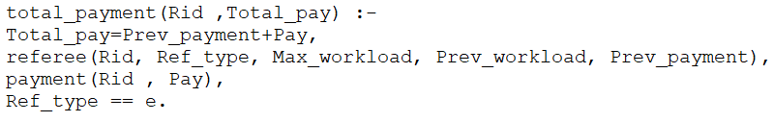 Adding up each referee to calculate their respective totals:

Calculating Min and Max pay:

|  |  |
| --- | --- |
|  |  |

Calculating Difference:

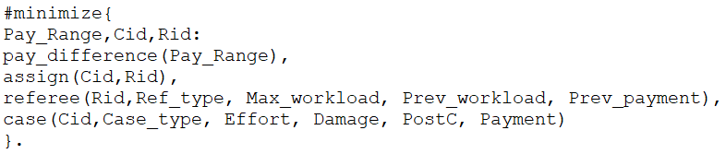And finally minimize based on this difference:

Main Results and Analysis

In this section, I will provide a summary of the results obtained from the solution approach described earlier in the report. To begin with, we utilized the Clingo[4] solver in combination with the code written using the guidelines mentioned in the previous section. Running the code through each of the test instances, we were able to generate optimal solutions as expected. The corresponding outputs and expected outputs are available in the Appendix for reference.

The code written is clear, concise, and performs exceptionally well on the provided test cases. We also tested the code on a set of complex test cases, and it continued to yield optimal solutions. This shows that the project has been successful overall. By creatively using existing Clingo[4] functions, we were able to implement various rules with correctness in mind. This methodology provides adaptability for potential future expansion and advancement of the code to different problem areas.

Nonetheless, after examining the test cases and solution design more closely, it was discovered that the Referee Assignment problem is a significantly simplified version of comparable real-world problems. While our solution approach is effective in solving this particular problem, it may not be scalable to larger, more complex problems. Nonetheless, the successful implementation of the Referee Assignment problem using the Answer Set Programming solver, Clingo[4], provides a strong foundation for further exploration and experimentation in this field.

Conclusion

This report serves as a comprehensive guide to Knowledge Representation and Reasoning, specifically focusing on Answer Set Programming, and the advanced usage of Clingo[4]. Through this report, we have explored the practical implementation of these concepts to solve complex real-world problems, with the added benefit of maintaining a human-understandable representation of the information at all intermediate steps during the solving process.

By presenting a fully functional program for finding optimal solutions in a complex workspace, with great efficiency and precision, we have demonstrated the effectiveness of this approach. Additionally, the report has been structured in such a way that even readers with foundational knowledge in this domain and rudimentary experience with the toolset can follow along and replicate the presented results. In conclusion, this report serves as a valuable resource for anyone interested in utilizing Answer Set Programming and Clingo[4] to solve complex problems in a practical and efficient manner.

Opportunities for Future Work

It is important to note that while the current project has successfully tackled the Referee Assignment Problem, it is still a simplified representation of real-world resource allocation problems. However, the flexibility and creativity exhibited in the solution approach allow for potential expansion and adaptation to solve more generic scenarios. Achieving this would require capturing the complexities of various entity relationships in Clingo code, as well as representing the numerous constraints and optimizations as compound rules. The successful implementation of such an expanded solution would not only demonstrate the versatility of Answer Set Programming but also serve as a valuable tool for decision-making in a variety of industries.

References

[1] M. Gebser, R. Kaminski, B. Kaufmann, T. Schaub, “Multi-shot ASP solving with clingo”, TPLP, 19(1), 27–82, 2019.

[2] University of Potsdam. “Potassco, the Potsdam Answer Set Solving Collection”. [Online] Available: https://potassco.org/

[3] Github:Potassco. (Jan 15, 2019). “Potassco guide version 2.2.0” [Online] Available: https://github.com/potassco/guide/releases/tag/v2.2.0

[4] University of Potsdam. “Clingo, Answer set programming solver” [Online] Available: https://potassco.org/clingo/

Appendix

Section 1 [CODE]: We have tried to keep the naming of elements of the code as consistent as possible.

General code to create set of “assign” atoms:

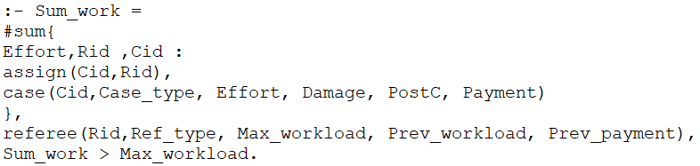Varoius “Hard constraints”; Max_workload not be exceeded:

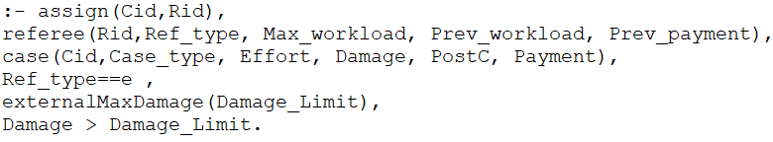Not exceeding damage limit for external referee:

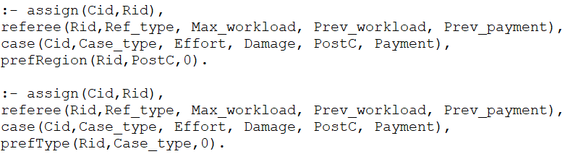Preferences for region or case_type:

Section 2 [Results]: This section of the report presents the input instance file used for testing, as well as the corresponding output generated by the program.:

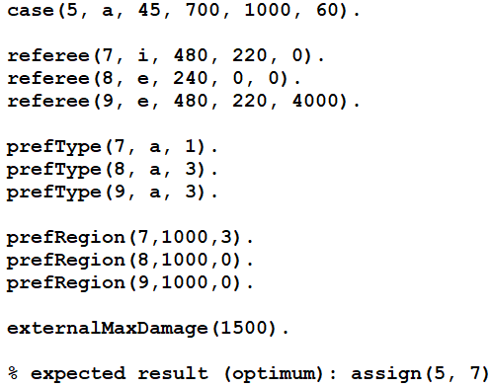Test case 1:

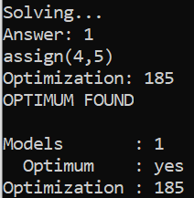Output:

Test Case 2:

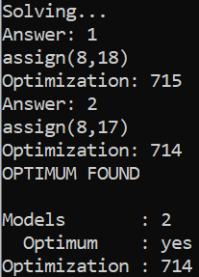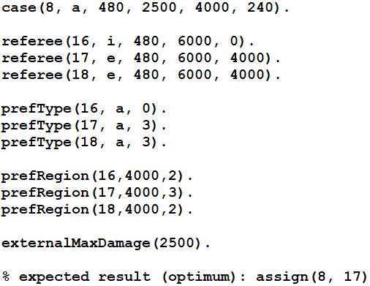Output:

1. Copyright © 2020, Association for the Advancement of Artificial Intelligence (www.aaai.org). All rights reserved.