**BPSK**

clc;

close all;

clear all;

t=[0:0.01:5*pi];% For setting the sampling interval

A=5;%Amplitude of input signal

wc=2;%For Angular frequency

Vi=A.*square(t); % Generating Input Signal

Vc=A.*sin(wc.*t);% Generating Carrier Sine

Vp= Vi.*Vc;% Sine wave multiplied with square wave in order to generate BPSK

subplot(3,1,1);% For Plotting Input signal

plot(t,Vi);

xlabel('time')

ylabel('amplitude')

title('Input Signal')

subplot(3,1,2);%For Plotting The Carrier wave

plot(t,Vc);

xlabel('Time')

ylabel('Amplitude')

title('Carrier')

subplot(3,1,3);% For Plotting BPSK (Binary Phase Shift Keying) signal

plot(t,Vp);

xlabel('t')

ylabel('Y')

title('BPSK')

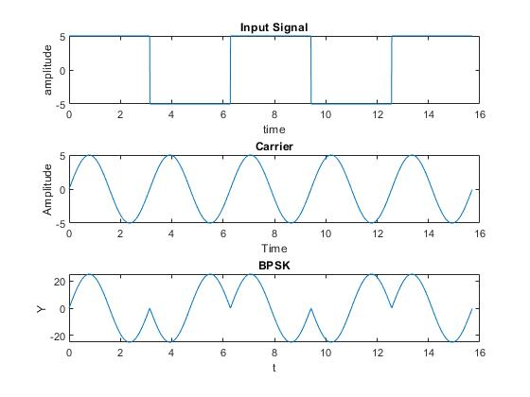

Name:Mayank Chourasia

TETB126

Block1 Batch2