**PROJECT REPORT**

**PROJECT NAME** :-Student database system

**DEVELOPMENT** :- C Language.

**PROJECT BY** :- Amey Kallekar

Student database system

## TABLE OF CONTENTS

|  |  |  |
| --- | --- | --- |
| **S No.** | **Content** | **Page No.** |
| **1.** | Introduction | **3** |
| **2.** | Objective | **4** |
| **3.** | Requirements | **5** |
|  |  |  |
| **4.** | Input and output Display | **6** |
|  |  |  |
|  |  |  |
| **5.** | Reference | **6** |

Student database system

# INTRODUCTION

Student Database System Project is a simple console application designed to demonstrate the practical use of C programming language and its features as wells as to generate an application which can be used in any school, colleges, university etc. for storing data of the student.

You can use this application to keep the records such as name, address, mobile number, date of birth, fees amount etc. of your student. Moreover, if you have a new Student, you can add and edit the account at any time.

**Features:**

1. It can hold any number of students data and can be added to the program at any time.
2. The programming of student database such as storing information of name,address ,phone no. etc. have been embed in the code of project.
3. The student database System project in C gives you the facility of searching the account by two ways, either by name of the student or by the no of student.
4. If you have nothing to do with the program, you can directly exit from the main menu.

Student database system

**OBJECTIVE**

Student Database System Project is a simple console application designed to demonstrate the practical use of C programming language and its features as wells as to generate an application which can be used in any school, colleges, university etc. for storing data of the student.

Student database System application is so simple to use. In order to use the application, click at the exe file and then, you will have three options to:

1. To add name
2. To search name
3. To exit

As per your need, enter 1, 2,or 3 and follow the instructions provided by the application itself.

Student database system

**REQUIREMENTS**

**Software Requirement**

* Operating System : Windows
* Application Software: Code-Blocks/Visual Studio
* Language : C-Programming

#### Hardware Requirements Specification

#### Processor : Intel core i3 or i5

#### Hard Disk : 250GB

#### Ram : 2GB

Student database system

**INPUT AND OUTPUT DISPLAY**

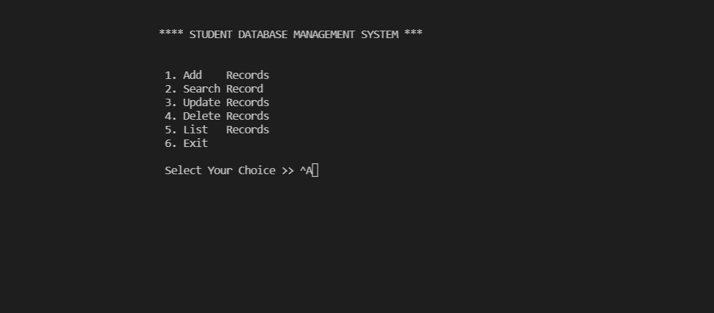

Student database system

**Reference**

* [**https://youtu.be/Gwv-oeERToQ**](https://youtu.be/Gwv-oeERToQ)
* **https://youtu.be/E9HHKiwvlH8**