CREATE TABLE "COLLEGE"

( "COLID" NUMBER NOT NULL ENABLE,

"COLNAME" VARCHAR2(30),

"ADDR" VARCHAR2(100),

"FEES" NUMBER,

"GRADE" VARCHAR2(2),

"TYPE" VARCHAR2(15),

"MINTYPE" VARCHAR2(20),

"QUOTA" NUMBER,

CONSTRAINT "COLLEGE_PK" PRIMARY KEY ("COLID") ENABLE

)

/

CREATE TABLE "STREAM"

( "STRID" NUMBER NOT NULL ENABLE,

"STRNAME" VARCHAR2(30),

CONSTRAINT "STREAM_PK" PRIMARY KEY ("STRID") ENABLE

)

/

CREATE TABLE "STUDENT"

( "SEATNO" NUMBER NOT NULL ENABLE,

"PMARK" NUMBER,

"CMARK" NUMBER,

"MMARK" NUMBER,

"ADDR" VARCHAR2(100),

"PIN" NUMBER,

"PASSWORD" VARCHAR2(20),

"FNAME" VARCHAR2(20),

"LNAME" VARCHAR2(20),

"RANK" NUMBER,

"STRID" NUMBER,

"COLID" NUMBER,

"DOB" DATE,

"EMAIL" VARCHAR2(20),

"SUBMIT" NUMBER,

"PHONE" NUMBER,

CONSTRAINT "STUDENT_PK" PRIMARY KEY ("SEATNO") ENABLE,

CONSTRAINT "STUDENT_CON" FOREIGN KEY ("COLID")

REFERENCES "COLLEGE" ("COLID") ENABLE,

CONSTRAINT "STUDENT_CON1" FOREIGN KEY ("STRID")

REFERENCES "STREAM" ("STRID") ENABLE

)

/

ALTER TABLE Student MODIFY Submit number(2) Default '0'

/

CREATE TABLE "PREFERENCES"

( "COURSECODE" VARCHAR2(20) NOT NULL ENABLE,

"STRNAME" VARCHAR2(30),

"COLNAME" VARCHAR2(30),

"STRID" NUMBER,

"COLID" NUMBER,

CONSTRAINT "PREFERENCES_PK" PRIMARY KEY ("COURSECODE") ENABLE,

CONSTRAINT "PREFERENCES_FK" FOREIGN KEY ("COLID")

REFERENCES "COLLEGE" ("COLID") ENABLE,

CONSTRAINT "PREFERENCES_FK2" FOREIGN KEY ("STRID")

REFERENCES "STREAM" ("STRID") ENABLE

)

/

CREATE TABLE "OFFERS"

( "COLID" NUMBER NOT NULL ENABLE,

"STRID" NUMBER NOT NULL ENABLE,

"INTAKE" NUMBER,

CONSTRAINT "OFFERS_PK" PRIMARY KEY ("COLID", "STRID") ENABLE,

CONSTRAINT "OFFERS_FK" FOREIGN KEY ("COLID")

REFERENCES "COLLEGE" ("COLID") ENABLE,

CONSTRAINT "OFFERS_FK2" FOREIGN KEY ("STRID")

REFERENCES "STREAM" ("STRID") ENABLE

)

/

CREATE TABLE "OPTFOR"

( "SEATNO" NUMBER NOT NULL ENABLE,

"COURSECODE" VARCHAR2(20) NOT NULL ENABLE,

"PREFNO" NUMBER,

CONSTRAINT "OPTFOR_PK" PRIMARY KEY ("SEATNO", "COURSECODE") ENABLE,

CONSTRAINT "OPTFOR_CK1" CHECK (Prefno<=5) ENABLE,

CONSTRAINT "OPTFOR_FK" FOREIGN KEY ("SEATNO")

REFERENCES "STUDENT" ("SEATNO") ENABLE,

CONSTRAINT "OPTFOR_CON" FOREIGN KEY ("COURSECODE")

REFERENCES "PREFERENCES" ("COURSECODE") ENABLE

)

/

COLLEGE

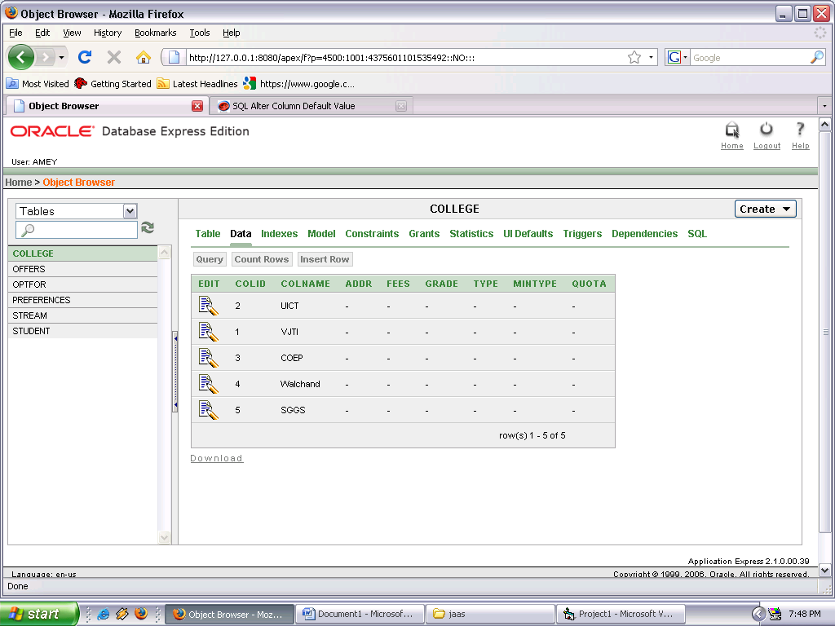

STREAM [change ‘Texttile’ to ‘Textile’]

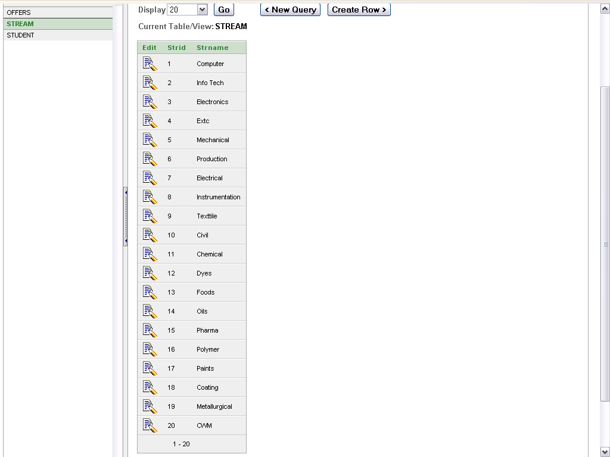

Student

We will see later.

Preferences

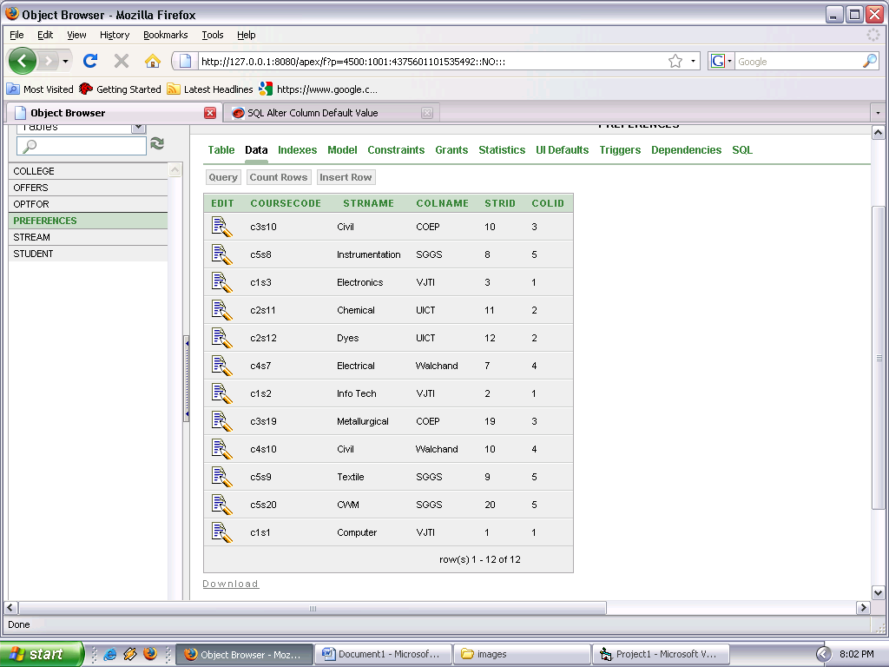

Offers

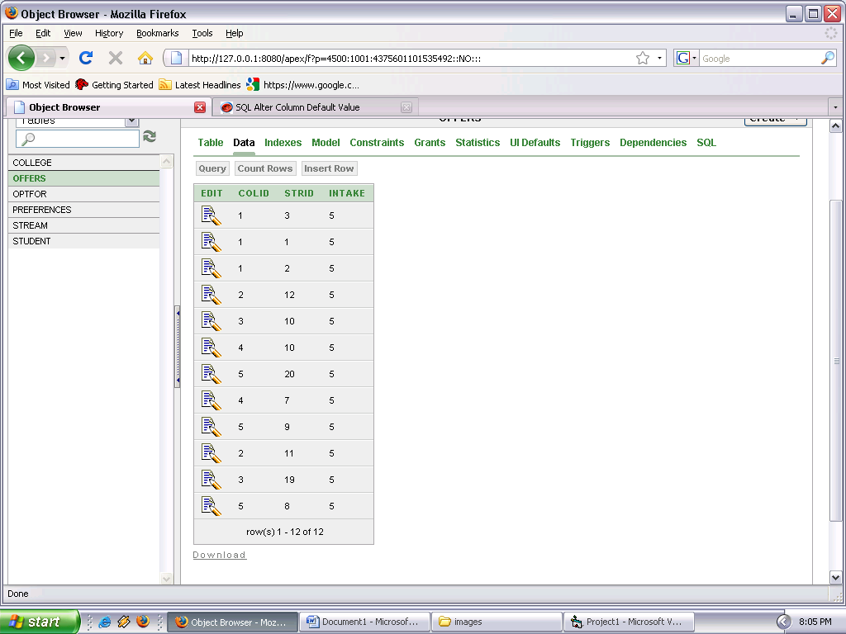

Optfor [do not add this]

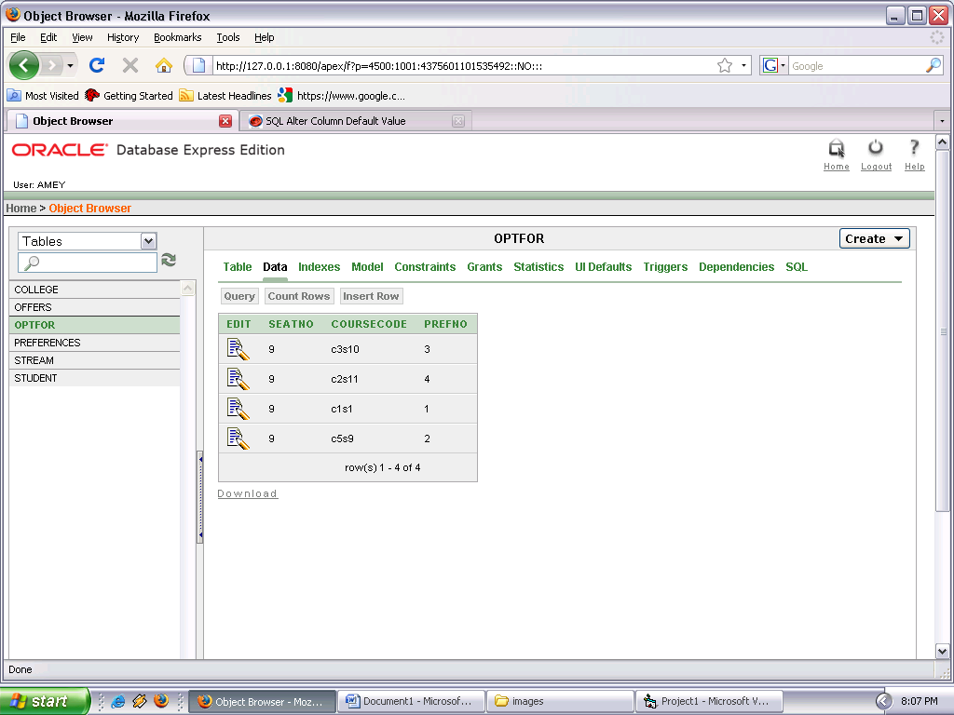

alter table "OPTFOR" add constraint

"OPTFOR_CON" foreign key ("SEATNO") references "STUDENT" ("SEATNO") on delete cascade