CHAPTER 1
INTRODUCTION
________________________________________________________

Unified Character Recognition System is an integrated solution for various pattern recognition systems.
Printed Character Recognition (PCR)
PCR engines turn images of machine-printed characters into machine-readable characters. Images of machine-printed characters are extracted from a bitmap. Forms can be scanned through an imaging scanner, faxed, or computer generated to produce the bitmap.
Intelligent Character Recognition (ICR)
ICR reads images of hand-printed characters (not cursive) and converts them into machine-readable characters. Images of hand-printed characters are extracted from a bitmap of the scanned image. ICR recognition of numeric characters is much more accurate than the recognition of letters.
Optical Mark Recognition (OMR)
OMR technology detects the existence of a mark, not its shape. OMR forms usually contain small ovals, referred to as 'bubbles,' or check boxes that the respondent fills in. OMR cannot recognize alphabetic or numeric characters. The accuracy of OMR is a result of precise measurement of the darkness of a mark, and the sophisticated mark discrimination algorithms can be used for determining whether what is detected is an erasure or a mark.
Magnetic Ink Character Recognition (MICR)
MICR is a specialized character recognition technology adopted by the U.S. banking industry to facilitate cheque processing. Background designs can interfere with optical recognition, the banking industry uses magnetic ink on cheques to ensure accuracy.
Barcode Recognition
A barcode is a machine-readable representation of information. Barcodes can be read by optical scanners called barcode readers or scanned from an image using software.

1.1. Problem Definition:
Optical character recognition (OCR) is one of the most successful applications of automatic pattern recognition. Since mid-1950s, OCR has been an active field in research and development. Today, reasonably good packages of OCR can be easily found in the commercial market. However,
- They are still limited to recognize high quality printed text documents.
- There exists no OCR package which implements all the pattern recognition systems.
‘Unified Character Recognition’ aims at building a single application program for different character recognition systems. The UCR system may contain different subsystems as mentioned above.
The high variability and complexity of handwritten words and numerals, notable deformations during the writing process, and possible noise contamination during the scanning process make ICR a very difficult problem than PCR. But in spite of having similarities between two systems, very few application programs support both of them.
On the other hand, OMR, MICR and Barcode are three closely related systems having different applications. OMR can reduce manual work to great extent while checking large number of answer-sheets having similar format. MICR is a technique which has been developed to simplify pattern recognition and make the bank transactions safe, secure and accurate. Lastly, Barcode is the well established standard for secure product information transfer.
The sole aim of all the above mentioned systems is to reduce the workload and eliminate the manual process. Unified Character Recognition System would be significant to the simplification of the workflow in corporate and commercial sector. Also its use is important on individual level. Further to deal with the problem that all the forms of character recognition are not there in the single application ‘Unified Character Recognition System’ is proposed.

1.2. Scope
In this project efforts are under way towards unifying various pattern recognition systems and also increasing the accuracy of handwritten and printed character recognition.
This work can be further extended to the character recognition of other languages as well as for special character recognition. For doing so, sufficient training and also a sufficient number of samples are required so that network could be trained for them. Although, a lot of efforts have been made to complete a great deal of work but still it has tremendous scope for further improvement/enhancement. In future, efforts can be made to improve the recognition accuracy of the network for special characters by using more training samples. An automatic system for recognizing all handwritten characters can also be developed. This work can be extended for word recognition in any language by including regular expressions. It can also be extended for language translation by including regular expressions and grammar.

CHAPTER 2
LITERATURE REVIEW
________________________________________________________

2.1. Printed Character Recognition (PCR)
There is a clear need for optical character recognition in order to provide a fast and accurate method to search both existing images as well as large archives of existing paper documents. However, existing optical character recognition programs suffer from a flawed tradeoff between speed and accuracy, making it less attractive for large quantities of documents.
There are two major limitations in the implementation given by Dipayan Sarkar[1] which make extensive testing difficult. One is speed. The feature extraction process was implemented in interpreted R code, which is fairly slow. For a single page (consisting of about 1500 glyphs), recognition can take more than an hour on a moderately fast computer. It should be possible to improve the performance considerably by internally using C code to do the feature extraction. The other problem was the identification of glyphs in the training stage. It was done by specifying an input image, which is segmented and the user is asked to identify each glyph. The problem with this approach is that some glyphs appear far more frequently than others, which may lead to a bias in the recognition step. In particular, capital letters appear very rarely.

2.2. Intelligent Character Recognition (ICR)
ICR involves the following 2 steps:
i. Image compensation: This step is used in the trial to compensate the quality of the original image, enhancing certain details of the image as noise or contrast. It includes:
a) Identification and background noise removal: A low-resolution scanned image, not clean original or a coloured envelope, certainly produces a poor result. For this type of image, a threshold factor will be necessary to remove the background colour by filtering.
b) Contrast enhancement: Used to enhance bright images.
c) Removal of spurious pixels: Can also be eliminated or reduced using the projection histograms
d) Cut: The next step is to detach the central part where we can find the objects of interest, in this in case, the digits of the postal code (CEP).
ii. Refine: The second level of the decision tree is still based on the projection histogram, using a new refinement rate. The elements not segmented successfully, in the succession of the refinements will be dealt with other segmentation methods in the sequence of the decision tree.
2.3. Optical Mark Recognition (OMR)
Automatic mark reading seems to be a relatively straightforward task of document processing and several OMR algorithms have been already available for quite a long time.
The form reading algorithms of Maciej Smiatacz are designed in such a way that there is no image preprocessing, such as filtering or skew correction. The algorithms operate on 8-bit greyscale images which means that binarization is not performed.
The main type of data, on which the algorithms directly operate, is the vertical or horizontal projection (sometimes called a “histogram”). The analysis of such intensity distribution profiles, extracted from the appropriate areas, is the most common technique used. Histogram equalization or operations can consume significant amount of time.

2.4. Magnetic Ink Character Recognition (MICR)
MICR is a specialized character recognition technology adopted by the banking industry to facilitate check processing. There are number of techniques proposed for recognition of magnetic ink characters.
MICR technique proposed by ‘Jesse Hansen’ involves several steps including pre-processing, feature extraction, and classification. The pre-processing steps proposed in this technique are binarization, morphological operations and segmentation. Binarization – Usually presented with a greyscale image, binarization is then simply a matter of choosing a threshold value. Morphological Operators are used to remove isolated specks and holes in characters. In segmentation connectivity of shapes, label is checked and isolated. Segmentation is by far the most important aspect of the pre-processing stage. It allows the
recognizer to extract features from each individual character.
Feature extraction process identifies and extracts the useful features. Mainly moment based features such as Total mass (number of pixels in a binarized character), Centroid - Center of mass, Elliptical parameters - Eccentricity (ratio of major to minor axis) or Orientation (angle of major axis), Skewness, Kurtosis, Higher order moments.
In model estimation, using the labelled sets of features for many characters, where the labels correspond to the particular classes that the characters belong to, we wish to estimate a statistical model for each character class.
For the Classification the statistical algorithms or clustering algorithms based on statistical model estimated in previous step are used. This step can increase the computation efficiency. Also, the accuracy of the system is primarily based on this step.

2.5. Barcode Recognition
There is quite a number of research works carried out on barcode reading and localization using camera. Finding of one of these works is explained here.
Usman Ullah Sheikh[2], real-time barcode reader using Active vision. This is to decode the UPC-A and EAN-13 barcodes using an active vision system, consisting of a camera and user-written software. The camera will feed the software with continuous frames of images from the environment. These images are converted to grayscale and some preprocessing is performed. Image is filtered (such as sharpening and noise reduction) and converted to binary.
An adaptive thresholding algorithm is used to reduce the effects of uneven illumination. Image is then scanned horizontally, vertically and diagonally for barcodes, thus enabling it to decode rotated barcodes. Error correction and predictive decoding is implemented to improve the speed and accuracy of the system. Overall system performance is benchmarked with existing commercially available software.

CHAPTER 3
FORMULATION OF PROJECT
________________________________________________________

3.1. Project Flow

Figure 1: Flow of Project

The input image is uploaded on the system of the size according to the system’s requirement. The recognition method for the image is selected from the given options. The output is displayed in a text file.
3.2. UML Diagrams

3.2.1. Usecase Diagram

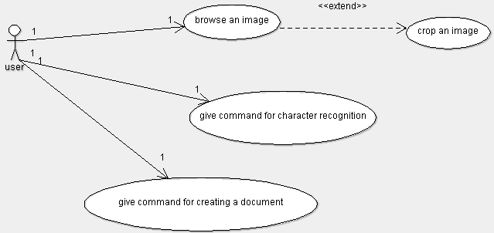

Figure 2: Use-Case Diagram

3.2.2. Activity Diagram

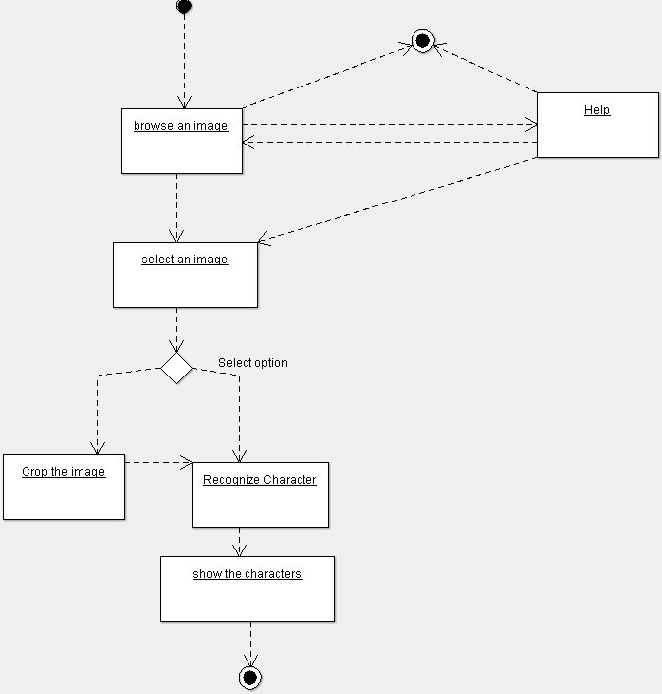

Figure 3: Activity Diagram

3.3. Data Flow Diagrams

Level 0:

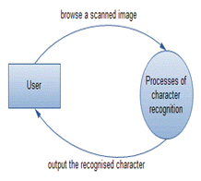

Figure 4: Level 0 DFD

Level 1:

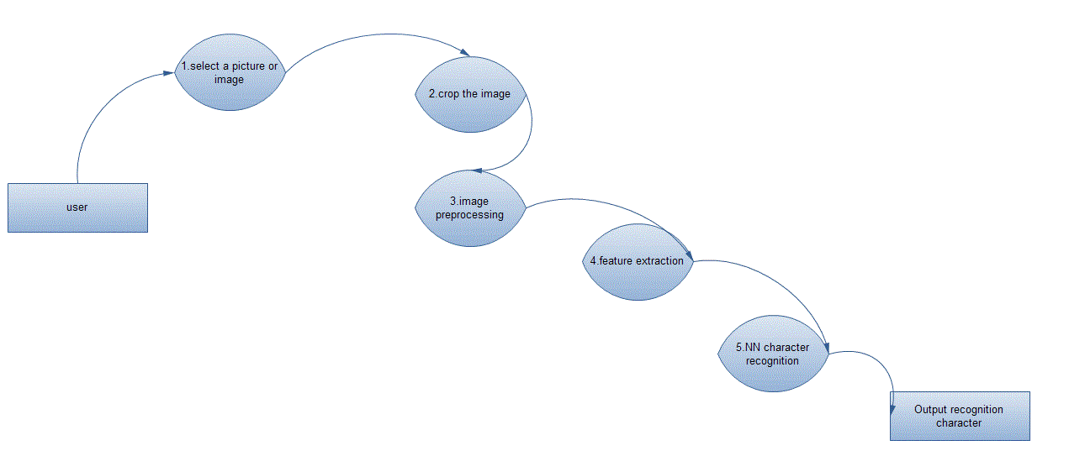
Figure 5: Level 1 DFD
Level 2: 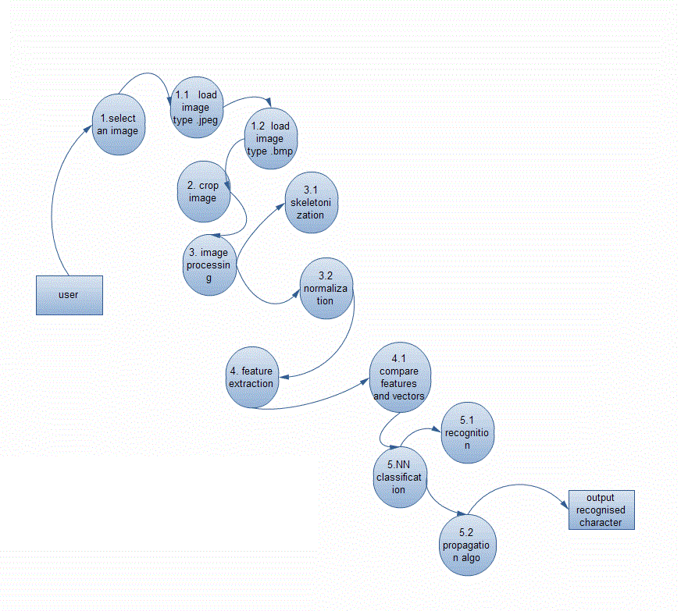
Figure 6: Level 2 DFD

CHAPTER 4
PLAN FOR IMPLEMENTATION
________________________________________________________

Figure 7: Plan for implementation

4.1. Pre-Processing
4.1.1. Binarization
Modern computers can represent over four billion colours. To represent each colour, computers require thirty-two bits. For colour images, this means that every pixel will consume at least four bytes of memory. However, optical character recognition is colour independent—a black letter is the exact same as a red letter. Binarization is a method to reduce coloured images to two colours, black and white. Black and white images only require a single bit per pixel, as opposed to thirty-two for colour images. Logically, this greatly reduces the complexity of the image.
4.1.1.1. Threshold Algorithm
One algorithm to perform binarization is the threshold algorithm [3]. This algorithm calculates an arbitrary threshold, T, which is a colour. Each pixel’s colour is compared to the chosen threshold. If the colour is above the threshold, then the pixel is converted to a white pixel. If it is below the threshold, the pixel is a black pixel. Although fast and simple, this algorithm has a key flaw. The flaw is the reliance on calculating a single threshold for the entire image. Often the threshold is calculated by averaging the colour of every pixel. However, many images may contain very light or dark text which affects the threshold in a negative way. Experimental results showed that low values of the threshold produced letters which appeared to have holes in them, because pixels that should have been black, were chosen to be white. On the other hand, higher values for the threshold produced blurry characters. One method to fix this flaw is called local binarization [2].
4.1.1.2. Local Binarization
Rather than calculating a threshold for the entire image at once, local binarization algorithm analyzes each pixel of the image in a small window; as small as five by five pixels. It analyzes each pixel relative to the pixels nearest it in order to convert it into a black or a white pixel. This compensates for variations in text colour, as the threshold can be lower for darker text, and higher for lighter text.
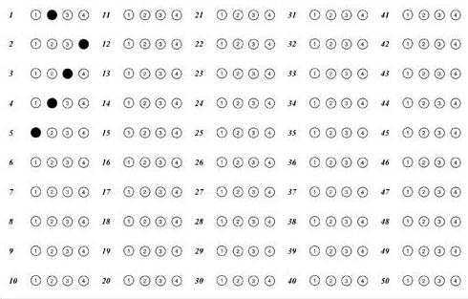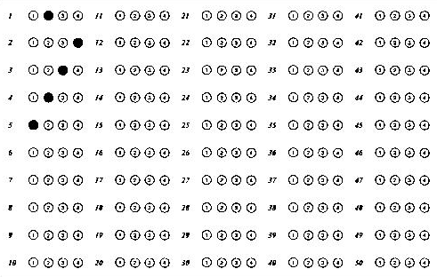
Figure 8: Original OMR Sheet Figure 9: After Binarization
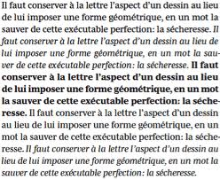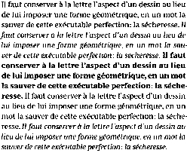
Figure 10: Original Printed Text Figure 11: After Binarization

4.1.2. Pre-thinning
This step aims to reduce the noise due to the binarization process. The pre-thinning algorithm is as follows:

P3 | P2 | P1
P4 | P | P0
P5 | P6 | P7
Figure 12: P and the labelling of its 8 neighbours
Input: A digitized image I.
Output: A pre-thinned image I'.
begin
1. For each pixel P in image I, let P0 to P7 be its 8 neighbours, starting from the east neighbour and counted in an anti-clockwise fashion (Figure 12).
2. Let B(P) = P0 + P2 + P4 + P6 . Let P' be the corresponding pixel of P in the pre-thinned image I’.
3. If B(P) < 2 then set P' to white
Else If B(P) > 2 then set P' to black
Else set P' to the value of P;
End
4.1.3. Thinning
Thinning is an algorithm to further reduce the amount of information in the image to process, thereby reducing the complexity of processing the image [4]. Thinning recognizes that a thick bold letter is the exact same as a letter which is one pixel thick. Thinner letters represent the same information more efficiently.
Thinning is a simple algorithm. Moreover, it is fast and has no flaws. Each row of pixels in the image is scanned left to right. In each row, every sequence of connected black pixels is replaced by a single black pixel in the middle of the sequence. Repeated for the entire image, this technique reduces bold lines to thin, single pixel thick lines.
Figure 13: Thinning of character ‘A’

Algorithm:
- Divide the image into two distinct subfields in a checkerboard pattern.
- In the first subiteration, delete pixel p from the first subfield if and only if the conditions G₁, G₂, and G₃ are all satisfied.
- In the second subiteration, delete pixel p from the second subfield if and only if the conditions G₁, G₂, and G₃’are all satisfied.
Condition G1:
Where
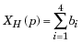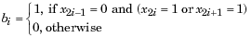
x₁, x₂, ..., x₈ are the values of the eight neighbours of p, starting with the east neighbour and numbered in counter-clockwise order.
Condition G2:
where
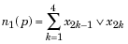
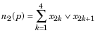
Condition G3:
Condition G3':
The two subiterations together make up one iteration of the thinning algorithm. When the user specifies an infinite number of iterations (n=Inf), the iterations are repeated until the image stops changing.
4.1.4. Post-thinning
After thinning, a post-thinning is used to correct the deformation of the image caused by discontinuity in the thinned image such as gaps, cuts and holes. In order to fill the undesired gaps in the image, we need to understand the fact that the gaps create pseudo end points. From the end points, paths are explored in all directions looking for the nearest black pixel except the direction of arrival for a distance in pixels decided by a threshold limit. Eight directions are possible: East, West, North, South, North East, North West, South East and South West. If such paths can be found within the threshold limit, the pixel in the shortest path is blackened, thereby filling the gaps. This operation is illustrated by Figure 6.

Figure 14: Example of an original character and its thinned image
after applying the post-thinning algorithm.

Input: A character image I and its thinned skeleton I’.
Output: A thinned skeleton I’’ with spurious branches and merged splitted fork points.
Method:
1. for each fork point Pi do
begin
Calculate the radius Ri of Ci, where Ci is the largest circlecentered at Pi and within the original unthinned image I;
Create a set S containing only the point Pi ;
end;
2. for every pair of fork points Pi and Pj do
begin
if (distance between Pi and Pj) <= Ri +Rj then
Merge sets Si and Sj, i.e. sets containing Pi and Pj;
end;
end;
3. for each of the set S created in (2) do
begin
for each point Pi in S do
begin
Reset pixels within the circle Ci ;
end;
calculate the average X and average Y of all Pi in S;
the point with coordinate (X, Y) is the new fork point;
rejoin the line from the perimeters of circles to the new fork point;
end.

4.2. Segmentation
Segmentation is a method to isolate text in an image. Specifically, it attempts to separate graphics, such as the picture of a tree, from other text contained in an image. It also attempts to separate text from other text, relying on the notion that processing one word or even one letter at a time is faster than processing the entire document at once. Ultimately, segmentation enhances optical character recognition efficiency.
In the algorithm [6], the scanned gray scale image is read into an image matrix which is converted into a monochromatic image matrix which pixel values of 0 for black points and 255 for white points. Then row wise searching is started from the point (0, 0) to find out the first black point. This is the assumed top point of the first word of the handwritten text that has been inputted. This point is referred to the “Upper Point”. After the upper point is found, all the black pixels that are connected to this pixel are given a value of 999.
- b.
c.
Figure 15(a-c): Different stages of handwriting segmentation.
Once this step is complete, then all the characters linked to that word have a value of 999 in the matrix under consideration. After finding all the connected points, a row wise search starts from the bottom to the top to find the first 999 value. This value corresponds to the “Lowest Point”. After this point is obtained, the area between the top and bottom point is searched on the left to check if any word has been missed on the left. In case another word is present on the left, then the new top point is obtained and the bottom point is found again else the procedure continues. After this is carried out, the left and right points of the word are found out by column wise searches. After the four points, the Upper, Lower, Right and Left point are found out, the letter can be extracted and stored in a different matrix.

4.3. Feature Extraction
Binary tree construction and then retrieving structural information from it is very good approach for feature extraction. But it is little complicated, though efficient, you can not guarantee its accuracy. So, rather than finding primitives from structural information and then using those primitives as the features, we directly use group of pixels as our feature.
Figure 16: Feature Extraction as a group of pixels
The process of feature extraction is important here for the neural network used in the system. In this process, the input image is sampled into a binary window which forms the input to the recognition system. In the above figure, the alphabet A has been digitized into 6 X 8 = 48 digital cells, each having a single colour, either black or white. It becomes important for us to encode this information in a form meaningful to a computer. For this, we assign a value +1 to each black pixel and 0 to each white pixel and create the binary image matrix I which is shown in the Fig. (16.c). So much of conversion is enough for neural networking which is described next. Digitization of an image into a binary matrix of specified dimensions makes the input image invariant of its actual dimensions. Hence an image of whatever size gets transformed into a binary matrix of fixed pre-determined dimensions. This establishes uniformity in the dimensions of the input and stored patterns as they move through the recognition system.

4.4. Classification
A neural network is used for handwritten and printed character recognition. The neural network used in our context serves as a classification tool which learns from given examples. It has been demonstrated in several studies that neural networks are valuable classifiers for non-linear data [7]. A neural network consists of a network architecture and a learning rule for solving a given pattern recognition problem. There are several available architectures and learning methods which may be selected depending on a given problem. In this project we have selected a multi-layer perceptron architecture using the backpropagation learning scheme. These are popular neural network methods used widely for several types of problems which are solved with supervised learning. In supervised learning as with the handwritten character data, target outputs are known in advance so that the network can learn from past examples as opposed to unsupervised learning where the network attempts to cluster input data into distinct regions by itself.
4.4.1. Learning Mechanism
In the proposed system, a highly simplified architecture of artificial neural networks is used. Also we are going to compare the results with Backpropagation algorithm. For purpose of easy understanding, the learning mechanism of the neural network is described first and its architecture is described next. In the used method, various characters are taught to the network in a supervised manner. A character is presented to the system and is assigned a particular label. Several variant patterns of the same character are taught to the network under the same label. Hence the network learns various possible variations of a single pattern and becomes adaptive in nature. During the training process, the input to the neural network is the input matrix M defined as follows:
If I (i, j) =1 Then M(i, j) =1
Else:
If I (i, j) = 0 Then M(i, j) = -1
The input matrix M is now fed as input to the neural network. It is typical for any neural network to learn in a supervised or unsupervised manner by adjusting its weights. In the current method of learning, each candidate character taught to the network possesses a corresponding weight matrix. For the kth character to be taught to the network, the weight matrix is denoted by Wk. As learning of the character progresses, it is this weight matrix that is updated. At the commencement of teaching (supervised training), this matrix is initialized to zero. Whenever a character is to be taught to the network, an input pattern representing that character is submitted to the network. The network is then instructed to identify this pattern as, say, the kth character in a knowledge base of characters. That means that the pattern is assigned a label k. In accordance with this, the weight matrix Wk is updated in the following manner:
for all i=1 to x
for all j=1 to y
W_{k}( i , j ) = W_{k}( i , j ) + M( i , j )
Here x and y are the dimensions of the matrix Wk (and M).
The following figure shows the digitization of three input patterns representing S that are presented to the system for it to learn.
Figure 17: Input Patterns of character ‘S’
Note that the patterns slightly differ from each other, just as handwriting differs from person to person (or time to time) and like printed characters differ from machine to machine.
Figure 18 gives the weight matrix, say, W_{S} corresponding to the alphabet S. The matrix has been updated thrice to learn the alphabet S. It should be noted that this matrix is specific to the alphabet S alone. Other characters shall each have a corresponding weight matrix.
Figure 18: Weight Matrix for ‘S’
A close observation of the matrix would bring the following points to notice:
1. The matrix-elements with higher (positive) values are the ones which stand for the most commonly occurring image-pixels.
2. The elements with lesser or negative values stand for pixels which appear less frequently in the images.
Neural networks learn through such updating of their weights. Each time, the weights are adjusted in such a manner as to give an output closer to the desired output than before. The weights may represent the importance or priority of a parameter, which in the instant case is the occurrence of a particular pixel in a character pattern. It can be seen that the weights of the most frequent pixels are higher and usually positive and those of the uncommon ones are lower and often negative. The matrix therefore assigns importance to pixels on the basis of their frequency of occurrence in the pattern. In other words, highly probable pixels are assigned higher priority while the less-frequent ones are penalized. However, all labelled patterns are treated without bias, so as to include impartial adaptation in the system.

4.4.2. Network Architecture
The overall architecture of the recognition system is shown in Figure 19. In this system, the candidate pattern I is the input. The block ‘M’ provides the input matrix M to the weight blocks Wk for each k. There are totally n weightblocks for the totally n characters to be taught (or already taught) to the system.
Figure 19: Neural Network Architecture
The recognition of patterns is now done on the basis of certain statistics that shall be defined next.
Candidate Score (Ψ): This statistic is a product of corresponding elements of the weight matrix Wk of the kth learnt pattern and an input pattern I as its candidate. It is formulated using the as follows:
It should be noted that unlike in the training process where M was the processed input matrix, in the recognition process, the binary image matrix I is directly fed to the system for recognition.
Ideal Weight-Model Score (µ): This statistic simply gives the sum total of all the positive elements of the weight matrix of a learnt pattern. It may be formulated as follows (with π (k) initialized to 0 each time).
Recognition Quotient (Q): This statistic gives a measure of how well the recognition system identifies an input pattern as a matching candidate for one of its many learnt patterns. It is simply given by:
The greater the value of Q, the more confidence does the system bestow on the input pattern as being similar to a pattern already known to it.
For greater accuracy in overall character recognition, use of back-propagation algorithm is proposed. The results of simplified network system and back-propagation algorithm will be compared and combined. This model is the most popular in the supervised learning architecture because of the weight error correct rules. It is considered a generalization of the delta rule for nonlinear activation functions and multilayer networks.
In a back-propagation neural network, the learning algorithm has two phases. First, a training input pattern is presented to the network input layer. The network propagates the input pattern from layer to layer until the output pattern is generated by the output layer. If this pattern is different from the desired output, an error is calculated and then propagated backward through the network from the output layer to the input layer. The weights are modified as the error is propagated. The back-propagation training algorithm is an iterative gradient designed to minimize the mean square error between the actual output of multi-layer feed forward perceptron and the desired output.
CHAPTER 5
SYSTEM REQUIREMENTS
________________________________________________________

5.1. Hardware Requirements
- Pentium Compatible CPU (P-4 or higher)
- Processor 166 MHz or above
- Disk Space Required 4 GB or more
- Memory Requirement 2GB or more

5.2. Software Requirements
- Operating Systems Microsoft®Windows XP/Vista/7
- MATLAB version 7.0.1 (R14SP1) or higher
MATLAB is a high-performance language for technical computing. It integrates computation, visualization, and programming in an easy-to-use environment where problems and solutions are expressed in familiar mathematical notation. Typical uses include:
- Math and computation
- Algorithm development
- Image Processing
- Modeling, simulation, and prototyping
- Data analysis, exploration, and visualization
- Scientific and engineering graphics
- Application development, including Graphical User Interface building

CHAPTER 6
EXPERIMENTS AND RESULTS
________________________________________________________

Experiments are carried out on Optical Mark Recognition system. User is asked to upload the answer sheet or more specifically OMR sheet. Matlab program is written to give the text file as an output. Output text file will have question numbers and corresponding answers marked in the answer-sheet.

First, the input image is read.

I=uint8(imread('omr.jpg'));

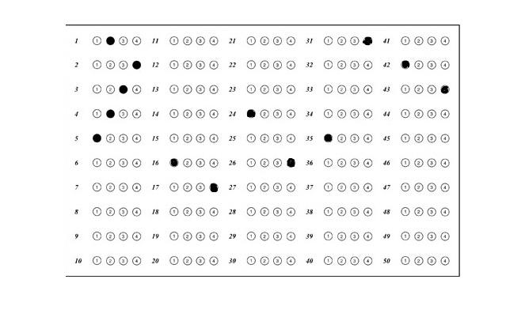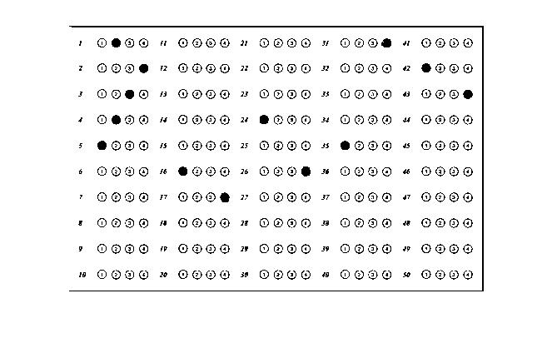
Figure 20: I Figure 21: BW1
Then the input image is converted to greyscale image.
level = graythresh(I);
BW1 = im2bw(I,level);
level = graythresh(I) computes a global threshold (level) that can be used to convert an intensity image to a binary image with im2bw. level is a normalized intensity value that lies in the range [0, 1].
The graythresh function uses Otsu's method, which chooses the threshold to minimize the intraclass variance of the black and white pixels.
After converting image to the greyscale image, morphological functions are applied on the grayscale image.
BW2 = bwmorph(BW1,'dilate');
BW2 = bwmorph(BW1,operation) applies a specific morphological operation to the binary image BW. BW2 = bwmorph(BW1,operation,n) applies the operation n times. n can be Inf, in which case the operation is repeated until the image no longer changes. Operation is a string that can have different values.
Morphology is a broad set of image processing operations that process images based on shapes. Morphological operations apply a structuring element to an input image, creating an output image of the same size. In a morphological operation, the value of each pixel in the output image is based on a comparison of the corresponding pixel in the input image with its neighbors. By choosing the size and shape of the neighborhood, you can construct a morphological operation that is sensitive to specific shapes in the input image.
One of the most basic morphological operation is dilation. Dilation adds pixels to the boundaries of objects in an image. The number of pixels added to the objects in an image depends on the size and shape of the structuring element used to process the image. In the morphological dilation operation, the state of any given pixel in the output image is determined by applying a rule to the corresponding pixel and its neighbours in the input image.
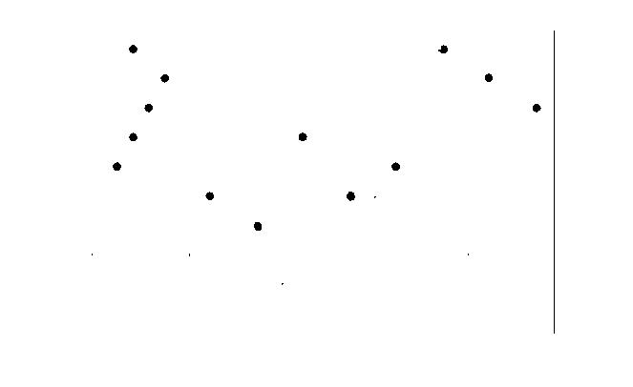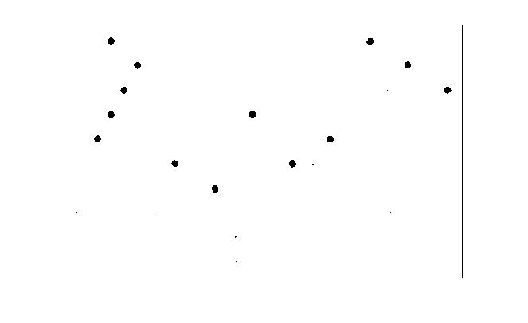
Figure 22: BW2 Figure 23: BW3

BW3 = bwmorph(BW2,'fill');

Fills isolated interior pixels (individual 0's that are surrounded by 1's), such as the center pixel in this pattern.
1 1 1 1 1 1
1 0 1 1 1 1
1 1 1 1 1 1

BW4 = bwmorph(BW3,'majority');

It sets a pixel to 1 if five or more pixels in its 3-by-3 neighborhood are 1's; otherwise, it sets the pixel to 0.
After the morphological operations, the code is written to find the centres of the filled circles. For that purpose, we are checking the pixel’s neighbours. If all the pixels in the surroundings of the current pixel have value 1 then the pixel is noted and coordinates are saved in ‘d’. Note that here neighbours of any pixel are 24 pixels surrounding that pixel.

v=1;
sm=0;
d=zeros(100,2);
[m,n,p]=size(BW4);
e(:,:)=zeros(m,n);
for i=3:m-2
for j=3:n-2
if BW4(i,j)==0
sm=0;
for x=-2:2
for y=-2:2
sm=sm+uint8(BW4(i+x,j+y));
end
end
if sm==0
d(v,1)=i;
d(v,2)=j;
e(i,j)=255;
v=v+1;
end
end
end
end
figure, imshow(e);

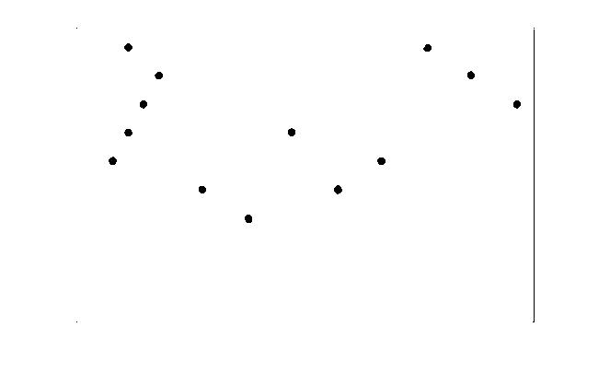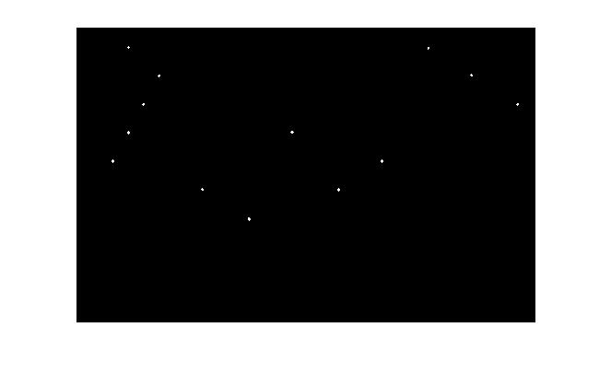
Figure 24: BW4 Figure 25: e
Elimination of duplicate centres – In some cases, it is observed that there are more than 1 centre corresponding to a bubble or circle. So, to eliminate those multiple points we compare points with their Euclidean distance and if that distance is less than predefined threshold, the point is eliminated.

for i=2:m
if(d(i,1)==0 & d(i,2)==0)
break;
end
flg=0;
for k=1:x
if(((d(i,1)-f(k,1))^2+(d(i,2)-f(k,2))^2)<36)
flg=1;
break;
end
end
if(flg==0)
x=x+1;
f(x,1)=d(i,1);
f(x,2)=d(i,2);
end
end

Finally, we get the array of points each corresponding to distinct bubble.
Now, we have to map the bubble to one of the answers 1, 2, 3 or 4. Also, we have to map that bubble to correct question number. We use the corresponding centre point of that bubble and image dimensions for the same purpose.

for i=1:x
q=int8(f(i,1)*10/310);
r=22+(q-1)*31;
s=ceil(f(i,2)*5/490);
g(y,1)=(s-1)*10+q;
l=40+(s-1)*97;
h=l+50;
opt=int8((f(i,2)-l)*3/(h-l))+1;
g(y,2)=opt;
y=y+1;
end

Lastly, the question number and corresponding answer marked in the OMR sheet is written to text file (here ans.text). The text file can be compared with the text file having solution.

fid1=fopen('ans.txt','w+');
for i=1:50
dataline=[num2str(t(i,1)),'-',num2str(t(i,2))];
fprintf(fid1,dataline,'\n');
end

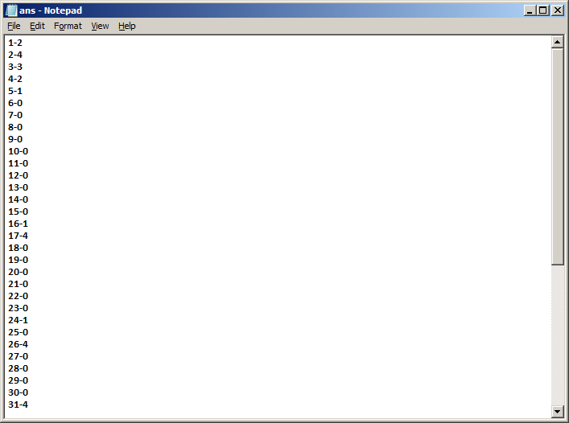

Figure 26: Output File

CHAPTER 7
LIST OF REFERENCES
________________________________________________________

[1] Optical Character Recognition using Neural Networks, (ECE 539 Project Report), Deepayan Sarkar, December 18, 2003

[2] Usman Ullah Sheikh, Real–time barcode reader using active vision, UTM, 2004. (final project-barcode-literature).
[3] Fu Chang, “Retrieving information from document images: problems and solutions,” International Journal on Document Analysis and Recognition, Vol. 4, No. 1, August 2001, pp. 46-55, doi: 10.1007/PL00013573.
[4] Rangachar Kasturi, Lawrence O’Gorman and Venu Govindaraju, “Document image analysis: A primer,” Sadhana, Vol. 27, No. 1, February 2002, pp. 3-22, doi: 10.1007/BF02703309.
[5] Lam, L., Seong-Whan Lee, and Ching Y. Suen, "Thinning Methodologies-A Comprehensive Survey," IEEE Transactions on Pattern Analysis and Machine Intelligence, Vol 14, No. 9, September 1992, page 879, bottom of first column through top of second column.
[6] Tripathy N. and Pal U. 2006, ”Handwriting segmentation of constrained Oriya text”, Sadhna, Vol. 31, Part 6, pp. 755-769.
[7] B. Kosko, “Neural Networks and Fuzzy Systems – A Dynamical Systems Approach to Machine Intelligence”, Prentice Hall, 1992.
[8] Shashank Araokar, “Visual Character Recognition using Artificial Neural Networks”, University of Mumbai, India.
[9] Fakhraddin Mamedov and Jamal Fathi Abu Hasna, “Character Recognition Using Neural Networks”, Near East University, North Cyprus, Turkey via Mersin-10, KKTC
[10] Singh, S. and Amin, A. “Neural Network Recognition of Hand Printed Characters”, Neural Computing and Applications, vol. 8, no. 1, pp. 67-76, 1999.

