Convertian

A project report submitted in partial fulfillment of the requirements for the

Second Year of Artificial Intelligence & Data Science

by

Vinit Dave (Roll No. 9362)

Jonathan Joseph (Roll No. 9377)

Amey Managute (Roll No. 9384)

Jacob Mire (Roll No. 9386)

Under the guidance of

Prof. Prajakta Dhamanskar


DEPARTMENT OF ARTIFICIAL INTELLIGENCE & DATA SCIENCE.

Fr. Conceicao Rodrigues College of Engineering, Bandra (W), Mumbai - 400050
University of Mumbai 2020-21

This work is dedicated to my family.
I am very thankful for their motivation and support.

Internal Approval Sheet

CERTIFICATE
This is to certify that the project entitled "Convertian" is a bonafide work of Vinit Dave (Roll No. 9362)Jonathan Joseph (Roll No. 9377)Amey Managute (Roll No. 9384)Jacob Mire (Roll No. 9386) submitted to the University of Mumbai in partial fulfillment of the requirement for term work submission of Mini Project 1- A Second year Artificial Intelligence & Data Science.

(Name and sign) Supervisor/Guide

(Name and sign) Head of Department
(Name and sign) Principal

Approval Sheet

Project Report Approval
This project report entitled Convertian by Vinit Dave, Jonathan Joseph, Amey Managute, Jacob Mire is approved for the Term work submission of Mini Project –1 A, Second year Artificial Intelligence & Data Science.

Examiners 1.————————————–
2.————————————–

Date: 30 April 2022

Place: Mumbai

Declaration
We declare that this written submission represents our ideas in our own words and where others’ ideas or words have been included, we have adequately cited and referenced the original sources. We also declare that we have adhered to all principles of academic honesty and integrity and have not misrepresented or fabricated or falsified any idea/data/fact/source in my submission. We understand that any violation of the above will be cause for disciplinary action by the Institute and can also evoke penal action from the sources which have thus not been properly cited or from whom proper permission has not been taken when needed.




Vinit Dave (Roll No. 9362) (sign)

Jonathan Joseph (Roll No. 9377) (sign)

Amey Managute (Roll No. 9384) (sign)
Jacob Mire (Roll No. 9386) (sign)

Date: 30 April 2022

Acknowledgments

We have great pleasure in presenting the report on "Convertian". We take this opportunity to express our sincere thanks towards our guide Prof. Prajakta Dhamanskar, C.R.C.E, Bandra (W), Mumbai, for providing the technical guidelines, and the suggestions regarding the line of this work. We enjoyed discussing the work progress with her during our visits to department.

We thank Dr. Jagruti Save, Head of Artificial Intelligence & Data Science Department, Principal and the management of C.R.C.E., Mumbai for encouragement and providing necessary infrastructure for pursuing the project.

We also thank all non-teaching staff for their valuable support, to complete our project.

Date: 30 April 2022

Vinit Dave (Roll No. 9362)
Jonathan Joseph (Roll No. 9377)
Amey Managute (Roll No. 9384)
Jacob Mire (Roll No. 9386)

ABSTRACT

The recent COVID-19 global pandemic has created the largest disruptions in carrying out educational activities throughout the world. As a result of this unprecedented situation posed by COVID-19, educational institutions at all levels have been forced to take concerted efforts to maintain learning continuity by offering new possibilities of knowledge acquisition and transfer to students, predominantly using online or distance learning mode.

However, several challenges have been reported besides opportunities for online classes, which have been found and analyzed in various studies. In an attempt to solve few of those problems, we have developed this website which will help students to use various conversion methods
Under one platform.

This way students can have direct access to conversion types they want to perform without any difficulty, saving a lot of time and energy

CONTENTS

Abstract iv

1 INTRODUCTION 1

2 LITERATURE REVIEW 2

3 PROPOSED SYSTEM

3.1 List of Conversions
3.2 Class Diagram
3.3 Limitations in existing systems

4 PROJECT DESCRIPTION

4.1 Hardware Software requirements 8
4.2 Hardware Software requirements on client side 8

5 SOFTWARE REQUIREMENTS 9

5.1 Frontend Programming
5.2 Backend Programming
5.3 IDE implemented11

6 IMPLEMENTATION DETAILS
6.1 Libraries Implemented
6.2 APIs Implemented
6.3 Block Diagram

7 RESULTS

7.1 a) Home Page
7.2 b) Area Converter
7.3 c) Currency Converter
7.4 d) Volume Converter
7.5 e) Power Converter
7.6 f) Weight Converter
7.7 g) Image Compression
7.8 h) Mobile version of the home page
7.9 i) Word to Pdf converter
7.10 j) Pdf to Docx converter
7.11 k) Image to Pdf

8 CONCLUSION AND FUTURE ENHANCEMENTS

Chapter 1

Introduction

In today's online era where everyone is working and studying at home, there is a constant need of converting various things such as pdfs, word files, image files from one format to another.

We constantly need to fill form for admission our word related stuff where images size is restricted to certain kb therefore we are even adding image compression which will ease the task

At the same time, students also require unit /measurement converters, currency converters , weight converters , area converters ,volume converters ,file converters and much more

We at synergetiks have come up with a solution to all this and we present to you convertian ,convertian is a website that converts all units; from temperature to currencies and everything in between.

7

Chapter 2

Literature Review

What is conversion?
A conversion is defined as an exchange from one unit of measure to another. An example of conversion is exchanging dollars for euros. An example of conversion is figuring out how many cups are in a liter etc. A change in the form of a quantity, a unit, or an expression without a change in the value.

In today's online era where everyone is working and studying at home ,there is a constant need of converting various things such as pdfs ,word files ,image files from one format to another.

At the same time, students also require unit /measurement converters , currency converters , weight converters , area converters ,volume converters ,file converters and much more

We have observed a lack of number of conversions in certain websites ,they are very subject limited or very specific to a particular scenario .Some websites didn’t have universally compatible resolution, resulting in website/browser crashes and inefficiencies. These old websites don’t work on new and popular browsers. They had Complex and Outdated UIs and their contents were very unorganized, which made them hard to use

Chapter 3

Proposed system

Our objective is to make a convenient website that converts all types of quantities and units at one place. the following are the list of all the conversions possible through convertian :-

- Length Converter(mm,cm,m,km,miles,yards ,ft,inches, lightyears)

- Weight converter(mg,g,kg,tons,pounds,quintal)

- Area converter(mm²,cm²,km²,acres,hectares)

- Volume converter(mm,cm,m,litres,kilo litres)

- Image to pdf conversion (vice versa)

- Pdf to word doc conversion

- Temperature converter(f°,c°,k)

- Pressure(psi,pa,kpa,barr,atm,tor)

- Currency(rupees,dollars,british pounds,dirhams and many more……)

- Number system conversion(binary,decimal,octal,hexadecimal)

- Power conversion(mw,watts,mw,gw,hp)

- Angle conversions(degrees,radian)

- Image compression

Class Diagram

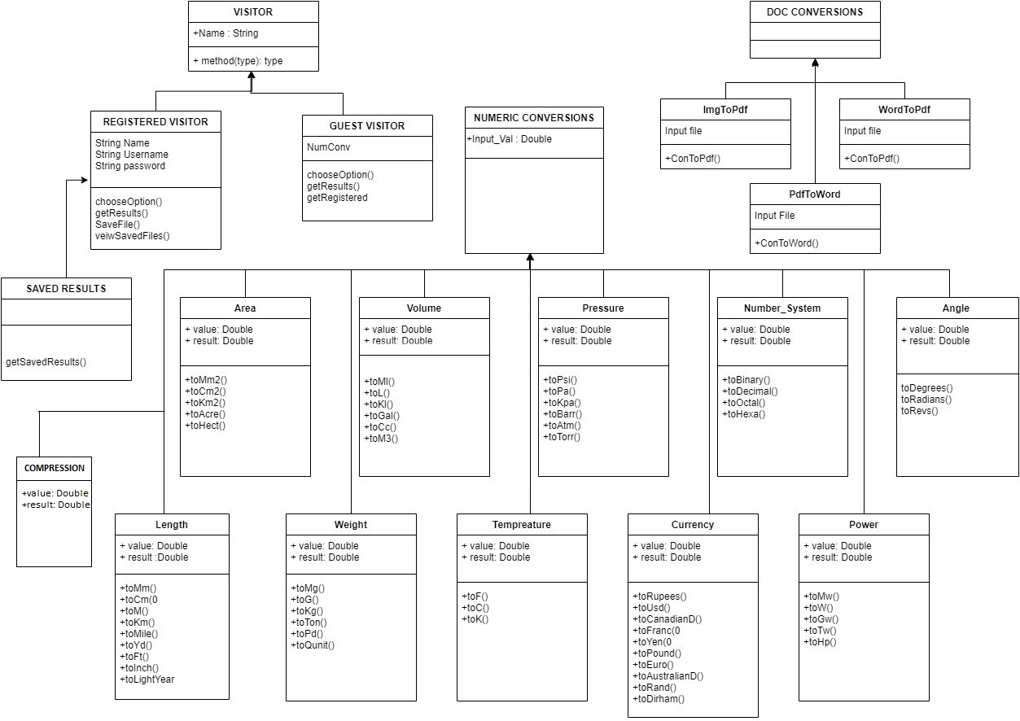

Chapter 4

Project Description

Our Objective is create an updated and organized website which is not subject limited, presentable , easy and convenient to use as well as having an integrated chatbot all in one place.

We have observed a lack of number of conversions in certain websites ,they are very subject limited or very specific to a particular scenario .Some websites didn’t have universally compatible resolution, resulting in website/browser crashes and inefficiencies. These old websites don’t work on new and popular browsers. They had Complex and Outdated UIs and their contents were very unorganized, which made them hard to use .

Our website covers all domains of conversions from Financial ,scientifical, Mathematical all the way to document conversions.

Limitation In Existing System

NAME | universally compatible resolution | ease of usage | quantity of conversions
https://www.onlineconversion.com/ | 🗶 | 🗶 | ✔
https://www.everythingconverter.com/ | ✔ | ✔ | 🗶
https://www.calculatorsoup.com/calculators/conversions/index.php | ✔ | 🗶 | subject limited
https://www.metric-conversions.org/time-conversion.htm | ✔ | 🗶 | 🗶
https://www.digikey.com/en/resources/online-conversion-calculators | ✔ | 🗶 | subject limited

Chapter 5

Software requirements

- Frontend programming
  - Html for describing the structure of web pages.
  - Css for defining the styles for web pages.
  - Bootstrap to add dynamic behavior to the webpage and add special effects to the webpage.

- Backend programming
  - Python web development, database connectivity
  - Firebase as database

- Vscode as an ide

Chapter 6

Implementation Details

For image to pdf, we have used pillow library .Using this library we can convert image to pdf .We take the image from the front-end and process it in the backend with our logic and upload the converted pdf to cloud.

For currency conversions we have used forex-python which uses forex api (The Forex API is a free service for current and historical foreign exchange rates built on top of data published by European Central Bank).When we press convert we get latest conversions values converted through latest conversion rates.

For bitcoin price it uses coindesk api(coindesk is cryptocurrency exchange platfrom).

For the scientific conversions such as(weight, temperature,
volume, pressure, number system, angle, length)we are using
simple formulas.

The converted files and compressed images are stored on firebase cloud storage.

We are using Python Imaging Library(Pillow) for image compression which takes compression parameter

(1 from extreme image compression and 100 for lighter compression).

Block Diagram

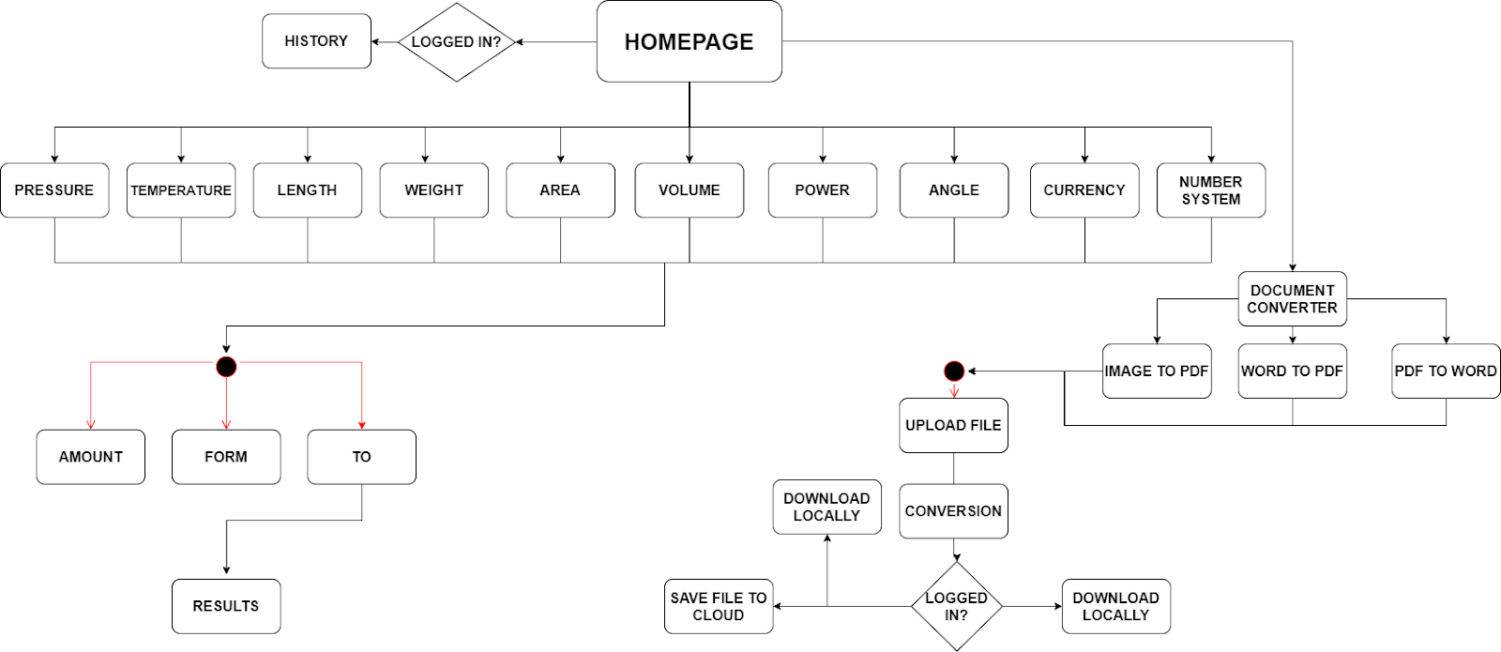

CHAPTER 7

Results

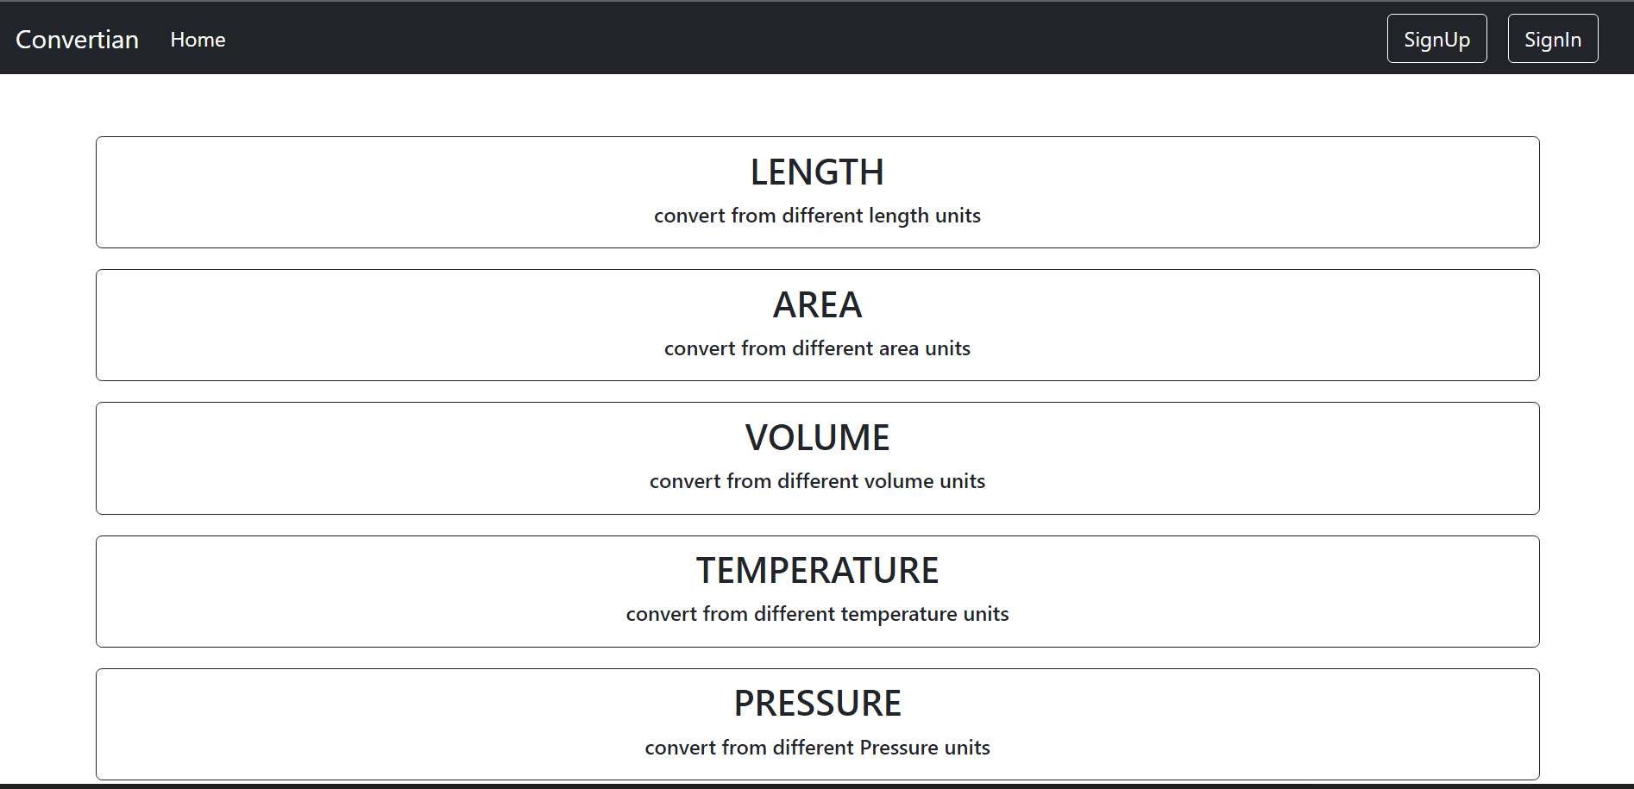

7.1 a)Home page

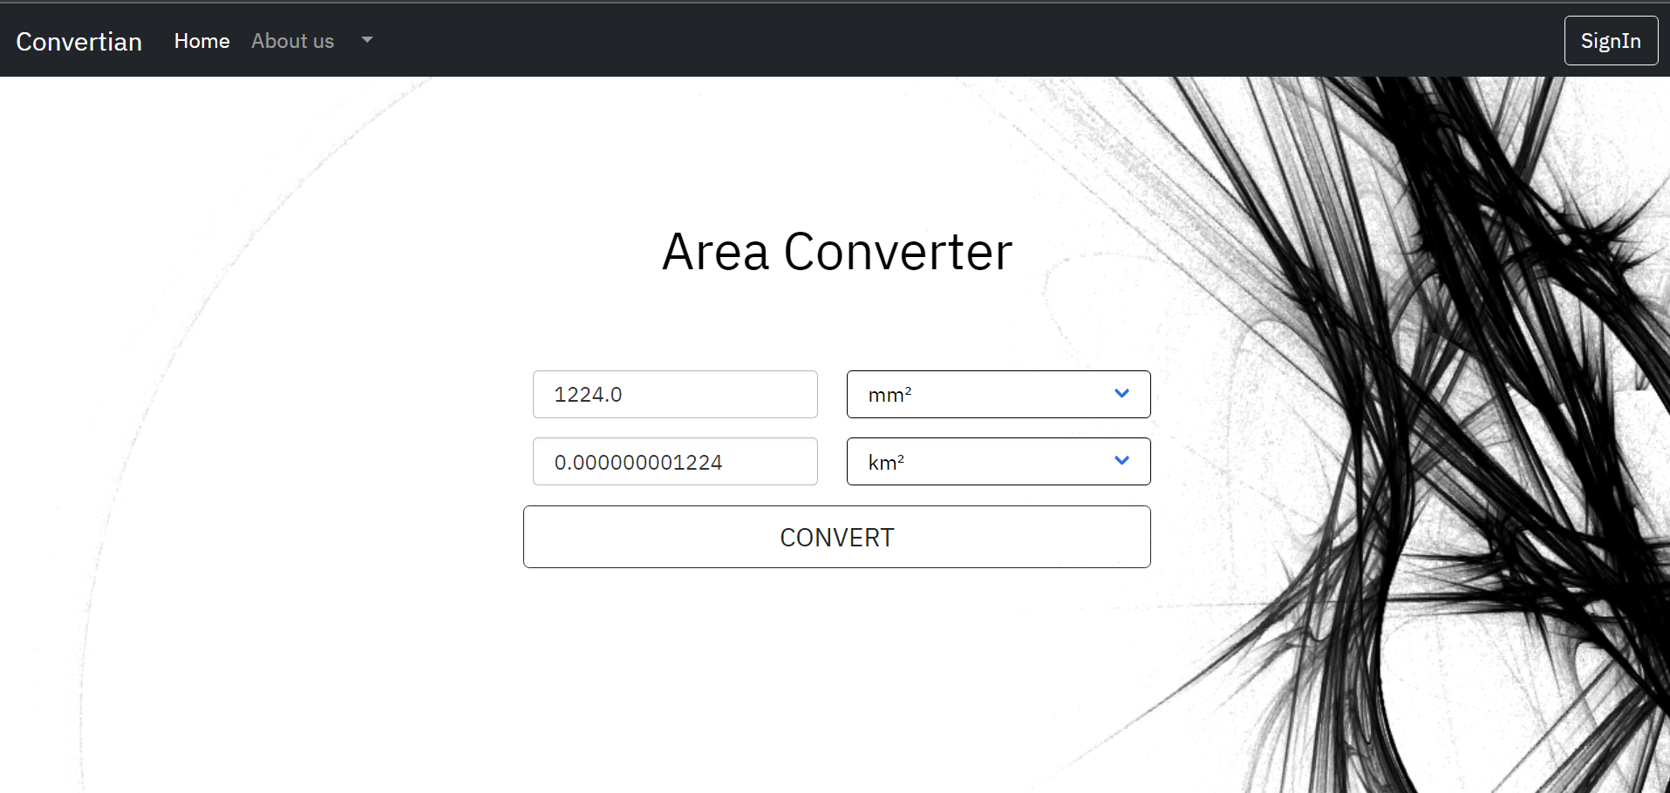

7.2 b)Area Converter
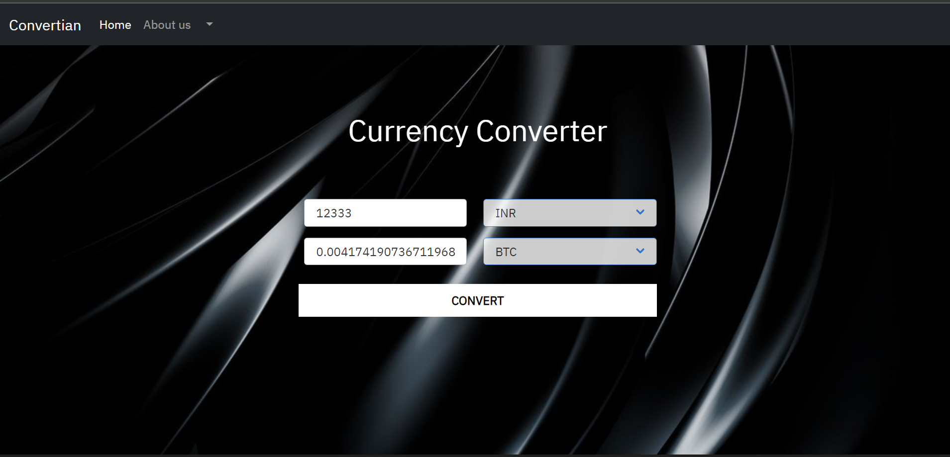

7.3 c)Currency Converter

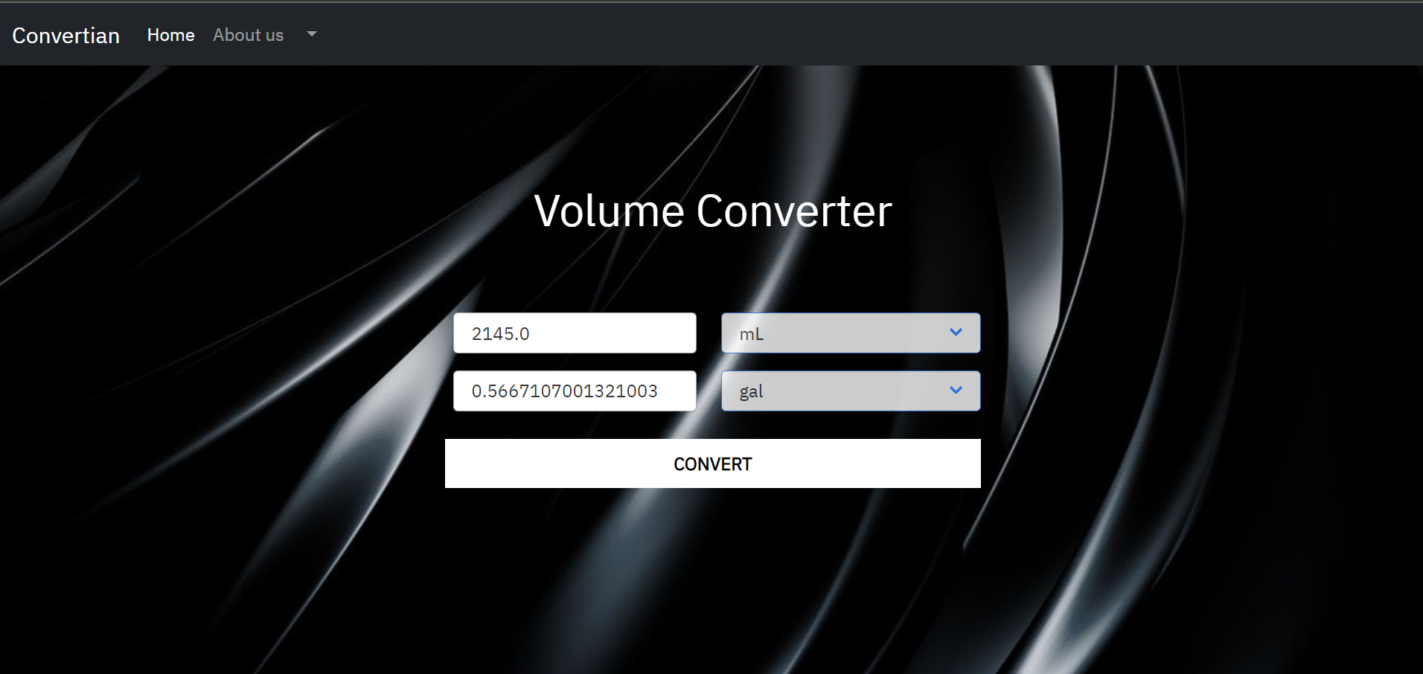

7.4 d)Volume Converter

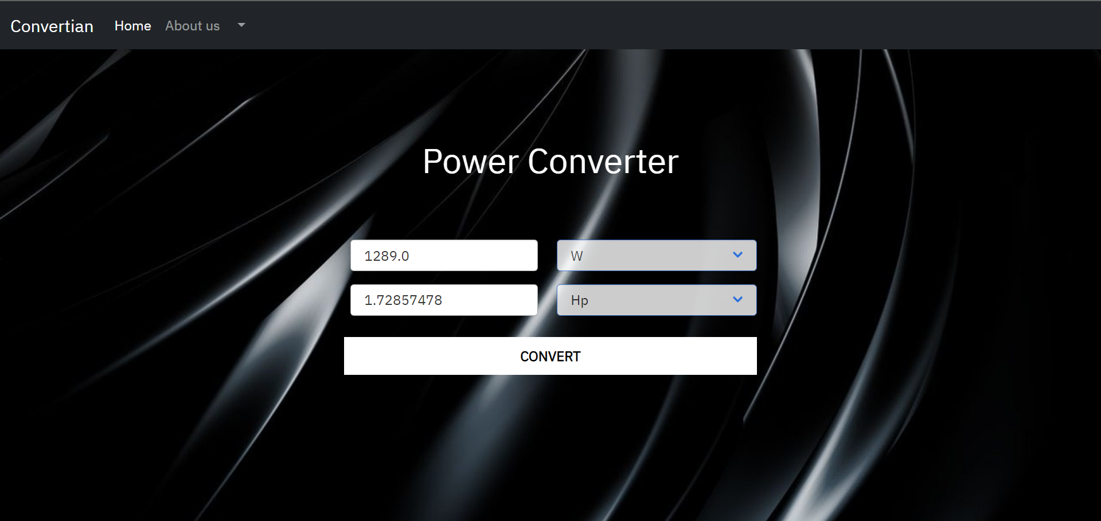

7.5 e) Power Converter

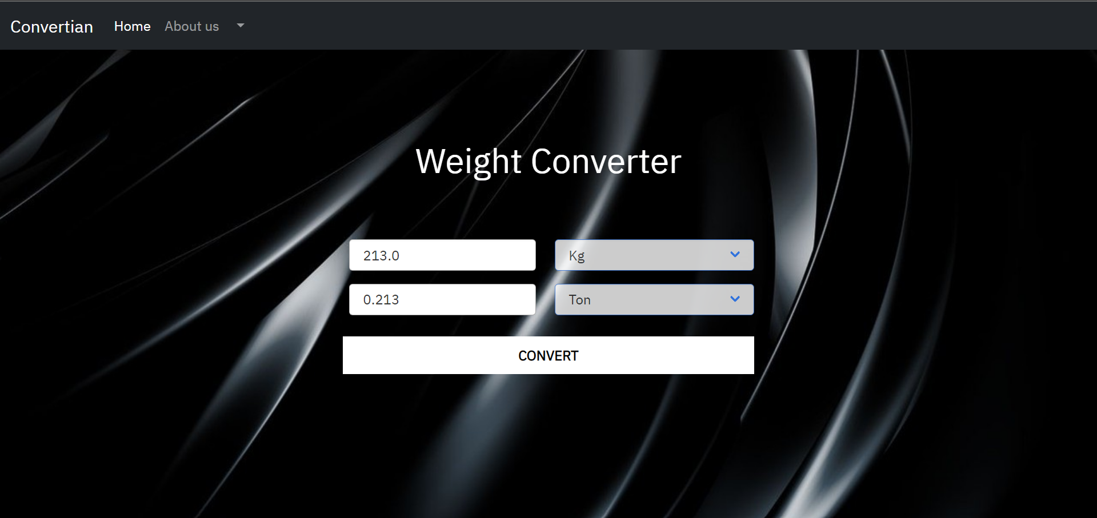

7.6 f)Weight Converter
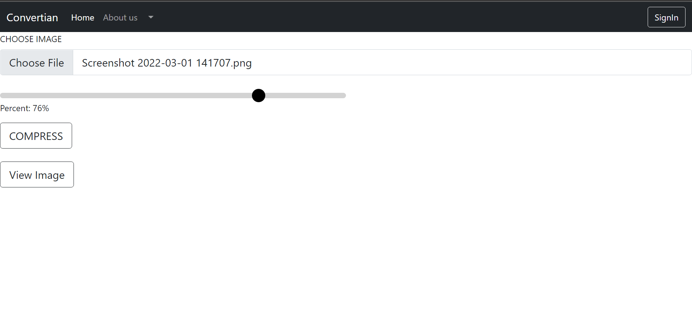
7.7 g) Image Compression

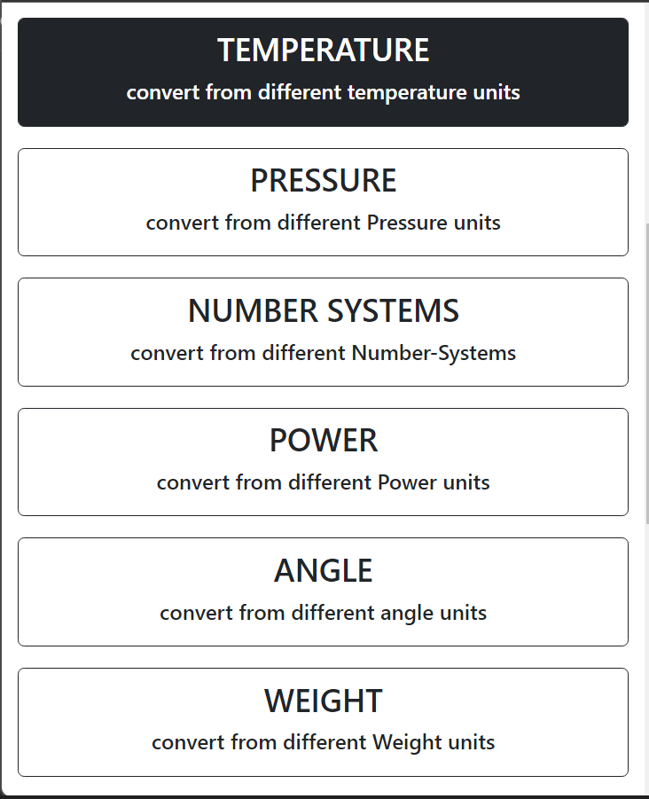
7.8 h) Mobile version of home page

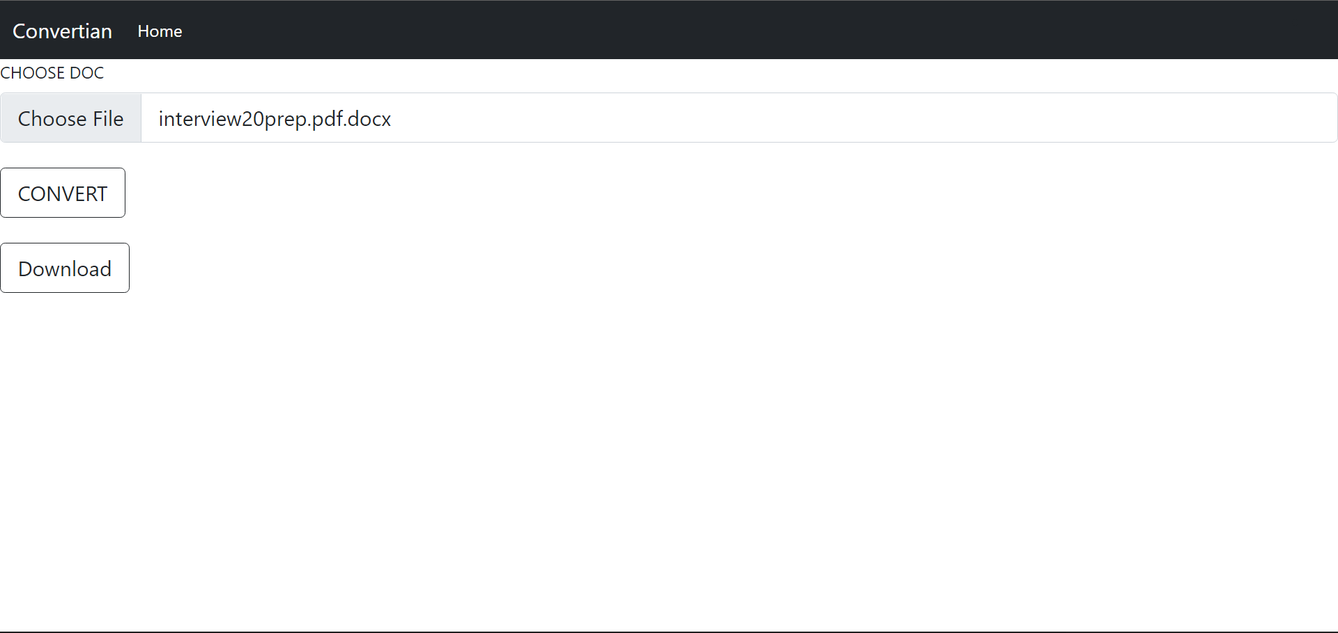

7.9 i) word to pdf converter

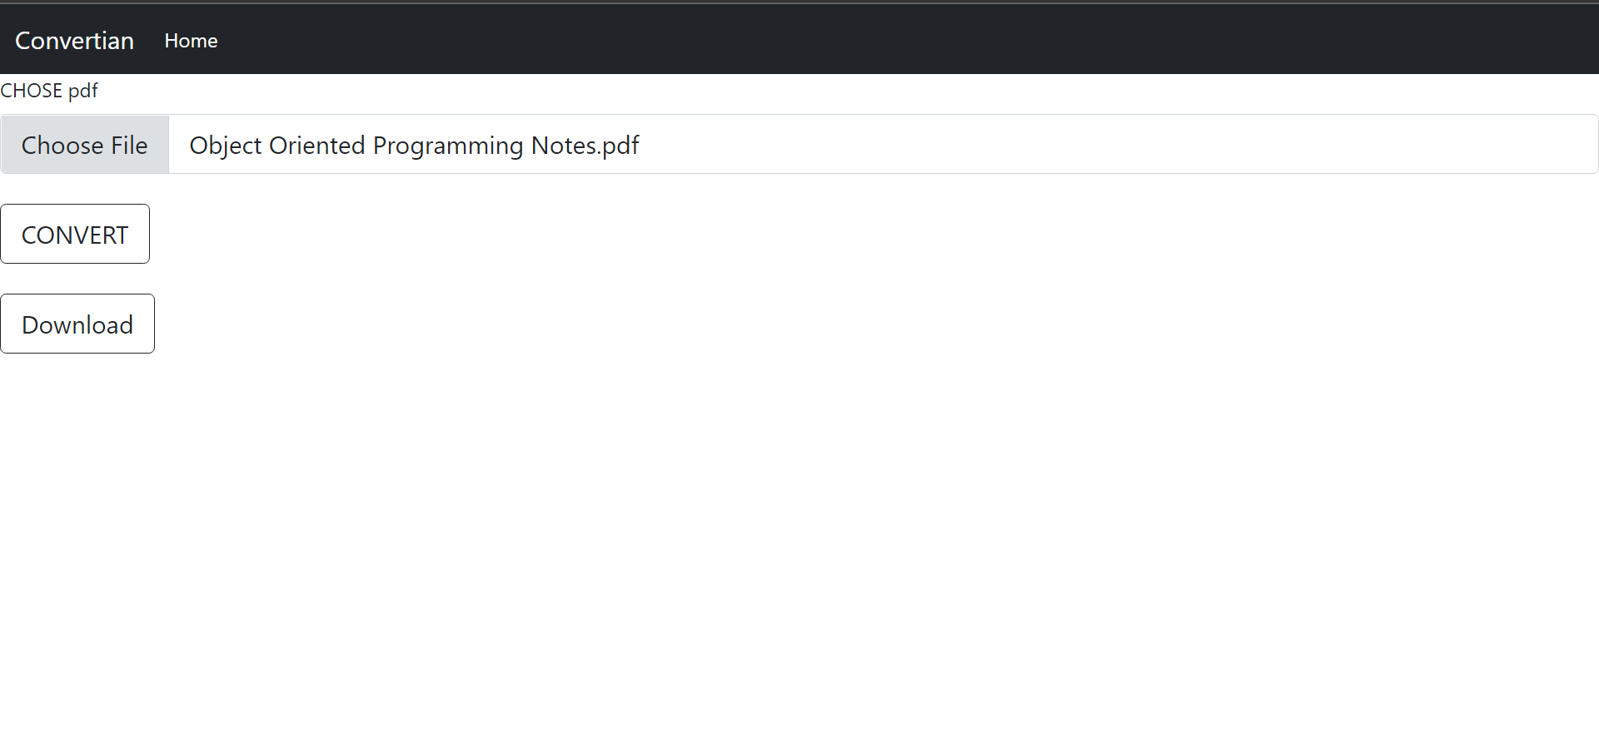

7.10 j) pdf to docx converter

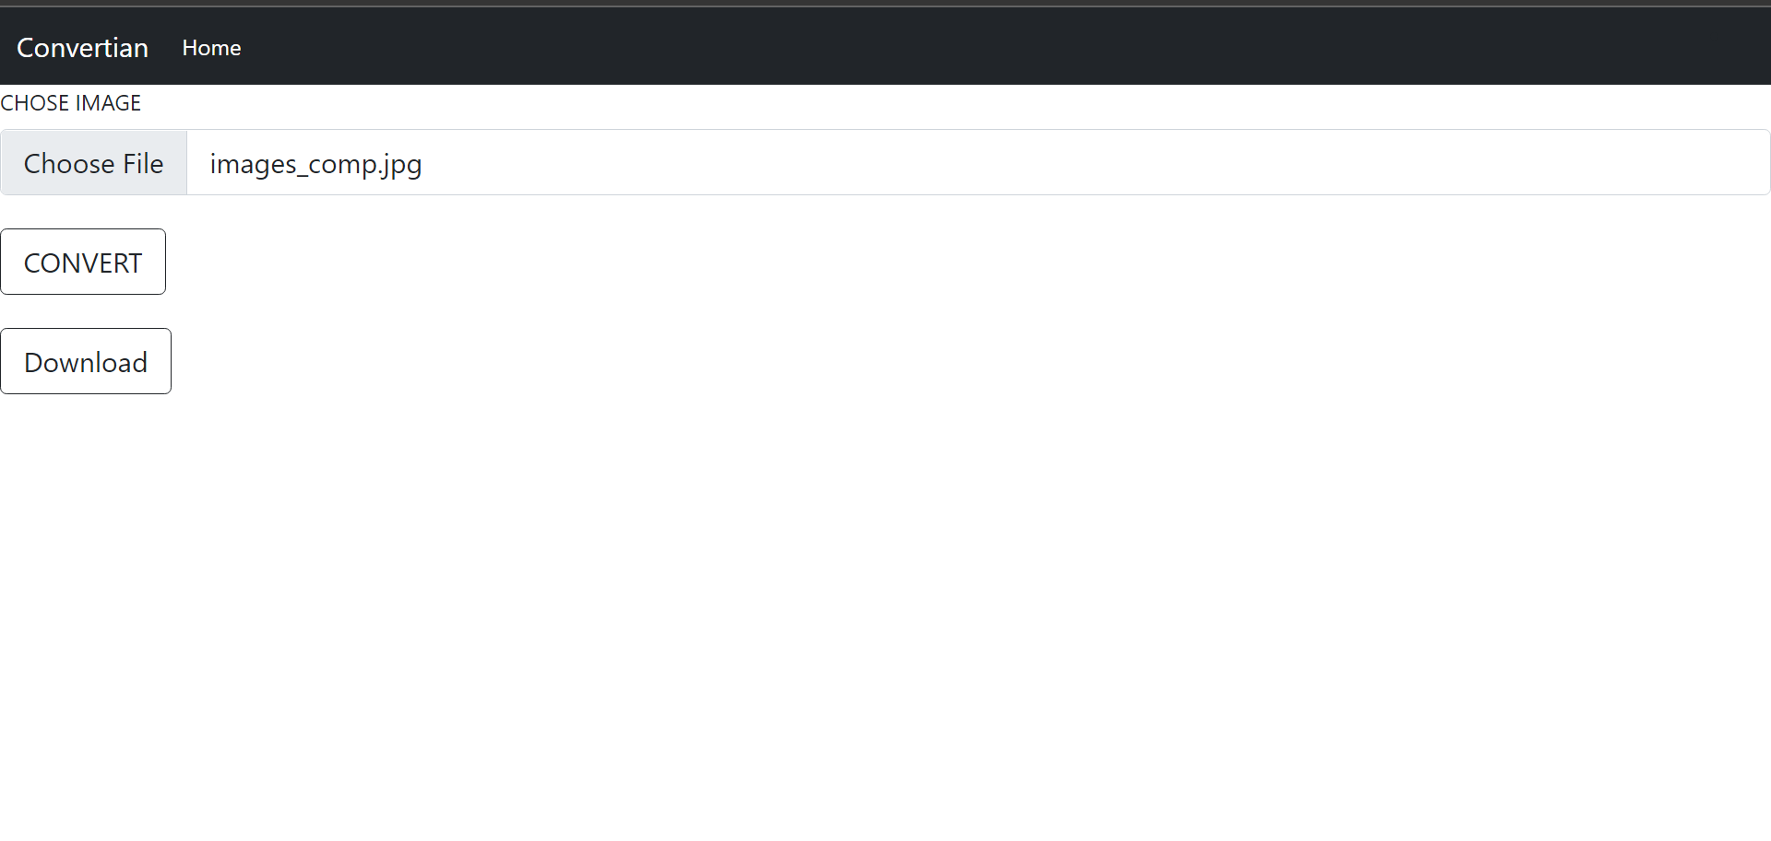

7.11 k) image to pdf converter

Chapter 8

Conclusion

- After 5,000 lines of code
- With skillful backend optimization
- A self implemented cloud storage
- A beautiful Use Interface
- Days of determination and hardwork

We aim to create website having priority as user’s comfort and easy to operate
layout. By implementing the Web Development knowledge, we learnt
throughout this process in creating absolutely simple design
which makes operating self-explanatory.

Chapter 9

Future Work

There is scope for future development of this project. To keep abstract of technical improvements, the system may be further refined.

So, enhancements can be made to improve the experience and usability of our website. We can improve the UI to improve our user experience. We can add more conversion if possible . We can improve user management show them their previous records of conversions which they have performed.

We can host this website if possible .

References

[1] https://getbootstrap.com/docs/5.1/getting-started/introduction

[2] https://docs.djangoproject.com/en/4.0/

[3] https://www.youtube.com/watch?v=8wa4AHGKUJM

[4] https://pypi.org/project/img2pdf/

[5]https://forex-python.readthedocs.io/en/latest/usage.html

[6]https://www.section.io/engineering-education/integrating-firebase-database- in-django/

[7]https://www.geeksforgeeks.org/django-authentication-project-with-firebase/#:~:text=Grant%20Permissions%20on%20Firebase%20Dashboard,Project%20using%20MVT%20in%20Django%20%3F

