**Evaluation Only. Created with Aspose.Words. Copyright 2003-2022 Aspose Pty Ltd.**

**My name is Amey Managute .I am currently persuing my bachelor’s of engineering In Artificial intelligence and data science from Fr. Conceicao Rodrigues College of Engineering. I am much more excited about IT industry and I believe that I can bring my skills to this industry. With rapidly changing and advances in technologies ,staying up to date with all recent technology**   **is important ,this also**

**makes me curious about the future .** **I can work in a team and I do posses good leadership skills as well.**

**I am part of ACM CRCE council wherein we coordinated and conducted different sessions on technology. we had even organized a national level hackathon which was exclusive for 2nd year students. I spend my free time learning new things from platforms like coursera and youtube.I also read notebooks on Kaggle, blogs and article related to Artificial intelligence. Besides my academic, I like to play chess and table tennis.**

**Thank you for listening. Have a nice day!.** Career goal

**My main career goal is to learn every day. I want to learn new and emerging technologies. As of now, my short term goal is to get a industry level experience that compliments my expertise and helps me widen my horizons with exciting learning opportunities . .also Improving** [**personalskills**](https://theinterviewguys.com/top-interpersonal-skills-for-job-seekers/) **likecommunication, networking,** [**teamwork**](https://theinterviewguys.com/teamwork-interview-questions/) **and** [**leadership**](https://theinterviewguys.com/leadership-interview-questions/) **will help me achieve both short-term and long-term goals easier. IN the bigger picture I want to publish research papers and work with an R&D team.A few of my future goals include leading a AI team.**

**Strengths**

**I believe that my greatest strength is the ability to solve problems quickly and efficiently. I can see any given situation from multiple perspectives, which makes me uniquely qualified to complete my work even under challenging conditions. That problem solving allows me to be a better communicator. My strongest asset is my work ethic and my willingness to step in when needed .I think my ability to see all sides of an issue will make me a great asset to the team***.*

**Why jp morgan?**

I believe major two reasons

Firstly having heard about Code for Good from my sister who was one of the participants of CFG event held in 2017.Having fair idea about the exposure an induvial experiences via Code for good is impeccable. For me code for good is just not about coding but also leveraging technologies for providing better solutions to NGOs.Code for Good is an opportunity for students like me who are curious to solve real life problems leveraging technologies

around us to build a better future. The best part about Code for good is the exposure to tools and technologies like AWS cloud used in industry which are beyond reach for students which gives a hang of what technology is beyond textbooks.

The second reason is  *JPMorgan Chase invests $12 billion per year on technology and* JPMorgan Chase being the first major bank to roll out an AI-powered virtual assistant

.I also have keen interest in Ai technologies

It will indeed be a proud moment to be a part of JP Morgan chase which provides opportunity for career growth

**Motivates u to work**

**Lots of things motivate me**

**I am motivated by learning new skills because that means I am continually improving and I am not sitting still**

**I would like to think I am a highly self-motivated person and I never feel unhappy in my work. I believe its up to me to make the most out of my time whilst I am at work. Working with latest technology also motivates me and make me curious about what was lacking in existing technology.**

**Worked with someone who was extremely difficult to work with Yes**

**Vinit**

**He is one of my team member in college project. He was also least contributing person in our project and everyone felt bad we used to do project and he was also getting credits with us simultaneously.**

**I once had to work with someone who wasn’t giving me information and clarifying my doubts .as I was new to the organization and auditing. Things where new too me and I needed guidance and clarity with respect to work.**

**Handling Tight deadlines**

**I used to believe in Planning ahead and working on it will always work.**

**Art of saying No Problem Solving**

**Recently during my tenure with pwc while I was working for Capgemini client engagement we face severe problem do to the way we raised request for data from client.**

**Pwc uses Myconnect portal wherein we can raise rquest with details and the client can then attach files there instead of sending data via email.**

**For infrastructure related controls we had to raise request for getting population and then once we received population sampling will be done and samples evidence request will be raised.**

**For infrastructure controls we had OS and DB and Os we had AiX Linus and windows and Os we had SQL and Oracle**

**So while raising request I raised only 1 request stating please provide me population details for OS- AIX linux and windows….as I was instructed to do same by my senior.**

**But later there was a huge miscommunication and client only provided data for windows.so I had a discussion with them asking why data for aix and linux is not provided.then I realized that the way we raised request was not very clear and created confusion.**

**And we had signoff for a small entity wherein we had to attach 2-3 evidence for OS control. Instead of playing blame games.me and my senior decided to connect with client via teams and told them to open the population on call and we did sampling of 3-4 users on call itself and told client to share evidence for same at the earliest and we were able to finish testing and documentation on time.**

**But later for the sampling part of other controls I suggested my senior that why not raise separate request for each Os and DB and I did that which was then easy to track for us and provided clarity to client.**

**so whenever I will try and contact my senior person I will always get replies like “ask someone else” “I already told u “.But all these replies never cleared my doubts**

**so I decided that irrespective of not getting reply .i kept on asking my doubts until my doubts got cleared and I communicated to that person saying I appreciate your time for explaining things to me but I am new to auditing and this organization so I am taking my own time in processing and figuring out things and work and at any moment whenever I get stuck would like to get things clarified with u rather than performing tasks in wrong way and redoing also clarifying things will help me in not repeat those mistakes again.**

**This taught me to never assume anything and if in doubt always get it clarified “better to ask 1000 times instead of performing any wrong actions”.**

**Strengths & weakness**

**Optimistic**

**I always made it a point to find the bright side of a problem for eg : during this pandemic situation when my SIP started initially for 2-3 days we were facing communication gap and things were really unclear…the role offered also got changed even the project…but I remained optimsictic about the project and the work and then things turned out better .I do read books..but not regularly…The secret is one of the book which talks about how impactful it is if we start seeing things in positive way and recently I have even started reading the power of subconscious mind..which also talks about how subconscious mind accepts things and is not able to differentiate between right and wrong…so been optimistic always helps.**

**I believe there are no failures just chances to learn**

**Consistency**

**I have always been consistent with my performance.**

**In academics consistent hard work and willingness to learn is what made me score good percentage throughout.**

**While at work my performance was consistent both as an individual contributor as well as with the team. As an individual I was awarded “star performer” and highest performance band “A” in my team of 20 members by TCS and Sony Pictures entertainment and along with the team our proudest moment was receiving worth 1.9 billion Migration project to TCS by sony owing to successful implementation of POC. with pwc I have successfully completed 4 client engagement.**

**Stress Management yoga**

**Calm and Composed**

**No matter what is happening around you, you never lose your calm. Even in the middle of a major crisis you keep your composure, because you know that acting hastily is never advisable.**

**I handle stress and pressure by focusing on the task in hand, by remaining calm and by creating lists of what needs to be done and in what order. For example, at my pervious company we were facing issue as to since we were 3 developers and 1 qa the bugs and functionality to be tested was lacking I agreed to do testing as well as fixing those bugs at the same time . To make sure I handled the stress that came with doing two jobs at once, I obtained a clear brief from manager, I created a list of what needed to be done and by what timescale, and I focused intently on each task without any distractions. I also handle stress and pressure by making sure I keep myself fit and healthy. I eat well and I visit the gym three times a week. By doing these things it enables me to maintain optimum concentration levels at work.”**

**W—**

**Multitasker**

**I was not a multitasker but doing MBA made me and I am still improving on that area.**

**Recently during my SIP which was for 2 months we were allocated SIRP at the same time which was of 6 weeks there I managed my time and also implemented multitasking by planning well the activities and identifying which activities are similar which activities are urgent and important used sticky notes so that I am always aware of the things that are to be done.**

**During my tenure with Pwc I have learnt multitasking. The work culture is completely different to what I have experienced in TCS. At pwc we are allocated multiple clients at a time and we are supposed to perform different task at same time. For eg performing task A for client A, task B for client B and so on Also for each client the team members are different. It was challenging as I never had this exposure before but I started planning my work by asking my seniors about signoff date , priority tasks, how long will it take for client to provide data.**

**And I even learnt to set work boundaries depending on my bandwidth and whats on my plate.**

**Procrastinator**

**.**

**My biggest weakness is putting things off to the last minute.**

**It was hard at first but careful organization and more structure is helping me improve my workflow and mind set.**

**So during lockdown I started using this approach wherein I started making my own timetable for entire week…so I had a clear picture of what things I need to focus on and what things are on high priority…also i used to map my college lecture time table in my schedule and depending on that the rest free hours work was managed..**

**So we used to college lecture timetable for entire week and mostly on sat/sun**

**So I used to plan for next week on Sundays .**

**So this helped me a lot..as my entire do to list was always right in front of me and this even helped me in putting things off to the last minute.**

**Why we shouldn’t hire u?**

**I m sorry.I must lack imagination because I really don’t see any viable reason for you not to hire me.My resume shows my qualifications and I stand by them 100%.**

**Something not mentioned in cv? RPA - assignemt**

**Strengths weakness**

**Why job change**

I have learned a lot and gained important skills in my previous role. The work which I was doing was more inclined toward auditing although it had few IT aspects. But I no longer get the opportunity to use the skills

set that I am best equipped for. My skills and *aspirations were not aligned with the position* and I no longer find the work fulfilling. I realized that auditing is just not for me and was unable to see myself growing up in that position. I am looking for better career prospects, professional growth and work opportunities .I *have read about the work culture and value system of --. The job* description blends

well with my long-term career goals. Given my excellent resource utilization skills, I am optimistic about adding immense value to this position.'

**My organization had different expectations to what was in my job description and that has changed significantlyI am looking for a role that plays to my strengths in this area**

At my current organization

*“I’ve learned a lot in my current role, but I’m looking for an opportunity that provides more challenges as I continue developing my skills and abilities.”*

or

*“While I’ve gained important skills in my experience with this role, like communication and time management, I want to focus more on honing my leadership and writing skills. I’m excited that this role provides more opportunities to grow those skills.”*

**Interested in the work the company is doing and you would love to be a part of it**

**But now I am looking for a job that will let me from what I have learnt from the job posting ,company website your company is a great place for me to utilize my strength in the areas of …what something extra u will get to do here…that u didn’t get to do at last job**

**Challenges**

**Fitting In**

**In my most recent role fitting in was challenging to me as I had work experience and the culture and work was completely different and initially was figuring out how to be part of a new work culture.**

**As simple as filling timesheet was different**

**What if we don’t hire u today?**

**I will be disappointed as I have already put in my best efforts for this interview and really want to be a part of your organization.All my academic performance and previous work experience I would definitely retrospect the reason by which I got rejected and try to improve myself in those areas so I can perform better in my next interview and would even try to clear an interview with this same company in the future**

**“best is yet to come” Binge watch “mr.nobody”**

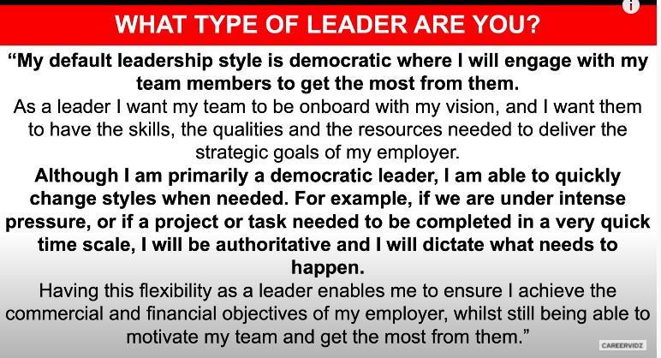

**Management vs leadership**

**M – is all about controlling and directing the resources and the people whom you are responsible for**

**L – is about inspiring, motivating and influencing people to achieve your objectives in order to be effective manager u need to be good at mangemtn as well as leadership**

**Learnings from SIP ?**

**I did my SIP with Arvind Lifestyle brand LTD as a Digital Excellence Research intern for NNNow.com.**

**Situtation- Analyzing each and every aspect of the online shopping journey to understanding the customer and optimizing the digital platform to improve customer acquisition and retention to constantly improve ROI.**

**Task –**

🞂 **shopping flow(Home -> CLP -> PLP -> PDP -> Cart. ), which**

**includes all the stages starting from the customer search to the final purchase.**

🞂 **Assess the total time involved in the journey, and the**

**factors contributing to the said time lag.**

🞂 **Figure out the factors prompting a customer to go ahead or**

**drop-off at every stage, such as landing page,CLP (category listing page) PLP (product listing page), PDP(product detail page), and sizing the contribution of each factor.**

🞂 **Find out the reasons behind cart abandonment and size the**

**chunks.**

🞂 **Find out the consumer preferences with respect to the**

**payment methods and how it varies with platform familiarity, cart value, probability of return and expected delivery time.**

**Actions—**

🞂 **Quantitative research Methods for Primary Data Collection:**

🞂 **Survey**

**Secondary data collection -- Think with google,statista,salecycle**

**Competitive analysis -- benchmarking with myntra, Ajio, Koovs**

**Similarweb was used to get details like total visits,avg visit duration,page per visit,bounce rate**

**Bounce rate is calculated by the total number of one-page visits divided by the total number of entries to a website. For example, if the homepage of a website receives 1,000 visitors over the course of a month, and 500 of those visitors leave the site after viewing the homepage without proceeding to any other pages, then the bounce rate of the homepage would be 50%.**

**Bounce rate measures the number of users who enter a website and exit without visiting any other page on the website. Exit rate measures the number of users who exit a website from a specific page.**

**The key difference between the two is that exit rate measures the percentage of visitors who exited a certain page, but it does not say anything about whether that was the only page that user visited or not. Therefore, all bounces are exits (and one-page visits), but not all exits are bounces.**

**The definition of a “good” bounce rate is also subjective based on the type of page, and the source of traffic. For example, if you have an informational article that answers a specific question, and the primary source of traffic to the page is from organic search, the bounce rate of the page could be as high as 90%. This doesn’t mean that the page is necessarily a “bad**

**bounce rate” even though it has a high bounce rate, it could just mean that the user found exactly what they were looking for, and no longer had any need to view any other pages. Conversely, a page with a low bounce rate may not necessarily be “good” if it has a poor user experience.**

**20% – 40% retail / ecommerce**

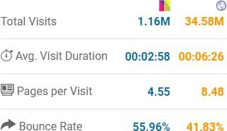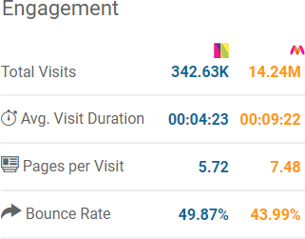

**total visitors is monthly**

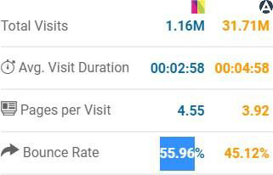

**Result---**

**Yes few recommendations were provided like**

**Add Social Sign-In**

🞂 **Cut out lengthy registration process(Guest**

**Checkout)**

🞂 **Auto-Fill data**

🞂 **Shorten checkout process form to a single click.** 🞂 **Product description options should be provided.**

🞂

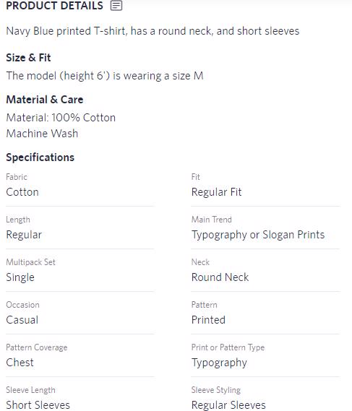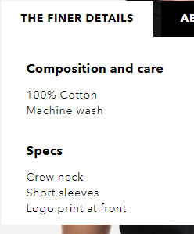

🞂

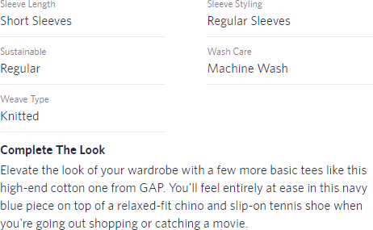

🞂 **Number of products displayed on PLP should be**

**limited(Page Navigation required).**

🞂 **Majority of customers read product reviews before**

**purchasing. -85% check review**

🞂 **No consistency in terms of title tag**

🞂 **Page speed needs improvement (currently its 17.3sec) 57%**

**after 3sec – 80% of that wont return to your page again**

**Myntra 7 sec**

**Cart abandommnnt Shipping – 67 % ,return exchange refund policy isn’t satisfactory**



**Checkout – unable to change/modify order Payment – security,preffered method not accepted**

**Choosing payment method – website familiarity,refund policy,cart value**

**delivery – delivery too slow, no flexibility of choosing date n time**

**bounce rate – ad/pop up heavy…low/under optimized content,slow to load page**

**PLP – unclear title tag,inadequate filter/sort by**

**PDP – zoom inout,,,size chart pop up ….description**

**Lead time – company website/other online shopping website**

**These recommendations have been taken into consideration by my mentor**

**They have not implemented it yet as they already have things lined up for their website and these recommendations need to go through long confidential process and once they clear all this….they will be implemented .**

**Key learnings were knowing the different KPIs for ecommerce for eg : Bounce rate, Pay per Click, churn rate, Email conversion rate, website traffic, average session on website etc**

**Also different insights about online shopping, customer behavior wrt to online shopping and how the smallest detail of website can make huge difference to customers**

**It was altogether a new experience as I have never worked on ecommerce when it comes to business part and yess…covid has impacted the customer buying behavior and e-commerce is indeed booming….Companies like amzon flipkart they have claimed that they have experienced 30% increase in sales in just 4 days which is indeed a huge % growth. 2.7 billion – 3.5billion**

**Learnings from SIRP**

**Quality issues related to enhancing customer satisfaction to ensure long-term customer loyalty**

* **Learning about the quality dimensions (Performance,Features,Realibility,Durability, Conformance, Serviceability, Aesthetics, Perceived quality)**

**How quality control tools and methods can be utilized for quality control**

**Understanding and analyzing customers perspective towards quality in their purchasing behavior.**

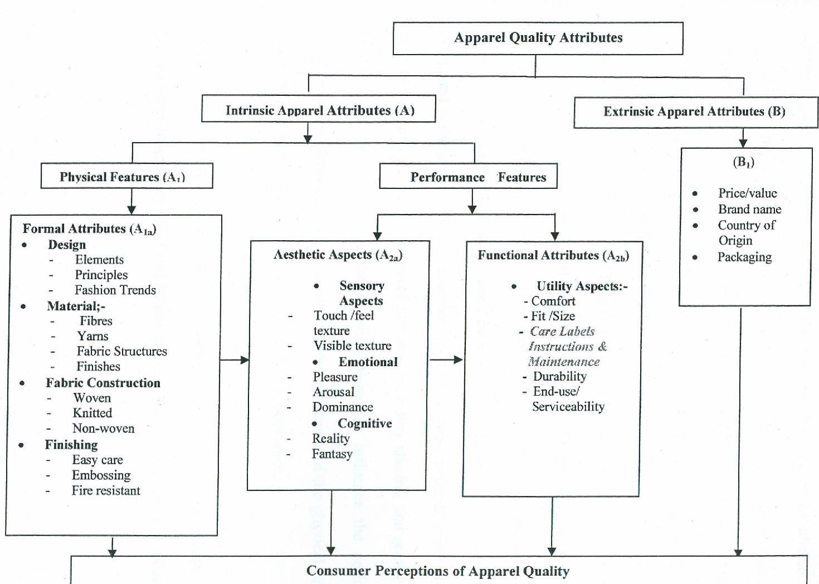

**Zone A**

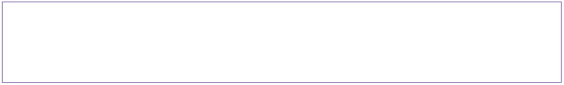

Place that is a more visible place of garments in the front. Ashirt Zone A is the Shoulder to Waist length.

**Zone B**

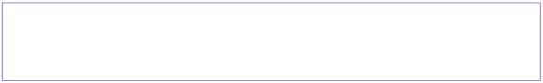

Place of garments in the front. A shirt Zone B is the Waist toBottom length.

**Zone C**

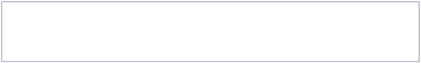

Place of garments in the back. A shirt Zone C is the Shoulder tobottom of the inside of the garments.

**M**U**i**n**n**cu**o**t**r**th**D**rea**e**d **M**B**a**ro**j**k**o**e**r**n  **Cr**B**it**ro**i**k**c**e**a**n



**l**ne**D**ed**e**le**f**, **e**Pi**c**n,**ts f**.**ects** S**D**tit**e**c**f**h**e**. **cts** Bro

ken

butt

Spot (Oil + Dirt). Skip Stitch. on.



Raw Edge. Crack Stitch. Open Siz

e

Puckering. Seam. Pleat. lab

Piling. el

mis

tak

es.

An

y

typ

es

of

tri

Insects,etc. ms

**This document was truncated here because it was created in the Evaluation Mode.**