BIRLA INSTITUTE OF TECHNOLOGY & SCIENCE, PILANI

Instructions to candidates appearing in BITSAT-2016 online test

Note: There are 3 pages of instructions. Please make sure that you have printed all the 3 pages
Dear candidate,

Keep the printed ‘Hall ticket’ in a safe place and carry it to the test venue on the day allotted to you. You will be allowed entry to the test venue only on production of the hall ticket. Carefully read the instructions given below.

- Reach the test venue at least 40 minutes before the test starting time. For example, if the test slot assigned to you is 8:30 AM to 11:30 AM, you should reach the venue by 7:50 AM latest. The personal verifications and other formalities will take time. Latecomers will not be allowed entry to the test venue.

- The address of the test center is printed in the Hallticket. In your own interest, please familiarize yourself with the center location and approach to the same a few days before the test date, so that you do not experience any difficulty on the day of the test.

- On the Hall ticket, there is a space identified for your signature. Put your signature immediately on the same so that others cannot misuse it. Also, write your emergency contact phone number, if any, on the space provided. Do not write anything else on the Hallticket either before or during the test. Any tampering of the Hallticket will lead to automatic disqualification.

- On the Hall ticket there is a space provided for pasting your recent passport size photograph. Please paste your photograph on the space provided and self attest by signing across it. This is must to appear in the BITSAT examination.

- A password is printed on the Hall ticket. Don’t share it with anyone else. The password will be required at the test center and also to access certain features at BITSAT website.

- You can appear in BITSAT-2016 only once. If it is found that you have appeared more than once in BITSAT-2016 you will be disqualified and will be ineligible for admissions to BITS. The test centers are monitored by cameras for security purpose and to avoid impersonations.

- Do not carry any personal belongings like bags, mobile, camera, electronic gadgets etc. to the test venue. You should bring a pen/pencil for signing/for doing rough work. You will be provided worksheets inside the venue for rough work. Calculators and logarithmic tables are NOT allowed inside the test venue. You should not take any paper away from the test venue, except your own hall ticket.

- You are strongly advised to familiarize yourself on the use of computer, keyboard and mouse. For your benefit, a sample test is already available at BITSAT website, which you can download and practice. The Institute cannot provide practice in computer operation at the test venue.

- Regularly check the following website for latest information and instructions regarding BITSAT-2016:

http://www.bitsadmission.com/

Contd…
Page 2
10. For your benefit, some of the screen shots of the actual test are given below. Since you have only limited time for the test, you have to familiarize yourself with the features before coming to the venue. You are also strongly advised to go through the sample test available at the BITSAT website. Also go through the BITSAT-2016 brochure and other instructions provided at BITSAT website.
The test is designed to be user friendly and you should have no problem in understanding and following the instructions given on the computer monitor.

(i) Initially, you have to type in your password to login:
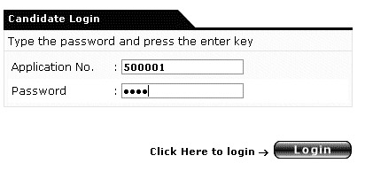
(ii) After you confirm your name and photograph and agree to the terms and conditions of the test, you will be shown the different symbols used:
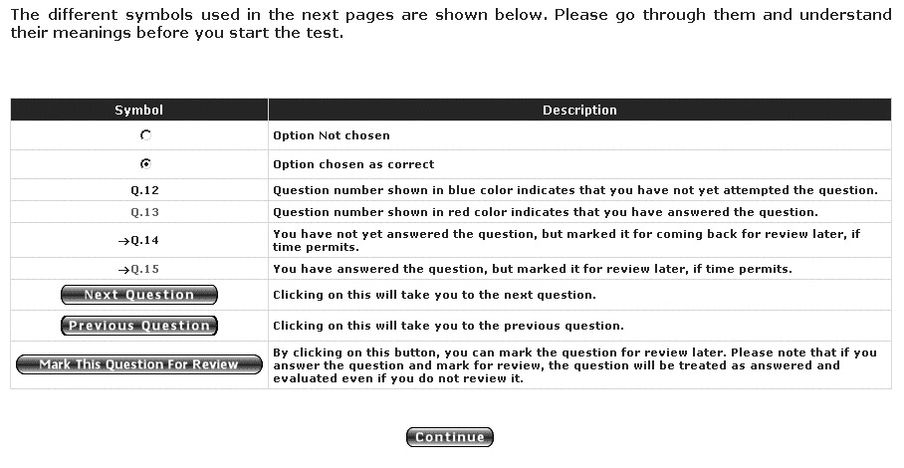
(iii) After that, you will be asked to choose the Part, which you want to answer first.
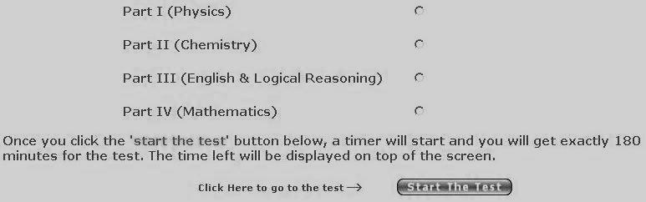
Contd…
Page 3
(iv) A typical test page that follows looks like this:
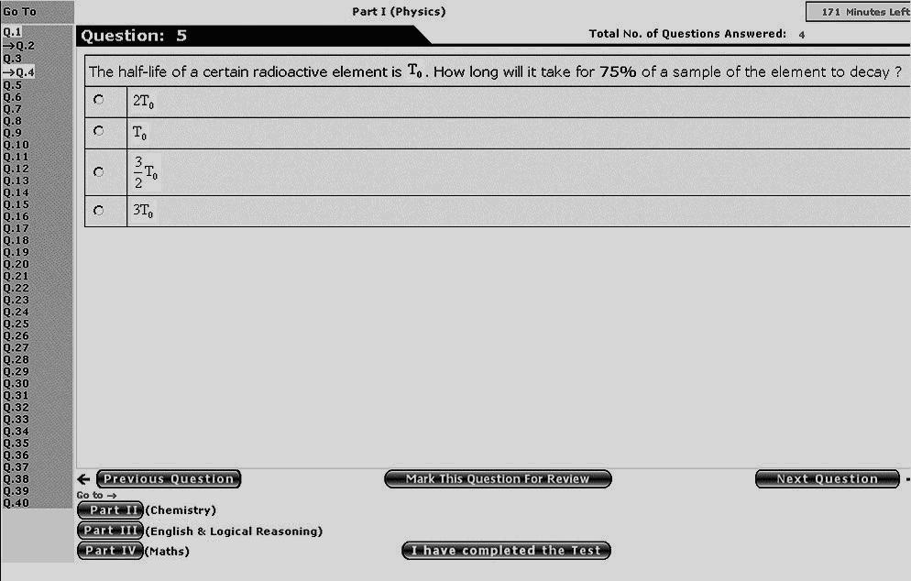
Important note: (a) You choose a particular answer by clicking on the circle adjacent to the same. By clicking again on the same circle, you can delete your choice.
(b) You can move from one part to another or from one question to another by clicking on the appropriate buttons. However, if you are not familiar with them, you may answer the question and move to next question by simply clicking on the ‘Next question’ button. You can thus go through all the 150 questions in a sequence.
(c) You should click on the ‘I have completed the Test’ button only when you want to close the test. Once you confirm that you want to generate the score, you will not be allowed to go back to the test.
(d) As explained in the brochure, you have the option of attempting 12 more questions if you complete attempting all the 150 questions. This feature will be available only when you complete answering the 150 questions and click on the ‘I have completed the test’ button, provided there is still time left.
(e) During the test, if you experience any problem with the computer/monitor etc., please inform the invigilator immediately. The system will be set right at the earliest. The answers entered by you are stored in a separate server and you will not loose any data. Further, the time lost due to malfunction of the machine will not be counted against the time allotted to you.
Test center regulations:
Once your hall ticket is verified, you will be allowed entry to the test venue. Proceed to the computer assigned to you. Read and follow the instructions on the computer monitor. The test administrators will make further announcements, if required. If you need help, please raise your hand. Do not shout or make noise to attract the attention of the administrator.
The administrator is authorized to dismiss you from the test for any of the following reasons:
- Creating disturbance
- Attempting to take the test on behalf of someone else
- Talking to other test takers
- Attempting to tamper with the computer system (hardware/software)
- Using calculators, logarithmic tables, cell phones, concealed microphones, wireless devices or
any other material that may aid in answering the questions
- Any other malpractice like carrying notes, presenting fake documents etc.
The test is of 180 minutes duration, without break. If you need to take any break like going for the toilet, please raise your hand to take permission from the administrator. However, the timer will be running and you will loose time during the break taken by you.

Dean Admissions

