HIGH-LEVEL DESIGN
IoT Vitals Monitoring on AWS and Databricks
Near-real-time alerting and lakehouse analytics for connected-device health data
Item | Detail
Status | Proof of concept (synthetic data only)
Author | Amey Paranjape
Date | October 2026
AWS region | eu-west-2 (London)
Platforms | AWS IoT Core, SNS, Amazon Data Firehose, S3, IAM; Databricks Free Edition (Delta Lake)

Disclaimer: This design uses synthetic data only. It is a learning and demonstration project, not a medical device or a clinical alerting system.

1. Purpose and scope
The project demonstrates a cloud pattern for monitoring patient vital signs from a connected device. A simulated blood-pressure and pulse-oximeter device publishes readings at a configurable interval. The platform must:
- Raise a near-real-time alert when a reading crosses a clinical threshold.
- Retain every reading and turn it into governed, analysis-ready tables for reconciliation, trend detection and reporting.
In scope: device simulation, secure ingestion, rule-based alerting, durable storage, medallion-layer analytics, cost and security controls, scripted teardown.
Out of scope: clinical validation, regulatory approval (for example UK MDR / UKCA), multi-tenant patient management, production-grade operations.

Alert thresholds
Condition | Threshold
Low oxygen saturation | SpO2 below 85%
High blood pressure | Systolic 180 mmHg or above

2. Architecture overview
A single device message feeds two independent paths: a hot path that acts on the data within seconds, and a cold path that stores it for analysis.
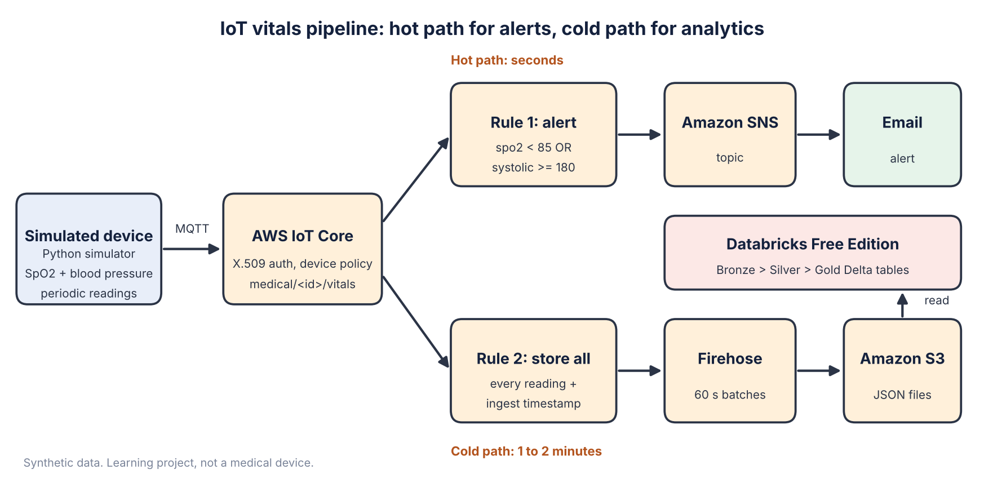
Figure 1. End-to-end architecture with hot and cold paths

3. Component design
Layer | Component | Responsibility
Device | Python simulator | Publishes JSON readings to medical/<deviceId>/vitals at QoS 1. Injects short abnormal episodes to exercise the alert path. Supports MQTT with certificates, an HTTPS fallback and an offline print mode.
Ingestion | AWS IoT Core | Authenticates the device by certificate, enforces a topic-scoped policy and routes each message to the rules engine.
Alerting | IoT rule 1 + SNS | A SQL filter on the stream (spo2 < 85 OR systolic >= 180) publishes only breaching readings to an SNS topic with an email subscription.
Stream to storage | IoT rule 2 + Firehose | Forwards every reading, adds an ingest timestamp, and batches records into newline-delimited JSON objects on S3.
Storage | Amazon S3 | Landing zone partitioned by date. Public access blocked. A 7-day lifecycle rule expires demo data.
Analytics | Databricks Free Edition | A serverless notebook reads the landing files and builds Delta tables in medallion layers.
Provisioning | setup_aws.py (boto3) | Creates and tears down every AWS resource, so the environment is reproducible and disposable.

Why the alert runs in AWS and not in Databricks
Databricks Free Edition limits outbound network access, runs on quota-bound serverless compute and is not built for always-on streaming. An alert that must fire within seconds belongs where the data first arrives. IoT Core rules are serverless, evaluate SQL per message and cost nothing while idle. Databricks does what it does best: history, joins, aggregation and pattern detection that a single-reading rule cannot do.

4. Data flow
- The device publishes a reading to medical/bp-oximeter-001/vitals over MQTT with TLS (QoS 1).
- IoT Core delivers the message to both rules in parallel.
- Hot path: rule 1 evaluates the thresholds. If breached, the message goes to SNS, which emails the subscriber within seconds.
- Cold path: rule 2 stamps the message with the ingest time and sends it to Firehose. Firehose buffers for 60 seconds and writes one object per batch under bronze/vitals/dt=YYYY-MM-DD/ in S3.
- The Databricks notebook reads the landing files and builds Bronze, Silver and Gold tables.
- Alert counts in gold_alerts are reconciled against the alert emails received, which shows both paths saw the same data.

Message schema
Field | Type | Description
deviceId | string | Device identifier, equal to the IoT thing name
ts | long | Device event time (epoch milliseconds)
spo2 | double | Oxygen saturation (%)
systolic / diastolic | int | Blood pressure (mmHg)
heartRate | int | Pulse (bpm)
ingestTs | long | AWS ingest time, added by rule 2

5. Data model (medallion architecture)
Layer | Table | Contents | Purpose
Bronze | bronze_vitals | Raw readings as landed, plus source file name. Nothing is dropped. | Replay and audit
Silver | silver_vitals | Typed and de-duplicated on device and timestamp. Adds event time, ingest time, latency and an is_valid flag. Implausible values are kept but flagged. | Trusted, queryable base
Gold | gold_alerts | Readings that crossed the thresholds, with alert type. | Reconcile with emails
Gold | gold_trend_warnings | 30-second moving averages (three readings) that drift towards danger before a single reading breaches. | Early warning
Gold | gold_hourly_summary | Per device per hour: reading count, average and minimum SpO2, maximum systolic, alert count, latency. | Reporting

6. Security design
Area | Control
Device identity | One X.509 certificate per device. The private key never leaves the device and is excluded from source control.
Device authorisation | IoT policy allows connect only as the device's own client ID and publish only to its own topic.
Service-to-service access | Three IAM roles (IoT to SNS, IoT to Firehose, Firehose to S3), each limited to the minimum actions on a single resource.
Data at rest | S3 public access blocked. Data expires after 7 days.
Analytics access | Databricks reads S3 through a dedicated read-only IAM user scoped to one bucket. Credentials are entered at run time as notebook widgets, never stored in code.
Account hygiene | Non-root IAM user, secrets excluded through .gitignore, teardown removes roles, keys and certificates.
Production considerations (not implemented): health data is special-category data under UK GDPR. A real system would need encryption with customer-managed keys, fine-grained access control, audit logging, consent management and a clinical safety case.

7. Non-functional characteristics
Attribute | Design approach
Latency | Alert path: seconds, bounded by IoT Core rule execution and email delivery. Analytics path: 1 to 2 minutes, bounded by the 60-second Firehose buffer.
Reliability | MQTT QoS 1 gives at-least-once delivery, so duplicates are possible. Silver de-duplicates and alerting is designed to be safe to repeat. Firehose writes failed deliveries to an errors/ prefix.
Scalability | IoT Core, SNS, Firehose and S3 are managed and scale with message volume. Additional devices fit the existing topic wildcard (medical/+/vitals).
Observability | Row-count reconciliation between alerts, Bronze and Silver. Ingest-to-event latency measured in Silver. The IoT MQTT test client supports message-level debugging.
Cost | Serverless and pay-per-use. A two-minute run is about a dozen messages. Budget alert at 80% of a USD 5 monthly budget. One-command teardown.
Repeatability | All AWS resources are created and removed by script, using fixed resource names.

8. Key design decisions
Decision | Rationale
Rules engine for alerting, not custom code | No servers to run or patch, evaluates per message, zero idle cost.
Separate hot and cold paths | Decouples time-critical action from analytics. A failure in one does not block the other.
Firehose between IoT Core and S3 | Batches many small messages into fewer, larger files. Lower S3 request cost and faster downstream reads.
Medallion layers | Preserves raw data for replay, separates cleansing from business logic, and serves each audience from the right layer.
Keep invalid readings, flag them | Avoids silent data loss. Analysts decide how to treat outliers.
Least-privilege IAM per integration | Limits the blast radius if any one component is compromised.
Scripted provisioning and teardown | Reproducible environment and controlled cost.

9. Limitations
- Synthetic data from a single simulated device.
- Databricks Free Edition allows serverless compute only, restricts outbound network access, has a usage quota and cannot assume an IAM role. The notebook therefore pulls files with a read-only key and includes a manual-upload fallback.
- The notebook loads in batches rather than ingesting continuously.
- Every abnormal reading triggers its own email, so a sustained breach produces repeated alerts (alert fatigue).
- Not a clinical system: no safety case, regulatory work or data-protection controls beyond those above.

10. Future enhancements
Enhancement | Benefit
Lambda and DynamoDB alert cooldown with escalation | Suppress repeat alerts and escalate if the condition persists
Databricks Auto Loader on a Unity Catalog external location | Incremental file ingestion (paid workspace)
Firehose Parquet conversion | Smaller, faster columnar storage
Infrastructure as code (CloudFormation or Terraform) | Version-controlled, reviewable infrastructure
CloudWatch alarms and a rule error action | Operational visibility on rule and delivery failures
SMS or Slack alert channels | Wider and faster notification routes
Dashboard on Gold tables | Trend and summary view
Multi-device, multi-patient model | Scale beyond a single device

