ABC Cyber Shield
AI-Powered Cybersecurity Threat Detection, Incident Response and Security Management Platform

ABC Cyber Shield
AI-Powered Cybersecurity Threat Detection, Incident Response and Security Management Platform
Submitted in partial fulfillment of the requirements for the award of degree of
Bachelor of Technology (B.Tech)
In
Computer Science & Engineering

Submitted By
Balaji Tanaji Patil
PRN No.: 2022011031141
Roll No.: 62

Submitted To
Department of Computer Science & Engineering
D.Y. Patil Agricultural and Technical University, Talsande
Academic Year: 2025-26

CERTIFICATE
CERTIFICATE OF PROJECT COMPLETION
This is to certify that the project entitled "ABC Cyber Shield: AI-Powered Cybersecurity Threat Detection, Incident Response and Security Management Platform" submitted by Mr. Balaji Tanaji Patil (PRN No. 2022011031141) in partial fulfillment of the requirements for the award of the degree of Bachelor of Technology in Computer Science & Engineering has been carried out successfully during the academic year 2025-26.
The work presented in this project report is original and has been completed under the prescribed academic guidelines.

Project Guide

Department of Computer Science & Engineering

Head of Department

Department of Computer Science & Engineering

DECLARATION
I hereby declare that the project entitled "ABC Cyber Shield: AI-Powered Cybersecurity Threat Detection, Incident Response and Security Management Platform" submitted by me in partial fulfillment of the requirements for the award of Bachelor of Technology degree in Computer Science & Engineering is a record of original work carried out by me.
I further declare that this project has not been submitted to any other university or institution for the award of any degree or diploma.

Place: Talsande
Date: 17/06/2026
Signature
Balaji Tanaji Patil
PRN No. 2022011031141

ACKNOWLEDGEMENT
I express my sincere gratitude to the Department of Computer Science & Engineering, D.Y. Patil Agricultural and Technical University, Talsande, for providing me with the opportunity to undertake this project.
I would like to thank all faculty members of the department for their valuable guidance, encouragement, and support throughout the project development process.
I am also grateful to my friends and well-wishers who directly or indirectly contributed to the successful completion of this project.
Finally, I would like to express my heartfelt gratitude to my parents for their constant motivation, support, and encouragement throughout my academic journey.

ABSTRACT
The increasing sophistication of cyber threats has created significant challenges for organizations attempting to protect their digital assets and critical infrastructure. Modern cyberattacks such as phishing campaigns, malware infections, ransomware attacks, insider threats, and unauthorized access attempts require intelligent and proactive security solutions.
ABC Cyber Shield is an AI-powered cybersecurity platform developed to provide comprehensive threat detection, vulnerability assessment, incident response management, and security monitoring within a centralized environment. The platform integrates modern web technologies and Artificial Intelligence to enhance threat visibility and improve security operations.
The system incorporates multiple security modules including Threat Monitoring, Phishing Detection, Malware Analysis Sandbox, Vulnerability Scanner, Incident Response Center, User Management, Role-Based Access Control, Alerts & Notifications, Reports & Analytics, and an AI Security Assistant powered by Google Gemini AI.
The platform utilizes the MERN technology stack consisting of MongoDB, Express.js, React.js, and Node.js. Real-time security alerts and notifications are supported through modern communication mechanisms, enabling rapid incident response and improved situational awareness.
ABC Cyber Shield provides organizations with a scalable and intelligent cybersecurity solution capable of identifying security threats, assessing vulnerabilities, and assisting security analysts with AI-driven recommendations. The proposed system enhances organizational security posture while reducing response times and improving operational efficiency.
Keywords: Cybersecurity, Artificial Intelligence, Threat Detection, Incident Response, Vulnerability Scanner, Phishing Detection, Malware Analysis, MERN Stack, Gemini AI.

TABLE OF CONTENTS
- Introduction
- Literature Survey
- Existing System
- Proposed System
- Problem Statement
- Objectives
- Scope of Project

INTRODUCTION
1.1 Background
Cybersecurity has become one of the most critical concerns in today's digital era. Organizations heavily depend on digital infrastructure for business operations, customer management, financial transactions, and communication. This increasing dependency on technology has significantly expanded the attack surface available to cybercriminals.
Cyber threats continue to evolve in complexity and frequency. Attackers employ sophisticated techniques including phishing attacks, malware deployment, social engineering, credential theft, ransomware attacks, and vulnerability exploitation to compromise systems and gain unauthorized access to sensitive information.
Traditional security solutions often operate independently, creating challenges in centralized monitoring, incident management, and threat intelligence generation. Security teams frequently struggle to correlate information from multiple security tools, resulting in delayed incident response and reduced operational effectiveness.
To address these challenges, organizations require intelligent cybersecurity platforms capable of consolidating security functions into a unified environment while leveraging Artificial Intelligence for advanced threat detection and analysis.

1.2 Overview of ABC Cyber Shield
ABC Cyber Shield is an integrated cybersecurity management platform developed to address modern security challenges through centralized monitoring, threat intelligence, vulnerability assessment, and AI-assisted incident response.
The platform combines multiple cybersecurity functionalities into a single solution, enabling organizations to monitor security events, analyze suspicious activities, investigate incidents, and generate actionable security insights.
ABC Cyber Shield leverages Google Gemini Artificial Intelligence to provide intelligent threat analysis, security recommendations, vulnerability explanations, and incident investigation assistance.
The platform includes several core components:
- Security Dashboard
- Threat Monitoring System
- Phishing Detection Engine
- Malware Analysis Sandbox
- Vulnerability Scanner
- Incident Response Center
- AI Security Assistant
- Alerts and Notifications
- Reports and Analytics
- User and Permission Management

1.3 Need for the System
Modern organizations face numerous cybersecurity challenges including:
Increasing Threat Volume
Cyberattacks continue to increase in both frequency and sophistication.
Fragmented Security Tools
Many organizations utilize multiple independent security solutions, resulting in operational complexity.
Delayed Incident Response
Manual security investigations often increase incident response times.
Lack of Threat Intelligence
Security teams require contextual information and intelligent recommendations for effective decision-making.
Compliance Requirements
Organizations must maintain security controls and monitoring mechanisms to satisfy regulatory requirements.
ABC Cyber Shield addresses these challenges through centralized security management and AI-assisted threat analysis.

1.4 Scope of the Project
The scope of ABC Cyber Shield includes:
- User Authentication and Authorization
- Threat Detection and Monitoring
- Phishing Detection
- Malware Analysis
- Vulnerability Assessment
- Incident Response Management
- Security Alerts and Notifications
- AI-Based Security Assistance
- Reporting and Analytics
- Role-Based Access Control
The platform is designed to support security administrators, analysts, and organizational users through a secure and scalable architecture.

1.5 Objectives
The primary objectives of the project are:
- To develop a centralized cybersecurity monitoring platform.
- To detect and analyze cyber threats in real time.
- To identify phishing attempts using AI-assisted analysis.
- To perform malware analysis on suspicious files.
- To identify security vulnerabilities within target systems.
- To provide effective incident response capabilities.
- To implement role-based access control mechanisms.
- To generate security insights using Artificial Intelligence.
- To improve organizational cybersecurity awareness.
- To provide actionable security recommendations.

LITERATURE SURVEY
2.1 Introduction
Cybersecurity has become a major research area due to the rapid increase in cyber threats targeting organizations worldwide. Researchers and industry professionals continuously develop new methods to improve threat detection, incident response, and security monitoring capabilities.
Several cybersecurity technologies have emerged over the years, including antivirus solutions, intrusion detection systems, security information and event management platforms, endpoint protection systems, and artificial intelligence-based security tools.
The following section discusses existing technologies and their limitations.

2.2 Antivirus Systems
Traditional antivirus software focuses on identifying malicious files through signature-based detection techniques.
Examples:
- Norton Antivirus
- McAfee
- Quick Heal
- Kaspersky
Advantages
- Effective against known threats.
- Easy deployment.
Limitations
- Limited protection against zero-day attacks.
- Inability to provide centralized threat management.
- Reactive rather than proactive security approach.

2.3 Intrusion Detection Systems
Intrusion Detection Systems (IDS) monitor network traffic and system activities to identify suspicious behavior.
Examples:
- Snort
- Suricata
- Zeek
Advantages
- Network visibility.
- Attack detection capabilities.
Limitations
- High false positive rates.
- Limited incident response capabilities.

LITERATURE SURVEY
2.4 Security Information and Event Management (SIEM)
Security Information and Event Management (SIEM) systems provide centralized logging, event correlation, and security monitoring capabilities.
Popular SIEM Platforms
- IBM QRadar
- Splunk Enterprise Security
- Microsoft Sentinel
- LogRhythm
Advantages
- Centralized monitoring
- Log correlation
- Threat visibility
- Compliance support
Limitations
- High deployment cost
- Complex configuration
- Requires experienced security analysts
- Limited AI-driven recommendations

2.5 Artificial Intelligence in Cybersecurity
Artificial Intelligence has become a powerful technology for cybersecurity applications. AI enables systems to identify unusual patterns, detect threats, automate responses, and generate intelligent recommendations.
Applications of AI in Cybersecurity
- Threat Detection
- Malware Classification
- Phishing Detection
- Behavioral Analysis
- Risk Assessment
- Security Recommendations
Benefits
- Faster threat identification
- Reduced manual workload
- Improved accuracy
- Automated analysis

2.6 Research Gap
Although modern cybersecurity solutions provide effective protection mechanisms, several limitations still exist:
Identified Gaps
- Lack of centralized security management.
- High dependency on manual investigations.
- Limited AI integration.
- Complex user interfaces.
- Expensive enterprise solutions.
- Lack of integrated incident response workflows.
ABC Cyber Shield addresses these limitations by combining multiple cybersecurity functions into a unified AI-powered platform.

EXISTING SYSTEM
3.1 Existing Security Environment
Most organizations use multiple standalone security tools for protection and monitoring.
Examples include:
- Antivirus Software
- Firewalls
- Intrusion Detection Systems
- SIEM Platforms
- Vulnerability Scanners
These tools often operate independently and require manual coordination by security teams.

3.2 Limitations of Existing Systems
Fragmented Monitoring
Security information is distributed across multiple tools.
Delayed Response
Manual investigation increases response time.
Limited Threat Intelligence
Existing solutions provide limited contextual threat analysis.
High Operational Cost
Enterprise security solutions require significant investment.
Complex Management
Managing multiple security products creates operational challenges.

3.3 Existing System Workflow
Security Event
|
V
Individual Security Tool
|
V
Manual Investigation
|
V
Threat Analysis
|
V
Response Action

PROPOSED SYSTEM
4.1 Proposed Solution
ABC Cyber Shield is a centralized AI-powered cybersecurity management platform designed to improve threat visibility, incident response, and security decision-making.
The platform integrates:
- Threat Monitoring
- Phishing Detection
- Malware Analysis
- Vulnerability Scanning
- Incident Management
- AI Security Assistant
- Alerts & Notifications
- User Management
into a single unified system.

4.2 Features of Proposed System
Centralized Dashboard
Provides complete visibility into security operations.
AI Security Assistant
Powered by Google Gemini AI for intelligent recommendations.
Threat Monitoring
Real-time monitoring of cyber threats.
Malware Analysis Sandbox
Analyzes suspicious files and malicious content.
Vulnerability Assessment
Identifies known vulnerabilities and security weaknesses.
Incident Response Center
Tracks and manages security incidents.
Role-Based Access Control
Controls access based on user roles.

4.3 Advantages of Proposed System
- AI-Powered Threat Analysis
- Centralized Security Management
- Improved Visibility
- Faster Incident Response
- Enhanced User Experience
- Reduced Security Risks
- Better Decision Making

PROBLEM STATEMENT
Modern organizations face increasing cybersecurity threats including phishing attacks, malware infections, unauthorized access attempts, and security vulnerabilities. Existing security solutions often operate independently, resulting in fragmented monitoring, delayed response times, and limited threat intelligence.
There is a need for an integrated cybersecurity platform capable of providing centralized monitoring, intelligent threat analysis, vulnerability assessment, incident management, and AI-powered security recommendations.
ABC Cyber Shield aims to address these challenges by providing an intelligent cybersecurity management platform that improves threat detection, response efficiency, and overall organizational security posture.

Security Administrator
Thinks
- Are our systems secure?
- How can we reduce security risks?
- How can incidents be resolved faster?
Feels
- Concerned about cyber threats.
- Responsible for protecting organizational assets.
Says
- We need better visibility.
- We need real-time monitoring.
Does
- Reviews security reports.
- Monitors alerts.
- Investigates incidents.

Security Analyst
Thinks
- Which threats are critical?
- How can I investigate efficiently?
Feels
- Pressured to respond quickly.
- Responsible for threat mitigation.
Says
- We need better threat intelligence.
- We need AI assistance.
Does
- Monitors dashboards.
- Performs investigations.
- Responds to incidents.

CHAPTER 7
BRAINSTORMING MAP
Identified Problems
- Phishing attacks
- Malware infections
- Unauthorized access attempts
- Lack of centralized monitoring
- Delayed incident response

Proposed Ideas
Idea 1
AI-Powered Security Assistant
Impact: High
Feasibility: High

Idea 2
Real-Time Threat Monitoring
Impact: High
Feasibility: High

Idea 3
Malware Analysis Sandbox
Impact: High
Feasibility: Medium

Idea 4
Vulnerability Scanner
Impact: High
Feasibility: High

Idea 5
Incident Response Center
Impact: High
Feasibility: High

Selected Solution
ABC Cyber Shield
A centralized cybersecurity platform integrating AI-powered threat analysis, incident response, and security monitoring.

CHAPTER 8
REQUIREMENT ANALYSIS
8.1 Functional Requirements
User Authentication
- User Registration
- User Login
- Password Encryption
- JWT Authentication

Threat Monitoring
- View Threats
- Search Threats
- Filter Threats
- Update Status

Phishing Detection
- URL Analysis
- Email Content Analysis
- Threat Scoring

Malware Analysis
- File Upload
- Hash Generation
- Malware Detection

Vulnerability Scanner
- CVE Detection
- Risk Assessment
- Patch Recommendations

Incident Response
- Create Incident
- Assign Incident
- Update Incident Status
- Add Investigation Notes

AI Security Assistant
- Threat Explanation
- Security Recommendations
- Risk Assessment

Reports & Analytics
- Security Reports
- Threat Statistics
- Vulnerability Reports

8.2 Non-Functional Requirements
Security
- JWT Authentication
- Password Encryption
- Input Validation
Performance
- Fast Response Time
- Efficient Database Queries
Reliability
- Stable Operation
- Error Handling
Scalability
- Support Multiple Users
- Expandable Architecture
Availability
- Continuous Access

DATA FLOW DIAGRAM (DFD)
9.1 Introduction
A Data Flow Diagram (DFD) is a graphical representation used to illustrate the movement of information within a system. It shows how data enters the system, how it is processed, stored, and delivered to users.
In ABC Cyber Shield, DFDs are used to represent the interaction between users, security modules, AI services, databases, and system outputs.

9.2 DFD Level 0 (Context Diagram)
Description
DFD Level 0 represents the overall interaction between users and the ABC Cyber Shield platform.
+----------------+
| USER |
+--------+-------+
|
|
v
+------------------------+
| ABC Cyber Shield |
+------------------------+
|
|
v
+------------------------+
| Security Analysis & |
| Threat Response System |
+------------------------+
Explanation
The user interacts with the platform by submitting login requests, URLs, files, and incident reports.
The platform processes the information and returns:
- Threat Analysis
- Security Recommendations
- Alerts
- Reports
- Incident Updates

9.3 DFD Level 1
Description
Level 1 DFD represents the major modules within the system.
User
|
v
Authentication Module
|
v
+-------------------+
| Threat Monitoring |
+-------------------+
|
+----> Phishing Detection
|
+----> Malware Analysis
|
+----> Vulnerability Scanner
|
v
AI Security Assistant
|
v
Alert Generation
|
v
Dashboard & Reports
Explanation
The user first authenticates.
After successful authentication:
- Threats are monitored.
- URLs are analyzed.
- Files are scanned.
- Vulnerabilities are detected.
- AI recommendations are generated.
- Alerts are created.
- Results are displayed on dashboards.

9.4 DFD Level 2
Description
This level represents detailed internal processing.
User Input
|
v
Authentication
|
v
Validation Layer
|
+------------+
| |
v v
Threat Vulnerability
Analysis Analysis
| |
+------------+
|
v
Gemini AI
|
v
Risk Assessment
|
v
Alert Engine
|
v
MongoDB
|
v
Dashboard & Reports

USER STORIES
User Story 1
As a Security Analyst
I want to monitor active threats
So that I can investigate suspicious activities quickly.

User Story 2
As a Security Analyst
I want to analyze URLs and emails
So that I can identify phishing attacks.

User Story 3
As an Administrator
I want to manage users and permissions
So that I can enforce security policies.

User Story 4
As a Security Analyst
I want to scan suspicious files
So that I can identify malware infections.

User Story 5
As an Administrator
I want to track security incidents
So that I can ensure timely resolution.

User Story 6
As a User
I want to receive alerts
So that I can be informed about security threats.

User Story 7
As a Security Analyst
I want AI-powered recommendations
So that I can make better security decisions.

SOLUTION ARCHITECTURE
11.1 Architecture Overview
ABC Cyber Shield follows a multi-layer architecture.
The architecture consists of:
- Presentation Layer
- Application Layer
- AI Layer
- Database Layer
- Security Layer

11.2 Solution Architecture Diagram
+----------------------+
| Users |
+----------+-----------+
|
v
+----------------------+
| React Frontend |
+----------+-----------+
|
v
+----------------------+
| Express API Server |
+----------+-----------+
|
+-------+-------+
| |
v v
MongoDB Gemini AI
| |
+-------+-------+
|
v
+----------------------+
| Security Modules |
+----------------------+

11.3 Layer Description
Presentation Layer
Responsible for user interaction.
Technology:
- React.js
- Tailwind CSS
- Framer Motion

Application Layer
Handles business logic.
Technology:
- Node.js
- Express.js

AI Layer
Provides intelligent threat analysis.
Technology:
- Google Gemini AI

Database Layer
Stores system information.
Technology:
- MongoDB
- Mongoose

Security Layer
Protects user accounts and APIs.
Technology:
- JWT
- Bcrypt

TECHNOLOGY STACK
Frontend Technologies
React.js
Used for building dynamic user interfaces.
Tailwind CSS
Used for responsive styling.
Framer Motion
Used for animations.
React Router
Used for navigation.

Backend Technologies
Node.js
Server-side JavaScript runtime.
Express.js
REST API framework.

Database
MongoDB
NoSQL database used for storing application data.
Mongoose
ODM used for database operations.

Security Technologies
JWT
Used for authentication.
Bcrypt
Used for password hashing.

Artificial Intelligence
Google Gemini AI
Used for:
- Threat Analysis
- Security Recommendations
- Vulnerability Explanation
- Incident Investigation

DATABASE DESIGN
13.1 User Collection
Stores user details.
Fields:
- name
- email
- mobile
- password
- role
- status
- permissions

13.2 Threat Collection
Stores detected threats.
Fields:
- type
- source
- target
- severity
- status

13.3 Vulnerability Collection
Stores vulnerability records.
Fields:
- cve
- target
- severity
- component
- description
- status

13.4 Incident Collection
Stores security incidents.
Fields:
- title
- assignee
- priority
- status
- notes

13.5 Alert Collection
Stores alerts.
Fields:
- message
- type
- isRead
- timestamp

13.6 ChatHistory Collection
Stores AI conversations.
Fields:
- user
- role
- content
- timestamp

ENTITY RELATIONSHIP DIAGRAM (ER DIAGRAM)
+----------------+
| USER |
+----------------+
| _id |
| name |
| email |
| role |
+----------------+
|
| 1:N
|
v

+----------------+
| CHAT HISTORY |
+----------------+
| userId |
| messages |
+----------------+

|
| Assigned To
|
v

+----------------+
| INCIDENT |
+----------------+
| title |
| priority |
| status |
+----------------+

+----------------+
| THREAT |
+----------------+
| type |
| severity |
| status |
+----------------+

+----------------+
| ALERT |
+----------------+
| message |
| type |
+----------------+

+----------------+
|VULNERABILITY |
+----------------+
| cve |
| severity |
| component |
+----------------+

PROJECT SPRINT PLANNING
Sprint | Task
Sprint 1 | Authentication & User Management
Sprint 2 | Dashboard Development
Sprint 3 | Threat Monitoring
Sprint 4 | Phishing Detection
Sprint 5 | Malware Analysis
Sprint 6 | Vulnerability Scanner
Sprint 7 | Incident Response
Sprint 8 | AI Assistant
Sprint 9 | Reports & Analytics
Sprint 10 | Testing & Deployment

CODING & SOLUTIONING
16.1 Introduction
The implementation of ABC Cyber Shield was carried out using the MERN technology stack, integrating modern web development frameworks, database technologies, and Artificial Intelligence services.
The project was developed using a modular architecture to ensure maintainability, scalability, and security.

16.2 Frontend Development
Technologies Used
- React.js
- Vite
- Tailwind CSS
- Framer Motion
- React Router DOM
- Axios
Responsibilities
The frontend is responsible for:
- User Interface
- Dashboard Visualization
- Data Presentation
- User Interaction
- Authentication Screens
- Report Generation Views

16.3 Backend Development
Technologies Used
- Node.js
- Express.js
- MongoDB
- Mongoose
- JWT
- Bcrypt.js
Responsibilities
The backend handles:
- API Management
- Authentication
- Authorization
- Business Logic
- Threat Processing
- Vulnerability Processing
- AI Communication

16.4 AI Integration
Google Gemini AI
ABC Cyber Shield utilizes Google Gemini AI to provide intelligent security analysis.
Functions:
- Threat Analysis
- Security Recommendations
- Vulnerability Explanation
- Incident Investigation Assistance
- Malware Risk Evaluation
Benefits:
- Faster Analysis
- Improved Accuracy
- Reduced Analyst Workload

MODULE IMPLEMENTATION

17.1 Dashboard Module
Purpose
Provides a centralized overview of the security posture.
Features
- Total Threat Count
- Active Threats
- Vulnerabilities
- Incidents
- Security Score
- Analytics
Benefits
- Better Visibility
- Faster Decision Making

17.2 Threat Monitoring Module
Purpose
Tracks active threats across the organization.
Features
- Threat Listing
- Search Threats
- Filter Threats
- Severity Tracking
Severity Levels
- Low
- Medium
- High
- Critical

17.3 Phishing Detection Module
Purpose
Identifies phishing URLs and suspicious email content.
Features
- URL Analysis
- Email Analysis
- Threat Scoring
- AI Recommendations
Output
- Safe
- Suspicious
- Malicious

17.4 Malware Analysis Sandbox
Purpose
Analyzes uploaded files for malicious behavior.
Features
- File Upload
- SHA-256 Generation
- Threat Detection
- Heuristic Analysis
Supported Files
- PDF
- DOCX
- ZIP
- EXE
- Scripts

17.5 Vulnerability Scanner
Purpose
Identifies known security vulnerabilities.
Features
- CVE Detection
- Risk Assessment
- Patch Recommendation
Severity Classification
- Low
- Medium
- High
- Critical

17.6 Incident Response Center
Purpose
Manages security incidents from creation to resolution.
Features
- Incident Creation
- Incident Assignment
- Investigation Notes
- Status Updates
Status Values
- Open
- Investigating
- Mitigated
- Resolved

17.7 AI Security Assistant
Purpose
Provides AI-powered cybersecurity guidance.
Features
- Threat Explanation
- Security Recommendations
- Vulnerability Guidance
- Security Best Practices

17.8 Alerts & Notifications
Purpose
Provides real-time alerts regarding security events.
Features
- Critical Alerts
- Warning Alerts
- Informational Alerts

17.9 User Management
Purpose
Manages platform users and access.
Features
- Create User
- Update User
- Delete User
- Assign Roles

17.10 Permissions Management
Purpose
Controls module-level access.
Features
- Role Permissions
- Access Control
- Security Policy Enforcement

TESTING
18.1 Testing Strategy
ABC Cyber Shield was tested using functional and performance testing approaches.

18.2 Functional Testing
Test Case | Expected Result | Status
User Login | Successful Authentication | Pass
URL Scan | Threat Analysis Generated | Pass
File Upload | Malware Analysis Generated | Pass
Vulnerability Scan | Vulnerabilities Displayed | Pass
Incident Creation | Incident Added Successfully | Pass
AI Assistant | AI Response Generated | Pass

Metric | Result
Login Response | < 1 sec
Dashboard Load Time | < 2 sec
Threat Analysis | 2–5 sec
Vulnerability Scan | 3–6 sec
AI Response | 3–8 sec
File Analysis | 5–10 sec

Authentication Testing
Verified:
- JWT Token Generation
- Token Validation
- Session Security
Authorization Testing
Verified:
- Role-Based Access
- Permission Validation
Password Security
Verified:
- Password Hashing
- Bcrypt Encryption

RESULTS & DISCUSSION
Dashboard Results
The Dashboard successfully provides centralized visibility into security operations.
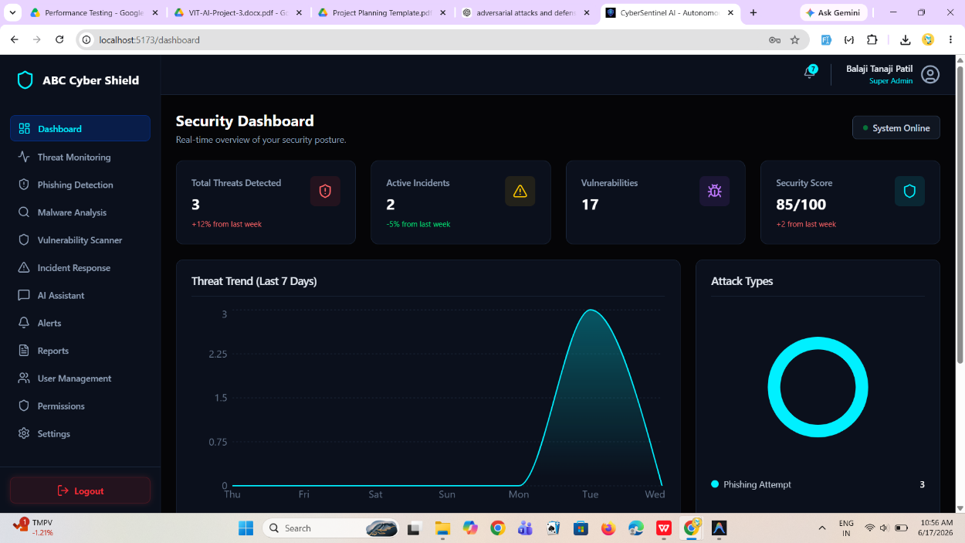

Threat Monitoring Results
Threats are successfully identified, categorized, and monitored according to severity levels.

Phishing Detection Results
URLs and email content are analyzed and assigned risk scores.

Malware Analysis Results
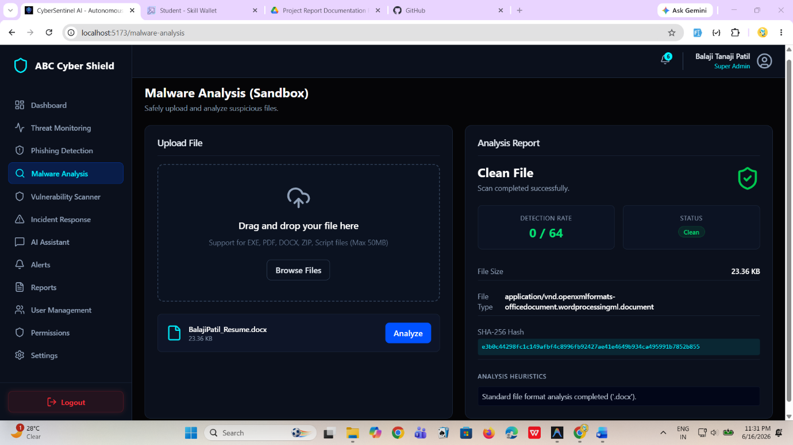
Files are successfully analyzed and classified based on threat indicators.

Vulnerability Scanner Results
The scanner identifies vulnerabilities and provides remediation recommendations.
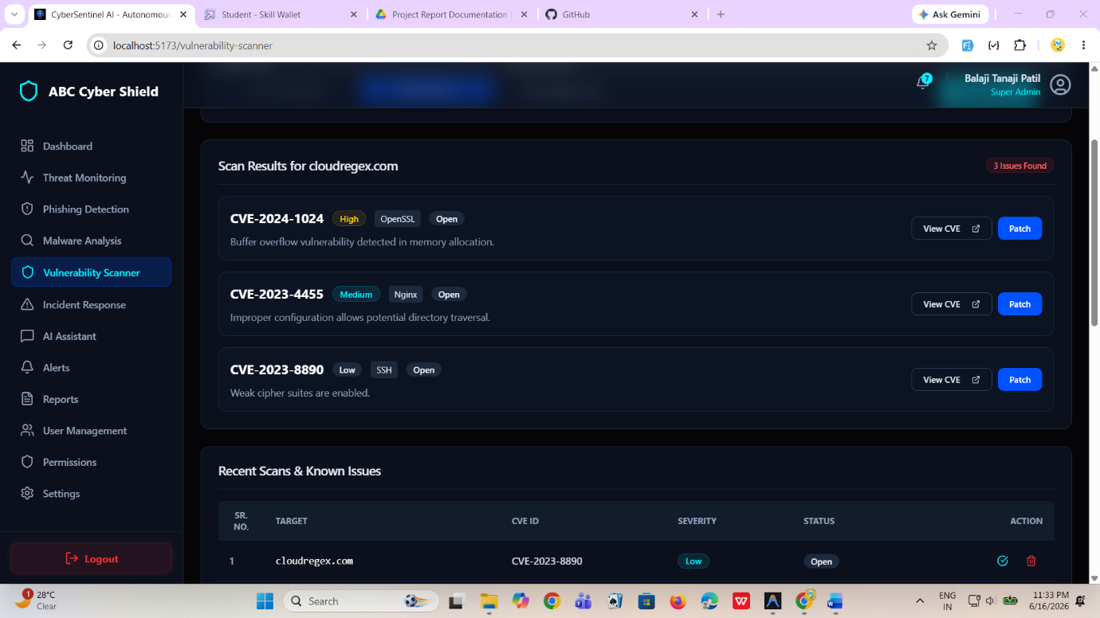

Incident Progress
Security incidents are tracked efficiently throughout their lifecycle.
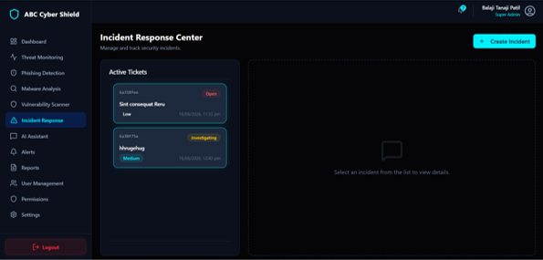

AI Assistant Results
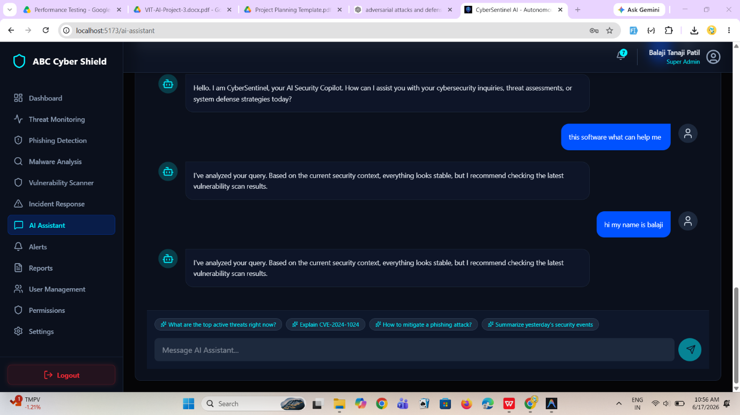
Google Gemini AI successfully generates intelligent security recommendations and explanations.

ADVANTAGES & LIMITATIONS
Advantages
Technical Advantages
- Centralized Security Platform
- AI-Powered Analysis
- Real-Time Monitoring
- Modern User Interface
- Scalable Architecture
- Role-Based Access Control
Business Advantages
- Reduced Response Time
- Improved Threat Visibility
- Better Security Management
- Enhanced Decision Making

Limitations
- Requires Internet Connectivity
- AI Responses Depend on External Service Availability
- Limited Network Traffic Monitoring
- Requires Regular Vulnerability Updates

CONCLUSION
ABC Cyber Shield successfully achieves its objective of providing a centralized cybersecurity management platform capable of detecting, analyzing, and responding to modern cyber threats.
The integration of Artificial Intelligence through Google Gemini AI enhances threat analysis and assists security analysts in making informed decisions. The platform provides comprehensive capabilities including threat monitoring, phishing detection, malware analysis, vulnerability assessment, incident response, and user management.
The project demonstrates how AI and modern web technologies can be combined to create an effective cybersecurity solution capable of improving organizational security posture and operational efficiency.

FUTURE SCOPE
Future enhancements may include:
Security Features
- Network Traffic Analysis
- Intrusion Detection System
- Endpoint Protection Integration
- Threat Intelligence Feeds
Artificial Intelligence
- Machine Learning Threat Prediction
- Behavioral Analytics
- Automated Threat Classification
- Predictive Risk Assessment
Enterprise Features
- SIEM Integration
- Cloud Security Monitoring
- Multi-Tenant Support
- SOC Automation
Platform Expansion
- Mobile Application
- Desktop Agent
- API Marketplace
- Third-Party Integrations

REFERENCES
- OWASP Top 10 Security Risks
- NIST Cybersecurity Framework
- MongoDB Documentation
- Node.js Documentation
- Express.js Documentation
- React.js Documentation
- Tailwind CSS Documentation
- Google Gemini AI Documentation
- JWT Authentication Documentation
- Mongoose ODM Documentation

APPENDIX
Source Code Repository
GitHub Repository:
https://github.com/BalajiPatil1207/CyberSentinel_AI

Technologies Used
Frontend
- React.js
- Vite
- Tailwind CSS
- Framer Motion
- React Router
Backend
- Node.js
- Express.js
Database
- MongoDB
- Mongoose
Security
- JWT
- Bcrypt.js
Artificial Intelligence
- Google Gemini AI

