

BloodBridge: Optimising Lifesaving
Resources

Prepared for submission to
Smart
-
Internz
in partial fulfilment of the Cloud Practitioner Cuided Project programme. This
report

presents

the

design,

architecture,

implementation,

and

outcomes

of

BloodBridge

—

an

AWS
-
powered

platform
for end
-
to
-
end blood management optimisation.

Institution:

D

Y

Patil

Agriculture

and

Technical

University,

Talsande

Student Name:

Balaji Tanaji Patil

SMART
-
INTERNZ

–

CLOUD

PRACTITIONER

CUIDED

PROJECT

Certificate, Acknowledgement & Table of Contents
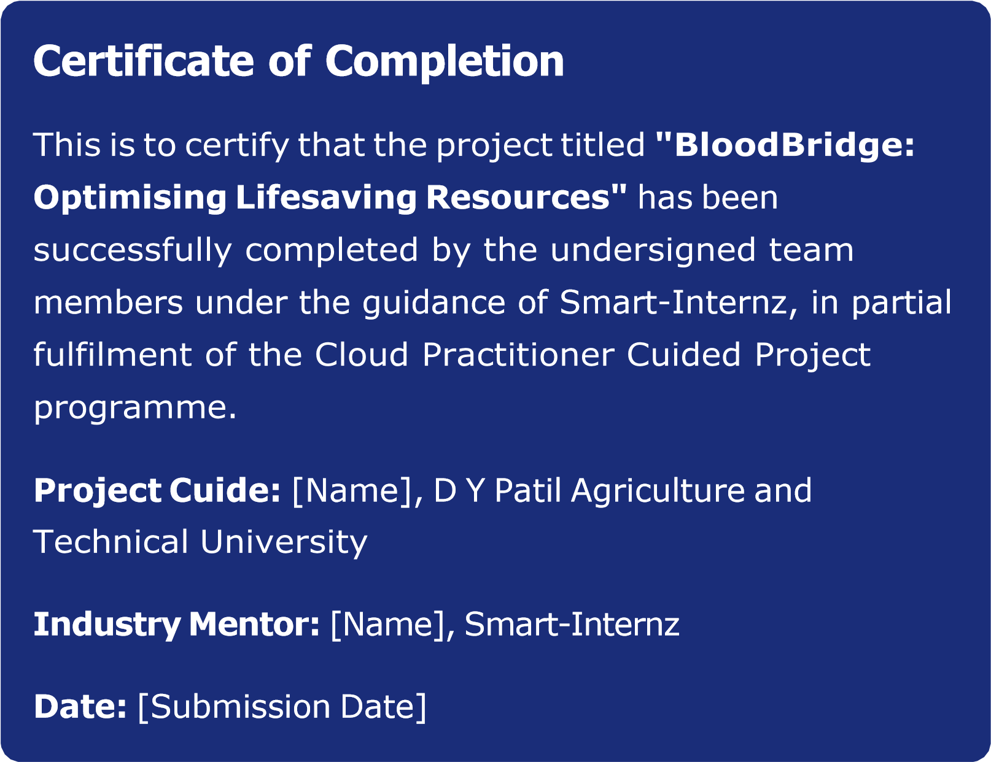

Acknowledgement
The team expresses sincere gratitude to the faculty of D Y Patil Agriculture and Technical University, Talsande, for their academic guidance. Special thanks to SmartInternz for the structured cloud practitioner programme and AWS documentation resources that informed this project's technical design.

Table of Contents

01 02

Abstract & Introduction  Project overview, problem context, purpose, scope, and significance | Problem Analysis & System Architecture  Problem statements, AWS architecture, and componentwise explanation
03 | 04

Project Proposal & Agile Planning  Proposed solution, sprint breakdown, and Agile methodology | AWS Services & Deployment  Service details, selection rationale, and deployment workflow
05 | 06

Results, Advantages & Disadvantages  Module outcomes, performance analysis, and critical | Conclusion, Future Scope & References  Project outcomes, roadmap, and academic bibliography
evaluation

