

Image scraping and classification

Submitted by:

Amey Takle

**ACKNOWLEDGMENT**

* **Research on image classification model based on deep convolution neural network** [MingYuan Xin, Yong Wang]

# Image Classification on ImageNet ()

# Advancements in Image Classification using Convolutional Neural Network [Farhana Sultana, A. Sufian, Paramartha Dutta]

* **AlexNet** (2012) [Alex Krizhevsky, Ilya Sutskever, and Geoffrey E. Hinton]
* **Residual Attention Network for Image Classification** (2017)   
  [Fei Wang, Mengqing Jiang, Chen Qian, Shuo Yang, Cheng Li, Honggang Zhang, Xiaogang Wang, Xiaoou Tang]
* **Regularizing deep networks using efﬁcient layerwise adversarial training** [Rama Chellappa, Swami Sankaranarayanan, Arpit Jain, Ser Nam Lim ]

**INTRODUCTION**

* Business Problem Framing

The objective here is to build a deep learning model to classify the images that are scraped.

The model implementation can be used in various real life scenarios like security, e commerce, etc.

* Conceptual Background of the Domain Problem

The projects requires good understanding of how neural networks work.

Image processing is a major part of the project and hence understanding how images are handled is required.

* Motivation for the Problem Undertaken

The main objective here was to understand image handling and image classification in python.

The project would prove to be a boon in sectors like identification, e commerce, automated maintenance, etc.

**Analytical Problem Framing**

* Mathematical/ Analytical Modeling of the Problem

The images are converted to numpy arrays as processing raw images/ png files is not possible.

The images are converted to 3 dimensional arrays (x,y,z).

Which is a representation of all 3 RGB planes.

.

* Data Sources and their formats

The data is scraped directly from Amazon.

The sources of images were scraped first and further processing was done on these images

* Data Preprocessing Done

Even though no much scope was available for data cleaning/ pre-processing here, the array elements were scaled down to reduce the complexity.

The images were shrunk in same shape to fix the

* State the set of assumptions (if any) related to the problem under consideration

There were no assumptions made.

The model was fed with the data directly

* Hardware and Software Requirements and Tools Used

As the project involves image processing following tools or prerequisites can help in increasing processing speed.

1. Multithreaded CPU
2. A GPU

**Model/s Development and Evaluation**

* Identification of possible problem-solving approaches (methods)

Two deep leaning models developed for classification purpose.

1. ANN
2. CNN

Neural networks are considered as best when graphic data is involved hence the proposed solution

* Testing of Identified Approaches (Algorithms)

The neural networks were trained as per below.

Input shape (224, 224, 3)

SGD used as optimizer for ANN and ADAM used as optimizer for CNN

* Run and Evaluate selected models

ANN model:

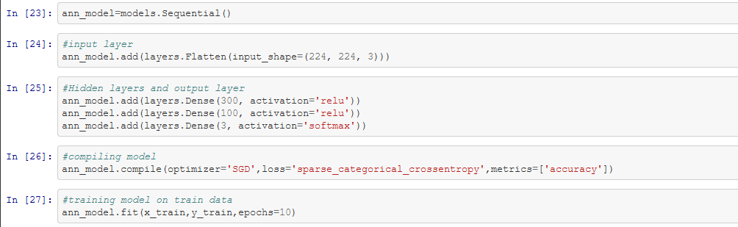

Accuracy of this model was around 73%.

The model was able to predict 69 sarees, 52 jeans and 3 trousers correctly of the test data

CNN model:

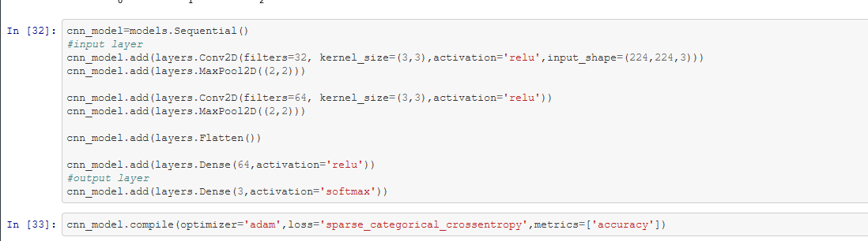

Accuracy of this model cam out to be around 96%

The model was able to predict 69 sarees, 34 jeans and 47 trousers correctly of the test data

* Key Metrics for success in solving problem under consideration

The metrics that were used to check the accuracy were

1. Accuracy
2. Confusion matrices.

* Visualizations

Visualizations were done to check if the data was correct.

The class and corresponding image was visualized using the matshow function of matplotlib.

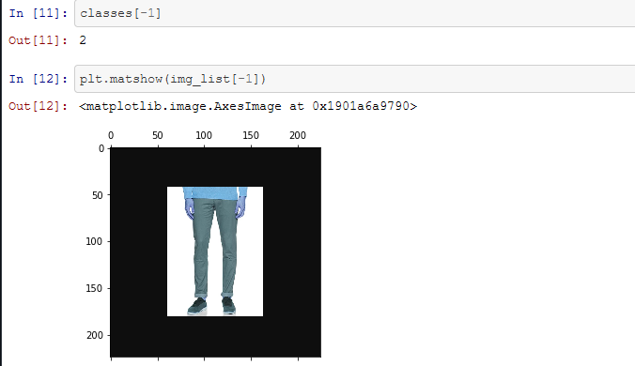

Further the confusion matrices were visualized on a heatmap

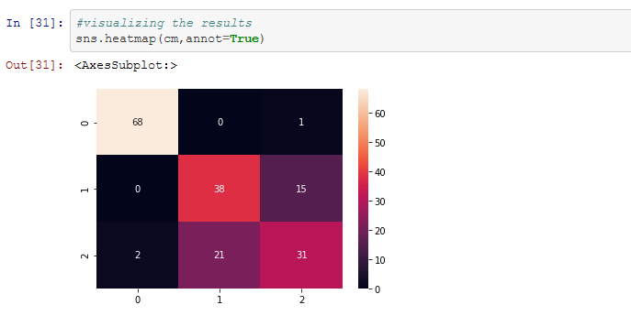

* Interpretation of the Results

Visualizing the arrays using the matshow confirmed that the data/images were imported correctly.

Further visualizing the confusion matrix gave a good idea about the performance of the models.

**CONCLUSION**

* Key Findings and Conclusions of the Study
* Image data must be processed before feeding to model
* Neural networks are better at handling graphic data
* Scaling down the data helps speed up the process.
* Loss decreases as the model progresses. The optimizer plays an important role in this.
* Losses reduce when weights are coreected duing back propagation.

.

* Learning Outcomes of the Study in respect of Data Science

The issue that I faced while developing this model was of types.

The neural network accepts on numpy arrays, while the data I was feeding was pandas series.

To overcome this instead of forming a dataframe of the images and classes, I fed the lists to train test split post converting to arrays.