StockPilot
Inventory Management System
Final Project Report

Submitted in partial fulfilment of the requirements of
[Course / Programme Name]

Submitted by
[Team Member 1] — [Roll No. 1]
[Team Member 2] — [Roll No. 2]
[Team Member 3] — [Roll No. 3]
[Team Member 4] — [Roll No. 4]

[Department Name]
[College / Institute Name]
Guide: [Guide / Project Mentor Name]
[Academic Year, e.g. 2025-26]

Certificate
This is to certify that the project titled "StockPilot — Inventory Management System" has been successfully completed by the students named below, in partial fulfilment of the requirements of [Course / Programme Name], during the academic year [Academic Year, e.g. 2025-26], under the guidance of [Guide / Project Mentor Name].

- [Team Member 1] — [Roll No. 1]
- [Team Member 2] — [Roll No. 2]
- [Team Member 3] — [Roll No. 3]
- [Team Member 4] — [Roll No. 4]

_______________________________
[Guide / Project Mentor Name]
Project Guide

_______________________________
Head of Department

Acknowledgement
We would like to express our sincere gratitude to [Guide / Project Mentor Name] for continuous guidance and support throughout this project, and to the [Department Name] of [College / Institute Name] for providing the resources and opportunity to undertake this work. We also thank our peers and families for their encouragement during the development of StockPilot — Inventory Management System.

Abstract
StockPilot — Inventory Management System is a college project that models a complete, small-business inventory workflow across three coordinated deliverables built on .NET 8: a menu-driven console application demonstrating core object-oriented programming concepts; an ASP.NET Core MVC web application backed by a normalized SQL Server database, offering category, supplier, product and stock management with session-based authentication and five printable reports; and a Progressive Web App layer that makes the same web application installable, responsive on mobile, and partly usable offline, with low-stock notifications. A central design goal is correctness under everyday operational pressure -- most visibly, the system refuses to record a Stock Out that would push a product's quantity below zero, enforced both in application code and as a database check constraint. The system ships with realistic demo data (6 categories, 6 suppliers, 30 products and 40 stock transactions) and a seeded administrator account so it can be evaluated immediately after a first run.

Table of Contents

Chapter 1: Introduction

1.1 Overview
StockPilot — Inventory Management System addresses the everyday problem of tracking stock by hand -- notebooks and spreadsheets that drift out of sync with reality. The project delivers a working, demonstrable system rather than a purely theoretical design: a console application, a full web application, and a PWA layer on top of it, all sharing the same domain concepts.

1.2 Objectives
- Provide CRUD management of categories, suppliers and products.
- Track stock levels accurately through Stock In / Stock Out transactions.
- Prevent stock from ever going negative, at both the application and database layers.
- Give management a live dashboard and a set of filterable, printable reports.
- Demonstrate core OOP concepts (encapsulation, inheritance, polymorphism, exceptions, collections) in a standalone console application.
- Make the system usable on mobile, including partial offline access, via a Progressive Web App.

1.3 Scope
The system is single-tenant and single-store: it does not model multiple warehouses, branches or currencies. Authentication is session-based and covers a single seeded administrator account for the web app; the console app separately demonstrates role-based behaviour (Admin / Staff / Viewer) as an OOP exercise. See the Future Scope section (Chapter 7) for planned extensions beyond this scope.

Chapter 2: Requirements
This chapter summarizes the Software Requirements Specification (full detail in Documentation/SRS/README.md).

2.1 Users
- Admin -- full access: manage categories, suppliers, products, stock, and view all reports. Seeded account: admin / Admin@123.
- Staff -- day-to-day operator: records Stock In/Out, views reports.
- Viewer (console app) -- read-only; any add/update/delete is blocked.

2.2 Key functional requirements
ID | Requirement
FR-01 | Log in / log out with session-based authentication
FR-05/07/09 | Create, edit, delete, search Categories / Suppliers / Products
FR-06/08 | Block deleting a Category/Supplier still referenced by a Product
FR-12/13 | Record Stock In / Stock Out; reject a Stock Out that would go negative
FR-16 | Dashboard with live KPIs, low-stock list, category summary
FR-17 | Five filterable, print-friendly reports
FR-19 | PWA install, offline browsing of cached data, low-stock notifications
FR-20 | Demo data seeded automatically on first run

2.3 Non-functional requirements
- Security -- passwords are hashed (PBKDF2-SHA512), never stored in plain text; anti-forgery tokens on state-changing requests.
- Usability -- responsive Bootstrap UI down to phone width; clear success/error messages.
- Availability -- PWA offline access to previously synced product/stock data.
- Data integrity -- database check constraints back up application-level validation.

Chapter 3: Design

3.1 System Architecture
The system is built in three layered phases that share one domain model. Phase 1, the console application, is an in-memory, file-free implementation used to demonstrate OOP fundamentals: classes, inheritance (Person -> Admin/Staff/User), polymorphism (overridden DisplayInfo()), custom exceptions (InsufficientStockException) and collections (List<T>, Dictionary<TKey,TValue>). Phase 2, the ASP.NET Core MVC web application, is the primary deliverable: Controllers handle requests, Entity Framework Core 8 maps six normalized tables in SQL Server, and Razor views render the UI. A SessionAuthFilter enforces that every page but Login requires an active session. Phase 3, the Progressive Web App layer, sits on top of Phase 2 without a separate backend: a Web App Manifest and Service Worker make the same web app installable and partly usable offline, backed by a small JSON API (Controllers/Api/InventoryApiController.cs).

3.2 Data Dictionary
Six tables, normalized to Third Normal Form (3NF) -- see Database/ERDiagram/README.md for the full normalization rationale.

Categories
Column | Type | Constraint
CategoryId | int | PK, identity
CategoryName | nvarchar(100) | required, unique index
Description | nvarchar(250) | optional

Suppliers
Column | Type | Constraint
SupplierId | int | PK, identity
SupplierName | nvarchar(150) | required
ContactNumber | nvarchar(20) | optional
Email | nvarchar(150) | optional, email format
Address | nvarchar(250) | optional

Products
Column | Type | Constraint
ProductId | int | PK, identity
ProductName | nvarchar(150) | required, indexed
Price | decimal(10,2) | CK_Products_Price >= 0
Unit | nvarchar(20) | required, e.g. pcs/kg/L
CategoryId | int | FK -> Categories, ON DELETE RESTRICT
SupplierId | int | FK -> Suppliers, ON DELETE RESTRICT

Stocks
Column | Type | Constraint
StockId | int | PK, identity
ProductId | int | FK -> Products, unique index, ON DELETE CASCADE
QuantityAvailable | int | CK_Stocks_QuantityAvailable >= 0
ReorderLevel | int | CK_Stocks_ReorderLevel >= 0
LastUpdated | datetime2 | defaults to current time

StockTransactions
Column | Type | Constraint
TransactionId | int | PK, identity
ProductId | int | FK -> Products, ON DELETE CASCADE, indexed
Type | nvarchar(10) | CK_StockTransactions_Type IN ('StockIn','StockOut')
Quantity | int | CK_StockTransactions_Quantity > 0
TransactionDate | datetime2 | indexed
PerformedBy | nvarchar(100) | required
Remarks | nvarchar(250) | optional

Users
Column | Type | Constraint
UserId | int | PK, identity
Username | nvarchar(50) | required, unique index
PasswordHash | nvarchar(256) | required, hashed (PBKDF2-SHA512)
FullName | nvarchar(100) | required
Email | nvarchar(150) | optional, email format
Role | nvarchar(20) | required, e.g. Admin

3.3 Entity-Relationship Diagram
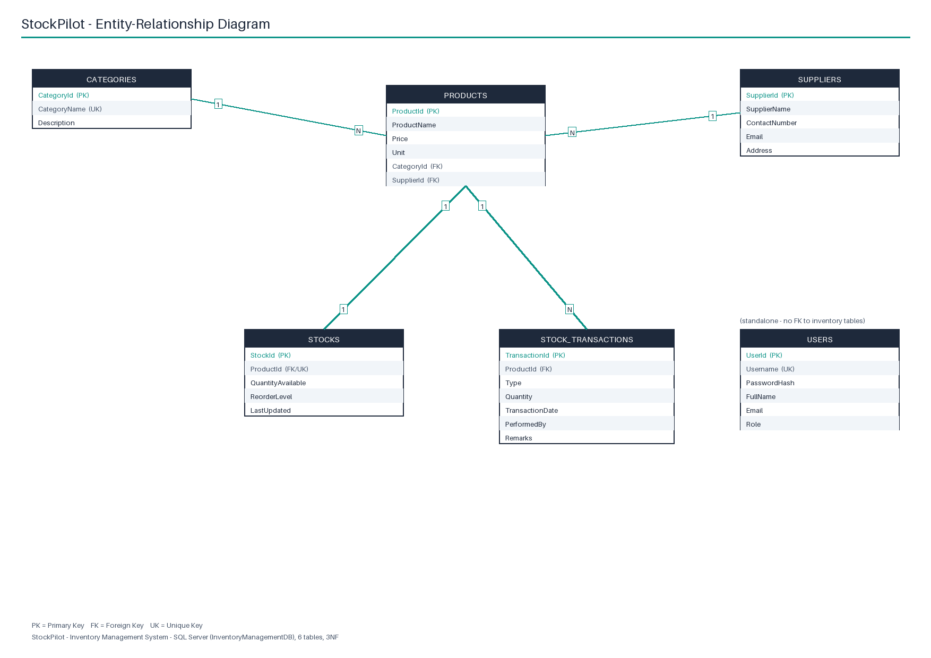
Category -> Product and Supplier -> Product are one-to-many with ON DELETE RESTRICT (a master record in use cannot be deleted). Product -> Stock is one-to-one (optional) and Product -> StockTransaction is one-to-many, both with ON DELETE CASCADE (dependent data is removed with its product). Users has no foreign key relationship to the inventory tables.

3.4 Web Application Routes
Controller | Route | Purpose
Account | GET /Account/Login | Show the login form
Account | POST /Account/Login | Validate credentials, start session
Account | POST /Account/Logout | Clear session, redirect to Login
Account | GET/POST /Account/ChangePassword | Change the current user's password
Home | GET / | Redirects to /Dashboard
Category | GET /Category?searchTerm= | List/search categories
Category | GET/POST /Category/Create | Create a category
Category | GET/POST /Category/Edit/{id} | Edit a category
Category | GET /Category/Delete/{id} + POST confirm | Delete a category (blocked if in use)
Product | GET /Product?searchTerm=&categoryId= | List/search/filter products
Product | GET/POST /Product/Create | Create a product (+ opening stock, reorder level)
Product | GET/POST /Product/Edit/{id} | Edit a product
Product | GET /Product/Delete/{id} + POST confirm | Delete a product (cascades to stock/transactions)
Supplier | GET /Supplier?searchTerm= | List/search suppliers
Supplier | GET/POST /Supplier/Create | Create a supplier
Supplier | GET/POST /Supplier/Edit/{id} | Edit a supplier
Supplier | GET /Supplier/Delete/{id} + POST confirm | Delete a supplier (blocked if in use)
Stock | GET /Stock?searchTerm=&status= | List/search/filter stock
Stock | GET/POST /Stock/Initialize | Set opening stock for a product with none
Stock | GET/POST /Stock/StockIn?productId= | Record a Stock In transaction
Stock | GET/POST /Stock/StockOut?productId= | Record a Stock Out transaction (guards negative stock)
Stock | GET /Stock/Transactions?type= | List stock transactions
Dashboard | GET /Dashboard | KPIs, low-stock list, category summary, recent activity
Report | GET /Report | Reports landing page
Report | GET /Report/ProductCatalog | Product catalog report
Report | GET /Report/StockSummary | Stock summary report
Report | GET /Report/LowStock | Low stock report
Report | GET /Report/TransactionHistory | Transaction history report
Report | GET /Report/InventoryValue | Inventory value report
Pwa | GET /Pwa, /Pwa/Search, /Pwa/Stock, /Pwa/LowStock | Mobile-first PWA pages
Api | GET /api/products?q= | JSON product list (optionally filtered)
Api | GET /api/stock | JSON stock list with status
Api | GET /api/stock/low | JSON low/out-of-stock list

Chapter 4: Implementation

4.1 Console Application
A menu-driven .NET 8 console app (ConsoleApplication/Program.cs) covering Product Management, Stock Management, Reports and Viewing Users. Domain objects (Product, Category, Supplier, Stock, StockTransaction) use private fields with validating properties -- encapsulation. Person is an abstract base class with Admin, Staff and User derived classes overriding the virtual DisplayInfo() method -- inheritance and polymorphism. MasterDataService and UserService use Dictionary<TKey,TValue> for fast name/username lookup; ProductService and StockService use List<T>. StockService throws a custom InsufficientStockException on an invalid Stock Out, caught explicitly in Program.cs. Input reading goes through InputHelper.ReadLine(), which exits cleanly on EOF instead of looping forever.

4.2 ASP.NET Core MVC Web Application
Controllers (Account, Home, Category, Product, Supplier, Stock, Dashboard, Report, Pwa, Api/InventoryApi) sit over an Entity Framework Core DbContext (ApplicationDbContext) mapping the six tables described in Chapter 3. DbInitializer creates the database on first run, seeds the admin account with a hashed password, and loads demo data from Database/SQLScripts/SeedData.sql. A SessionAuthFilter action filter enforces login on every controller action except those marked [AllowAnonymous], returning a redirect for page requests and a 401 JSON response for API requests under /api. State-changing POST actions require anti-forgery tokens. StockController.StockIn/StockOut validate the requested quantity in code before saving, and the database check constraints (CK_Stocks_QuantityAvailable, CK_StockTransactions_Quantity, CK_StockTransactions_Type, CK_Products_Price) enforce the same rules as a backstop.

4.3 Progressive Web App
manifest.json declares the installable app identity (name, icons, theme colour #1E293B, start URL /Pwa). sw.js implements three caching strategies across three named caches: network-first for /api/* JSON calls and for page navigations (each falling back to a cached copy, and further to offline.html for pages), and stale-while-revalidate for static assets. pwa.js registers the service worker, manages the install prompt, the offline banner and low-stock notification scheduling; pwa-pages.js renders the Search / Stock / Low Stock pages from JSON returned by InventoryApiController, working from cached data when offline. Full detail is in PWA/README.md.

Chapter 5: Testing
Test results pending — run build_docs.py after testing
tools/test_results.json has not been produced yet by the test run. The table below lists the planned test cases with every status shown as "Pending" -- no result is claimed until the real test run writes tools/test_results.json and this report is regenerated.
ID | Area | Test | Expected | Actual | Status
TC-01 | Auth | Log in with valid admin credentials (admin / Admin@123) | Redirect to Dashboard; session established | Pending | Pending
TC-02 | Auth | Log in with a wrong password | Error message shown; stays on Login | Pending | Pending
TC-03 | Auth | Request /Product while logged out | Redirect to /Account/Login | Pending | Pending
TC-04 | Auth | Request /api/products while logged out | 401 JSON response | Pending | Pending
TC-05 | Auth | Change password with the wrong current password | Error shown; password unchanged | Pending | Pending
TC-06 | Auth | Change password correctly, then log in with the new password | Success message; new password works | Pending | Pending
TC-07 | Category | Delete a category that is still used by a product | Delete blocked with an explanatory message | Pending | Pending
TC-08 | Product | Search products by name/category/supplier | Only matching products are listed | Pending | Pending
TC-09 | Stock | Stock In a valid quantity | Quantity increases; transaction logged | Pending | Pending
TC-10 | Stock | Stock Out a quantity greater than available | "Insufficient stock" error; quantity unchanged | Pending | Pending
TC-11 | Stock | Stock In / Stock Out with a zero or negative quantity | Request rejected | Pending | Pending
TC-12 | Dashboard | Total Inventory Value KPI | Matches sum(QuantityAvailable * Price) across all products | Pending | Pending
TC-13 | Reports | Transaction History filtered by type=StockOut and a date range | Only matching rows are shown | Pending | Pending
TC-14 | Reports | Print a report | Print layout hides navigation/buttons; shows a clean report | Pending | Pending
TC-15 | Console | Log in as viewer and attempt to add a product | "Access denied: viewers cannot modify data." | Pending | Pending
TC-16 | Console | Send EOF on stdin mid-session | "No more input. Exiting." and a clean exit | Pending | Pending
TC-17 | PWA | Request /manifest.json, /sw.js, /offline.html, /icons/icon-192.png | 200 OK with the correct content types | Pending | Pending

Chapter 6: Setup
Full click-by-click instructions are in Documentation/UserManual/UserManual.md (also available as UserManual.docx). Summary for a Windows/Visual Studio 2022 examiner machine:
- Install Visual Studio 2022 Community with the "ASP.NET and web development" workload and the .NET 8.0 Runtime.
- Open InventoryManagementSystem.sln.
- Press F5 -- the database and demo data are created automatically on first run (LocalDB).
- Log in with admin / Admin@123.
- Optionally run the console app (right-click ConsoleApplication -> Set as Startup Project -> Ctrl+F5).

Chapter 7: Conclusion & Future Scope

7.1 Conclusion
StockPilot — Inventory Management System meets its stated objectives: a normalized, constraint-backed database; a full-featured web application with authentication, CRUD, stock control and reporting; a console application demonstrating core OOP concepts; and a PWA layer that makes the system installable and partly usable offline. The negative-stock guard -- checked in application code and enforced again by a database CHECK constraint -- exemplifies the project's approach of defending correctness at more than one layer.

7.2 Future Scope
- Role-based access control in the web app (Admin/Staff/Viewer), mirroring the console app's role model.
- Barcode/QR scanning for faster Stock In/Out from a mobile device.
- Multi-branch/multi-warehouse support.
- Purchase-order workflow tied directly to Low Stock alerts.
- Automated test suite and CI pipeline.
Note: .NET 8 is a Long-Term Support (LTS) release; its official Microsoft support window ends November 2026. This is fine for the current submission, but any future maintenance of this project should plan a migration to the next LTS release before that date.

References
- Base project by Milan Gite (MilanGite06/InventoryManagementSystem) -- https://github.com/MilanGite06/InventoryManagementSystem
- Microsoft Learn -- ASP.NET Core documentation (learn.microsoft.com/aspnet/core)
- Microsoft Learn -- Entity Framework Core documentation (learn.microsoft.com/ef/core)
- Microsoft Learn -- ASP.NET Core Identity password hashing (PasswordHasher)
- MDN Web Docs -- Progressive Web Apps, Service Worker API, Web App Manifest
- Bootstrap 5.3 documentation (getbootstrap.com)
- Microsoft -- .NET support policy (dotnet.microsoft.com/platform/support-policy)

Appendix A: Syllabus Requirement Mapping
Maps each graded syllabus requirement to the file(s) that implement it.
Requirement | File(s)
Menu-driven console interface | ConsoleApplication/Program.cs
Classes & encapsulation | ConsoleApplication/Models/*.cs (private fields + validating setters)
Inheritance & polymorphism | Person.cs -> Admin.cs / Staff.cs / User.cs, used by Services/UserService.cs
Exception handling | Program.cs catch blocks + Exceptions/InsufficientStockException.cs
List / Dictionary collections | ProductService / StockService (List); MasterDataService, UserService, ReportService.GenerateCategoryWiseReport (Dictionary)
Search | ProductService.SearchProduct
Reports | Reports/ReportService.cs
Login / Logout / Change Password | AccountController.cs + Views/Account/* + Filters/SessionAuthFilter.cs
Master add/update/delete/search | CategoryController, ProductController, SupplierController + views
Stock transactions + negative-stock prevention | StockController.StockIn/StockOut + CK_Stocks_QuantityAvailable
Dashboard | DashboardController + Views/Dashboard/Index.cshtml
Reports search/filter/print | ReportController, Views/Report/*, site.css @media print, _ReportHeader.cshtml
SQL Server PK/FK/relationships, 6 normalized tables | ApplicationDbContext.OnModelCreating, Database/SQLScripts/CreateTables.sql, Database/ERDiagram/README.md
PWA responsive/installable/SW/offline/notifications | _Layout.cshtml, site.css, manifest.json, sw.js, pwa.js, pwa-pages.js, PwaController, InventoryApiController
PWA modules: Product Search / Low Stock Alerts / Stock Overview | Views/Pwa/Search.cshtml, LowStock.cshtml, Stock.cshtml

