Effects of neighbouring competition on saplings performance

# EFFECTS OF TREES SIZE AND DISTANCES

In this first part, I assess some effects of the size of target (pines) and neighbour (oaks...) trees, and distance between them on different performance indicators. I took the paper by Coates et al. (2009) as a guide to perform similar analyses and interpret the results. Some comments are actually extracted from their paper.

RG = PRG × SE × ShE × CE

* RG: Observed diameter growth
* PRG: Potential growth of a hypothetical 'free growing' tree
* SE (Size effect): effect of neighbour size in relation to the target tree
$$SE=exp(-\frac{1}{2}·{\frac{ln(d_{n}/X_{0})}{X_{b}}}^{2})$$

* ShE (Shading effect): (not considered)
* CE (Competition effect)

$$CE=exp(-C·NCI^{D})$$

$$C=C'·d^{γ}$$

$$NCI=\sum_{i=1}^{S}{\sum_{j=1}^{n}{λ_{i}}}\frac{d_{ij}^{α}}{dist^{β}}$$

See details in Coates et al. (2009)

Assumptions:

* Growth depends on PRG, SE, and CE. Shading effect will be considered as covariate in the second part of the study.
* Size of target trees have an effect on CE ($C=C'·d^{γ}$).
* Neighbour species have equivalent effects on target trees ($λ_{i}=1$).

## Effects of tree size on potential growth

Potential growth rates are growth rates predicted for a tree of optimal size (i.e. a target tree with $DB=X_{0}$).

The potential tree growth is predicted to increase throughout the range of sampled tree sizes.  
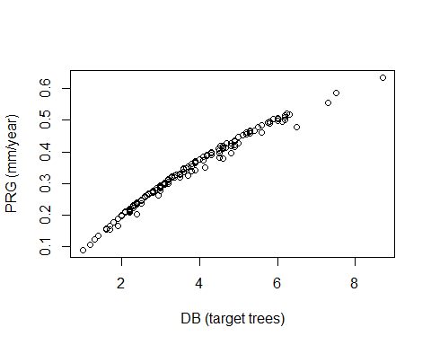

## Effects of tree size on sensitivity to crowding

The estimate of $γ$ was positive ($γ=1.96$), indicating that **larger trees are more sensitive to crowding than smaller trees**.

## Effects of distance to neighbours on degree of crowding

NCI sums the crowding effects of all neighbouring trees.

The $β$ parameter in the NCI equation determines the decline (if any) in the belowground effect of a neighbour with increasing distance from a target tree.

The $β$ parameter resulted large ($β=1.07$), indicating that **the effects of neighbours declined as an inverse linear or square root function of distance from the target tree**.

## Effects of size of neighbours on degree of crowding

The exponent $α$ in *NCI* controls the scaling of the effects of neighbouring tree size on *NCI* (and hence, on target tree radial growth).

In our case $α=1.59$. Therefore, **the degree of crowding is roughly proportional to the biomass of the neighbouring trees**, without being scaled to their basal area.

# EFFECTS OF COMPETITION INDICES ON PINES GROWTH

In this section, I check the influence of different competition indices on the mean basal area increment (BAI) for the last five years, and the increment in basal diameter (DI).

The selection of competition indices was done based on Contreras et al. (2011) results, so I kept their nomenclature. I also included the NCI calculated considering three different models (Model.03: tree size is not considered; Model.04: tree size is considered; Model.05: Gaussian competition effect).

### Considered competition indices

* Neighbourhood Competition Index (NCI)
* Hegyi (C8)
* Rouvinen and Kuuluvainen (C10)
* Rouvinen and Kuuluvainen (C11)
* Braathe (C9)
* Rouvinen and Kuuluvainen (C12)
* Rouvinen and Kuuluvainen (C13)

## Effects of NCI on BAI and DI

The NCI specifies the net crowding effect of the neighbours on the target trees.

$$NCI=\sum_{i=1}^{S}{\sum_{j=1}^{n}{λ_{i}}}\frac{d_{ij}^{α}}{dist^{β}}$$

### NCI calculated from "Model.03" (Size effect + Competition effect)

**Figure** Relationship between the competition index and the BAI (left panels) and the diameter increment (right panels) for all target pines (top panels), pines lower than the mean height (centre panels), and pines higher than the mean height (bottom panels)

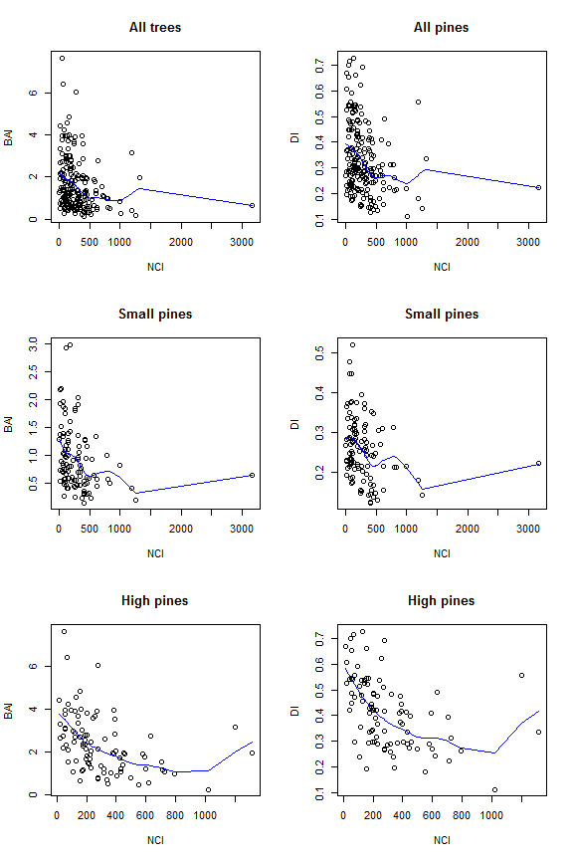

### NCI calculated from "Model.04" (Size effect + Competition effect (considering the effect of tree size))

**Figure** Relationship between the competition index and the BAI (left panels) and the diameter increment (right panels) for all target pines (top panels), pines lower than the mean height (centre panels), and pines higher than the mean height (bottom panels)

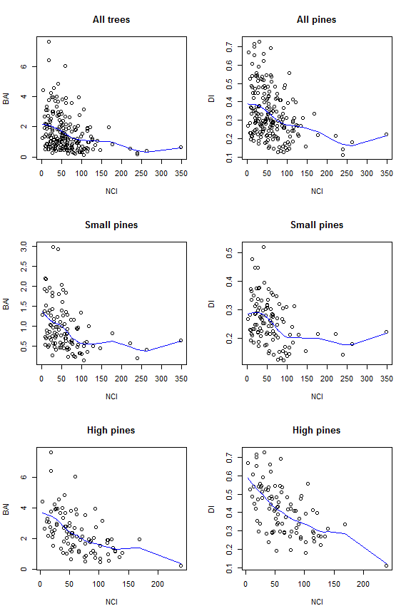

### NCI calculated from "Model.05" (Size effect + Gaussian competition effect)

**Figure** Relationship between the competition index and the BAI (left panels) and the diameter increment (right panels) for all target pines (top panels), pines lower than the mean height (centre panels), and pines higher than the mean height (bottom panels)

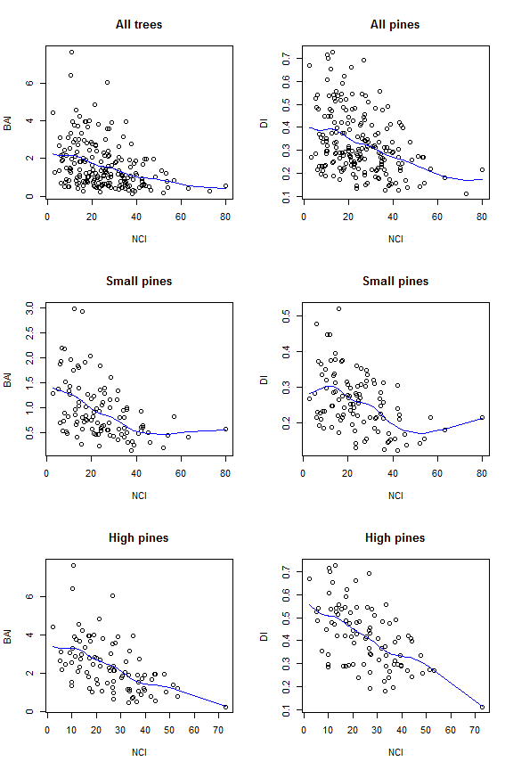

## Effects of CI8 on BAI and DI

Hegyi (C8)

$$CI_{8}=\sum_{i=1}^{n}{\frac{d_{i}}{d·dist_{i}}}$$

**Figure** Relationship between the competition index and the BAI (left panels) and the diameter increment (right panels) for all target pines (top panels), pines lower than the mean height (centre panels), and pines higher than the mean height (bottom panels)

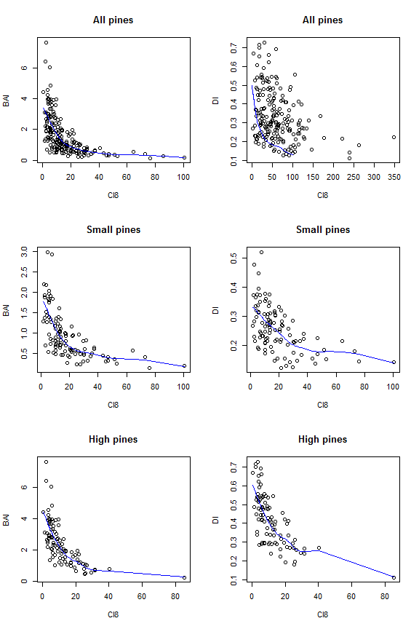

## Effects of CI10 on BAI and DI

Rouvinen and Kuuluvainen (C10) Sum of the horizontal angles from the target tree and spanning the basal diameter of each neighbour.

$$CI_{10}=\sum_{i=1}^{n}{a}rctan\frac{d_{i}}{dist_{i}}$$

**Figure** Relationship between the competition index and the BAI (left panels) and the diameter increment (right panels) for all target pines (top panels), pines lower than the mean height (centre panels), and pines higher than the mean height (bottom panels)

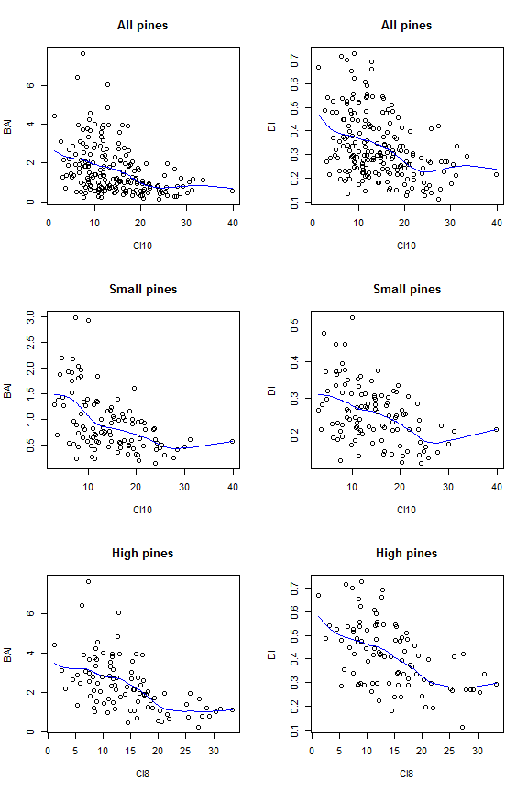

## Effects of CI11 on BAI and DI

Rouvinen and Kuuluvainen (C11) Sum of the horizontal angles from the target tree and spanning the basal diameter of each neighbour considering higher competition of neighbours larger than the target tree.

$$CI_{11}=\sum_{i=1}^{n}{\frac{d_{i}}{d}}arctan\frac{d_{i}}{dist_{i}}$$

**Figure** Relationship between the competition index and the BAI (left panels) and the diameter increment (right panels) for all target pines (top panels), pines lower than the mean height (centre panels), and pines higher than the mean height (bottom panels)

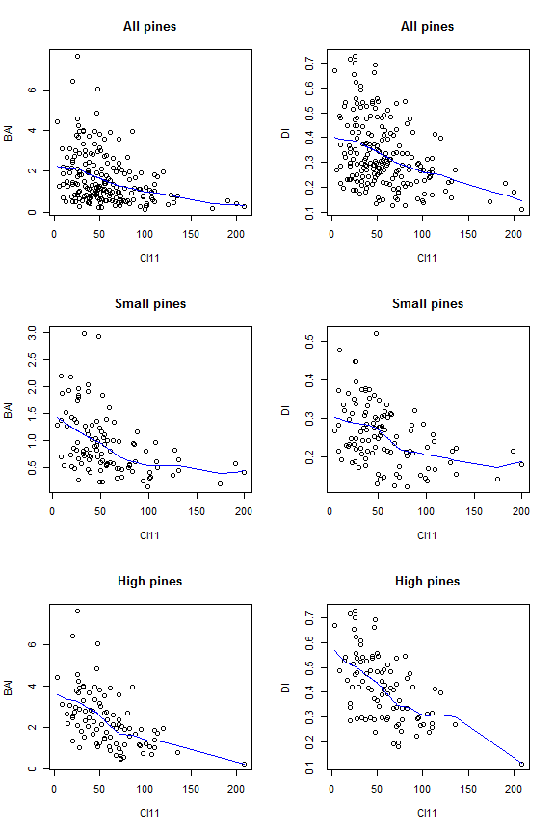

## Effects of CI9 on BAI and DI

Braathe (C9)

$$CI_{9}=\sum_{i=1}^{n}{\frac{h_{i}}{h·dist_{i}}}$$

**Figure** Relationship between the competition index and the BAI (left panels) and the diameter increment (right panels) for all target pines (top panels), pines lower than the mean height (centre panels), and pines higher than the mean height (bottom panels)

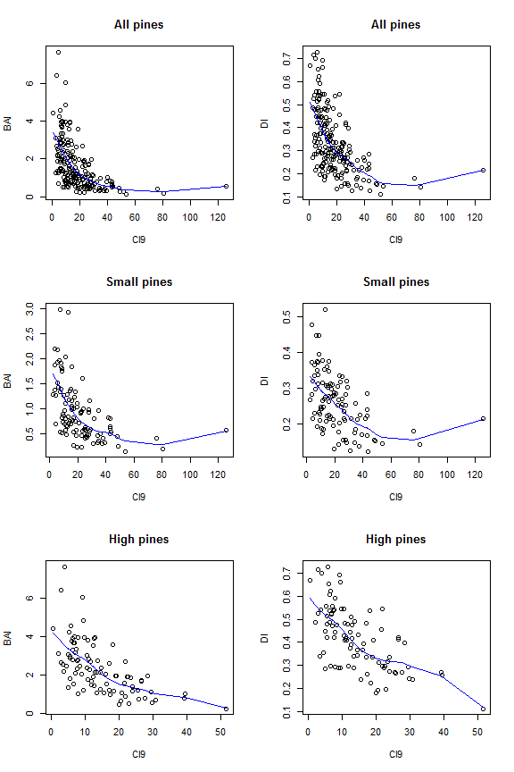

## Effects of CI12 on BAI and DI

Rouvinen and Kuuluvainen (C12) Sum of vertical angles from the target tree's base to the slope-adjusted top of each neighbour tree.

$$CI_{12}=\sum_{i=1}^{n}{a}rctan\frac{h_{i}}{dist_{i}}$$

**Figure** Relationship between the competition index and the BAI (left panels) and the diameter increment (right panels) for all target pines (top panels), pines lower than the mean height (centre panels), and pines higher than the mean height (bottom panels)

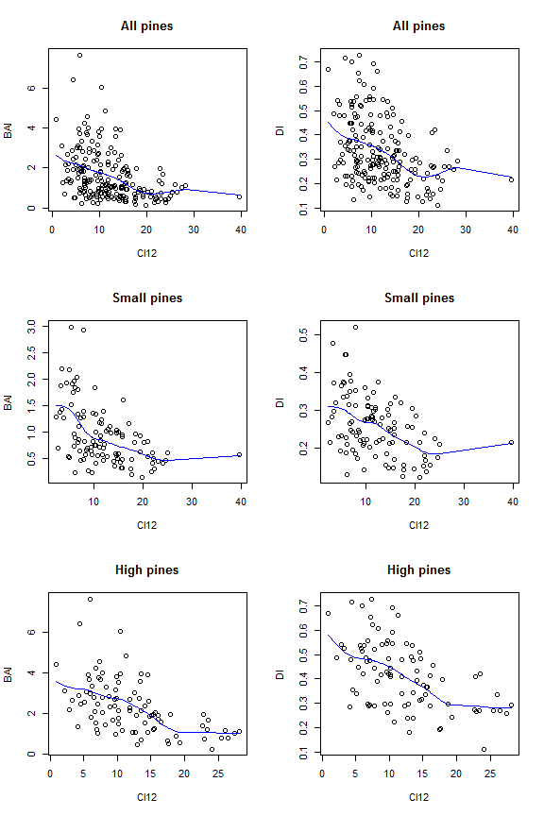

## Effects of CI12 on BAI and DI

Rouvinen and Kuuluvainen (C13) Sum of vertical angles from the target tree's base to the slope-adjusted top of each neighbour tree considering higher competition of neighbours larger than the target tree.

$$CI_{13}=\sum_{i=1}^{n}{\frac{h_{i}}{h}}arctan\frac{h_{i}}{dist_{i}}$$

**Figure** Relationship between the competition index and the BAI (left panels) and the diameter increment (right panels) for all target pines (top panels), pines lower than the mean height (centre panels), and pines higher than the mean height (bottom panels)

