PROMPT ENGINEERING FOR
MOBILE ROBOT NAVIGATION

AMIR FARHAN BIN GHAFFAR



DEPARTMENT OF MECHATRONICS ENGINEERING KULLIYAH OF ENGINEERING

INTERNATIONAL ISLAMIC UNIVERSITY MALAYSIA
JUNE 2026

PROMPT ENGINEERING FOR
MOBILE ROBOT NAVIGATION

AMIR FARHAN BIN GHAFFAR

Project Supervisor: Assoc. Prof. Ts. Dr. Hasan Firdaus Bin Mohd Zaki



A REPORT SUBMITTED IN PARTIAL FULFILMENT OF THE REQUIREMENT FOR A DEGREE OF BACHELOR OF MECHATRONICS ENGINEERING WITH HONOURS

ACKNOWLEDGEMENTS

I would like to express my sincere appreciation to my supervisor, Dr. Hasan Firdaus Bin Mohd Zaki, for his guidance, advice, and support throughout this Final Year Project. I am also thankful to the Kulliyyah of Engineering, Mechatronics Department, International Islamic University Malaysia (IIUM) for providing facilities and a good environment to carry out this project. Lastly, I would like to thank my friends who helped and supported me during the process, as well as my family for their encouragement and motivation.

LIST OF ABBREVIATIONS

IIUM International Islamic University Malaysia
AUV Autonomous Underwater Vehicle
BMS Battery Management System
BoM Bill of Materials
CB Centre of Buoyancy
CAD Computer-Aided Design
CG Centre of Gravity
DC-DC Direct Current to Direct Current (converter)
DOF Degree(s) of Freedom
ESC Electronic Speed Controller
FPS Frames Per Second
GND Ground (negative terminal)
IMU Inertial Measurement Unit
LAN Local Area Network
PWM Pulse Width Modulation
ROV Remotely Operated Vehicle
SBC Single Board Computer
UDP User Datagram Protocol
USB Universal Serial Bus
VCC Positive Supply Voltage

CHAPTER 1
INTRODUCTION

1.1 Overview
Mobile robots are increasingly used in indoor environments for inspection, assistance, delivery, monitoring, and research. For a robot to be useful to a non-technical user, the interaction method should be simple and natural. Instead of requiring coordinates, joystick control, or programming commands, a user should be able to provide an instruction such as "Find the green marker" or, in later development, "Go to the door".
Natural-language mobile robot navigation is challenging because a human instruction must be converted into information that a robot can understand and execute. The robot must identify the intended target, connect the instruction with its current camera view, choose an appropriate movement action, and stop safely when the action is uncertain or an obstacle is detected.
This Final Year Project investigates how structured prompt engineering can support this process on one low-cost indoor mobile robot prototype. The finalized physical system uses a Raspberry Pi 4 for onboard prompt processing, USB-webcam perception, lightweight OpenCV visual grounding, action selection, and result logging. An ESP32 performs sensor reading, local safety checks, and four-motor control through two MX1508 motor-driver modules.
The first prototype intentionally targets the basic and repeatable goal find the green marker. It adapts the modular language-to-vision-to-action concept demonstrated by LM-Nav and the restricted prompt-based action-selection idea used by VLMnav. It does not attempt to reproduce a large autonomous navigation platform or run an unrestricted large vision-language model directly onboard.

1.2 Background and Motivation
Traditional mobile robot navigation commonly uses maps, localization, path planning, and sensor feedback. These methods are effective when the destination is represented by coordinates or predefined waypoints. However, ordinary users normally describe destinations using natural language and visual concepts.
Prompt engineering can constrain language interpretation into a structured response containing a target, landmarks, spatial relation, action goal, and uncertainty. Visual grounding can then connect the structured target to an image captured by the robot. For a physical robot, the output must also be restricted to approved actions and checked against local safety information.
The motivation for this project is therefore to investigate a practical division of responsibility. The Raspberry Pi 4 performs high-level language and visual processing, while the ESP32 performs time-sensitive sensor reading, motor commands, obstacle detection, and command-timeout safety. This architecture supports prompt-based robot navigation without allowing uncertain high-level output to bypass deterministic local safety rules.

1.3 Problem Statement
Natural-language instructions are intuitive for humans but are not directly usable by a mobile robot. Instructions may be ambiguous, incomplete, or dependent on objects visible in the environment. Free-form model responses are also difficult to connect reliably to motor control because they may contain unsupported actions or inconsistent wording.
Low-cost mobile robot platforms introduce further constraints. A USB webcam does not provide depth or a complete map. The Raspberry Pi 4 has limited resources for large vision-language models, so the first prototype requires a lightweight and measurable visual-grounding method. Two front ultrasonic sensors provide limited obstacle coverage, and the low-cost motor and power subsystems require careful integration.
There is therefore a need for a focused low-cost system that can convert a simple natural-language indoor goal into structured machine-readable information, ground a supported target using a webcam image, restrict the result to an approved action set, and validate the action using ESP32 safety information before movement.

1.4 Research Questions
1. How can structured prompt engineering convert simple indoor navigation instructions into consistent machine-readable targets, actions, and uncertainty?
2. How can Raspberry Pi 4 webcam-based visual grounding and ESP32 sensor feedback be combined to select and execute safe basic robot actions?
3. How reliably can the completed Raspberry Pi 4 prototype find and approach a supported visual landmark in a controlled indoor environment?

1.5 Aim and Objectives
The aim of this project is to design and implement a Raspberry Pi 4-based prompt-engineered mobile robot for basic navigation in a controlled indoor environment.
The objectives are:
1. To develop a structured prompt-engineering pipeline that converts a simple natural-language navigation instruction into fixed fields and an approved action set.
2. To integrate a Raspberry Pi 4, USB webcam, ESP32, two HC-SR04 sensors, GY-291 / ADXL345 accelerometer, two MX1508 motor drivers, four DC gear motors, and the completed protected power system into one physical robot.
3. To evaluate prompt validity, visual grounding, action correctness, latency, local safety behaviour, and simple physical navigation success.

1.6 Research Scope
The project is limited to one low-cost four-wheel indoor mobile robot using a Raspberry Pi 4 as the only onboard high-level compute platform. The robot operates in supervised controlled areas such as rooms, laboratories, and simple landmark test zones.
The first physical prototype focuses on the single-target goal find the green marker. The approved action set is limited to move_forward, turn_left, turn_right, search, and stop. The Raspberry Pi performs structured instruction processing, webcam capture, visual grounding, action selection, validation, and logging. The ESP32 reads the ultrasonic sensors and GY-291, controls four motors through two MX1508 modules, and enforces obstacle, sensor-fault, invalid-command, and command-timeout stop behaviour.
The GY-291 is used for X/Y/Z acceleration, gravity-based roll and pitch tilt, motion, vibration, and shock observations. It is not treated as a heading sensor. Advanced functions such as full simultaneous localization and mapping, precise coordinate navigation, wheel-encoder odometry, autonomous route planning, LiDAR, RGB-D perception, and unrestricted large-model control are outside the current scope.
A separate Docker-based laptop webcam demonstration may be used during FYP1 to illustrate expected action outputs before final physical testing. It is not a second physical project approach.

1.7 Significance of the Project
The project contributes a practical framework for connecting prompt engineering with a real low-cost robot. Structured output makes navigation decisions easier to parse, log, evaluate, and reject when unsafe. Separating Raspberry Pi high-level processing from ESP32 local control also demonstrates how model-based navigation can be combined with deterministic safety behaviour.
The first-prototype focus makes the research achievable and measurable. A reliable marker-navigation demonstration provides a baseline that can later be extended with object detection for chairs, doors, and signboards, relation-aware instructions, additional sensors, mapping, and stronger navigation models.

1.8 Organization of the Thesis
Chapter 1 introduces the project background, problem statement, research questions, objectives, scope, and significance. Chapter 2 reviews related work on language-guided navigation, prompt engineering, visual grounding, and suitable low-cost hardware. Chapter 3 presents the Raspberry Pi 4 methodology, system architecture, mechanical and electrical design, implementation procedure, and validation plan. Chapter 4 presents the expected FYP1 results and defines the physical measurements required during FYP2.

1.9 Summary
This chapter established the need for a focused and safety-aware approach to natural-language mobile robot navigation. The finalized project develops one Raspberry Pi 4 physical prototype with one ESP32 sensor, safety, and motor-control layer.

CHAPTER 2
LITERATURE REVIEW

2.1 Introduction
This chapter reviews literature related to Prompt Engineering for Mobile Robot Navigation. The project investigates how a mobile robot can receive a natural language instruction, extract useful navigation information, ground the instruction using visual input, and convert the result into simple movement commands. The work is positioned as a low-cost indoor Final Year Project (FYP) research prototype rather than an industry-level autonomous navigation system.
The main baseline paper for this project is LM-Nav: Robotic Navigation with Large Pre-Trained Models of Language, Vision, and Action by Shah et al. (2023a). LM-Nav is important because it presents a modular architecture for language-guided navigation. Its pipeline separates the problem into language understanding, visual grounding, and navigation execution. This structure is suitable for this FYP because the same idea can be adapted into one focused low-cost Raspberry Pi 4 robot with ESP32 low-level control.
The project does not attempt to reproduce the complete hardware capability of LM-Nav or newer large-scale navigation systems. Instead, the project adapts the core research idea into a student-level Raspberry Pi 4 physical robot. The first prototype uses the basic instruction "Find the green marker". The Raspberry Pi 4 produces structured navigation information, uses the USB-webcam image and lightweight OpenCV grounding, validates the proposed action using ESP32 sensor status, and sends a simple command such as move_forward, turn_left, turn_right, stop, or search to the ESP32 motor-control layer.
Several related works are reviewed to clarify the project scope. VLMnav is included as the main prompt and action-selection reference because it formulates navigation as a question-answering or action-choice task. VLMaps and HOV-SG are reviewed because they improve spatial grounding, but they require map construction, RGB-D sensing, or scene graph construction, so they are treated as future work rather than the main implementation. ViNT and NoMaD are reviewed as stronger navigation execution models, but they are not the main focus because this FYP emphasizes prompt engineering, visual grounding, and simple action control. More recent VLM and VLA navigation systems such as NaVid, Uni-NaVid, and NaVILA are also discussed as advanced research directions.
The aim of this chapter is therefore not only to describe related papers, but also to critically compare their suitability for a low-cost indoor robot prototype.

2.2 Mobile Robot Navigation and Natural Language Instructions
Mobile robot navigation normally requires a robot to perceive its environment, decide where to move, and execute motion safely. Traditional navigation systems often rely on a map, localization, path planning, obstacle detection, and low-level motor control. These systems are effective when the goal is specified in a robot-readable form, such as a coordinate, waypoint, or selected map location. However, this interaction style is not natural for non-technical users.
Natural language provides a more intuitive interface. A user can describe a goal using objects, places, and relations, for example "go to the door", "find the signboard", or "move toward the chair near the table". These instructions are simple for humans, but they are difficult for robots because they contain semantic meaning that must be connected to the physical environment.
Language-guided navigation therefore requires three main capabilities. First, the robot must understand the user's instruction. Second, it must ground the instruction in visual input or spatial knowledge. Third, it must convert the result into movement. This general process is shown in Figure 2.1.
Figure 2.1: General language-guided navigation process
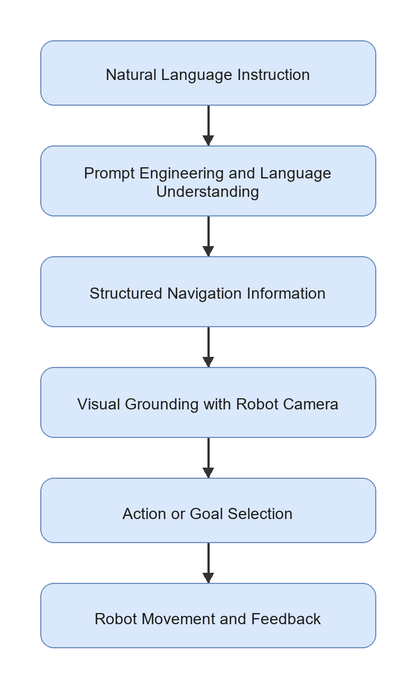
For this FYP, the navigation problem is intentionally limited to indoor environments such as a corridor, room, laboratory, door area, table area, chair area, or signboard location. This limitation is necessary because the proposed hardware uses a USB webcam and simple wheeled motion, not LiDAR, RGB-D SLAM, or high-cost navigation hardware. The controlled environment makes it possible to evaluate the core research question: whether structured prompt engineering can produce useful navigation information for a simple mobile robot.

2.3 Prompt Engineering for Robot Navigation
Prompt engineering is the design of model instructions, examples, constraints, and output formats so that an LLM or VLM produces useful responses. In robot navigation, prompt engineering is important because the model output must be connected to a physical robot. A free-form explanation is not enough. The output should contain machine-readable information such as the target object, relevant landmarks, spatial relation, action goal, suggested action, and uncertainty level.
In an LM-Nav-style system, prompt engineering can be used to extract landmarks from a natural language command. In a VLMnav-style system, prompt engineering can ask a model to choose the best next action from a fixed set. For a low-cost robot prototype, both ideas are useful. The robot does not need a complex high-level planner in the first implementation if the prompt output can be converted into a small set of validated motor commands.
Table 2.1: Roles of prompt engineering in mobile robot navigation

Role | Example Output | Purpose in This FYP
Landmark extraction | door, chair, table, signboard | Identify objects or places mentioned by the user
Target selection | target: door | Decide the main navigation goal
Spatial relation extraction | chair near table | Preserve relations that affect grounding
Route or action interpretation | move_forward, turn_left | Convert instruction meaning into simple action options
Structured output formatting | JSON-style response | Allow Python code on the selected compute platform to parse the result
Uncertainty handling | uncertainty: high | Prevent unsafe execution when the model is unsure
Visual grounding query generation | door in indoor corridor | Improve matching between text and webcam image

For this project, prompt engineering is treated as the interface between human language and robot action. The prompt must not only produce a correct sentence; it must produce an output that can be checked, logged, evaluated, and used by the onboard Raspberry Pi 4 decision logic.

2.4 Vision-Language Grounding for Indoor Landmarks
Vision-language grounding is the process of connecting text descriptions to visual observations. For mobile robot navigation, this means matching a target word such as "door", "chair", "table", "corridor", or "signboard" with what the robot sees through its camera.
CLIP and OpenCLIP-style models are common choices for image-text grounding because they embed images and text into a shared feature space. A text query can be compared with an image using cosine similarity:
score(image, text) = cosine_similarity(E_image(image), E_text(text))
where E_image is the image encoder and E_text is the text encoder. The image or region with the highest score can be treated as the most relevant match. A modern VLM may also be used by asking a question such as "Does this image contain a door?" or "Which action should the robot take to find the chair near the table?"
However, visual grounding remains a limitation for low-cost robots. A USB webcam provides only RGB images and does not directly provide depth, object distance, or a 3D map. The system may also struggle when multiple similar objects are visible, when lighting is poor, or when the target is partly outside the camera view. For this reason, the proposed project focuses on simple indoor landmarks and a small action set rather than full autonomous navigation in complex environments.

2.5 LM-Nav as the Main Baseline

Figure 2.2: LM-Nav real-world visual navigation platform (Shah et al., 2023a)

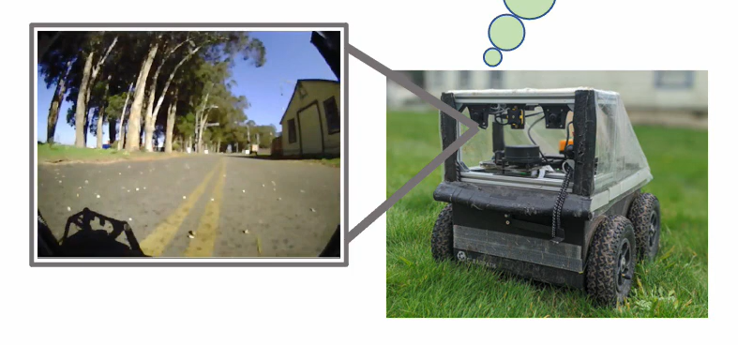

2.5.1 Overview of LM-Nav
LM-Nav: Robotic Navigation with Large Pre-Trained Models of Language, Vision, and Action by Shah et al. (2023a) is the main baseline for this project. LM-Nav addresses the problem that many visual navigation systems expect a goal image, while human users naturally provide language instructions. The paper avoids collecting a large language-annotated robot navigation dataset by composing pre-trained models.
The LM-Nav pipeline contains three main stages:
1. GPT-3 extracts landmarks from the natural language instruction.
2. CLIP grounds the extracted landmarks in visual observations.
3. ViNG navigates toward the selected visual goal.
This pipeline is shown in Figure 2.3.
Figure 2.3: LM-Nav baseline pipeline
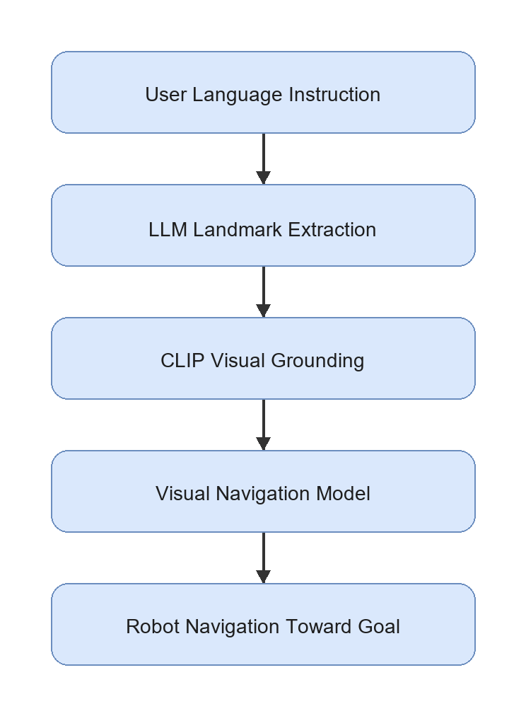

2.5.2 Strength of LM-Nav
The main strength of LM-Nav is its modular architecture. It does not require one end-to-end model that directly maps language and images to motor commands. Instead, it separates language understanding, visual grounding, and action execution. This separation is useful for research because each module can be tested and improved independently.
LM-Nav is also important because it demonstrates that pre-trained models can be combined for robot navigation without training a new language-conditioned navigation model from scratch. This idea is suitable for an FYP because collecting a large robot dataset is not realistic within the time and cost constraints of a student project.

2.5.3 Limitation of LM-Nav
LM-Nav also has limitations that motivate this project. The language module mainly extracts landmarks. This may be insufficient for instructions that include spatial relations, route order, or constraints. For example, "move toward the chair near the table" should not be reduced only to chair and table; the relation chair near table is also important.
Another limitation is hardware and navigation complexity. LM-Nav was demonstrated with a more capable outdoor robot platform and a visual navigation model. A student FYP setup using a Raspberry Pi 4, ESP32 sensor and motor control, USB webcam, two ultrasonic sensors, and four DC motors cannot reproduce the full navigation capability directly. Therefore, this project uses LM-Nav as an architectural inspiration, not as a full implementation target.

2.5.4 Relevance to This Project
LM-Nav provides the central structure for the proposed prototype: language understanding, visual grounding, and action execution. The difference is that this project adapts the final execution stage into a simple action-control system. Instead of using a full visual navigation policy, the Raspberry Pi 4 chooses one of a small set of actions, checks obstacle status from the ESP32 ultrasonic module, and sends validated commands to the ESP32 motor-control layer. This makes the project realistic for a low-cost indoor robot while preserving the research value of structured prompt engineering.

2.6 VLMnav as a Prompt-Based Action Selection Reference
Figure 2.4: VLMnav prompt and action-selection interface (Goetting et al., 2024)
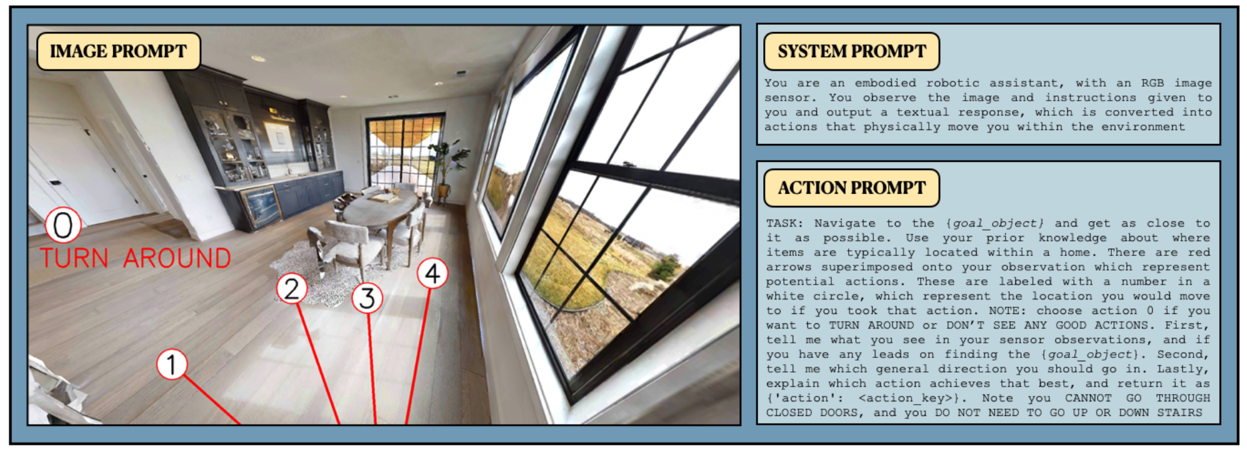
VLMnav: End-to-End Navigation with Vision Language Models by Goetting et al. (2024) is highly relevant because it formulates navigation as a question-answering problem. Instead of requiring the model to output a long navigation plan, the system can ask a VLM to choose among possible actions. This is close to the needs of the proposed robot because the first prototype only needs a small action set: move_forward, turn_left, turn_right, stop, and search.
The strength of VLMnav is that it connects visual observation, language instruction, and action selection through prompting. This supports the idea that prompt design can affect not only landmark extraction but also robot movement decisions. For example, a prompt can ask whether the current webcam image contains the target, whether the robot should turn to search, or whether it should stop because the target has been found.
The limitation is that direct VLM action selection may not be safe enough for unsupervised robot control. VLM outputs can be inconsistent, and the model may choose an action even when the target is not visible or the instruction is ambiguous. For this reason, the proposed FYP will validate the structured output, uncertainty level, model latency, and ESP32 ultrasonic obstacle status before physical motor execution. VLMnav is therefore treated as a prompt/action-selection reference, while the robot remains a controlled research prototype.

2.7 Spatial Grounding Methods: VLMaps and HOV-SG
Spatial grounding methods improve the connection between language and the physical environment. Two important examples are VLMaps and HOV-SG.

Figure 2.5: VLMaps language-grounded navigation example (Huang et al., 2023)
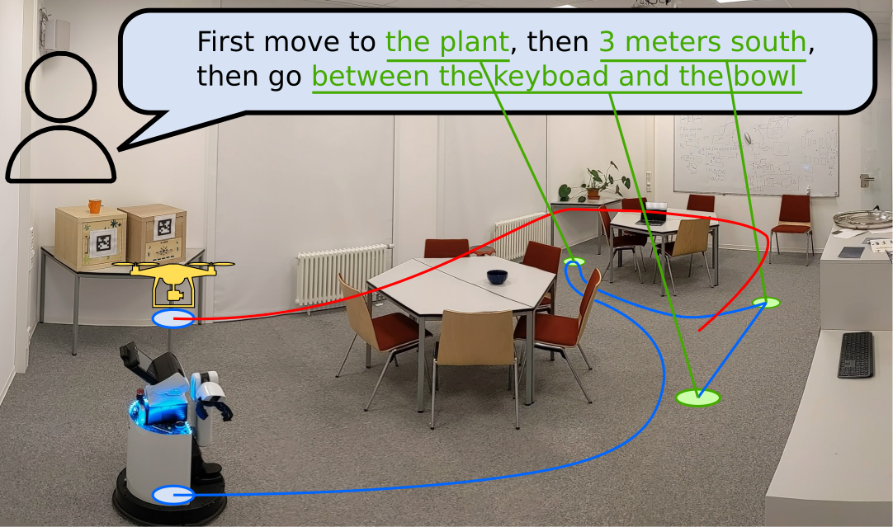
VLMaps: Visual Language Maps for Robot Navigation by Huang et al. (2023) builds an open-vocabulary visual-language map. Instead of matching a text query only to the current camera image, the robot can query a map that stores semantic visual features. The strength of VLMaps is that it provides spatial memory and can connect language to locations. Its limitation is that it requires map construction, camera pose information, and RGB-D or mapping support. This makes it more complex than the first version of the proposed FYP robot.

Figure 2.6: HOV-SG hierarchical navigation platform (Werby et al., 2024)
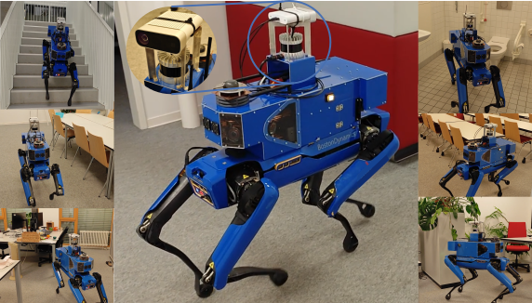
HOV-SG: Hierarchical Open-Vocabulary 3D Scene Graphs for Language-Grounded Robot Navigation by Werby et al. (2024) uses a hierarchical 3D scene graph to represent floors, rooms, and objects. This is powerful for long-horizon and multi-room navigation because the robot can reason about object and room relationships. However, it requires segmentation, 3D perception, graph construction, and more advanced sensing. This is not suitable for the first low-cost prototype, but it is valuable as a future improvement direction.
Both papers show that spatial grounding is important. They also highlight a gap for this project: a low-cost robot without RGB-D mapping still needs a way to preserve spatial relations from language. Structured prompt engineering can support this by extracting fields such as target, landmarks, and spatial_relation, even if the first implementation only uses webcam-based grounding.

2.8 Navigation Execution Models: ViNT and NoMaD
The execution stage determines how a robot physically moves toward a target. In advanced systems, this may involve a learned navigation policy, obstacle avoidance, and goal-conditioned control. ViNT and NoMaD are important because they represent stronger navigation execution methods than a simple rule-based motor command system.

Figure 2.7: ViNT visual navigation transformer architecture (Shah et al., 2023b)
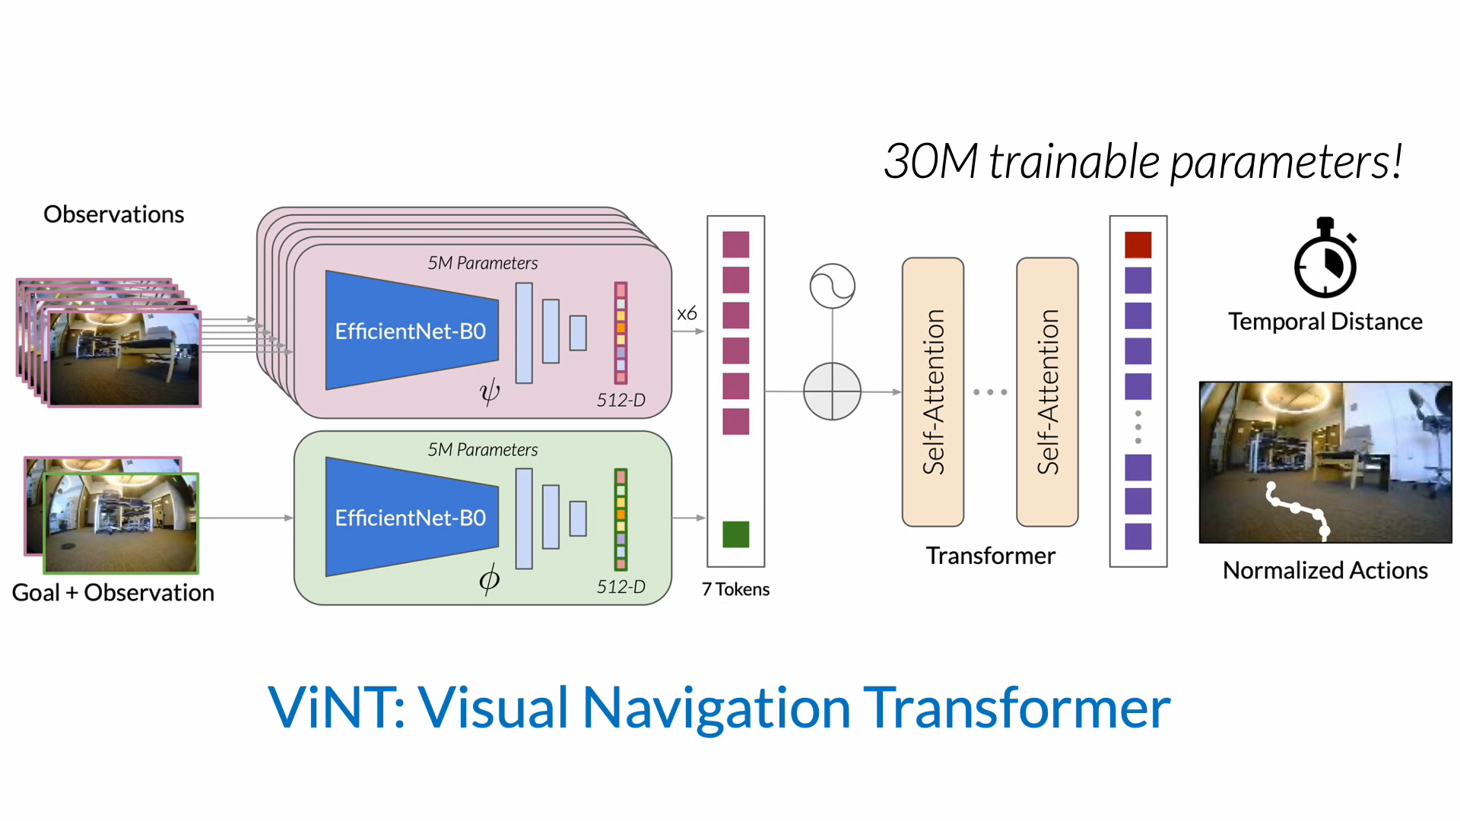
ViNT: A Foundation Model for Visual Navigation by Shah et al. (2023b) proposes a visual navigation foundation model trained across diverse robot datasets. Its strength is generalization across platforms and environments. Its limitation for this FYP is that deploying and validating a full visual navigation model is outside the main scope. This project focuses on prompt engineering, visual grounding, and simple action control, not training or deploying a foundation navigation policy.

Figure 2.8: NoMaD visual navigation examples (Sridhar et al., 2023)
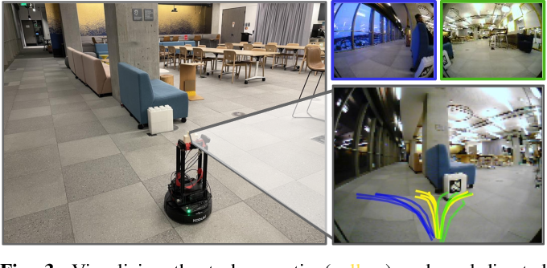
NoMaD: Goal Masked Diffusion Policies for Navigation and Exploration by Sridhar et al. (2023) uses a diffusion-based policy for goal-directed navigation and exploration. Its strength is stronger navigation behavior and exploration ability. Its limitation is that it requires a more complex policy deployment pipeline and suitable robot data. For the proposed project, NoMaD is therefore best treated as future work after the basic Raspberry Pi 4 physical robot pipeline is functioning.
These works are important because they show how the simple action-control layer in this FYP could later be replaced by a stronger navigation model. However, they are not the main implementation because the research focus is prompt-engineered interpretation of natural language instructions.

2.9 Recent VLM and VLA Navigation Systems
Recent work has moved toward more integrated VLM and VLA navigation systems. These systems can reason over video, language, and action more directly than the earlier modular LM-Nav design.

Figure 2.9: NaVid video-based navigation architecture (Zhang et al., 2024)
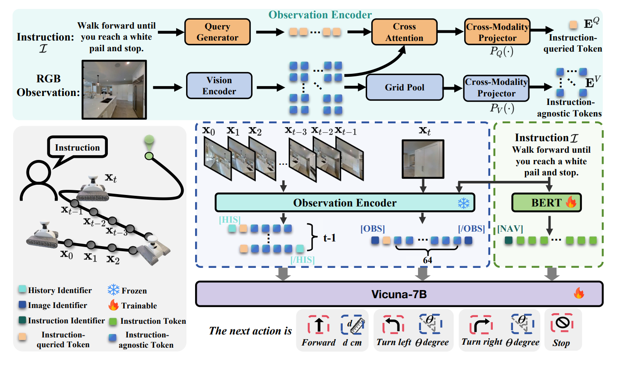
NaVid by Zhang et al. (2024) uses video-based VLM planning for vision-and-language navigation. Its strength is that it uses temporal visual context rather than a single image. This is useful for robot navigation because the current view alone may not contain enough information. Its limitation is that video-based reasoning and model inference can be expensive for a small embedded robot.

Figure 2.10: Uni-NaVid embodied navigation examples (Zhang et al., 2026)
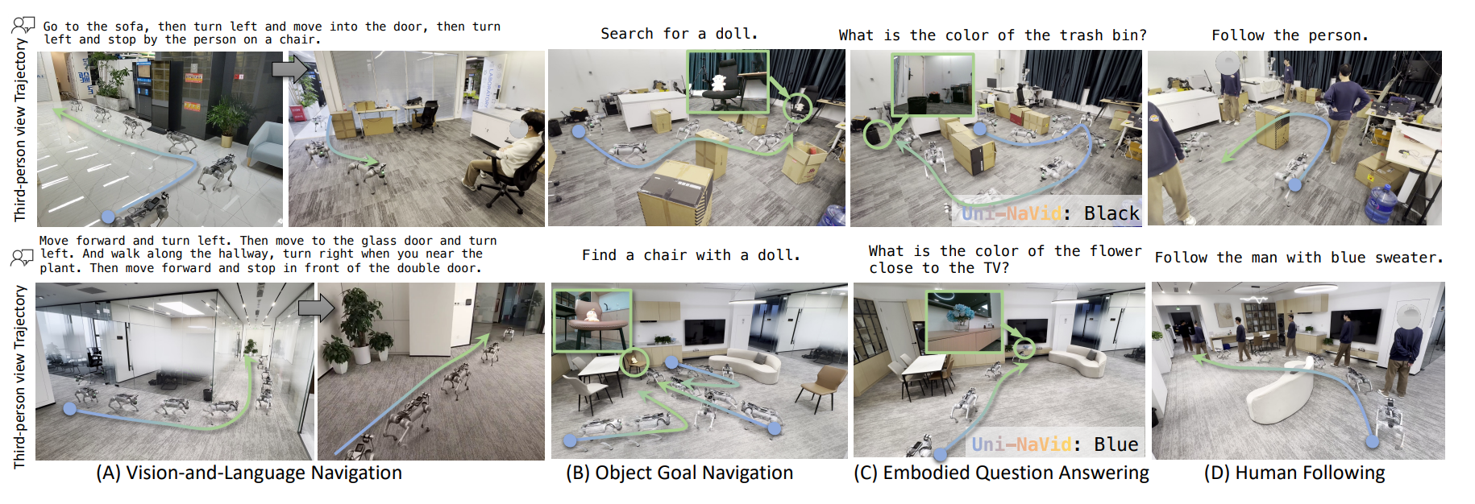
Uni-NaVid by Zhang et al. (2026) extends the video-based approach toward a unified model for multiple embodied navigation tasks. Its strength is broad task coverage. Its limitation is that the system is more advanced and resource-intensive than a first FYP prototype.
Figure 2.11: NaVILA vision-language-action navigation examples (Cheng et al., 2025)
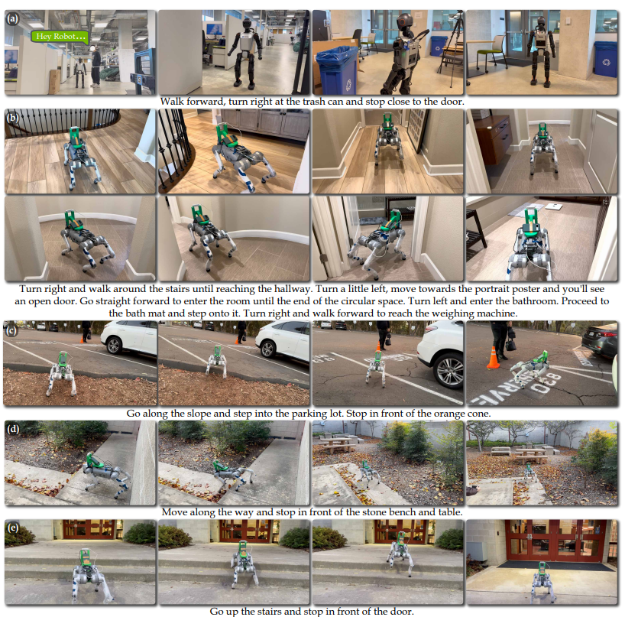
NaVILA by Cheng et al. (2025) studies VLA navigation for legged robots. Its strength is the connection between vision-language reasoning and real robot movement. Its limitation for this project is that it focuses on more complex legged platforms and server-style model pipelines, while the proposed robot is a wheeled low-cost indoor platform.
These papers are relevant because they show the direction of future navigation research. However, they also reinforce the need for a realistic baseline prototype. A student project can first demonstrate prompt-engineered instruction parsing, webcam grounding, and simple action control before attempting advanced VLA navigation.

2.10 Critical Comparison of Related Works
The reviewed papers differ significantly in method, hardware complexity, cost, and suitability for student-level implementation. Table 2.2 compares the papers based on their main method, strength, limitation, and relevance to this project.
Table 2.2: Critical comparison of related papers

Paper | Main Method | Hardware or Platform | Strength | Limitation | Relevance to This Project
LM-Nav | GPT-3 landmark extraction, CLIP grounding, ViNG navigation | Real robot platform with RGB cameras and navigation sensors | Clear modular baseline for language to vision to action | Landmark-only extraction may lose spatial relations; full navigation setup is more complex than this FYP | Main baseline architecture adapted into a low-cost indoor prototype
VLMnav | VLM question-answering for action choice | Simulation-style embodied navigation setup with visual observations and action choices | Strong reference for prompt-based action selection | Direct VLM actions require validation before real robot control | Supports the proposed fixed action set and prompt design
VLMaps | Open-vocabulary visual-language maps | Mapping-based setup using RGB-D or pose-supported observations | Stronger spatial grounding and language-map querying | Requires map construction and additional sensing | Future improvement for map-based grounding
HOV-SG | Hierarchical open-vocabulary 3D scene graph | 3D perception, scene graph construction, and robot/simulator experiments | Supports object, room, and floor-level reasoning | Too complex for first low-cost webcam prototype | Future improvement for structured spatial memory
ViNT | Visual navigation foundation model | Multi-robot visual navigation datasets and deployment platforms | Stronger visual navigation execution | Does not focus on prompt engineering; deployment is beyond initial scope | Possible future replacement for simple action control
NoMaD | Diffusion-based goal-conditioned navigation policy | Robot navigation experiments with visual observations | Improves exploration and goal reaching | Requires navigation policy deployment and data support | Future work after baseline prototype
NaVid | Video-based VLM next-step planning | Simulation and real-world video navigation experiments | Uses temporal context for navigation decisions | More model and compute intensive than single-webcam baseline | Future direction for video-based reasoning
Uni-NaVid | Unified video-based VLA navigation model | Advanced embodied navigation platforms | Supports multiple navigation task types | Resource-intensive and not suitable as first implementation | Long-term improvement direction
NaVILA | Vision-language-action navigation for legged robots | Legged robot demonstrations and simulation benchmarks | Connects VLA reasoning to real movement | Focuses on complex legged platforms and larger model pipelines | Relevant conceptually but not the main hardware target

The comparison shows that LM-Nav and VLMnav are the most directly relevant to this project. LM-Nav provides the modular structure, while VLMnav supports the idea of selecting actions through prompt-based reasoning. VLMaps, HOV-SG, ViNT, NoMaD, NaVid, Uni-NaVid, and NaVILA are important, but they require additional sensing, mapping, model deployment, or compute resources that are not realistic for the first prototype.

2.11 Hardware Suitability for This FYP
A critical issue for this project is hardware feasibility. Many research systems use expensive robots, RGB-D cameras, LiDAR, server GPUs, or advanced navigation policies. This FYP must use a lower-cost platform while still preserving a meaningful research contribution. Table 2.3 summarizes the suitability of literature components for the proposed implementation.
Table 2.3: Hardware and method suitability for this FYP

Component or Method from Literature | Used in Original Paper or Related Work | Suitability for This FYP | Decision
RGB camera or webcam | Used in LM-Nav and many VLM navigation works as visual input | Highly suitable because it is low-cost and easy to connect through USB | An unbranded 1080p USB webcam will be used as the main visual sensor
Raspberry Pi 4 | Related to low-cost onboard Linux robot-compute platforms | Suitable for Python, OpenCV, USB devices, lightweight inference, and flexible development | Finalized and only physical compute board
ESP32 microcontroller | Not central in reviewed AI navigation papers, but common in low-cost sensor and motor integration | Suitable for reading ultrasonic sensors and controlling a motor driver independently from model inference | Will be used as the motor, sensor, and local safety controller
Two HC-SR04 ultrasonic sensors | Not the main perception method in the reviewed VLM papers | Suitable as a low-cost front-left and front-right proximity safety aid | Will be used for simple front obstacle awareness
GY-291 / ADXL345 accelerometer | Not the main perception method in the reviewed VLM papers | Suitable for three-axis acceleration, roll/pitch tilt, motion, vibration, and shock observations | Will support physical movement and chassis-condition monitoring
Two MX1508 dual motor drivers | Common low-cost motor-control hardware rather than a reviewed AI-navigation component | Suitable for controlling four small DC gear motors after current-rating verification | Will be used as the shared motor-driver subsystem
Four DC motors and chassis | Common in low-cost mobile robots but not the focus of high-level papers | Suitable for simple wheeled movement | Will be used for movement execution
18650 battery pack | Standard power source for small mobile robot prototypes | Suitable for mobile operation when voltage and current requirements are handled safely | Will be used as the robot power source
RGB-D camera | Used or required by mapping-based works such as VLMaps and HOV-SG-style pipelines | Useful but increases cost and complexity | Optional future improvement
LiDAR | Used in some advanced robot navigation and scene understanding systems | Useful for safety and mapping but too costly for the first prototype | Not used in the baseline prototype
Full 3D scene graph | Used in HOV-SG and related spatial reasoning systems | Strong for spatial reasoning but requires 3D perception and mapping | Future improvement only
Large VLA model or server GPU | Used in advanced VLA systems such as NaVILA or Uni-NaVid-style pipelines | Powerful but outside the finalized onboard implementation scope | Future work only
CLIP, OpenCLIP, or VLM grounding | Used in LM-Nav-style grounding and VLM navigation | Suitable for prototype testing with indoor images | Will be used or evaluated depending on available compute
Learned navigation policy such as ViNT or NoMaD | Used in advanced navigation execution research | Useful but outside the main prompt-engineering scope | Future replacement for simple action control

This table supports the design decision to build a low-cost indoor prototype. The project will not claim full autonomy in complex environments. Instead, it will demonstrate a baseline pipeline that future researchers can improve with better sensors, mapping, and navigation policies.
The positioning of the reviewed papers around the proposed baseline is shown in Figure 2.12.
Figure 2.12: Positioning of related works around LM-Nav
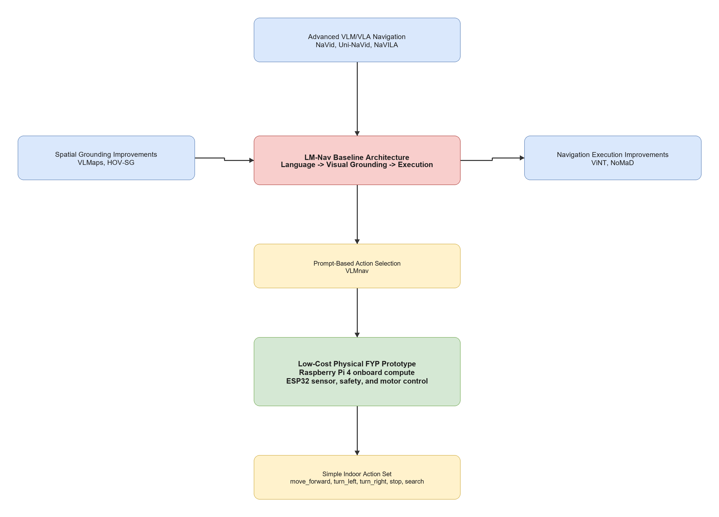

2.12 Research Gap and Motivation
The literature shows that language-guided robot navigation is an active research area, but several gaps remain for a low-cost FYP prototype.
First, existing systems can perform language-guided navigation, but many require expensive hardware, complex mapping, large models, or server-level compute. These systems are valuable research contributions, but they are not directly suitable for a student prototype using a Raspberry Pi 4, ESP32, USB webcam, two ultrasonic sensors, two MX1508 motor drivers, GY-291 accelerometer, and four DC gear motors.
Second, LM-Nav provides a strong modular baseline, but its language stage mainly extracts landmarks. Natural language instructions often include spatial relations and route information, such as "near the table", "turn left after the door", or "find the signboard". A low-cost prototype still needs to preserve this information, even if the first grounding module is simple.
Third, many advanced methods improve spatial grounding or navigation execution, but they do not directly answer how structured prompt engineering can support a simple indoor robot. VLMaps and HOV-SG show the value of maps and scene graphs, while ViNT and NoMaD show stronger navigation execution. However, this project begins earlier in the pipeline by asking how natural language can be converted into structured, validated robot action information.
Fourth, there is a need for a focused baseline physical prototype that future researchers can extend. A Raspberry Pi 4 robot with webcam grounding, ESP32 safety control, acceleration and tilt feedback, and simple actions provides a practical platform for later improvements such as RGB-D sensing, LiDAR, scene graph mapping, ViNT, NoMaD, or advanced VLM/VLA models.
Table 2.4: Research gap synthesis and project strategy

Research Gap | Supporting Literature | Project Strategy
Many language-guided navigation systems use costly or complex hardware | LM-Nav, HOV-SG, NaVILA, Uni-NaVid | Build one focused low-cost Raspberry Pi 4 prototype with ESP32 sensor, safety, and motor control
Landmark extraction alone may lose spatial relations and route information | LM-Nav, VLMaps, HOV-SG | Use structured prompt output with target, landmarks, spatial relation, action goal, suggested action, and uncertainty
VLM action selection needs validation before real robot execution | VLMnav | Check uncertainty, latency, approved actions, and ESP32 ultrasonic status before sending commands to the ESP32 motor-control layer
Mapping and scene-graph systems are useful but complex | VLMaps, HOV-SG | Treat RGB-D mapping and scene graphs as future work
Strong navigation policies are beyond the first prototype | ViNT, NoMaD | Start with simple action control and document future replacement options

Based on these gaps, the project is motivated by the following research direction:
How can structured prompt engineering support visual grounding and simple action selection for a low-cost indoor mobile robot navigation prototype?

2.13 Chapter Summary
This chapter reviewed literature related to prompt engineering for mobile robot navigation. LM-Nav was identified as the main baseline because it provides a clear modular architecture of language understanding, visual grounding, and navigation execution. VLMnav was reviewed as the main prompt/action-selection reference because it frames navigation as a question-answering or action-choice task.
The chapter also reviewed VLMaps and HOV-SG as spatial grounding improvements, ViNT and NoMaD as stronger navigation execution models, and NaVid, Uni-NaVid, and NaVILA as advanced VLM/VLA navigation directions. These works show the potential of language-guided navigation, but they also reveal limitations related to cost, sensing requirements, compute resources, and implementation complexity.
The research gap is that there is a need for a low-cost indoor physical prototype that studies structured prompt engineering for simple mobile robot navigation. Chapter 3 explains how this project addresses the gap using one Raspberry Pi 4 implementation with an ESP32 motor, sensor, and safety layer.

CHAPTER 3
RESEARCH METHODOLOGY

3.1 Introduction
This chapter presents the finalized methodology for Prompt Engineering for Mobile Robot Navigation. The project contains one physical implementation: a Raspberry Pi 4 mobile robot with an ESP32 sensor, safety, and motor-control layer.
The methodology is inspired by the modular structure of LM-Nav and the prompt-based action-selection idea of VLMnav. Language interpretation, visual grounding, and navigation execution are separated so each stage can be tested. The first prototype targets find the green marker and restricts all output to the approved action set.
The finalized project contains one Raspberry Pi 4 physical robot approach.
- Raspberry Pi 4 performs onboard prompt processing, webcam processing, action selection, and logging.
- ESP32 performs sensor reading, deterministic safety, and four-motor control.
The robot uses a four-wheel chassis, USB webcam, two MX1508 motor drivers, adjustable motor buck converter, two HC-SR04 ultrasonic sensors, GY-291 / ADXL345 accelerometer, and the completed protected power system.
The intended action set is:
- move_forward
- turn_left
- turn_right
- stop
- search
The laptop-only Docker demonstration produces expected-results evidence before physical testing. It is not a second physical approach.

3.2 Research Design and Project Workflow
The project follows an iterative prototype methodology. The already-built mechanical and power systems are completed by wiring and validating the ESP32 sensor and motor layer, connecting Raspberry Pi USB serial, verifying webcam capture and OpenCV visual grounding, and testing one complete basic goal.

3.2.1 Methodology Alignment with Research Objectives
Table 3.1: Methodology Alignment with Research Objectives

Research Objective | Method Used | Expected Output | Evaluation
Objective 1: Develop a structured prompt-engineering pipeline | Convert a simple instruction into fixed navigation fields and approved actions | Parseable target, action goal, and uncertainty | Prompt validity and target-extraction accuracy
Objective 2: Integrate one Raspberry Pi 4 physical robot | Connect Raspberry Pi, ESP32, webcam, sensors, MX1508 drivers, motors, and completed power system | Working end-to-end robot | Wiring, sensor, motor, USB serial, and power tests
Objective 3: Evaluate basic prompt-engineered navigation | Run repeated single-target indoor trials | Measured action, latency, safety, and movement results | Grounding correctness, action accuracy, safe-stop rate, and goal completion

3.2.2 Overall Project Workflow
Figure 3.1: Proposed project workflow
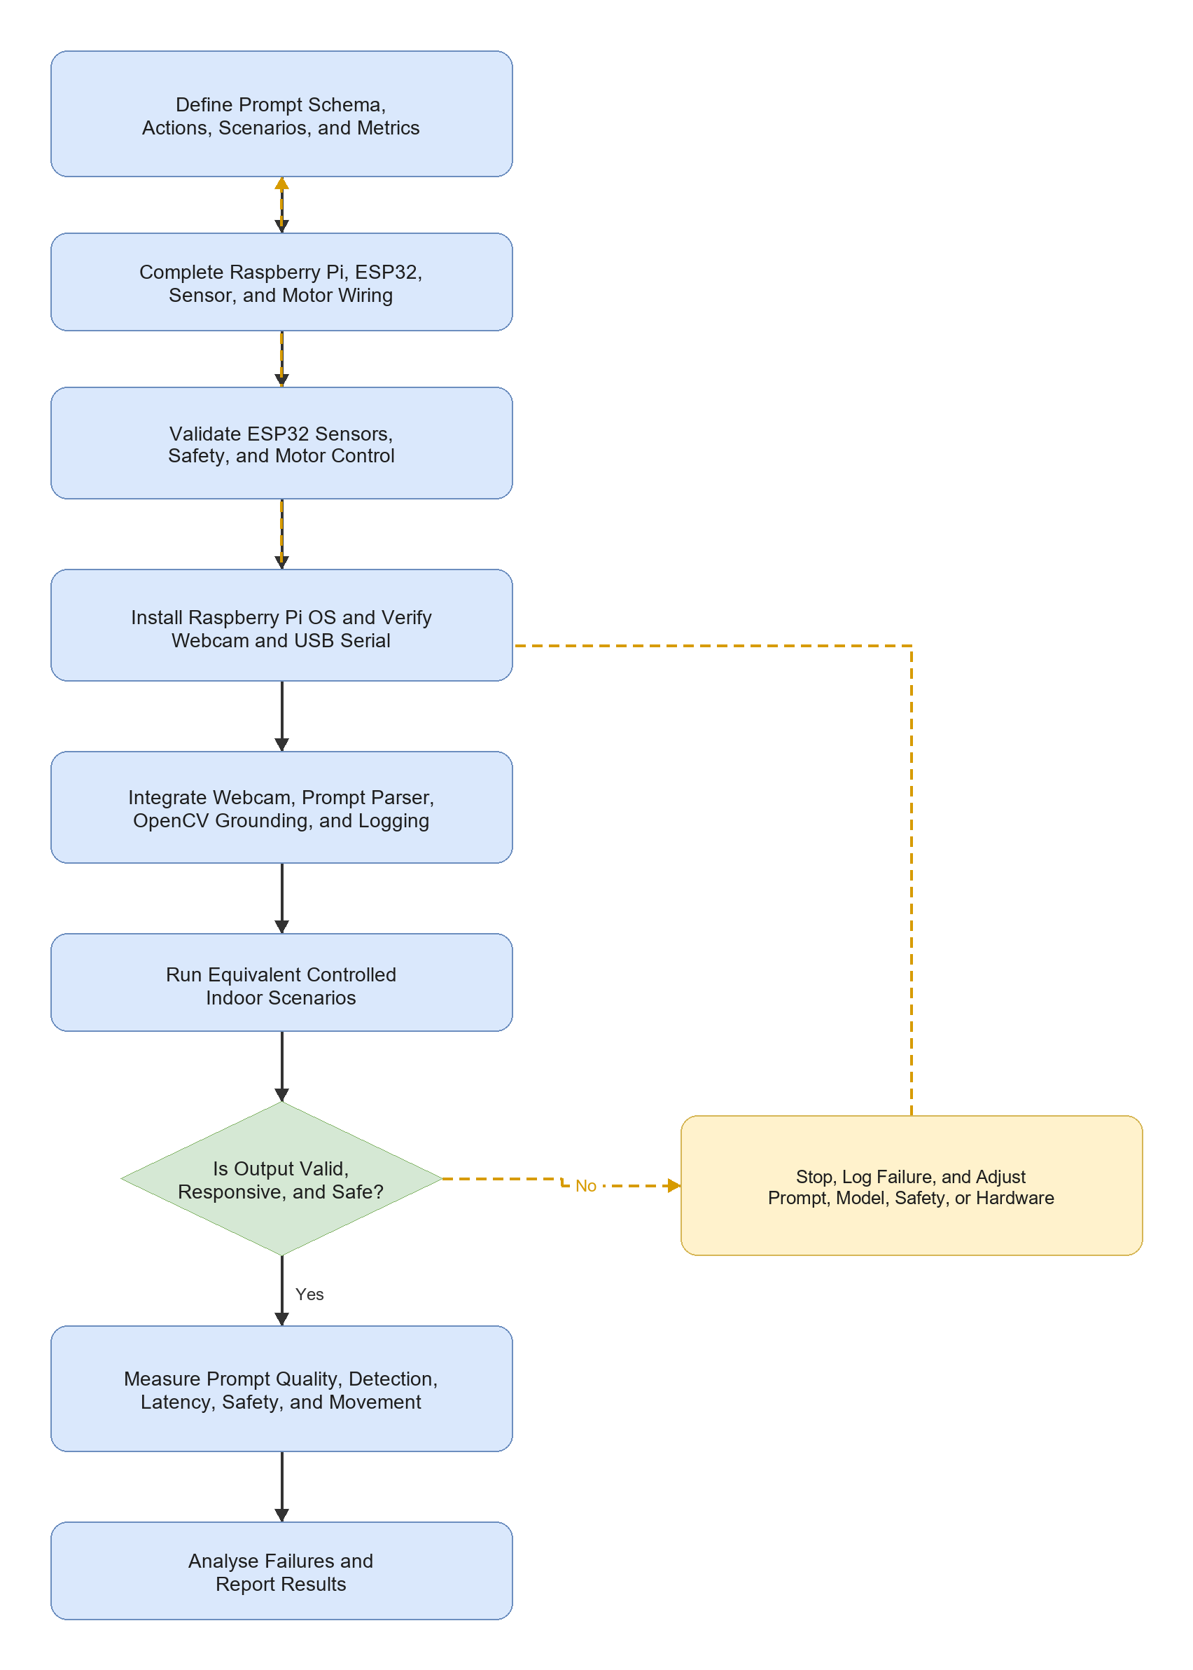

3.2.3 Development Workflow
Table 3.2: Development Workflow

Stage | Activity | Expected Output
Stage 1 | Finalize the basic goal, action set, prompt schema, scenarios, and logging format | Common experimental definition
Stage 2 | Verify the completed power system and common-ground architecture | Stable compute and motor supplies
Stage 3 | Wire ESP32 sensors and two MX1508 drivers, then connect Raspberry Pi USB devices | Completed signal wiring
Stage 4 | Test ESP32 sensing, motor directions, timeout, and obstacle stop | Verified local safety and movement
Stage 5 | Install Raspberry Pi OS and verify webcam and USB serial | Working Raspberry Pi platform
Stage 6 | Integrate structured prompt processing, OpenCV grounding, action selection, and logging | Working end-to-end prototype
Stage 7 | Run repeated controlled trials and calculate metrics | Final physical results

3.3 Finalized System Architecture
The Raspberry Pi 4 performs high-level processing. The ESP32 handles local real-time sensing, safety, and motor control. USB serial is used between the boards because it is simple to debug and leaves all ESP32 motor GPIO pins available.
Figure 3.2: Proposed system architecture
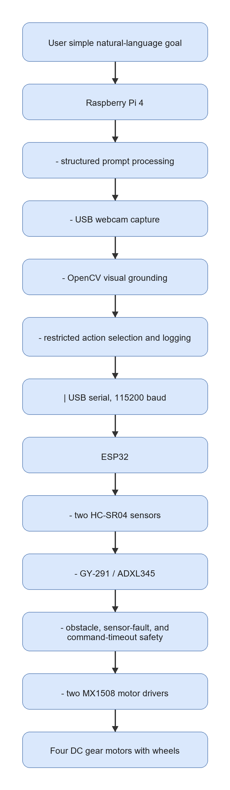

3.3.1 Hardware Roles
Table 3.3: Finalized Hardware Roles

Component | Finalized Role | Main Interface | Main Strength | Main Constraint
Raspberry Pi 4 | Onboard prompt processing, webcam capture, OpenCV grounding, action selection, and logging | USB webcam and USB serial | Flexible Linux and Python environment | Limited performance for large models
ESP32 | Sensor reading, deterministic safety, and four-motor control | USB serial and GPIO | Independent real-time safety layer | Runs only approved low-level commands
USB webcam | Front RGB image input | Raspberry Pi USB | Low-cost visual input | No dense depth or 3D map
Two HC-SR04 sensors | Front-left and front-right obstacle safety | ESP32 GPIO with Echo level shifting | Low-cost local obstacle detection | Limited coverage and accuracy
GY-291 / ADXL345 | Acceleration, roll/pitch tilt, motion, vibration, and shock observations | ESP32 I2C | Useful chassis-condition feedback | Does not provide yaw heading
Two MX1508 drivers | Four independent DC motor channels | ESP32 GPIO and regulated motor rail | Compact four-motor control | Requires current and thermal verification
Four DC gear motors | Physical forward, turn, search, and stop behaviour | MX1508 outputs | Simple four-wheel movement | No wheel-encoder feedback

3.4 Requirements, Constraints, and Acceptance Criteria
Table 3.4: Requirements and Acceptance Criteria

Requirement | Specification | Verification Method | Pass Criteria
Natural-language input | Accept a supported goal such as find the green marker | Input test | Instruction is accepted without manual rewriting
Structured prompt output | Return fixed machine-readable fields | JSON validation | Required fields are present and parseable
Raspberry Pi onboard processing | Run prompt parser, webcam, grounding, action selection, and logging onboard | Integration test | Raspberry Pi completes the navigation loop
Webcam visual grounding | Detect a supported coloured marker | Camera scenario test | Correct grounding or safe search response
Raspberry Pi-to-ESP32 USB serial | Exchange commands and sensor JSON at 115200 baud | Serial test | Stable command and status communication
Four-motor control | Two MX1508 modules control four motors | Raised-wheel test | Forward, left, right, search, and stop work
Local safety | Obstacle, sensor fault, timeout, or invalid command stops movement | Failure-case test | Unsafe movement is prevented
Power stability | Completed power system supplies stable rails | Voltage and runtime test | No unsafe voltage, reset, or severe drop

The baseline does not include SLAM, LiDAR mapping, dense depth, or an unrestricted large vision-language model.

3.5 Data, Test Environment, and Experimental Materials
Table 3.5: First-Prototype Scenarios

Scenario | Example Instruction | Expected Behaviour | Purpose
Supported target absent | "Find the green marker." | search | Verify safe visual search
Target on left | "Find the green marker." | turn_left | Verify left action selection
Target on right | "Find the green marker." | turn_right | Verify right action selection
Target centred and distant | "Find the green marker." | move_forward | Verify approach action
Target centred and close | "Find the green marker." | stop | Verify goal-stop behaviour
Unsupported or ambiguous target | "Go there." | stop | Verify prompt uncertainty handling
Obstacle present | "Find the green marker." | ESP32 forces stop | Verify independent local safety

Table 3.6: Experimental Materials

Material | Quantity or Role
Raspberry Pi 4 | Only onboard high-level compute board
ESP32 | Sensor, safety, USB serial, and motor-control controller
USB webcam | One front RGB camera
DC gear motor with wheel | Four motors and wheels
MX1508 dual motor-driver module | Two modules controlling four motors
Adjustable motor buck converter | Regulated motor-driver rail
HC-SR04 ultrasonic sensor | Two front obstacle sensors
GY-291 / ADXL345 accelerometer | Acceleration, roll/pitch tilt, motion, vibration, and shock sensing
Completed battery and power system | Mobile robot power source
Coloured marker | Repeatable first visual landmark
Instruction and scenario list | Common experimental inputs
JSONL result logs | Store prompts, detections, sensors, actions, latency, and failures

Figure 3.3: Main hardware components for the finalized Raspberry Pi 4 robot
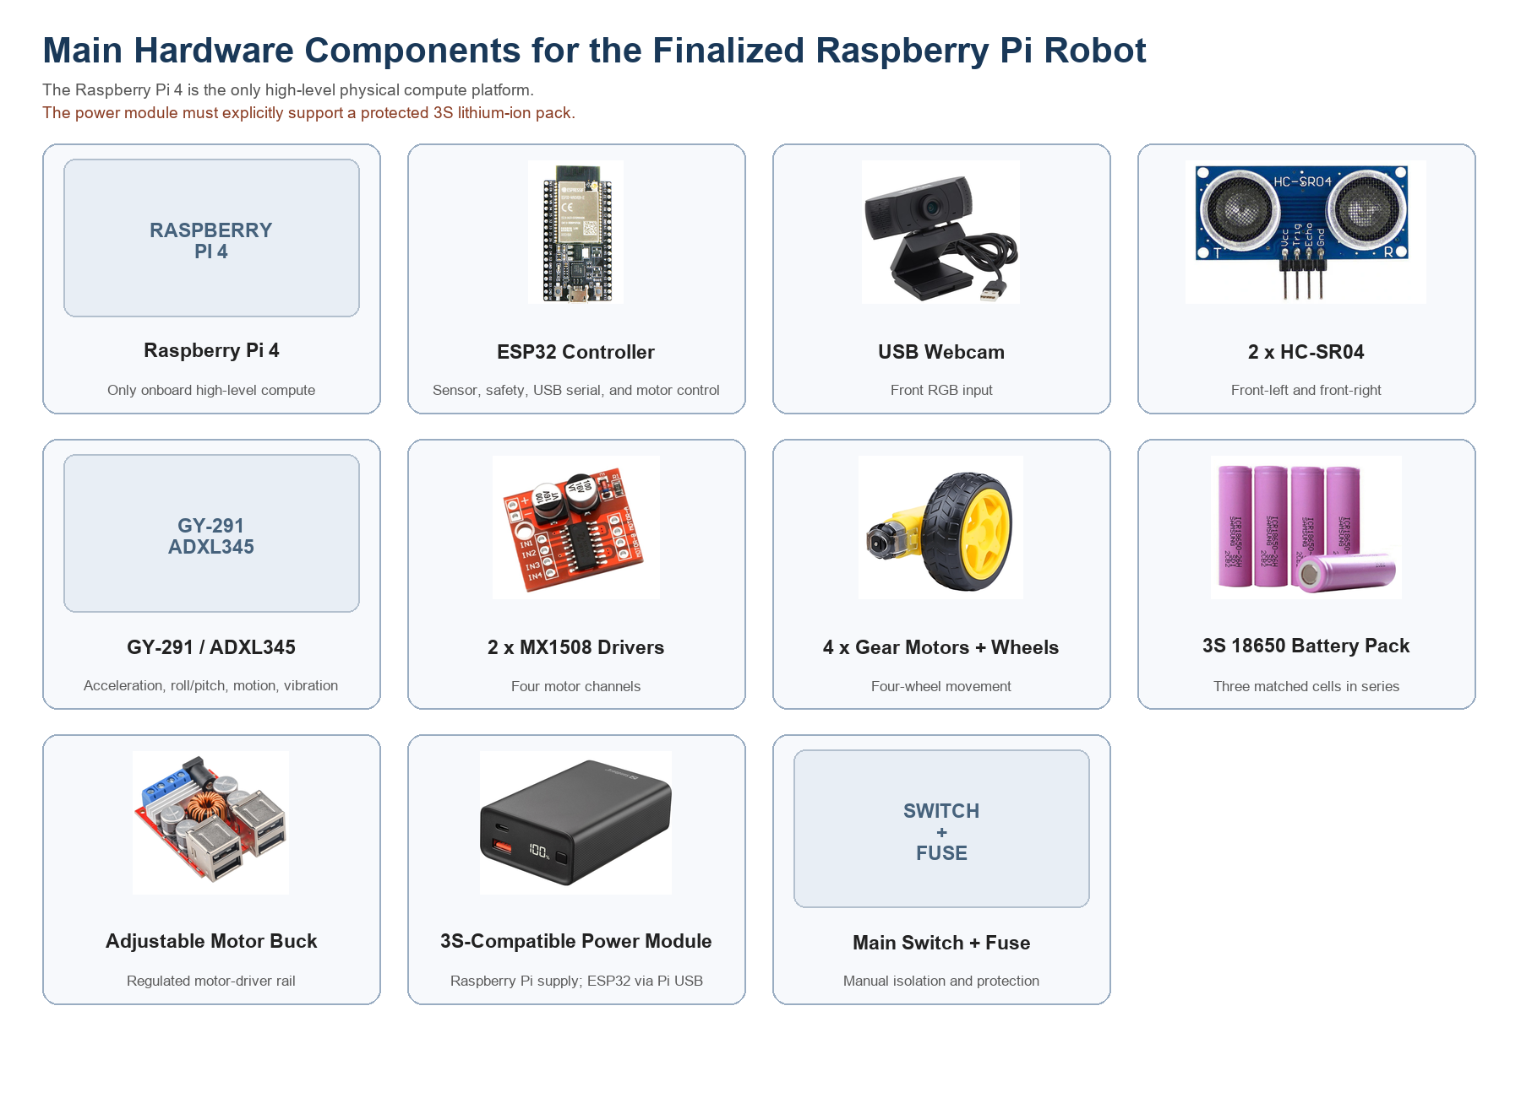
Table 3.7: Software and Model Requirements

Item | Purpose | Finalized Tool or Example
Raspberry Pi operating system | Run the onboard application | Raspberry Pi OS Lite 64-bit
High-level language | Prompt parser, grounding, validation, serial, and logging | Python
Webcam processing | Capture and process RGB frames | OpenCV
Prompt processing | Produce structured basic-goal output | Deterministic fixed-schema parser
Initial visual grounding | Detect supported coloured marker | OpenCV HSV segmentation
ESP32 firmware | Sensors, safety, USB serial, and two-MX1508 motor control | Arduino framework
Communication | Raspberry Pi to ESP32 commands and status | USB serial at 115200 baud
Result storage | Record experimental data | JSONL
Future grounding | Detect indoor objects and landmarks | OpenCV DNN, TensorFlow Lite, or API-based VLM

3.6 Prompt Engineering Design
The first prototype uses a deterministic structured parser. This applies the main prompt-engineering principles required by the study: fixed fields, restricted actions, explicit uncertainty, and safe rejection of unsupported goals.
Table 3.8: Supported First-Prototype Prompt Inputs

Prompt Input | First-Prototype Interpretation | Expected Result
"Find the green marker." | Supported target and basic goal | Structured low-uncertainty output
"Go to the green marker." | Supported target and approach goal | Structured low-uncertainty output
"Go there." | Unsupported ambiguous target | High uncertainty and stop
Unsupported landmark instruction | Target outside first-prototype capability | High uncertainty and stop

{
"target": "door",
"landmarks": ["door"],
"spatial_relation": null,
"action_goal": "find and move toward the door",
"suggested_action": "move_forward",
"uncertainty": "low"
}
Table 3.9: Structured Prompt Fields

Field | Description | First-Prototype Example
instruction | Original user instruction | find the green marker
target | Main supported target | green marker
landmarks | Important instruction objects | ["green marker"]
spatial_relation | Relation if supported | null
action_goal | Short interpreted goal | find and approach the green marker
uncertainty | Safety-oriented confidence label | low or high

3.7 Webcam-Based Visual Grounding and Action Selection
The Raspberry Pi captures a USB-webcam frame and detects the selected marker using OpenCV HSV colour segmentation. The largest valid marker region is used for simple action selection.
Table 3.10: Visual Grounding and Action Decision Rules

Condition | Selected Action | Reason
Structured target unsupported or uncertain | stop | Prevent unsupported execution
Marker not detected | search | Rotate slowly to locate target
Marker centre is left of image centre zone | turn_left | Align camera with target
Marker centre is right of image centre zone | turn_right | Align camera with target
Marker is centred and below goal-size threshold | move_forward | Approach the target
Marker reaches configured image-area threshold | stop | Target is considered reached
ESP32 reports obstacle or sensor fault | stop | Local safety overrides high-level action

3.8 Robot Action and Command Mapping
Table 3.11: Action Set and Motor Command Mapping

Action | ESP32 Command | Four-Motor Behaviour
move_forward | FWD | All motors move forward
turn_left | LEFT | Left motors reverse and right motors move forward
turn_right | RIGHT | Right motors reverse and left motors move forward
search | SEARCH | Robot rotates slowly
stop | STOP | All motor outputs stop

The ESP32 accepts only the approved commands. Unknown commands, loss of both ultrasonic readings, and a command delay above 1,000 ms cause stop.

3.9 Baseline and Future Extension Boundaries
Table 3.12: Baseline and Future Extension Boundaries

Criterion | Raspberry Pi 4 Baseline | Future Extension
Physical implementation | One Raspberry Pi 4 and ESP32 robot | Retain the same safe robot base
Prompt processing | Deterministic fixed-schema parser | Lightweight local model or API-based VLM
Visual grounding | OpenCV HSV coloured-marker detection | Object detector or vision-language grounding
Navigation action | Restricted five-action set | Relation-aware planning or learned policy
Position feedback | Ultrasonic and GY-291 observations | Wheel encoders, magnetometer, or full IMU
Environment model | Current RGB frame only | RGB-D, LiDAR, mapping, or scene graph
Result role | Final physical robot results | More advanced FYP2 or future research

3.10 Mechanical Design and Physical Integration
The finalized Fusion 360 robot design provides mounting positions for the Raspberry Pi 4, ESP32, USB webcam, two front ultrasonic sensors, GY-291, two MX1508 drivers, completed power system, and four motors.
Figure 3.4: Finalized Fusion 360 physical robot model
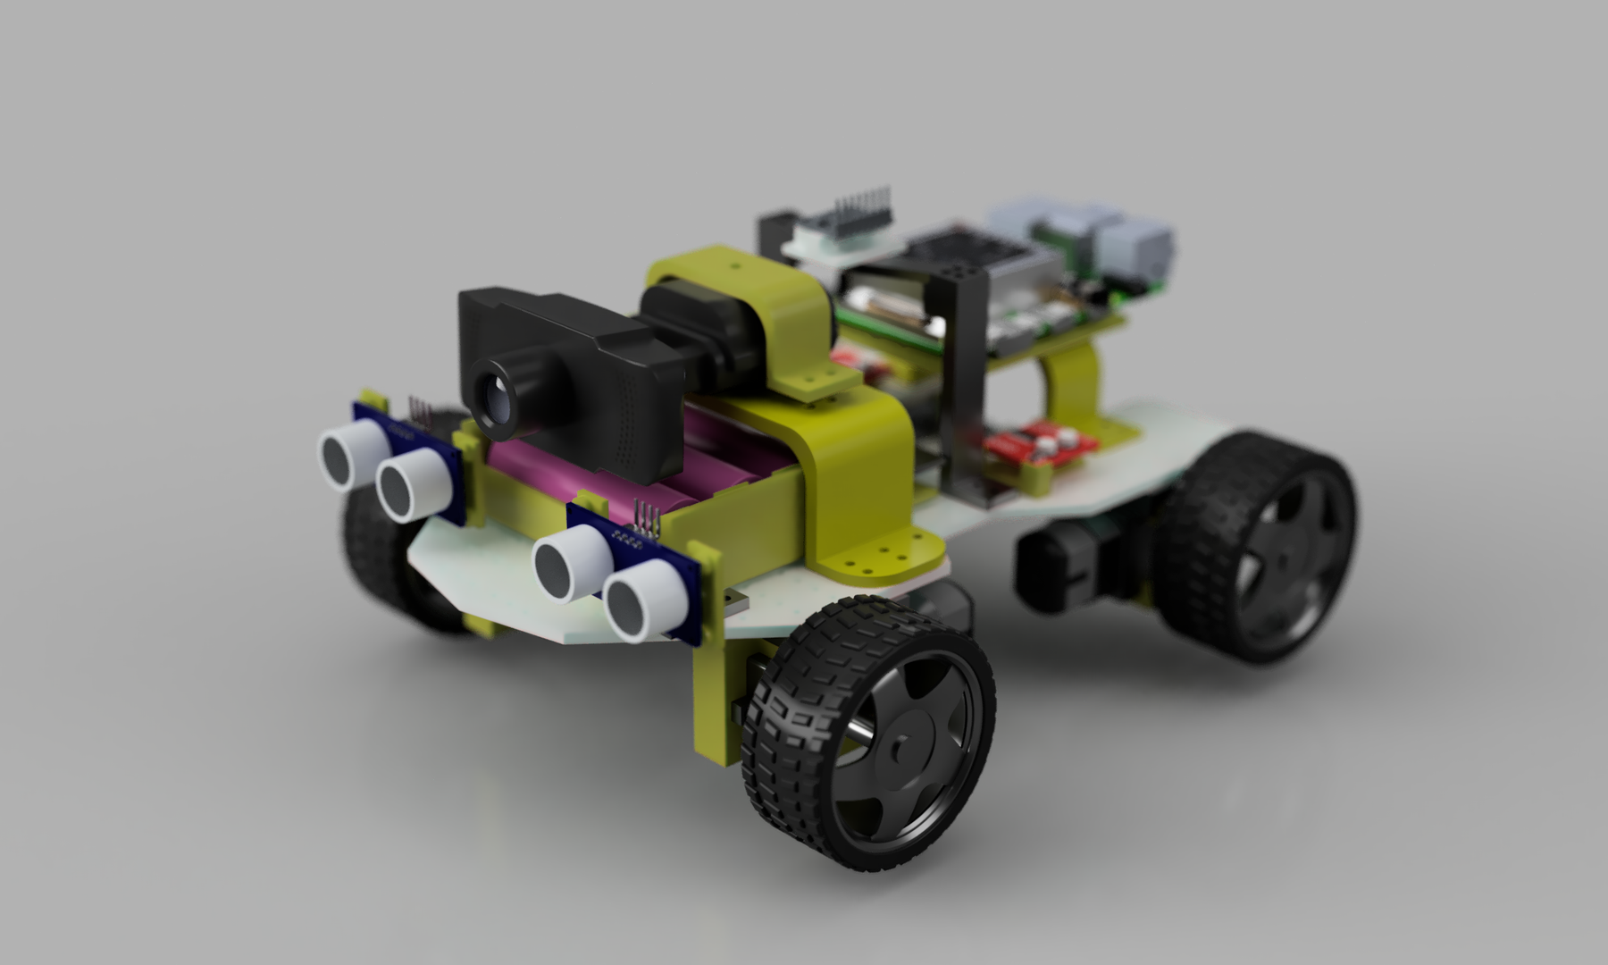
The existing render records the physical design and Raspberry Pi 4 mounting layout.
Figure 3.5: Finalized Fusion 360 robot multi-view layout
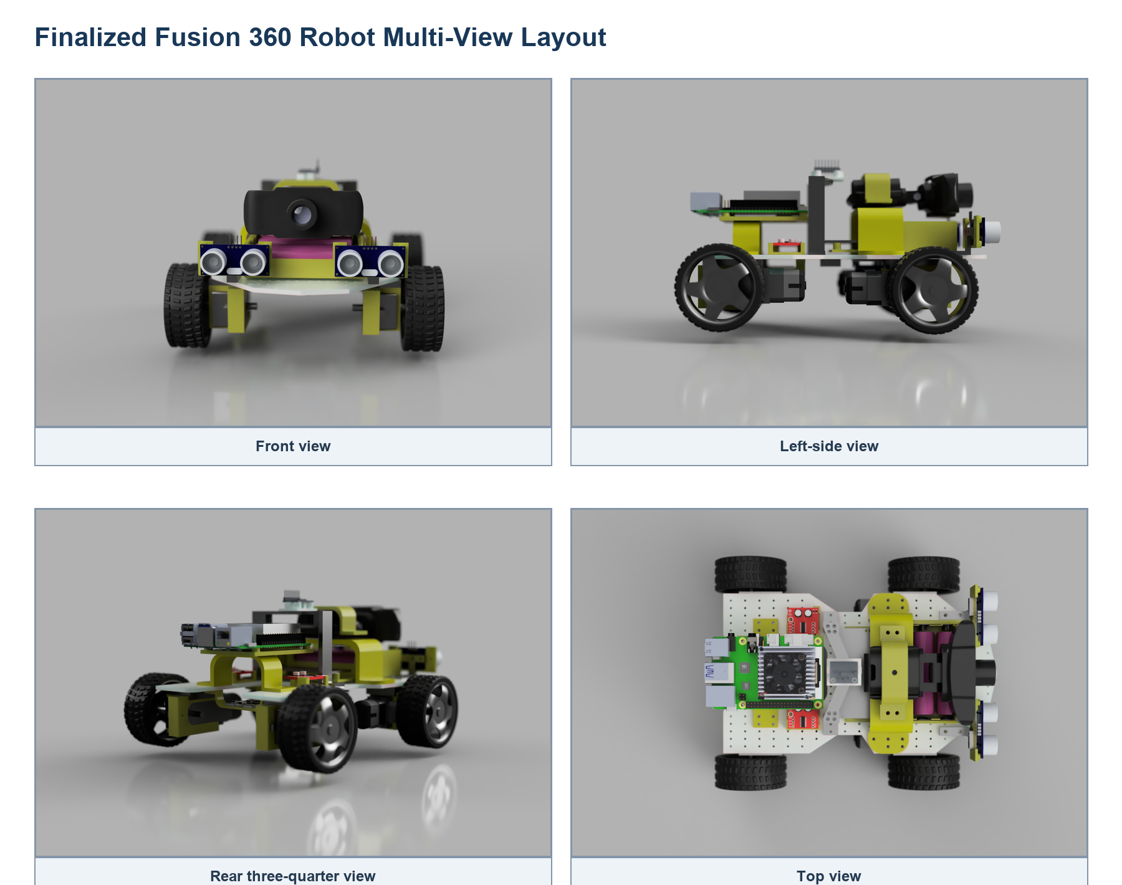
The front, side, rear, and top views support sensor visibility, wheel clearance, component spacing, cable access, and Raspberry Pi 4 mounting verification.
Figure 3.6: Finalized mechanical design sketch and dimensions
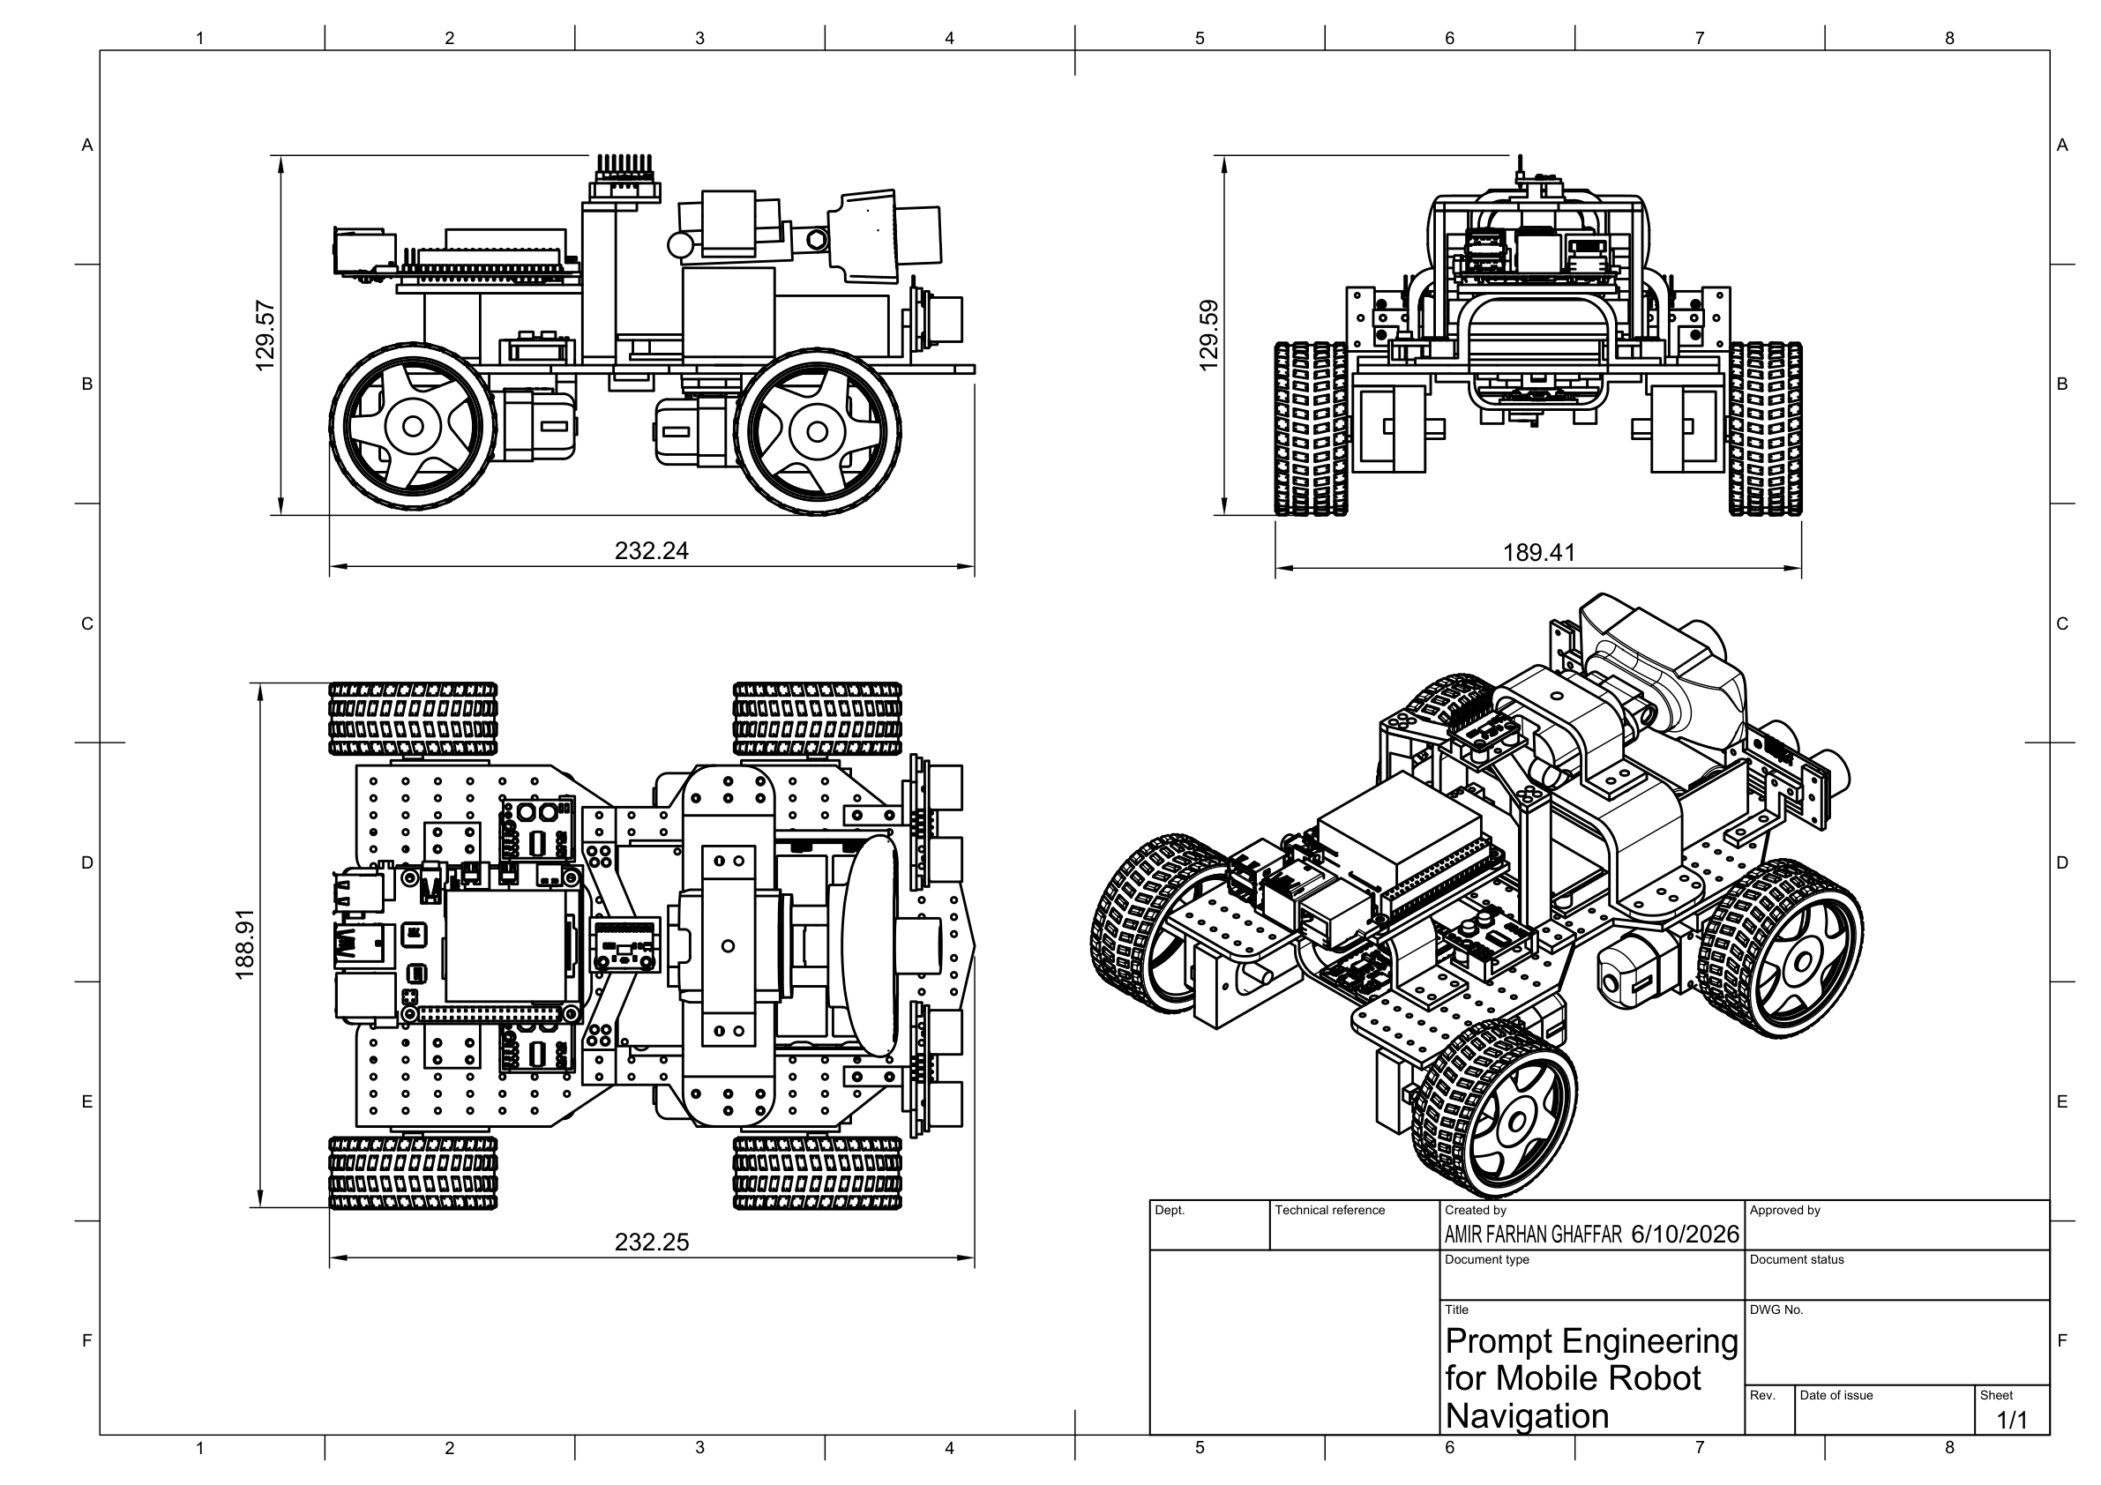
The dimensioned design sketch records an approximate overall length of 232.24 mm, width of 188.91 mm, and height of 129.57 mm. These dimensions guide fabrication, mounting, and clearance checks before physical assembly.

3.10.1 Custom-Designed and Fabricated Components
The robot design includes modular printable parts for the Raspberry Pi 4, ESP32, battery system, motor drivers, GY-291, webcam, and both ultrasonic sensors. These mounts organize components, maintain sensor visibility, and reduce movement during operation.
The STL files are stored in the project STL/ directory so that damaged or revised mounts can be reproduced without redesigning the complete chassis.

3.10.2 Finalized Circuit Architecture
An L298N is a motor driver rather than a buck converter. The finalized architecture therefore uses one separate adjustable motor buck converter and two MX1508 dual motor-driver modules.
Figure 3.7: Finalized component-based circuit architecture
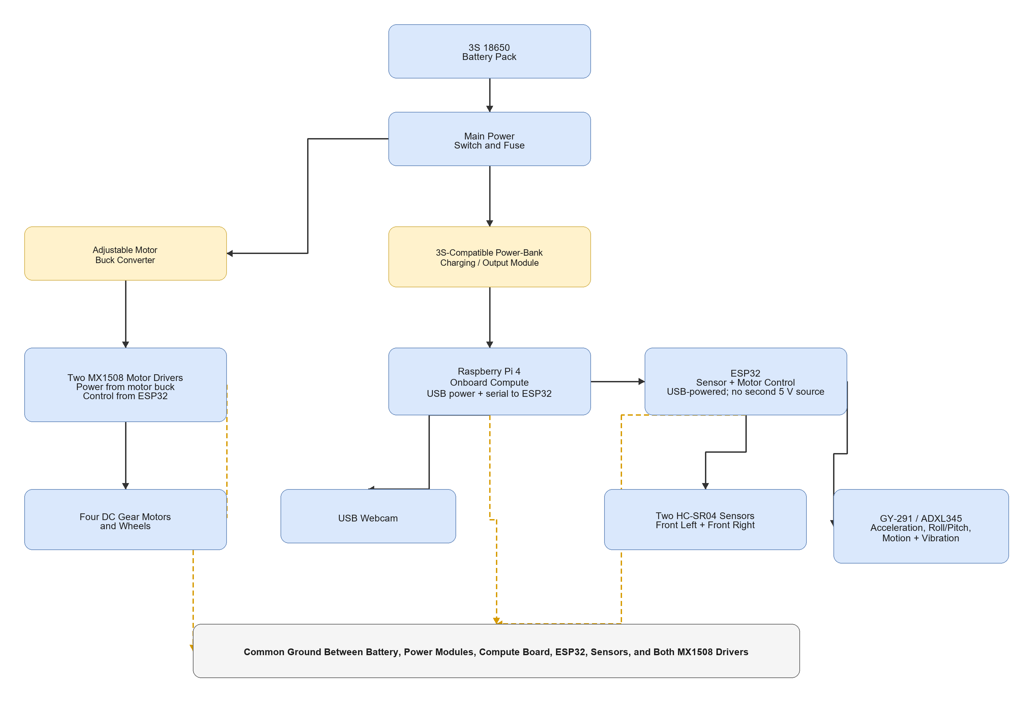
The power-bank module must explicitly support a 3S lithium-ion pack and the required continuous current. A common single-cell power-bank board must not be connected directly to the 3S pack. HC-SR04 Echo signals must be level-shifted before entering ESP32 GPIO.
Figure 3.8: Finalized ESP32 sensor and motor wiring
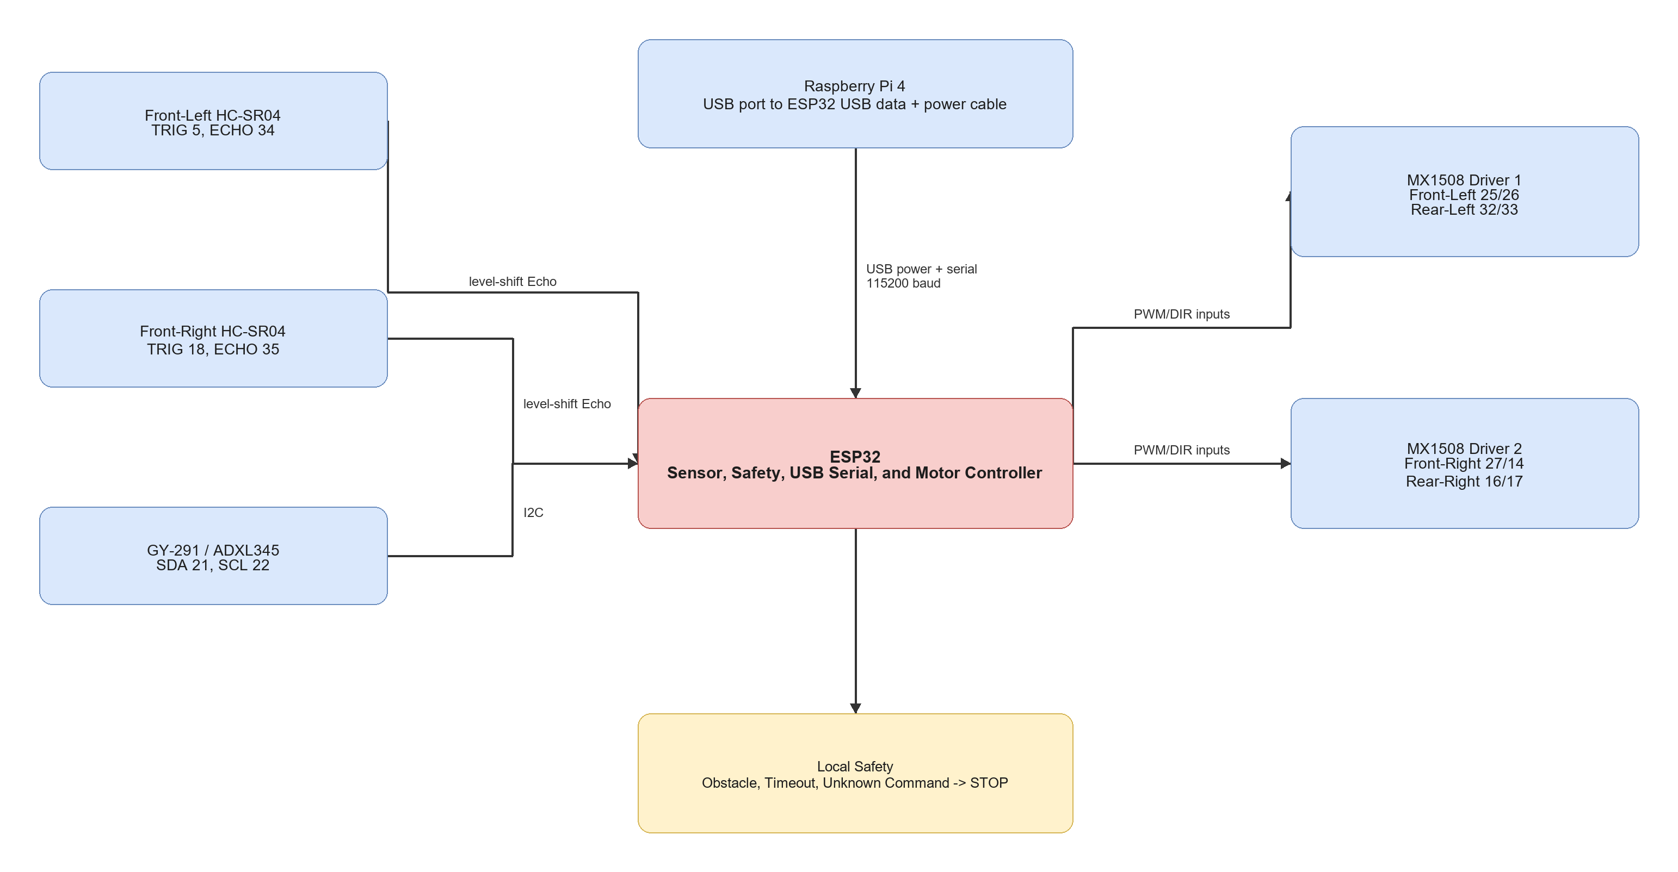

3.11 Company, Software, and Tool Involvement
Table 3.13: Company, Component, and Software Involvement

Component or Tool | Company or Organization | Involvement
Raspberry Pi 4 | Raspberry Pi Ltd | Only onboard high-level compute board
ESP32 | Espressif Systems | Low-level sensing, safety, and motor control
GY-291 / ADXL345 | Analog Devices device on third-party module | Acceleration, roll/pitch tilt, motion, vibration, and shock sensing
MX1508 modules | Supplier to be confirmed | Four-motor driver subsystem
Autodesk Fusion 360 | Autodesk | Mechanical design
Python | Python Software Foundation | High-level software
OpenCV | OpenCV project | Webcam processing and marker grounding
Arduino framework | Arduino project / Espressif ecosystem | ESP32 firmware
Docker | Docker, Inc. | Isolated laptop expected-results demonstration
diagrams.net / draw.io | JGraph / diagrams.net | Report diagrams

3.12 Software Implementation and Coding
Table 3.14: Source Code and Documentation Modules

File or Module | Target | Purpose | Status
docs/raspberry_pi_4_full_software_setup.md | Documentation | Raspberry Pi OS-to-final-result setup | Provided
docs/circuit_wiring_guide.md | Documentation | Exact Raspberry Pi, ESP32, sensor, and MX1508 wiring | Provided
docs/laptop_only_expected_results_setup.md | Documentation | Separate Docker-based FYP1 expected-results demonstration | Provided
src/raspberry_pi_robot/robot_controller.py | Raspberry Pi 4 | Prompt parser, OpenCV grounding, action selection, USB serial, and logging | Provided
src/laptop_expected_results/web_app.py | Docker laptop demo | Browser-webcam frame processing and expected action output | Provided
firmware/esp32_robot_controller/esp32_robot_controller.ino | ESP32 | USB serial, sensors, safety, and four-motor control | Provided

3.13 Equations and Decision Rules
Table 3.15: Main Equations and Decision Rules

Equation or Rule | Description | Evaluation Use
d_cm = t_echo_us / 58 | HC-SR04 distance approximation | Convert Echo duration to centimetres
Prompt Validity = N_valid / N_total * 100 percent | Valid structured-output percentage | Prompt reliability
Accuracy = N_correct / N_total * 100 percent | General correctness percentage | Grounding and action metrics
T_total = T_prompt + T_capture + T_grounding + T_sensor + T_comm | End-to-end response time | Raspberry Pi latency
a_exec = stop for invalid output, high uncertainty, obstacle, sensor fault, timeout, or invalid action | Safety decision rule | Safe-failure evaluation
Movement Success Rate = N_success / N_scenarios * 100 percent | Successful simple-goal percentage | Physical robot behaviour
a_mag = sqrt(a_x^2 + a_y^2 + a_z^2) | Total measured acceleration magnitude | Motion, vibration, and shock observation

3.14 Implementation Procedure
Table 3.16: Implementation Procedure

Stage | Activity | Verification | Expected Result
Stage 1 | Verify completed power rails and common ground | Multimeter and load test | Stable compute and motor supplies
Stage 2 | Wire ESP32, sensors, and both MX1508 drivers | Continuity and pin-map review | Correct signal wiring
Stage 3 | Flash ESP32 and connect it to Raspberry Pi by USB | PING and sensor-status test | Stable commands and JSON status
Stage 4 | Test four motors with wheels raised | Individual and combined action tests | Correct movement directions
Stage 5 | Install Raspberry Pi OS and test webcam | Camera capture test | Working Raspberry Pi platform
Stage 6 | Run Raspberry Pi controller without --execute | Dry-run logs | Correct prompt, grounding, action, and STOP command
Stage 7 | Enable supervised raised-wheel movement | End-to-end command test | Correct action-to-motor behaviour
Stage 8 | Run controlled floor scenarios | Scenario checklist and logs | Measured basic-goal results

3.15 Testing and Validation Plan
Table 3.17: Testing and Validation Matrix

Test Stage | Test Setup | Metric | Pass Criteria
Prompt format test | Supported and unsupported instructions | Prompt output validity | Required fields parse correctly
Webcam test | USB webcam on Raspberry Pi | Frame capture success | Reliable usable frames
Grounding test | Supported marker in controlled views | Grounding correctness | Correct match or safe search
USB serial test | Raspberry Pi and ESP32 | Command/status reliability | Repeated valid exchanges
Ultrasonic test | Two front sensors | Distance availability and error | Both sensors report usable values
GY-291 test | Stationary, tilted, moved, and lightly vibrated robot | Plausibility and response | Expected changes are observable
Motor test | Two MX1508 modules and four motors | Movement correctness | All approved actions work
Safety test | Obstacle, sensor fault, timeout, invalid command, and uncertainty | Safe-stop rate | Robot stops safely
Full scenario test | Controlled green marker | Goal completion | Intended basic behaviour is completed

3.16 Evaluation Metrics
Table 3.18: Evaluation Metrics

Metric | Description
Prompt output validity | Percentage of outputs containing all required fields
Supported-target extraction accuracy | Percentage of correctly extracted supported targets
Visual grounding correctness | Percentage of correctly grounded marker conditions
Action-selection accuracy | Percentage of expected selected actions
End-to-end latency | Time from instruction and frame input to validated action
USB serial reliability | Percentage of valid command and sensor-status exchanges
Safe-stop rate | Percentage of unsafe cases correctly stopped
Movement success rate | Percentage of completed simple-goal scenarios
GY-291 response | Plausibility of acceleration, tilt, motion, and vibration observations
Power stability | Resets, voltage drops, or failures during testing

3.17 Safety, Limitations, and Future Work
Testing must use the completed protected power system, fuse, reachable main switch, correct regulated rails, and a common ground. Motor tests begin with the robot raised. HC-SR04 Echo pins require level shifting. During the first prototype, the ESP32 is powered only by the Raspberry Pi USB cable.
The robot stops for invalid output, high uncertainty, obstacle detection, sensor fault, unknown commands, or command timeout. Testing is supervised in a controlled indoor area, and webcam testing avoids recording identifiable people without permission.
The USB webcam does not provide dense depth or a 3D map. Two ultrasonic sensors provide limited obstacle coverage. The GY-291 does not provide yaw heading. The Raspberry Pi 4 has limited performance for large models, and the first prototype supports only simple coloured-marker goals.
Future work may include lightweight object detection, API-based VLM experiments, wheel encoders, magnetometer or full IMU, RGB-D camera, LiDAR, mapping, relation-aware prompts, and stronger navigation policies.

3.18 Summary
This chapter finalized the methodology around one Raspberry Pi 4 physical robot. The project connects structured prompt processing and OpenCV visual grounding to an ESP32 that independently handles sensors, safety, and four-motor control.
The first measurable target is a reliable and safe single-goal indoor marker-navigation demonstration.

CHAPTER 4
EXPECTED RESULTS AND DISCUSSION

4.1 Introduction
This chapter presents the expected results for FYP1. The expectations are based on the finalized Raspberry Pi 4 architecture, structured prompt design, completed physical hardware, ESP32 safety logic, Docker laptop expected-results demonstration, and planned physical validation. Final measured robot results will be presented during FYP2.

4.2 Expected Basic Prototype Result
The first Raspberry Pi 4 prototype is expected to complete the simple and repeatable goal find the green marker. The instruction should be converted into a structured target and approved action set. OpenCV colour grounding should locate the marker in the webcam view and select an action from its image position.
Table 4.1: Summary of Expected Basic Prototype Results

Condition | Expected Result
Clear supported marker instruction | Produces a valid structured target and low uncertainty
Unsupported or unclear instruction | Stops safely
Marker not visible | Selects search
Marker visible on left or right | Selects the corresponding turn action
Marker centred and not close | Selects move_forward
Marker reaches configured goal size | Selects stop
Ultrasonic obstacle, sensor fault, or command timeout | ESP32 forces stop

4.3 Expected Docker Laptop Demonstration
The laptop-only Docker demonstration is expected to show the same planned action interface before physical robot testing. A browser captures a coloured marker through the laptop webcam and sends frames to the containerized Python/OpenCV service. The application displays TURN LEFT, TURN RIGHT, MOVE FORWARD, SEARCH, or STOP, and the user manually moves the laptop according to the displayed action.
Table 4.2: Expected Raspberry Pi Physical and Docker Demonstration Roles

Area | Raspberry Pi 4 Physical Prototype | Laptop Docker Expected-Results Demonstration
Camera input | Robot-mounted USB webcam | Laptop browser webcam
Processing | Onboard Python and OpenCV | Containerized Flask, Python, OpenCV, and NumPy
Action output | Validated command sent to ESP32 | Instruction displayed on screen for manual movement
Result status | Final physical robot result during FYP2 | Expected-results evidence only

This demonstration provides expected-results evidence only. It is not a second physical implementation and is not used as the final robot result.

4.4 Expected Safety Simulations
The ESP32 uses the minimum reading from the two front HC-SR04 sensors. With the planned 25 cm threshold, the robot is expected to stop when either valid sensor reading is below 25 cm.
Figure 4.1: Expected obstacle-stop response at the planned 25 cm threshold
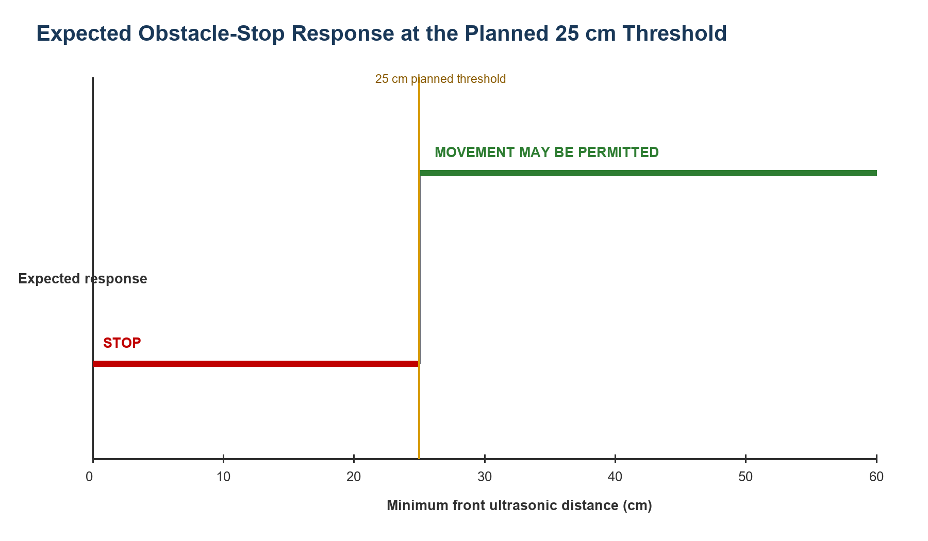
The ESP32 also applies a 1,000 ms command timeout. If no new valid command is received within this period, all motor outputs are expected to stop.
Figure 4.2: Expected motor response when the command timeout exceeds 1,000 ms
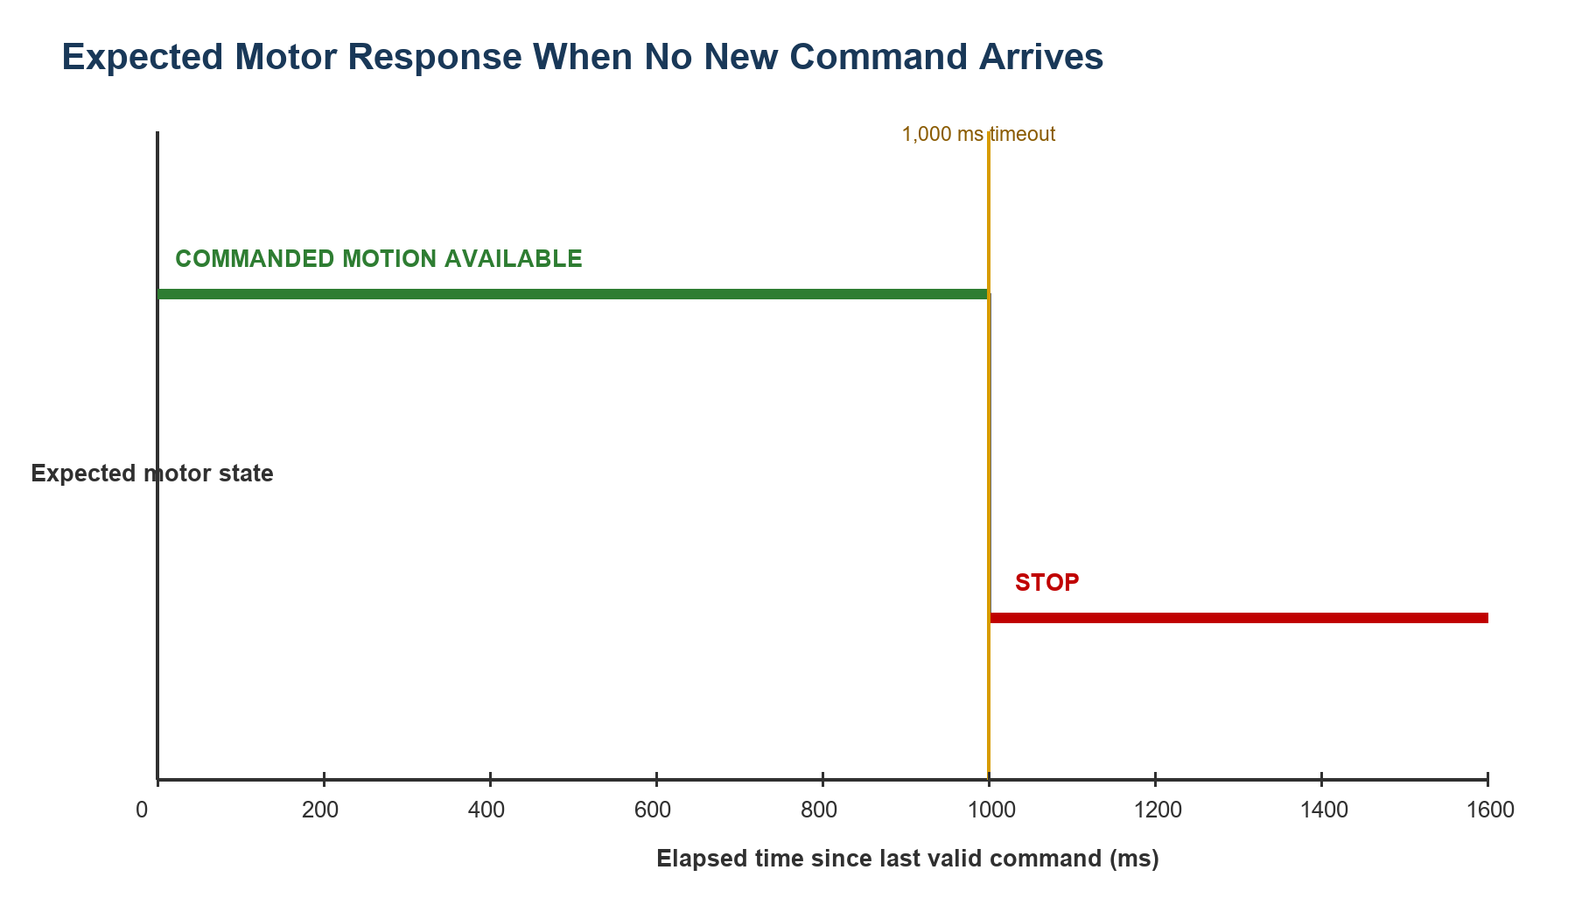
These simulations demonstrate the intended decision logic only. The final distance threshold and physical stopping response require calibration and repeated testing during FYP2.

4.5 Required FYP2 Results
Table 4.3: Required FYP2 Measurements

Evaluation Area | Required Measurement
Prompt engineering | Structured output validity and supported-target extraction accuracy
Visual grounding | Marker-grounding correctness and safe missing-target behaviour
Raspberry Pi performance | OpenCV processing and end-to-end action latency
USB communication | Command and sensor-status reliability
Sensors and safety | Ultrasonic error, GY-291 response, timeout, and safe-stop success
Robot movement | Action correctness and simple-goal completion rate
Power system | Voltage stability, resets, current, and operating duration

4.6 Discussion
The expected results suggest that structured prompt engineering can provide a simple interface between a natural-language goal and a restricted robot action set. The Raspberry Pi 4 is expected to provide a flexible environment for Python, OpenCV, USB devices, logging, and later model experiments, while the ESP32 independently prevents movement during obstacle, sensor-fault, timeout, and invalid-command conditions.
The basic marker goal is intentionally limited. Demonstrating it reliably is more valuable than claiming complex navigation without sufficient sensor coverage, mapping, or model capability. Once the baseline is verified, the project can extend to object detection for indoor landmarks and more complex instructions.

4.7 Summary
This chapter presented the expected FYP1 outcomes for the Raspberry Pi 4 prototype, Docker laptop expected-results demonstration, and safety logic. Final physical results will measure whether the robot can safely find and approach a supported visual landmark.

REFERENCE
Cheng, A.-C., Ji, Y., Yang, Z., Gongye, Z., Zou, X., Kautz, J., Biyik, E., Yin, H., Liu, S., & Wang, X. (2025). NaVILA: Legged robot vision-language-action model for navigation. *Proceedings of Robotics: Science and Systems*. https://doi.org/10.15607/RSS.2025.XXI.018
Goetting, D., Singh, H. G., & Loquercio, A. (2024). *End-to-end navigation with vision language models: Transforming spatial reasoning into question-answering*. arXiv. https://doi.org/10.48550/arXiv.2411.05755
Huang, C., Mees, O., Zeng, A., & Burgard, W. (2023). Visual language maps for robot navigation. *Proceedings of the IEEE International Conference on Robotics and Automation (ICRA)*. https://vlmaps.github.io/
Shah, D., Osinski, B., Ichter, B., & Levine, S. (2023a). LM-Nav: Robotic navigation with large pre-trained models of language, vision, and action. *Proceedings of the 6th Conference on Robot Learning, Proceedings of Machine Learning Research, 205*, 492-504. https://proceedings.mlr.press/v205/shah23b.html
Shah, D., Sridhar, A., Dashora, N., Stachowicz, K., Black, K., Hirose, N., & Levine, S. (2023b). ViNT: A foundation model for visual navigation. *Proceedings of the 7th Conference on Robot Learning, Proceedings of Machine Learning Research, 229*, 711-733. https://proceedings.mlr.press/v229/shah23a.html
Sridhar, A., Shah, D., Glossop, C., & Levine, S. (2023). *NoMaD: Goal masked diffusion policies for navigation and exploration*. arXiv. https://arxiv.org/abs/2310.07896
Werby, A., Huang, C., Buchner, M., Valada, A., & Burgard, W. (2024). Hierarchical open-vocabulary 3D scene graphs for language-grounded robot navigation. *Proceedings of Robotics: Science and Systems*. https://doi.org/10.15607/RSS.2024.XX.077
Zhang, J., Wang, K., Xu, R., Zhou, G., Hong, Y., Fang, X., Wu, Q., Zhang, Z., & Wang, H. (2024). NaVid: Video-based VLM plans the next step for vision-and-language navigation. *Proceedings of Robotics: Science and Systems*. https://doi.org/10.15607/RSS.2024.XX.079
Zhang, J., Wang, K., Wang, S., Li, M., Liu, H., Wei, S., Wang, Z., Zhang, Z., & Wang, H. (2026). Uni-NaVid: A video-based vision-language-action model for unifying embodied navigation tasks. *Robotics: Science and Systems 2026 Program*. https://roboticsconference.org/program/papers/13/

