PROMPT ENGINEERING FOR
MOBILE ROBOT NAVIGATION

AMIR FARHAN BIN GHAFFAR



DEPARTMENT OF MECHATRONICS ENGINEERING KULLIYAH OF ENGINEERING

INTERNATIONAL ISLAMIC UNIVERSITY MALAYSIA
JUNE 2026

PROMPT ENGINEERING FOR
MOBILE ROBOT NAVIGATION

AMIR FARHAN BIN GHAFFAR

Project Supervisor: Assoc. Prof. Ts. Dr. Hasan Firdaus Bin Mohd Zaki



A REPORT SUBMITTED IN PARTIAL FULFILMENT OF THE REQUIREMENT FOR A DEGREE OF BACHELOR OF MECHATRONICS ENGINEERING WITH HONOURS

ACKNOWLEDGEMENTS

I would like to express my sincere appreciation to my supervisor, Dr. Hasan Firdaus Bin Mohd Zaki, for his guidance, advice, and support throughout this Final Year Project. I am also thankful to the Kulliyyah of Engineering, Mechatronics Department, International Islamic University Malaysia (IIUM) for providing facilities and a good environment to carry out this project. Lastly, I would like to thank my friends who helped and supported me during the process, as well as my family for their encouragement and motivation.

LIST OF ABBREVIATIONS

IIUM International Islamic University Malaysia
AUV Autonomous Underwater Vehicle
BMS Battery Management System
BoM Bill of Materials
CB Centre of Buoyancy
CAD Computer-Aided Design
CG Centre of Gravity
DC-DC Direct Current to Direct Current (converter)
DOF Degree(s) of Freedom
ESC Electronic Speed Controller
FPS Frames Per Second
GND Ground (negative terminal)
IMU Inertial Measurement Unit
LAN Local Area Network
PWM Pulse Width Modulation
ROV Remotely Operated Vehicle
SBC Single Board Computer
UDP User Datagram Protocol
USB Universal Serial Bus
VCC Positive Supply Voltage

CHAPTER 1
INTRODUCTION

1.1 Overview
Mobile robots are increasingly used in indoor environments for inspection, assistance, delivery, monitoring, and research. For a robot to be useful to a non-technical user, the interaction method should be simple and natural. Instead of requiring coordinates, joystick control, or programming commands, a user should be able to provide an instruction such as "Go to the door", "Find the signboard", or "Move toward the chair near the table".
Natural-language mobile robot navigation is challenging because a human instruction must be converted into information that a robot can understand and execute. The robot must identify the intended target, recognize relevant landmarks or spatial relations, connect the instruction with its current camera view, choose an appropriate movement action, and stop safely when the action is uncertain or an obstacle is detected.
This Final Year Project investigates how structured prompt engineering can support this process on a low-cost indoor mobile robot. The proposed system adapts the modular language-to-vision-to-action concept demonstrated by LM-Nav and the prompt-based action-selection idea used by VLMnav. The project does not attempt to reproduce a large autonomous navigation platform. Instead, it develops a practical student-level prototype that connects natural-language instructions, USB-webcam observations, onboard processing, ESP32 sensor feedback, and a restricted set of safe movement commands.
Two physical implementation approaches are designed and compared:
1. Raspberry Pi 4 with ESP32.
2. Coral Dev Board with ESP32.
Both approaches use the same four-wheel chassis, USB webcam, two front HC-SR04 ultrasonic sensors, GY-291 / ADXL345 accelerometer, two MX1508 motor-driver modules, four DC gear motors, and shared battery and power architecture. This shared platform allows the effect of the high-level compute board and compatible model runtime to be studied while the mechanical and low-level control systems remain consistent.

1.2 Background and Motivation
Traditional mobile robot navigation commonly uses maps, localization, path planning, and sensor feedback. These methods are effective when the destination is represented by coordinates or predefined waypoints. However, ordinary users normally describe destinations using natural language and visual concepts. A person may refer to a door, table, chair, corridor, or signboard without knowing its exact position.
Recent language models and vision-language models provide new methods for interpreting these instructions. Prompt engineering can constrain a model to return a structured response containing the target, landmarks, spatial relation, intended action, and uncertainty. Visual grounding can then connect the structured target to an image captured by the robot. These techniques may reduce the complexity of human-robot interaction, but direct model output should not be allowed to control a physical robot without validation.
The motivation for this project is therefore to investigate a balanced architecture. High-level language and visual processing are performed by a Raspberry Pi 4 or Coral Dev Board, while an ESP32 handles time-sensitive sensor reading, motor commands, obstacle detection, and command-timeout safety. This division provides a practical way to explore prompt-based robot navigation without depending on expensive sensors or allowing uncertain model output to bypass local safety rules.

1.3 Problem Statement
Natural-language instructions are intuitive for humans but are not directly usable by a mobile robot. Instructions may be ambiguous, incomplete, or dependent on objects visible in the environment. A free-form response from a language or vision-language model is also difficult to connect reliably to motor control because it may contain unsupported actions, inconsistent wording, or excessive explanation.
Low-cost mobile robot platforms introduce additional constraints. A USB webcam does not provide depth or a complete map. The Raspberry Pi 4 has limited resources for large vision-language models, while the Coral Dev Board can accelerate only compatible quantized TensorFlow Lite models. Small ultrasonic sensors provide limited obstacle coverage, and low-cost motor drivers and battery modules must be integrated carefully to avoid unstable or unsafe operation.
There is therefore a need for a low-cost system that can convert simple natural-language indoor navigation instructions into structured, machine- readable information, ground the target using a webcam image, restrict the result to an approved action set, and validate the action using local sensor and safety information before movement. The system should also allow two onboard compute approaches to be compared fairly using the same physical robot platform.

1.4 Research Questions
This project addresses the following research questions:
1. How can structured prompt engineering convert simple indoor navigation instructions into consistent machine-readable targets, landmarks, spatial relations, actions, and uncertainty?
2. How can webcam-based visual grounding and ESP32 sensor feedback be combined to validate simple robot actions safely?
3. What are the practical differences between Raspberry Pi 4 and Coral Dev Board implementations when they use the same robot hardware, instructions, scenarios, action set, and safety rules?

1.5 Aim and Objectives
The aim of this project is to design, implement, and compare two low-cost onboard prompt-engineered mobile robot navigation approaches for controlled indoor environments.
The objectives are:
1. To develop a structured prompt-engineering pipeline that converts natural-language indoor navigation instructions into fixed navigation fields and an approved action set.
2. To design and integrate a shared four-wheel mobile robot platform using an ESP32, USB webcam, two HC-SR04 sensors, GY-291 / ADXL345 accelerometer, two MX1508 motor drivers, and a protected power architecture.
3. To implement and compare Raspberry Pi 4 and Coral Dev Board onboard navigation approaches using common scenarios, evaluation metrics, and local safety validation.

1.6 Research Scope
The project is limited to a low-cost four-wheel indoor mobile robot operating in controlled areas such as corridors, rooms, laboratories, and landmark test zones. The language scope covers short instructions involving common indoor landmarks and relations, including doors, chairs, tables, corridors, and signboards.
The approved robot action set is limited to move_forward, turn_left, turn_right, search, and stop. The selected compute board performs prompt processing, webcam capture, visual grounding or action selection, validation, and logging. The ESP32 reads the two ultrasonic sensors and GY-291, controls the four motors through two MX1508 modules, and enforces obstacle, invalid-command, and command-timeout stop behavior.
The project compares exactly two onboard approaches: Raspberry Pi 4 with ESP32 and Coral Dev Board with ESP32. Both use the same chassis and low-level hardware. The GY-291 is used for X/Y/Z acceleration, gravity-based roll and pitch tilt, motion, vibration, and shock observations. It is not treated as a heading sensor.
Advanced functions such as full simultaneous localization and mapping, precise coordinate navigation, wheel-encoder odometry, autonomous route planning, LiDAR, RGB-D perception, and unrestricted large-model control are outside the current scope. Physical testing is performed only in supervised indoor conditions at low speed.

1.7 Significance of the Project
The project contributes a practical framework for connecting prompt engineering with a real low-cost robot. Its structured output makes model decisions easier to parse, log, evaluate, and reject when unsafe. Separating high-level processing from ESP32 local control also demonstrates how model-based navigation can be combined with deterministic safety behavior.
The two-approach comparison provides useful engineering evidence about the trade-off between the Raspberry Pi 4's flexible Linux and Python environment and the Coral Dev Board's efficient but specialized Edge TPU-compatible inference. The finalized CAD design, mounting parts, wiring architecture, firmware, and validation plan also provide a reusable platform for future work on visual navigation, mapping, and stronger perception models.

1.8 Organization of the Thesis
Chapter 1 introduces the project background, problem statement, research questions, objectives, scope, and significance. Chapter 2 reviews related work on language-guided navigation, prompt engineering, visual grounding, navigation models, and suitable low-cost hardware. Chapter 3 presents the research methodology, system architecture, mechanical and electrical design, implementation procedure, and validation plan. Chapter 4 presents the expected FYP1 results, discusses the anticipated system behavior, and defines the measurements required for the final Raspberry Pi 4 and Coral Dev Board comparison during FYP2.

1.9 Summary
This chapter established the need for a structured and safety-aware approach to natural-language mobile robot navigation. The project addresses this need by developing two onboard compute approaches that share one low-cost physical robot platform and one ESP32 safety and motor-control layer.

CHAPTER 2
LITERATURE REVIEW

2.1 Introduction
This chapter reviews literature related to Prompt Engineering for Mobile Robot Navigation. The project investigates how a mobile robot can receive a natural language instruction, extract useful navigation information, ground the instruction using visual input, and convert the result into simple movement commands. The work is positioned as a low-cost indoor Final Year Project (FYP) research prototype rather than an industry-level autonomous navigation system.
The main baseline paper for this project is LM-Nav: Robotic Navigation with Large Pre-Trained Models of Language, Vision, and Action by Shah et al. (2023a). LM-Nav is important because it presents a modular architecture for language-guided navigation. Its pipeline separates the problem into language understanding, visual grounding, and navigation execution. This structure is suitable for this FYP because the same idea can be adapted into two practical low-cost physical robot approaches: a Raspberry Pi 4 robot with ESP32 low-level control and a Coral Dev Board robot with ESP32 low-level control.
The project does not attempt to reproduce the complete hardware capability of LM-Nav or newer large-scale navigation systems. Instead, the project adapts the core research idea into a student-level physical robot implementation. A user may give instructions such as "Go to the door", "Find the signboard", or "Move toward the chair near the table". The selected compute board uses prompt engineering to produce structured navigation information, uses the USB-webcam image for visual grounding or action selection, validates the proposed action using ESP32 sensor status, and sends a simple command such as move_forward, turn_left, turn_right, stop, or search to the ESP32 motor-control layer.
Several related works are reviewed to clarify the project scope. VLMnav is included as the main prompt and action-selection reference because it formulates navigation as a question-answering or action-choice task. VLMaps and HOV-SG are reviewed because they improve spatial grounding, but they require map construction, RGB-D sensing, or scene graph construction, so they are treated as future work rather than the main implementation. ViNT and NoMaD are reviewed as stronger navigation execution models, but they are not the main focus because this FYP emphasizes prompt engineering, visual grounding, and simple action control. More recent VLM and VLA navigation systems such as NaVid, Uni-NaVid, and NaVILA are also discussed as advanced research directions.
The aim of this chapter is therefore not only to describe related papers, but also to critically compare their suitability for a low-cost indoor robot prototype.

2.2 Mobile Robot Navigation and Natural Language Instructions
Mobile robot navigation normally requires a robot to perceive its environment, decide where to move, and execute motion safely. Traditional navigation systems often rely on a map, localization, path planning, obstacle detection, and low-level motor control. These systems are effective when the goal is specified in a robot-readable form, such as a coordinate, waypoint, or selected map location. However, this interaction style is not natural for non-technical users.
Natural language provides a more intuitive interface. A user can describe a goal using objects, places, and relations, for example "go to the door", "find the signboard", or "move toward the chair near the table". These instructions are simple for humans, but they are difficult for robots because they contain semantic meaning that must be connected to the physical environment.
Language-guided navigation therefore requires three main capabilities. First, the robot must understand the user's instruction. Second, it must ground the instruction in visual input or spatial knowledge. Third, it must convert the result into movement. This general process is shown in Figure 2.1.
Figure 2.1: General language-guided navigation process
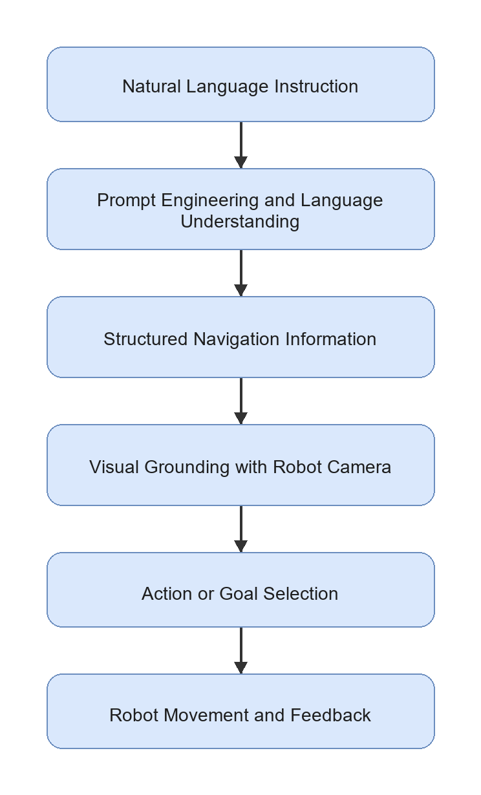
For this FYP, the navigation problem is intentionally limited to indoor environments such as a corridor, room, laboratory, door area, table area, chair area, or signboard location. This limitation is necessary because the proposed hardware uses a USB webcam and simple wheeled motion, not LiDAR, RGB-D SLAM, or high-cost navigation hardware. The controlled environment makes it possible to evaluate the core research question: whether structured prompt engineering can produce useful navigation information for a simple mobile robot.

2.3 Prompt Engineering for Robot Navigation
Prompt engineering is the design of model instructions, examples, constraints, and output formats so that an LLM or VLM produces useful responses. In robot navigation, prompt engineering is important because the model output must be connected to a physical robot. A free-form explanation is not enough. The output should contain machine-readable information such as the target object, relevant landmarks, spatial relation, action goal, suggested action, and uncertainty level.
In an LM-Nav-style system, prompt engineering can be used to extract landmarks from a natural language command. In a VLMnav-style system, prompt engineering can ask a model to choose the best next action from a fixed set. For a low-cost robot prototype, both ideas are useful. The robot does not need a complex high-level planner in the first implementation if the prompt output can be converted into a small set of validated motor commands.
Table 2.1: Roles of prompt engineering in mobile robot navigation

Role | Example Output | Purpose in This FYP
Landmark extraction | door, chair, table, signboard | Identify objects or places mentioned by the user
Target selection | target: door | Decide the main navigation goal
Spatial relation extraction | chair near table | Preserve relations that affect grounding
Route or action interpretation | move_forward, turn_left | Convert instruction meaning into simple action options
Structured output formatting | JSON-style response | Allow Python code on the selected compute platform to parse the result
Uncertainty handling | uncertainty: high | Prevent unsafe execution when the model is unsure
Visual grounding query generation | door in indoor corridor | Improve matching between text and webcam image

For this project, prompt engineering is treated as the interface between human language and robot action. The prompt must not only produce a correct sentence; it must produce an output that can be checked, logged, evaluated, and used by the onboard decision logic on the Raspberry Pi 4 or Coral Dev Board.

2.4 Vision-Language Grounding for Indoor Landmarks
Vision-language grounding is the process of connecting text descriptions to visual observations. For mobile robot navigation, this means matching a target word such as "door", "chair", "table", "corridor", or "signboard" with what the robot sees through its camera.
CLIP and OpenCLIP-style models are common choices for image-text grounding because they embed images and text into a shared feature space. A text query can be compared with an image using cosine similarity:
score(image, text) = cosine_similarity(E_image(image), E_text(text))
where E_image is the image encoder and E_text is the text encoder. The image or region with the highest score can be treated as the most relevant match. A modern VLM may also be used by asking a question such as "Does this image contain a door?" or "Which action should the robot take to find the chair near the table?"
However, visual grounding remains a limitation for low-cost robots. A USB webcam provides only RGB images and does not directly provide depth, object distance, or a 3D map. The system may also struggle when multiple similar objects are visible, when lighting is poor, or when the target is partly outside the camera view. For this reason, the proposed project focuses on simple indoor landmarks and a small action set rather than full autonomous navigation in complex environments.

2.5 LM-Nav as the Main Baseline

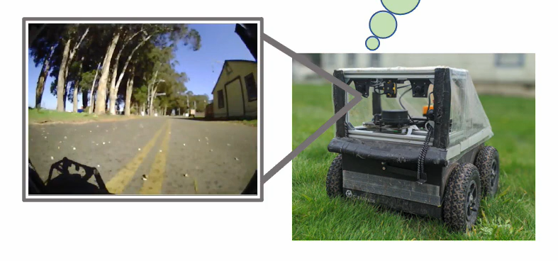

2.5.1 Overview of LM-Nav
LM-Nav: Robotic Navigation with Large Pre-Trained Models of Language, Vision, and Action by Shah et al. (2023a) is the main baseline for this project. LM-Nav addresses the problem that many visual navigation systems expect a goal image, while human users naturally provide language instructions. The paper avoids collecting a large language-annotated robot navigation dataset by composing pre-trained models.
The LM-Nav pipeline contains three main stages:
1. GPT-3 extracts landmarks from the natural language instruction.
2. CLIP grounds the extracted landmarks in visual observations.
3. ViNG navigates toward the selected visual goal.
This pipeline is shown in Figure 2.2.
Figure 2.2: LM-Nav baseline pipeline
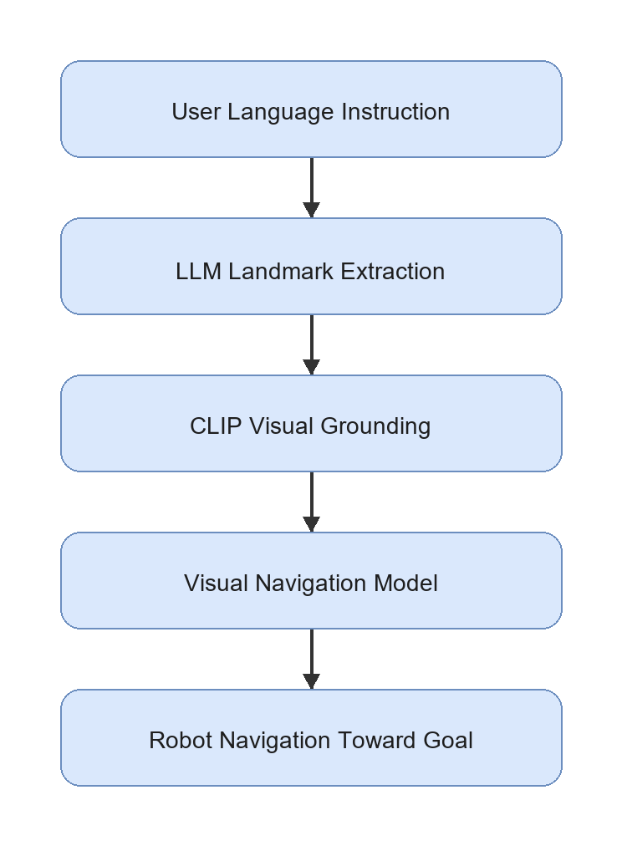

2.5.2 Strength of LM-Nav
The main strength of LM-Nav is its modular architecture. It does not require one end-to-end model that directly maps language and images to motor commands. Instead, it separates language understanding, visual grounding, and action execution. This separation is useful for research because each module can be tested and improved independently.
LM-Nav is also important because it demonstrates that pre-trained models can be combined for robot navigation without training a new language-conditioned navigation model from scratch. This idea is suitable for an FYP because collecting a large robot dataset is not realistic within the time and cost constraints of a student project.

2.5.3 Limitation of LM-Nav
LM-Nav also has limitations that motivate this project. The language module mainly extracts landmarks. This may be insufficient for instructions that include spatial relations, route order, or constraints. For example, "move toward the chair near the table" should not be reduced only to chair and table; the relation chair near table is also important.
Another limitation is hardware and navigation complexity. LM-Nav was demonstrated with a more capable outdoor robot platform and a visual navigation model. A student FYP setup using a Raspberry Pi 4 or Coral Dev Board, ESP32 sensor and motor control, USB webcam, two ultrasonic sensors, and four DC motors cannot reproduce the full navigation capability directly. Therefore, this project uses LM-Nav as an architectural inspiration, not as a full implementation target.

2.5.4 Relevance to This Project
LM-Nav provides the central structure for the proposed prototype: language understanding, visual grounding, and action execution. The difference is that this project adapts the final execution stage into a simple action-control system. Instead of using a full visual navigation policy, the Raspberry Pi 4 or Coral Dev Board chooses one of a small set of actions, checks obstacle status from the ESP32 ultrasonic module, and sends validated commands to the ESP32 motor-control layer. This makes the project realistic for a low-cost indoor robot while preserving the research value of structured prompt engineering.

2.6 VLMnav as a Prompt-Based Action Selection Reference
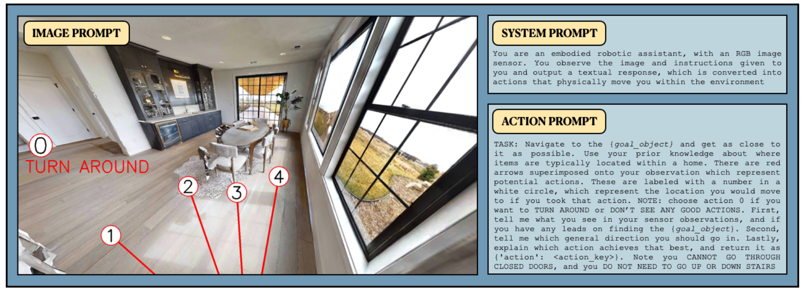
VLMnav: End-to-End Navigation with Vision Language Models by Goetting et al. (2024) is highly relevant because it formulates navigation as a question-answering problem. Instead of requiring the model to output a long navigation plan, the system can ask a VLM to choose among possible actions. This is close to the needs of the proposed robot because the first prototype only needs a small action set: move_forward, turn_left, turn_right, stop, and search.
The strength of VLMnav is that it connects visual observation, language instruction, and action selection through prompting. This supports the idea that prompt design can affect not only landmark extraction but also robot movement decisions. For example, a prompt can ask whether the current webcam image contains the target, whether the robot should turn to search, or whether it should stop because the target has been found.
The limitation is that direct VLM action selection may not be safe enough for unsupervised robot control. VLM outputs can be inconsistent, and the model may choose an action even when the target is not visible or the instruction is ambiguous. For this reason, the proposed FYP will validate the structured output, uncertainty level, model latency, and ESP32 ultrasonic obstacle status before physical motor execution. VLMnav is therefore treated as a prompt/action-selection reference, while the robot remains a controlled research prototype.

2.7 Spatial Grounding Methods: VLMaps and HOV-SG
Spatial grounding methods improve the connection between language and the physical environment. Two important examples are VLMaps and HOV-SG.

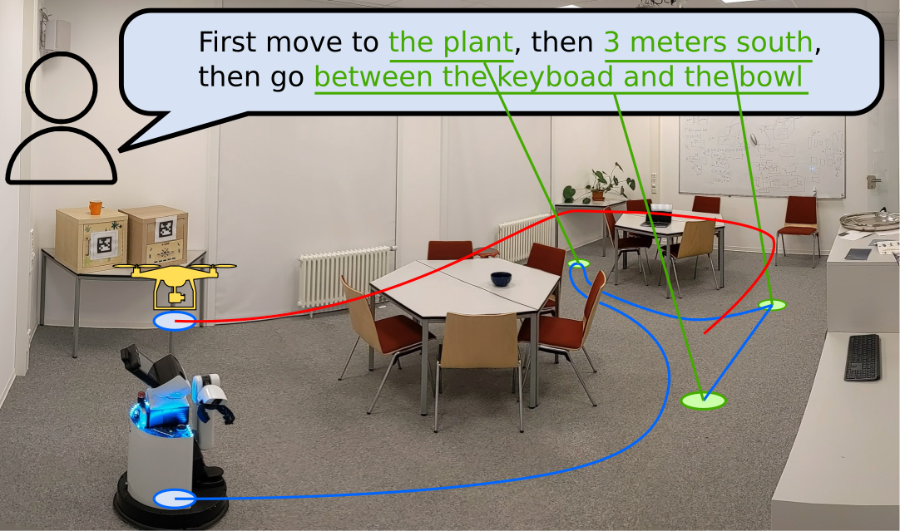
VLMaps: Visual Language Maps for Robot Navigation by Huang et al. (2023) builds an open-vocabulary visual-language map. Instead of matching a text query only to the current camera image, the robot can query a map that stores semantic visual features. The strength of VLMaps is that it provides spatial memory and can connect language to locations. Its limitation is that it requires map construction, camera pose information, and RGB-D or mapping support. This makes it more complex than the first version of the proposed FYP robot.

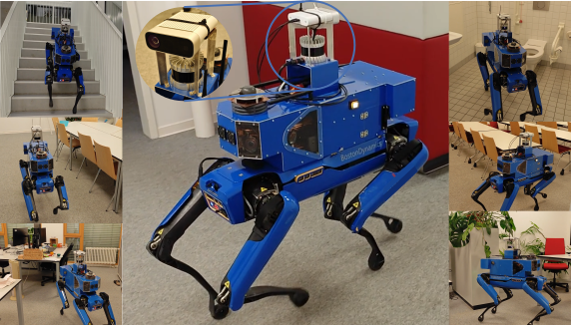
HOV-SG: Hierarchical Open-Vocabulary 3D Scene Graphs for Language-Grounded Robot Navigation by Werby et al. (2024) uses a hierarchical 3D scene graph to represent floors, rooms, and objects. This is powerful for long-horizon and multi-room navigation because the robot can reason about object and room relationships. However, it requires segmentation, 3D perception, graph construction, and more advanced sensing. This is not suitable for the first low-cost prototype, but it is valuable as a future improvement direction.
Both papers show that spatial grounding is important. They also highlight a gap for this project: a low-cost robot without RGB-D mapping still needs a way to preserve spatial relations from language. Structured prompt engineering can support this by extracting fields such as target, landmarks, and spatial_relation, even if the first implementation only uses webcam-based grounding.

2.8 Navigation Execution Models: ViNT and NoMaD
The execution stage determines how a robot physically moves toward a target. In advanced systems, this may involve a learned navigation policy, obstacle avoidance, and goal-conditioned control. ViNT and NoMaD are important because they represent stronger navigation execution methods than a simple rule-based motor command system.

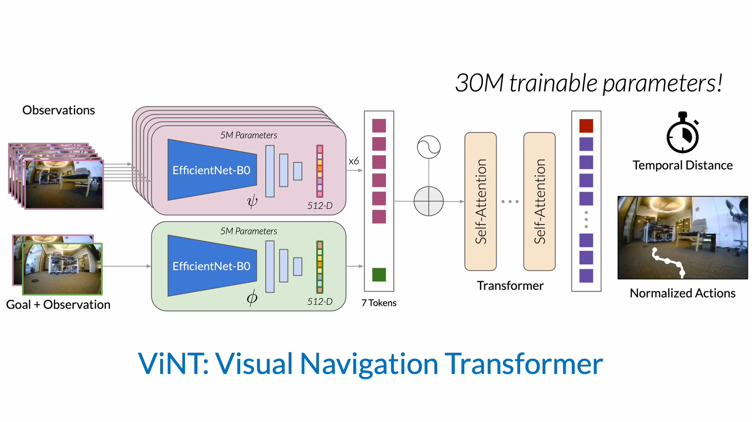
ViNT: A Foundation Model for Visual Navigation by Shah et al. (2023b) proposes a visual navigation foundation model trained across diverse robot datasets. Its strength is generalization across platforms and environments. Its limitation for this FYP is that deploying and validating a full visual navigation model is outside the main scope. This project focuses on prompt engineering, visual grounding, and simple action control, not training or deploying a foundation navigation policy.

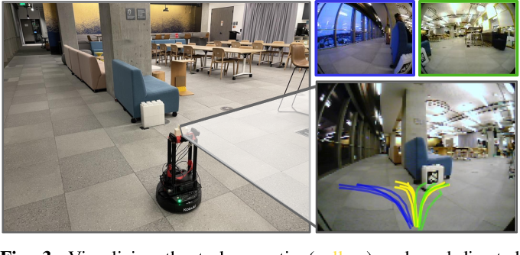
NoMaD: Goal Masked Diffusion Policies for Navigation and Exploration by Sridhar et al. (2023) uses a diffusion-based policy for goal-directed navigation and exploration. Its strength is stronger navigation behavior and exploration ability. Its limitation is that it requires a more complex policy deployment pipeline and suitable robot data. For the proposed project, NoMaD is therefore best treated as future work after the Raspberry Pi 4 and Coral Dev Board physical robot pipelines are functioning.
These works are important because they show how the simple action-control layer in this FYP could later be replaced by a stronger navigation model. However, they are not the main implementation because the research focus is prompt-engineered interpretation of natural language instructions.

2.9 Recent VLM and VLA Navigation Systems
Recent work has moved toward more integrated VLM and VLA navigation systems. These systems can reason over video, language, and action more directly than the earlier modular LM-Nav design.

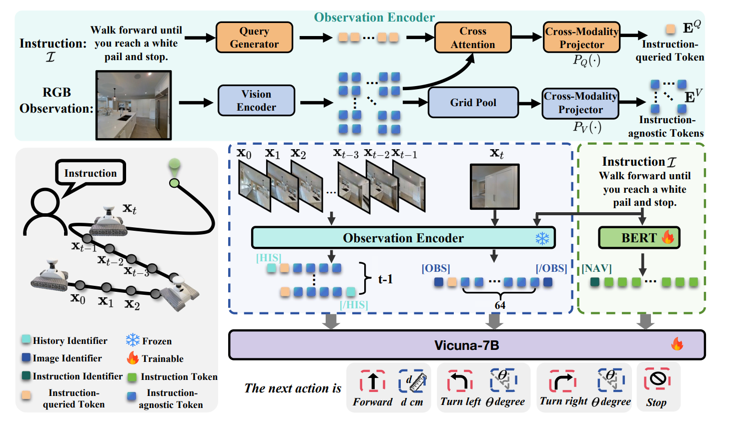
NaVid by Zhang et al. (2024) uses video-based VLM planning for vision-and-language navigation. Its strength is that it uses temporal visual context rather than a single image. This is useful for robot navigation because the current view alone may not contain enough information. Its limitation is that video-based reasoning and model inference can be expensive for a small embedded robot.

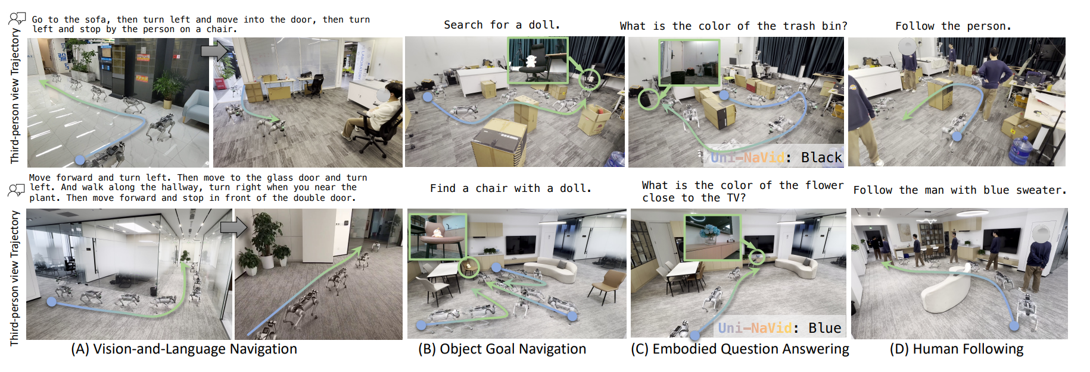
Uni-NaVid by Zhang et al. (2026) extends the video-based approach toward a unified model for multiple embodied navigation tasks. Its strength is broad task coverage. Its limitation is that the system is more advanced and resource-intensive than a first FYP prototype.
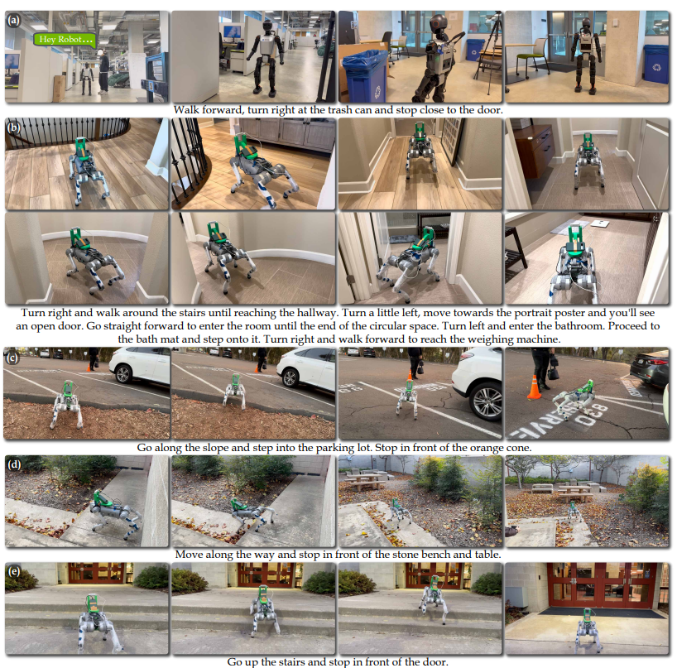
NaVILA by Cheng et al. (2025) studies VLA navigation for legged robots. Its strength is the connection between vision-language reasoning and real robot movement. Its limitation for this project is that it focuses on more complex legged platforms and server-style model pipelines, while the proposed robot is a wheeled low-cost indoor platform.
These papers are relevant because they show the direction of future navigation research. However, they also reinforce the need for a realistic baseline prototype. A student project can first demonstrate prompt-engineered instruction parsing, webcam grounding, and simple action control before attempting advanced VLA navigation.

2.10 Critical Comparison of Related Works
The reviewed papers differ significantly in method, hardware complexity, cost, and suitability for student-level implementation. Table 2.2 compares the papers based on their main method, strength, limitation, and relevance to this project.
Table 2.2: Critical comparison of related papers

Paper | Main Method | Hardware or Platform | Strength | Limitation | Relevance to This Project
LM-Nav | GPT-3 landmark extraction, CLIP grounding, ViNG navigation | Real robot platform with RGB cameras and navigation sensors | Clear modular baseline for language to vision to action | Landmark-only extraction may lose spatial relations; full navigation setup is more complex than this FYP | Main baseline architecture adapted into a low-cost indoor prototype
VLMnav | VLM question-answering for action choice | Simulation-style embodied navigation setup with visual observations and action choices | Strong reference for prompt-based action selection | Direct VLM actions require validation before real robot control | Supports the proposed fixed action set and prompt design
VLMaps | Open-vocabulary visual-language maps | Mapping-based setup using RGB-D or pose-supported observations | Stronger spatial grounding and language-map querying | Requires map construction and additional sensing | Future improvement for map-based grounding
HOV-SG | Hierarchical open-vocabulary 3D scene graph | 3D perception, scene graph construction, and robot/simulator experiments | Supports object, room, and floor-level reasoning | Too complex for first low-cost webcam prototype | Future improvement for structured spatial memory
ViNT | Visual navigation foundation model | Multi-robot visual navigation datasets and deployment platforms | Stronger visual navigation execution | Does not focus on prompt engineering; deployment is beyond initial scope | Possible future replacement for simple action control
NoMaD | Diffusion-based goal-conditioned navigation policy | Robot navigation experiments with visual observations | Improves exploration and goal reaching | Requires navigation policy deployment and data support | Future work after baseline prototype
NaVid | Video-based VLM next-step planning | Simulation and real-world video navigation experiments | Uses temporal context for navigation decisions | More model and compute intensive than single-webcam baseline | Future direction for video-based reasoning
Uni-NaVid | Unified video-based VLA navigation model | Advanced embodied navigation platforms | Supports multiple navigation task types | Resource-intensive and not suitable as first implementation | Long-term improvement direction
NaVILA | Vision-language-action navigation for legged robots | Legged robot demonstrations and simulation benchmarks | Connects VLA reasoning to real movement | Focuses on complex legged platforms and larger model pipelines | Relevant conceptually but not the main hardware target

The comparison shows that LM-Nav and VLMnav are the most directly relevant to this project. LM-Nav provides the modular structure, while VLMnav supports the idea of selecting actions through prompt-based reasoning. VLMaps, HOV-SG, ViNT, NoMaD, NaVid, Uni-NaVid, and NaVILA are important, but they require additional sensing, mapping, model deployment, or compute resources that are not realistic for the first prototype.

2.11 Hardware Suitability for This FYP
A critical issue for this project is hardware feasibility. Many research systems use expensive robots, RGB-D cameras, LiDAR, server GPUs, or advanced navigation policies. This FYP must use a lower-cost platform while still preserving a meaningful research contribution. Table 2.3 summarizes the suitability of literature components for the proposed implementation.
Table 2.3: Hardware and method suitability for this FYP

Component or Method from Literature | Used in Original Paper or Related Work | Suitability for This FYP | Decision
RGB camera or webcam | Used in LM-Nav and many VLM navigation works as visual input | Highly suitable because it is low-cost and easy to connect through USB | An unbranded 1080p USB webcam will be used as the main visual sensor
Raspberry Pi 4 | Related to low-cost onboard Linux robot-compute platforms | Suitable for flexible Python development and lightweight onboard inference | Finalized Approach 1 compute board
Coral Dev Board | Related to low-power embedded Edge TPU deployment rather than the original LM-Nav platform | Suitable when the visual model can be converted to an Edge TPU-compatible TFLite model | Finalized Approach 2 compute board
ESP32 microcontroller | Not central in reviewed AI navigation papers, but common in low-cost sensor and motor integration | Suitable for reading ultrasonic sensors and controlling a motor driver independently from model inference | Will be used as the motor and ultrasonic controller in physical approaches
Two HC-SR04 ultrasonic sensors | Not the main perception method in the reviewed VLM papers | Suitable as a low-cost front-left and front-right proximity safety aid | Will be used for simple front obstacle awareness
GY-291 / ADXL345 accelerometer | Not the main perception method in the reviewed VLM papers | Suitable for three-axis acceleration, roll/pitch tilt, motion, vibration, and shock observations | Will support physical movement and chassis-condition monitoring
Two MX1508 dual motor drivers | Common low-cost motor-control hardware rather than a reviewed AI-navigation component | Suitable for controlling four small DC gear motors after current-rating verification | Will be used as the shared motor-driver subsystem
Four DC motors and chassis | Common in low-cost mobile robots but not the focus of high-level papers | Suitable for simple wheeled movement | Will be used for movement execution
18650 battery pack | Standard power source for small mobile robot prototypes | Suitable for mobile operation when voltage and current requirements are handled safely | Will be used as the robot power source
RGB-D camera | Used or required by mapping-based works such as VLMaps and HOV-SG-style pipelines | Useful but increases cost and complexity | Optional future improvement
LiDAR | Used in some advanced robot navigation and scene understanding systems | Useful for safety and mapping but too costly for the first prototype | Not used in the baseline prototype
Full 3D scene graph | Used in HOV-SG and related spatial reasoning systems | Strong for spatial reasoning but requires 3D perception and mapping | Future improvement only
Large VLA model or server GPU | Used in advanced VLA systems such as NaVILA or Uni-NaVid-style pipelines | Powerful but outside the finalized onboard implementation scope | Future work only
CLIP, OpenCLIP, or VLM grounding | Used in LM-Nav-style grounding and VLM navigation | Suitable for prototype testing with indoor images | Will be used or evaluated depending on available compute
Learned navigation policy such as ViNT or NoMaD | Used in advanced navigation execution research | Useful but outside the main prompt-engineering scope | Future replacement for simple action control

This table supports the design decision to build a low-cost indoor prototype. The project will not claim full autonomy in complex environments. Instead, it will demonstrate a baseline pipeline that future researchers can improve with better sensors, mapping, and navigation policies.
The positioning of the reviewed papers around the proposed baseline is shown in Figure 2.3.
Figure 2.3: Positioning of related works around LM-Nav
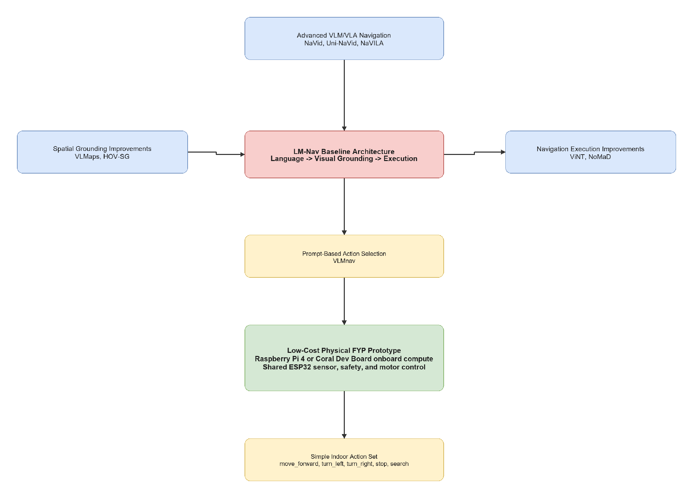

2.12 Research Gap and Motivation
The literature shows that language-guided robot navigation is an active research area, but several gaps remain for a low-cost FYP prototype.
First, existing systems can perform language-guided navigation, but many require expensive hardware, complex mapping, large models, or server-level compute. These systems are valuable research contributions, but they are not directly suitable for a student prototype using a Raspberry Pi 4 or Coral Dev Board, ESP32, USB webcam, two ultrasonic sensors, two MX1508 motor drivers, GY-291 accelerometer, and four DC gear motors.
Second, LM-Nav provides a strong modular baseline, but its language stage mainly extracts landmarks. Natural language instructions often include spatial relations and route information, such as "near the table", "turn left after the door", or "find the signboard". A low-cost prototype still needs to preserve this information, even if the first grounding module is simple.
Third, many advanced methods improve spatial grounding or navigation execution, but they do not directly answer how structured prompt engineering can support a simple indoor robot. VLMaps and HOV-SG show the value of maps and scene graphs, while ViNT and NoMaD show stronger navigation execution. However, this project begins earlier in the pipeline by asking how natural language can be converted into structured, validated robot action information.
Fourth, there is a need for a baseline physical prototype that future researchers can extend. Comparing Raspberry Pi 4 and Coral Dev Board onboard processing on the same ESP32-controlled robot with webcam grounding, ultrasonic safety sensing, acceleration and tilt feedback, and simple actions provides a practical platform for later improvements such as RGB-D sensing, LiDAR, scene graph mapping, ViNT, NoMaD, or advanced VLM/VLA models.
Table 2.4: Research gap synthesis and project strategy

Research Gap | Supporting Literature | Project Strategy
Many language-guided navigation systems use costly or complex hardware | LM-Nav, HOV-SG, NaVILA, Uni-NaVid | Compare two low-cost onboard physical approaches: Raspberry Pi 4 and Coral Dev Board, both using shared ESP32 sensor and motor control
Landmark extraction alone may lose spatial relations and route information | LM-Nav, VLMaps, HOV-SG | Use structured prompt output with target, landmarks, spatial relation, action goal, suggested action, and uncertainty
VLM action selection needs validation before real robot execution | VLMnav | Check uncertainty, latency, approved actions, and ESP32 ultrasonic status before sending commands to the ESP32 motor-control layer
Mapping and scene-graph systems are useful but complex | VLMaps, HOV-SG | Treat RGB-D mapping and scene graphs as future work
Strong navigation policies are beyond the first prototype | ViNT, NoMaD | Start with simple action control and document future replacement options

Based on these gaps, the project is motivated by the following research direction:
How can structured prompt engineering support visual grounding and simple action selection for a low-cost indoor mobile robot navigation prototype?

2.13 Chapter Summary
This chapter reviewed literature related to prompt engineering for mobile robot navigation. LM-Nav was identified as the main baseline because it provides a clear modular architecture of language understanding, visual grounding, and navigation execution. VLMnav was reviewed as the main prompt/action-selection reference because it frames navigation as a question-answering or action-choice task.
The chapter also reviewed VLMaps and HOV-SG as spatial grounding improvements, ViNT and NoMaD as stronger navigation execution models, and NaVid, Uni-NaVid, and NaVILA as advanced VLM/VLA navigation directions. These works show the potential of language-guided navigation, but they also reveal limitations related to cost, sensing requirements, compute resources, and implementation complexity.
The research gap is that there is a need for a low-cost indoor physical prototype that studies structured prompt engineering for simple mobile robot navigation. Chapter 3 explains how this project addresses the gap by comparing Raspberry Pi 4 and Coral Dev Board onboard implementations that share the same ESP32 motor, sensor, and safety platform.

CHAPTER 3
RESEARCH METHODOLOGY

3.1 Introduction
This chapter presents the finalized methodology for the project Prompt Engineering for Mobile Robot Navigation. The project investigates how structured prompt engineering and webcam-based visual grounding can be used to select safe, simple movement actions for a low-cost indoor mobile robot.
The methodology is inspired by the modular structure of LM-Nav and the prompt-based action-selection idea of VLMnav. LM-Nav motivates the separation between language understanding, visual grounding, and navigation execution. VLMnav motivates restricting model output to a fixed action set.
The finalized project contains exactly two physical robot approaches:
- **Approach 1:** Raspberry Pi 4 and ESP32.
- **Approach 2:** Coral Dev Board and ESP32.
Both approaches use the same four-wheel chassis, USB webcam, two MX1508 motor drivers, adjustable motor buck converter, two HC-SR04 ultrasonic sensors, GY-291 / ADXL345 accelerometer, three 18650 cells in series, and a 3S-compatible power-bank charging/output module. Only the high-level compute board and compatible model runtime change.
The intended action set is:
- move_forward
- turn_left
- turn_right
- stop
- search
The main contribution is the design, implementation, and comparison of two onboard prompt-engineered indoor navigation systems that share the same low-level robot platform.

3.2 Research Design and Project Workflow
The project follows an iterative prototyping and comparative experimental methodology. Shared hardware modules are tested first, followed by the Raspberry Pi 4 implementation and Coral Dev Board implementation. The two approaches are then compared using the same instructions, indoor landmarks, action set, safety rules, and evaluation metrics.

3.2.1 Methodology Alignment with Research Objectives
Table 3.1: Methodology Alignment with Research Objectives

Research Objective | Method Used | Expected Output | Evaluation
Objective 1: Develop a structured prompt-engineering pipeline for indoor navigation | Convert natural-language instructions into fixed navigation fields and actions | Parseable target, landmarks, relation, action goal, action, and uncertainty | Prompt validity, landmark accuracy, relation accuracy, and action accuracy
Objective 2: Build a shared low-cost physical robot platform | Integrate ESP32, two HC-SR04 sensors, GY-291, two MX1508 drivers, four motors, webcam, and finalized power architecture | Working shared robot base | Sensor tests, motor tests, power tests, timeout tests, and obstacle-stop tests
Objective 3: Compare Raspberry Pi 4 and Coral Dev Board onboard navigation | Run equivalent camera, prompt, grounding, validation, and action workflows on both compute boards | Two functioning implementation approaches | Model compatibility, latency, accuracy, reliability, power stability, and scenario success

3.2.2 Overall Project Workflow
Figure 3.1: Proposed project workflow
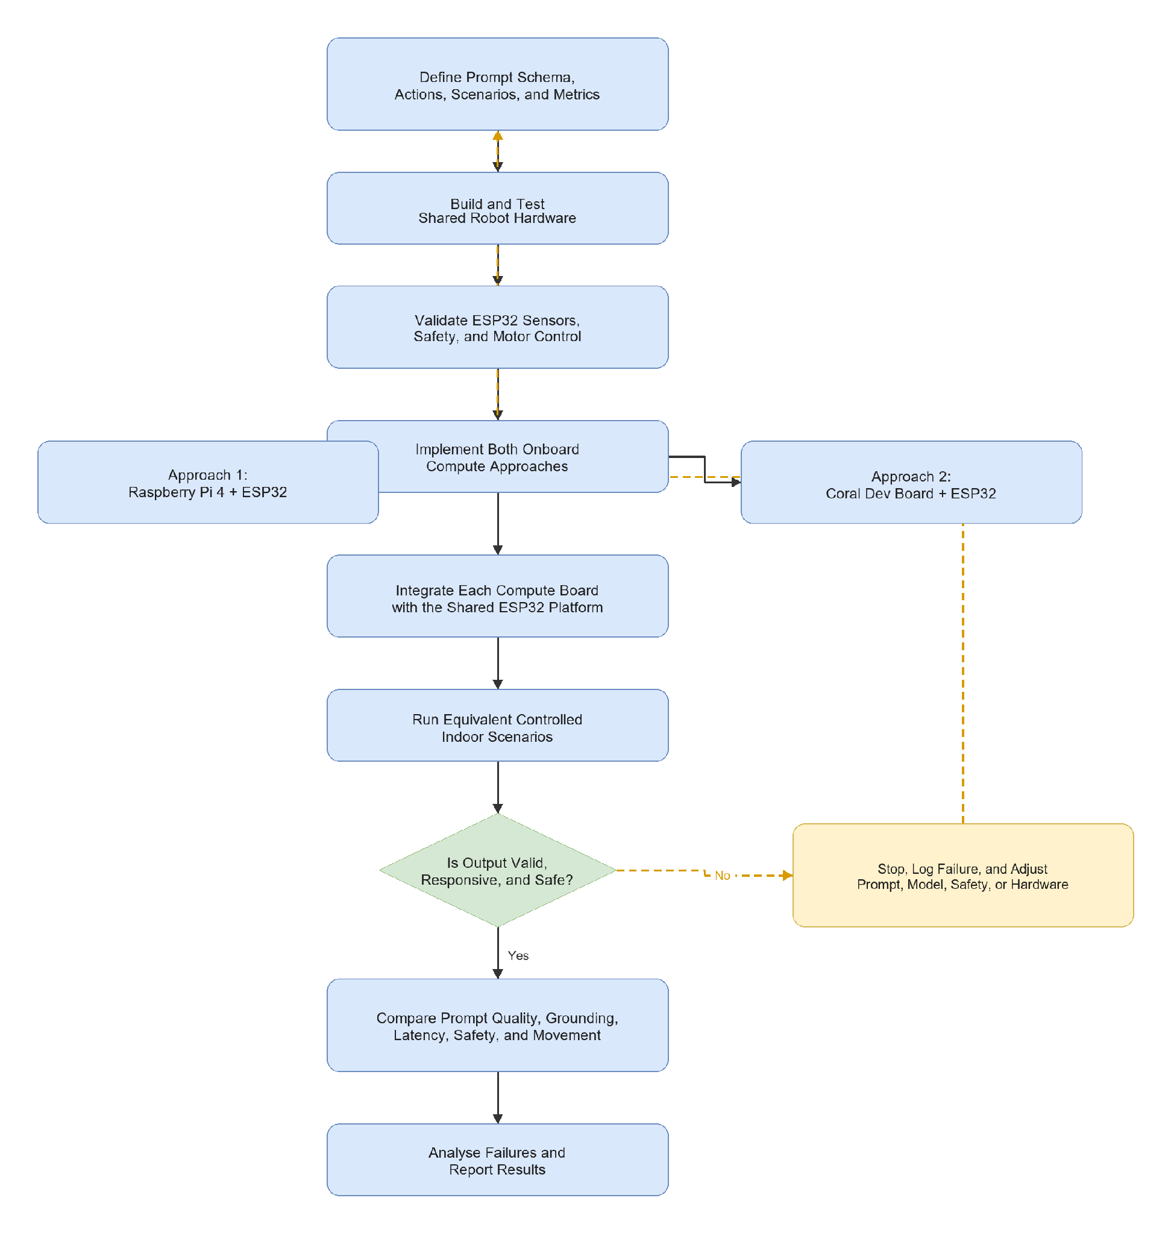

3.2.3 Development Workflow
Table 3.2: Development Workflow

Stage | Activity | Expected Output
Stage 1 | Finalize action set, prompt schema, instructions, scenarios, and logging format | Common experimental definition
Stage 2 | Verify 3S battery protection, power module, motor buck converter, and common-ground architecture | Safe and stable power system
Stage 3 | Assemble ESP32, two HC-SR04 sensors, GY-291, two MX1508 drivers, and four motors | Working shared low-level platform
Stage 4 | Test ESP32 sensing, motor directions, command timeout, and obstacle stop | Verified local safety and movement control
Stage 5 | Implement Raspberry Pi 4 webcam, prompt, grounding, validation, and logging modules | Working Approach 1
Stage 6 | Implement Coral Dev Board webcam, prompt, Edge TPU grounding, validation, and logging modules | Working Approach 2
Stage 7 | Integrate each compute board with the shared ESP32 platform | Two end-to-end robot implementations
Stage 8 | Run controlled indoor scenarios using identical inputs and conditions | Comparable result logs
Stage 9 | Calculate metrics and analyse failure cases | Final comparison and discussion

3.3 Proposed System Architecture
Both approaches use the same layered architecture. The high-level compute board processes language and webcam input. The ESP32 handles real-time sensors, safety, and motor control. This division prevents model latency from directly controlling motor timing.
Figure 3.2: Proposed system architecture
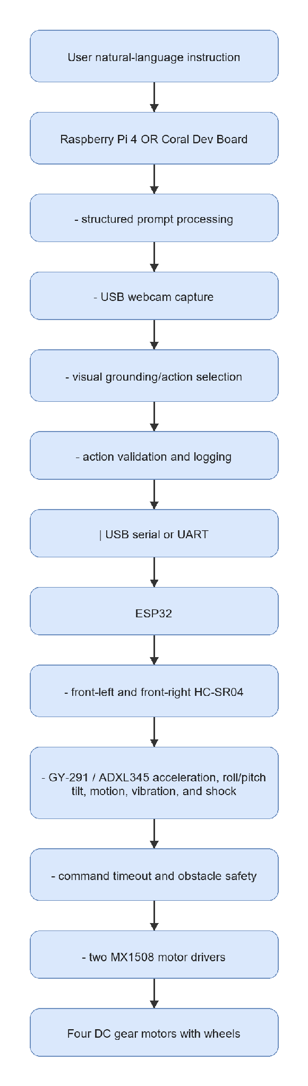

3.3.1 Finalized Implementation Approaches and Hardware Roles
Table 3.3: Finalized Implementation Approaches and Hardware Roles

Approach | High-Level Compute | Shared Low-Level Hardware | Main Strength | Main Risk
Approach 1: Raspberry Pi 4 and ESP32 | Raspberry Pi 4 runs onboard prompt processing, webcam processing, lightweight visual grounding, validation, and logging | ESP32, two HC-SR04 sensors, GY-291, two MX1508 drivers, four motors, and shared power system | Flexible Linux and Python development environment | Limited performance for large VLMs
Approach 2: Coral Dev Board and ESP32 | Coral Dev Board runs onboard prompt processing and Edge TPU-compatible visual inference | Same ESP32, sensors, motor drivers, motors, and power architecture | Efficient acceleration for compatible quantized TFLite models | Model conversion and Edge TPU compatibility

3.4 System Requirements, Constraints, and Acceptance Criteria
Table 3.4: Requirements and Acceptance Criteria

Requirement | Specification | Verification Method | Pass Criteria
Natural-language input | Accept simple indoor navigation instructions | Input test | Instruction is received without manual rewriting
Structured prompt output | Return fixed machine-readable fields | JSON validation | Required fields are present and parseable
USB webcam input | Capture the robot's front view | Camera test | Frames are captured reliably
Visual grounding/action selection | Connect instruction and current image to an approved action | Scenario comparison | Action is relevant or uncertainty causes stop
Onboard processing | Run entirely on the selected robot compute board | Integration test | Selected compute board completes the navigation loop
Two ultrasonic sensors | Report front-left and front-right distances | ESP32 serial test | Both readings are available and can trigger stop
GY-291 sensing | Report X/Y/Z acceleration, roll/pitch tilt, motion, vibration, and shock observations | I2C sensor test | Plausible readings and detection responses are received
Four-motor control | Two MX1508 modules control four motors | Raised-wheel test | Forward, left, right, search, and stop work
Safety validation | Invalid, uncertain, timed-out, or obstructed actions stop | Failure-case test | Unsafe movement is prevented
Power stability | Separate regulated motor and compute rails operate reliably | Voltage and runtime test | No unsafe voltage, reset, or severe drop occurs

The baseline is limited to controlled indoor areas and a small action set. It does not include full SLAM, LiDAR mapping, dense depth, or a learned navigation policy.

3.5 Data, Test Environment, and Experimental Materials
Table 3.5: Instruction Categories and Indoor Landmarks

Category | Example Instruction | Target or Relation | Purpose
Single landmark | "Go to the door." | door | Test target extraction and approach action
Object search | "Find the signboard." | signboard | Test search behavior
Landmark with relation | "Move toward the chair near the table." | chair near table | Test relation-aware prompting
Corridor movement | "Move forward in the corridor." | corridor | Test scene-aware forward action
Stop condition | "Stop at the door." | door and stop | Test goal-stop behavior
Ambiguous instruction | "Go there." | unclear | Test uncertainty and safe stop

Table 3.6: Experimental Materials

Material | Quantity or Role
Raspberry Pi 4 | Approach 1 high-level compute board
Coral Dev Board | Approach 2 high-level compute board
ESP32 | Shared sensor, motor-control, and safety controller
USB webcam | One front RGB camera
DC gear motor with wheel | Four motors and wheels
MX1508 dual motor-driver module | Two modules controlling four motors
Adjustable motor buck converter | Regulates the motor-driver rail
HC-SR04 ultrasonic sensor | Two sensors mounted at front-left and front-right
GY-291 / ADXL345 accelerometer | X/Y/Z acceleration, roll/pitch tilt, motion, vibration, and shock sensing
18650 battery cells | Three matched cells connected as a protected 3S pack
3S-compatible power-bank charging/output module | Regulated compute-board and ESP32 supply
Main switch and fuse | Battery isolation and protection
Navigation instruction and scenario list | Common experimental inputs
Result logs | Store outputs, sensors, latency, actions, and failures

Figure 3.3: Main hardware components for the finalized approaches
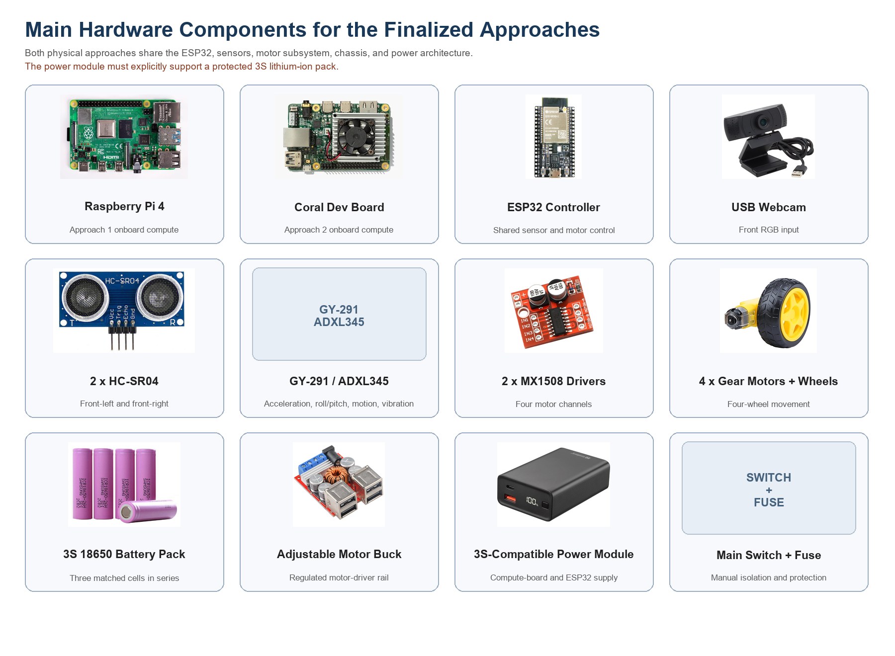
Table 3.7: Software, Model, and Platform Requirements

Item | Purpose | Planned Tool or Example
Programming language | High-level control, camera, prompting, validation, and logging | Python
Webcam processing | Capture and prepare RGB frames | OpenCV
Prompt processing | Produce structured navigation output | Rule-based parser, lightweight local model, or compatible API during development
Raspberry Pi 4 visual grounding | Lightweight onboard grounding/action selection | Optimized TFLite, OpenCV, small CLIP-style model, or lightweight detector
Coral visual grounding | Edge TPU-compatible onboard grounding/action selection | Quantized TFLite model compiled for Edge TPU
ESP32 firmware | Sensors, safety, and two-MX1508 motor control | Arduino IDE, PlatformIO, or ESP-IDF
Communication | Compute board to ESP32 status and commands | USB serial or UART
Result storage | Record comparable experiment data | JSONL or CSV

3.6 Prompt Engineering Design
Prompt engineering converts user instructions into a structured navigation representation. Both approaches use the same schema so that compute-platform performance can be compared fairly.
Table 3.8: Prompt Templates for Evaluation

Prompt Type | Description | Expected Output
Baseline landmark prompt | Extract the main target | Target and landmark list
Structured navigation prompt | Require all fixed output fields | Parseable JSON
Relation-aware prompt | Preserve phrases such as near, beside, toward, after, and at | Target and spatial relation
Action-choice prompt | Restrict action to the approved set | Valid action label
Safety-aware prompt | Require stop and high uncertainty for unclear instructions | Safe ambiguous-instruction output

{
"target": "door",
"landmarks": ["door"],
"spatial_relation": null,
"action_goal": "find and move toward the door",
"suggested_action": "move_forward",
"uncertainty": "low"
}
Table 3.9: Structured Output Fields

Field | Description | Example
target | Main object or place | door
landmarks | Important mentioned objects or places | ["chair", "table"]
spatial_relation | Relation between target and reference | chair near table
action_goal | Short interpreted navigation goal | find and move toward the door
suggested_action | Action from the approved set | move_forward
uncertainty | Safety-oriented confidence label | low, medium, or high

3.7 Webcam-Based Visual Grounding and Action Selection
After prompt processing, the selected compute board captures a USB-webcam frame and combines it with the structured instruction. The Raspberry Pi 4 uses a lightweight onboard method. The Coral Dev Board uses a compatible quantized TFLite or Edge TPU model.
Table 3.10: Visual Grounding and Action Selection Strategies

Strategy | Description | Platform Suitability
Rule-based baseline | Use known labels and safe fallback rules | Both approaches
Lightweight object detection | Detect target labels and choose action from image position | Raspberry Pi 4 or Coral
Edge TPU object detection | Run a compiled quantized detector | Coral Dev Board
Prompt-expanded grounding | Add indoor context to target descriptions | Raspberry Pi 4 if model permits
Safety fallback | Use search or stop when uncertain | Both approaches

3.8 Robot Action Set and Motor Command Mapping
Table 3.11: Action Set and Motor Command Mapping

Action | ESP32 Command | Four-Motor Behavior
move_forward | FWD | All motors move forward
turn_left | LEFT | Left motors reverse and right motors move forward
turn_right | RIGHT | Right motors reverse and left motors move forward
search | SEARCH | Robot rotates slowly
stop | STOP | All motor outputs stop

The GY-291 is used to measure X/Y/Z acceleration, calculate roll and pitch tilt, and observe motion, vibration, and shock during robot operation.

3.9 Approach Comparison Criteria
Table 3.12: Comparison of Implementation Approaches

Criterion | Approach 1: Raspberry Pi 4 | Approach 2: Coral Dev Board
Physical robot | Yes | Yes
High-level inference | Onboard Raspberry Pi 4 | Onboard Coral Dev Board
Low-level controller | ESP32 | ESP32
Shared sensors and motion | Two HC-SR04, GY-291, two MX1508, four motors | Same
Main model option | Flexible lightweight Linux-compatible models | Edge TPU-compatible quantized TFLite models
Main strength | Software flexibility | Efficient compatible inference
Main limitation | Limited compute for large models | Model conversion and operator compatibility

3.10 Mechanical Design and Physical Integration
The finalized Fusion 360 robot design provides mounting positions for the selected compute board, ESP32, USB webcam, two front ultrasonic sensors, GY-291, two MX1508 drivers, battery system, power modules, and four motors. The same chassis is used for both approaches so that the compute-board comparison is not affected by different mechanical layouts.
Figure 3.4: Finalized Fusion 360 physical robot model
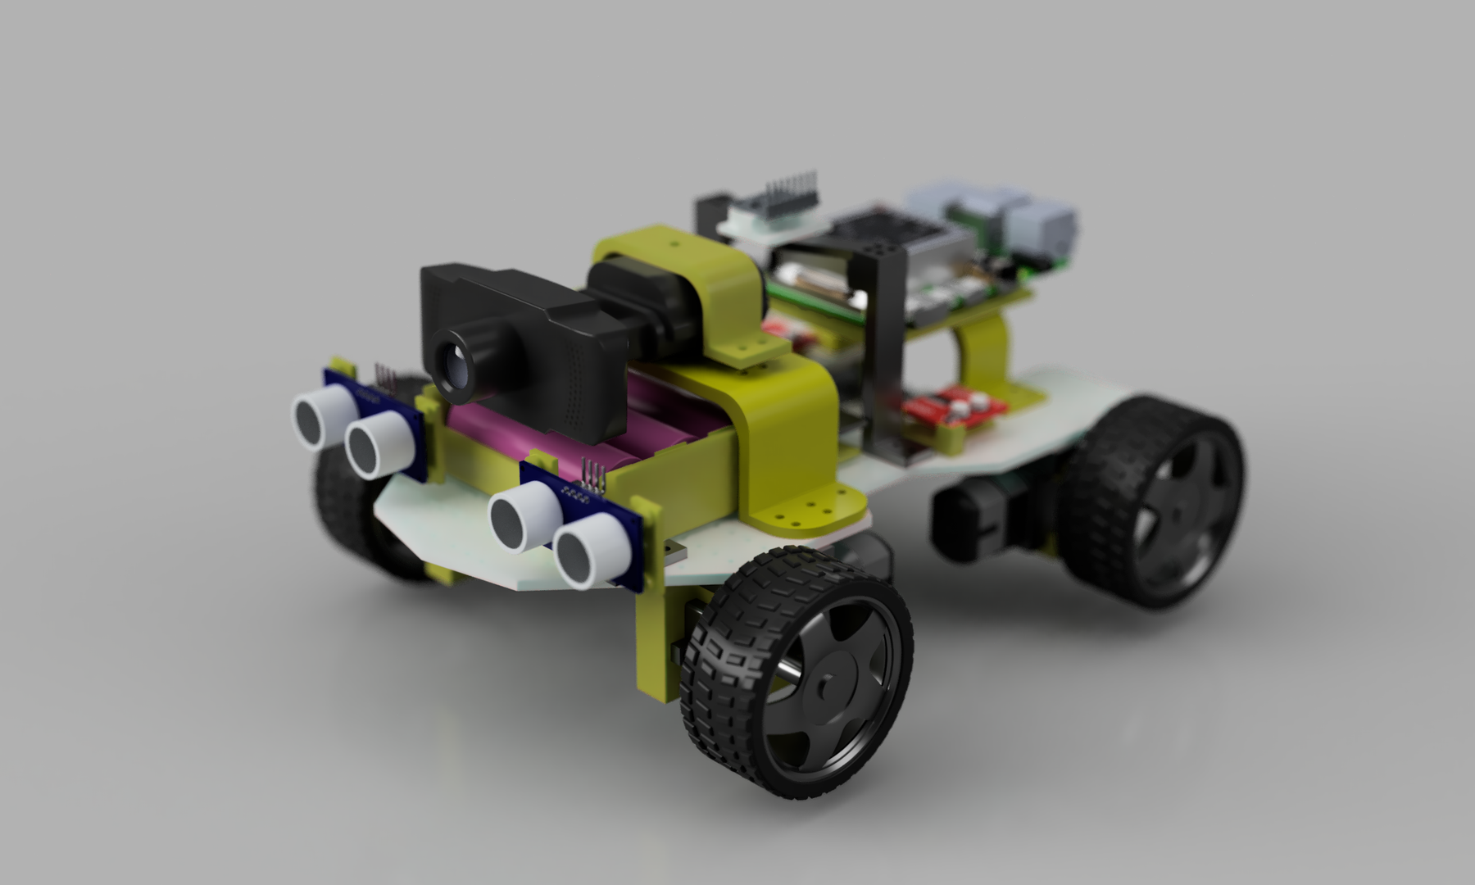
The overview render shows the front-mounted webcam and ultrasonic sensors, central protected battery position, four-wheel drive arrangement, and elevated compute-board mounting area. The supplied render illustrates the Raspberry Pi 4 configuration; Approach 2 replaces it with the Coral Dev Board while retaining the same shared chassis and compute-board mounting area.
Figure 3.5: Finalized Fusion 360 robot multi-view layout
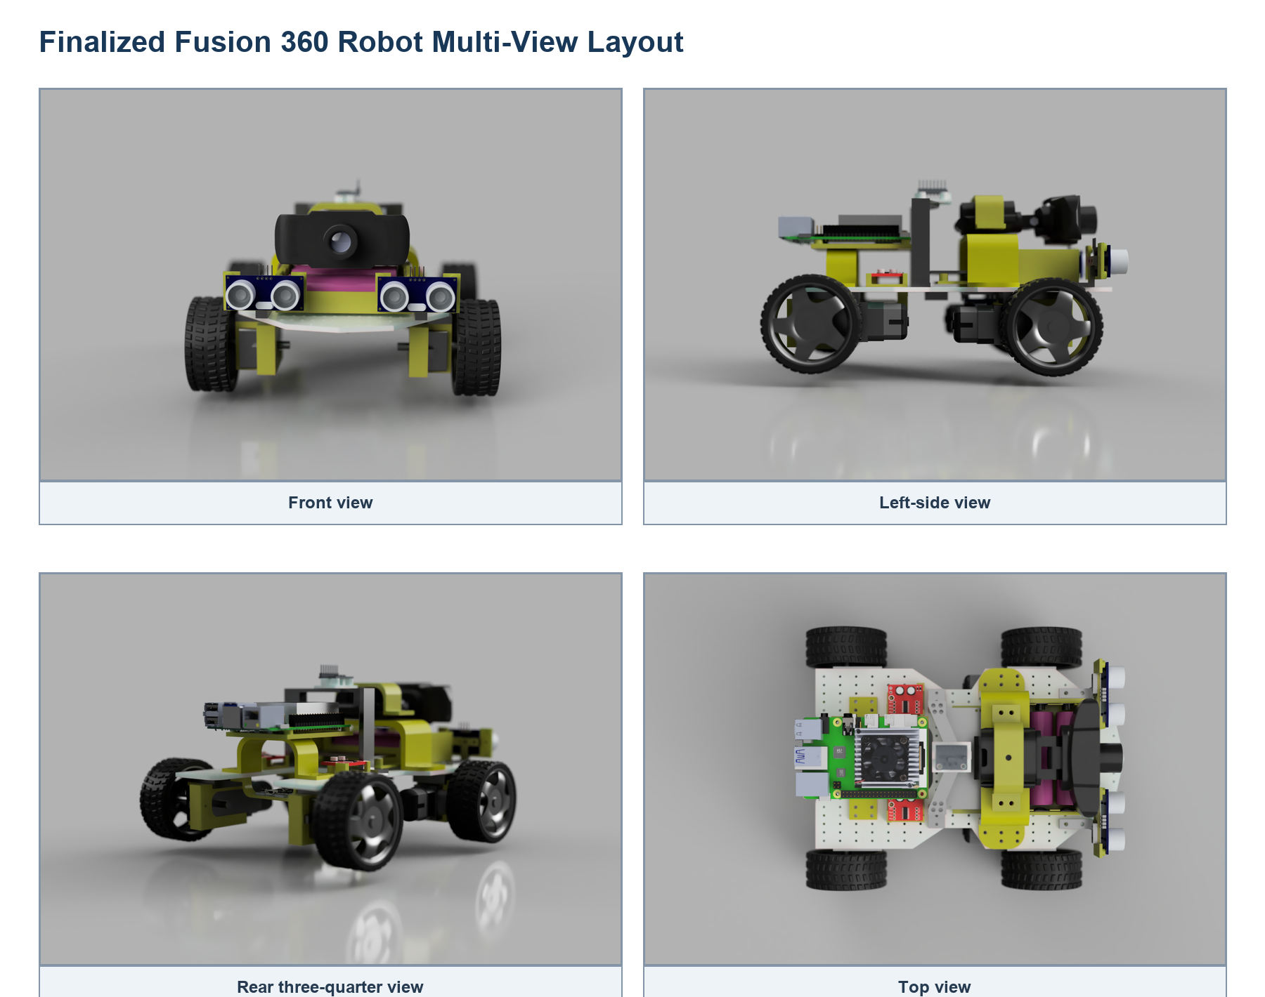
The front, side, rear, and top views are used to verify sensor visibility, wheel clearance, component spacing, cable access, and the mounting locations for both compute-board approaches.
Figure 3.6: Finalized mechanical design sketch and dimensions
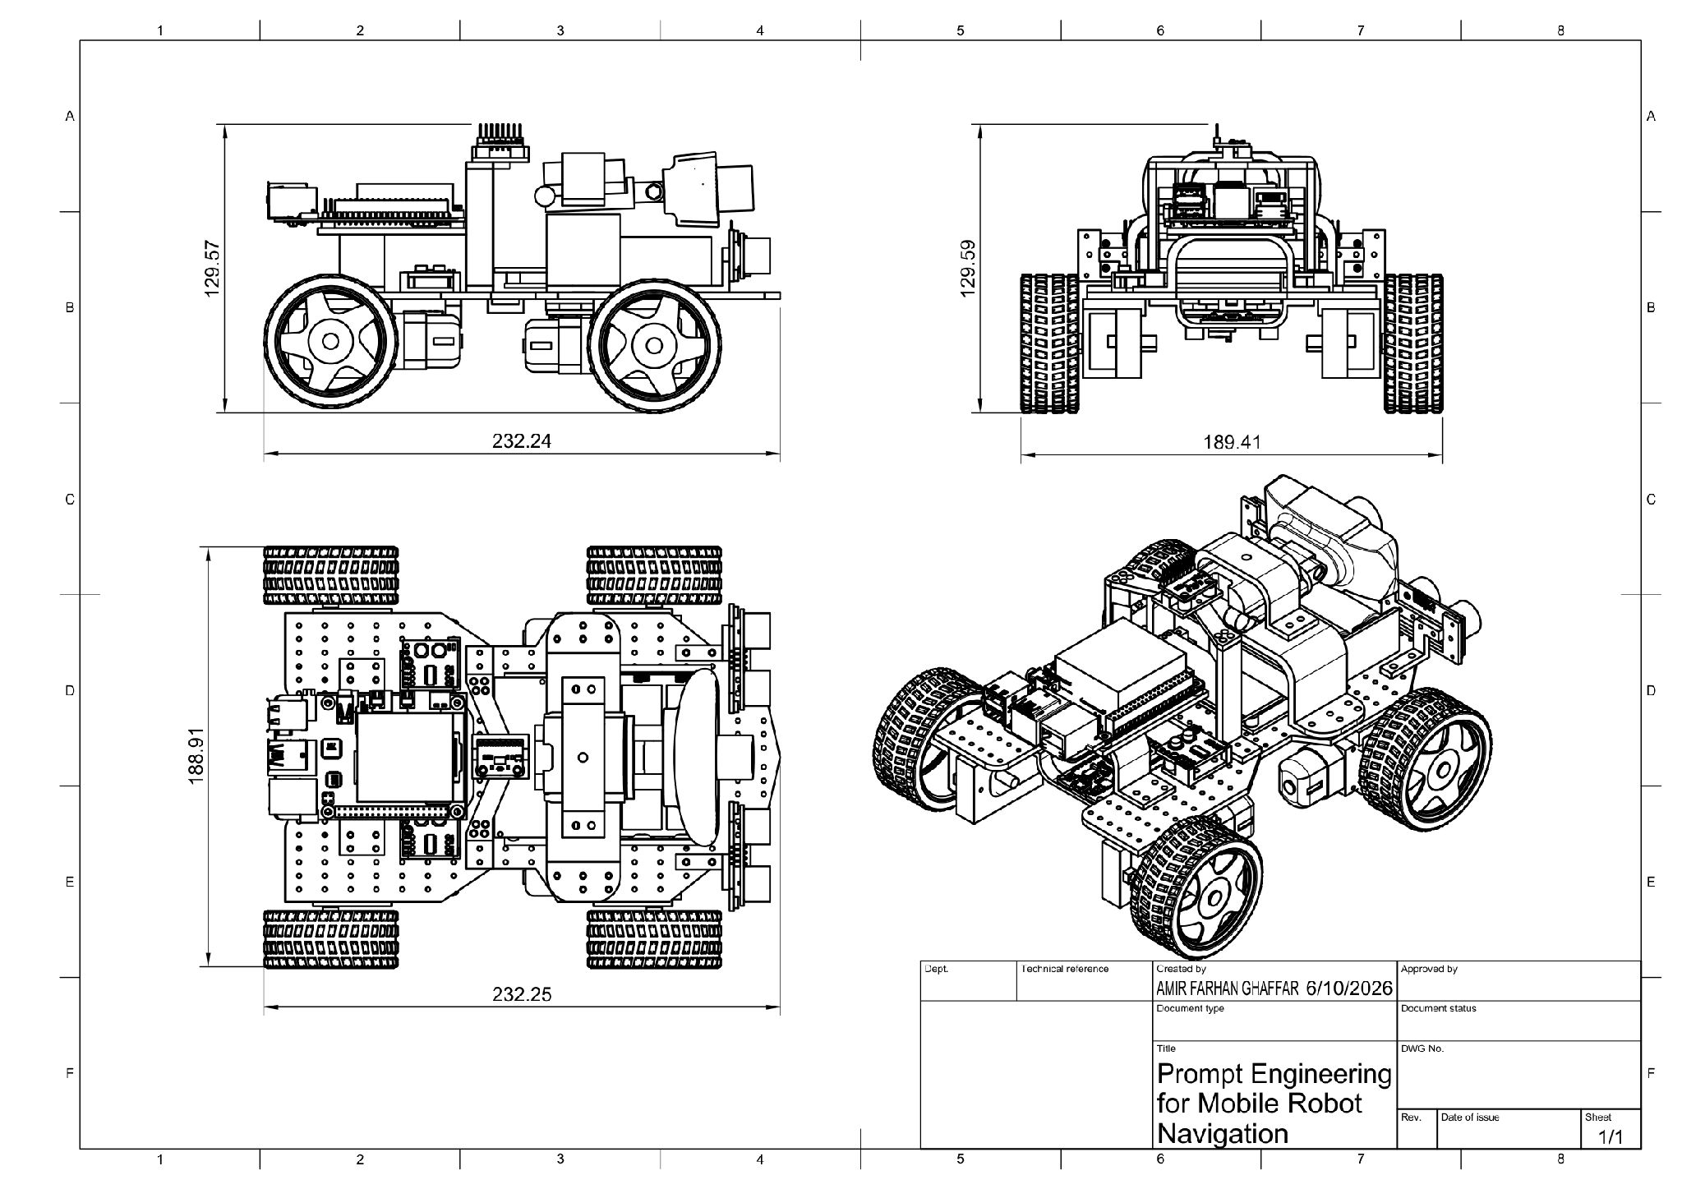
The dimensioned design sketch records an approximate overall length of 232.24 mm, width of 188.91 mm, and height of 129.57 mm. These dimensions guide fabrication, mounting, and clearance checks before physical assembly.

3.10.1 Custom-Designed and Fabricated Components
The robot design includes modular printable parts for the Raspberry Pi 4, ESP32, battery system, motor drivers, GY-291, webcam, and both ultrasonic sensors. Separate left and right ultrasonic mounts position the sensors at the front of the chassis, while the webcam fitting and stand provide a fixed forward-facing camera location. The compute-board, IMU, battery, and driver mounts organize components and reduce movement during operation.
The STL files are stored in the project STL/ directory so that damaged or revised mounts can be reproduced without redesigning the complete chassis. Approach 2 may require an adjusted compute-board mounting plate for the exact Coral Dev Board dimensions while retaining the same shared chassis locations.

3.10.2 Finalized Circuit Architecture
An L298N is a motor driver rather than a buck converter. The finalized architecture therefore uses one separate adjustable motor buck converter and two MX1508 dual motor-driver modules.
Figure 3.7: Finalized component-based circuit architecture
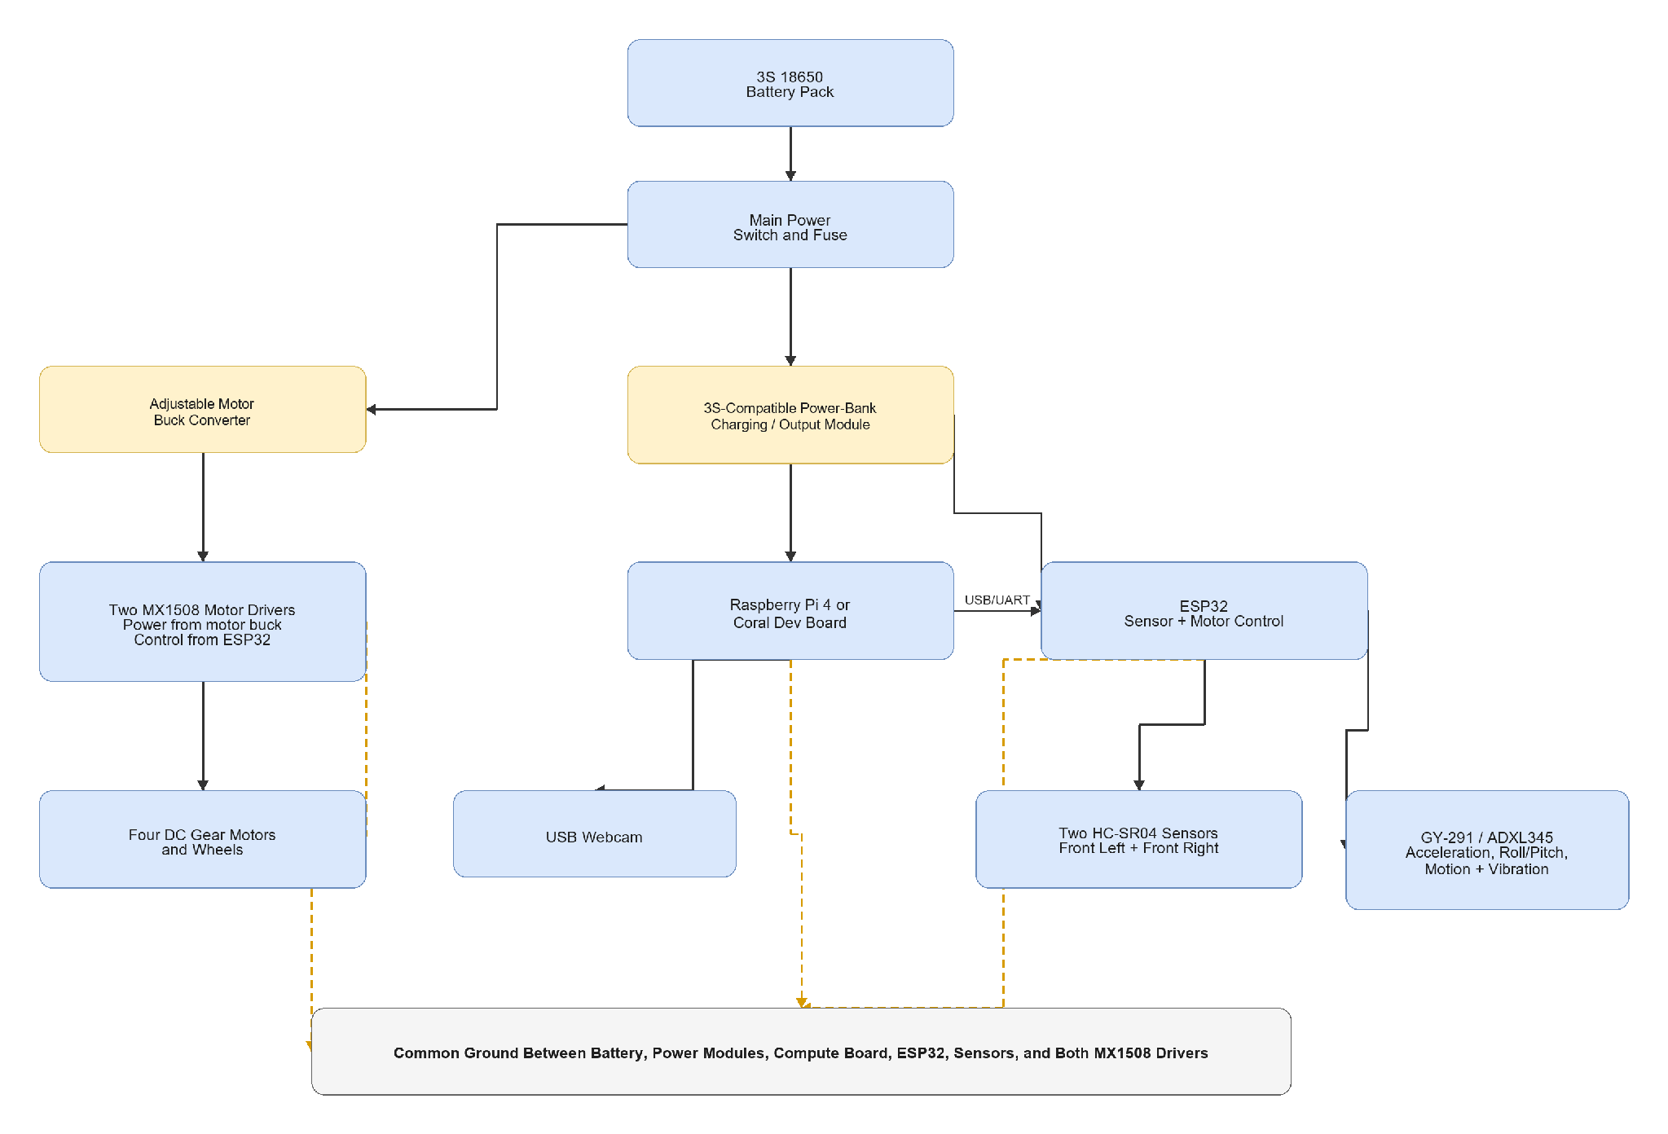
The power-bank module must explicitly support a 3S lithium-ion pack and the required continuous current. A common single-cell power-bank board must not be connected directly to the 3S pack. HC-SR04 Echo signals must be level-shifted before entering ESP32 GPIO.
Figure 3.8: Finalized ESP32 sensor and motor wiring
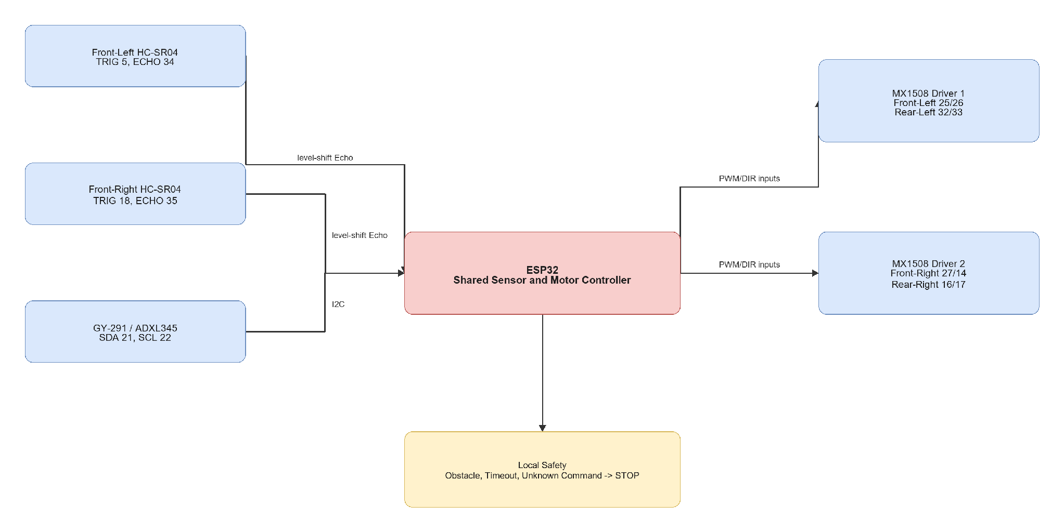

3.11 Company, Software, and Tool Involvement
Table 3.13: Company, Component, and Software Involvement

Component or Tool | Company or Organization | Involvement
Raspberry Pi 4 | Raspberry Pi Ltd | Approach 1 high-level compute
Coral Dev Board and Edge TPU | Google | Approach 2 high-level compute and compatible inference
ESP32 | Espressif Systems | Shared low-level sensing, safety, and motor control
GY-291 / ADXL345 | Analog Devices device on third-party module | Acceleration, roll/pitch tilt, motion, vibration, and shock sensing
MX1508 modules | Supplier to be confirmed | Four-motor driver subsystem
Autodesk Fusion 360 | Autodesk | Mechanical design
Python | Python Software Foundation | High-level software
OpenCV | OpenCV project | Webcam processing
Arduino IDE, PlatformIO, or ESP-IDF | Relevant tool provider | ESP32 firmware
diagrams.net / draw.io | JGraph / diagrams.net | Report diagrams

3.12 Software Implementation and Coding
Table 3.14: Source Code Modules for Baseline Implementation

File or Module | Hardware Target | Purpose | Status
docs/approach_1_raspberry_pi_4_esp32.md | Documentation | Raspberry Pi 4 implementation guide | Provided
docs/approach_2_coral_dev_board_esp32.md | Documentation | Coral Dev Board implementation guide | Provided
docs/circuit_wiring_guide.md | Documentation | Shared finalized electrical guide | Provided
src/raspberry_pi_robot/robot_controller.py | Raspberry Pi 4 | Planned onboard camera, prompt, grounding, validation, serial, and logging controller | Planned
src/coral_dev_board_robot/robot_controller.py | Coral Dev Board | Planned onboard Edge TPU camera, prompt, validation, serial, and logging controller | Planned
firmware/esp32_robot_controller/esp32_robot_controller.ino | ESP32 | Shared sensor, safety, and two-MX1508 motor-control firmware | Provided
firmware/esp32_ultrasonic_hub/esp32_ultrasonic_hub.ino | ESP32 | Shared sensor-only test firmware | Provided

3.13 Equations and Decision Rules
Table 3.15: Main Equations and Decision Rules

Equation or Rule | Description | Evaluation Use
d_cm = t_echo_us / 58 | HC-SR04 distance approximation | Convert Echo duration to centimetres
Prompt Validity = N_valid / N_total * 100 percent | Valid structured prompt percentage | Prompt reliability
Accuracy = N_correct / N_total * 100 percent | General correctness percentage | Extraction, grounding, and action metrics
T_total = T_prompt + T_capture + T_grounding + T_sensor + T_comm | End-to-end response time | Platform latency comparison
a_exec = stop when output is invalid, uncertainty is high, obstacle exists, timeout occurs, or action is invalid | Safety decision rule | Safe-failure evaluation
Movement Success Rate = N_success / N_scenarios * 100 percent | Successful scenario percentage | Robot behavior comparison
a_mag = sqrt(a_x^2 + a_y^2 + a_z^2) | Total measured acceleration magnitude | Motion, vibration, and shock observation

3.14 Implementation Procedure
Table 3.16: Implementation Procedure

Stage | Activity | Verification | Expected Result
Stage 1 | Confirm finalized components and electrical ratings | Datasheet and measurement review | Compatible selected hardware
Stage 2 | Assemble protected 3S power system and separate rails | Multimeter and load test | Stable compute and motor supplies
Stage 3 | Connect ESP32, two HC-SR04 sensors, and GY-291 | Serial sensor test | Valid distance and acceleration data
Stage 4 | Connect two MX1508 modules and four motors | Raised-wheel movement test | Correct action-to-wheel behavior
Stage 5 | Verify timeout, obstacle, and invalid-command stopping | Safety test | Local ESP32 stop behavior
Stage 6 | Implement and integrate Raspberry Pi 4 approach | End-to-end Approach 1 test | Working Raspberry Pi robot
Stage 7 | Implement and integrate Coral Dev Board approach | End-to-end Approach 2 test | Working Coral robot
Stage 8 | Run common indoor scenarios | Scenario checklist and logs | Comparable results
Stage 9 | Calculate metrics and analyse failures | Data analysis | Final findings

3.15 Testing and Validation Plan
Table 3.17: Testing and Validation Matrix

Test Stage | Test Setup | Metric | Pass Criteria
Prompt format test | Common instructions on both boards | Prompt output validity | Required fields are parseable
Landmark and relation test | Annotated instruction set | Extraction accuracy | Expected target and relation are represented
Webcam test | USB webcam on each compute board | Frame capture success | Reliable usable frames
Visual grounding test | Common images and targets | Grounding correctness | Correct match or safe uncertainty
Model latency test | Both compute boards | Response time | Suitable for slow controlled movement
Ultrasonic test | Two front sensors | Distance availability and error | Both sensors report usable values
GY-291 test | Stationary, tilted, moved, and lightly vibrated robot | Plausibility and detection behavior | Acceleration, roll/pitch, motion, and vibration changes are observable
Motor test | Two MX1508 modules and four motors | Movement correctness | All approved actions work
Safety test | Obstacle, timeout, invalid command, and high uncertainty | Safe stop rate | Robot stops safely
Full scenario test | Controlled indoor landmarks | Scenario success | Intended simple behavior is completed

3.16 Evaluation Metrics
Table 3.18: Evaluation Metrics

Metric | Description
Prompt output validity | Percentage of outputs containing all required fields
Landmark extraction accuracy | Percentage of correctly extracted targets and landmarks
Spatial relation accuracy | Percentage of correctly represented relations
Visual grounding correctness | Percentage of correctly grounded targets
Action-selection accuracy | Percentage of expected selected actions
End-to-end latency | Time from instruction and frame input to validated action
Safe stop rate | Percentage of unsafe cases correctly stopped
Movement success rate | Percentage of completed simple robot scenarios
GY-291 acceleration stability | Variation in stationary and controlled-motion acceleration readings
Roll/pitch tilt correctness | Agreement between expected and reported chassis tilt
Motion and vibration detection | Correct detection response during controlled movement and vibration tests
Power stability | Resets, voltage drops, or failures during testing

3.17 Safety, Ethics, and Practical Considerations
Testing must use matched protected cells, an appropriate 3S battery-management system, a fuse, and a reachable main switch. The selected power-bank module must explicitly support 3S input. Motor tests must begin with the robot raised from the floor. HC-SR04 Echo pins require level shifting for ESP32 safety.
The robot must stop for invalid output, high uncertainty, obstacle detection, unknown command, or command timeout. Tests must be supervised in a controlled indoor area. Webcam testing should avoid recording identifiable people without permission.

3.18 Limitations and Future Work
The webcam does not provide dense depth or a 3D map. Two front ultrasonic sensors provide limited obstacle coverage. GY-291 roll and pitch calculations are most reliable while the robot is stationary or moving slowly because dynamic acceleration and vibration affect gravity-based tilt calculations. The Raspberry Pi 4 cannot run large models efficiently, while the Coral Dev Board supports only compatible Edge TPU models.
Future improvements may include wheel encoders, RGB-D camera, LiDAR, stronger motor drivers, improved battery monitoring, mapping, ViNT, NoMaD, or more advanced VLM/VLA models.

3.19 Summary
This chapter finalized the project around two physical onboard approaches: Raspberry Pi 4 with ESP32 and Coral Dev Board with ESP32. Both approaches share the same four-wheel chassis, two MX1508 motor drivers, adjustable motor buck converter, two front HC-SR04 sensors, GY-291 accelerometer, USB webcam, 3S battery pack, and 3S-compatible power module.
The methodology defines a fair platform comparison using common prompts, scenarios, safety rules, hardware, and evaluation metrics. It also separates high-level language and visual processing from ESP32 real-time sensing and motor control.

CHAPTER 4
EXPECTED RESULTS AND DISCUSSION

4.1 Introduction
This chapter presents the expected results for FYP1. The expectations are based on the proposed system architecture, structured prompt design, selected hardware, ESP32 safety logic, and validation plan. Final measured results and the completed physical robot will be presented during FYP2.

4.2 Expected System Results
The proposed robot is expected to convert simple indoor navigation instructions into structured outputs containing the target, landmarks, spatial relation, suggested action, and uncertainty. Clear instructions such as "Go to the door" should produce a relevant action with low uncertainty. Ambiguous instructions such as "Go there" should produce high uncertainty and cause the robot to stop or search safely.
The webcam-based grounding stage is expected to identify clear indoor landmarks under suitable lighting. When the target is not visible or the result is uncertain, the expected behavior is search or stop.
Table 4.1: Summary of Expected System Results

System Area | Expected Result
Structured prompt | Produces consistent machine-readable navigation fields
Visual grounding | Connects common indoor landmarks with the webcam image
Motor actions | Executes forward, left, right, search, and stop commands
Ultrasonic safety | Stops when either front sensor detects a close obstacle
GY-291 sensing | Reports acceleration, roll/pitch tilt, motion, vibration, and shock observations
Uncertain or invalid output | Stops safely instead of executing unsupported movement

4.3 Expected Platform Comparison
Both compute approaches are expected to complete the same navigation pipeline using the shared ESP32-controlled robot. The Raspberry Pi 4 is expected to provide greater software flexibility for Python, OpenCV, and lightweight models. The Coral Dev Board is expected to provide efficient inference for compatible Edge TPU models, but it requires quantized TensorFlow Lite models and has stricter compatibility limits.
Table 4.2: Expected Raspberry Pi 4 and Coral Dev Board Comparison

Area | Raspberry Pi 4 | Coral Dev Board
Main advantage | Flexible software and easier model experimentation | Efficient compatible visual inference
Main limitation | Limited performance for large models | Model-conversion and operator restrictions
Expected use | General development and lightweight processing | Edge TPU-compatible visual grounding

Actual accuracy and latency conclusions will be measured using identical tests during FYP2.

4.4 Expected Safety Simulations
The ESP32 uses the minimum reading from the two front HC-SR04 sensors. With the planned 25 cm threshold, the robot is expected to stop when either valid sensor reading is below 25 cm.
Figure 4.1: Expected obstacle-stop response at the planned 25 cm threshold
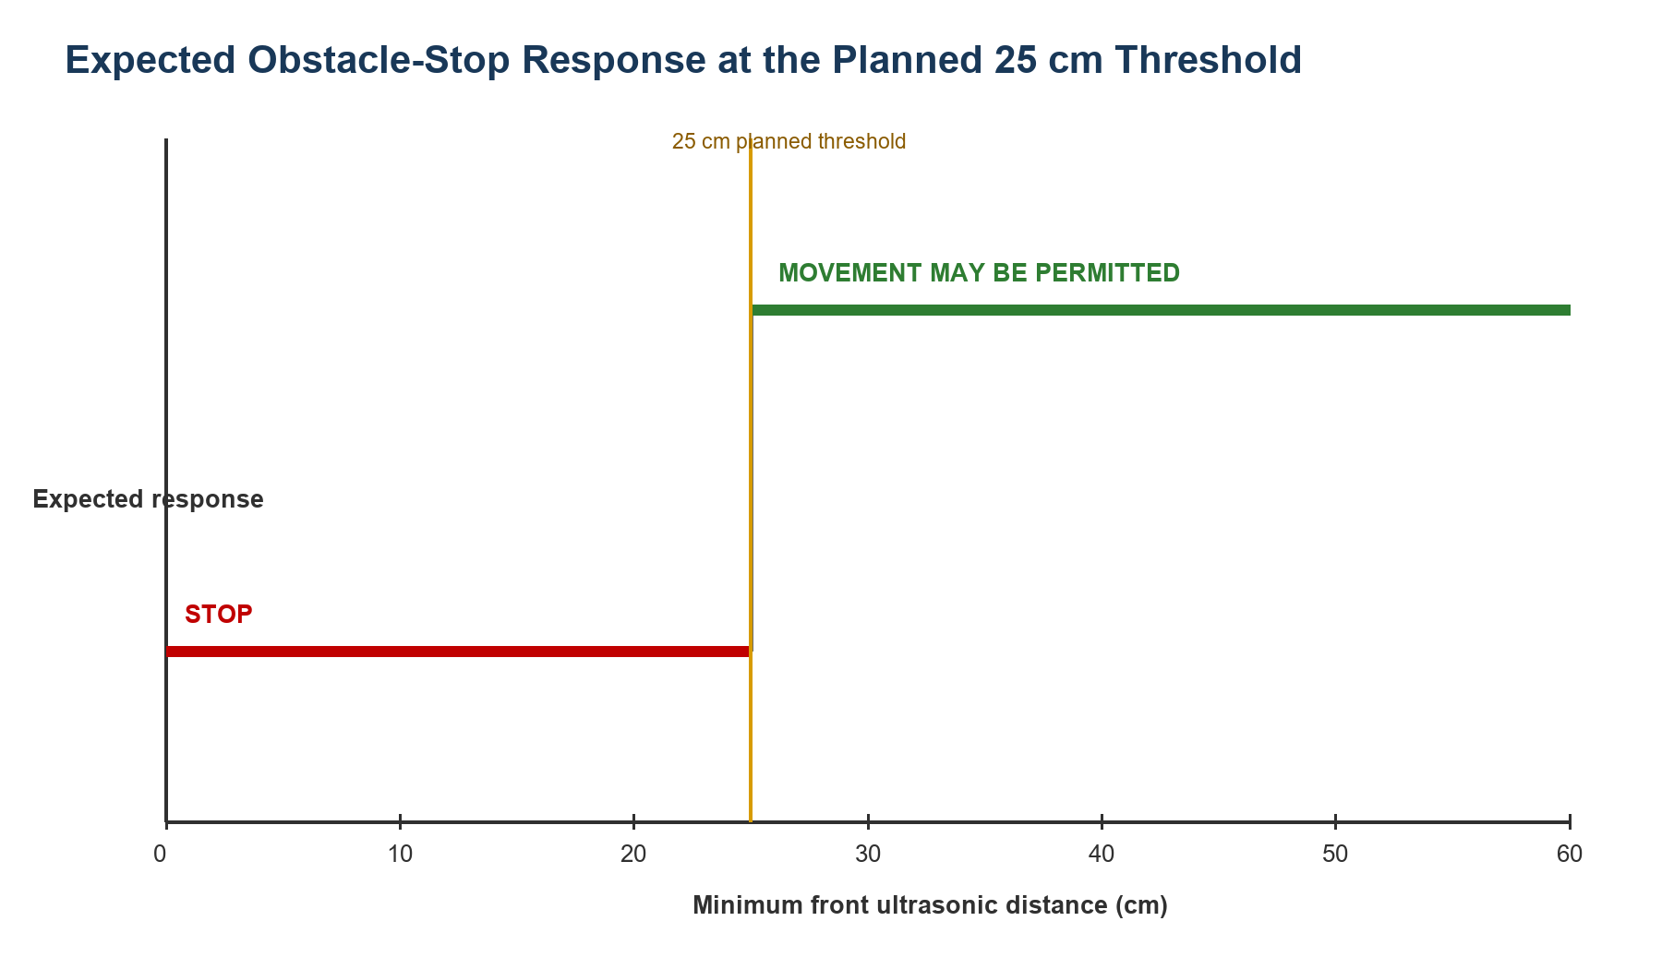
The ESP32 also applies a 1,000 ms command timeout. If no new valid command is received within this period, all motor outputs are expected to stop.
Figure 4.2: Expected motor response when the command timeout exceeds 1,000 ms
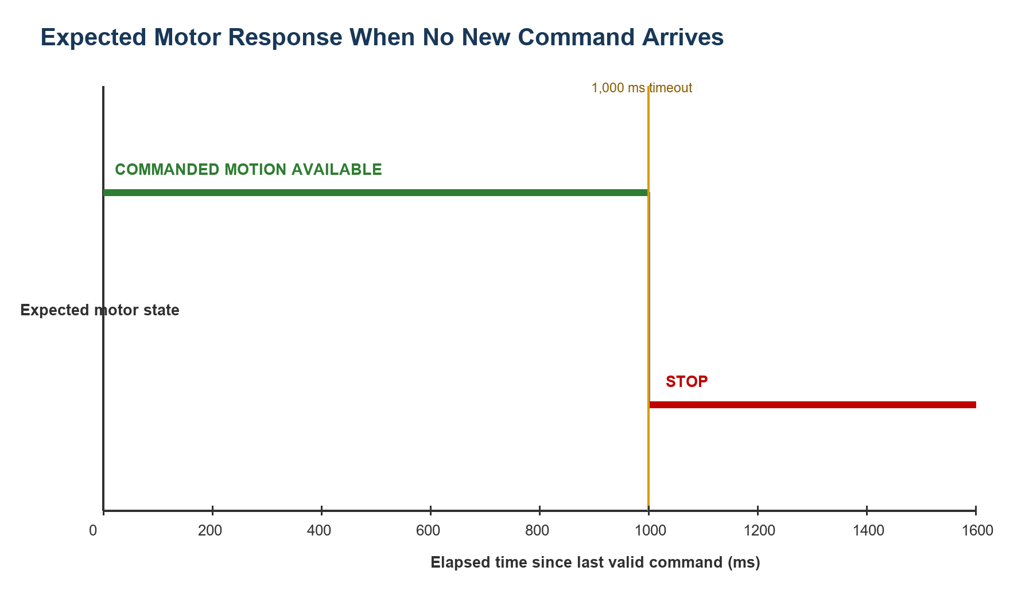
These simulations demonstrate the intended decision logic only. The final distance threshold and physical stopping response require calibration and repeated testing during FYP2.

4.5 Required FYP2 Results
FYP2 will replace these expectations with measured results from the completed robot.
Table 4.3: Required FYP2 Measurements

Evaluation Area | Required Measurement
Prompt engineering | Output validity and landmark or relation accuracy
Visual grounding | Target-grounding correctness and uncertainty behavior
Platform comparison | Raspberry Pi 4 and Coral processing latency
Sensors and safety | Ultrasonic error, GY-291 response, and safe-stop success
Robot movement | Action correctness and indoor scenario success rate
Power system | Voltage stability, resets, current, and operating duration

4.6 Discussion
The expected results suggest that structured prompt engineering can provide a simple interface between natural-language instructions and a restricted robot action set. The two-level safety architecture is expected to reduce unsafe movement by validating high-level outputs and applying local ESP32 obstacle and timeout rules.
The platform comparison is expected to show a trade-off: Raspberry Pi 4 should be easier to develop and modify, while Coral Dev Board should be efficient for compatible models. These expectations must not be treated as final conclusions until both approaches are tested under the same FYP2 conditions.

4.7 Summary
This chapter presented the expected FYP1 outcomes for prompt processing, visual grounding, platform comparison, robot behavior, and safety. The included simulations show the planned obstacle-stop and command-timeout logic. Final physical and comparative results will be collected during FYP2.

REFERENCE
Cheng, A.-C., Ji, Y., Yang, Z., Gongye, Z., Zou, X., Kautz, J., Biyik, E., Yin, H., Liu, S., & Wang, X. (2025). NaVILA: Legged robot vision-language-action model for navigation. *Proceedings of Robotics: Science and Systems*. https://doi.org/10.15607/RSS.2025.XXI.018
Goetting, D., Singh, H. G., & Loquercio, A. (2024). *End-to-end navigation with vision language models: Transforming spatial reasoning into question-answering*. arXiv. https://doi.org/10.48550/arXiv.2411.05755
Huang, C., Mees, O., Zeng, A., & Burgard, W. (2023). Visual language maps for robot navigation. *Proceedings of the IEEE International Conference on Robotics and Automation (ICRA)*. https://vlmaps.github.io/
Shah, D., Osinski, B., Ichter, B., & Levine, S. (2023a). LM-Nav: Robotic navigation with large pre-trained models of language, vision, and action. *Proceedings of the 6th Conference on Robot Learning, Proceedings of Machine Learning Research, 205*, 492-504. https://proceedings.mlr.press/v205/shah23b.html
Shah, D., Sridhar, A., Dashora, N., Stachowicz, K., Black, K., Hirose, N., & Levine, S. (2023b). ViNT: A foundation model for visual navigation. *Proceedings of the 7th Conference on Robot Learning, Proceedings of Machine Learning Research, 229*, 711-733. https://proceedings.mlr.press/v229/shah23a.html
Sridhar, A., Shah, D., Glossop, C., & Levine, S. (2023). *NoMaD: Goal masked diffusion policies for navigation and exploration*. arXiv. https://arxiv.org/abs/2310.07896
Werby, A., Huang, C., Buchner, M., Valada, A., & Burgard, W. (2024). Hierarchical open-vocabulary 3D scene graphs for language-grounded robot navigation. *Proceedings of Robotics: Science and Systems*. https://doi.org/10.15607/RSS.2024.XX.077
Zhang, J., Wang, K., Xu, R., Zhou, G., Hong, Y., Fang, X., Wu, Q., Zhang, Z., & Wang, H. (2024). NaVid: Video-based VLM plans the next step for vision-and-language navigation. *Proceedings of Robotics: Science and Systems*. https://doi.org/10.15607/RSS.2024.XX.079
Zhang, J., Wang, K., Wang, S., Li, M., Liu, H., Wei, S., Wang, Z., Zhang, Z., & Wang, H. (2026). Uni-NaVid: A video-based vision-language-action model for unifying embodied navigation tasks. *Robotics: Science and Systems 2026 Program*. https://roboticsconference.org/program/papers/13/

