CHAPTER 3
RESEARCH METHODOLOGY

3.1 Introduction
This chapter presents the finalized methodology for Prompt Engineering for Mobile Robot Navigation. Following supervisor feedback, the project contains one physical implementation only: a Coral Dev Board mobile robot with an ESP32 sensor, safety, and motor-control layer.
The methodology is inspired by the modular structure of LM-Nav and the prompt-based action-selection idea of VLMnav. Language interpretation, visual grounding, and navigation execution are separated so each stage can be tested. The first prototype targets a basic goal such as find the chair and restricts all output to:
- move_forward
- turn_left
- turn_right
- search
- stop
The laptop-only webcam demonstration is used only to produce expected-results evidence before physical testing. Its Python/OpenCV processing runs in a Docker container while a local browser captures the webcam. It is not a second physical approach.

3.2 Research Design and Project Workflow
The project follows an iterative prototype methodology. The already-built mechanical and power systems are completed by wiring and validating the ESP32 sensor and motor layer, integrating Coral UART communication, verifying Edge TPU-compatible visual inference, and testing one complete basic goal.

3.2.1 Methodology Alignment with Research Objectives
Table 3.1: Methodology Alignment with Research Objectives

3.2.2 Overall Project Workflow
Figure 3.1: Proposed project workflow
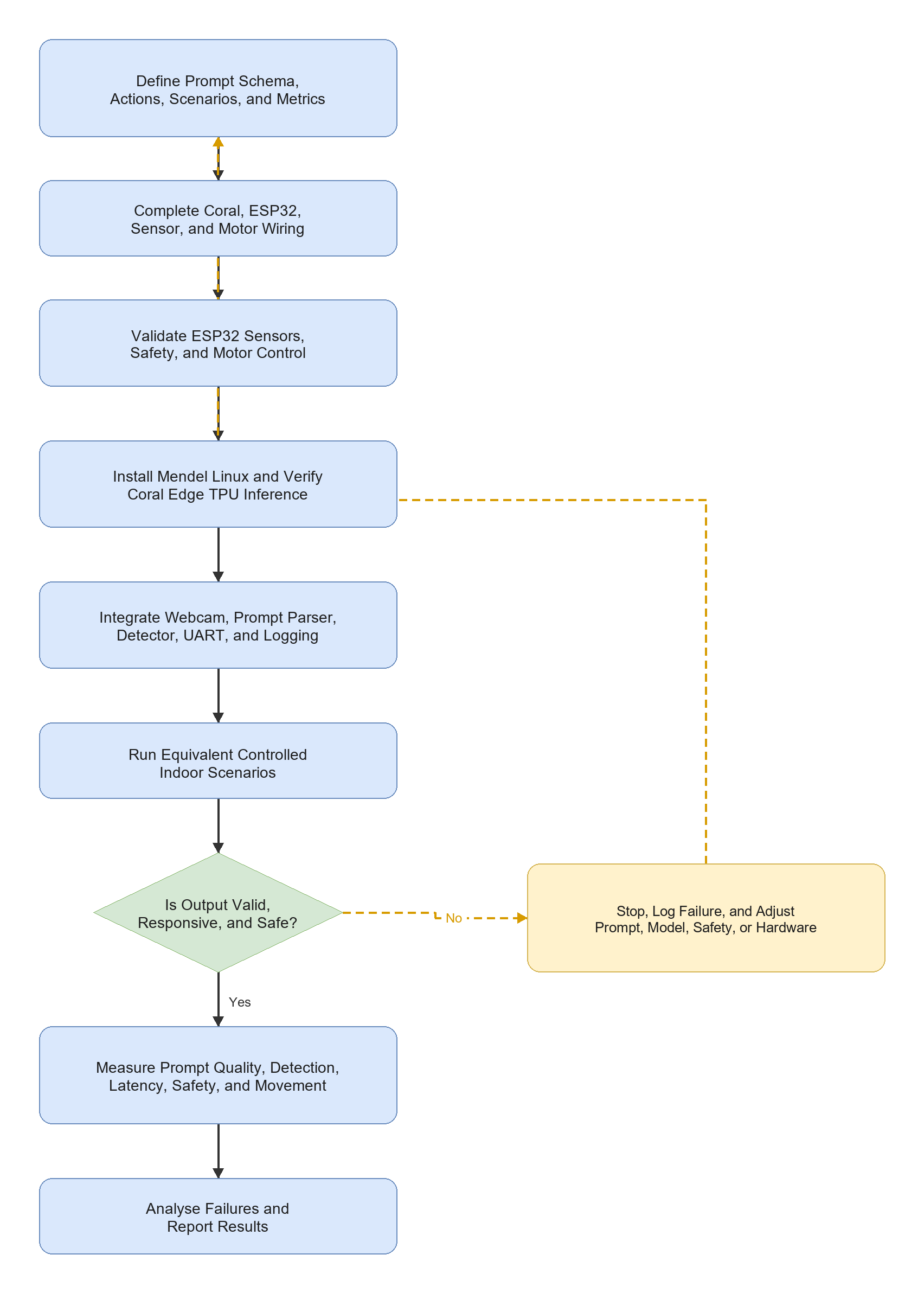

3.2.3 Development Workflow
Table 3.2: Development Workflow

3.3 Finalized System Architecture
The Coral Dev Board performs high-level processing. The ESP32 handles local real-time sensing, safety, and motor control. Direct 3.3 V UART is used between the boards so the Coral USB-A host port remains available for the webcam.
Figure 3.2: Proposed system architecture
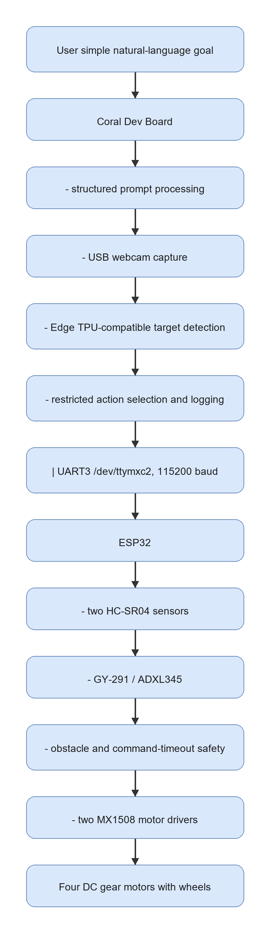

3.3.1 Hardware Roles
Table 3.3: Finalized Hardware Roles

3.4 Requirements, Constraints, and Acceptance Criteria
Table 3.4: Requirements and Acceptance Criteria
The baseline does not include SLAM, LiDAR mapping, dense depth, or an unrestricted large vision-language model.

3.5 Data, Test Environment, and Experimental Materials

3.5.1 Basic Goal and Scenarios
Table 3.5: First-Prototype Scenarios

3.5.2 Experimental Materials
Table 3.6: Experimental Materials
Figure 3.3: Main hardware components for the finalized Coral Dev Board robot
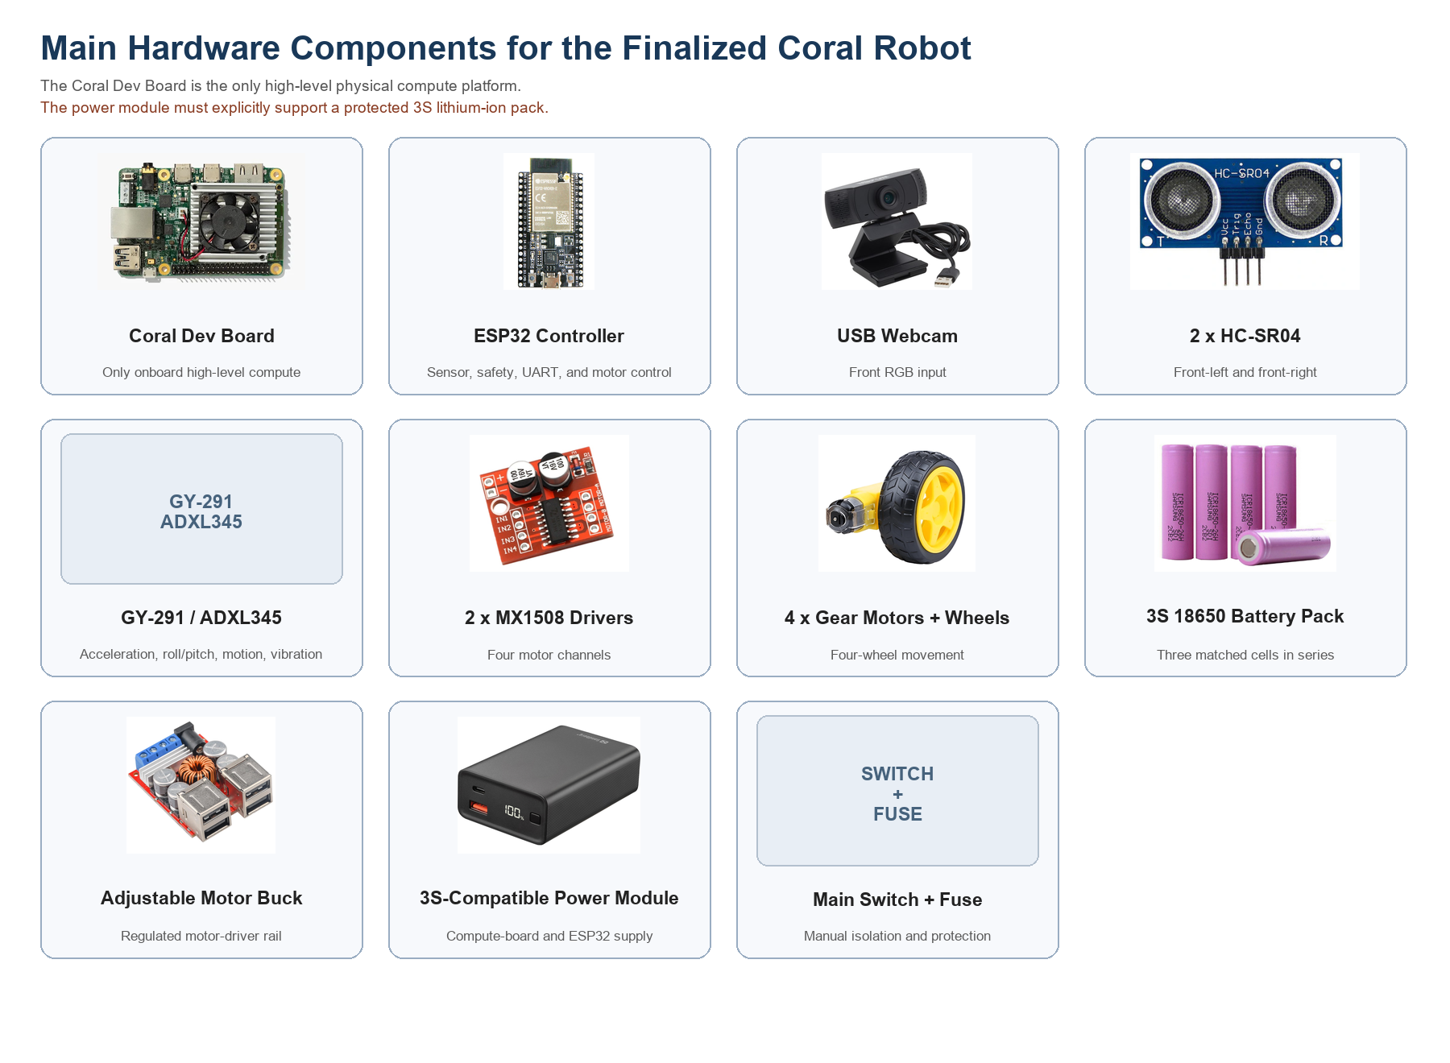

3.5.3 Software and Model Requirements
Table 3.7: Software, Model, and Platform Requirements

3.6 Prompt Engineering Design
The first prototype uses a deterministic structured parser because the Coral Edge TPU cannot run a general-purpose LLM. This parser still applies the main prompt-engineering principles required by the study: fixed fields, restricted actions, explicit uncertainty, and safe rejection of unsupported goals.
Table 3.8: Structured Prompt Fields
{
"instruction": "find the chair",
"target": "chair",
"landmarks": ["chair"],
"spatial_relation": null,
"action_goal": "find and approach the chair",
"uncertainty": "low"
}
Unsupported or unclear instructions produce high uncertainty and stop.

3.7 Webcam-Based Visual Grounding and Action Selection
The Coral captures a USB-webcam frame and runs an Edge TPU-compatible object detector. The highest-confidence detection matching the structured target is used for simple action selection.
Table 3.9: Visual Grounding and Action Decision Rules
The first model may use a COCO-compatible detector and the target chair. Custom classes such as door and signboard are future extensions requiring custom data collection, training, quantization, and Edge TPU compilation.

3.8 Robot Action and Command Mapping
Table 3.10: Action Set and Motor Command Mapping
The ESP32 accepts only these commands. Unknown commands, loss of both ultrasonic readings, and a command delay above 1,000 ms cause stop.

3.9 Mechanical Design and Physical Integration
The finalized Fusion 360 robot design provides mounting positions for the compute board, ESP32, USB webcam, two front ultrasonic sensors, GY-291, two MX1508 drivers, completed power system, and four motors.
Figure 3.4: Finalized Fusion 360 physical robot model
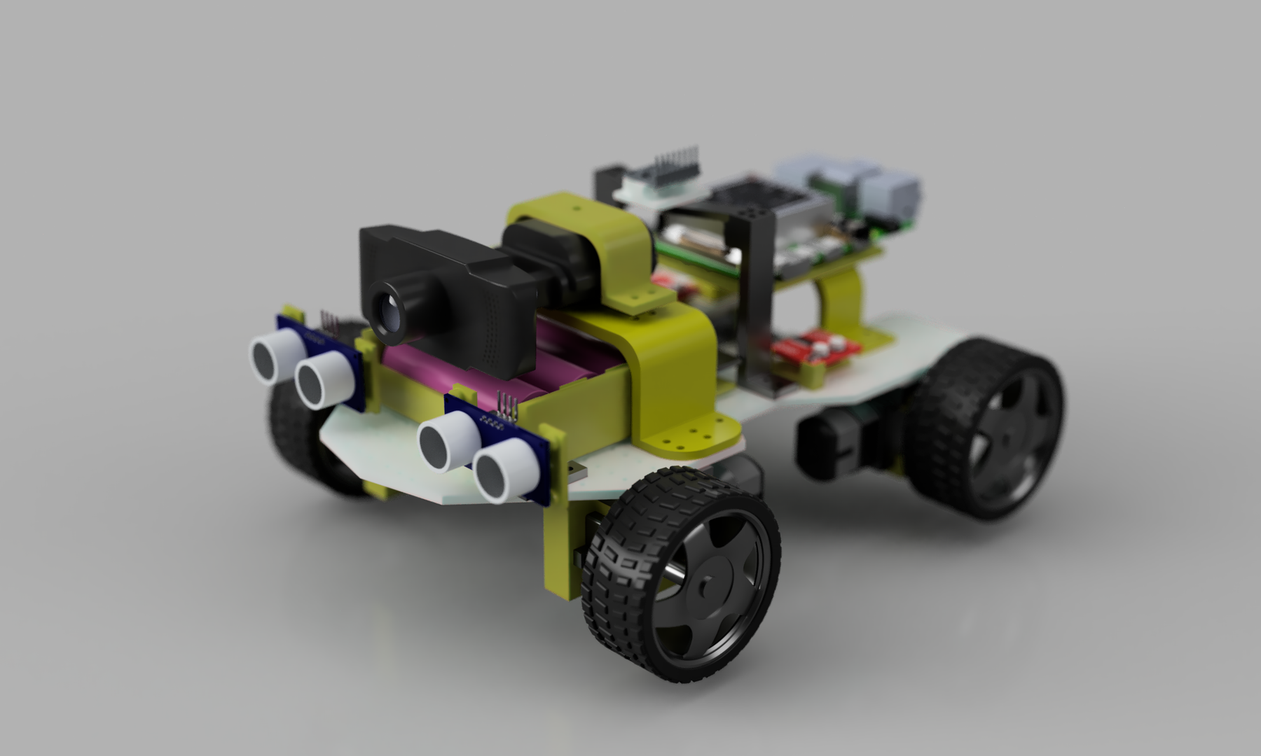
The existing render records the mechanical design stage. The completed physical prototype uses the Coral Dev Board as the only high-level compute board, with an appropriate mounting plate or adaptor.
Figure 3.5: Finalized Fusion 360 robot multi-view layout
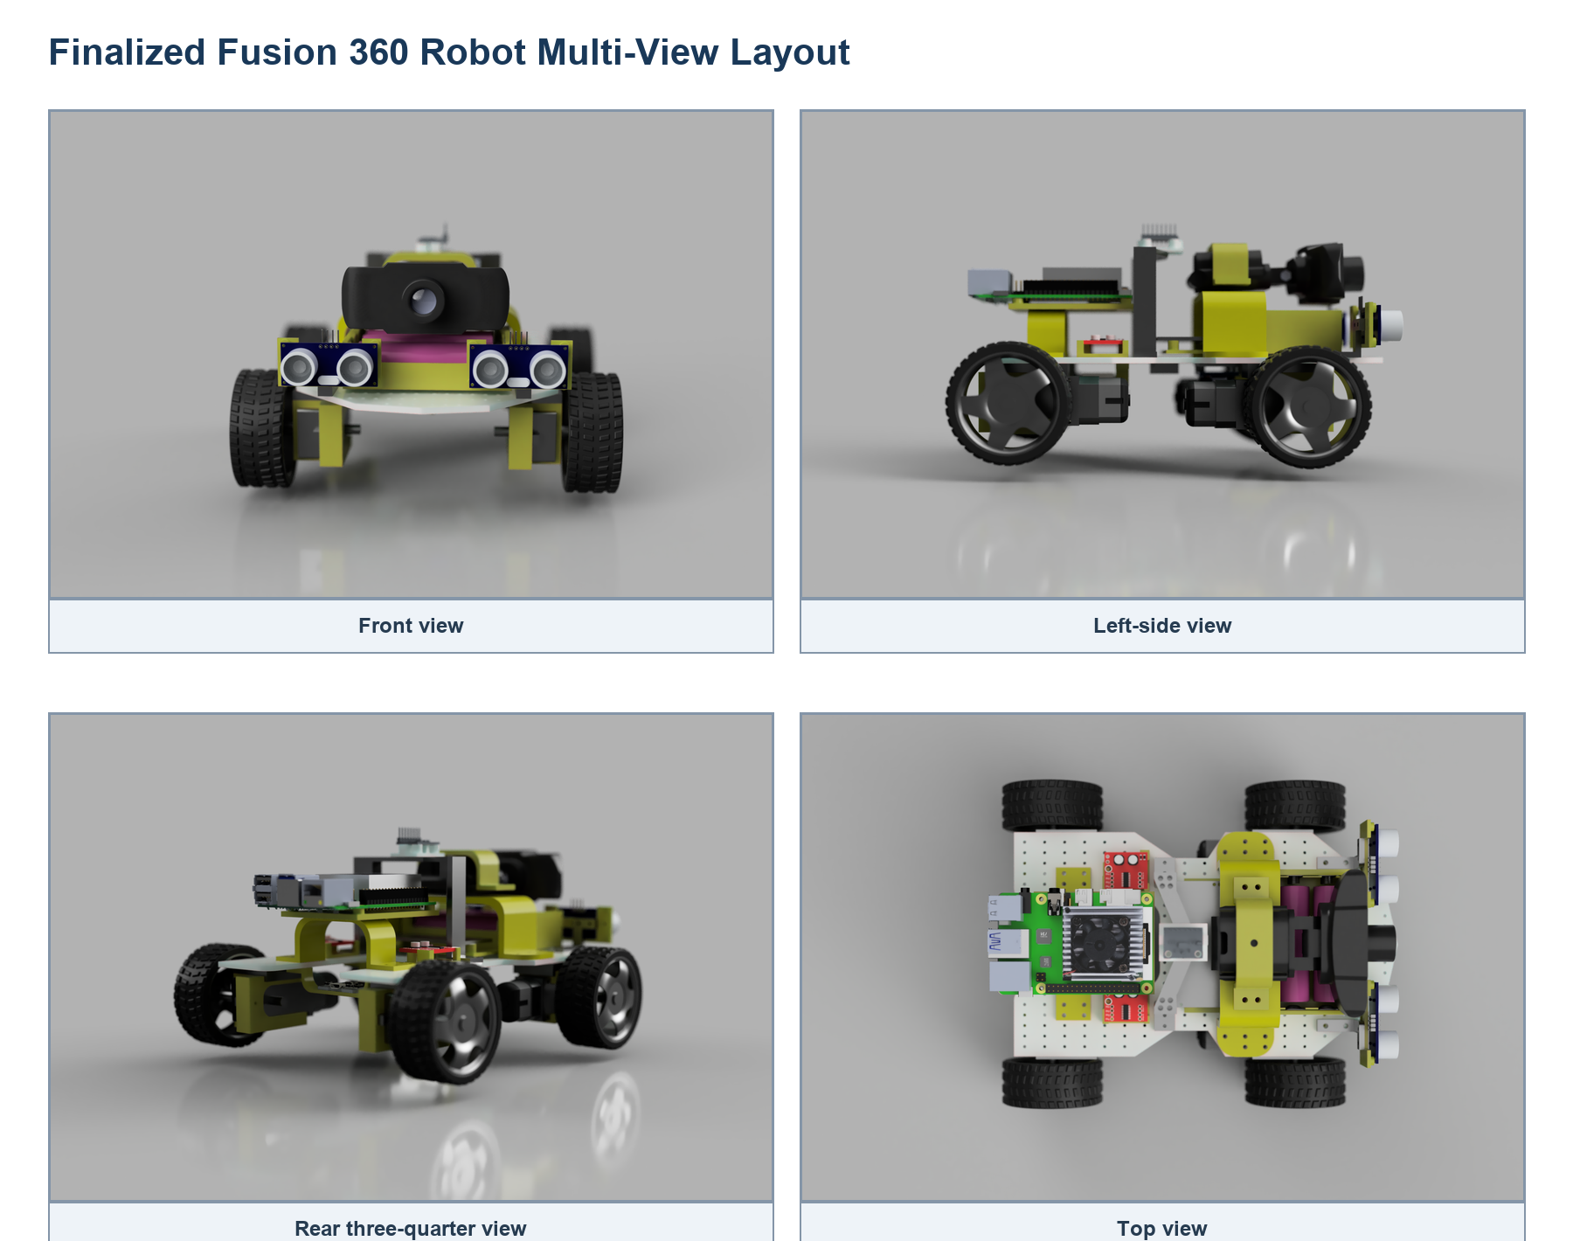
The views support sensor visibility, wheel clearance, component spacing, cable access, and Coral mounting verification.
Figure 3.6: Finalized mechanical design sketch and dimensions
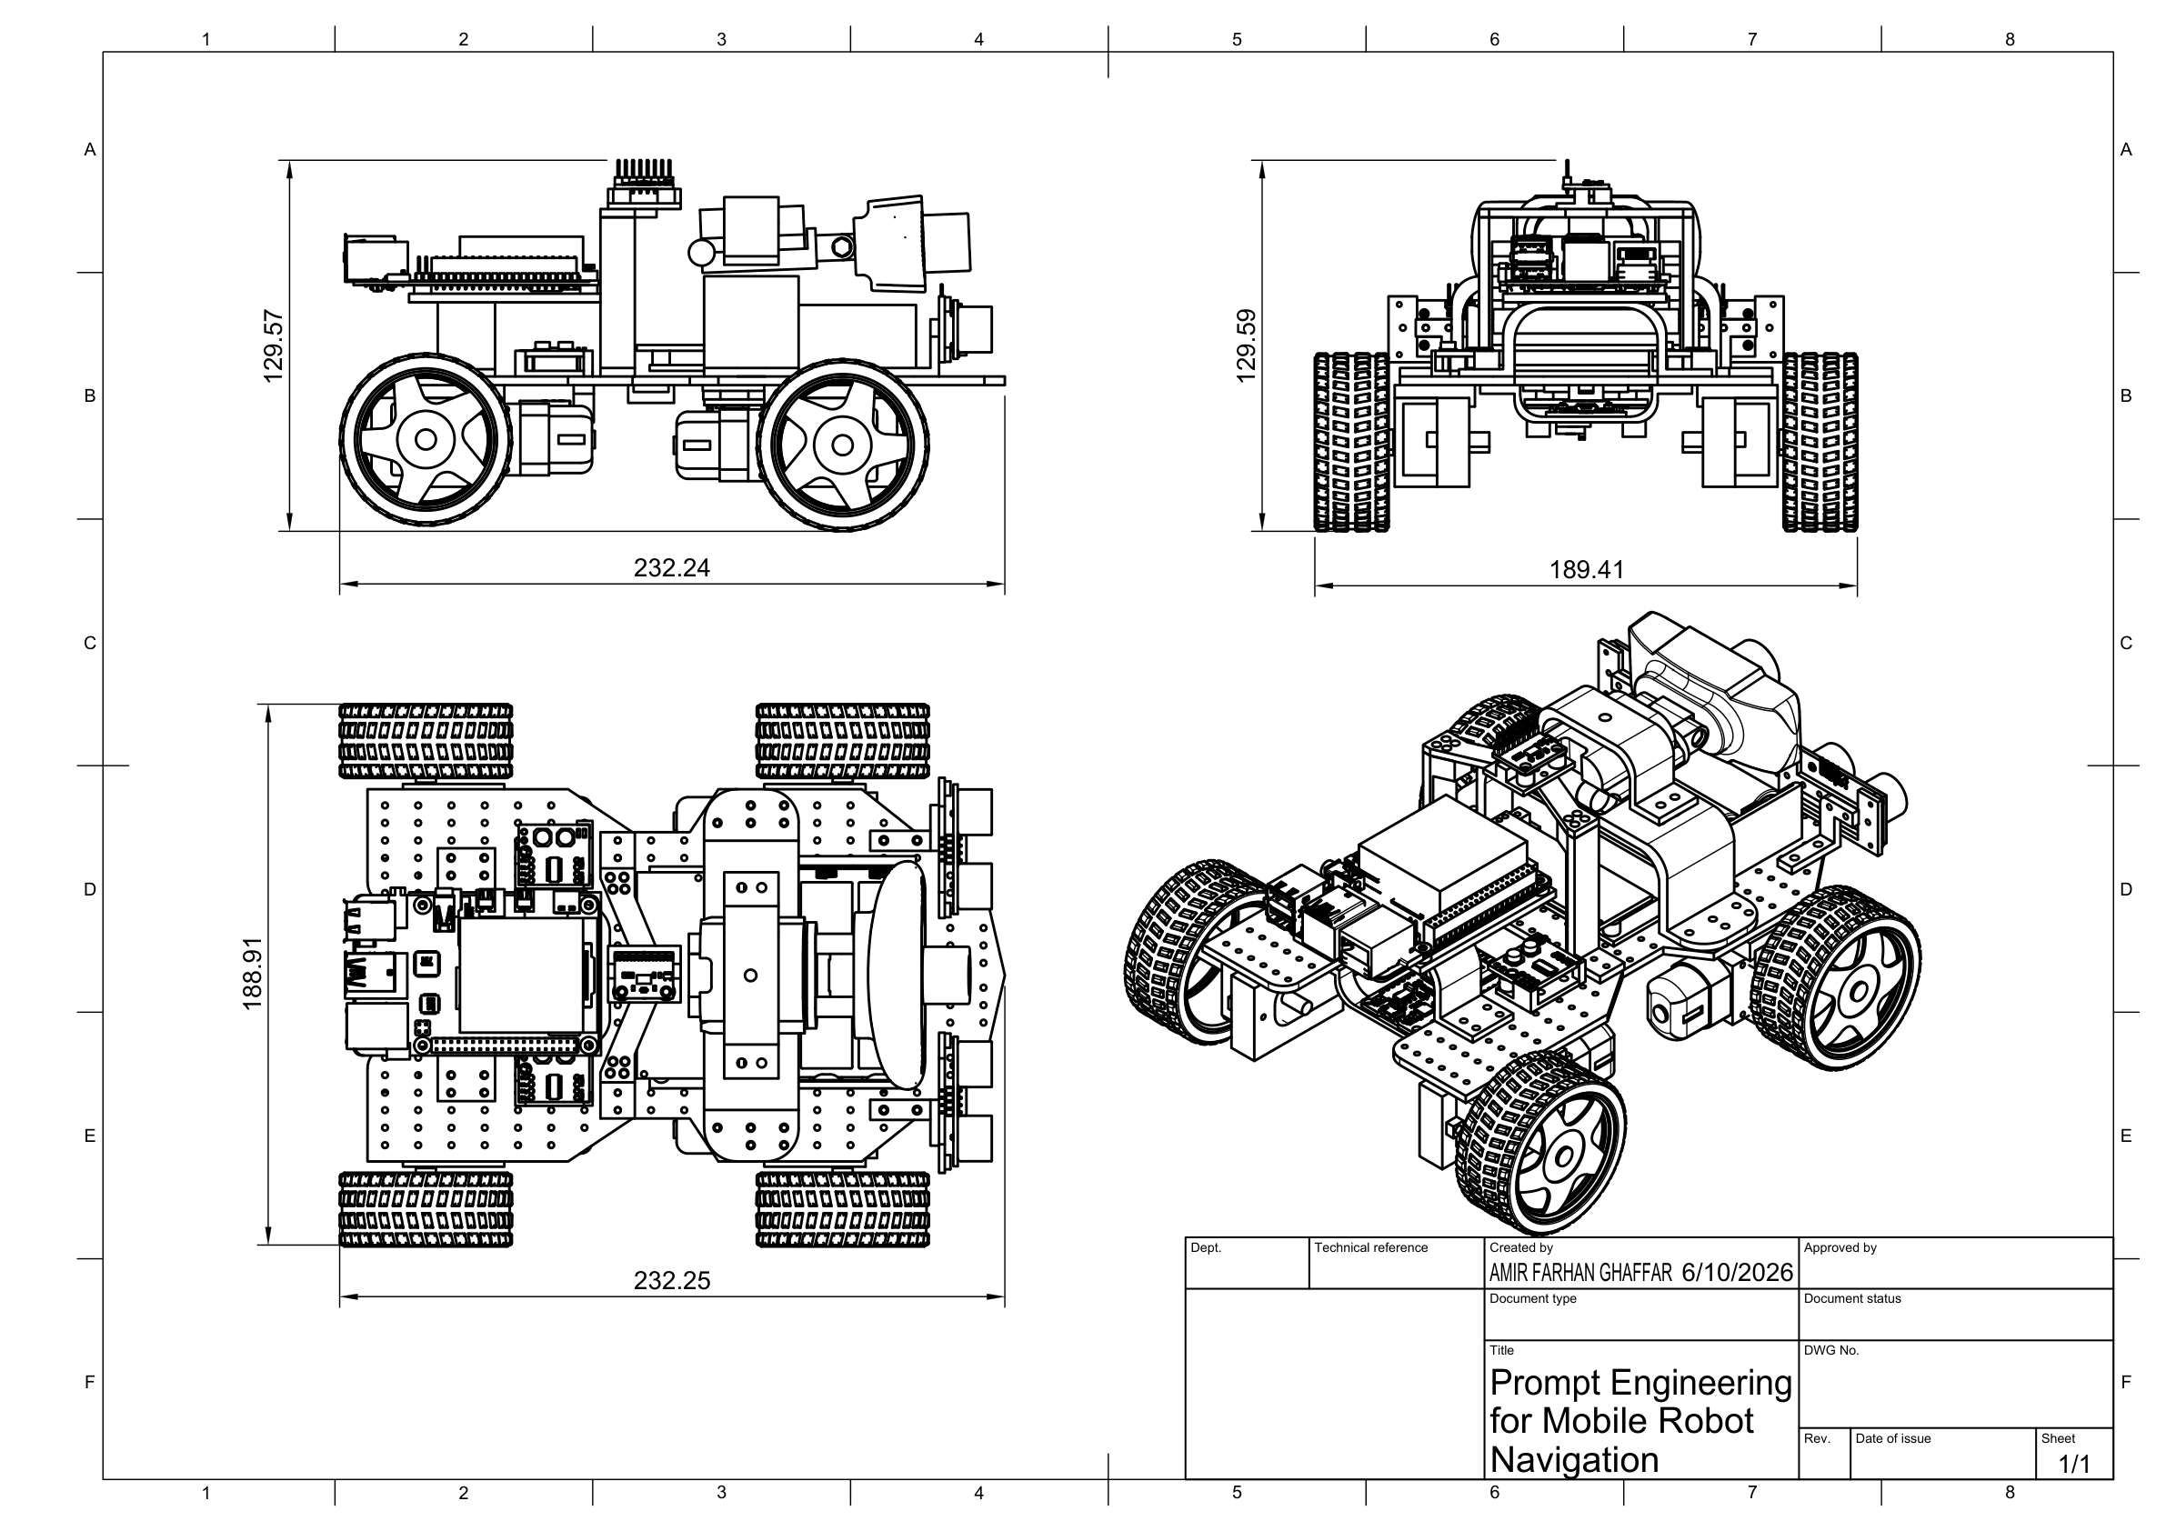
The approximate overall dimensions are 232.24 mm long, 188.91 mm wide, and 129.57 mm high.

3.10 Finalized Wiring Architecture
Figure 3.7: Finalized component-based circuit architecture
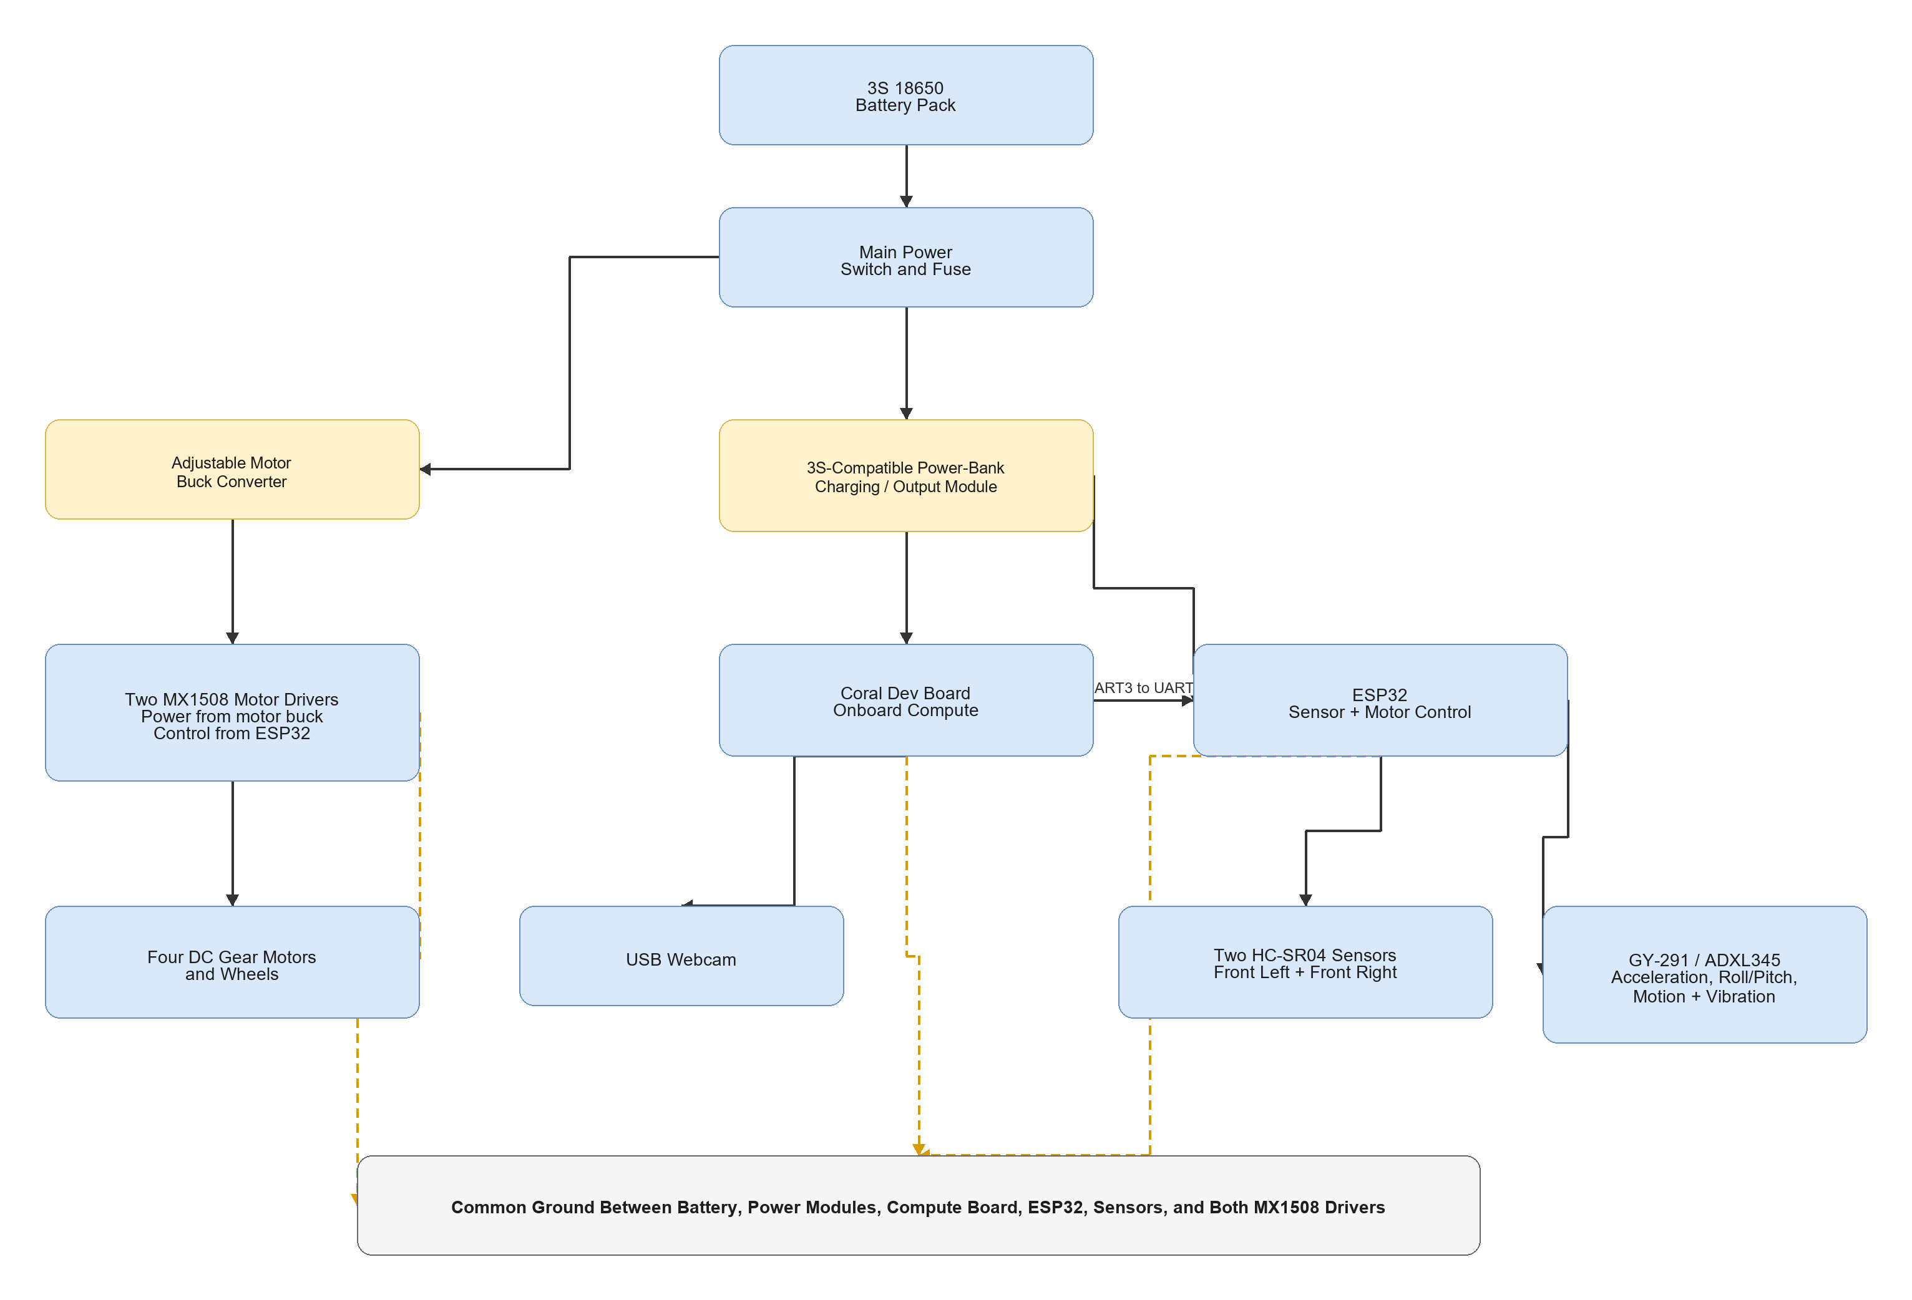
Figure 3.8: Finalized ESP32 sensor and motor wiring
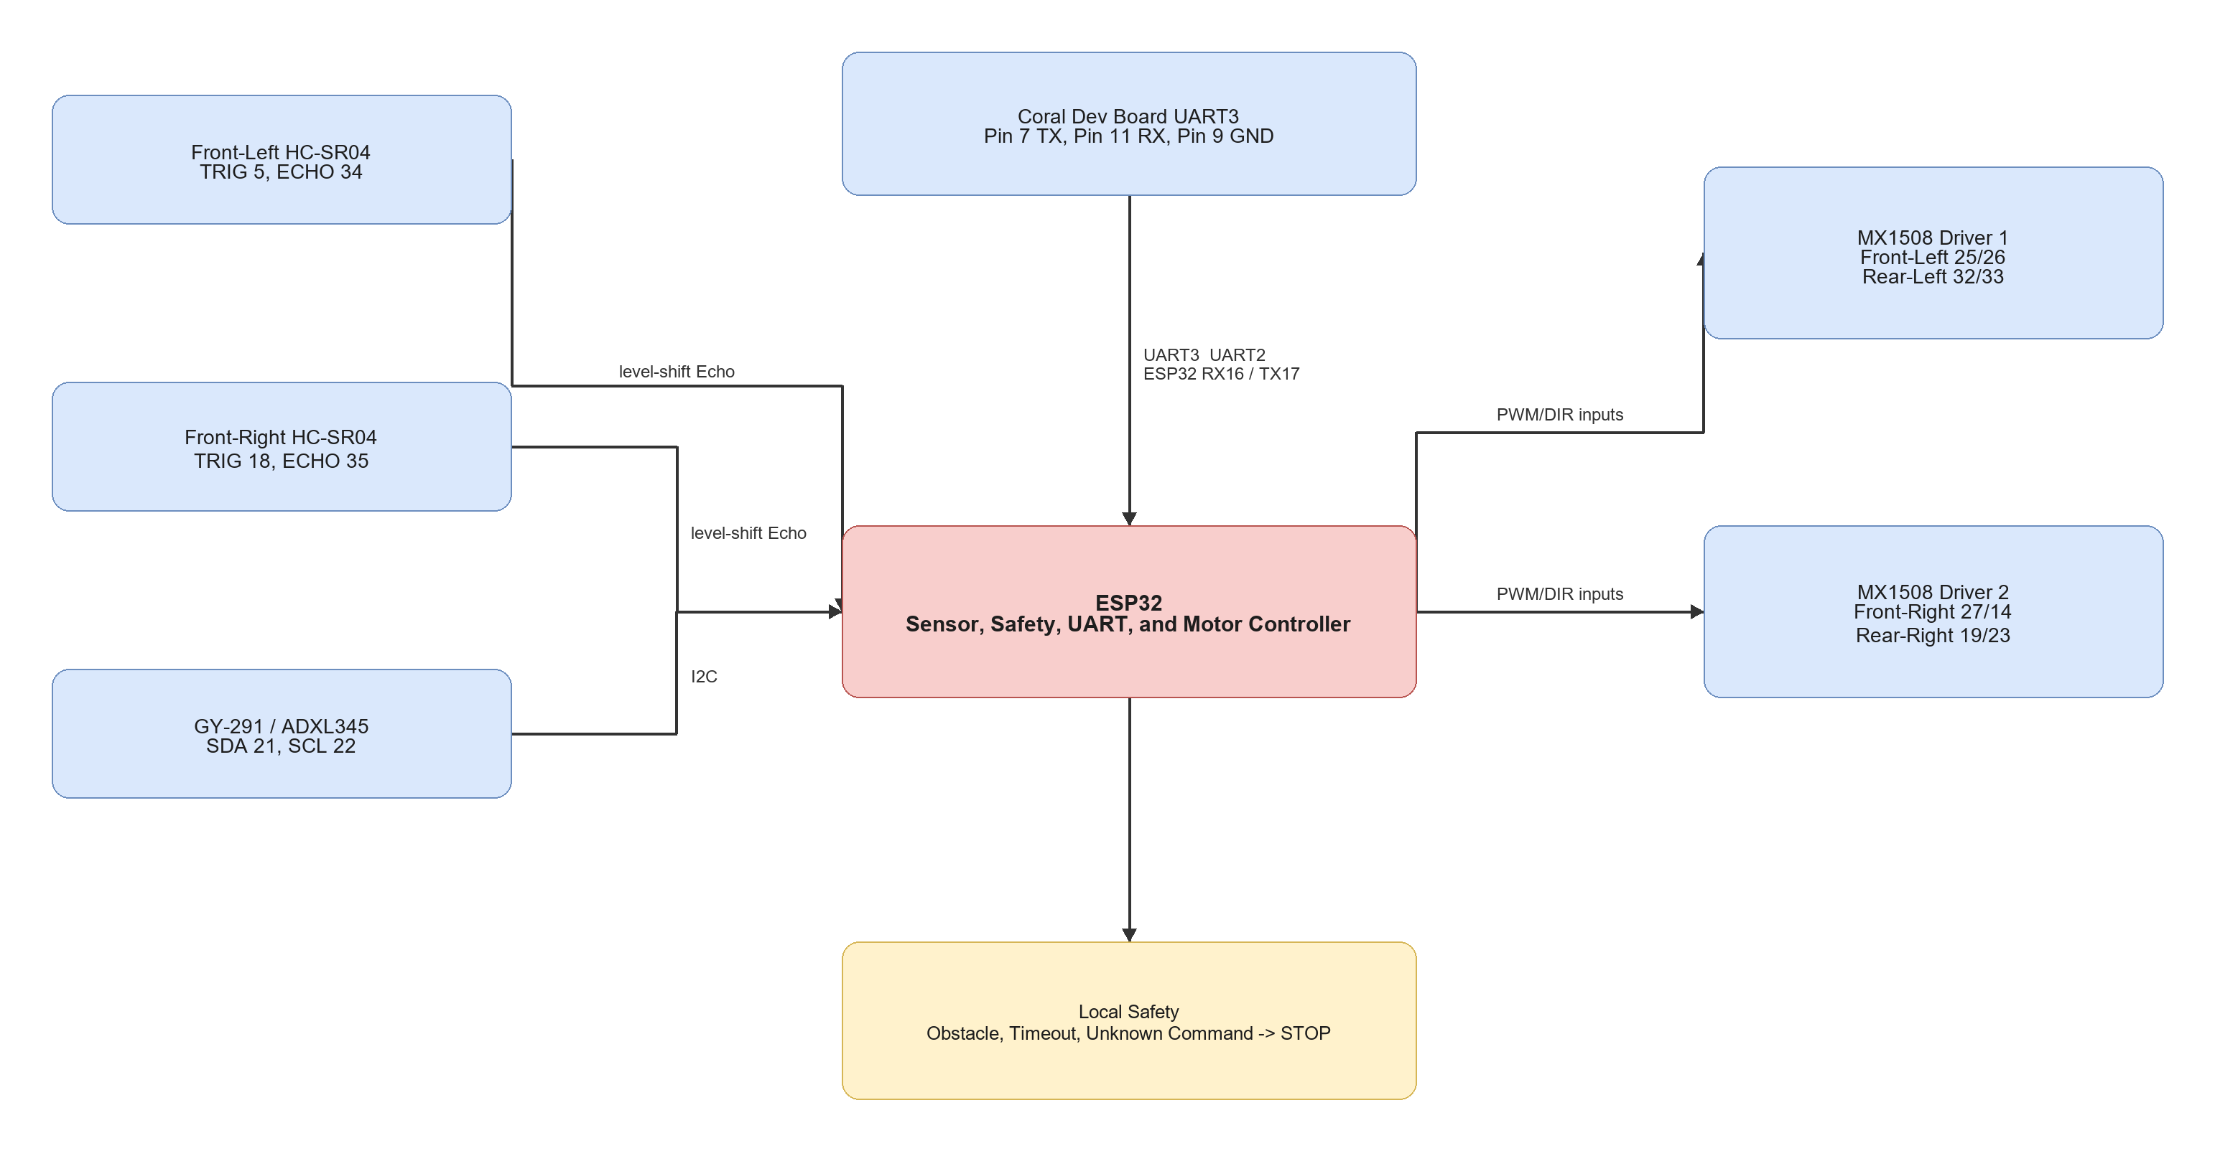
The detailed connection and test sequence is provided in docs/circuit_wiring_guide.md.

3.11 Software Implementation
Table 3.11: Source Code and Documentation Modules

3.12 Main Equations and Decision Rules
Table 3.12: Main Equations and Decision Rules

3.13 Implementation Procedure
Table 3.13: Implementation Procedure

3.14 Testing and Validation Plan
Table 3.14: Testing and Validation Matrix

3.15 Evaluation Metrics
Table 3.15: Evaluation Metrics

3.16 Laptop-Only Expected-Results Demonstration
The separate laptop demo uses a browser webcam and coloured marker to display expected navigation actions. A Docker container provides the isolated Flask, OpenCV, NumPy, and logging environment. This allows the action interface and software environment to be demonstrated reproducibly during FYP1. The user manually moves the laptop; no motor interface or physical robot claim is made. Final results must come from the Coral Dev Board physical robot.

3.17 Safety, Limitations, and Future Work
Testing must use the completed protected power system, fuse, reachable main switch, correct regulated rails, and a common ground. Motor tests begin with the robot raised. HC-SR04 Echo pins require level shifting.
The robot stops for invalid output, high uncertainty, obstacle detection, unknown commands, or command timeout. Testing is supervised in a controlled indoor area.
The USB webcam does not provide dense depth or a 3D map. Two ultrasonic sensors provide limited obstacle coverage. The GY-291 does not provide yaw heading. The Coral Dev Board supports only Edge TPU-compatible models, and the first prototype supports only simple goals and detector-known target classes.
Future work may include a custom door and signboard detector, wheel encoders, magnetometer or full IMU, RGB-D camera, LiDAR, mapping, relation-aware prompts, and stronger navigation policies.

3.18 Summary
This chapter finalized the methodology around one Coral Dev Board physical robot. The project connects structured prompt processing and Edge TPU visual grounding to an ESP32 that independently handles sensors, safety, and four-motor control. The first measurable target is a reliable and safe single-goal indoor navigation demonstration.

