CHAPTER 4
EXPECTED RESULTS AND DISCUSSION

4.1 Introduction
This chapter presents the expected results for FYP1. The expectations are based on the finalized Coral Dev Board architecture, structured prompt design, completed physical hardware, ESP32 safety logic, laptop-only expected-results demonstration, and planned physical validation. Final measured robot results will be presented during FYP2.

4.2 Expected Basic Prototype Result
The first Coral Dev Board prototype is expected to complete one simple and repeatable goal such as find the chair. The instruction should be converted into a structured target and approved action set. The Edge TPU-compatible detector should identify the chair in the webcam view and select an action from its image position.
Table 4.1: Summary of Expected Basic Prototype Results

4.3 Expected Laptop-Only Demonstration
The laptop-only Docker demonstration is expected to show the planned action interface before physical robot testing. A browser captures a coloured target through the laptop webcam and sends frames to the containerized Python/OpenCV service. The application displays TURN LEFT, TURN RIGHT, MOVE FORWARD, SEARCH, or STOP, and the user manually moves the laptop according to the displayed action.
This demonstration provides expected-results evidence only. It is not a second physical implementation and is not used as the final robot result.

4.4 Expected Safety Simulations
The ESP32 uses the minimum reading from the two front HC-SR04 sensors. With the planned 25 cm threshold, the robot is expected to stop when either valid sensor reading is below 25 cm.
Figure 4.1: Expected obstacle-stop response at the planned 25 cm threshold
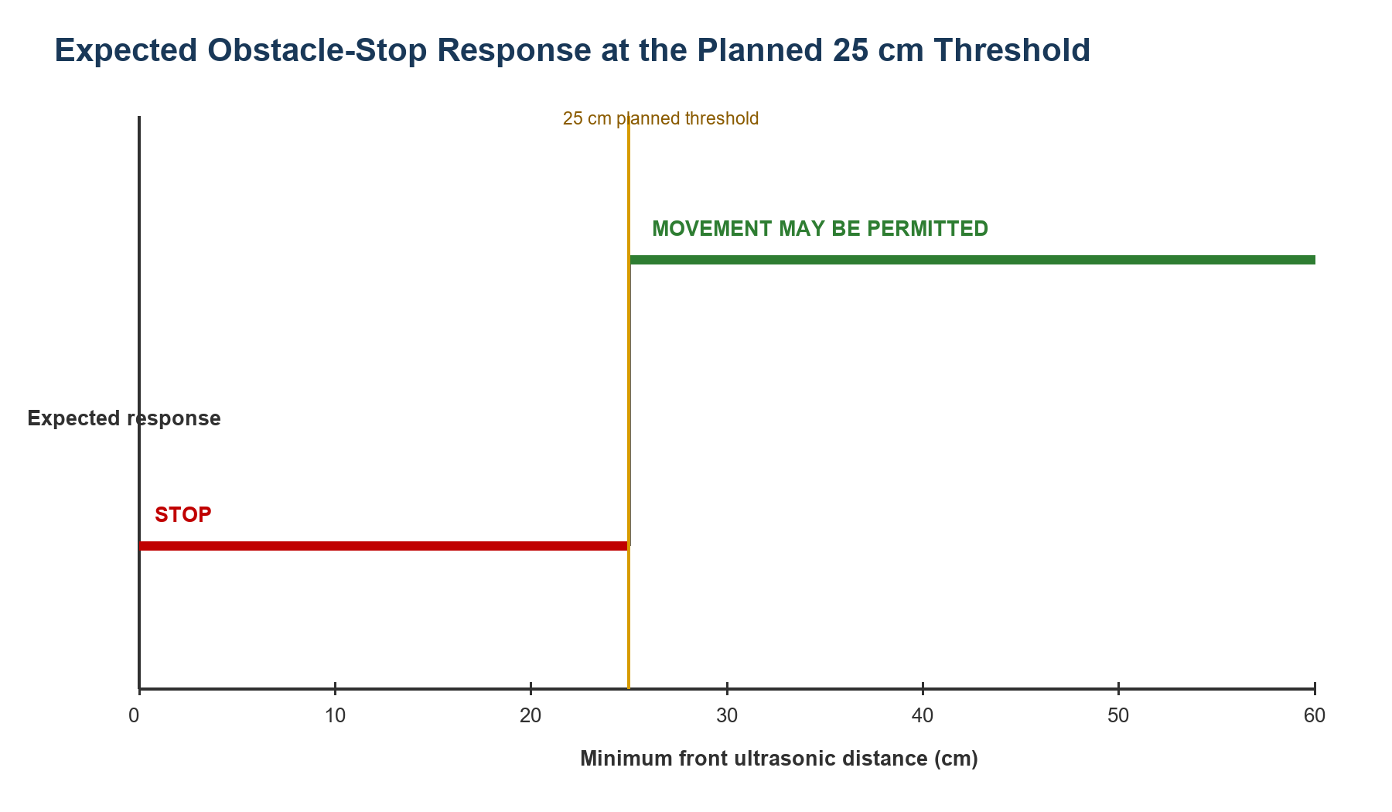
The ESP32 also applies a 1,000 ms command timeout. If no new valid command is received within this period, all motor outputs are expected to stop.
Figure 4.2: Expected motor response when the command timeout exceeds 1,000 ms
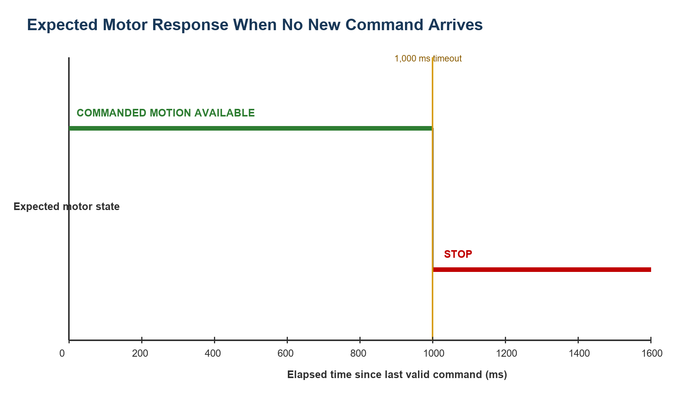
These simulations demonstrate the intended decision logic only. The final distance threshold and physical stopping response require calibration and repeated testing during FYP2.

4.5 Required FYP2 Results
FYP2 will replace these expectations with measured results from the completed Coral Dev Board robot.
Table 4.2: Required FYP2 Measurements

4.6 Discussion
The expected results suggest that structured prompt engineering can provide a simple interface between a natural-language goal and a restricted robot action set. The Coral Dev Board is expected to provide efficient visual inference for a compatible detector, while the ESP32 independently prevents movement during obstacle, timeout, and invalid-command conditions.
The basic single-target goal is intentionally limited. Demonstrating it reliably is more valuable than claiming complex navigation without sufficient sensor coverage, mapping, or model capability. Once the baseline is verified, the project can extend to custom indoor-landmark classes and more complex instructions.

4.7 Summary
This chapter presented the expected FYP1 outcomes for the Coral Dev Board prototype, laptop-only expected-results demonstration, and safety logic. Final physical results will measure whether the robot can safely find and approach a supported indoor target.

