PROMPT ENGINEERING FOR
MOBILE ROBOT NAVIGATION

AMIR FARHAN BIN GHAFFAR



DEPARTMENT OF MECHATRONICS ENGINEERING KULLIYAH OF ENGINEERING

INTERNATIONAL ISLAMIC UNIVERSITY MALAYSIA
JUNE 2026

PROMPT ENGINEERING FOR
MOBILE ROBOT NAVIGATION

AMIR FARHAN BIN GHAFFAR

Project Supervisor: Assoc. Prof. Ts. Dr. Hasan Firdaus Bin Mohd Zaki



A REPORT SUBMITTED IN PARTIAL FULFILMENT OF THE REQUIREMENT FOR A DEGREE OF BACHELOR OF MECHATRONICS ENGINEERING WITH HONOURS

ACKNOWLEDGEMENTS

I would like to express my sincere appreciation to my supervisor, Dr. Hasan Firdaus Bin Mohd Zaki, for his guidance, advice, and support throughout this Final Year Project. I am also thankful to the Kulliyyah of Engineering, Mechatronics Department, International Islamic University Malaysia (IIUM) for providing facilities and a good environment to carry out this project. Lastly, I would like to thank my friends who helped and supported me during the process, as well as my family for their encouragement and motivation.

TABLE OF CONTENT

ACKNOWLEDGEMENTS 3
TABLE OF CONTENT 4
LIST OF FIGURES 6
LIST OF TABLES 7
LIST OF ABBREVIATIONS 8
CHAPTER 1 9
INTRODUCTION 9
1.1 Overview 9
1.2 Background and Motivation 10
1.3 Problem Statement 10
1.4 Research Questions 11
1.5 Aim and Objectives 11
1.6 Research Scope 11
1.7 Significance of the Project 12
1.8 Organization of the Thesis 12
1.9 Summary 12
CHAPTER 2 13
LITERATURE REVIEW 13
2.1 Introduction 13
2.2 Mobile Robot Navigation and Natural Language Instructions 14
2.3 Prompt Engineering for Robot Navigation 16
2.4 Vision-Language Grounding for Indoor Landmarks 17
2.5 LM-Nav as the Main Baseline 18
2.5.1 Overview of LM-Nav 19
2.5.2 Strength of LM-Nav 20
2.5.3 Limitation of LM-Nav 20
2.5.4 Relevance to This Project 21
2.6 VLMnav as a Prompt-Based Action Selection Reference 21
2.7 Spatial Grounding Methods: VLMaps and HOV-SG 22
2.8 Navigation Execution Models: ViNT and NoMaD 24
2.9 Recent VLM and VLA Navigation Systems 27
2.10 Critical Comparison of Related Works 30
2.11 Hardware Suitability for This FYP 32
2.12 Research Gap and Motivation 36
2.13 Chapter Summary 38
CHAPTER 3 39
RESEARCH METHODOLOGY 39
3.1 Introduction 39
3.2 Research Design and Project Workflow 40
3.2.1 Methodology Alignment with Research Objectives 40
3.2.2 Overall Project Workflow 41
3.2.3 Development Workflow 43
3.3 Finalized System Architecture 44
3.3.1 Hardware Roles 46
3.4 Requirements, Constraints, and Acceptance Criteria 47
3.5 Data, Test Environment, and Experimental Materials 49
3.6 Prompt Engineering Design 52
3.7 Webcam-Based Visual Grounding and Action Selection 54
3.8 Robot Action and Command Mapping 55
3.9 Baseline and Future Extension Boundaries 56
3.10 Mechanical Design and Physical Integration 57
3.10.1 Custom-Designed and Fabricated Components 59
3.10.2 Finalized Circuit Architecture 60
3.11 Company, Software, and Tool Involvement 61
3.12 Software Implementation and Coding 62
3.13 Equations and Decision Rules 63
3.14 Implementation Procedure 64
3.15 Testing and Validation Plan 65
3.16 Evaluation Metrics 67
3.17 Safety, Limitations, and Future Work 67
3.18 AI Models Intended for Research 68
3.18.1 Language Model: Quantized TinyLlama 69
3.18.2 Vision Model: MobileNetV2-SSD Lite TensorFlow Lite 70
3.18.3 Action Model: VLM-NAV-Inspired Neural Classifier 71
3.18.4 Models Outside the First Physical Implementation 71
3.19 AI Model Experimental Procedure and Validation 72
3.19.1 Reproducibility and Reporting 73
3.19.2 Physical Integration Rule 73
3.20 Summary 73
CHAPTER 4 74
RESULTS AND DISCUSSION 74
4.1 Introduction 74
4.2 Docker Demonstration Setup 75
4.3 Observed Results 77
4.3.1 Structured Prompt Result 77
4.3.2 Door Detection and STOP Result 77
4.3.3 Missing-Target SEARCH Result 79
4.3.4 Detection of a Second Similar Door 80
4.3.5 Right-Side Door TURN RIGHT Result 81
4.4 Discussion 82
4.5 Required Physical Validation During FYP2 84
4.6 Summary 85
CHAPTER 5 86
CONCLUSION 86
5.1 Introduction 86
5.2 Summary of Final Year Project 1 Work 86
5.3 Achievement of Research Objectives 86
5.4 Main Contributions 88
5.5 Limitations 88
5.6 Recommended FYP2 Work 88
5.7 Conclusion 89
REFERENCE 90

LIST OF FIGURES

Figure 2.1: General language-guided navigation process 15
Figure 2.2: LM-Nav real-world visual navigation platform (Shah et al., 2023a) 18
Figure 2.3: LM-Nav baseline pipeline 19
Figure 2.4: VLMnav prompt and action-selection interface (Goetting et al., 2024) 21
Figure 2.5: VLMaps language-grounded navigation example (Huang et al., 2023) 23
Figure 2.6: HOV-SG hierarchical navigation platform (Werby et al., 2024) 24
Figure 2.7: ViNT visual navigation transformer architecture (Shah et al., 2023b) 25
Figure 2.8: NoMaD visual navigation examples (Sridhar et al., 2023) 26
Figure 2.9: NaVid video-based navigation architecture (Zhang et al., 2024) 27
Figure 2.10: Uni-NaVid embodied navigation examples (Zhang et al., 2026) 28
Figure 2.11: NaVILA vision-language-action navigation examples (Cheng et al., 2025) 29
Figure 2.12: Positioning of related works around LM-Nav 36
Figure 3.1: Proposed project workflow 43
Figure 3.2: Proposed system architecture 46
Figure 3.3: Main hardware components for the finalized Raspberry Pi 4 robot 52
Figure 3.4: Finalized Fusion 360 physical robot model 58
Figure 3.5: Finalized Fusion 360 robot multi-view layout 59
Figure 3.6: Finalized mechanical design sketch and dimensions 60
Figure 3.7: Finalized component-based circuit architecture 61
Figure 3.8: Finalized ESP32 sensor and motor wiring 62
Figure 4.1: Docker result when the close grey-blue door is detected and the goal-stop threshold is reached 78
Figure 4.2: Docker result when an open grey-blue door region is detected and STOP is selected 78
Figure 4.3: Docker SEARCH result when no valid full door region is detected 79
Figure 4.4: Docker result when a second grey-blue corridor door is detected and STOP is selected 80
Figure 4.5: Docker TURN RIGHT result when the detected door is on the right side of the processed frame 81

LIST OF TABLES

Table 2.1: Roles of prompt engineering in mobile robot navigation 17
Table 2.2: Critical comparison of related papers 32
Table 2.3: Hardware and method suitability for this FYP 35
Table 2.4: Research gap synthesis and project strategy 38
Table 3.1: Methodology Alignment with Research Objectives 42
Table 3.2: Development Workflow 44
Table 3.3: Finalized Hardware Roles 48
Table 3.4: Requirements and Acceptance Criteria 49
Table 3.5: First-Prototype Scenarios 50
Table 3.6: Experimental Materials 51
Table 3.7: Software and Model Requirements 53
Table 3.8: Supported First-Prototype Prompt Inputs 54
Table 3.9: Structured Prompt Fields 55
Table 3.10: Visual Grounding and Action Decision Rules 56
Table 3.11: Action Set and Motor Command Mapping 57
Table 3.12: Baseline and Future Extension Boundaries 58
Table 3.13: Company, Component, and Software Involvement 63
Table 3.14: Source Code and Documentation Modules 64
Table 3.15: Main Equations and Decision Rules 65
Table 3.16: Implementation Procedure 66
Table 3.17: Testing and Validation Matrix 67
Table 3.18: Evaluation Metrics 68
Table 3.19: Baseline and AI Models Intended for Research 70
Table 3.20: Planned TinyLlama Prompt-Engineering Configurations 71
Table 3.21: AI Model Comparisons, Measurements, and Safety Gates 74
Table 4.1: Summary of Docker Screenshot Evidence 76
Table 4.2: Interpretation and Limitations of the Demonstrated Results 83
Table 4.3: Required FYP2 Validation After the Docker Demonstration 84
Table 5.1: Achievement of Research Objectives 86
Table 5.2: Recommended FYP2 Implementation and Validation Work 88

LIST OF ABBREVIATIONS

IIUM International Islamic University Malaysia
AUV Autonomous Underwater Vehicle
BMS Battery Management System
BoM Bill of Materials
CB Centre of Buoyancy
CAD Computer-Aided Design
CG Centre of Gravity
DC-DC Direct Current to Direct Current (converter)
DOF Degree(s) of Freedom
ESC Electronic Speed Controller
FPS Frames Per Second
GND Ground (negative terminal)
IMU Inertial Measurement Unit
LAN Local Area Network
PWM Pulse Width Modulation
ROV Remotely Operated Vehicle
SBC Single Board Computer
UDP User Datagram Protocol
USB Universal Serial Bus
VCC Positive Supply Voltage
FYP1 Final Year Project 1
FYP2 Final Year Project 2

CHAPTER 1

INTRODUCTION

1.1 Overview
Mobile robots are increasingly used in indoor environments for inspection, assistance, delivery, monitoring, and research. For a robot to be useful to a non-technical user, the interaction method should be simple and natural. Instead of requiring coordinates, joystick control, or programming commands, a user should be able to provide an instruction such as "Find the green marker" or, in later development, "Go to the door".
Natural-language mobile robot navigation is challenging because a human instruction must be converted into information that a robot can understand and execute. The robot must identify the intended target, connect the instruction with its current camera view, choose an appropriate movement action, and stop safely when the action is uncertain or an obstacle is detected.
This Final Year Project investigates how structured prompt engineering can support this process on one low-cost indoor mobile robot prototype. The finalized physical system uses a Raspberry Pi 4 for onboard prompt processing, USB-webcam perception, lightweight OpenCV visual grounding, action selection, and result logging. An ESP32 performs sensor reading, local safety checks, and four-motor control through two MX1508 motor-driver modules.
The first prototype intentionally targets the basic and repeatable goal find the green marker. It adapts the modular language-to-vision-to-action concept demonstrated by LM-Nav and the restricted prompt-based action-selection idea used by VLMnav. It does not attempt to reproduce a large autonomous navigation platform or run an unrestricted large vision-language model directly onboard.

1.2 Background and Motivation
Traditional mobile robot navigation commonly uses maps, localization, path planning, and sensor feedback. These methods are effective when the destination is represented by coordinates or predefined waypoints. However, ordinary users normally describe destinations using natural language and visual concepts.
Prompt engineering can constrain language interpretation into a structured response containing a target, landmarks, spatial relation, action goal, and uncertainty. Visual grounding can then connect the structured target to an image captured by the robot. For a physical robot, the output must also be restricted to approved actions and checked against local safety information.
The motivation for this project is therefore to investigate a practical division of responsibility. The Raspberry Pi 4 performs high-level language and visual processing, while the ESP32 performs time-sensitive sensor reading, motor commands, obstacle detection, and command-timeout safety. This architecture supports prompt-based robot navigation without allowing uncertain high-level output to bypass deterministic local safety rules.

1.3 Problem Statement
Natural-language instructions are intuitive for humans but are not directly usable by a mobile robot. Instructions may be ambiguous, incomplete, or dependent on objects visible in the environment. Free-form model responses are also difficult to connect reliably to motor control because they may contain unsupported actions or inconsistent wording.
Low-cost mobile robot platforms introduce further constraints. A USB webcam does not provide depth or a complete map. The Raspberry Pi 4 has limited resources for large vision-language models, so the first prototype requires a lightweight and measurable visual-grounding method. Two front ultrasonic sensors provide limited obstacle coverage, and the low-cost motor and power subsystems require careful integration.
There is therefore a need for a focused low-cost system that can convert a simple natural-language indoor goal into structured machine-readable information, ground a supported target using a webcam image, restrict the result to an approved action set, and validate the action using ESP32 safety information before movement.

1.4 Research Questions
1. How can structured prompt engineering convert simple indoor navigation instructions into consistent machine-readable targets, actions, and uncertainty?
2. How can Raspberry Pi 4 webcam-based visual grounding and ESP32 sensor feedback be combined to select and execute safe basic robot actions?
3. How reliably can the completed Raspberry Pi 4 prototype find and approach a supported visual landmark in a controlled indoor environment?

1.5 Aim and Objectives
The aim of this project is to design and implement a Raspberry Pi 4-based prompt-engineered mobile robot for basic navigation in a controlled indoor environment.
The objectives are:
1. To develop a structured prompt-engineering pipeline that converts a simple natural-language navigation instruction into fixed fields and an approved action set.
2. To integrate a Raspberry Pi 4, USB webcam, ESP32, two HC-SR04 sensors, GY-291 / ADXL345 accelerometer, two MX1508 motor drivers, four DC gear motors, and the completed protected power system into one physical robot.
3. To evaluate prompt validity, visual grounding, action correctness, latency, local safety behaviour, and simple physical navigation success.

1.6 Research Scope
The project is limited to one low-cost four-wheel indoor mobile robot using a Raspberry Pi 4 as the only onboard high-level compute platform. The robot operates in supervised controlled areas such as rooms, laboratories, and simple landmark test zones.
The first physical prototype focuses on the single-target goal find the green marker. The approved action set is limited to move_forward, turn_left, turn_right, search, and stop. The Raspberry Pi performs structured instruction processing, webcam capture, visual grounding, action selection, validation, and logging. The ESP32 reads the ultrasonic sensors and GY-291, controls four motors through two MX1508 modules, and enforces obstacle, sensor-fault, invalid-command, and command-timeout stop behaviour.
The GY-291 is used for X/Y/Z acceleration, gravity-based roll and pitch tilt, motion, vibration, and shock observations. It is not treated as a heading sensor. Advanced functions such as full simultaneous localization and mapping, precise coordinate navigation, wheel-encoder odometry, autonomous route planning, LiDAR, RGB-D perception, and unrestricted large-model control are outside the current scope.
A separate Docker-based laptop webcam demonstration may be used during FYP1 to illustrate expected action outputs before final physical testing. It is not a second physical project approach.

1.7 Significance of the Project
The project contributes a practical framework for connecting prompt engineering with a real low-cost robot. Structured output makes navigation decisions easier to parse, log, evaluate, and reject when unsafe. Separating Raspberry Pi high-level processing from ESP32 local control also demonstrates how model-based navigation can be combined with deterministic safety behaviour.
The first-prototype focus makes the research achievable and measurable. A reliable marker-navigation demonstration provides a baseline that can later be extended with object detection for chairs, doors, and signboards, relation-aware instructions, additional sensors, mapping, and stronger navigation models.

1.8 Organization of the Thesis
Chapter 1 introduces the project background, problem statement, research questions, objectives, scope, and significance. Chapter 2 reviews related work on language-guided navigation, prompt engineering, visual grounding, and suitable low-cost hardware. Chapter 3 presents the Raspberry Pi 4 methodology, system architecture, mechanical and electrical design, implementation procedure, and validation plan. Chapter 4 presents the expected FYP1 results and defines the physical measurements required during FYP2.

1.9 Summary
This chapter established the need for a focused and safety-aware approach to natural-language mobile robot navigation. The finalized project develops one Raspberry Pi 4 physical prototype with one ESP32 sensor, safety, and motor-control layer.

CHAPTER 2

LITERATURE REVIEW

2.1 Introduction
This chapter reviews literature related to Prompt Engineering for Mobile Robot Navigation. The project investigates how a mobile robot can receive a natural language instruction, extract useful navigation information, ground the instruction using visual input, and convert the result into simple movement commands. The work is positioned as a low-cost indoor Final Year Project (FYP) research prototype rather than an industry-level autonomous navigation system.
The main baseline paper for this project is LM-Nav: Robotic Navigation with Large Pre-Trained Models of Language, Vision, and Action by Shah et al. (2023a). LM-Nav is important because it presents a modular architecture for language-guided navigation. Its pipeline separates the problem into language understanding, visual grounding, and navigation execution. This structure is suitable for this FYP because the same idea can be adapted into one focused low-cost Raspberry Pi 4 robot with ESP32 low-level control.
The project does not attempt to reproduce the complete hardware capability of LM-Nav or newer large-scale navigation systems. Instead, the project adapts the core research idea into a student-level Raspberry Pi 4 physical robot. The first prototype uses the basic instruction "Find the green marker". The Raspberry Pi 4 produces structured navigation information, uses the USB-webcam image and lightweight OpenCV grounding, validates the proposed action using ESP32 sensor status, and sends a simple command such as move_forward, turn_left, turn_right, stop, or search to the ESP32 motor-control layer.
Several related works are reviewed to clarify the project scope. VLMnav is included as the main prompt and action-selection reference because it formulates navigation as a question-answering or action-choice task. VLMaps and HOV-SG are reviewed because they improve spatial grounding, but they require map construction, RGB-D sensing, or scene graph construction, so they are treated as future work rather than the main implementation. ViNT and NoMaD are reviewed as stronger navigation execution models, but they are not the main focus because this FYP emphasizes prompt engineering, visual grounding, and simple action control. More recent VLM and VLA navigation systems such as NaVid, Uni-NaVid, and NaVILA are also discussed as advanced research directions.
The aim of this chapter is therefore not only to describe related papers, but also to critically compare their suitability for a low-cost indoor robot prototype.

2.2 Mobile Robot Navigation and Natural Language Instructions
Mobile robot navigation normally requires a robot to perceive its environment, decide where to move, and execute motion safely. Traditional navigation systems often rely on a map, localization, path planning, obstacle detection, and low-level motor control. These systems are effective when the goal is specified in a robot-readable form, such as a coordinate, waypoint, or selected map location. However, this interaction style is not natural for non-technical users.
Natural language provides a more intuitive interface. A user can describe a goal using objects, places, and relations, for example "go to the door", "find the signboard", or "move toward the chair near the table". These instructions are simple for humans, but they are difficult for robots because they contain semantic meaning that must be connected to the physical environment.
Language-guided navigation therefore requires three main capabilities. First, the robot must understand the user's instruction. Second, it must ground the instruction in visual input or spatial knowledge. Third, it must convert the result into movement. This general process is shown in Figure 2.1.
Figure 2.1 presents the general information flow required for language-guided mobile robot navigation. It links a user's natural-language instruction with language interpretation, visual grounding, action selection, and safe physical execution.
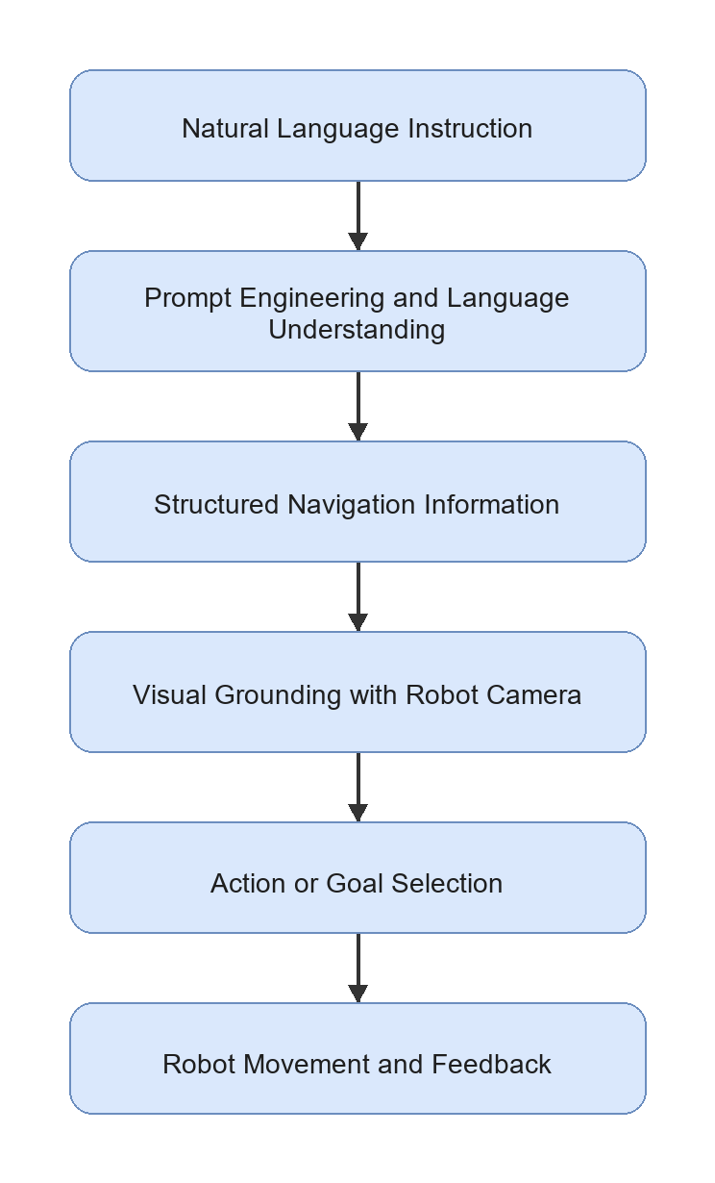

Figure 2.1: General language-guided navigation process
The process shows that a language instruction cannot be sent directly to the motors. The instruction must first be converted into a structured goal, matched with the current visual observation, and translated into a restricted action. Sensor and safety validation must then confirm that the action is suitable before movement. This sequence provides the conceptual foundation for the Raspberry Pi 4 and ESP32 architecture proposed in this project.

For this FYP, the navigation problem is intentionally limited to indoor environments such as a corridor, room, laboratory, door area, table area, chair area, or signboard location. This limitation is necessary because the proposed hardware uses a USB webcam and simple wheeled motion, not LiDAR, RGB-D SLAM, or high-cost navigation hardware. The controlled environment makes it possible to evaluate the core research question: whether structured prompt engineering can produce useful navigation information for a simple mobile robot.

2.3 Prompt Engineering for Robot Navigation
Prompt engineering is the design of model instructions, examples, constraints, and output formats so that an LLM or VLM produces useful responses. In robot navigation, prompt engineering is important because the model output must be connected to a physical robot. A free-form explanation is not enough. The output should contain machine-readable information such as the target object, relevant landmarks, spatial relation, action goal, suggested action, and uncertainty level.
In an LM-Nav-style system, prompt engineering can be used to extract landmarks from a natural language command. In a VLMnav-style system, prompt engineering can ask a model to choose the best next action from a fixed set. For a low-cost robot prototype, both ideas are useful. The robot does not need a complex high-level planner in the first implementation if the prompt output can be converted into a small set of validated motor commands.

Table 2.1 summarizes the roles that prompt engineering can perform within a mobile robot navigation pipeline. It links each role with an example output and its purpose in the proposed FYP.

Role | Example Output | Purpose in This FYP
Landmark extraction | door, chair, table, signboard | Identify objects or places mentioned by the user
Target selection | target: door | Decide the main navigation goal
Spatial relation extraction | chair near table | Preserve relations that affect grounding
Route or action interpretation | move_forward, turn_left | Convert instruction meaning into simple action options
Structured output formatting | JSON-style response | Allow Python code on the selected compute platform to parse the result
Uncertainty handling | uncertainty: high | Prevent unsafe execution when the model is unsure
Visual grounding query generation | door in indoor corridor | Improve matching between text and webcam image

Table 2.1: Roles of prompt engineering in mobile robot navigation
The table shows that prompt engineering is used to produce structured and verifiable navigation information rather than only a natural-language response. Target extraction, relations, approved actions, output formatting, and uncertainty handling create an interface that can be parsed and checked before a command reaches the physical robot.

For this project, prompt engineering is treated as the interface between human language and robot action. The prompt must not only produce a correct sentence; it must produce an output that can be checked, logged, evaluated, and used by the onboard Raspberry Pi 4 decision logic.

2.4 Vision-Language Grounding for Indoor Landmarks
Vision-language grounding is the process of connecting text descriptions to visual observations. For mobile robot navigation, this means matching a target word such as "door", "chair", "table", "corridor", or "signboard" with what the robot sees through its camera.
CLIP and OpenCLIP-style models are common choices for image-text grounding because they embed images and text into a shared feature space. A text query can be compared with an image using cosine similarity:
score(image, text) = cosine_similarity(E_image(image), E_text(text))
where E_image is the image encoder and E_text is the text encoder. The image or region with the highest score can be treated as the most relevant match. A modern VLM may also be used by asking a question such as "Does this image contain a door?" or "Which action should the robot take to find the chair near the table?"
However, visual grounding remains a limitation for low-cost robots. A USB webcam provides only RGB images and does not directly provide depth, object distance, or a 3D map. The system may also struggle when multiple similar objects are visible, when lighting is poor, or when the target is partly outside the camera view. For this reason, the proposed project focuses on simple indoor landmarks and a small action set rather than full autonomous navigation in complex environments.

2.5 LM-Nav as the Main Baseline
Figure 2.2 shows the real-world robot platform used to demonstrate LM-Nav. The figure provides context for the scale and hardware capability of the main baseline system reviewed in this chapter.

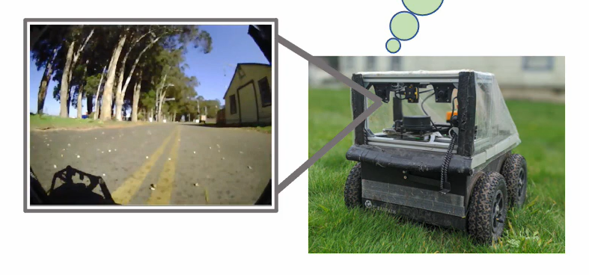

Figure 2.2: LM-Nav real-world visual navigation platform (Shah et al., 2023a)
The platform demonstrates that LM-Nav was evaluated using a complete robot with more capable navigation hardware and pretrained models than the proposed low-cost prototype. Therefore, this project adopts LM-Nav's modular language, vision, and action structure rather than attempting to reproduce its full platform. The comparison also motivates the use of a smaller controlled indoor task on Raspberry Pi 4.

2.5.1 Overview of LM-Nav
LM-Nav: Robotic Navigation with Large Pre-Trained Models of Language, Vision, and Action by Shah et al. (2023a) is the main baseline for this project. LM-Nav addresses the problem that many visual navigation systems expect a goal image, while human users naturally provide language instructions. The paper avoids collecting a large language-annotated robot navigation dataset by composing pre-trained models.
The LM-Nav pipeline contains three main stages:
1. GPT-3 extracts landmarks from the natural language instruction.
2. CLIP grounds the extracted landmarks in visual observations.
3. ViNG navigates toward the selected visual goal.

This pipeline is shown in Figure 2.3.
Figure 2.3 illustrates the modular LM-Nav pipeline that connects a language instruction to visual navigation. It separates landmark extraction, visual grounding, and navigation execution into distinct model stages.

Figure 2.3: LM-Nav baseline pipeline
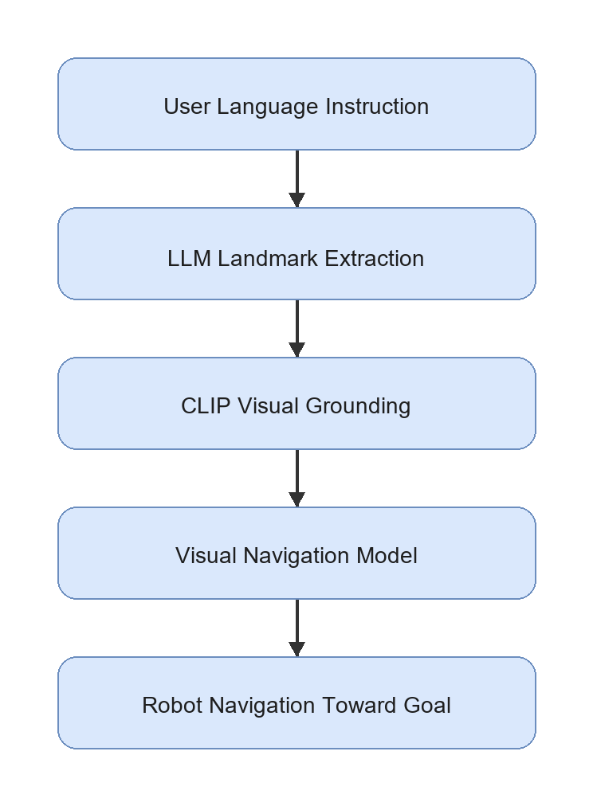
In LM-Nav, a language model extracts ordered landmarks, CLIP associates those landmarks with visual observations, and ViNG performs navigation toward the selected visual goal. The separation allows each stage to be studied independently. This project follows the same modular principle but replaces the full models with a structured prompt pipeline, lightweight grounding, restricted actions, and ESP32 safety suitable for Raspberry Pi 4.

2.5.2 Strength of LM-Nav
The main strength of LM-Nav is its modular architecture. It does not require one end-to-end model that directly maps language and images to motor commands. Instead, it separates language understanding, visual grounding, and action execution. This separation is useful for research because each module can be tested and improved independently.
LM-Nav is also important because it demonstrates that pre-trained models can be combined for robot navigation without training a new language-conditioned navigation model from scratch. This idea is suitable for an FYP because collecting a large robot dataset is not realistic within the time and cost constraints of a student project.

2.5.3 Limitation of LM-Nav
LM-Nav also has limitations that motivate this project. The language module mainly extracts landmarks. This may be insufficient for instructions that include spatial relations, route order, or constraints. For example, "move toward the chair near the table" should not be reduced only to chair and table; the relation chair near table is also important.
Another limitation is hardware and navigation complexity. LM-Nav was demonstrated with a more capable outdoor robot platform and a visual navigation model. A student FYP setup using a Raspberry Pi 4, ESP32 sensor and motor control, USB webcam, two ultrasonic sensors, and four DC motors cannot reproduce the full navigation capability directly. Therefore, this project uses LM-Nav as an architectural inspiration, not as a full implementation target.

2.5.4 Relevance to This Project
LM-Nav provides the central structure for the proposed prototype: language understanding, visual grounding, and action execution. The difference is that this project adapts the final execution stage into a simple action-control system. Instead of using a full visual navigation policy, the Raspberry Pi 4 chooses one of a small set of actions, checks obstacle status from the ESP32 ultrasonic module, and sends validated commands to the ESP32 motor-control layer. This makes the project realistic for a low-cost indoor robot while preserving the research value of structured prompt engineering.

2.6 VLMnav as a Prompt-Based Action Selection Reference
Figure 2.4 presents the VLMnav approach of using a prompt and visual observation to select a navigation action. It demonstrates how spatial reasoning can be formulated as a constrained question-answering or action-choice problem.

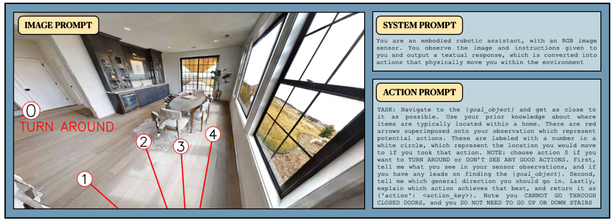

Figure 2.4: VLMnav prompt and action-selection interface (Goetting et al., 2024)
The interface is relevant because the proposed robot also uses a small approved action set instead of requesting an unrestricted motion plan. However, a model-selected action cannot be trusted automatically on a physical robot. The proposed system therefore validates the output format, permitted action, uncertainty, sensor status, and local ESP32 safety conditions before executing movement.

VLMnav: End-to-End Navigation with Vision Language Models by Goetting et al. (2024) is highly relevant because it formulates navigation as a question-answering problem. Instead of requiring the model to output a long navigation plan, the system can ask a VLM to choose among possible actions. This is close to the needs of the proposed robot because the first prototype only needs a small action set: move_forward, turn_left, turn_right, stop, and search.
The strength of VLMnav is that it connects visual observation, language instruction, and action selection through prompting. This supports the idea that prompt design can affect not only landmark extraction but also robot movement decisions. For example, a prompt can ask whether the current webcam image contains the target, whether the robot should turn to search, or whether it should stop because the target has been found.
The limitation is that direct VLM action selection may not be safe enough for unsupervised robot control. VLM outputs can be inconsistent, and the model may choose an action even when the target is not visible or the instruction is ambiguous. For this reason, the proposed FYP will validate the structured output, uncertainty level, model latency, and ESP32 ultrasonic obstacle status before physical motor execution. VLMnav is therefore treated as a prompt/action-selection reference, while the robot remains a controlled research prototype.

2.7 Spatial Grounding Methods: VLMaps and HOV-SG
Spatial grounding methods improve the connection between language and the physical environment. Two important examples are VLMaps and HOV-SG.
Figure 2.5 shows how VLMaps connects open-vocabulary language queries with locations in a visual-language map. It illustrates the value of representing objects and spatial concepts in a form that can be queried using natural language.
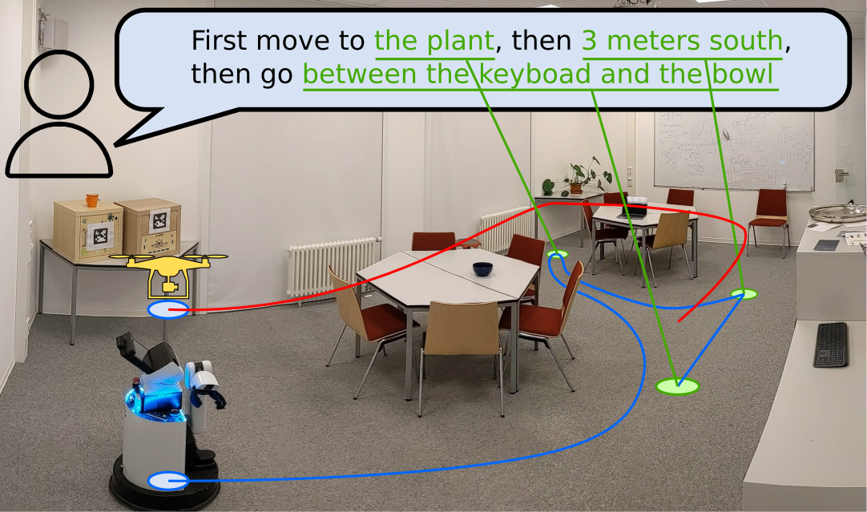

Figure 2.5: VLMaps language-grounded navigation example (Huang et al., 2023)
VLMaps supports richer object and relation-based goals than simple visual target detection. Its map construction and navigation capabilities, however, depend on RGB-D observations and reliable pose information that are not available in the current robot. The method is therefore treated as a future spatial-grounding direction rather than a first-prototype implementation.

VLMaps: Visual Language Maps for Robot Navigation by Huang et al. (2023) builds an open-vocabulary visual-language map. Instead of matching a text query only to the current camera image, the robot can query a map that stores semantic visual features. The strength of VLMaps is that it provides spatial memory and can connect language to locations. Its limitation is that it requires map construction, camera pose information, and RGB-D or mapping support. This makes it more complex than the first version of the proposed FYP robot.

Figure 2.6 presents the HOV-SG hierarchical open-vocabulary scene representation used for language-grounded navigation. The approach organizes spatial information into connected levels such as floors, rooms, and objects.
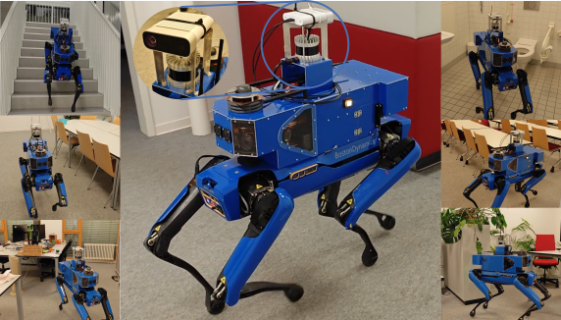

Figure 2.6: HOV-SG hierarchical navigation platform (Werby et al., 2024)
The hierarchical representation supports complex queries by narrowing a language goal from a broad area to a specific object. This capability is valuable for future indoor navigation, but constructing the scene graph requires posed RGB-D data, 3D processing, and substantial compute resources. The current project instead begins with a single supported target and documents HOV-SG as a possible later extension.

HOV-SG: Hierarchical Open-Vocabulary 3D Scene Graphs for Language-Grounded Robot Navigation by Werby et al. (2024) uses a hierarchical 3D scene graph to represent floors, rooms, and objects. This is powerful for long-horizon and multi-room navigation because the robot can reason about object and room relationships. However, it requires segmentation, 3D perception, graph construction, and more advanced sensing. This is not suitable for the first low-cost prototype, but it is valuable as a future improvement direction.
Both papers show that spatial grounding is important. They also highlight a gap for this project: a low-cost robot without RGB-D mapping still needs a way to preserve spatial relations from language. Structured prompt engineering can support this by extracting fields such as target, landmarks, and spatial_relation, even if the first implementation only uses webcam-based grounding.

2.8 Navigation Execution Models: ViNT and NoMaD
The execution stage determines how a robot physically moves toward a target. In advanced systems, this may involve a learned navigation policy, obstacle avoidance, and goal-conditioned control. ViNT and NoMaD are important because they represent stronger navigation execution methods than a simple rule-based motor command system.

Figure 2.7 illustrates the ViNT visual navigation transformer architecture, which learns navigation behaviour from visual observations and goal images collected across different robots and environments.
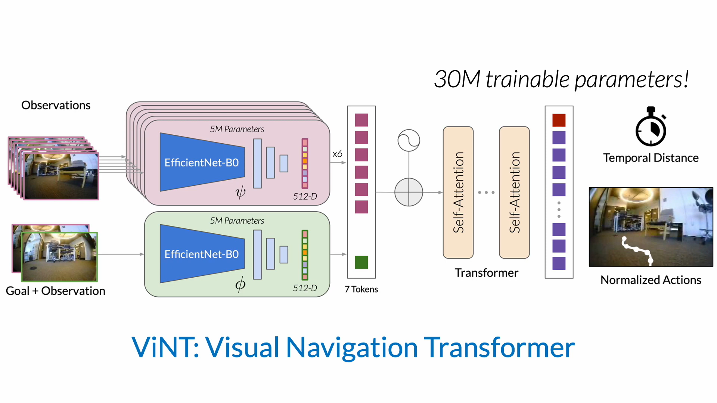

Figure 2.7: ViNT visual navigation transformer architecture (Shah et al., 2023b)
ViNT demonstrates that a learned visual policy can provide stronger navigation execution than fixed direction rules. Nevertheless, its deployment assumes suitable training data, model inference resources, and a robot control interface. For the first prototype, the proposed robot uses interpretable restricted actions; a ViNT-style taught-route or learned visual policy remains a future replacement after reliable physical control is established.

ViNT: A Foundation Model for Visual Navigation by Shah et al. (2023b) proposes a visual navigation foundation model trained across diverse robot datasets. Its strength is generalization across platforms and environments. Its limitation for this FYP is that deploying and validating a full visual navigation model is outside the main scope. This project focuses on prompt engineering, visual grounding, and simple action control, not training or deploying a foundation navigation policy.

Figure 2.8 presents examples of NoMaD performing goal-directed navigation and exploration from visual observations. The method extends visual navigation by using a goal-masked diffusion policy.
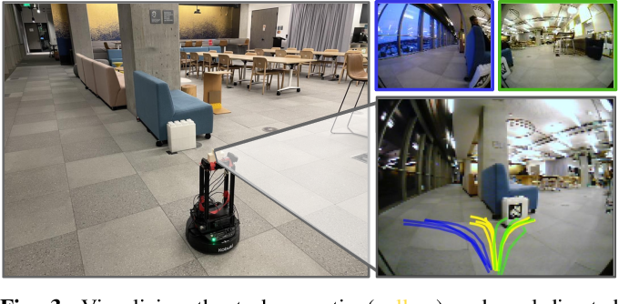

Figure 2.8: NoMaD visual navigation examples (Sridhar et al., 2023)
NoMaD illustrates how one learned policy can support both movement toward a known visual goal and exploration when the goal is unavailable. This behaviour is more advanced than the first prototype's deterministic search action and requires suitable model training and compute resources. It is reviewed as a future navigation-policy option rather than a model for immediate Raspberry Pi 4 physical deployment.

NoMaD: Goal Masked Diffusion Policies for Navigation and Exploration by Sridhar et al. (2023) uses a diffusion-based policy for goal-directed navigation and exploration. Its strength is stronger navigation behavior and exploration ability. Its limitation is that it requires a more complex policy deployment pipeline and suitable robot data. For the proposed project, NoMaD is therefore best treated as future work after the basic Raspberry Pi 4 physical robot pipeline is functioning.
These works are important because they show how the simple action-control layer in this FYP could later be replaced by a stronger navigation model. However, they are not the main implementation because the research focus is prompt-engineered interpretation of natural language instructions.

2.9 Recent VLM and VLA Navigation Systems
Recent work has moved toward more integrated VLM and VLA navigation systems. These systems can reason over video, language, and action more directly than the earlier modular LM-Nav design.
Figure 2.9 shows the NaVid architecture for selecting navigation actions from an instruction and a sequence of visual observations. The figure highlights the use of temporal visual context rather than relying only on the latest image.
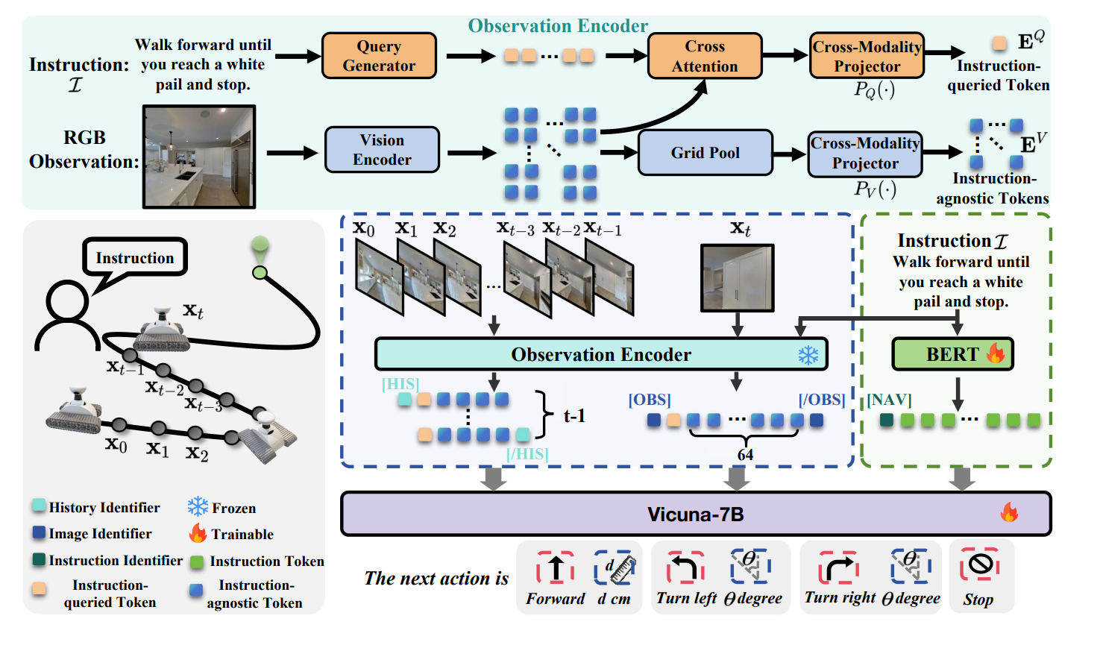

Figure 2.9: NaVid video-based navigation architecture (Zhang et al., 2024)
Using recent visual history can reduce unstable decisions and provide information about how the scene changes after an action. This project can adapt the principle by retaining a short history of target positions, sizes, and previous actions. The complete NaVid video VLM is not selected for the Raspberry Pi 4 baseline because its model and runtime requirements are too large for the intended first physical prototype.

NaVid by Zhang et al. (2024) uses video-based VLM planning for vision-and-language navigation. Its strength is that it uses temporal visual context rather than a single image. This is useful for robot navigation because the current view alone may not contain enough information. Its limitation is that video-based reasoning and model inference can be expensive for a small embedded robot.

Figure 2.10 presents Uni-NaVid examples across multiple embodied navigation tasks. It illustrates the research direction toward a unified video-based vision-language-action model capable of handling different navigation goals.
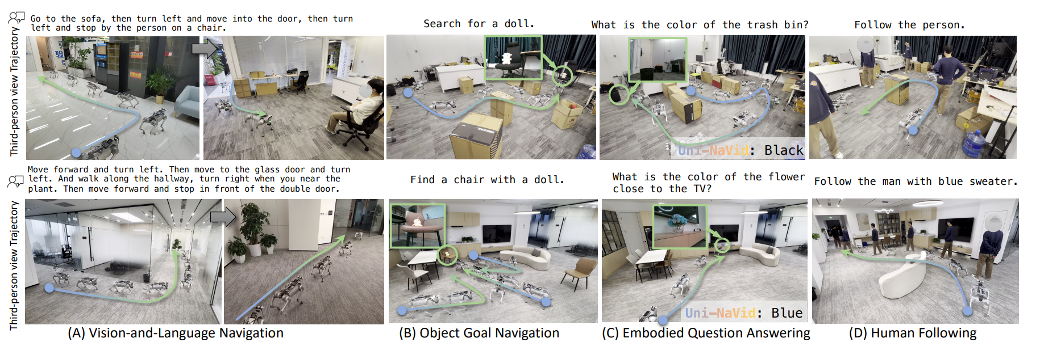

Figure 2.10: Uni-NaVid embodied navigation examples (Zhang et al., 2026)
The examples demonstrate broader task generalization than a single-target robot can provide. They also indicate the model, dataset, and compute complexity required by unified embodied navigation. For this reason, Uni-NaVid is used to identify a long-term research direction, while the current project focuses on a measurable low-cost baseline with explicit safety validation.

Uni-NaVid by Zhang et al. (2026) extends the video-based approach toward a unified model for multiple embodied navigation tasks. Its strength is broad task coverage. Its limitation is that the system is more advanced and resource-intensive than a first FYP prototype.
Figure 2.11 shows NaVILA connecting vision-language reasoning with physical navigation actions on a legged robot. The examples demonstrate an integrated vision-language-action approach to real-world movement.
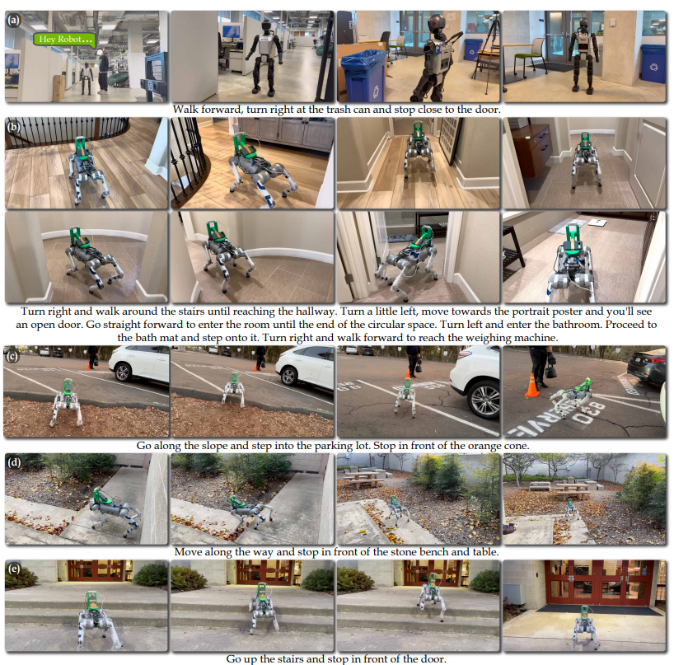

Figure 2.11: NaVILA vision-language-action navigation examples (Cheng et al., 2025)
NaVILA is relevant because it separates higher-level navigation reasoning from the lower-level locomotion required to execute movement safely. The proposed project adapts this architectural idea by assigning high-level prompt, vision, and action selection to the Raspberry Pi 4 while the ESP32 handles local safety and motor control. The full NaVILA model and legged platform remain outside the current implementation scope.

NaVILA by Cheng et al. (2025) studies VLA navigation for legged robots. Its strength is the connection between vision-language reasoning and real robot movement. Its limitation for this project is that it focuses on more complex legged platforms and server-style model pipelines, while the proposed robot is a wheeled low-cost indoor platform.
These papers are relevant because they show the direction of future navigation research. However, they also reinforce the need for a realistic baseline prototype. A student project can first demonstrate prompt-engineered instruction parsing, webcam grounding, and simple action control before attempting advanced VLA navigation.

2.10 Critical Comparison of Related Works
The reviewed papers differ significantly in method, hardware complexity, cost, and suitability for student-level implementation. Table 2.2 compares the papers based on their main method, strength, limitation, and relevance to this project.

Table 2.2 critically compares the main reviewed papers according to their method, hardware or platform, strengths, limitations, and relevance to the proposed project. The comparison is used to identify useful research ideas without assuming that every complete system is suitable for low-cost implementation.
Paper | Main Method | Hardware or Platform | Strength | Limitation | Relevance to This Project
LM-Nav | GPT-3 landmark extraction, CLIP grounding, ViNG navigation | Real robot platform with RGB cameras and navigation sensors | Clear modular baseline for language to vision to action | Landmark-only extraction may lose spatial relations; full navigation setup is more complex than this FYP | Main baseline architecture adapted into a low-cost indoor prototype
VLMnav | VLM question-answering for action choice | Simulation-style embodied navigation setup with visual observations and action choices | Strong reference for prompt-based action selection | Direct VLM actions require validation before real robot control | Supports the proposed fixed action set and prompt design
VLMaps | Open-vocabulary visual-language maps | Mapping-based setup using RGB-D or pose-supported observations | Stronger spatial grounding and language-map querying | Requires map construction and additional sensing | Future improvement for map-based grounding
HOV-SG | Hierarchical open-vocabulary 3D scene graph | 3D perception, scene graph construction, and robot/simulator experiments | Supports object, room, and floor-level reasoning | Too complex for first low-cost webcam prototype | Future improvement for structured spatial memory
ViNT | Visual navigation foundation model | Multi-robot visual navigation datasets and deployment platforms | Stronger visual navigation execution | Does not focus on prompt engineering; deployment is beyond initial scope | Possible future replacement for simple action control
NoMaD | Diffusion-based goal-conditioned navigation policy | Robot navigation experiments with visual observations | Improves exploration and goal reaching | Requires navigation policy deployment and data support | Future work after baseline prototype
NaVid | Video-based VLM next-step planning | Simulation and real-world video navigation experiments | Uses temporal context for navigation decisions | More model and compute intensive than single-webcam baseline | Future direction for video-based reasoning
Uni-NaVid | Unified video-based VLA navigation model | Advanced embodied navigation platforms | Supports multiple navigation task types | Resource-intensive and not suitable as first implementation | Long-term improvement direction
NaVILA | Vision-language-action navigation for legged robots | Legged robot demonstrations and simulation benchmarks | Connects VLA reasoning to real movement | Focuses on complex legged platforms and larger model pipelines | Relevant conceptually but not the main hardware target

Table 2.2: Critical comparison of related papers
The comparison indicates that the reviewed methods provide strong language grounding, mapping, visual navigation, or integrated reasoning capabilities, but many depend on larger models, advanced sensing, complex platforms, or substantial compute. The proposed project therefore adopts a modular combination of suitable ideas and retains a deterministic, safety-aware baseline for the Raspberry Pi 4 prototype.

The comparison shows that LM-Nav and VLMnav are the most directly relevant to this project. LM-Nav provides the modular structure, while VLMnav supports the idea of selecting actions through prompt-based reasoning. VLMaps, HOV-SG, ViNT, NoMaD, NaVid, Uni-NaVid, and NaVILA are important, but they require additional sensing, mapping, model deployment, or compute resources that are not realistic for the first prototype.

2.11 Hardware Suitability for This FYP
A critical issue for this project is hardware feasibility. Many research systems use expensive robots, RGB-D cameras, LiDAR, server GPUs, or advanced navigation policies. This FYP must use a lower-cost platform while still preserving a meaningful research contribution. Table 2.3 summarizes the suitability of literature components for the proposed implementation.

Table 2.3 evaluates whether the hardware and methods identified in the literature are suitable for the proposed FYP. It records the role of each item in related work and the decision made for the current prototype.
Component or Method from Literature | Used in Original Paper or Related Work | Suitability for This FYP | Decision
RGB camera or webcam | Used in LM-Nav and many VLM navigation works as visual input | Highly suitable because it is low-cost and easy to connect through USB | An unbranded 1080p USB webcam will be used as the main visual sensor
Raspberry Pi 4 | Related to low-cost onboard Linux robot-compute platforms | Suitable for Python, OpenCV, USB devices, lightweight inference, and flexible development | Finalized and only physical compute board
ESP32 microcontroller | Not central in reviewed AI navigation papers, but common in low-cost sensor and motor integration | Suitable for reading ultrasonic sensors and controlling a motor driver independently from model inference | Will be used as the motor, sensor, and local safety controller
Two HC-SR04 ultrasonic sensors | Not the main perception method in the reviewed VLM papers | Suitable as a low-cost front-left and front-right proximity safety aid | Will be used for simple front obstacle awareness
GY-291 / ADXL345 accelerometer | Not the main perception method in the reviewed VLM papers | Suitable for three-axis acceleration, roll/pitch tilt, motion, vibration, and shock observations | Will support physical movement and chassis-condition monitoring
Two MX1508 dual motor drivers | Common low-cost motor-control hardware rather than a reviewed AI-navigation component | Suitable for controlling four small DC gear motors after current-rating verification | Will be used as the shared motor-driver subsystem
Four DC motors and chassis | Common in low-cost mobile robots but not the focus of high-level papers | Suitable for simple wheeled movement | Will be used for movement execution
18650 battery pack | Standard power source for small mobile robot prototypes | Suitable for mobile operation when voltage and current requirements are handled safely | Will be used as the robot power source
RGB-D camera | Used or required by mapping-based works such as VLMaps and HOV-SG-style pipelines | Useful but increases cost and complexity | Optional future improvement
LiDAR | Used in some advanced robot navigation and scene understanding systems | Useful for safety and mapping but too costly for the first prototype | Not used in the baseline prototype
Full 3D scene graph | Used in HOV-SG and related spatial reasoning systems | Strong for spatial reasoning but requires 3D perception and mapping | Future improvement only
Large VLA model or server GPU | Used in advanced VLA systems such as NaVILA or Uni-NaVid-style pipelines | Powerful but outside the finalized onboard implementation scope | Future work only
CLIP, OpenCLIP, or VLM grounding | Used in LM-Nav-style grounding and VLM navigation | Suitable for prototype testing with indoor images | Will be used or evaluated depending on available compute
Learned navigation policy such as ViNT or NoMaD | Used in advanced navigation execution research | Useful but outside the main prompt-engineering scope | Future replacement for simple action control

Table 2.3: Hardware and method suitability for this FYP
The suitability analysis supports the selection of a Raspberry Pi 4, RGB webcam, ESP32, ultrasonic sensors, ADXL345, MX1508 drivers, and four-wheel chassis. It also explains why RGB-D mapping, LiDAR, full scene graphs, large VLA models, and advanced learned navigation policies are not included in the baseline. These exclusions keep the project achievable and prevent unsupported autonomy claims.

This table supports the design decision to build a low-cost indoor prototype. The project will not claim full autonomy in complex environments. Instead, it will demonstrate a baseline pipeline that future researchers can improve with better sensors, mapping, and navigation policies.
The positioning of the reviewed papers around the proposed baseline is shown in Figure 2.12.
Figure 2.12 positions the reviewed methods around LM-Nav according to the navigation stage or capability that they improve. It summarizes how spatial-grounding, navigation-policy, and integrated VLM or VLA research relates to the selected baseline.
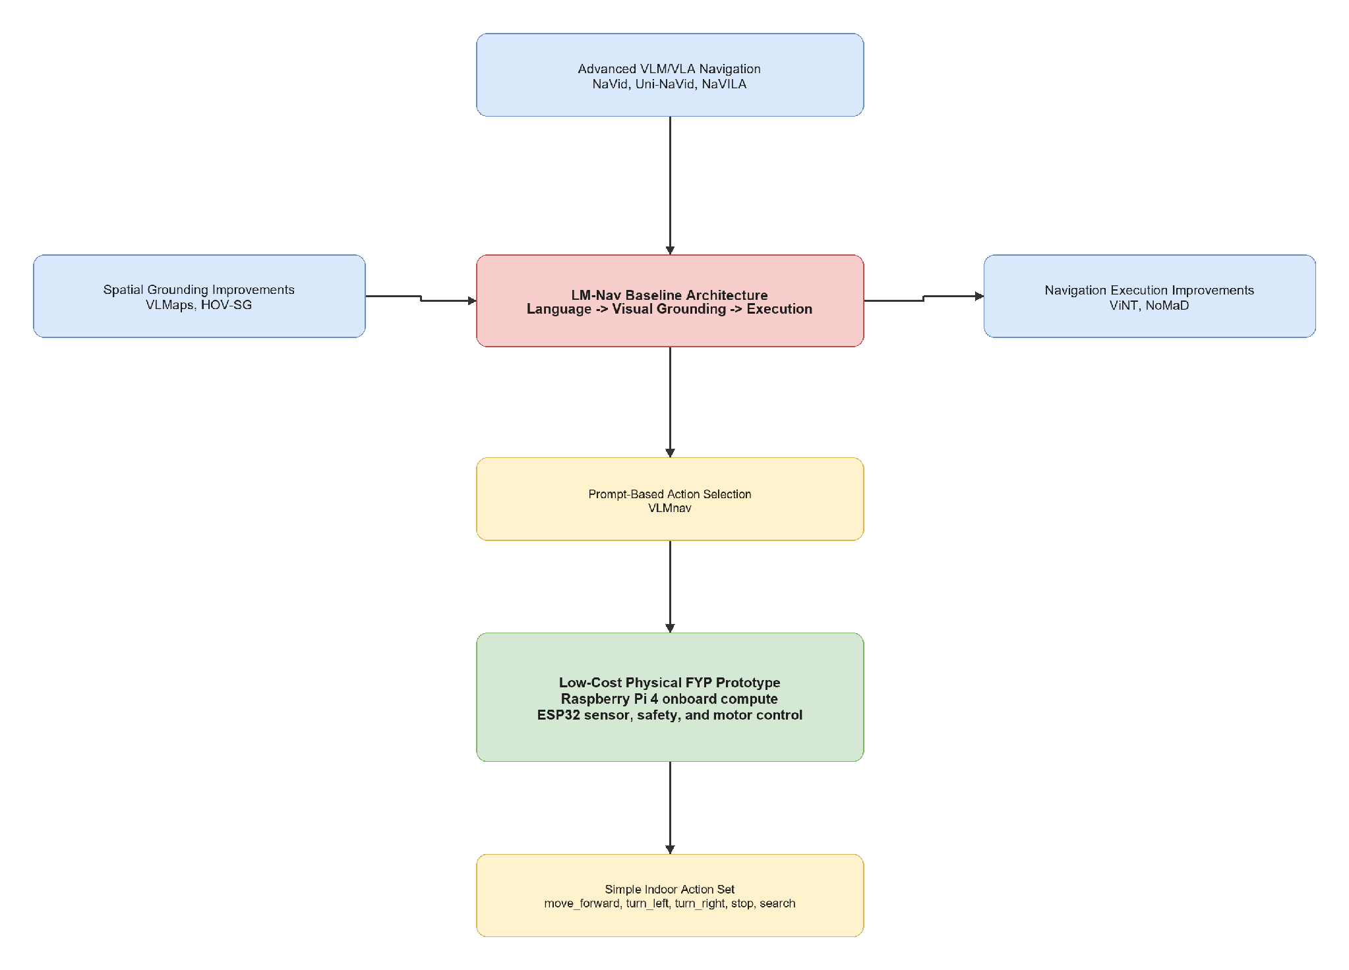

Figure 2.12: Positioning of related works around LM-Nav
The positioning shows why no complete reviewed system is copied directly. LM-Nav provides the modular foundation; VLMnav supports restricted prompt-based action selection; VLMaps and HOV-SG inform future spatial grounding; ViNT and NoMaD inform future navigation execution; and NaVid, Uni-NaVid, and NaVILA indicate advanced integrated directions. The proposed project selects only the parts compatible with a Raspberry Pi 4, RGB webcam, ESP32, and controlled first-prototype task.

2.12 Research Gap and Motivation
The literature shows that language-guided robot navigation is an active research area, but several gaps remain for a low-cost FYP prototype.
First, existing systems can perform language-guided navigation, but many require expensive hardware, complex mapping, large models, or server-level compute. These systems are valuable research contributions, but they are not directly suitable for a student prototype using a Raspberry Pi 4, ESP32, USB webcam, two ultrasonic sensors, two MX1508 motor drivers, GY-291 accelerometer, and four DC gear motors.
Second, LM-Nav provides a strong modular baseline, but its language stage mainly extracts landmarks. Natural language instructions often include spatial relations and route information, such as "near the table", "turn left after the door", or "find the signboard". A low-cost prototype still needs to preserve this information, even if the first grounding module is simple.
Third, many advanced methods improve spatial grounding or navigation execution, but they do not directly answer how structured prompt engineering can support a simple indoor robot. VLMaps and HOV-SG show the value of maps and scene graphs, while ViNT and NoMaD show stronger navigation execution. However, this project begins earlier in the pipeline by asking how natural language can be converted into structured, validated robot action information.
Fourth, there is a need for a focused baseline physical prototype that future researchers can extend. A Raspberry Pi 4 robot with webcam grounding, ESP32 safety control, acceleration and tilt feedback, and simple actions provides a practical platform for later improvements such as RGB-D sensing, LiDAR, scene graph mapping, ViNT, NoMaD, or advanced VLM/VLA models.

Table 2.4 synthesizes the research gaps identified from the literature and maps each gap to the strategy adopted by the proposed project. It connects the critical review directly to the research methodology.
Research Gap | Supporting Literature | Project Strategy
Many language-guided navigation systems use costly or complex hardware | LM-Nav, HOV-SG, NaVILA, Uni-NaVid | Build one focused low-cost Raspberry Pi 4 prototype with ESP32 sensor, safety, and motor control
Landmark extraction alone may lose spatial relations and route information | LM-Nav, VLMaps, HOV-SG | Use structured prompt output with target, landmarks, spatial relation, action goal, suggested action, and uncertainty
VLM action selection needs validation before real robot execution | VLMnav | Check uncertainty, latency, approved actions, and ESP32 ultrasonic status before sending commands to the ESP32 motor-control layer
Mapping and scene-graph systems are useful but complex | VLMaps, HOV-SG | Treat RGB-D mapping and scene graphs as future work
Strong navigation policies are beyond the first prototype | ViNT, NoMaD | Start with simple action control and document future replacement options

Table 2.4: Research gap synthesis and project strategy
The synthesis identifies a need for a low-cost physical prototype that preserves structured language information, validates model or parser output, and connects high-level decisions with deterministic local safety. The resulting project strategy is not intended to compete with full mapping or large-model systems; it establishes a measurable baseline that can be extended after physical integration and validation.

Based on these gaps, the project is motivated by the following research direction:
How can structured prompt engineering support visual grounding and simple action selection for a low-cost indoor mobile robot navigation prototype?

2.13 Chapter Summary
This chapter reviewed literature related to prompt engineering for mobile robot navigation. LM-Nav was identified as the main baseline because it provides a clear modular architecture of language understanding, visual grounding, and navigation execution. VLMnav was reviewed as the main prompt/action-selection reference because it frames navigation as a question-answering or action-choice task.
The chapter also reviewed VLMaps and HOV-SG as spatial grounding improvements, ViNT and NoMaD as stronger navigation execution models, and NaVid, Uni-NaVid, and NaVILA as advanced VLM/VLA navigation directions. These works show the potential of language-guided navigation, but they also reveal limitations related to cost, sensing requirements, compute resources, and implementation complexity.
The research gap is that there is a need for a low-cost indoor physical prototype that studies structured prompt engineering for simple mobile robot navigation. Chapter 3 explains how this project addresses the gap using one Raspberry Pi 4 implementation with an ESP32 motor, sensor, and safety layer.

CHAPTER 3

RESEARCH METHODOLOGY

3.1 Introduction
This chapter presents the finalized methodology for Prompt Engineering for Mobile Robot Navigation. The project contains one physical implementation: a Raspberry Pi 4 mobile robot with an ESP32 sensor, safety, and motor-control layer.
The methodology is inspired by the modular structure of LM-Nav and the prompt-based action-selection idea of VLMnav. Language interpretation, visual grounding, and navigation execution are separated so each stage can be tested. The first prototype targets find the green marker and restricts all output to the approved action set.
The finalized project contains one Raspberry Pi 4 physical robot approach.
- Raspberry Pi 4 performs onboard prompt processing, webcam processing, action selection, and logging.
- ESP32 performs sensor reading, deterministic safety, and four-motor control.
The robot uses a four-wheel chassis, USB webcam, two MX1508 motor drivers, adjustable motor buck converter, two HC-SR04 ultrasonic sensors, GY-291 / ADXL345 accelerometer, and the completed protected power system.
The intended action set is:
- move_forward
- turn_left
- turn_right
- stop
- search
The laptop-only Docker demonstration produces expected-results evidence before physical testing. It is not a second physical approach.
The AI-model research component is designed as a controlled comparison against the implemented deterministic baseline. The baseline fixed-schema parser, OpenCV detector, and rule-based action selector are not described as AI models. Three AI candidates are instead proposed for investigation: a quantized TinyLlama language model for instruction structuring, a MobileNetV2-SSD Lite TensorFlow Lite detector for visual grounding, and a small VLM-NAV-inspired neural classifier for action selection. Each model is evaluated independently before any combined physical test.

3.2 Research Design and Project Workflow
The project follows an iterative prototype methodology. The already-built mechanical and power systems are completed by wiring and validating the ESP32 sensor and motor layer, connecting Raspberry Pi USB serial, verifying webcam capture and OpenCV visual grounding, and testing one complete basic goal.

3.2.1 Methodology Alignment with Research Objectives
Table 3.1 links each research objective to the method, expected output, and evaluation activity used in this study. This alignment ensures that the proposed development work produces evidence that can answer the stated objectives.
Research Objective | Method Used | Expected Output | Evaluation
Objective 1: Develop a structured prompt-engineering pipeline | Convert a simple instruction into fixed navigation fields and approved actions | Parseable target, action goal, and uncertainty | Prompt validity and target-extraction accuracy
Objective 2: Integrate one Raspberry Pi 4 physical robot | Connect Raspberry Pi, ESP32, webcam, sensors, MX1508 drivers, motors, and completed power system | Working end-to-end robot | Wiring, sensor, motor, USB serial, and power tests
Objective 3: Evaluate basic prompt-engineered navigation | Run repeated single-target indoor trials | Measured action, latency, safety, and movement results | Grounding correctness, action accuracy, safe-stop rate, and goal completion

Table 3.1: Methodology Alignment with Research Objectives
The alignment shows that the research is evaluated at three connected levels: structured prompt processing, physical-system integration, and measurable navigation performance. Consequently, completing the hardware alone is insufficient without prompt, perception, action, and safety measurements.

3.2.2 Overall Project Workflow
Figure 3.1 illustrates the iterative workflow used to develop and evaluate the proposed robot. The workflow connects requirement definition, hardware preparation, software integration, controlled testing, safety validation, measurement, and final reporting.
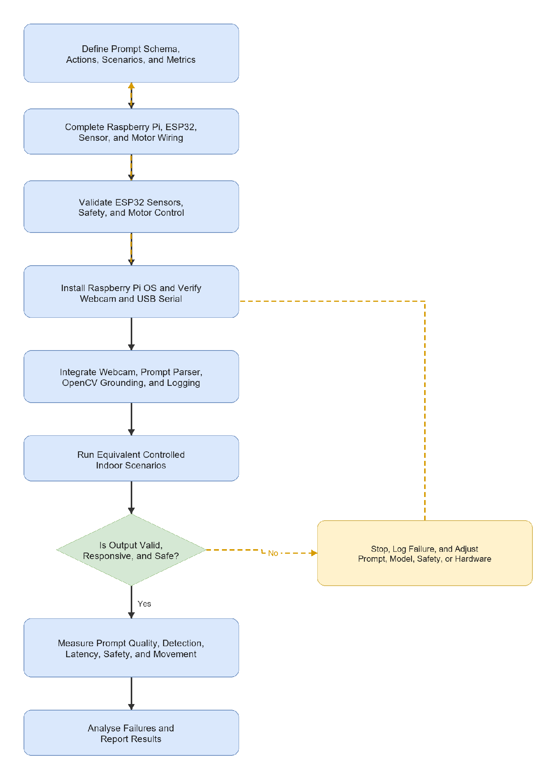

Figure 3.1: Proposed project workflow
The workflow begins by defining the prompt schema, approved actions, scenarios, and evaluation metrics before completing and validating the hardware. After the Raspberry Pi environment and high-level software are integrated, the robot is tested in controlled indoor scenarios. Invalid, unresponsive, or unsafe output causes the system to stop, log the failure, and return for adjustment. Only valid and safe behaviour proceeds to quantitative measurement and failure analysis. This feedback loop makes safety validation part of development rather than a final check.

3.2.3 Development Workflow
Table 3.2 presents the ordered development stages used to reduce integration risk. Each stage produces a verifiable output before the next hardware or software layer is enabled.
Stage | Activity | Expected Output
Stage 1 | Finalize the basic goal, action set, prompt schema, scenarios, and logging format | Common experimental definition
Stage 2 | Verify the completed power system and common-ground architecture | Stable compute and motor supplies
Stage 3 | Wire ESP32 sensors and two MX1508 drivers, then connect Raspberry Pi USB devices | Completed signal wiring
Stage 4 | Test ESP32 sensing, motor directions, timeout, and obstacle stop | Verified local safety and movement
Stage 5 | Install Raspberry Pi OS and verify webcam and USB serial | Working Raspberry Pi platform
Stage 6 | Integrate structured prompt processing, OpenCV grounding, action selection, and logging | Working end-to-end prototype
Stage 7 | Run repeated controlled trials and calculate metrics | Final physical results

Table 3.2: Development Workflow

The workflow begins with isolated subsystem checks and progresses toward supervised physical navigation. This order prevents an untested high-level decision or wiring fault from being introduced directly into a moving robot.

3.3 Finalized System Architecture
The Raspberry Pi 4 performs high-level processing. The ESP32 handles local real-time sensing, safety, and motor control. USB serial is used between the boards because it is simple to debug and leaves all ESP32 motor GPIO pins available.

Figure 3.2 presents the end-to-end information and control flow from a user's natural-language goal to four-wheel movement. It also shows the separation between Raspberry Pi high-level processing and ESP32 real-time sensing, safety, and motor control.
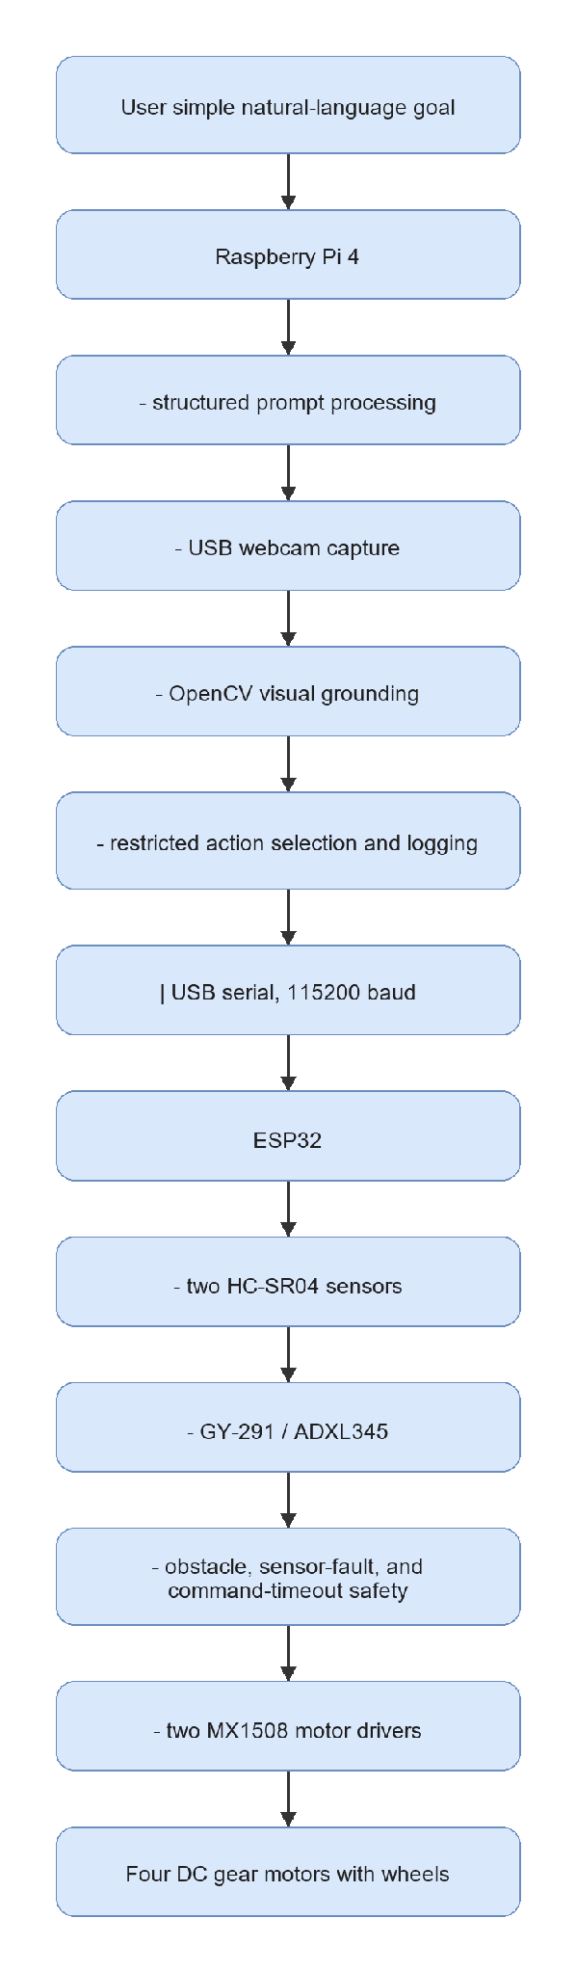

Figure 3.2: Proposed system architecture
The user instruction is processed on the Raspberry Pi 4 through structured prompt processing, webcam capture, visual grounding, restricted action selection, and logging. An approved command is then sent to the ESP32 through USB serial at 115200 baud. The ESP32 combines the command with ultrasonic and ADXL345 status before controlling the two MX1508 drivers and four motors. This architecture prevents high-level prompt or vision output from bypassing the independent local safety layer.

3.3.1 Hardware Roles
Table 3.3 summarizes the finalized responsibility, interface, strength, and constraint of each major hardware component. It clarifies how the components cooperate within the single Raspberry Pi 4 physical robot architecture.
Component | Finalized Role | Main Interface | Main Strength | Main Constraint
Raspberry Pi 4 | Onboard prompt processing, webcam capture, OpenCV grounding, action selection, and logging | USB webcam and USB serial | Flexible Linux and Python environment | Limited performance for large models
ESP32 | Sensor reading, deterministic safety, and four-motor control | USB serial and GPIO | Independent real-time safety layer | Runs only approved low-level commands
USB webcam | Front RGB image input | Raspberry Pi USB | Low-cost visual input | No dense depth or 3D map
Two HC-SR04 sensors | Front-left and front-right obstacle safety | ESP32 GPIO with Echo level shifting | Low-cost local obstacle detection | Limited coverage and accuracy
GY-291 / ADXL345 | Acceleration, roll/pitch tilt, motion, vibration, and shock observations | ESP32 I2C | Useful chassis-condition feedback | Does not provide yaw heading
Two MX1508 drivers | Four independent DC motor channels | ESP32 GPIO and regulated motor rail | Compact four-motor control | Requires current and thermal verification
Four DC gear motors | Physical forward, turn, search, and stop behaviour | MX1508 outputs | Simple four-wheel movement | No wheel-encoder feedback

Table 3.3: Finalized Hardware Roles
The division of roles places computationally flexible prompt and vision processing on the Raspberry Pi 4 while retaining time-sensitive sensing and motor safety on the ESP32. The listed constraints also define the limits of the conclusions that can be drawn from the prototype.

3.4 Requirements, Constraints, and Acceptance Criteria
Table 3.4 converts the project requirements into observable specifications, verification methods, and pass criteria. These criteria provide an objective basis for deciding whether each subsystem is ready for integration.
Requirement | Specification | Verification Method | Pass Criteria
Natural-language input | Accept a supported goal such as find the green marker | Input test | Instruction is accepted without manual rewriting
Structured prompt output | Return fixed machine-readable fields | JSON validation | Required fields are present and parseable
Raspberry Pi onboard processing | Run prompt parser, webcam, grounding, action selection, and logging onboard | Integration test | Raspberry Pi completes the navigation loop
Webcam visual grounding | Detect a supported coloured marker | Camera scenario test | Correct grounding or safe search response
Raspberry Pi-to-ESP32 USB serial | Exchange commands and sensor JSON at 115200 baud | Serial test | Stable command and status communication
Four-motor control | Two MX1508 modules control four motors | Raised-wheel test | Forward, left, right, search, and stop work
Local safety | Obstacle, sensor fault, timeout, or invalid command stops movement | Failure-case test | Unsafe movement is prevented
Power stability | Completed power system supplies stable rails | Voltage and runtime test | No unsafe voltage, reset, or severe drop

Table 3.4: Requirements and Acceptance Criteria
The acceptance criteria emphasize repeatability and safe failure rather than unrestricted autonomy. A subsystem that cannot meet its stated criterion must be corrected or excluded before physical navigation trials.
The baseline does not include SLAM, LiDAR mapping, dense depth, or an unrestricted large vision-language model.

3.5 Data, Test Environment, and Experimental Materials
Table 3.5 defines the controlled scenarios used to test the first prototype, including supported goals, missing targets, obstacles, and invalid inputs. The expected behaviour is specified before testing to avoid interpreting unsafe or accidental behaviour as success.
Scenario | Example Instruction | Expected Behaviour | Purpose
Supported target absent | "Find the green marker." | search | Verify safe visual search
Target on left | "Find the green marker." | turn_left | Verify left action selection
Target on right | "Find the green marker." | turn_right | Verify right action selection
Target centred and distant | "Find the green marker." | move_forward | Verify approach action
Target centred and close | "Find the green marker." | stop | Verify goal-stop behaviour
Unsupported or ambiguous target | "Go there." | stop | Verify prompt uncertainty handling
Obstacle present | "Find the green marker." | ESP32 forces stop | Verify independent local safety

Table 3.5: First-Prototype Scenarios
These scenarios test both goal-directed behaviour and conservative fallback behaviour. In particular, missing, unsupported, obstructed, or uncertain conditions are expected to result in search or stop rather than uncontrolled forward movement.

Table 3.6 lists the physical materials and their quantities or experimental roles. The list supports reproducibility by identifying the equipment required to construct and test the prototype.
Material | Quantity or Role
Raspberry Pi 4 | Only onboard high-level compute board
ESP32 | Sensor, safety, USB serial, and motor-control controller
USB webcam | One front RGB camera
DC gear motor with wheel | Four motors and wheels
MX1508 dual motor-driver module | Two modules controlling four motors
Adjustable motor buck converter | Regulated motor-driver rail
HC-SR04 ultrasonic sensor | Two front obstacle sensors
GY-291 / ADXL345 accelerometer | Acceleration, roll/pitch tilt, motion, vibration, and shock sensing
Completed battery and power system | Mobile robot power source
Coloured marker | Repeatable first visual landmark
Instruction and scenario list | Common experimental inputs
JSONL result logs | Store prompts, detections, sensors, actions, latency, and failures

Table 3.6: Experimental Materials
The selected materials form a low-cost RGB-camera robot without advanced mapping or depth sensing. Therefore, the experiments focus on controlled landmark or object approach and local obstacle safety.

Figure 3.3 identifies the main components selected for the finalized physical robot and summarizes the role of each component. The figure provides a visual reference for the compute, perception, sensing, motor-control, movement, power, and protection subsystems.
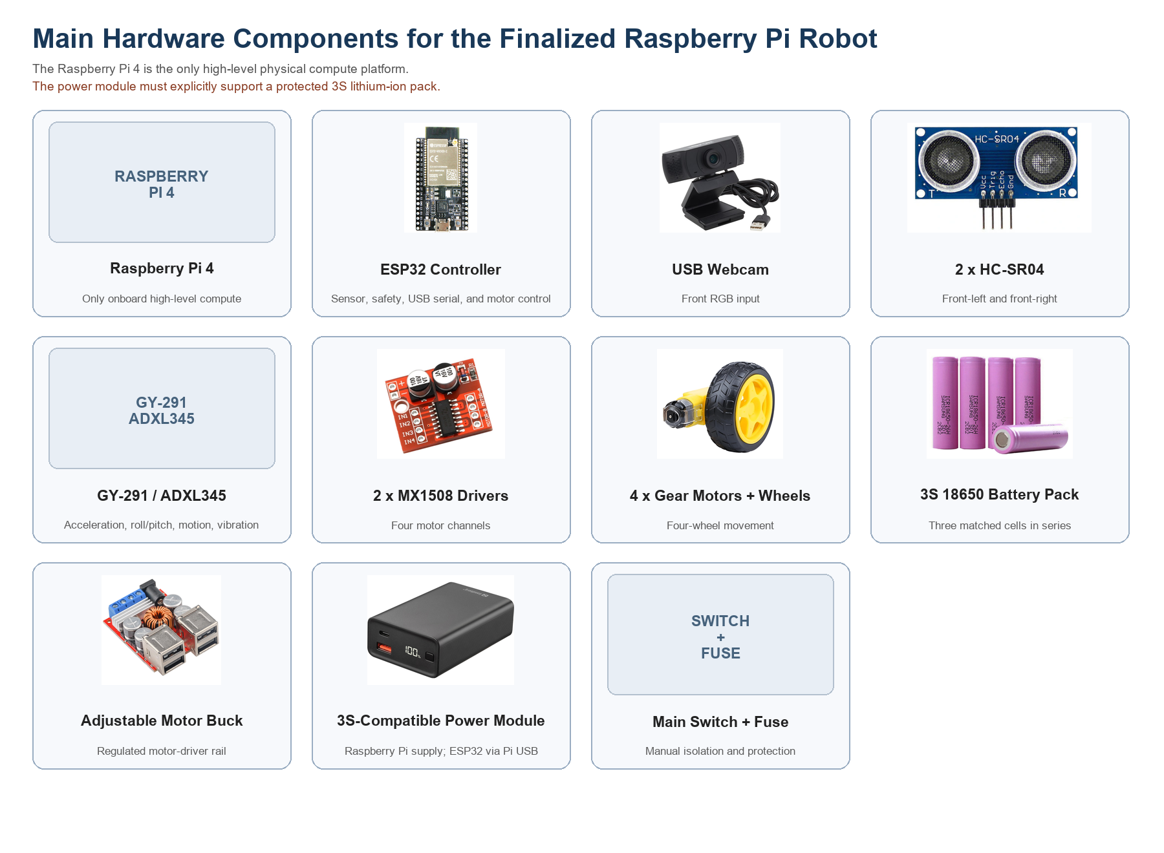

Figure 3.3: Main hardware components for the finalized Raspberry Pi 4 robot
The Raspberry Pi 4 is the only onboard high-level compute platform, while the ESP32 manages sensor, safety, serial, and motor-control duties. The USB webcam provides RGB input; the HC-SR04 sensors support front obstacle awareness; and the ADXL345 provides acceleration, roll or pitch, motion, and vibration observations rather than yaw heading. Two MX1508 drivers control four motors. The protected 3S battery system, compatible power module, adjustable motor buck converter, switch, and fuse must be verified for the required voltage and current before integration.

Table 3.7 identifies the software tools and model-related resources required for development, deployment, and evaluation. It separates currently implemented tools from planned AI-model experiments and future extensions.
Item | Purpose | Finalized Tool or Example
Raspberry Pi operating system | Run the onboard application | Raspberry Pi OS Lite 64-bit
High-level language | Prompt parser, grounding, validation, serial, and logging | Python
Webcam processing | Capture and process RGB frames | OpenCV
Prompt processing | Produce structured basic-goal output | Deterministic fixed-schema parser
Initial visual grounding | Detect supported coloured marker | OpenCV HSV segmentation
ESP32 firmware | Sensors, safety, USB serial, and two-MX1508 motor control | Arduino framework
Communication | Raspberry Pi to ESP32 commands and status | USB serial at 115200 baud
Result storage | Record experimental data | JSONL
Future grounding | Detect indoor objects and landmarks | OpenCV DNN, TensorFlow Lite, or API-based VLM

Table 3.7: Software and Model Requirements
The selected software supports a staged comparison between deterministic and learned methods. Lightweight runtimes are prioritized because every selected physical-control component must operate reliably within Raspberry Pi 4 resource limits.

3.6 Prompt Engineering Design
The first prototype uses a deterministic structured parser. This applies the main prompt-engineering principles required by the study: fixed fields, restricted actions, explicit uncertainty, and safe rejection of unsupported goals.

Table 3.8 defines the prompt inputs accepted by the first prototype and the expected response for each input type. It establishes a controlled language scope for evaluating structured instruction processing.
Prompt Input | First-Prototype Interpretation | Expected Result
"Find the green marker." | Supported target and basic goal | Structured low-uncertainty output
"Go to the green marker." | Supported target and approach goal | Structured low-uncertainty output
"Go there." | Unsupported ambiguous target | High uncertainty and stop
Unsupported landmark instruction | Target outside first-prototype capability | High uncertainty and stop

{
"target": "door",
"landmarks": ["door"],
"spatial_relation": null,
"action_goal": "find and move toward the door",
"suggested_action": "move_forward",
"uncertainty": "low"
}

Table 3.8: Supported First-Prototype Prompt Inputs
The table demonstrates that prompt handling is not evaluated only on valid commands. Ambiguous and unsupported instructions are included so that safe rejection can be measured as part of the prompt-engineering method.

Table 3.9 describes the fields in the machine-readable navigation goal and provides a first-prototype example for each field. These fields form the interface between language interpretation, visual grounding, and action validation.
Field | Description | First-Prototype Example
instruction | Original user instruction | find the green marker
target | Main supported target | green marker
landmarks | Important instruction objects | ["green marker"]
spatial_relation | Relation if supported | null
action_goal | Short interpreted goal | find and approach the green marker
uncertainty | Safety-oriented confidence label | low or high

Table 3.9: Structured Prompt Fields

A fixed schema makes model or parser outputs easier to compare, log, and reject when required information is missing. The uncertainty field and approved action representation are especially important because free-form text is not allowed to control the motors directly.

The deterministic parser described in Section 3.6 is the FYP1 control baseline rather than a language AI model. Its purpose is to establish repeatable structured outputs and safe failure behaviour. The planned TinyLlama experiments will use the same schema and test instructions so that the effect of model-based language interpretation can be measured fairly.

3.7 Webcam-Based Visual Grounding and Action Selection
The Raspberry Pi captures a USB-webcam frame and detects the selected marker using OpenCV HSV colour segmentation. The largest valid marker region is used for simple action selection.
Table 3.10 explains how visual target status and sensor conditions are converted into one of the approved actions. It documents the deterministic action-selection baseline used before comparison with a learned action classifier.
Condition | Selected Action | Reason
Structured target unsupported or uncertain | stop | Prevent unsupported execution
Marker not detected | search | Rotate slowly to locate target
Marker centre is left of image centre zone | turn_left | Align camera with target
Marker centre is right of image centre zone | turn_right | Align camera with target
Marker is centred and below goal-size threshold | move_forward | Approach the target
Marker reaches configured image-area threshold | stop | Target is considered reached
ESP32 reports obstacle or sensor fault | stop | Local safety overrides high-level action

Table 3.10: Visual Grounding and Action Decision Rules
The decision rules prioritize sensor availability and obstacle status before target-following behaviour. They also provide an interpretable reference against which the correctness and safety of future learned decisions can be evaluated.

3.8 Robot Action and Command Mapping
Table 3.11 maps each high-level action to the corresponding ESP32 serial command and four-motor behaviour. This mapping defines the restricted control interface between the Raspberry Pi 4 and the motor-control layer.
Action | ESP32 Command | Four-Motor Behaviour
move_forward | FWD | All motors move forward
turn_left | LEFT | Left motors reverse and right motors move forward
turn_right | RIGHT | Right motors reverse and left motors move forward
search | SEARCH | Robot rotates slowly
stop | STOP | All motor outputs stop

Table 3.11: Action Set and Motor Command Mapping
Restricting communication to the listed commands prevents arbitrary language or model output from being interpreted as motor instructions. Any command outside this mapping is invalid and must result in stop.
The ESP32 accepts only the approved commands. Unknown commands, loss of both ultrasonic readings, and a command delay above 1,000 ms cause stop.

3.9 Baseline and Future Extension Boundaries
Table 3.12 distinguishes the functions included in the current Raspberry Pi 4 baseline from possible future extensions. This distinction prevents planned advanced capabilities from being reported as completed prototype features.
Criterion | Raspberry Pi 4 Baseline | Future Extension
Physical implementation | One Raspberry Pi 4 and ESP32 robot | Retain the same safe robot base
Prompt processing | Deterministic fixed-schema parser | Lightweight local model or API-based VLM
Visual grounding | OpenCV HSV coloured-marker detection | Object detector or vision-language grounding
Navigation action | Restricted five-action set | Relation-aware planning or learned policy
Position feedback | Ultrasonic and GY-291 observations | Wheel encoders, magnetometer, or full IMU
Environment model | Current RGB frame only | RGB-D, LiDAR, mapping, or scene graph
Result role | Final physical robot results | More advanced FYP2 or future research

Table 3.12: Baseline and Future Extension Boundaries
The baseline is intentionally limited to measurable prompt, visual-grounding, action, and safety functions. Mapping, stronger sensing, and advanced navigation models remain future work until the necessary hardware and experimental evidence are available.

3.10 Mechanical Design and Physical Integration
The finalized Fusion 360 robot design provides mounting positions for the Raspberry Pi 4, ESP32, USB webcam, two front ultrasonic sensors, GY-291, two MX1508 drivers, completed power system, and four motors.
Figure 3.4 shows the finalized Fusion 360 concept model used to plan physical component placement and mounting before assembly. The render provides a combined view of the chassis, wheels, front perception hardware, battery area, compute board, and supporting electronics.
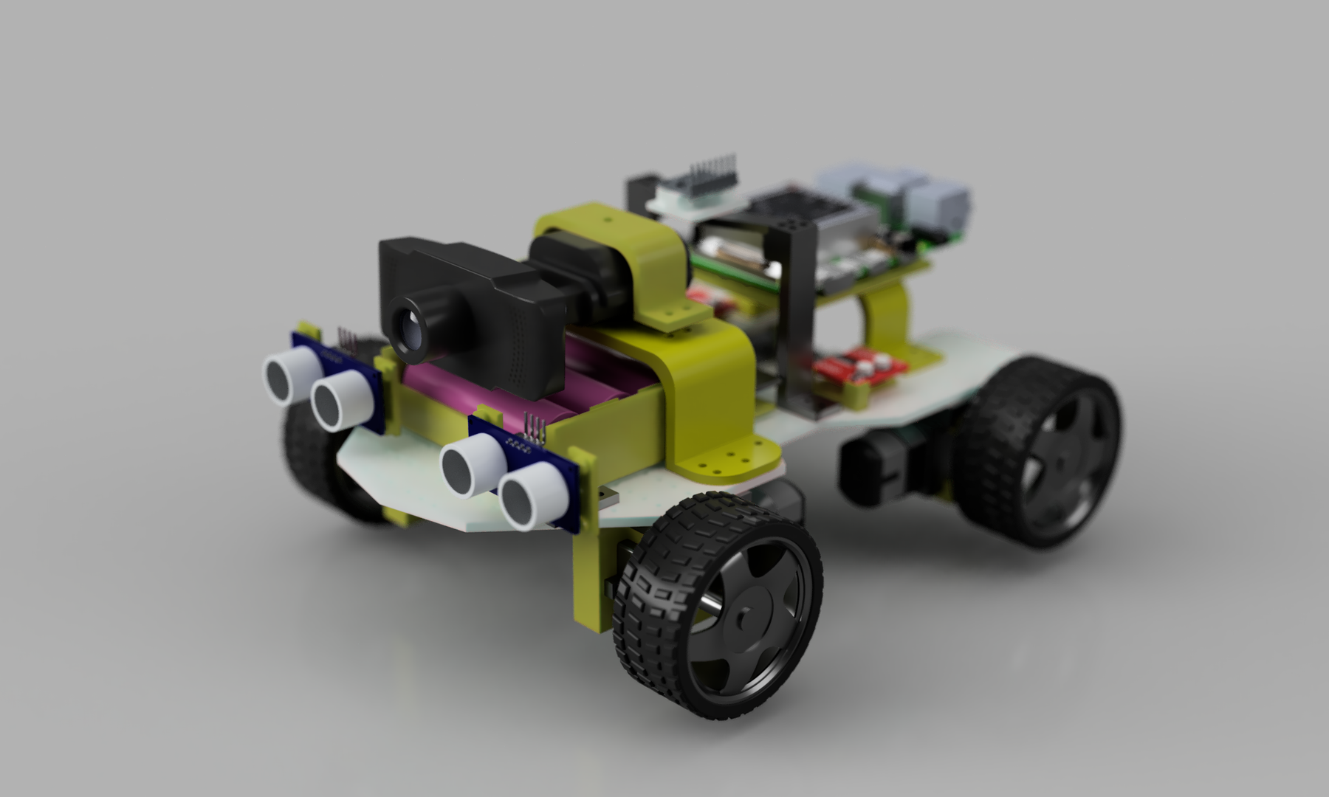

Figure 3.4: Finalized Fusion 360 physical robot model

The model positions the camera and ultrasonic sensing hardware toward the front of the robot while distributing the battery, Raspberry Pi, ESP32, and driver-related components across the chassis. The arrangement supports forward visibility, accessible electronics, and a balanced four-wheel layout. The render verifies intended fit and placement, but electrical operation, structural strength, and centre-of-mass behaviour must still be confirmed on the assembled prototype.
Figure 3.5 presents front, side, rear three-quarter, and top views of the Fusion 360 model. The multiple views are used to inspect component clearances and accessibility that may not be visible in a single perspective render.
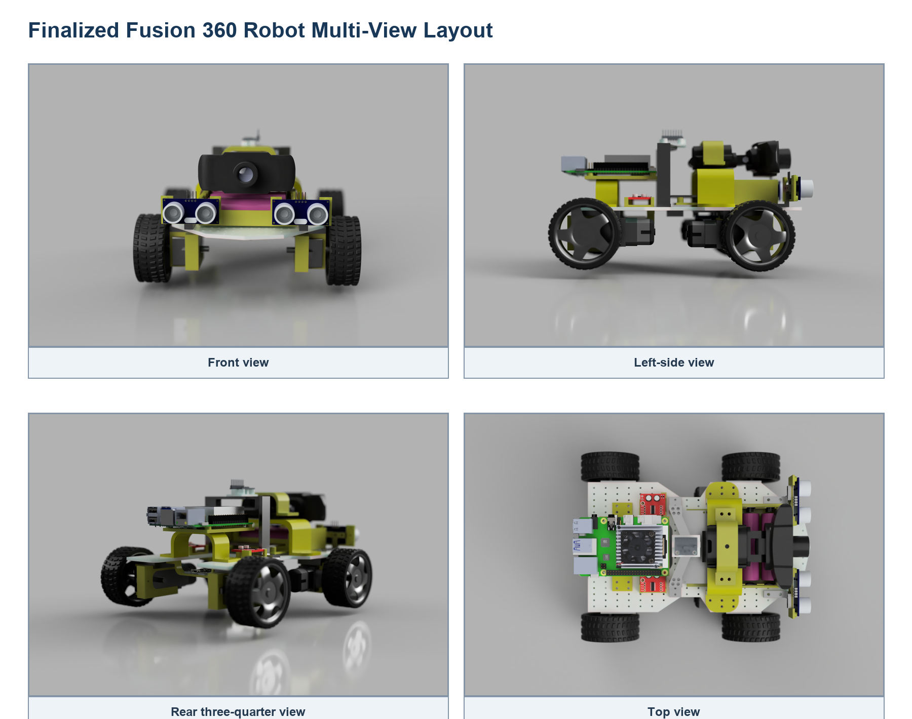

Figure 3.5: Finalized Fusion 360 robot multi-view layout

The front view supports checking camera and ultrasonic sensor visibility, while the side view shows chassis height, wheel clearance, and stacked component placement. The top and rear three-quarter views show the available mounting area, cable-access paths, and spacing between the Raspberry Pi, power system, sensors, and mechanical supports. These views guide assembly and reduce the likelihood of obstructed sensors or inaccessible connectors.
Figure 3.6 provides the dimensioned mechanical reference for fabrication and assembly. It combines side, front, top, and isometric views so that the overall robot envelope and component positions can be checked consistently.
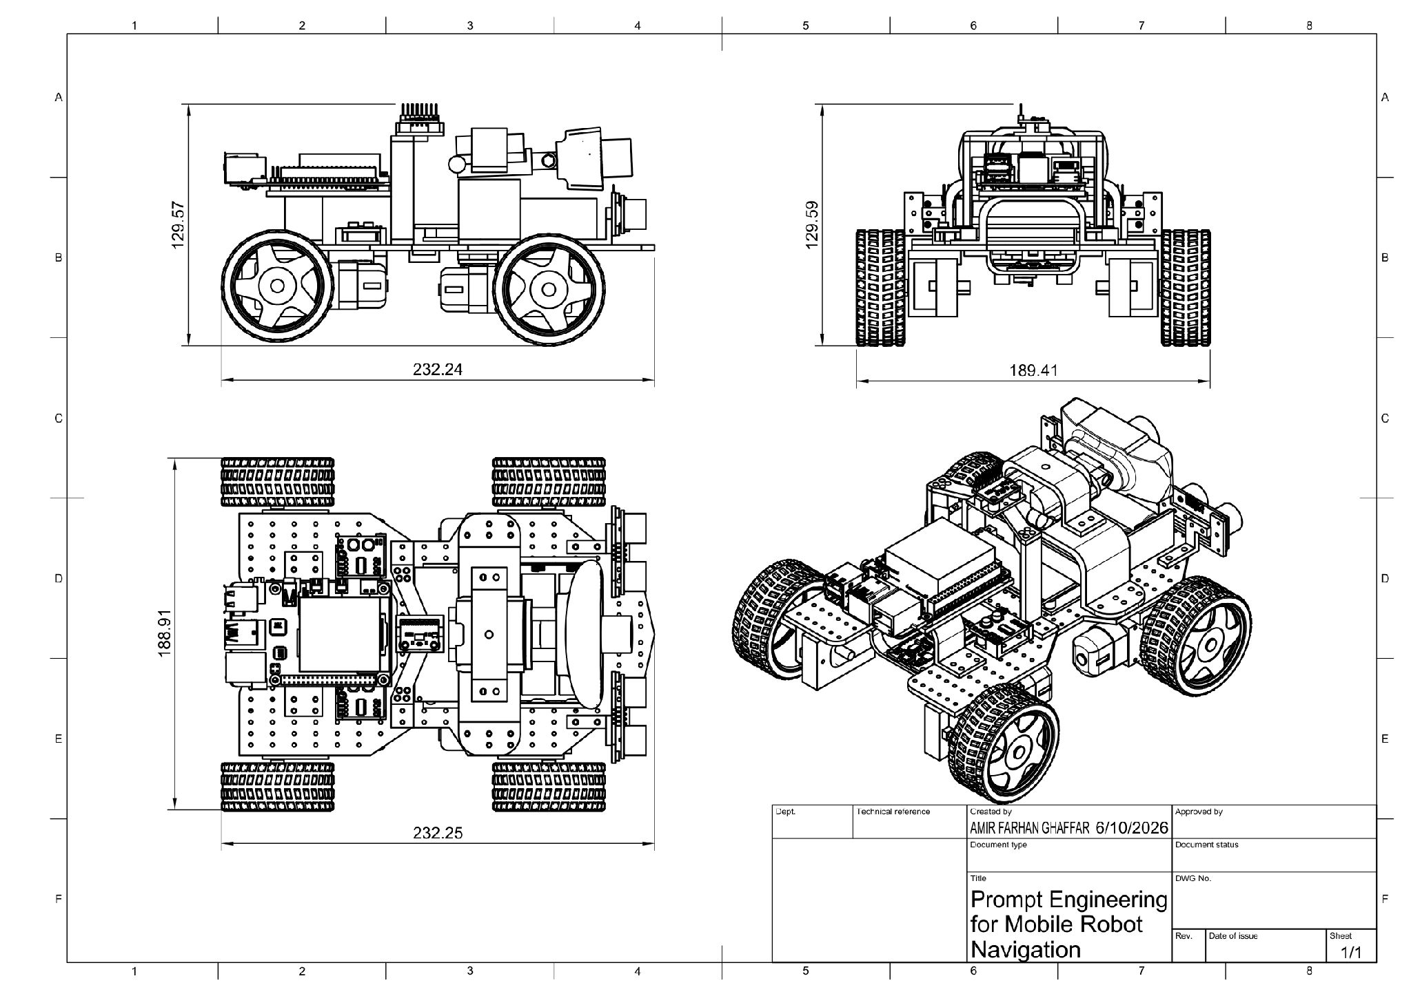

Figure 3.6: Finalized mechanical design sketch and dimensions

The drawing indicates an overall size of approximately 232 mm in length, 189 mm in width, and 130 mm in height. These dimensions are used to verify wheel spacing, ground clearance, sensor mounting, component fit, and the footprint required for indoor testing. Final measurements should be recorded after physical assembly because manufacturing tolerances, fasteners, and cable routing may change the completed dimensions.

3.10.1 Custom-Designed and Fabricated Components
The robot design includes modular printable parts for the Raspberry Pi 4, ESP32, battery system, motor drivers, GY-291, webcam, and both ultrasonic sensors. These mounts organize components, maintain sensor visibility, and reduce movement during operation.
The STL files are stored in the project STL/ directory so that damaged or revised mounts can be reproduced without redesigning the complete chassis.

3.10.2 Finalized Circuit Architecture
An L298N is a motor driver rather than a buck converter. The finalized architecture therefore uses one separate adjustable motor buck converter and two MX1508 dual motor-driver modules.
Figure 3.7 shows the finalized component-level power and communication architecture. It distinguishes the regulated motor-power branch from the compute-power branch and identifies the common-ground requirement across the complete system.
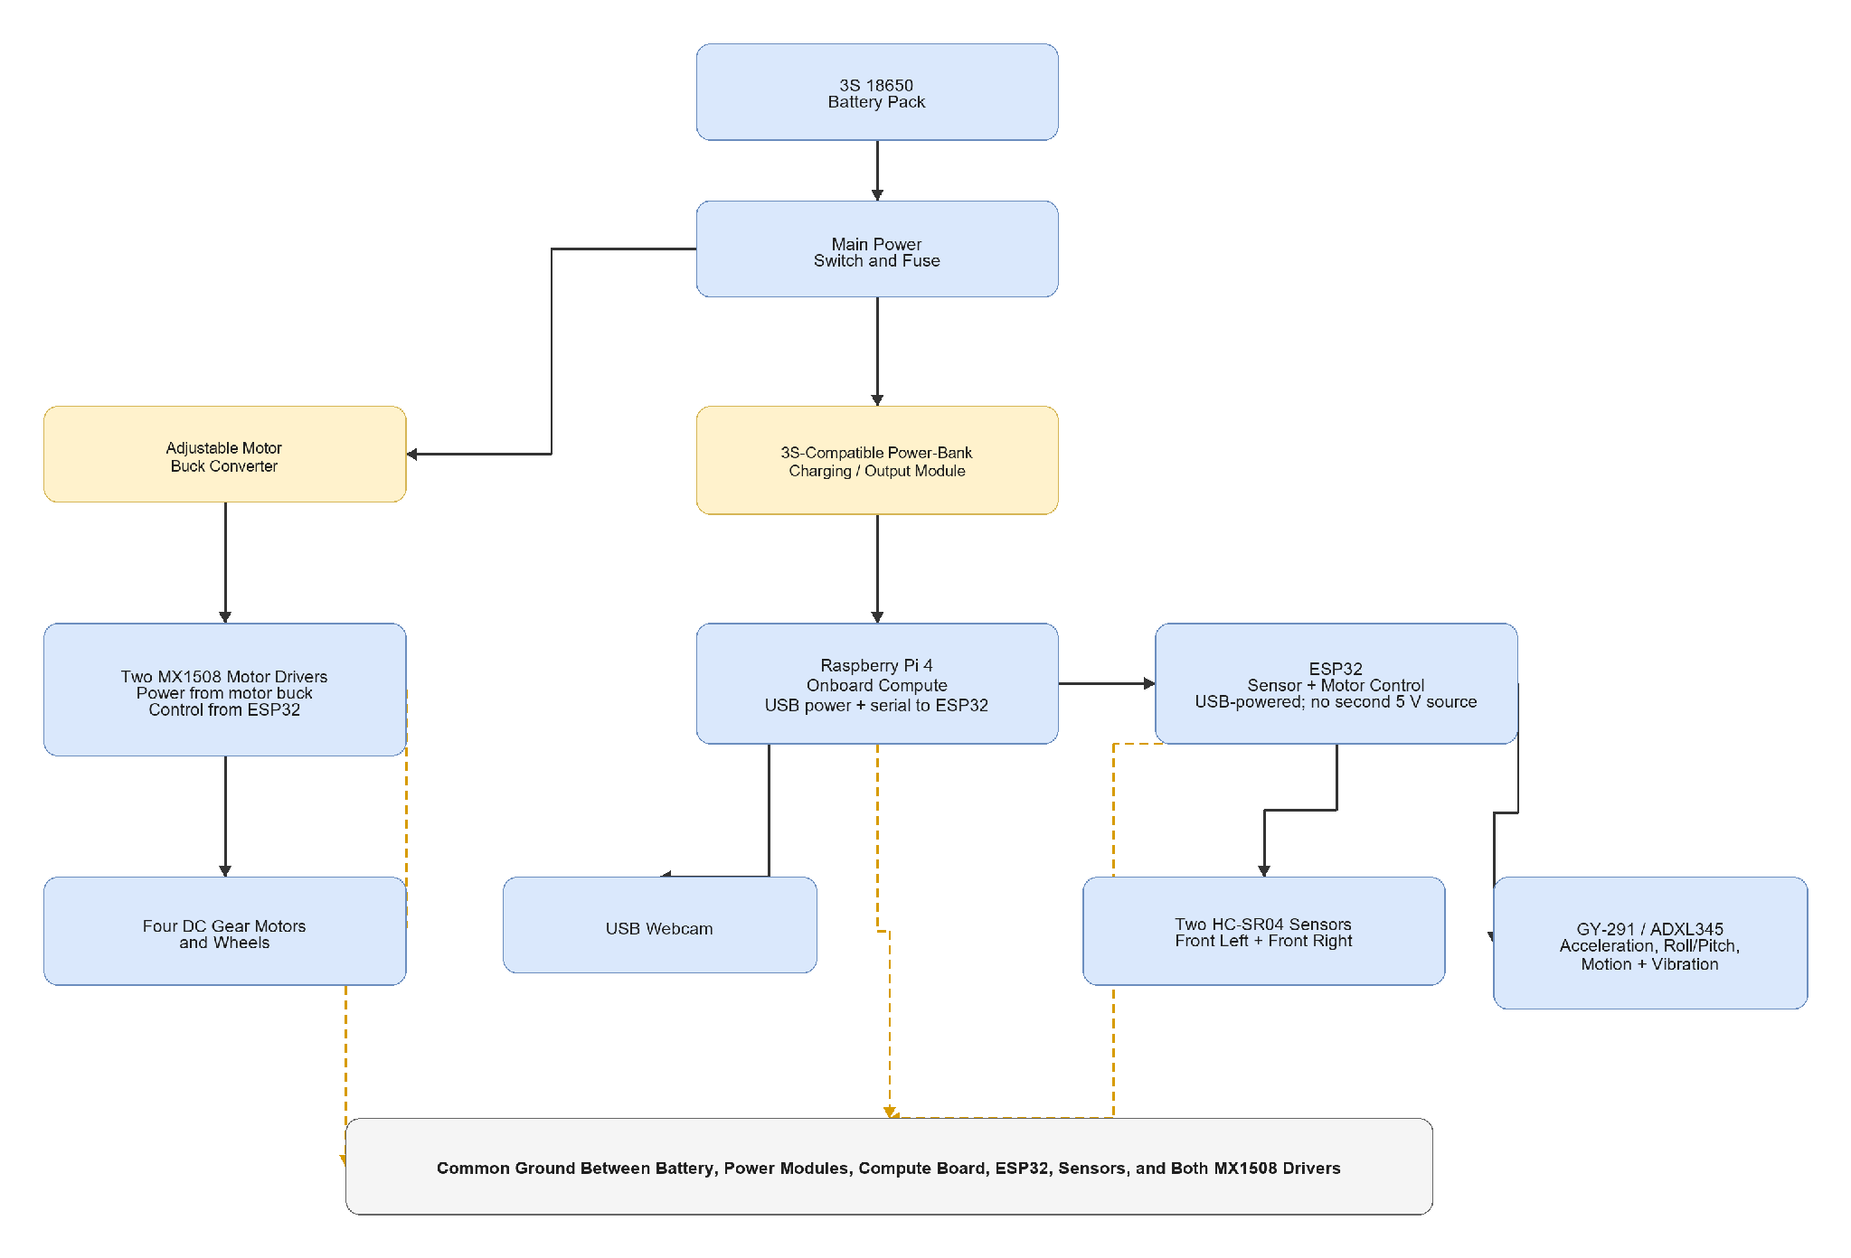

Figure 3.7: Finalized component-based circuit architecture

Power from the protected 3S battery pack passes through the main switch and fuse before branching. One branch uses an adjustable buck converter to supply the two MX1508 drivers and four motors. The other uses a 3S-compatible charging or output module to supply the Raspberry Pi 4, which connects to and powers the ESP32 through USB. The webcam connects to the Raspberry Pi, while sensors connect to the ESP32. A common ground is required for valid control signals, and every power module must be verified for battery compatibility, voltage, continuous current, and protection behaviour.
Figure 3.8 details the planned signal interfaces between the Raspberry Pi 4, ESP32, two ultrasonic sensors, ADXL345, and two MX1508 motor drivers. It provides the GPIO and communication reference required for wiring and firmware configuration.
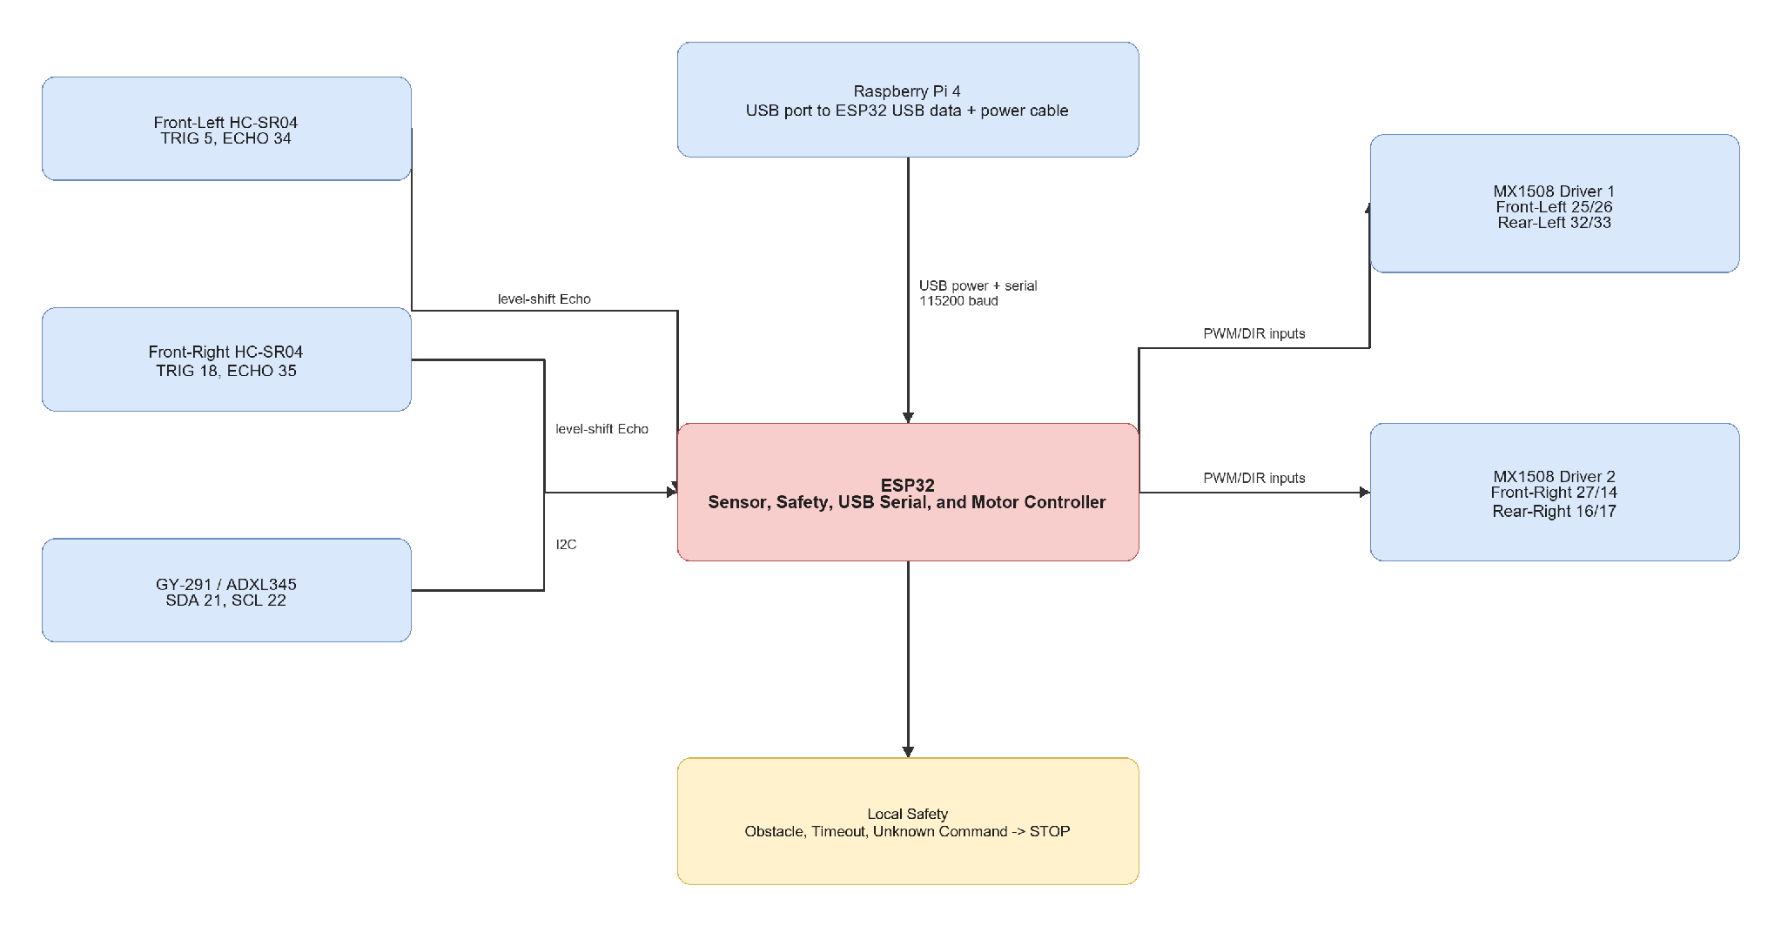

Figure 3.8: Finalized ESP32 sensor and motor wiring
The Raspberry Pi communicates with the ESP32 through a USB data and power connection at 115200 baud. The front-left ultrasonic sensor uses TRIG GPIO 5 and ECHO GPIO 34, while the front-right sensor uses TRIG GPIO 18 and ECHO GPIO 35; both Echo signals require level shifting before entering the ESP32. The ADXL345 uses I2C on SDA GPIO 21 and SCL GPIO 22. The two MX1508 drivers receive separate PWM or direction signals for the left and right motor pairs. The ESP32 applies local stop behaviour for obstacles, timeouts, and unknown commands before forwarding movement signals to the drivers.

3.11 Company, Software, and Tool Involvement
Table 3.13 records the organizations associated with the main components, software, and development tools used in the project. It clarifies the source and role of external technologies within the student-developed prototype.
Component or Tool | Company or Organization | Involvement
Raspberry Pi 4 | Raspberry Pi Ltd | Only onboard high-level compute board
ESP32 | Espressif Systems | Low-level sensing, safety, and motor control
GY-291 / ADXL345 | Analog Devices device on third-party module | Acceleration, roll/pitch tilt, motion, vibration, and shock sensing
MX1508 modules | Supplier to be confirmed | Four-motor driver subsystem
Autodesk Fusion 360 | Autodesk | Mechanical design
Python | Python Software Foundation | High-level software
OpenCV | OpenCV project | Webcam processing and marker grounding
Arduino framework | Arduino project / Espressif ecosystem | ESP32 firmware
Docker | Docker, Inc. | Isolated laptop expected-results demonstration
diagrams.net / draw.io | JGraph / diagrams.net | Report diagrams

Table 3.13: Company, Component, and Software Involvement
The project integrates existing hardware and open-source software into a new research prototype rather than claiming ownership of those underlying technologies. The original contribution is the project-specific architecture, integration, experiments, and analysis.

3.12 Software Implementation and Coding
Table 3.14 summarizes the project files, their target platform, purpose, and current status. It provides traceability between the methodology and the software or documentation artifact that implements each activity.
File or Module | Target | Purpose | Status
docs/raspberry_pi_4_full_software_setup.md | Documentation | Raspberry Pi OS-to-final-result setup | Provided
docs/circuit_wiring_guide.md | Documentation | Exact Raspberry Pi, ESP32, sensor, and MX1508 wiring | Provided
docs/laptop_only_expected_results_setup.md | Documentation | Separate Docker-based FYP1 expected-results demonstration | Provided
src/raspberry_pi_robot/robot_controller.py | Raspberry Pi 4 | Prompt parser, OpenCV grounding, action selection, USB serial, and logging | Provided
src/laptop_expected_results/web_app.py | Docker laptop demo | Browser-webcam frame processing and expected action output | Provided
firmware/esp32_robot_controller/esp32_robot_controller.ino | ESP32 | USB serial, sensors, safety, and four-motor control | Provided

Table 3.14: Source Code and Documentation Modules
The module separation mirrors the system architecture: laptop demonstration, Raspberry Pi high-level control, ESP32 safety and motor control, simulation, and documentation can be tested independently before complete integration.

3.13 Equations and Decision Rules
Table 3.15 presents the principal equations and threshold-based rules used to interpret camera regions, sensor readings, latency, and evaluation results. These definitions make the decision process reproducible.
Equation or Rule | Description | Evaluation Use
d_cm = t_echo_us / 58 | HC-SR04 distance approximation | Convert Echo duration to centimetres
Prompt Validity = N_valid / N_total * 100 percent | Valid structured-output percentage | Prompt reliability
Accuracy = N_correct / N_total * 100 percent | General correctness percentage | Grounding and action metrics
T_total = T_prompt + T_capture + T_grounding + T_sensor + T_comm | End-to-end response time | Raspberry Pi latency
a_exec = stop for invalid output, high uncertainty, obstacle, sensor fault, timeout, or invalid action | Safety decision rule | Safe-failure evaluation
Movement Success Rate = N_success / N_scenarios * 100 percent | Successful simple-goal percentage | Physical robot behaviour
a_mag = sqrt(a_x^2 + a_y^2 + a_z^2) | Total measured acceleration magnitude | Motion, vibration, and shock observation

Table 3.15: Main Equations and Decision Rules

The equations convert raw measurements into consistent variables and pass or fail decisions. Threshold values must be recorded during experiments because changes to these values can directly affect detection, stopping, and action-selection performance.

3.14 Implementation Procedure
Table 3.16 details the planned implementation procedure from subsystem preparation to integrated physical trials. Each activity is paired with a verification method and expected result.
Stage | Activity | Verification | Expected Result
Stage 1 | Verify completed power rails and common ground | Multimeter and load test | Stable compute and motor supplies
Stage 2 | Wire ESP32, sensors, and both MX1508 drivers | Continuity and pin-map review | Correct signal wiring
Stage 3 | Flash ESP32 and connect it to Raspberry Pi by USB | PING and sensor-status test | Stable commands and JSON status
Stage 4 | Test four motors with wheels raised | Individual and combined action tests | Correct movement directions
Stage 5 | Install Raspberry Pi OS and test webcam | Camera capture test | Working Raspberry Pi platform
Stage 6 | Run Raspberry Pi controller without --execute | Dry-run logs | Correct prompt, grounding, action, and STOP command
Stage 7 | Enable supervised raised-wheel movement | End-to-end command test | Correct action-to-motor behaviour
Stage 8 | Run controlled floor scenarios | Scenario checklist and logs | Measured basic-goal results

Table 3.16: Implementation Procedure
The procedure requires evidence at every stage before enabling the next stage. This staged approach is necessary because electrical, communication, perception, decision, and motor faults can otherwise be difficult to isolate during complete-system testing.

3.15 Testing and Validation Plan
Table 3.17 defines the test setup, metric, and pass criterion for each validation stage. It translates the implementation into a measurable experimental plan.
Test Stage | Test Setup | Metric | Pass Criteria
Prompt format test | Supported and unsupported instructions | Prompt output validity | Required fields parse correctly
Webcam test | USB webcam on Raspberry Pi | Frame capture success | Reliable usable frames
Grounding test | Supported marker in controlled views | Grounding correctness | Correct match or safe search
USB serial test | Raspberry Pi and ESP32 | Command/status reliability | Repeated valid exchanges
Ultrasonic test | Two front sensors | Distance availability and error | Both sensors report usable values
GY-291 test | Stationary, tilted, moved, and lightly vibrated robot | Plausibility and response | Expected changes are observable
Motor test | Two MX1508 modules and four motors | Movement correctness | All approved actions work
Safety test | Obstacle, sensor fault, timeout, invalid command, and uncertainty | Safe-stop rate | Robot stops safely
Full scenario test | Controlled green marker | Goal completion | Intended basic behaviour is completed

Table 3.17: Testing and Validation Matrix
The validation matrix includes normal operation and failure conditions, reflecting the project's safety-aware design. Final claims should be based on repeated recorded trials against these criteria rather than a single successful demonstration.

3.16 Evaluation Metrics
Table 3.18 defines the quantitative metrics used to assess prompt processing, visual grounding, action selection, system performance, safety, and navigation success. Common definitions allow results from different methods to be compared consistently.
Metric | Description
Prompt output validity | Percentage of outputs containing all required fields
Supported-target extraction accuracy | Percentage of correctly extracted supported targets
Visual grounding correctness | Percentage of correctly grounded marker conditions
Action-selection accuracy | Percentage of expected selected actions
End-to-end latency | Time from instruction and frame input to validated action
USB serial reliability | Percentage of valid command and sensor-status exchanges
Safe-stop rate | Percentage of unsafe cases correctly stopped
Movement success rate | Percentage of completed simple-goal scenarios
GY-291 response | Plausibility of acceleration, tilt, motion, and vibration observations
Power stability | Resets, voltage drops, or failures during testing

Table 3.18: Evaluation Metrics
No single metric is sufficient to evaluate the robot. Accuracy and goal completion must be considered together with latency, safe-stop behaviour, and failure cases before a method is accepted for physical operation.

3.17 Safety, Limitations, and Future Work
Testing must use the completed protected power system, fuse, reachable main switch, correct regulated rails, and a common ground. Motor tests begin with the robot raised. HC-SR04 Echo pins require level shifting. During the first prototype, the ESP32 is powered only by the Raspberry Pi USB cable.
The robot stops for invalid output, high uncertainty, obstacle detection, sensor fault, unknown commands, or command timeout. Testing is supervised in a controlled indoor area, and webcam testing avoids recording identifiable people without permission.
The USB webcam does not provide dense depth or a 3D map. Two ultrasonic sensors provide limited obstacle coverage. The GY-291 does not provide yaw heading. The Raspberry Pi 4 has limited performance for large models, and the first prototype supports only simple coloured-marker goals.
Future work may include lightweight object detection, API-based VLM experiments, wheel encoders, magnetometer or full IMU, RGB-D camera, LiDAR, mapping, relation-aware prompts, and stronger navigation policies.

3.18 AI Models Intended for Research
The model investigation follows the modular LM-Nav principle: language understanding, visual grounding, and navigation action selection are treated as separate research modules. This is important for the Raspberry Pi 4 because a failure can be isolated, measured, and safely rejected before it reaches the ESP32. The selected models are small enough to benchmark on limited hardware or to train on a laptop before deployment.
Table 3.19 identifies the implemented deterministic baseline and the three AI-model candidates intended for research. It also states the role, runtime, and comparison purpose of each method.
Method or Model | Research Role | Planned Runtime | Status and Comparison Purpose
Deterministic parser + OpenCV + rule-based action selector | Control baseline for language schema, marker or tuned-door grounding, and action rules | Python and OpenCV on laptop or Raspberry Pi 4 | Implemented baseline; it is not an AI model
TinyLlama-1.1B-Chat-v1.0, quantized GGUF candidate | Convert natural-language navigation instructions into the fixed JSON goal schema | llama.cpp-compatible CPU inference; laptop benchmark followed by Raspberry Pi 4 benchmark | Planned language-model experiment
MobileNetV2-SSD Lite TensorFlow Lite candidate | Detect a custom indoor target such as a door and return class, confidence, and bounding box | Train or fine-tune on laptop; TensorFlow Lite CPU inference on Raspberry Pi 4 | Planned visual-grounding experiment compared with OpenCV
VLM-NAV-inspired multilayer perceptron action classifier | Select search, turn_left, turn_right, move_forward, or stop from compact observations | Train on laptop; CPU inference on Raspberry Pi 4 | Planned learned-action experiment compared with rule-based selection

Table 3.19: Baseline and AI Models Intended for Research
The table makes a critical distinction between implemented and planned work. TinyLlama, MobileNetV2-SSD Lite, and the neural action classifier are research candidates until they are configured or trained, benchmarked, and validated against the baseline.

3.18.1 Language Model: Quantized TinyLlama
TinyLlama-1.1B-Chat-v1.0 is selected as the initial language-model candidate because its small parameter count makes local CPU benchmarking more realistic than a large unrestricted LLM. A quantized GGUF version will first be tested on the laptop and then benchmarked on the Raspberry Pi 4 using a llama.cpp-compatible runtime. Model selection remains subject to measured Raspberry Pi memory use and response latency.
The model input is a user navigation instruction together with a system prompt that defines the supported target vocabulary, five approved actions, required JSON keys, and the rule that uncertain or unsupported instructions must produce stop with high uncertainty. The model output is never sent directly to the ESP32. Python first parses the response, validates the schema and allowed values, and converts invalid, missing, or late responses to stop.
Table 3.20 defines four prompt configurations for evaluating the TinyLlama language-model candidate. The configurations progressively add schema constraints, examples, and explicit safety instructions.
Prompt Configuration | Model Instruction Design | Purpose
P1: Zero-shot | Request the structured navigation goal without examples | Measure the unconstrained model baseline
P2: Schema-constrained | Specify required JSON keys, supported targets, and approved actions | Measure whether explicit formatting improves valid-output rate
P3: Few-shot | Add examples of supported, ambiguous, and unsupported instructions | Measure target extraction and uncertainty handling
P4: Safety-aware few-shot | Add explicit stop rules for invalid output, unsupported targets, and high uncertainty | Measure safe rejection before physical integration

Table 3.20: Planned TinyLlama Prompt-Engineering Configurations
Using the same instruction test set across all four configurations isolates the effect of prompt design. The preferred configuration will be selected using valid-output, extraction, safe-rejection, latency, and memory measurements rather than response fluency alone.
Language-model evaluation will use a manually checked instruction set containing direct commands, paraphrases, ambiguous commands, unsupported targets, and malformed inputs. The main measurements are valid JSON rate, target and landmark extraction accuracy, approved-action compliance, unsupported-instruction rejection rate, response latency, and peak memory use. Temperature will be kept low and the same instruction set will be used for every prompt configuration.

3.18.2 Vision Model: MobileNetV2-SSD Lite TensorFlow Lite
MobileNetV2-SSD Lite is selected as the first learned visual-grounding candidate because it combines a lightweight feature extractor with object-detection outputs suitable for a Raspberry Pi 4. The model is intended to be trained or fine-tuned with project-specific indoor images. A custom door class is required; the study will not assume that a generic pre-trained model can reliably recognize the project's corridor doors.
The input is a resized RGB webcam frame. The output is a set of class labels, confidence scores, and bounding boxes. After confidence filtering, the selected target box supplies target visibility, horizontal centre, and apparent area to the action-selection stage. The current OpenCV marker and grey-blue door detectors remain the comparison baseline. Training and conversion to TensorFlow Lite will be performed on the laptop, while final inference latency and memory use will be measured on the Raspberry Pi 4.
The proposed image dataset will contain target-present and target-absent frames under different distances, lighting conditions, viewing angles, and door poses. Images will be labelled with bounding boxes and separated into training, validation, and held-out test sets. Evaluation will report precision, recall, false-positive behaviour, mAP at an IoU threshold of 0.5, Raspberry Pi inference latency, and frame-processing rate.

3.18.3 Action Model: VLM-NAV-Inspired Neural Classifier
A small multilayer perceptron is selected as the learned action-selection candidate. The local VLM-NAV reference Navigator uses compact observation features and two hidden layers of 16 ReLU units. The project adaptation begins with the same lightweight principle but changes the output to the five approved robot actions.
Candidate input features are target_visible, target_center_x, target_area_ratio, front-left distance, front-right distance, obstacle status, sensor-fault status, previous action, and optional roll, pitch, and motion observations from the ADXL345. The outputs are search, turn_left, turn_right, move_forward, and stop. Safe actions will be labelled from controlled observations, the model will be trained on the laptop, and inference will be benchmarked on the Raspberry Pi 4.
The classifier is compared with the rule-based action selector using held-out action accuracy, per-action precision and recall, confusion matrix, latency, oscillation frequency, and unsafe-forward proposal rate. Regardless of classifier output, the ESP32 independently forces stop for an obstacle, sensor fault, invalid command, or command timeout.

3.18.4 Models Outside the First Physical Implementation
Full NaVid, NaVILA, Uni-NaVid, VLMaps, HOV-SG, ViNT, and NoMaD implementations are not selected for the first Raspberry Pi 4 physical prototype. Their complete systems require stronger compute, additional sensing, map or pose information, or larger training resources. They remain literature references and future-work directions. An offboard VLM may be tested as a comparison, but network or free-form model output will not receive direct motor authority.

3.19 AI Model Experimental Procedure and Validation
The AI experiments will be introduced one module at a time. This procedure avoids confusing a model improvement with a change in another subsystem and protects the physical robot from untested end-to-end behaviour.
1. Record the deterministic parser, OpenCV detector, and rule-based action selector as the control baseline.
2. Evaluate TinyLlama prompt configurations on the same instruction test set, then benchmark the selected configuration on Raspberry Pi 4.
3. Train and evaluate the custom MobileNetV2-SSD Lite detector on the laptop, convert it to TensorFlow Lite, and benchmark held-out images on Raspberry Pi 4.
4. Collect and label safe-action observations, train the small neural action classifier, and compare it with the rule-based selector.
5. Integrate only models that pass offline validation, first with motor execution disabled and then in supervised raised-wheel and floor trials.
Table 3.21 links each AI-model research question to its baseline comparison, primary measurements, and mandatory safety gate. It defines how a candidate model will be judged before physical integration.
Research Question | Comparison | Primary Measurements | Safety Gate
Does model-based prompting improve instruction interpretation? | Deterministic parser versus TinyLlama P1-P4 | Valid JSON, extraction accuracy, rejection rate, latency, memory | Invalid, unsupported, or late output becomes stop
Does learned visual grounding improve target detection? | OpenCV detector versus MobileNetV2-SSD Lite | Precision, recall, mAP@0.5, false positives, latency, FPS | Low confidence or missing target prevents forward action
Does a learned action selector improve decisions? | Rule-based selector versus VLM-NAV-inspired classifier | Action accuracy, confusion matrix, oscillation, unsafe-forward proposals | ESP32 obstacle, fault, invalid-command, and timeout stops remain active
Can the selected models run on Raspberry Pi 4? | Laptop benchmark versus Raspberry Pi benchmark | End-to-end latency, peak memory, stability, processing rate | Model is excluded from physical control if timing or stability is unsuitable

Table 3.21: AI Model Comparisons, Measurements, and Safety Gates
A model is not accepted solely because it improves an accuracy metric. It must also meet resource, timing, output-validation, and safe-failure requirements, while the ESP32 safety layer remains active during every physical trial.

3.19.1 Reproducibility and Reporting
Every experiment will record the model name and version, quantization or TensorFlow Lite conversion, prompt version, dataset split, confidence threshold, Raspberry Pi configuration, input, output, latency, and final validated action. Fixed test sets and random seeds will be used where applicable. Failed and rejected cases will be reported rather than removed.

3.19.2 Physical Integration Rule
AI-model output is advisory until it passes deterministic validation. Only one of the five approved actions can be translated into a serial command. The Raspberry Pi sends stop when the model is unavailable, uncertain, invalid, or too slow, and the ESP32 retains final authority to stop the motors. This rule applies to all model comparisons and physical trials.

3.20 Summary
This chapter finalized the methodology around one Raspberry Pi 4 physical robot and now defines the AI models intended for research. The implemented deterministic parser, OpenCV visual grounding, and rule-based action selector provide the control baseline. Quantized TinyLlama, MobileNetV2-SSD Lite TensorFlow Lite, and a VLM-NAV-inspired neural action classifier provide measurable language, vision, and action-model comparisons, while the ESP32 independently handles sensors, safety, and four-motor control.
The first measurable target is a reliable and safe single-goal indoor marker-navigation demonstration.

CHAPTER 4

RESULTS AND DISCUSSION

4.1 Introduction
This chapter presents the observed FYP1 results from the Docker laptop expected-results demonstration. Unlike the previous expected-results chapter, the discussion in this chapter is based on screenshots captured while the containerized application was running on the laptop. The demonstration used the prompt "find the door", a browser webcam, and an OpenCV colour-and-shape detector tuned to the grey-blue corridor doors in the selected test area.
The Docker demonstration evaluates the high-level software interface before integration with the Raspberry Pi 4, ESP32, ultrasonic sensors, and motors. Therefore, the screenshots provide evidence of structured prompt processing, visual door-region detection, and displayed action selection only. They are not physical robot-navigation results.

4.2 Docker Demonstration Setup
The browser captured live webcam frames and sent them to the Docker container. The container converted the instruction into a structured goal with the target door, the action goal find and approach the door, low uncertainty, and the grey-blue door colour-and-shape detector. The processed frame displayed a green bounding box when a valid door region was detected.
Action selection was based on the detected bounding-box position and apparent image area. When no valid door region was detected, the application displayed SEARCH. When the detected door occupied the configured goal-size area, the application displayed STOP. The user moved the laptop manually; no motor command was executed.

Table 4.1 summarizes the observed scene, detector output, displayed action, and interpretation for each submitted Docker screenshot. It provides a traceable overview of the preliminary evidence before the screenshots are discussed individually.
Screenshot | Observed Scene | Detector Output | Displayed Action | Interpretation
Figure 4.1 | Close view of closed grey-blue door 38 | Door region enclosed by a green bounding box | STOP | The apparent door area reached the configured goal threshold.
Figure 4.2 | Large open grey-blue door region | Open door region enclosed by a green bounding box | STOP | The detector remained responsive to the door colour and shape under a changed pose.
Figure 4.3 | Corridor view without a valid full grey-blue door region | No bounding box | SEARCH | The application used the safe missing-target fallback.
Figure 4.4 | Second closed grey-blue corridor door | Door region enclosed by a green bounding box | STOP | The detector identified another similarly coloured door in the same test area.
Figure 4.5 | Grey-blue door located on the right side of the frame | Right-side door region enclosed by a green bounding box | TURN RIGHT | The horizontal door position was converted into the corresponding turn action.

Table 4.1: Summary of Docker Screenshot Evidence
The summarized evidence shows three STOP outcomes, one SEARCH outcome, and one TURN RIGHT outcome. These screenshots demonstrate the high-level instruction-to-vision-to-action software path, but they do not provide repeated-trial accuracy, MOVE FORWARD or TURN LEFT evidence, physical motor execution, or autonomous navigation results.

4.3 Observed Results

4.3.1 Structured Prompt Result
Across the screenshots, the application accepted the prompt "find the door" and displayed a structured goal. The visible fields included the original instruction, target door, landmark door, action goal find and approach the door, low uncertainty, and the selected grey-blue door colour-and-shape detector. This result demonstrates that the natural-language instruction was converted into a consistent machine-readable goal before visual processing.

4.3.2 Door Detection and STOP Result
Figure 4.1 shows the closed grey-blue door detected at close range. The green bounding box covers the main door region and the application displays STOP: expected goal reached. Within the current rule-based demonstration, this is the expected response because the detected door occupies a large part of the image.
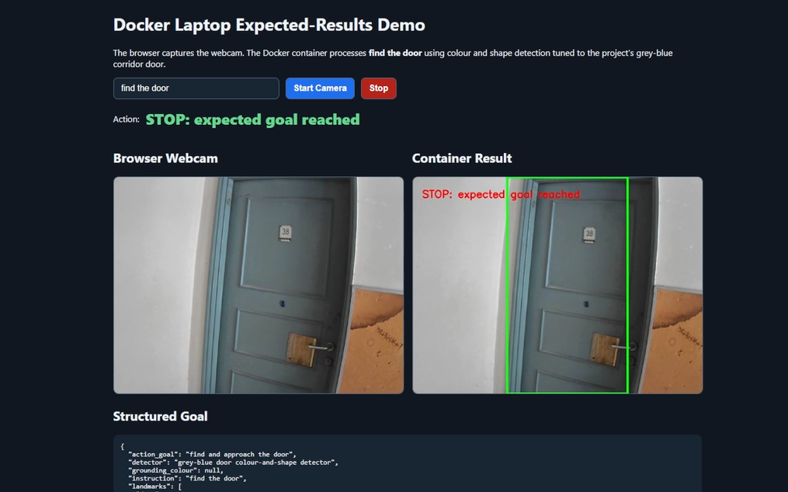

Figure 4.1: Docker result when the close grey-blue door is detected and the goal-stop threshold is reached
The screenshot confirms that the complete software path can identify a large grey-blue door region and convert the result into the restricted STOP action. However, goal arrival is estimated from bounding-box area rather than a physical distance measurement. The result therefore demonstrates expected software behaviour, not verified stopping distance or physical robot navigation.

Figure 4.2 shows an open grey-blue door region. The detector still forms a large bounding box and selects STOP. This demonstrates useful tolerance to a changed door pose, but it also shows that the stopping decision depends on apparent image area rather than measured physical distance.
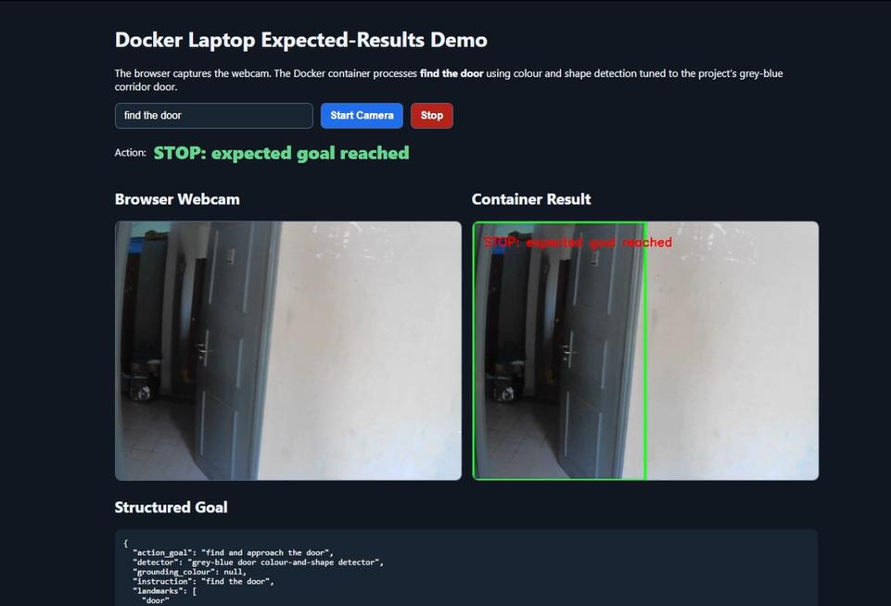

Figure 4.2: Docker result when an open grey-blue door region is detected and STOP is selected
The result indicates that the tuned detector remains responsive when the appearance of the door changes from closed to open. This tolerance is useful within the selected corridor, but the large detected region also exposes a possible false-stop condition because the method cannot distinguish goal proximity from a large open or similarly coloured region using physical distance.

4.3.3 Missing-Target SEARCH Result
Figure 4.3 shows a corridor frame in which no valid full grey-blue door region satisfies the detector rules. No green bounding box is produced and the application displays SEARCH: rotate or move laptop slowly. This is the intended safe fallback because the software does not command forward movement when the target cannot be grounded.
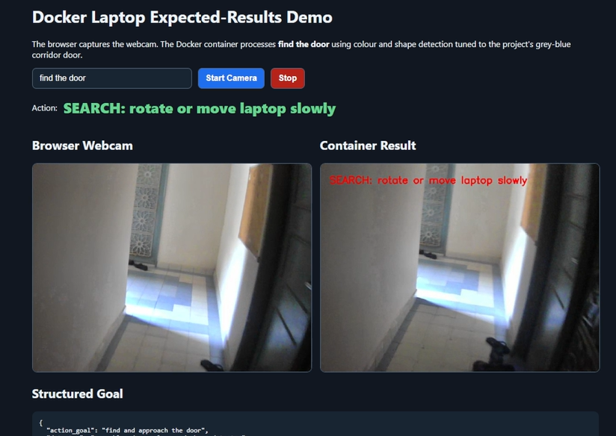

Figure 4.3: Docker SEARCH result when no valid full door region is detected
The SEARCH output demonstrates the intended conservative fallback when visual grounding does not produce a valid target. Avoiding MOVE FORWARD under this condition reduces the risk of blind movement. The screenshot validates the displayed decision only; physical search rotation and obstacle-aware movement remain to be tested after Raspberry Pi and ESP32 integration.

4.3.4 Detection of a Second Similar Door
Figure 4.4 shows the detector responding to a second grey-blue corridor door. The main door region is enclosed and STOP is displayed. This screenshot indicates that the current detector can respond to similarly coloured doors within the same corridor environment, although broader generalization has not been measured.
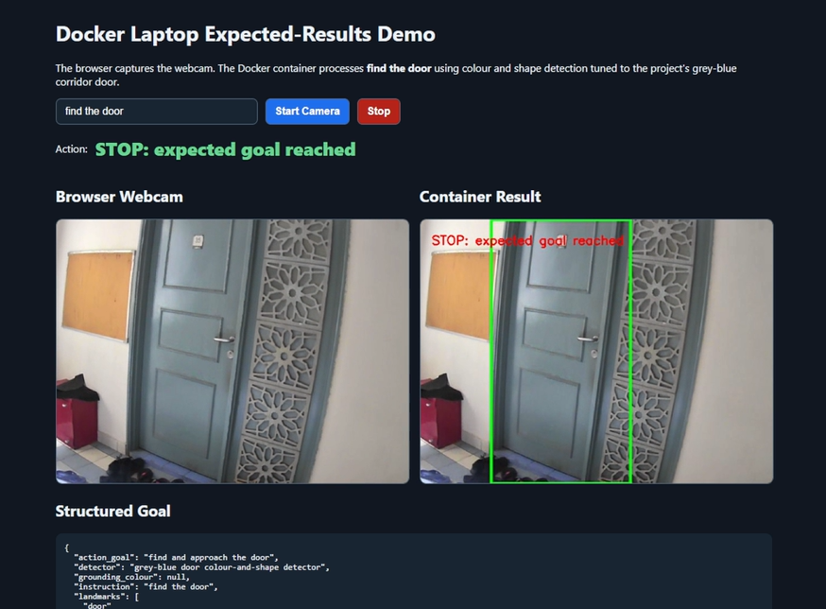

Figure 4.4: Docker result when a second grey-blue corridor door is detected and STOP is selected
Detection of a second similarly coloured door provides limited evidence that the rules are not restricted to one exact door image. Nevertheless, both doors belong to the same corridor and share similar visual properties. A broader image set with different colours, lighting, backgrounds, and non-door objects is required before general semantic door detection can be claimed.

4.3.5 Right-Side Door TURN RIGHT Result
Figure 4.5 shows the grey-blue door detected on the right side of the processed frame. The green bounding box remains on the right of the configured centre zone and the application displays TURN RIGHT: move laptop right. This provides direct screenshot evidence that the detector position can be converted into a directional action rather than only SEARCH or STOP.
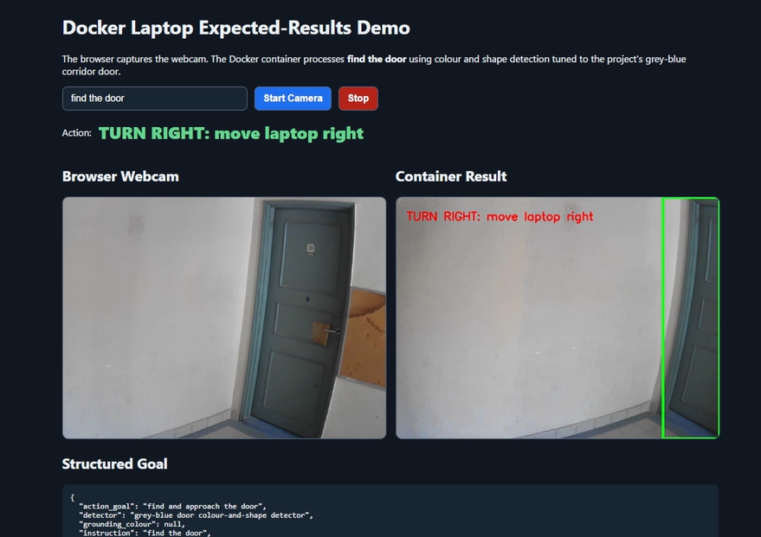

Figure 4.5: Docker TURN RIGHT result when the detected door is on the right side of the processed frame

The screenshot demonstrates that horizontal target position can be translated into a directional TURN RIGHT decision, extending the observed action evidence beyond SEARCH and STOP. The result remains a laptop display instruction; the accuracy of physical right turning, motor response, and obstacle-safe execution must be measured on the completed robot.

4.4 Discussion
The five screenshots demonstrate the complete Docker software path from a natural-language instruction to structured goal output, webcam processing, target-region annotation, and a restricted displayed action. Three screenshot conditions produced STOP after a large grey-blue door region was detected, one produced SEARCH when no valid region was detected, and one produced TURN RIGHT when the door was detected on the right side of the processed frame. These counts describe only the submitted screenshot evidence and must not be interpreted as an accuracy percentage.
The SEARCH result is important because it demonstrates a conservative response when visual grounding fails. However, the STOP results also reveal limitations. The system estimates goal arrival from bounding-box area and does not measure the actual distance to the door. An open door or nearby similarly coloured structure may therefore trigger STOP. The bounding box may also include part of the door frame or adjacent structure.
SEARCH, TURN RIGHT, and STOP are directly supported by the submitted screenshots. TURN LEFT and MOVE FORWARD remain implemented actions, but they require separate recorded evidence before their performance can be discussed as observed results. The detector is tuned to grey-blue doors in one corridor and is not a general semantic door-recognition model.

Table 4.2 connects the evidence visible in the Docker screenshots with the limitations that must be considered when interpreting the results. It prevents preliminary software behaviour from being reported as complete physical robot performance.

Area | Evidence from Screenshots | Limitation
Prompt processing | The instruction is represented as a structured door goal with low uncertainty. | Only one supported instruction is demonstrated.
Visual grounding | Green bounding boxes identify grey-blue door regions in three screenshots. | Detector is tuned to colour and geometry in the selected corridor.
Safe fallback | SEARCH is displayed when no valid door region is detected. | Physical search rotation is not demonstrated.
Directional action | TURN RIGHT is displayed when the detected door is on the right side of the frame. | TURN LEFT and physical turning are not yet demonstrated.
Goal stopping | STOP is displayed when the detected region occupies a large image area. | Apparent area is not a direct physical-distance measurement.
Robot execution | No physical movement is claimed. | Raspberry Pi, ESP32, sensors, motors, and safety overrides remain to be validated.

Table 4.2: Interpretation and Limitations of the Demonstrated Results

The table shows that the demonstration supports structured prompt processing, tuned visual grounding, conservative fallback, directional action selection, and area-based stopping. Its main limitations are the single supported instruction, corridor-specific detector, lack of distance measurement, incomplete action evidence, and absence of physical robot execution.

4.5 Required Physical Validation During FYP2
The Docker results establish a working software demonstration, but the final project result must come from the Raspberry Pi 4 physical robot. The same prompt and detector should be transferred to the Raspberry Pi and connected to the ESP32 safety and motor-control layer. Repeated trials are required before reporting accuracy, latency, movement success, or stopping performance.

Table 4.3 identifies the measurements required during FYP2 to progress from the Docker software demonstration to a validated Raspberry Pi 4 physical robot. The required work covers perception, action selection, performance, communication, safety, movement, and power.

Evaluation Area | Required Measurement
Door detection | Repeated detection and missing-target trials under different lighting, distance, and door poses
Action selection | Recorded SEARCH, TURN LEFT, TURN RIGHT, MOVE FORWARD, and STOP correctness
Raspberry Pi performance | Frame-processing rate and end-to-end action latency
ESP32 communication | USB serial command and sensor-status reliability
Safety | Ultrasonic obstacle stop, sensor-fault stop, invalid-command stop, and timeout stop
Physical navigation | Door-approach success rate and measured stopping distance
Power system | Voltage stability, resets, current, and operating duration

Table 4.3: Required FYP2 Validation After the Docker Demonstration
The listed measurements define the evidence needed before final performance claims can be made. Repeated physical trials must verify all approved actions, stopping distance, processing latency, serial reliability, power stability, and every ESP32 safety response. Results should include failures and limitations as well as successful trials.

4.6 Summary
This chapter presented the observed FYP1 Docker demonstration results for the prompt "find the door". The screenshots show consistent structured goal output, grey-blue door-region detection, STOP selection for large detected door regions, SEARCH selection when the target is not grounded, and TURN RIGHT selection when the door is on the right side of the frame. The demonstration confirms that the high-level software interface is functional, while also showing that physical-distance estimation, broader door recognition, remaining action evidence, and real robot validation remain necessary during FYP2.

CHAPTER 5

CONCLUSION

5.1 Introduction
This chapter concludes the final year project 1 study on Prompt Engineering for Mobile Robot Navigation. It summarizes the work completed, relates the current evidence to the research objectives, states the limitations honestly, and defines the work required to complete the Raspberry Pi 4 physical robot during final year project 2.

5.2 Summary of Final Year Project 1 Work
The project established a modular and safety-aware design for converting a natural-language navigation instruction into a restricted robot action. The finalized physical architecture uses a Raspberry Pi 4 for high-level prompt processing, webcam perception, action selection, validation, and logging. An ESP32 is responsible for ultrasonic sensing, local safety, and four-motor control through two MX1508 motor drivers.
During final year project 1, the robot's mechanical design and protected power system were developed, the main hardware and wiring architecture were finalized, and the software modules for the Raspberry Pi and ESP32 were prepared. A Docker laptop demonstration provided preliminary software evidence for the instruction "find the door". The demonstration converted the instruction into a structured goal, detected tuned grey-blue door regions, and displayed restricted SEARCH, TURN RIGHT, and STOP actions.
The Docker demonstration was an expected-results and interface validation activity. It did not execute motors and is not presented as a completed physical navigation result.

5.3 Achievement of Research Objectives
Table 5.1 summarizes the achievement status of each research objective during FYP1. It presents the evidence obtained from the current development activities and identifies the remaining work required during FYP2.

Objective | FYP1 Status | Evidence | Remaining Work
1. Develop a structured prompt-engineering pipeline with fixed fields and approved actions. | Partially achieved | The Docker demonstration and Python baseline produce a structured goal and restricted action output. | Evaluate the proposed TinyLlama prompt configurations and compare them with the deterministic parser.
2. Integrate the Raspberry Pi 4, webcam, ESP32, sensors, drivers, motors, and protected power system. | Partially achieved | The mechanical prototype and power system are built, and the circuit and software architecture are defined. | Complete I/O wiring, upload firmware, validate serial communication, and test motor and sensor operation.
3. Evaluate prompt validity, grounding, action correctness, latency, safety, and navigation success. | Preliminary evidence obtained | Screenshots demonstrate structured prompt output, tuned door detection, SEARCH, TURN RIGHT, and STOP. | Run repeated quantitative Raspberry Pi and physical robot trials, including all actions and safety cases.

Table 5.1: Achievement of Research Objectives
The findings show that all three research objectives have been partially achieved. The structured prompt-processing pipeline and Docker demonstration provide preliminary software evidence, while the mechanical prototype and power system provide the foundation for physical implementation. However, complete hardware integration, AI-model evaluation, and repeated physical navigation trials are still required before the objectives can be considered fully achieved.

5.4 Main Contributions
1. A focused low-cost architecture that separates Raspberry Pi high-level decisions from ESP32 real-time safety and motor control.
2. A fixed machine-readable navigation schema and five-action interface that can reject unsupported or uncertain instructions.
3. A reproducible Docker demonstration that verifies the high-level instruction-to-vision-to-action interface before physical integration.
4. A clear AI-model research plan comparing a deterministic baseline with TinyLlama, MobileNetV2-SSD Lite, and a small learned action classifier.
5. A physical robot design, protected power system, wiring plan, firmware baseline, and documented final year project 2 validation path.

5.5 Limitations
The current observed results are limited to a laptop Docker demonstration and a detector tuned to grey-blue doors in one corridor. The detector is not a general semantic door model, and its STOP decision uses apparent image area rather than measured physical distance. The submitted screenshots directly demonstrate SEARCH, TURN RIGHT, and STOP only.
The Raspberry Pi 4, ESP32, webcam, ultrasonic sensors, motor drivers, and motors have not yet been fully integrated and validated as an autonomous physical system. The robot has no wheel encoders, reliable yaw sensor, RGB-D camera, LiDAR, or SLAM pose. The ADXL345 provides acceleration and roll or pitch observations but does not provide yaw heading.
The proposed AI models remain research candidates until they are trained or configured, benchmarked, and compared with the baseline. No AI model will be claimed as implemented until reproducible experimental results are available.

5.6 Recommended FYP2 Work
Table 5.2 presents the recommended implementation and validation activities for FYP2. The activities are arranged in stages to ensure that the robot’s electrical system, baseline software, safety functions, AI models, and physical navigation performance are tested systematically.

Stage | Required Work | Expected Evidence
1. Electrical and firmware integration | Complete I/O wiring, validate voltage levels, upload ESP32 firmware, and verify USB serial communication. | Sensor logs, command logs, and safe raised-wheel motor tests
2. Baseline physical robot | Deploy the deterministic parser, OpenCV grounding, and rule-based actions on Raspberry Pi 4. | Repeated SEARCH, TURN LEFT, TURN RIGHT, MOVE FORWARD, and STOP trials
3. Safety validation | Test obstacle, sensor-fault, invalid-command, timeout, and emergency-stop behaviour. | Measured stop responses with no unsafe motor continuation
4. AI model experiments | Benchmark TinyLlama prompts, train or fine-tune MobileNetV2-SSD Lite, and train the small action classifier. | Model accuracy, rejection behaviour, latency, memory, and comparison tables
5. Final navigation evaluation | Run supervised physical goal-approach trials under varied lighting, distance, and target positions. | Success rate, action correctness, stopping distance, processing rate, and failure analysis

Table 5.2: Recommended FYP2 Implementation and Validation Work
The proposed FYP2 work begins with electrical and firmware integration before progressing to physical navigation and AI-model experiments. This staged approach reduces integration risk and ensures that each subsystem is verified before complete robot operation. The final evaluation will compare the proposed AI models with the deterministic baseline while maintaining the ESP32 safety layer during every physical trial.

5.7 Conclusion
Final year project 1 produced a realistic foundation for a prompt-engineered mobile robot rather than claiming a completed autonomous system prematurely. The project now has one finalized Raspberry Pi 4 architecture, a separate ESP32 safety layer, a completed mechanical and power foundation, a working Docker software demonstration, and an explicit methodology for researching language, vision, and action AI models.
The next stage is to complete physical integration and obtain quantitative results. The project will be considered successful when supported instructions can be converted into validated actions, the robot can safely approach a controlled indoor target, and every uncertain, invalid, obstructed, or timed-out condition reliably results in stop.

REFERENCE

Cheng, A.-C., Ji, Y., Yang, Z., Gongye, Z., Zou, X., Kautz, J., Biyik, E., Yin, H., Liu, S., & Wang, X. (2025). NaVILA: Legged robot vision-language-action model for navigation. *Proceedings of Robotics: Science and Systems*. https://doi.org/10.15607/RSS.2025.XXI.018
Goetting, D., Singh, H. G., & Loquercio, A. (2024). *End-to-end navigation with vision language models: Transforming spatial reasoning into question-answering*. arXiv. https://doi.org/10.48550/arXiv.2411.05755
Huang, C., Mees, O., Zeng, A., & Burgard, W. (2023). Visual language maps for robot navigation. *Proceedings of the IEEE International Conference on Robotics and Automation (ICRA)*. https://vlmaps.github.io/
Shah, D., Osinski, B., Ichter, B., & Levine, S. (2023a). LM-Nav: Robotic navigation with large pre-trained models of language, vision, and action. *Proceedings of the 6th Conference on Robot Learning, Proceedings of Machine Learning Research, 205*, 492-504. https://proceedings.mlr.press/v205/shah23b.html
Shah, D., Sridhar, A., Dashora, N., Stachowicz, K., Black, K., Hirose, N., & Levine, S. (2023b). ViNT: A foundation model for visual navigation. *Proceedings of the 7th Conference on Robot Learning, Proceedings of Machine Learning Research, 229*, 711-733. https://proceedings.mlr.press/v229/shah23a.html
Sridhar, A., Shah, D., Glossop, C., & Levine, S. (2023). *NoMaD: Goal masked diffusion policies for navigation and exploration*. arXiv. https://arxiv.org/abs/2310.07896
Werby, A., Huang, C., Buchner, M., Valada, A., & Burgard, W. (2024). Hierarchical open-vocabulary 3D scene graphs for language-grounded robot navigation. *Proceedings of Robotics: Science and Systems*. https://doi.org/10.15607/RSS.2024.XX.077
Zhang, J., Wang, K., Xu, R., Zhou, G., Hong, Y., Fang, X., Wu, Q., Zhang, Z., & Wang, H. (2024). NaVid: Video-based VLM plans the next step for vision-and-language navigation. *Proceedings of Robotics: Science and Systems*. https://doi.org/10.15607/RSS.2024.XX.079
Zhang, J., Wang, K., Wang, S., Li, M., Liu, H., Wei, S., Wang, Z., Zhang, Z., & Wang, H. (2026). Uni-NaVid: A video-based vision-language-action model for unifying embodied navigation tasks. *Robotics: Science and Systems 2026 Program*. https://roboticsconference.org/program/papers/13/

