CHAPTER 3
RESEARCH METHODOLOGY

3.1 Introduction
Chapter 2 identified a research gap in low-cost language-guided mobile robot navigation. Existing systems such as LM-Nav, VLMaps, HOV-SG, ViNT, NoMaD, VLMnav, NaVid, Uni-NaVid, and NaVILA show that language, vision, and action can be combined for robot navigation. However, many of these systems require expensive robot platforms, RGB-D cameras, LiDAR, mapping pipelines, server-level models, or complex navigation policies. This creates a practical gap for student-level implementation.
This chapter describes how the project addresses that gap through a low-cost indoor research prototype. The proposed system uses an RDK X5 development board with 8GB RAM as the onboard computing unit, a ROS Robot Control Board V3.0 with STM32F103RCT6 as the low-level motor controller, an ESP32 as the ultrasonic sensor controller, an unbranded 1080p USB webcam as the visual input sensor, four ultrasonic sensors as simple proximity sensors, four DC motors, a mobile robot chassis, and 18650 batteries. The robot is designed for controlled indoor testing in environments such as a corridor, room, laboratory, door area, signboard area, table area, and chair area.
The methodology is inspired by the modular structure of LM-Nav and the prompt-based action-selection idea of VLMnav. However, the methodology is adapted for this specific FYP prototype. The project does not attempt to build an industry-level autonomous navigation system. Instead, it studies whether structured prompt engineering can convert simple natural language instructions into useful navigation information, visually ground the target using a webcam image, and generate simple validated robot actions.
The intended action set is limited to:
- move_forward
- turn_left
- turn_right
- stop
- search
This restricted action set is suitable for the project because it allows the AI decision layer on the RDK X5 board to check obstacle readings from the ESP32 and communicate safely with the STM32-based motor controller. The main contribution of the methodology is therefore the design, implementation, and evaluation of a baseline prompt-engineered indoor navigation prototype that future researchers can improve.

3.2 Research Design and Project Workflow
The project follows an iterative prototyping methodology. This approach is suitable because the system contains hardware, software, AI processing, visual grounding, and motor-control components. Each component must be tested separately before the complete robot is evaluated in indoor navigation scenarios.
The methodology is organized around three main activities. First, the robot hardware and software platform are prepared. Second, prompt templates are designed to convert user instructions into structured navigation outputs. Third, the structured output, webcam image, and ESP32 ultrasonic readings are used to select a simple robot action, which is sent from the RDK X5 board to the STM32-based motor controller.

3.2.1 Methodology Alignment with Research Objectives
The methodology is aligned with the project objectives as shown in Table 3.1.
Table 3.1: Methodology Alignment with Research Objectives
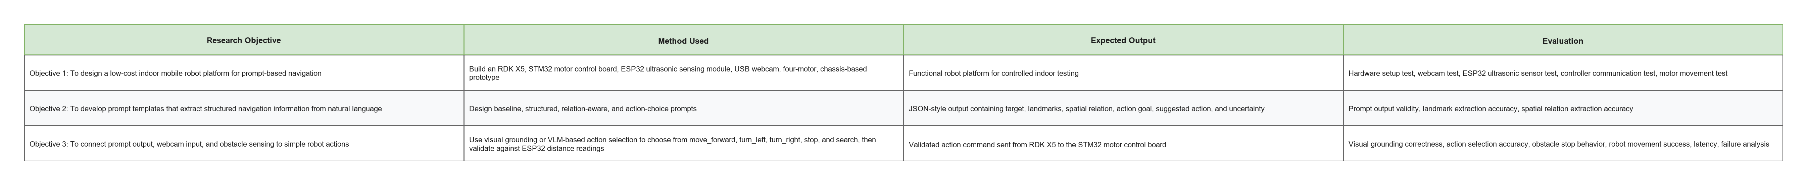

3.2.2 Overall Project Workflow
The overall project workflow begins with the preparation of the robot hardware and software environment. After the robot platform is functional, the prompt templates are developed and tested using sample instructions. The RDK X5 then captures a webcam image, processes the user instruction, performs visual grounding or action selection, receives ultrasonic distance readings from the ESP32 for basic safety, validates the output, and sends a simple command to the STM32-based motor control board. The robot control board drives the four DC motors according to the selected action.
The workflow is summarized in Figure 3.1.
Figure 3.1: Proposed project workflow
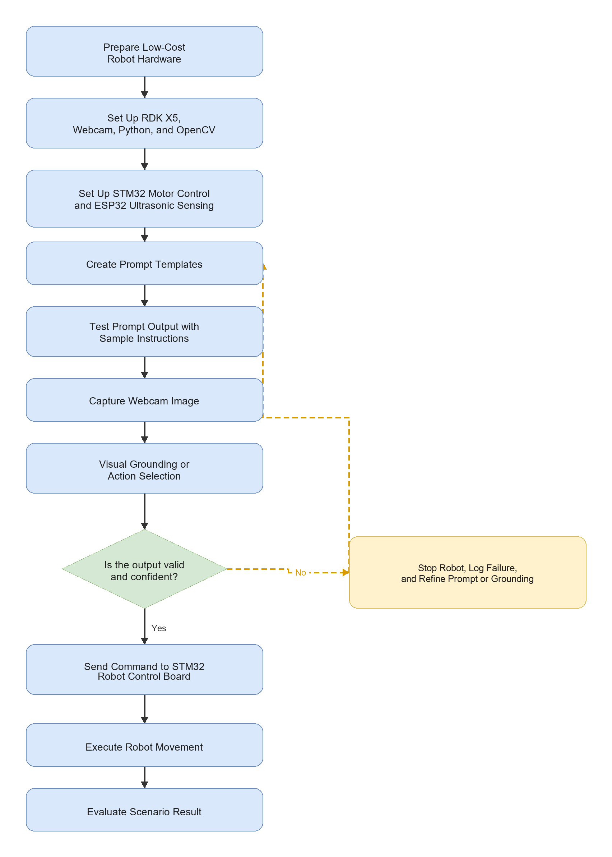

3.2.3 Development Workflow
The development workflow is divided into stages so that hardware and software risks can be reduced before full integration.
Table 3.2: Development Workflow
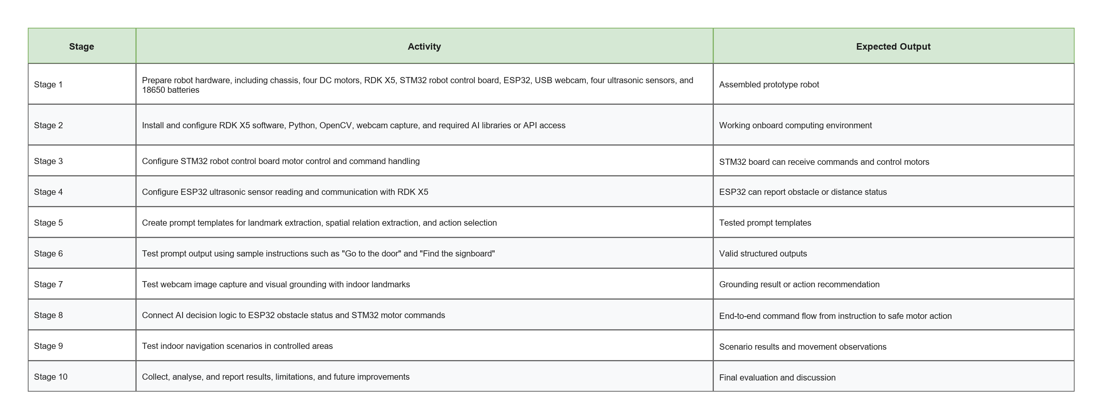

3.3 Proposed System Architecture
The proposed system architecture adapts the LM-Nav idea into a low-cost indoor robot system. LM-Nav separates language understanding, visual grounding, and navigation execution. In this project, these stages are implemented as user prompt processing, structured navigation output generation, webcam-based visual grounding or action selection, RDK X5 decision logic, ESP32 ultrasonic safety checking, STM32 motor command handling, and robot movement.
Figure 3.2: Proposed system architecture
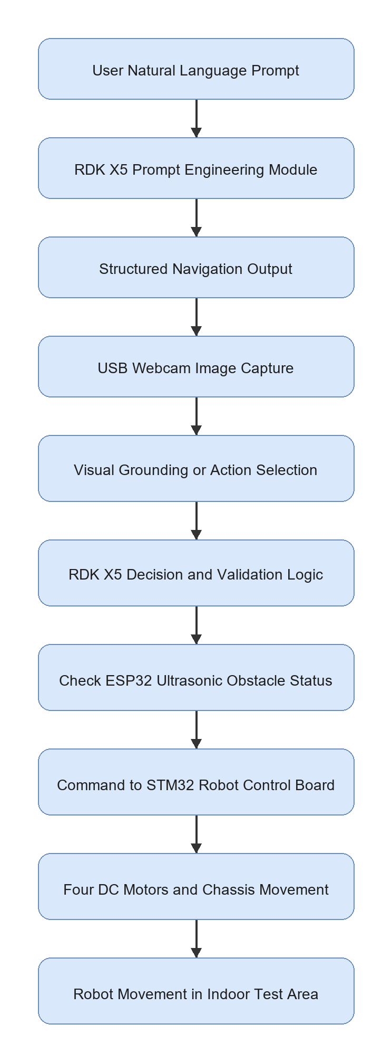
The architecture is intentionally modular. If the robot fails to reach the target, the failure can be traced to a specific component: prompt output, visual grounding, action selection, serial communication, motor control, or physical movement. This is important for an FYP because the project must be evaluated systematically rather than only judged by whether the robot moves.

3.3.1 Hardware Roles
The hardware components and their roles are shown in Table 3.3.
Table 3.3: Proposed Hardware Components and Roles
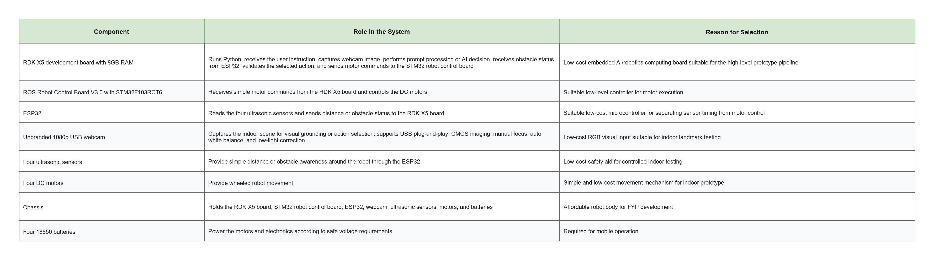
The RDK X5 is responsible for high-level decision making, the STM32-based robot control board is responsible for low-level motor execution, and the ESP32 is responsible for ultrasonic sensor handling. This separation prevents the AI processing loop from directly controlling motor pins or ultrasonic timing and makes the system easier to test.
The webcam is used only as the visual input device for indoor scene observation. Although the selected webcam includes a microphone and supports video-compression features such as H.264/H.265, the main requirement for this project is its 1920 x 1080 RGB image capture through a plug-and-play USB connection. Audio input is not part of the baseline methodology unless voice-command input is added as future work.

3.4 System Requirements, Constraints, and Acceptance Criteria
The system requirements are defined according to the actual scope of the project. The prototype must be able to accept a simple navigation instruction, process the instruction into a structured format, use webcam input for grounding or action selection, and move the robot using validated commands.
Table 3.4: Requirements and Acceptance Criteria
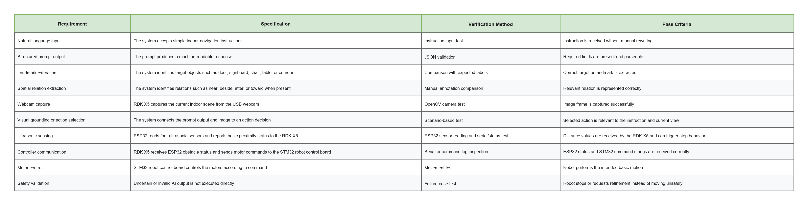
The project has several constraints. The robot operates only in a controlled indoor environment. The webcam does not provide depth information. The project does not include full SLAM, LiDAR mapping, large VLA model deployment, or advanced learned navigation policies. These constraints are acceptable because the goal is to build and evaluate a baseline prompt-engineered prototype.

3.5 Data, Test Environment, and Experimental Materials
The project uses simple indoor navigation instructions and webcam images from controlled test areas. The instruction set is designed to represent common commands that a user may give to a small indoor mobile robot.
Table 3.5: Instruction Categories and Indoor Landmarks
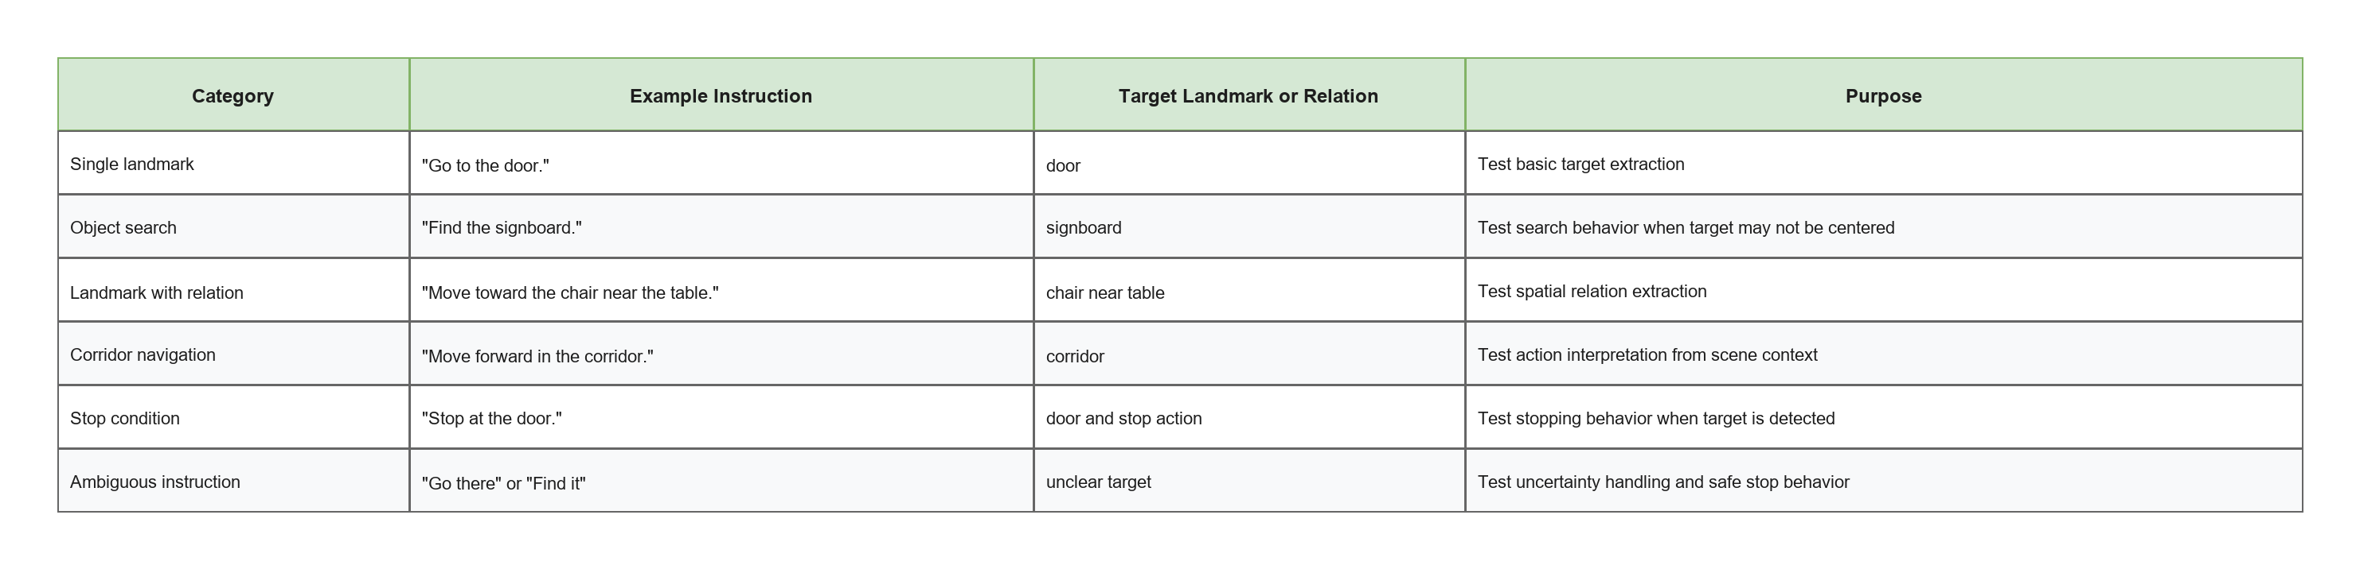
The indoor test environment will include simple visual landmarks such as a door, table, chair, signboard, corridor, wall, and room entrance. The environment should be controlled enough for safe movement but varied enough to test different prompt and grounding outcomes.
Table 3.6: Experimental Materials
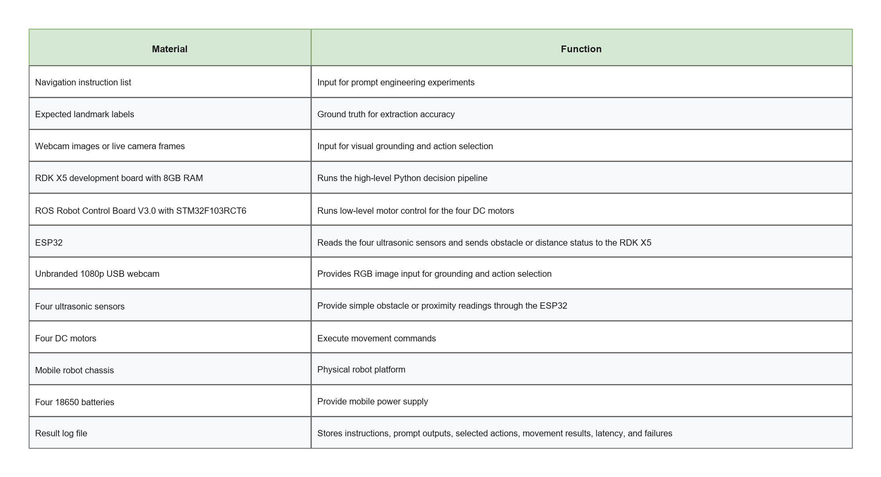
Table 3.7: Software, Model, and Platform Requirements
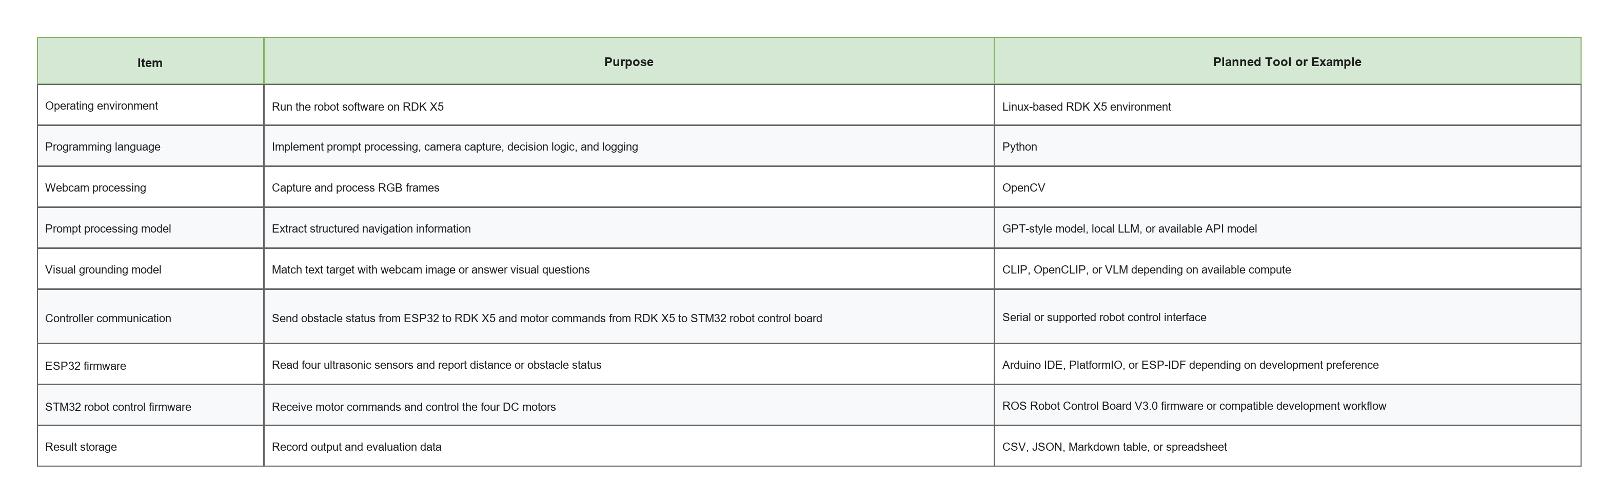

3.6 Prompt Engineering Design
Prompt engineering is the central research element of the project. The prompt must convert a user instruction into a structured navigation representation that can be parsed by the RDK X5 board. The output should be simple enough for the robot to use, but detailed enough to preserve target, landmark, relation, action goal, and uncertainty information.
Table 3.8: Prompt Templates for Evaluation
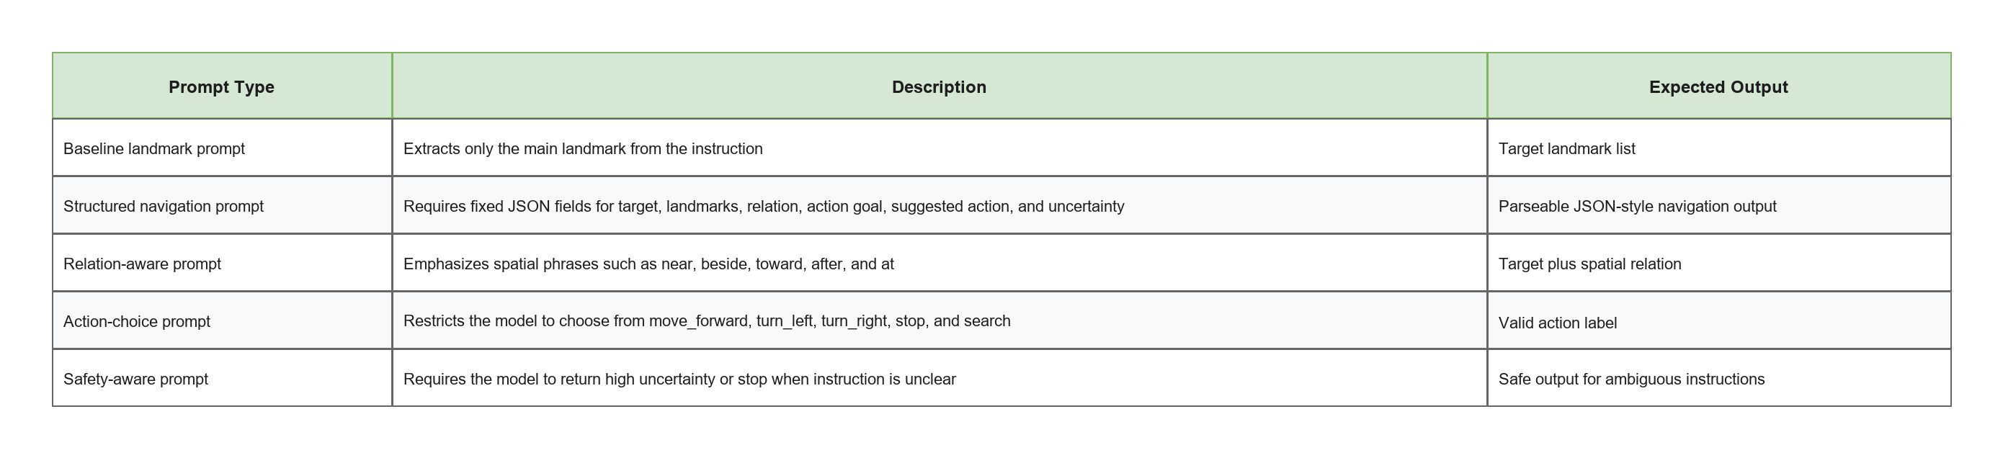
The structured output format is shown below.
{
"target": "door",
"landmarks": ["door"],
"spatial_relation": null,
"action_goal": "find and move toward the door",
"suggested_action": "move_forward",
"uncertainty": "low"
}
For a relation-based instruction, the expected output may be:
{
"target": "chair",
"landmarks": ["chair", "table"],
"spatial_relation": "chair near table",
"action_goal": "move toward the chair that is near the table",
"suggested_action": "search",
"uncertainty": "medium"
}
Table 3.9: Structured Output Fields
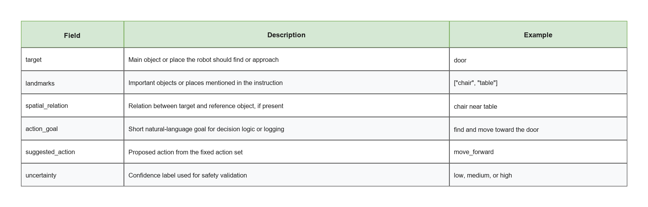
The RDK X5 will validate this output before execution. If required fields are missing, if the action is outside the approved action set, if uncertainty is high, or if ESP32 ultrasonic readings indicate that the path is too close to an obstacle, the robot should stop and log the failure instead of moving.

3.7 Webcam-Based Visual Grounding and Action Selection
After the prompt output is generated, the system captures an image from the USB webcam. The image is used to decide whether the target appears in the current view and which action should be taken. The visual grounding stage may use CLIP, OpenCLIP, a VLM, or a simplified image-based method depending on available compute and implementation constraints.
For CLIP or OpenCLIP-style grounding, the text query may be the target alone, such as door, or a prompt-expanded query, such as an indoor door in a corridor. The basic score is:
score(image, text) = cosine_similarity(E_image(image), E_text(text))
For VLM-style action selection, the model may be asked to choose the best action from the approved action set based on the instruction and current image. This follows the idea of VLMnav but is simplified for the FYP robot.
Table 3.10: Visual Grounding and Action Selection Strategies
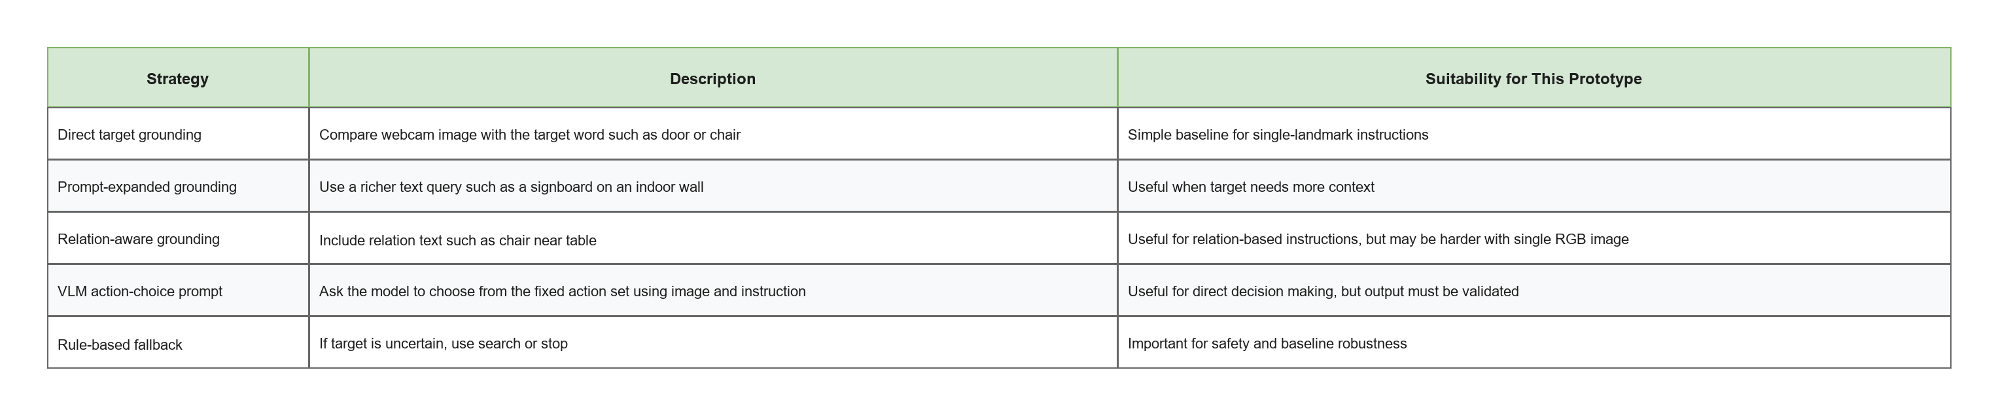
The grounding result is not treated as perfect. The system will log cases where the target is not visible, the model selects the wrong action, or the robot needs to search.

3.8 Robot Action Set and Motor Command Mapping
The robot uses a small action set because the prototype is intended for controlled indoor testing. The RDK X5 selects a high-level action and sends the corresponding command string to the STM32-based robot control board. The robot control board then translates the command into motor signals.
Table 3.11: Action Set and Motor Command Mapping
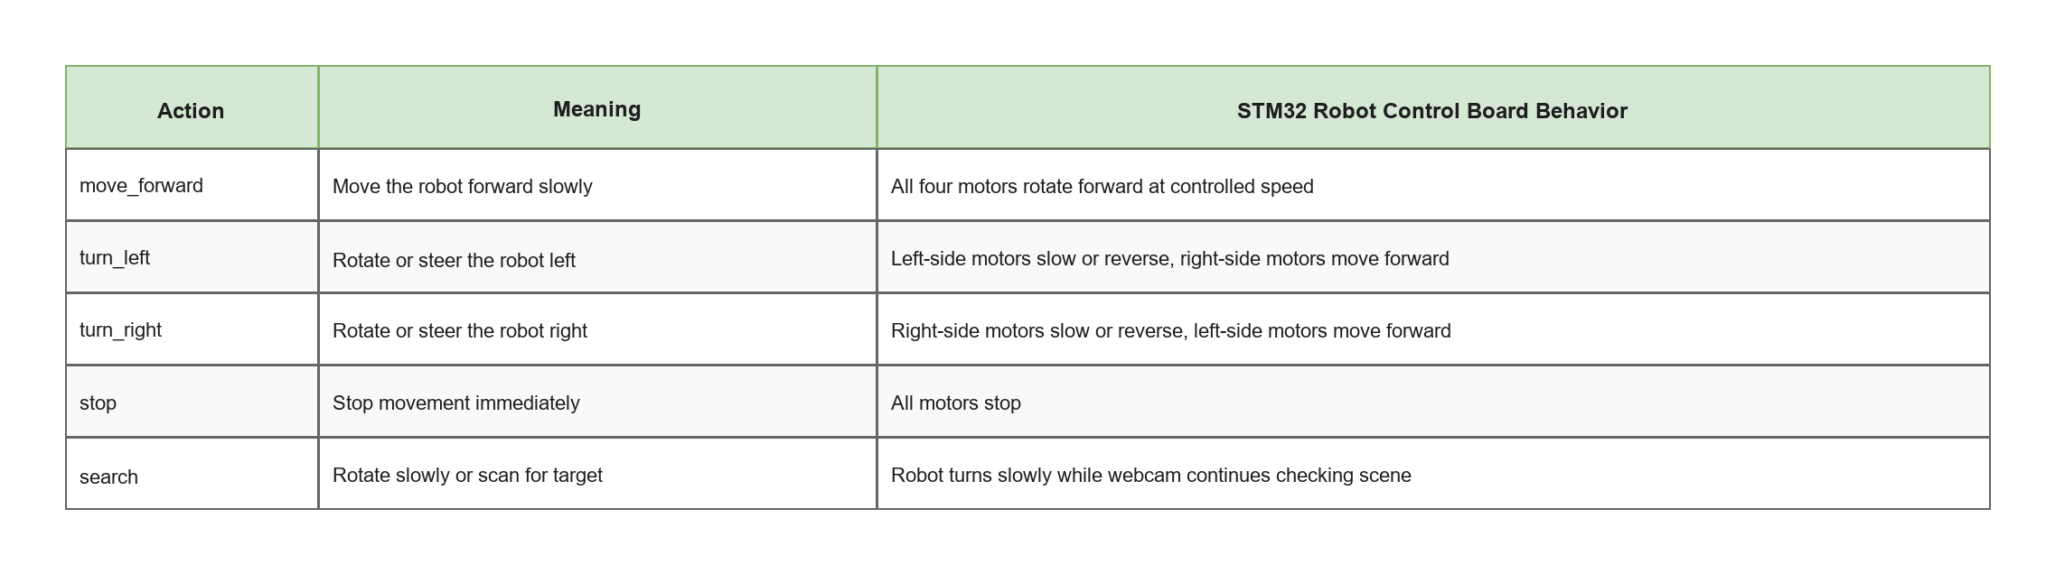
This action set is intentionally limited. It does not include full path planning, obstacle avoidance, or continuous velocity control. The purpose is to test whether language and visual information can be converted into simple, safe movement commands.

3.9 Baseline Prototype and Future Improvement Scope
The baseline implementation focuses on simple indoor navigation using prompt engineering and webcam-based grounding. More advanced methods from the literature are treated as future improvements.
Table 3.12: Baseline and Future Improvement Methods
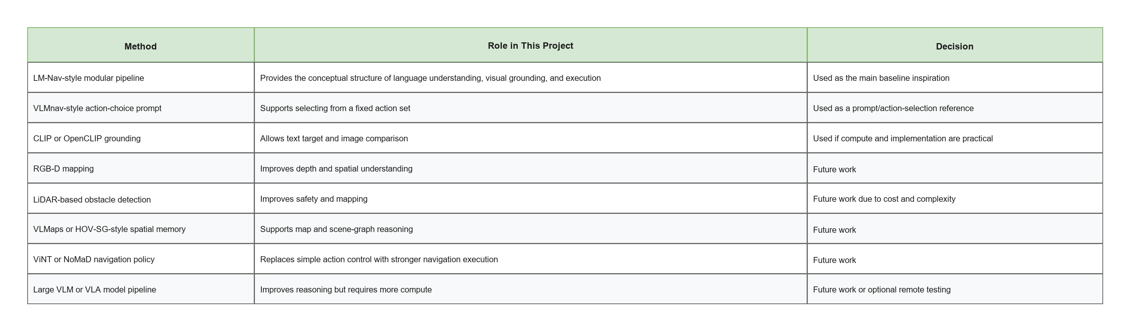
This table clarifies the scope of the FYP. The project is not evaluated as a complete industrial navigation stack. It is evaluated as a baseline research prototype that can support later improvements.

3.10 Mechanical Design and Physical Integration
The mobile robot chassis will be designed as a purpose-built low-cost platform for the project. The design is prepared in Autodesk Fusion 360 so that the RDK X5 board, STM32 robot control board, ESP32, webcam, ultrasonic sensors, battery holder, and four DC motors can be mounted in a controlled and repeatable layout. The 3D model is not treated as the main research contribution, but it is important because the sensor placement and component arrangement affect the reliability of the indoor navigation experiment.
The proposed chassis should provide mounting space for the webcam at the front of the robot, four ultrasonic sensors around the robot body, and accessible mounting positions for the controller boards. The battery holder should be placed low on the chassis to improve stability. The design should also allow the wiring to be routed safely so that cables do not touch the wheels or motors.
Figure 3.3: Placeholder for proposed Fusion 360 3D robot model
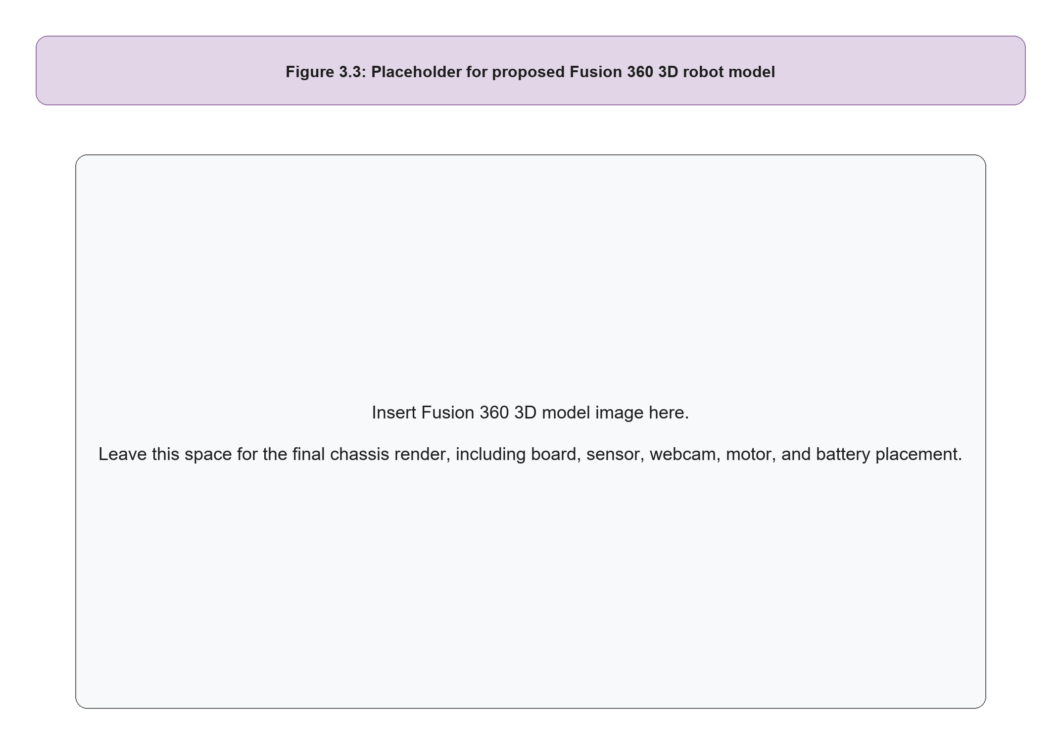

3.10.1 Suggested Circuit Architecture
The circuit architecture is divided into three layers: computing, sensing, and motion. The RDK X5 performs high-level prompt processing and decision logic. The ESP32 handles the timing-sensitive ultrasonic sensor readings. The STM32-based robot control board receives validated motor commands and controls the motors. This separation is suitable for an FYP prototype because each layer can be tested independently before full integration.
Figure 3.4: Suggested circuit architecture
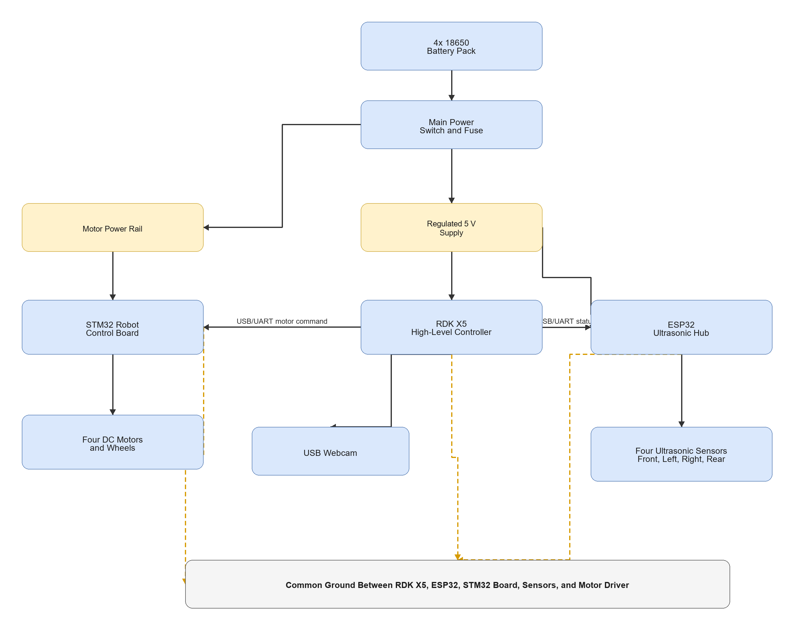
The final circuit diagram should show the battery connection, power switch, regulator, RDK X5, ESP32, STM32 robot control board, ultrasonic sensors, motor driver outputs, and motors. If the ultrasonic sensors are powered at 5 V, the echo signals should be reduced to 3.3 V before entering ESP32 input pins. This can be done using a voltage divider or logic-level shifter. The exact pin numbers should be confirmed after the physical boards and connectors are finalized.
Figure 3.5: Placeholder for final circuit diagram
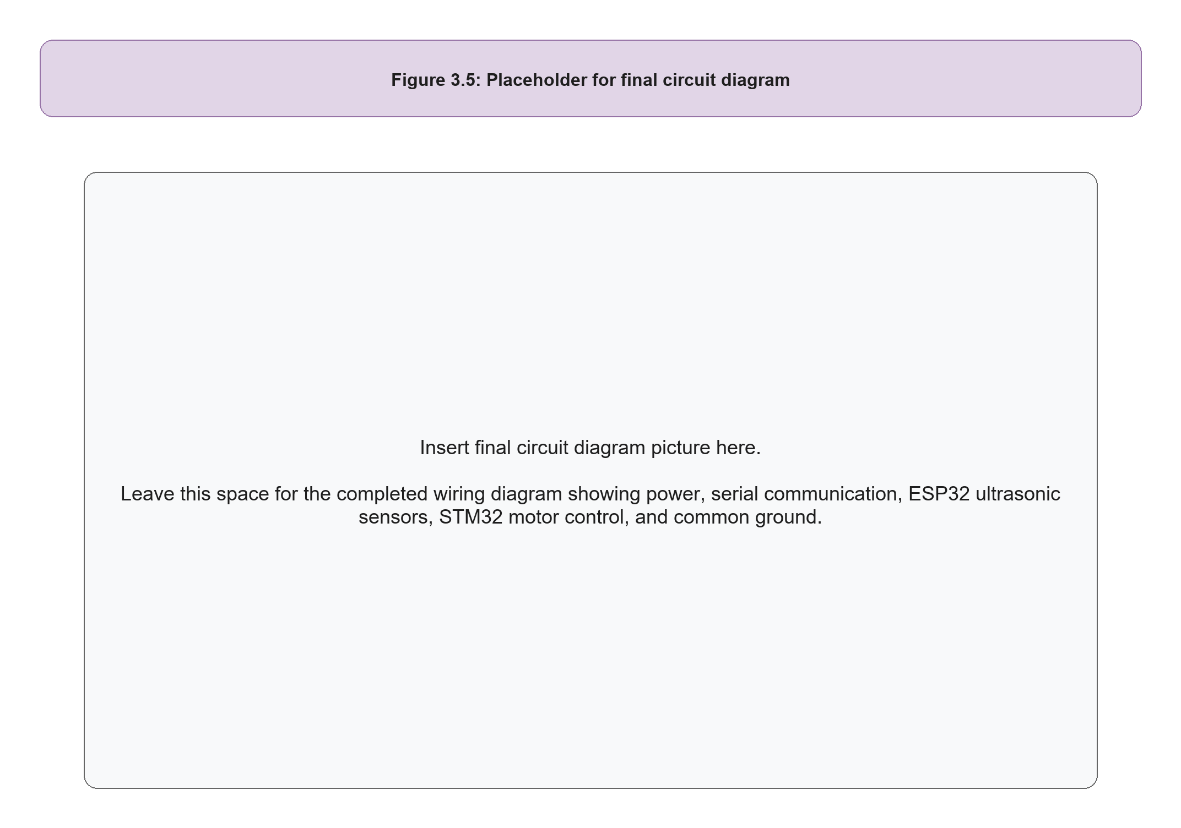

3.11 Company, Software, and Tool Involvement
The project does not involve industrial sponsorship. However, several hardware and software vendors, chip manufacturers, and open-source tools are used in the prototype. Table 3.13 identifies the companies or organizations related to the selected components and software tools. For final submission, the exact supplier name should be checked against the purchase receipt or product label, especially for unbranded or third-party robot-control boards.
Table 3.13: Company, Component, and Software Involvement
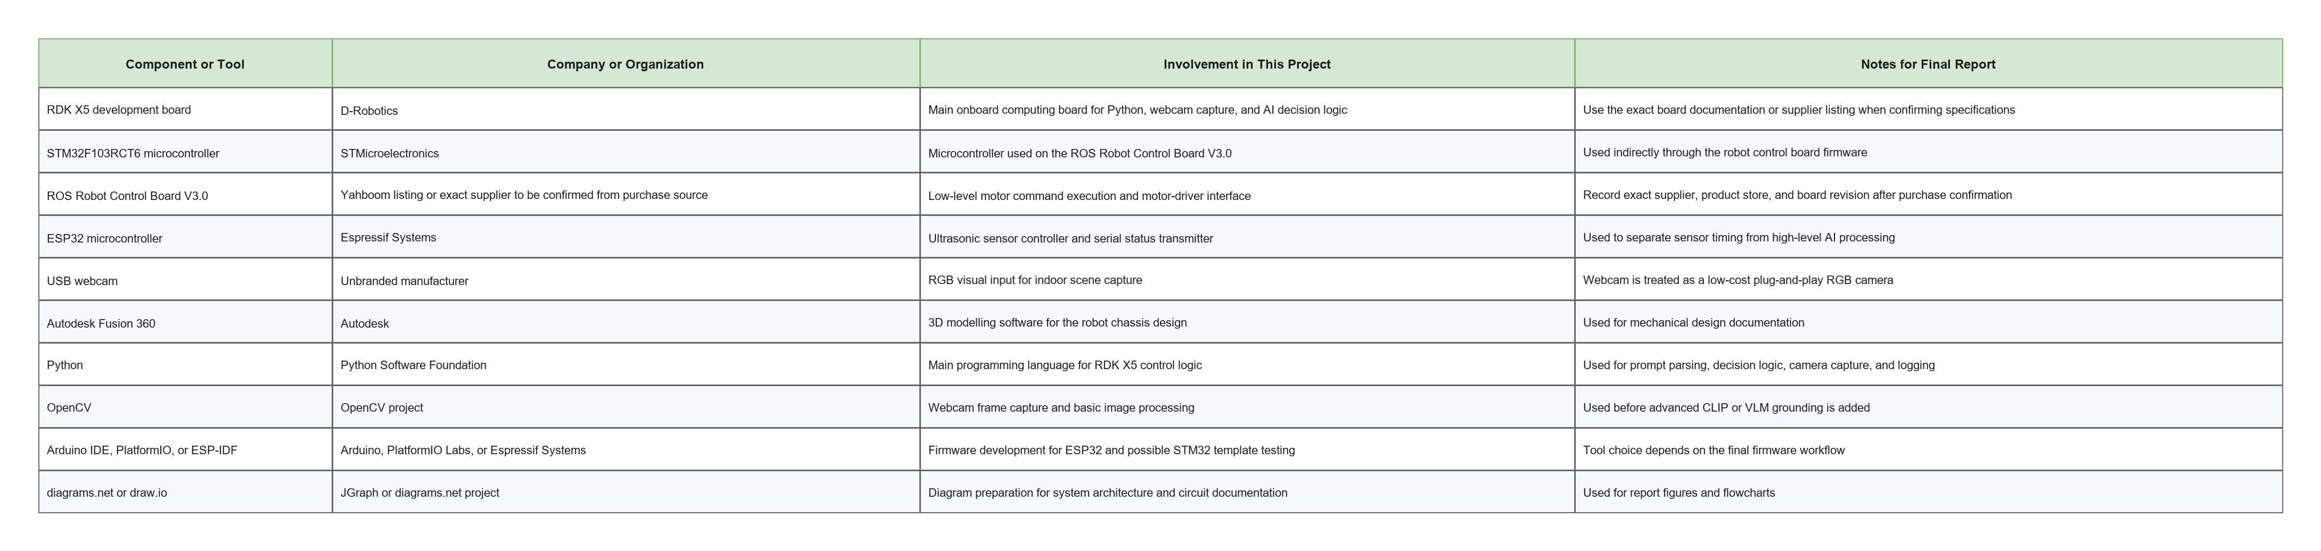

3.12 Software Implementation and Coding
The baseline coding is divided according to the hardware roles. The RDK X5 runs the main Python control program. The ESP32 runs firmware that reads four ultrasonic sensors and sends JSON status messages. The STM32 robot control board receives simple motor commands. If the selected STM32 board already provides vendor firmware, the vendor firmware should be used and the RDK X5 command strings should be mapped to the supported command protocol. If custom firmware is required, the provided STM32 template can be adapted after confirming the board pinout.
The full baseline source code is provided in the project repository so that the methodology is supported by an implementable software structure rather than only a conceptual flowchart.
Table 3.14: Source Code Modules for Baseline Implementation
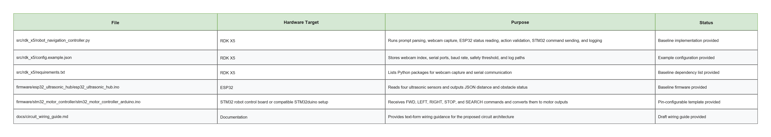
The RDK X5 controller follows the control logic shown below:
Receive user instruction
Generate structured prompt output
Capture webcam frame
Read ESP32 ultrasonic distance status
Select proposed action from fixed action set
If output is invalid, uncertainty is high, or obstacle is detected:
execute stop
Else:
send validated command to STM32 robot control board
Log instruction, structured output, sensor status, final action, and latency
This coding structure is influenced by LM-Nav and VLMnav but simplified for the proposed hardware. LM-Nav motivates the separation between language understanding, visual grounding, and execution. VLMnav motivates the use of action-choice prompting from a fixed action set. CLIP or OpenCLIP can be added later to replace the current baseline grounding function. VLMaps, HOV-SG, ViNT, NoMaD, NaVid, Uni-NaVid, and NaVILA are not implemented in the first prototype because they require additional sensors, mapping, model deployment, or compute resources beyond the initial FYP scope.

3.13 Equations and Decision Rules
The project uses simple equations and decision rules to evaluate the prototype. The equations are not intended to represent a complete navigation theory; they provide measurable criteria for prompt quality, visual grounding, action selection, ultrasonic safety checking, and response time.
Table 3.15: Main Equations and Decision Rules
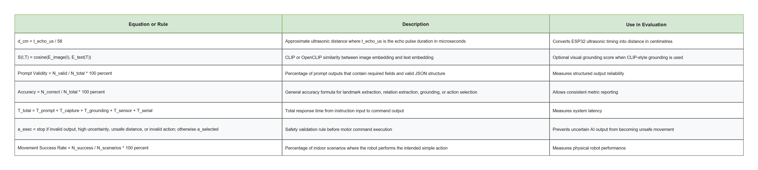
For ultrasonic sensing, an obstacle is considered present when the smallest valid distance from the ESP32 is lower than the selected safety threshold. In the baseline configuration, the threshold is set to 25 cm, but this value can be adjusted during testing depending on robot speed, braking distance, and sensor reliability.

3.14 Implementation Procedure
The implementation procedure follows ten stages. Each stage has a verification method so that the project can be developed and tested systematically.
Table 3.16: Implementation Procedure
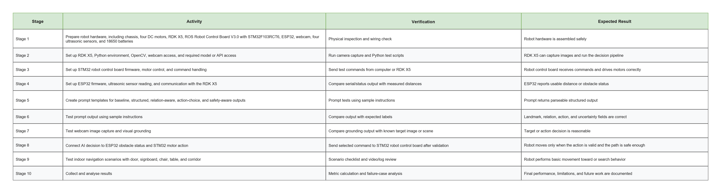

3.15 Testing and Validation Plan
Testing is divided into module testing, integration testing, and scenario testing. Module testing checks the prompt, webcam, grounding, ESP32 ultrasonic sensing, controller communication, and motor control separately. Integration testing checks whether the system can process an instruction, capture an image, select an action, check ESP32 proximity readings, and send a command to the STM32 robot control board. Scenario testing evaluates the robot in controlled indoor environments.
Table 3.17: Testing and Validation Matrix
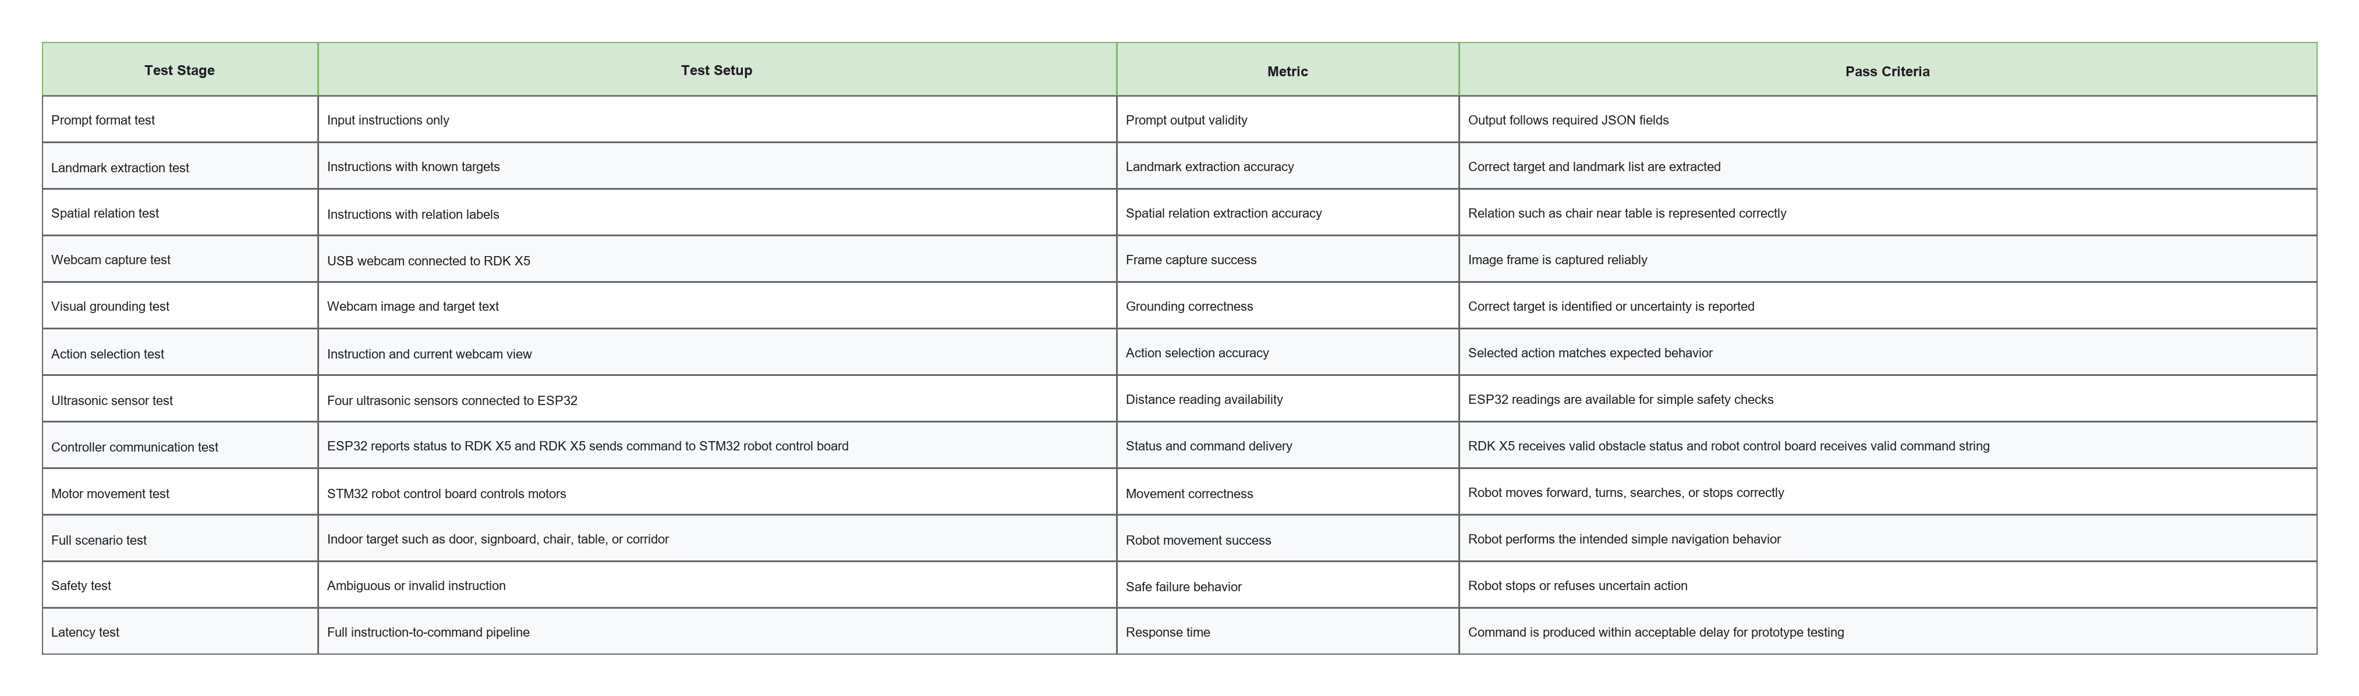

3.16 Evaluation Metrics
The evaluation focuses on both AI output quality and robot behavior. This is important because a prompt may produce a correct text output while the robot still fails to move correctly, or the robot may move correctly even when visual grounding is weak.
Table 3.18: Evaluation Metrics
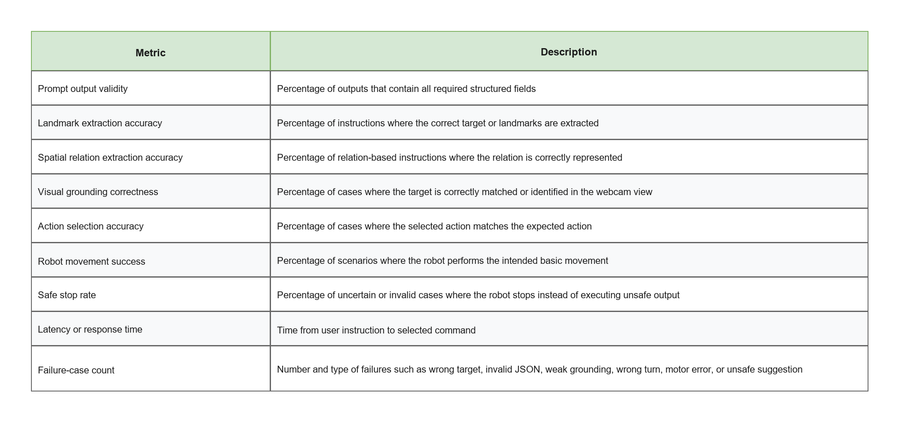
Qualitative analysis will also be conducted. Failure cases will be grouped into prompt errors, grounding errors, action-selection errors, serial communication errors, motor-control errors, and environmental limitations. This helps identify whether future work should improve prompts, visual grounding, hardware, or navigation control.

3.17 Safety, Ethics, and Practical Considerations
Safety is important even though the robot is a low-cost indoor prototype. The robot should move at low speed during testing. All tests should be conducted in a controlled indoor area with sufficient space. A manual stop or emergency stop method should be available during movement tests. The four ultrasonic sensors connected to the ESP32 should be used as a simple proximity safety layer, but testing must still be supervised manually because ultrasonic sensors do not provide complete obstacle understanding.
The system should not execute uncertain AI output directly. If the structured output is invalid, if the selected action is not in the approved action set, or if the uncertainty is high, the robot should stop and log the case. This prevents a hallucinated or ambiguous model response from becoming an unsafe motor command.
Privacy must also be considered when using a webcam. Testing should avoid capturing identifiable people unless permission is obtained. Images and logs should be used only for project evaluation.

3.18 Limitations and Future Work
The proposed prototype has clear limitations. It uses a USB webcam, so it does not directly estimate dense depth or build a 3D map. The ESP32-based ultrasonic sensing module provides only simple distance cues and is not equivalent to LiDAR or RGB-D mapping. The system uses a simple action set, so it cannot perform full path planning. It does not include LiDAR, RGB-D SLAM, 3D scene graph mapping, or a learned navigation policy. It also depends on the reliability of prompt output and visual grounding.
These limitations are acceptable because the project is designed as a baseline research prototype. Future work can improve the system by adding an RGB-D camera, LiDAR, stronger obstacle sensing, map building, VLMaps-style visual-language maps, HOV-SG-style scene graphs, ViNT or NoMaD navigation policies, or more advanced VLM/VLA models. The baseline prototype provides a practical platform for these improvements by establishing the first connection between natural language prompts, webcam-based grounding, ESP32-based ultrasonic safety checking, and STM32-controlled robot movement.

3.19 Summary
This chapter presented the methodology for the proposed low-cost indoor mobile robot navigation prototype. The system is inspired by LM-Nav and VLMnav but is adapted for an FYP-scale implementation using an RDK X5 development board with 8GB RAM, ROS Robot Control Board V3.0 with STM32F103RCT6 for motor control, ESP32 for ultrasonic sensing, unbranded USB webcam, four ultrasonic sensors, four DC motors, chassis, and 18650 batteries.
The methodology defines the system architecture, hardware roles, mechanical and circuit integration plan, software tools, source-code structure, prompt engineering design, structured output format, visual grounding and action-selection process, action set, implementation stages, testing plan, evaluation metrics, safety considerations, and future work. The project is positioned as a baseline prototype that investigates how structured prompt engineering can support simple indoor robot navigation, while leaving advanced mapping, sensing, and navigation policies for future researchers.

