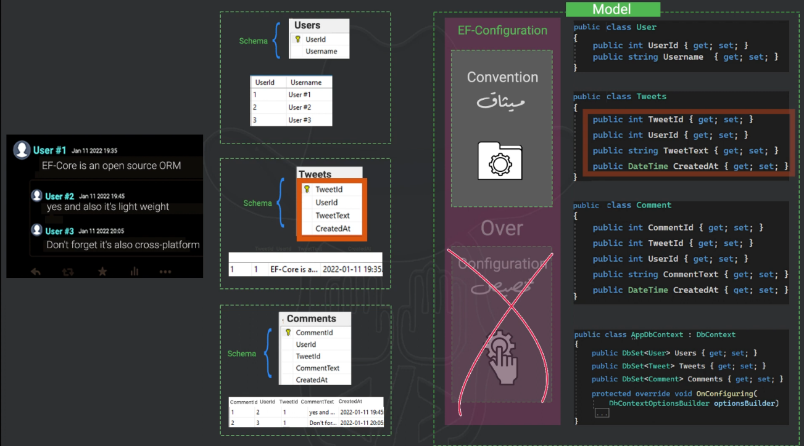
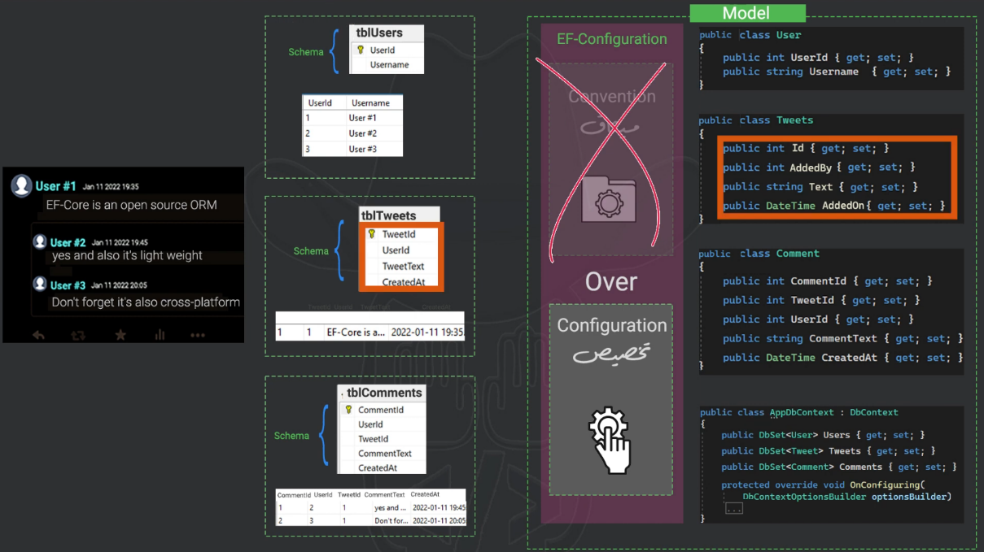
Ef-core007 – conventions :

Annotation :
- Dbset property name Must Match Table name .
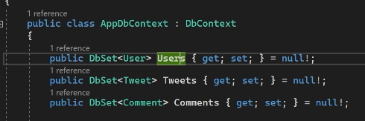
- Primary key must be [ id or classid ] .
- Column name must match propertyName .
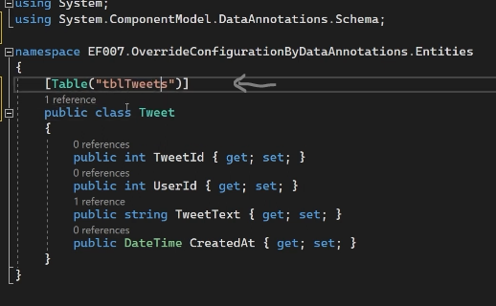
- table annotation :
If you have different table name,
you need to use attribute to annotate
between table and table name in database

- Column annotation :
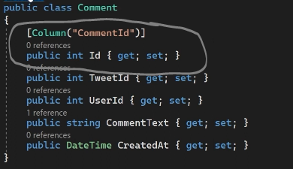

FluentAPi :
Instead of do annotation inside each class we can do it in specific place
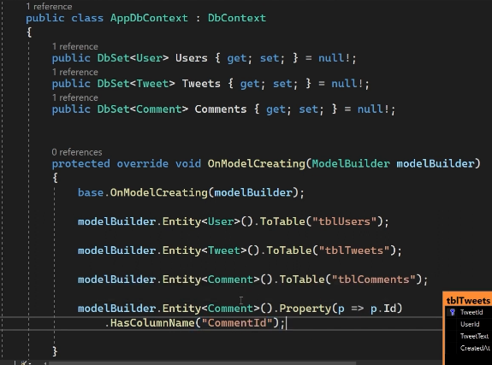

Override and grouping configuration :
Step1 :
Example of class comments and we make a sepreated class {as a file} in Config Folder of database
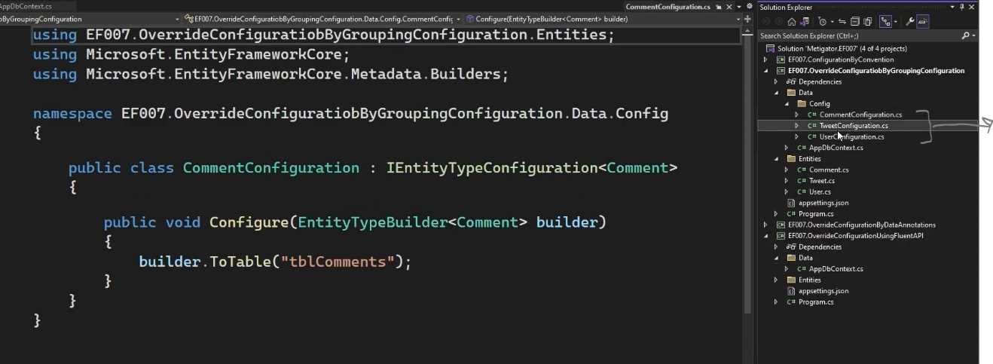

Step2 :
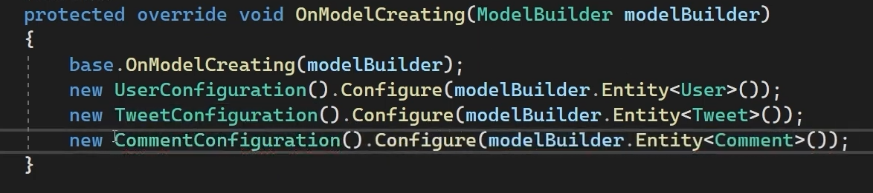
Use function on model creating to notice DbContext about the config File

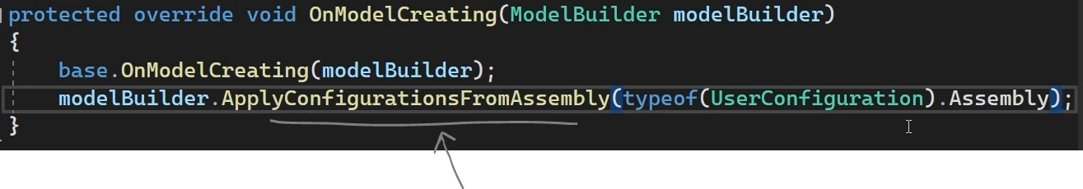
IF You have 1000 class I need to write them all ?
ofcourse not , you can use assembly

