Andrew Franks

FSW-140: Bob Ross

CREATING, ALTERING, AND DROPPING TABLES – In short, these queries can be used to formulate, edit, and delete tables in SQL databases. As rows and columns make up a SQL table, these can also be worked upon to change data in a database. The CREATE TABLE and DROP TABLE keywords and fairly straightforward, as they are responsible for adding or deleting tables. The alter keyword on the other hand, can be used to modify the structure of an actual table itself, including a table’s columns and rows.

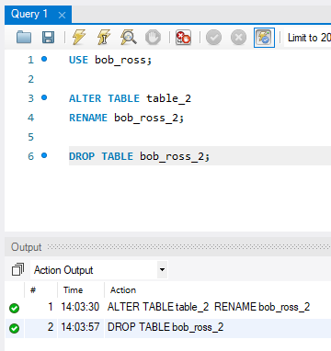

SET OPERATIONS – Set operators are used to join the results of multiple SELECT statements; these include UNION, UNION ALL, MINUS, INTERSECT, etc. With the SET operator, we can list the results from multiple different tables within a single result (or in different rows). One important thing to note is that the number of columns must match between queries, and their column data types must be compatible.

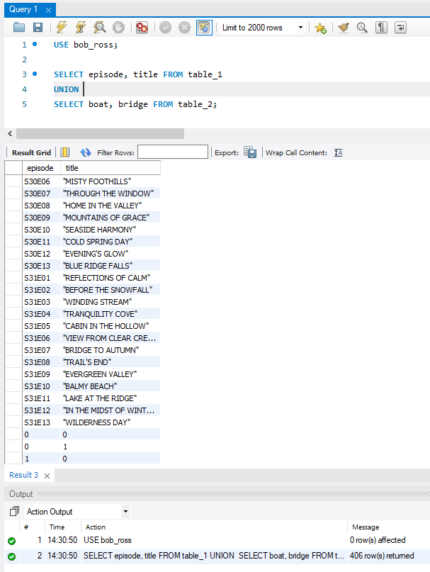

SUBQUERIES – A subquery (inner query) is simply a query within a query, and can result from the WHERE, FROM, or the SELECT clauses. These queries must be specified within parentheses and are generally executed first, so that it’s result can be used in to finish its outer query. Subqueries can be useful in many complex queries, like comparing expressions.

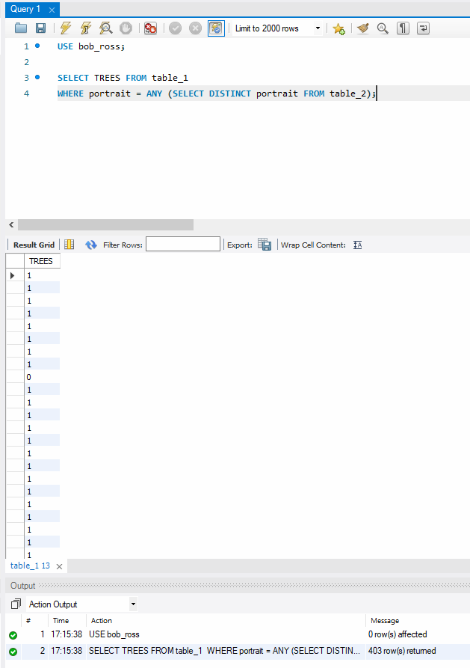

ORDER OF OPERATION OF QUERIES – Like PEMDAS in mathematical operations, queries also follow a specific order. Join statements, where clauses, group by, order by, select, distinct, and other commands are executed by keyword. For example, while the DISTINCT keyword is executed after a SELECT keyword, a GROUP BY command would be executed after the WHERE keyword.

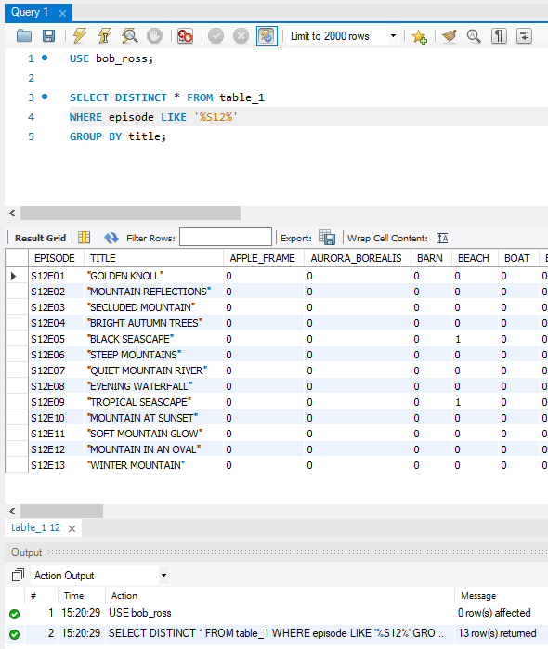

ASSOCIATIONS (FOREIGN KEYS) - In SQL, a foreign key is used to connect tables. While one table may have a primary key, another might have a foreign key, which would be used to relate table data. This relationship means that a row in one table is logically related to another row within another table that has the same value in its column.

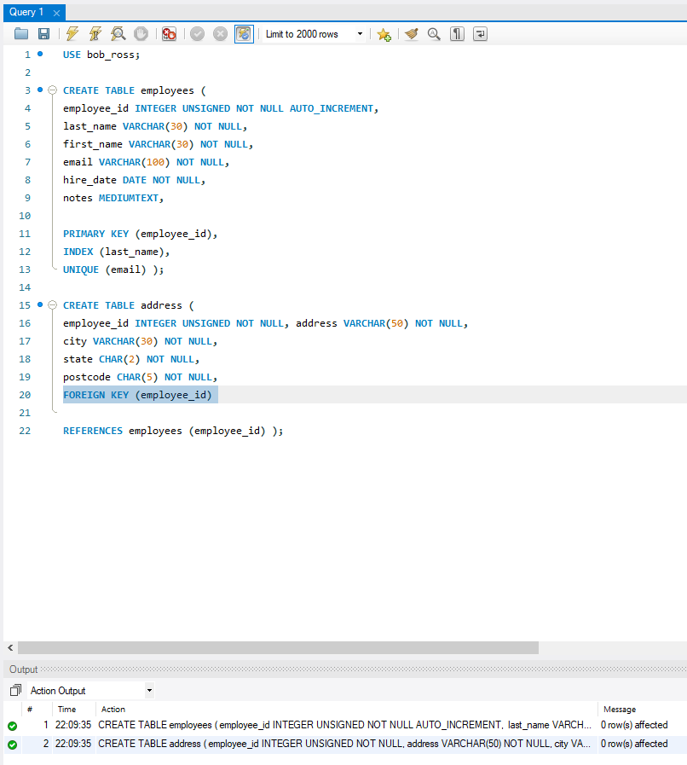

JOINS – A join in SQL enables you to retrieve records from two or more related tables. Using the JOIN clause, rows of multiple queries can be returned from multiple tables. Using associations (primary and foreign keys), tables can be joined upon with multiple different join statements.

