For this assignment, write queries using SQL to demonstrate the core aspects of writing SQL to produce data for reporting and analyzing information. There may be multiple ways to produce the same results, but ensure you are returning the requested fields.

Format of Data Structure: The units are 10th of a degree Celcius. The columns are yr and dy for year and day of month. The next twelve columns are for January through to December.

Using the White Christmas database, complete the queries below for the scenarios listed.

Scenario: Diaplay Days, Months, and Years

Query-1: Show the average daily temperature for August 10th, 1964.

1. Query: SELECT m5 / 10 FROM whitechristmasdata WHERE yr = '1964' AND dy = 10;
2. Columns: 1
3. Expected Row Count: 1
4. Screenshot: 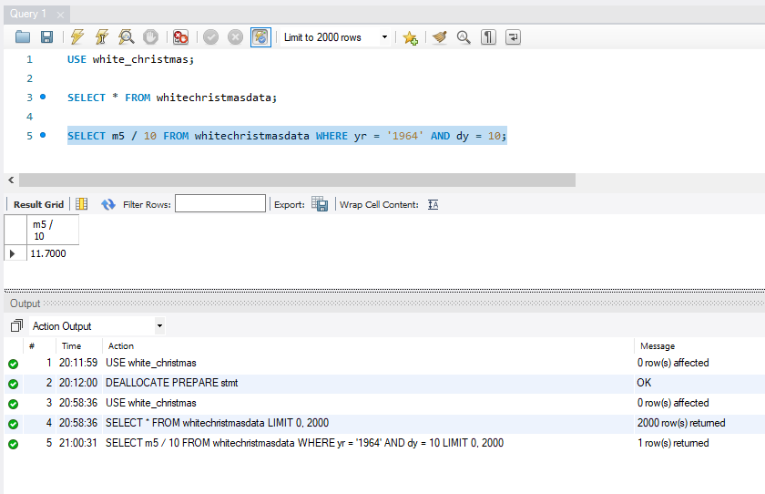

======================================================================

Scenario (Preteen Dickens): Charles Dickens is said to be responsible for the tradition of expecting snow at Christmas Daily Telegraph. Show the temperature on Christmas day (25th December) for each year of his childhood. He was born in February 1812 - so he was 1 (more or less) in December 1812.

Query-2: Show the twelve temperatures.

1. Query: SELECT yr-1811, m12/10 FROM whitechristmasdata WHERE yr BETWEEN 1812 AND 1812+11 AND dy=25;
2. Columns: 2
3. Expected Row Count: 12
4. Screenshot: 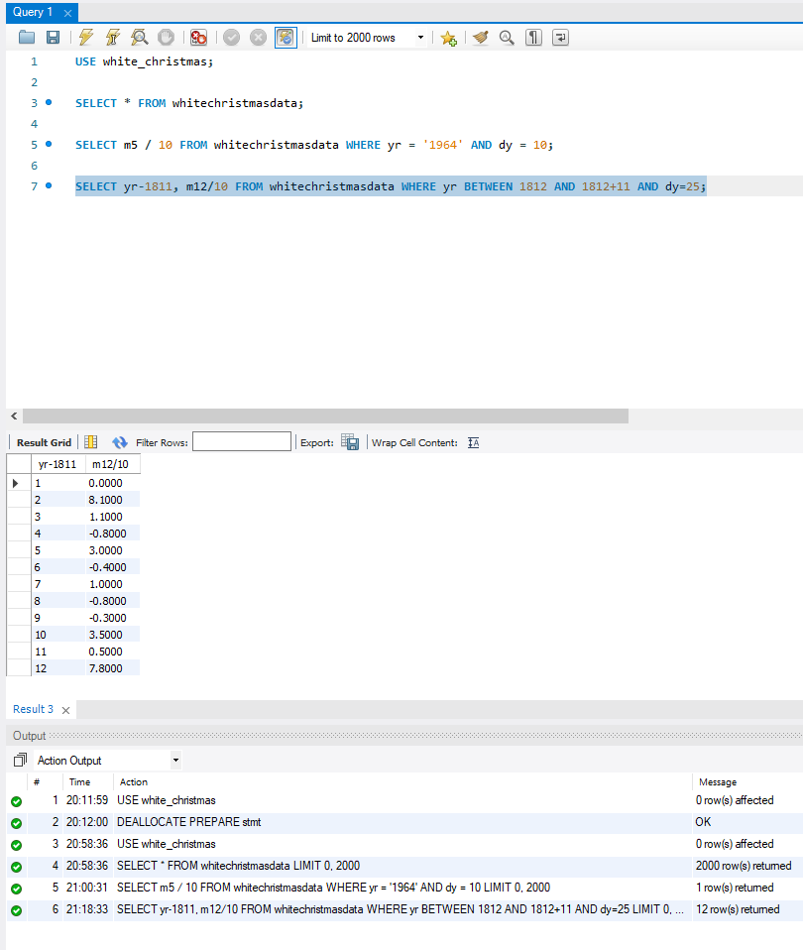

======================================================================

Scenario (Minimum Temperature Before Christmas): We declare a White Christmas if there was a day with an average temperature below zero between 21st and 25th of December.

Query-3: For each age 1-12 show which years were a White Christmas. Show 'White Christmas' or 'No snow' for each age.

1. Query: SELECT yr-1811 AS age,
2. CASE WHEN MIN(m12) < 0 THEN 'White' END white_christmas
3. FROM whitechristmasdata
4. WHERE yr BETWEEN 1812 AND 1812+11 AND dy BETWEEN 21 AND 25
5. GROUP BY age;
6. Columns: 2
7. Expected Row Count: 12
8. Screenshot: 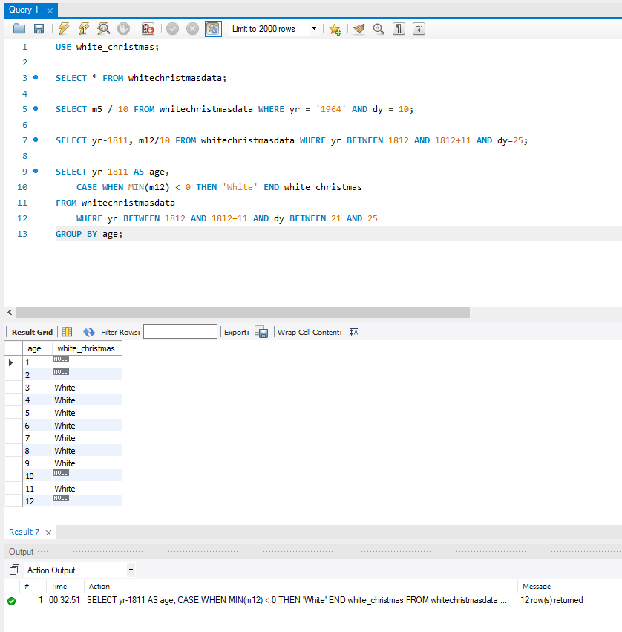

======================================================================

Scenario (White Christmas Count): A person's White Christmas Count (wcc) is the number of White Christmases they were exposed to as a child (between 3 and 12 inclusive assuming they were born at the beginning of the year and were about 1 year old on their first Christmas). Charles Dickens's wcc was 8.

Query-4: List all the years and the wcc for children born in each year of the data set. Only show years where the wcc was at least 7.

1. Query: SELECT a.yr AS year, SUM(b.white) AS wcc
2. FROM
3. (SELECT DISTINCT yr FROM whitechristmasdata) a
4. JOIN
5. (SELECT yr, CASE WHEN MIN(m12/10) < 0 THEN 1 ELSE NULL END AS white
6. FROM whitechristmasdata
7. WHERE dy BETWEEN 21 AND 25
8. GROUP BY yr) b
9. ON b.yr BETWEEN a.yr + 2 AND a.yr + 11
10. GROUP BY a.yr
11. HAVING SUM(b.white) >=7;
12. Columns: 2
13. Expected Row Count: 5
14. Screenshot: 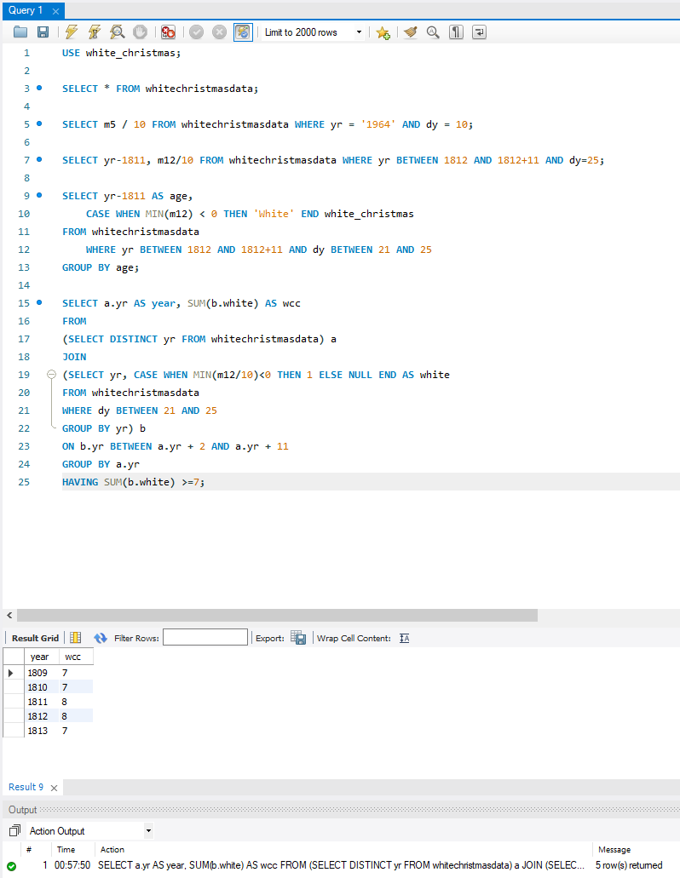

======================================================================

Scenario (Climate Change)

Query-5: Display the average temperatures for August by decade.

1. Query: SELECT ROUND(yr,-1) decade, ROUND(AVG(NULLIF(m8,-999))/10,1) AS AverageTemp
2. FROM whitechristmasdata
3. GROUP BY ROUND(yr,-1);
4. Columns: 2
5. Expected Row Count: 26
6. Screenshot: 

