Employee Attrition: What makes an employee leave?
Christopher Boomhower1, Stacey Fabricant ², Alex Frye¹, David Mumford², Michael Smith1, Lindsay Vitovsky1
1 Southern Methodist University, Dallas, TX, US
2 Penn Mutual Life Insurance Co, Horsham PA

Abstract. This paper investigates the reasons that contribute to employee attrition. By investigating publicly available data, we hope to generate, at the very least, a set of contributing factors statistically significant in an employee’s decision to depart. Our ultimate goal is to provide a model that an HR associate could use to estimate which departments or job roles might require their attention to reduce attrition. While there already exists a great number of articles on reducing attrition, we sought to find actual big data that gives us better insight into this topic.
1 Introduction
How much does it really cost to lose an employee? Precisely quantifying this may seem out of reach depending on the complexity of a particular position, but areas of impact that one could easily foresee at many organizations are 1) determining if the employee’s vacancy should be replaced or duties handed off to others, 2) posting the job opportunity to various outlets, 3) interviewing, hiring, and training the replacement, 4) enduring lowered employee morale / possible lower productivity from the remaining employees, and 5) tolerating a lower skill set from underdeveloped replacement. [1]

Corporations are certainly keenly aware of the downsides to losing employees. In their attempts to not just attract talented workers, but actually retain them, businesses have provided additional benefits that, despite their cost, are seen to be less than what it would cost to lose their valuable people. These seem to include everything from arguably the most valuable employee benefit, comprehensive health insurance [2], to more lifestyle-based benefits such as the infamous game and nap rooms of Silicon Valley.

What brought our team to this topic was the use of algorithms by corporations in the employment process, including the recruitment, hiring, maintaining, and termination of employees. We wanted to measure the effectiveness of these models and screenings, looking to see if their lack of transparency was masking an inappropriate deployment. However, as one can imagine, finding either publicly available data or data released with permission proved itself very difficult. Companies are understandably reluctant to release the methods, proprietary or purchased, that use even anonymous data to help them in their management of human resources. While there are plenty of articles available online that touch on this issue [3 4 5], we found it difficult to access the actual data to make interpretations for ourselves.

To make this paper 1) possible and 2) actually make a contribution to a corporate HR audience, we evolved our topic to focus more on the costly area of attrition, with publicly available data. To accomplish this, we settled on using publicly available data from the Office of Personnel Management. Through their website, www.opm.gov, government job employment data including salary, job code, reason for leaving, and many other attributes are available for research. To be sure that the background of the job types was applicable to the non-government, corporate world, we analyzed the breadth of job codes of the positions included in the data sets. The range of job levels included enough upper level position such as in engineering, law, and management positions, not to mention the size of the final data set itself, that we will show that this is still applicable in the corporate environment. In fact, these are exactly the types of more specialized jobs that are more costly and difficult to replace, making this data set very supportive to our needs.

Additionally, we analyzed an artificial data set, constructed by IBM. This data set, titled “IBM HR Analytics Employee Attrition” gave us additional factors to analyze that the OPM datasets did not. While this data set was small compared to the OPM data sets, it included performance, employee satisfaction, and geography attributes we did not have available otherwise.

Ultimately, we will show what the OPM and IBM data sets reveal regarding why employees might be leaving for other firms. This can certainly be circumstances out of one’s control, such as a disability, death, or retirement. But what about issues such as being able to earn more at another firm, even if this job is further away from the worker’s home? How much does the importance of actually enjoying one’s position fade with increased income? Ideally, we would be able to provide a model that an HR associate could use to determine the likelihood of attrition in their company or in a particular department. If this does not become possible, even our preliminary exploratory data analysis is revealing interesting patterns in the data that would be useful by this same audience.

For example, referring to the correlation heat map generated below [Figure 1], one can see that Length of Service (“LOS”) does not seem to be to highly correlated with any of the other variables included, except for the existence of a salary being over or under the industry standard (“SalaryOverUnderIndAvg”). This is perhaps obvious, but the level of correlation is interesting. One would think staying in a position is directly and heavily related to being able to be paid more elsewhere, but being that this correlation is shown as 0.44, there are obviously other variables at play. Perhaps certain job positions are more affected by this correlation than others, as well.

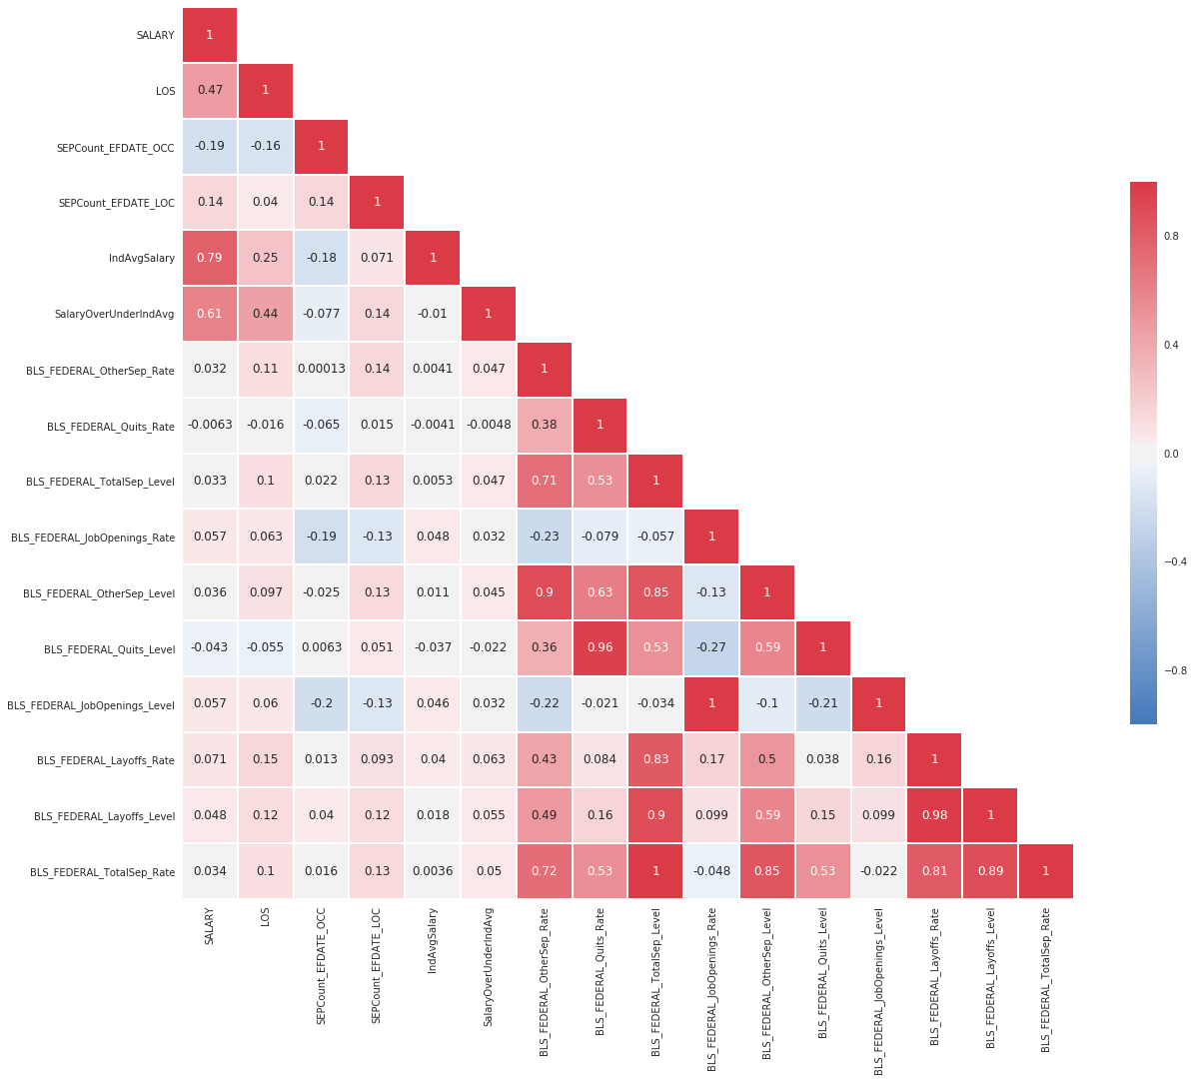

Fig. 1. Heat map of correlations among variables in OPM data set.

Our preliminary work can be found in our Jupyter notebook, rendered as an .html file included in our zip file submitted for this rough draft.

2 Background
2.1 Expand on existing research
2.2. Specific areas this paper will be addressing, and why it’s different

3 The OPM Dataset
3.1 Background
3.2Data sets available and steps taken to create the central data set
3.3 Variable descriptions
3.4 EDA
3.5 Models / relationships

4 The IBM Dataset
4.1 Background
4.2 Variable Descriptions
4.3 EDA
4.4 Models / relationships

5 Overall Model / Guidelines
5.1(can we connect anything from the two datasets?)
6 Conclusion

Works Cited
- Kantor, Julie. 2016. “High Turnover Costs More Than You Think.” www.huffingtonpost.com. [Online] 02 11, 2016. [Cited: 07 03, 2017.] http://www.huffingtonpost.com/julie-kantor/high-turnover-costs-way-more-than-you-think_b_9197238.html.

- Glassdoor. “Top 20 Employee Benefits and Perks.” www.glassdoor.com. [Online] 02 03, 2016. [Cited: 07 03, 2017.] https://www.glassdoor.com/blog/top-20-employee-benefits-perks/.

- Walker, Joseph. “Do New Job Tests Foster Bias?” Wall Street Journal [Online] 09 20, 2012. [Cited 07 03, 2017.] https://www.wsj.com/articles/SB10000872396390443890304578006283936708970 (need to order reprint)

- Abellin. “Woman Sues Over Personality Test Job Rejection.” ABC News. [Online] 10 01, 2012. [Cited 07 03, 2017]. http://abcnews.go.com/Business/personality-tests-workplace-bogus/story?id=17349051

- Richter, David. “Why Does HT Need to Collect Data? An Employer’s Guide.” www.octopus-hr.co.uk. [Online] 09 01, 2014. [Cited: 07 03, 2017]. http://www2.octopus-hr.co.uk/hrmoz/article/why-does-hr-need-to-collect-data.aspx

References
1. Lipton, Z. The Foundations of Algorithmic Bias. Aproximately Correct. (2016)
2. Angwin, J., Larson, J, Surya, M., Krichner, L. Machine Bias. ProPublica. (2016)
3. Akhtar, A. Is Pokémon Go racist? How the app may be redlining communities of color. USA Today (2016)
4. Reese, H. Why Microsoft’s ‘Tay’ AI Bot Went Wrong. TechRepublic. (2016)
5. Aletras, N., Tsarapatsanis, D., Preotiuc-Petro, D., Lampos, V. Predicting judicial decisions of the European Court of Human Rights: a Natural Language Processing Perspective. PeerJ Computer Science (2016).
6. IBM. Sample Data: HR Employee Attrition and Performance. IBM (2016).
7. Miller, Meg. This Algorithm is Better at Predicting Human Behavior Than Humans Are. Fast Company via Co.Design. (2016)
8. Burn-Murdoch, J. The Problem with Algorithms : Magnifying Misbehaviour. The Guardian. (2013)
9. Chu, C. ML in the Valley: ML insight and lessons learned from industry practice. Posthaven. (2014).

