Employee Analytics: Using Algorithms in the Workplace to Hire, Fire, and Train
Christopher Boomhower1, Stacey Fabricant ², Alex Frye¹, Michael Smith1, Lindsay Vitovsky1
1 Southern Methodis Univeristy, Dallas, TX, US
2 Penn Mutual Life Insurance Co, Horsham PA

Abstract. For better or worse, algorithms are a significant part of modern life. Whether the task is online matchmaking, finding a job, reading a social media feed, or taking an online quiz, algorithms are behind the scenes, forming an opinion about the user. The results of such rampant rule engineering have produced very interesting ethical dilemmas, as well as questionable results. To investigate this broad concept, this paper researches corporate hiring, firing, and training algorithms. We wish to ultimately produce a model that addresses certain ethical missteps the corporations have committed, as well as surmise if long term community outreach programs are indeed resulting in quality hires for a company.
1 Introduction
Our team proposes to investigate the conflict between the promise of algorithms to better understand our world against the danger of machine bias that can easily make such algorithms dangerous to society. Rather than take on this subject broadly, we will focus on corporate talent acquisition and retention algorithms. From the initial application process on websites such as CareerBuilder.com, to in house personality assessments, many corporations use at least one algorithm during the recruitment process to find the “right” candidate.

Continuing on, algorithms can be used to place hires in particular departments, correct for non-profitable behavior, and even be used to determine who should no longer be employed. Initially, this may seem like a smarter way to do business and minimize overhead, but certainly, questions about the effectiveness and ethics of such a process arise. Our initial review of existing research on machine bias and blind adoption of algorithms led us to this particular topic, and we want to find a possible solution for correcting for unethical use, intentional and not, in corporate talent processes that employ algorithms.

To make a possible model more useful, we also want to investigate the effectiveness of long term community efforts and internship opportunities offered by corporations. If the data is available at this point, and we are able to employ it, we want to further contribute to the model by narrowing in on those particular aspects of educational efforts meant to drive underserved markets to a particular industry (ex. more women in the financial services industry, more minorities applying for medical school, etc).

For our adviser, Stacey Fabricant will be assisting us in this role. Fabricant leads marketing research for Penn Mutual Life Insurance Co., and has worked in the data science community for over 23 years. Her background in corporate marketing research, both qualitative and quantitative, will help us balance the theoretical importance of this topic with the realistic application in today’s corporate environment.

Finally, our team seeks to produce a reproducible paper that is of interest to the Human Resources community. With so many companies using online recruitment tools and personality profiles, HR departments would, we believe, be interested in knowing ways to protect themselves against accidental bad hiring and employment practices. Regardless of a theoretical discussion of who is accountable for a bad algorithm, company executives might find themselves fighting a public relations nightmare if the use of hiring algorithms is not employed with human intuition.
2 Proposed Time Frame
Below is a GANTT chart outlining our proposed timeframe. We want to reserves as much time as possible for feedback from our adviser as well as preparing our presentation. Thus, our projected deadlines may seems slightly aggressive.

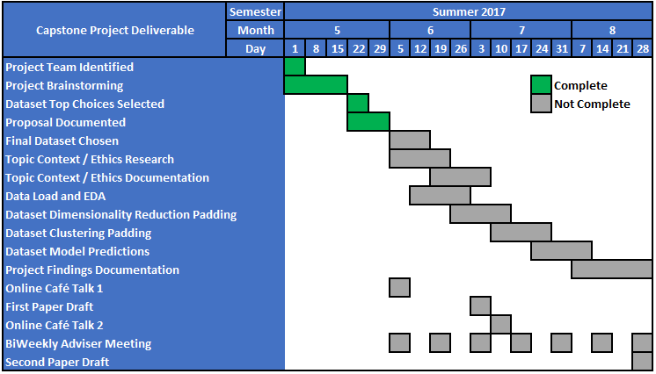
References
1. Lipton, Z. The Foundations of Algorithmic Bias. Aproximately Correct. (2016)
2. Angwin, J., Larson, J, Surya, M., Krichner, L. Machine Bias. ProPublica. (2016)
3. Akhtar, A. Is Pokémon Go racist? How the app may be redlining communities of color. USA Today (2016)
4. Reese, H. Why Microsoft’s ‘Tay’ AI Bot Went Wrong. TechRepublic. (2016)
5. Aletras, N., Tsarapatsanis, D., Preotiuc-Petro, D., Lampos, V. Predicting judicial decisions of the European Court of Human Rights: a Natural Language Processing Perspective. PeerJ Computer Science (2016).
6. IBM. Sample Data: HR Employee Attrition and Performance. IBM (2016).
7. Miller, Meg. This Algorithm is Better at Predicting Human Behavior Than Humans Are. Fast Company via Co.Design. (2016)
8. Burn-Murdoch, J. The Problem with Algorithms : Magnifying Misbehaviour. The Guardian. (2013)
9. Chu, C. ML in the Valley: ML insight and lessons learned from industry practice. Posthaven. (2014).

