Q.1.1) A LEX/Flex program that recognizes binary strings containing even number of 0’s.

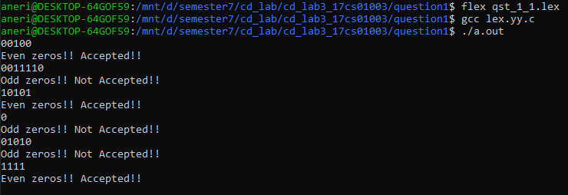

Q.1.2) A LEX/Flex program that recognizes binary strings containing even number of 0’s and even number of 1’s.

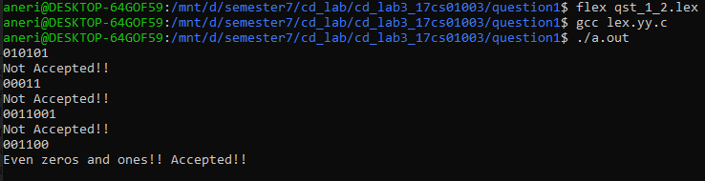

Q.1.3) A LEX/Flex program that recognizes binary strings whose integer equivalent is divisible by 3.

