**(NOTE:** Since I am using windows to execute the program, the new line is decoded as \n and extra character. Hence, the output labels extra character as error. I have tried the same code on a friend’s Ubuntu machine, it works as expected. **)**

**Trial Input 1**

if x>10.5 then

ifx == 17E+12

else 12Ele >= 10.5.6

**Output:**

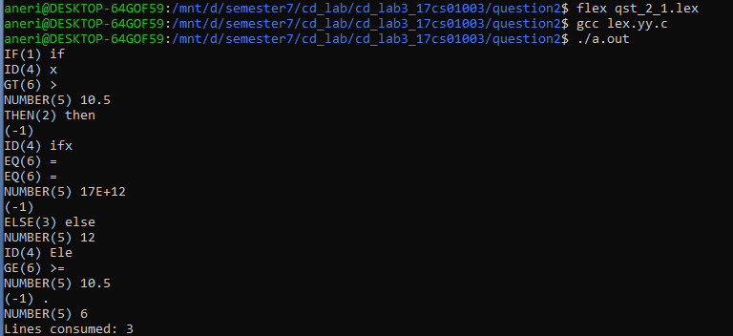

**Trial Input 2**

if else then 19.2E+3 prats 12.5.7

34 >= 20E2 false

543Esh

**Output:**

