**The output for the given text inputs ‘input1.txt’,’input2.txt’ and ‘input3.txt’ respectively is as follows:**

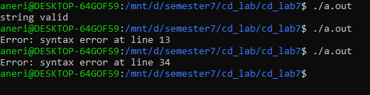

The input2 and input3 file are corrected and stored as input2_corrected.txt and input3_corrected.

Input2 has missing semicolons and Input3 had wrong assign operator.

The results after correction (input1,Input2_corrected and Input3_corrected):

