NETWORK INFRASTRUCTURE PROJECT

PROJECT TITLE

Group 3

Team Members
Amgad Mohamed Beshir | 343595 | LinkedIn
Antonios Sarhan Robel | 338269 | LinkedIn
Ayat Abdellateef Attia | 327424 | LinkedIn
Sarah Khaled Ibrahim | 322358 | LinkedIn
Shahd Ehab | 306722 | LinkedIn

Supervisor
Dr. Aya Magdy
Assistant Lecturer,
Faculty of Computers and Information

Table of Contents
1. Project Overview 4
2. Project Objectives 4
3. Team Members & Responsibilities 4
4. Network Topology 5
5. IP Addressing & VLSM Design 8
6. Routing 9
6.1 Routing Design 9
6.2 Configuration 9
6.3 Verification 9
7. Network Security 11
8. VLANs & Inter-VLAN Routing 12
8.1 Design / Configuration 12
8.2 Testing / Verification 12
9. Network Services 13
9.1 Design / Configuration 13
9.2 Testing / Verification 16
10. EtherChannel 16
10.1 Design / Configuration 16
10.2 Testing / Verification 16
11. HSRP 18
11.1 Design / Configuration 18
11.2 Testing / Verification 18
12. WLAN 20
12.1 Design / Configuration 20
12.2 Testing / Verification 20
13. NAT 20
13.1 Design / Configuration 20
13.2 Testing / Verification 21
14. Testing & Verification 21
15. Challenges & Solutions 22
16. Conclusion 23
17. Appendix 23
17.1 GitHub Repository 23
17.2 Project Files 23

1. Project Overview
The project implements an enterprise network infrastructure using Cisco Packet Tracer.
The network is divided into a Headquarters (HQ) and a Branch Office. Multilayer switches are used to provide inter-VLAN routing, HSRP is used for gateway redundancy, OSPF provides dynamic routing, EtherChannel provides link aggregation and redundancy, and centralized DHCP, DNS and HTTP services are provided through the Server Farm.
The Edge Router provides NAT/PAT connectivity between the internal enterprise network and the simulated Internet Router.

2. Project Objectives
- Implement VLSM-based IPv4 addressing.
- Divide the network into multiple VLANs.
- Implement inter-VLAN routing using Multilayer Switches.
- Provide gateway redundancy using HSRP.
- Implement dynamic routing using OSPF.
- Provide centralized DHCP, DNS and HTTP services.
- Implement EtherChannel for link aggregation.
- Provide wireless network connectivity.
- Implement NAT/PAT for Internet connectivity.
- Apply basic network security configurations.

3. Team Members & Responsibilities
Student Name | ID | Primary Responsibilities | Secondary Responsibilities
Amgad Mohamed Beshir | 343595 | Core network + HSRP | EtherChannel + Redundancy
Antonios Sarhan Robel | 338269 | Routing + Edge + Internet | OSBF + NAT + IP Addressing
Ayat Abdellateef Attia | 327424 | VLANs + Inter-VLAN | DHCP Relay + Access Switches
Sarah Khaled Ibrahim | 322358 | Network Services + WLAN | DHCP + DNS + HTTP + Wireless
Shahd Ehab | 306722 | Network Security + Testing | Security verification + Documentation + Presentation

4. Network Topology
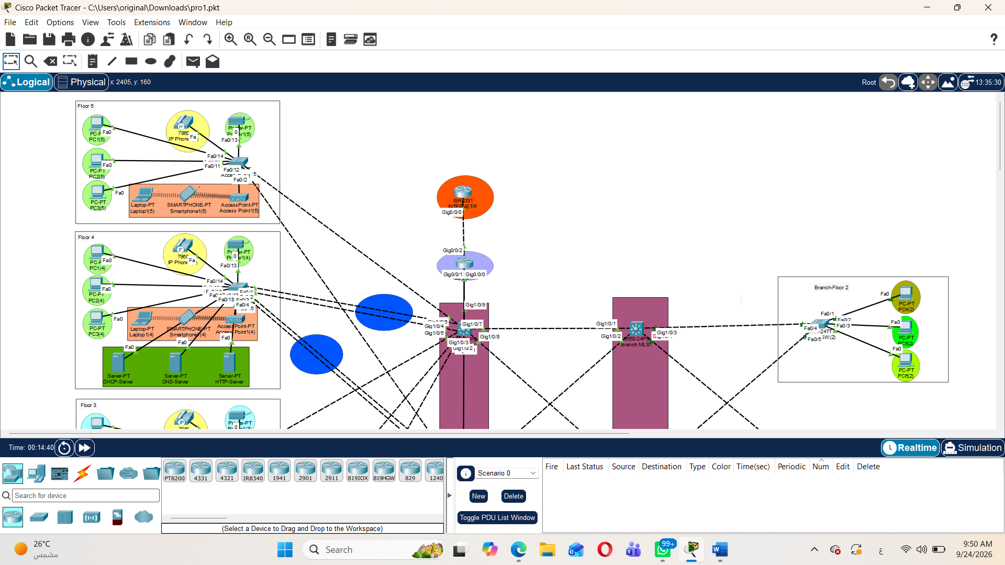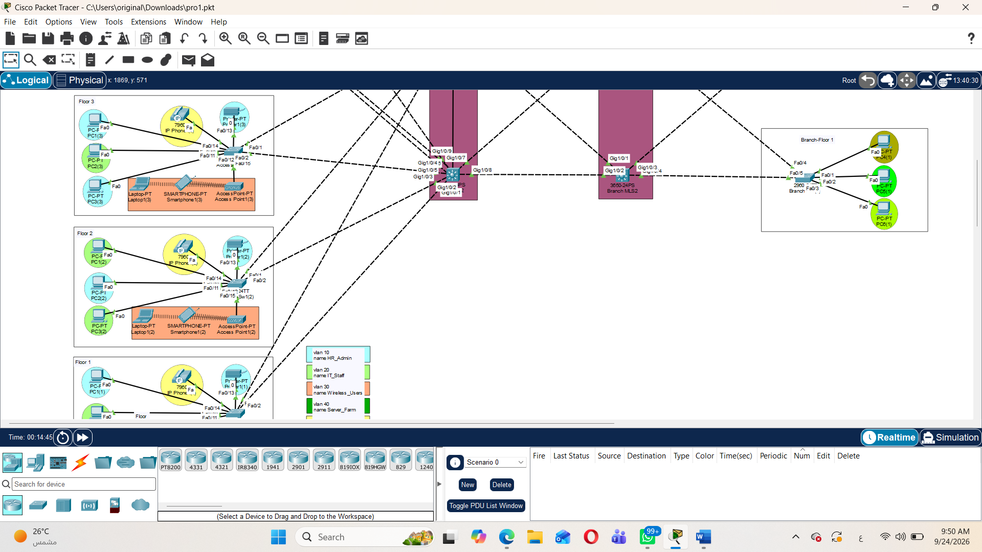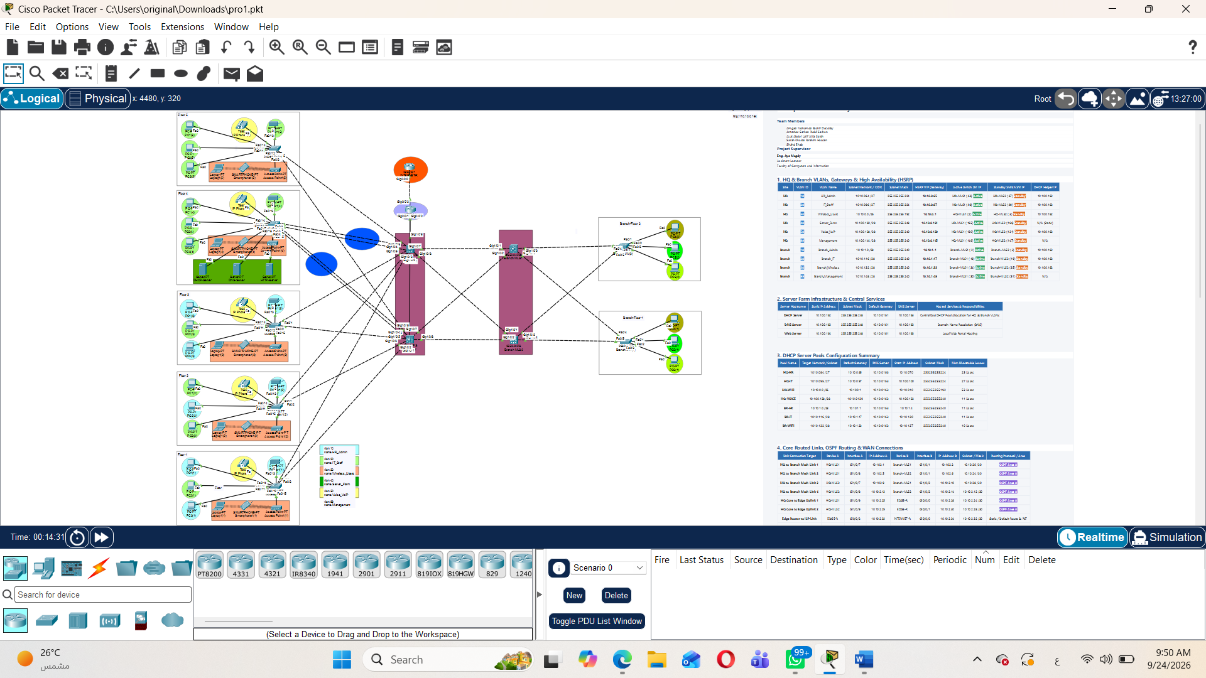
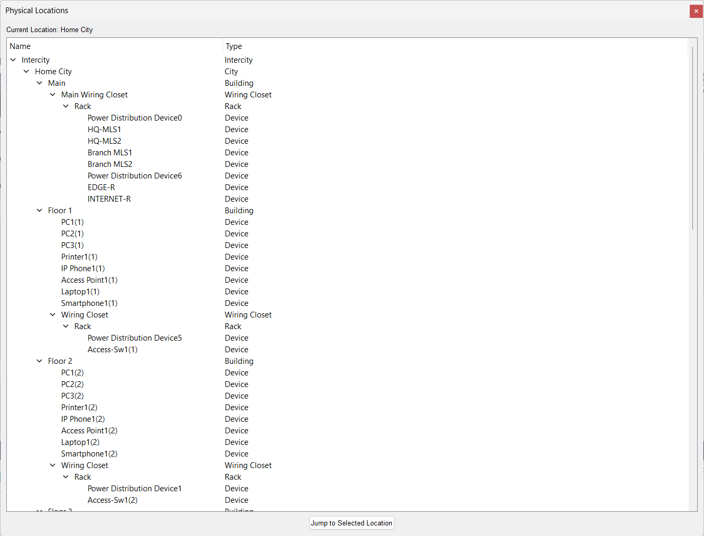
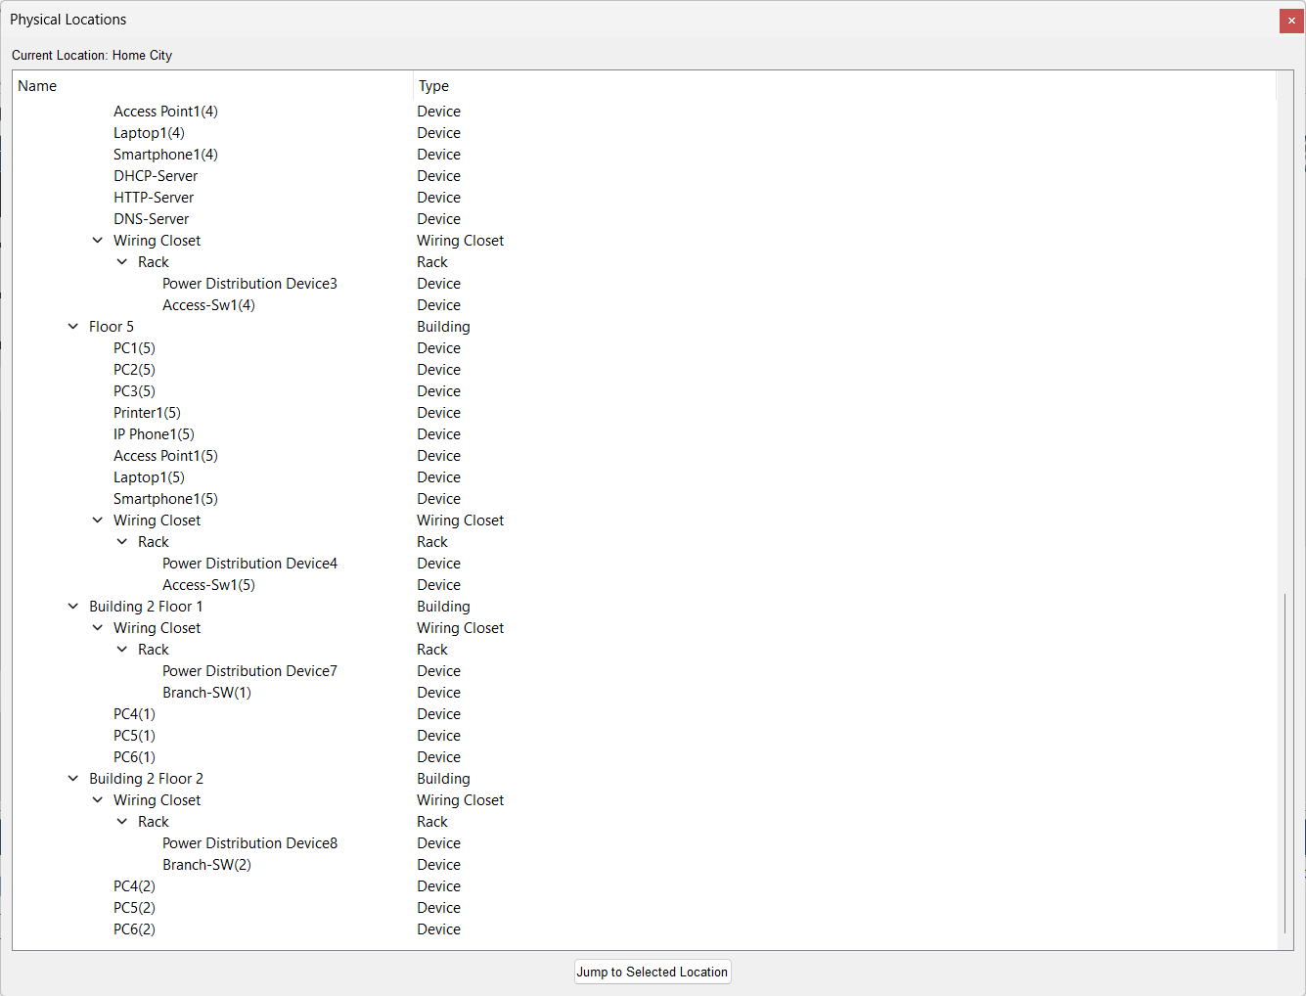
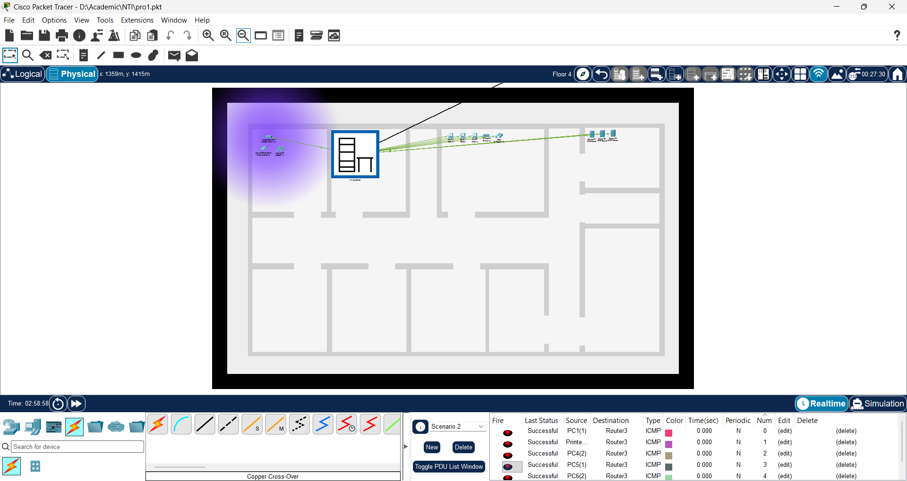
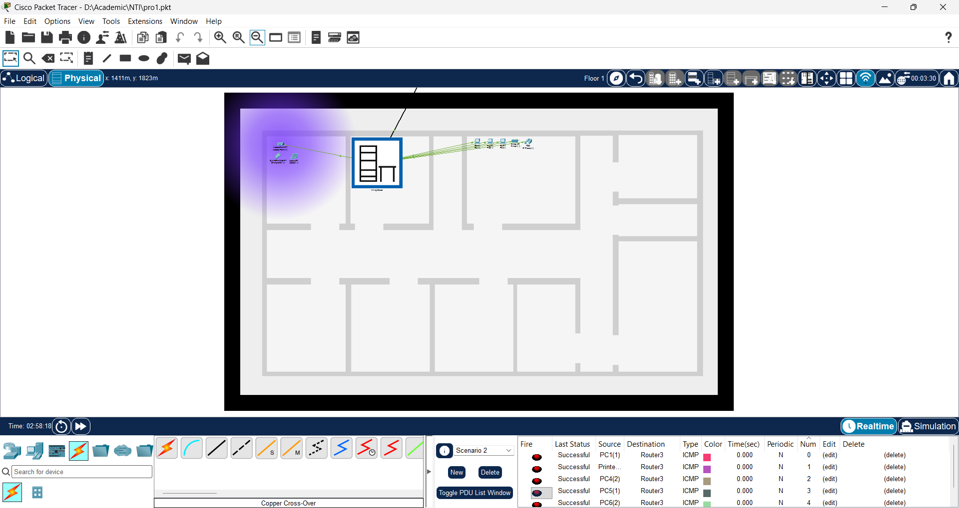
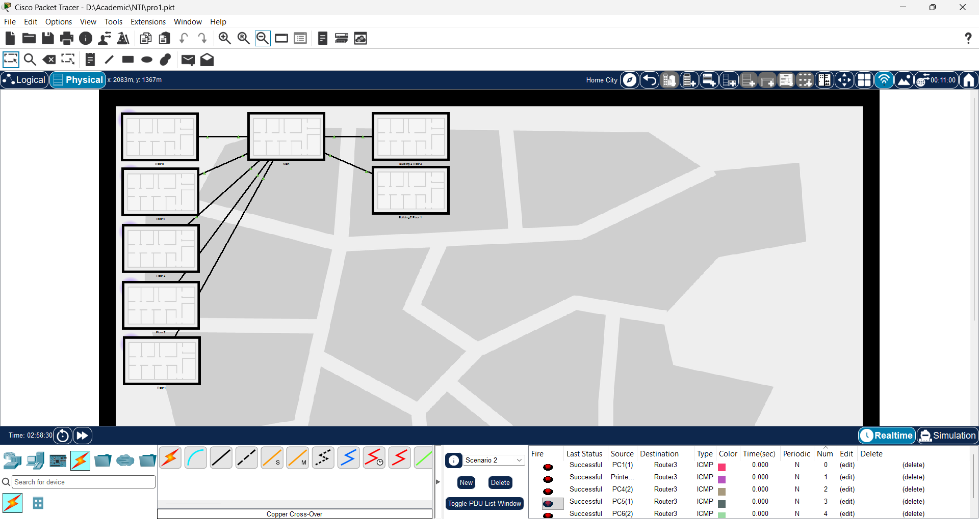

5. IP Addressing & VLSM Design
Site | VLAN ID | VLAN Name |  | Subnet Network / CIDR |  | Subnet Mask |  | HSRP VIP (Gateway)
HQ | 10 | HR_Admin |  | 10.10.0.64 /27 |  | 255.255.255.224 |  | 10.10.0.65
HQ | 20 | IT_Staff |  | 10.10.0.96 /27 |  | 255.255.255.224 |  | 10.10.0.97
HQ | 30 | Wireless_Users |  | 10.10.0.0 /26 |  | 255.255.255.192 |  | 10.10.0.1
HQ | 40 | Server_Farm |  | 10.10.0.160 /29 |  | 255.255.255.248 |  | 10.10.0.161
HQ | 50 | Voice_VoIP |  | 10.10.0.128 /28 |  | 255.255.255.240 |  | 10.10.0.129
HQ | 99 | Management |  | 10.10.0.144 /28 |  | 255.255.255.240 |  | 10.10.0.145
Branch | 10 | Branch_Admin |  | 10.10.1.0 /28 |  | 255.255.255.240 |  | 10.10.1.1
Branch | 20 | Branch_IT |  | 10.10.1.16 /28 |  | 255.255.255.240 |  | 10.10.1.17
Branch | 30 | Branch_Wireless |  | 10.10.1.32 /28 |  | 255.255.255.240 |  | 10.10.1.33
Branch | 99 | Branch_Management |  | 10.10.1.48 /28 |  | 255.255.255.240 |  | 10.10.1.49
Server Hostname |  |  | Static IP Address |  | Subnet Mask |  | Default Gateway |  | DNS Server
Central DHCP Server |  |  | 10.10.0.162 |  | 255.255.255.248 |  | 10.10.0.161 |  | 10.10.0.163
DNS Server |  |  | 10.10.0.163 |  | 255.255.255.248 |  | 10.10.0.161 |  | 10.10.0.163
Web Server |  |  | 10.10.0.164 |  | 255.255.255.248 |  | 10.10.0.161 |  | 10.10.0.163
Link Connection Target | Device A | Interface A | IP Address A | Device B | Interface B | IP Address B | Subnet / Mask
HQ to Branch Mesh Link 1 | HQ-MLS1 | Gi1/0/7 | 10.10.2.1 | Branch-MLS1 | Gi1/0/1 | 10.10.2.2 | 10.10.2.0 /30
HQ to Branch Mesh Link 2 | HQ-MLS1 | Gi1/0/8 | 10.10.2.5 | Branch-MLS2 | Gi1/0/1 | 10.10.2.6 | 10.10.2.4 /30
HQ to Branch Mesh Link 3 | HQ-MLS2 | Gi1/0/7 | 10.10.2.9 | Branch-MLS1 | Gi1/0/2 | 10.10.2.10 | 10.10.2.8 /30
HQ to Branch Mesh Link 4 | HQ-MLS2 | Gi1/0/8 | 10.10.2.13 | Branch-MLS2 | Gi1/0/2 | 10.10.2.14 | 10.10.2.12 /30
HQ Core to Edge Uplink 1 | HQ-MLS1 | Gi1/0/9 | 10.10.2.25 | EDGE-R | Gi0/0/0 | 10.10.2.26 | 10.10.2.24 /30
HQ Core to Edge Uplink 2 | HQ-MLS2 | Gi1/0/9 | 10.10.2.29 | EDGE-R | Gi0/0/1 | 10.10.2.30 | 10.10.2.28 /30
Edge Router to ISP Link | EDGE-R | Gi0/0/2 | 10.10.2.33 | INTERNET-R | Gi0/0/0 | 10.10.2.34 | 10.10.2.32 /30
ISP Internet Host | INTERNET-R | Loopback 0 | 8.8.8.8 | N/A | N/A | N/A | 8.8.8.8 /32

6. Routing

6.1 Routing Design
We used OSPF (Open Shortest Path First) in Area 0 for dynamic internal routing. OSPF allows all Multilayer Switches and Routers to dynamically discover subnets and automatically reroute traffic if a physical link fails.
Additionally, a Static Default Route (0.0.0.0 0.0.0.0) is configured on the Edge Router (EDGE-R) pointing toward the ISP. This default route is redistributed into OSPF so all internal switches can reach external Internet destinations.

6.2 Configuration
1. OSPF Configuration on Core Switch (HQ-MLS1):
HQ-MLS1(config)# router ospf 1
HQ-MLS1(config-router)# router-id 1.1.1.1
HQ-MLS1(config-router)# network 10.10.0.0 0.0.255.255 area 0
2. Default Route & OSPF Redistribution on Edge Router (EDGE-R):
EDGE-R(config)# ip route 0.0.0.0 0.0.0.0 10.10.2.34
EDGE-R(config)# router ospf 1
EDGE-R(config-router)# router-id 5.5.5.5
EDGE-R(config-router)# network 10.10.2.24 0.0.0.3 area 0
EDGE-R(config-router)# network 10.10.2.28 0.0.0.3 area 0
EDGE-R(config-router)# default-information originate

6.3 Verification
Routing operation and neighbor adjacencies were verified using the following Cisco IOS verification commands:
- "show ip ospf neighbor": Confirms that all Core switches and Routers established full OSPF neighbor relationships.
- "show ip route": Confirms that all internal subnets and the OSPF default route (O*E2 0.0.0.0/0) are properly populated in the routing table.
- "ping / traceroute": Verified 100% end-to-end connectivity between internal VLAN PCs and external ISP IP address.
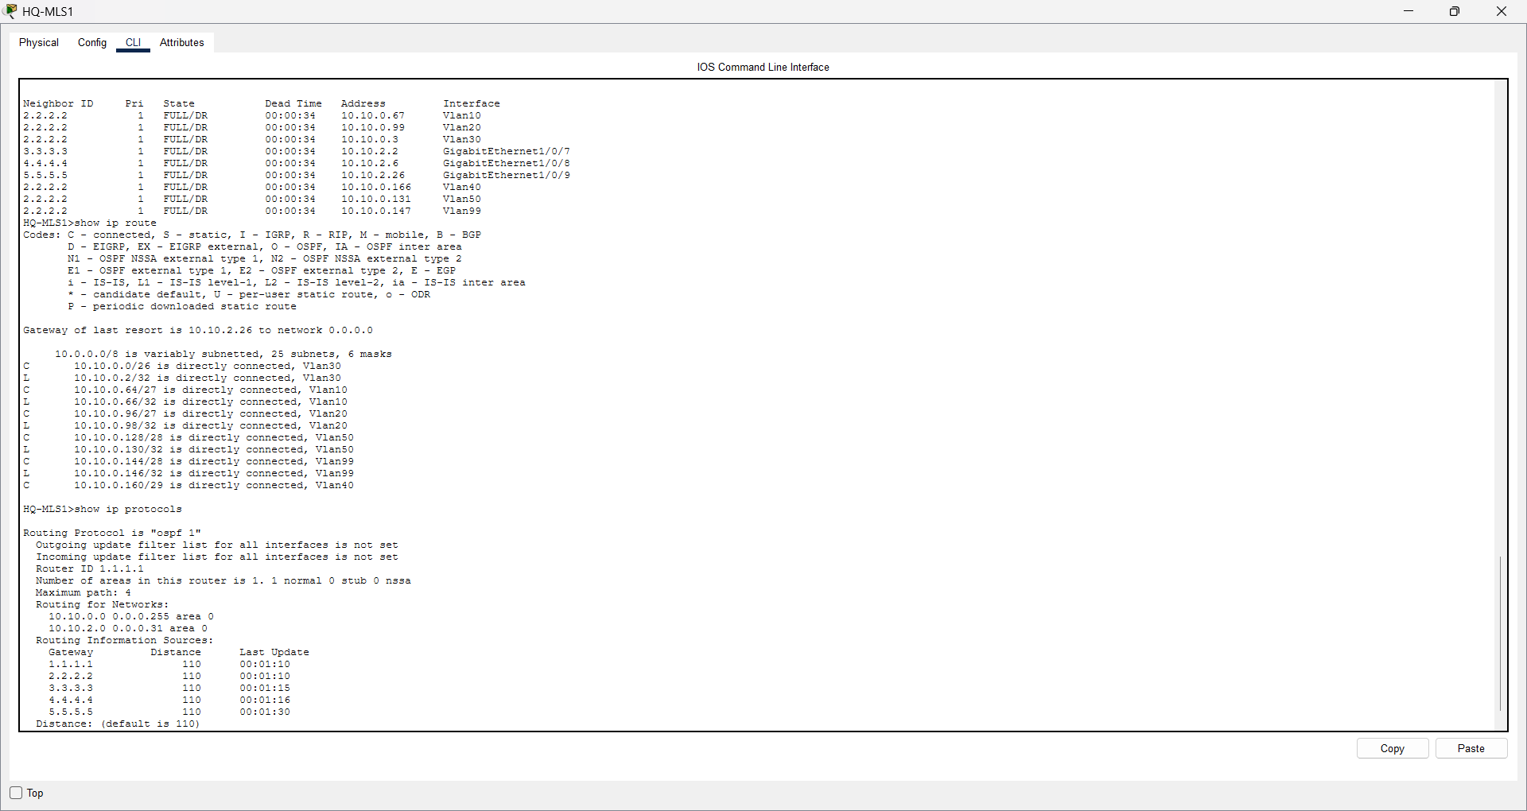

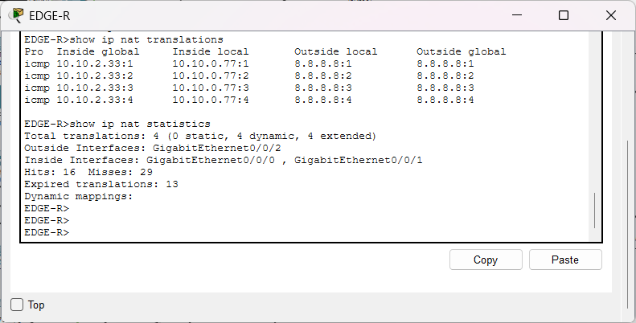

7. Network Security
Security Feature | Device(s) | Purpose | Verification
PAT (NAT Overload) | EDGE-R Router | Hides internal IP addresses behind a single Public IP for internet security. | Show ip nat translations
VLAN Segmentation | Core & Access Switches | Isolates department traffic to prevent unauthorized network access. | show vlan brief
Secure SSH Protocol | All Routers & Switches | Encrypts remote management sessions instead of clear-text Telnet. | Show ip ssh
STP PortFast & BPDU Guard | Access Switches | Prevents unauthorized switches from connecting and disrupting topology. | show spanning-tree summary
Voice VLAN Separation | Access Switches | Protects VoIP phone calls from data network sniffing. | show interface switchport

8. VLANs & Inter-VLAN Routing

8.1 Design / Configuration
We created 5 distinct VLANs to separate network traffic:
- VLAN 10 (HR_Admin)
- VLAN 20 (IT_Staff)
- VLAN 30 (Wireless_Users)
- VLAN 40 (Server_Farm)
- VLAN 50 (Voice_VoIP).

Inter-VLAN Routing is configured on Multilayer Switches (HQ-MLS1 and HQ-MLS2) using Switched Virtual Interfaces (SVIs) for fast hardware-based routing between subnets.

Configuration Example (HQ-MLS1):
HQ-MLS1(config)# vlan 10
HQ-MLS1(config-vlan)# name HR_Admin
HQ-MLS1(config-vlan)# interface vlan 10
HQ-MLS1(config-if)# ip address 10.10.0.66 255.255.255.224
HQ-MLS1(config-if)# ip helper-address 10.10.0.162
HQ-MLS1(config)# ip routing

8.2 Testing / Verification
Inter-VLAN Routing and Trunk configurations were verified using the following steps:

1. Executed "show vlan brief" to verify VLAN creation and access port assignments.
2. Executed "show interfaces trunk" to ensure 802.1Q encapsulation is active on all switch-to-switch links.
3. Performed Ping tests between hosts in different VLANs (e.g., HR PC in VLAN 10 pinging IT PC in VLAN 20), achieving 100% success rate.

9. Network Services

9.1 Design / Configuration
We centralized core network services inside the Server Farm (VLAN 40) using dedicated servers:

- DHCP Server (IP: 10.10.0.162):
Configured with IP scopes for each VLAN. The command "ip helper-address 10.10.0.162" is added on SVI interfaces so clients receive dynamic IPs across different VLANs.
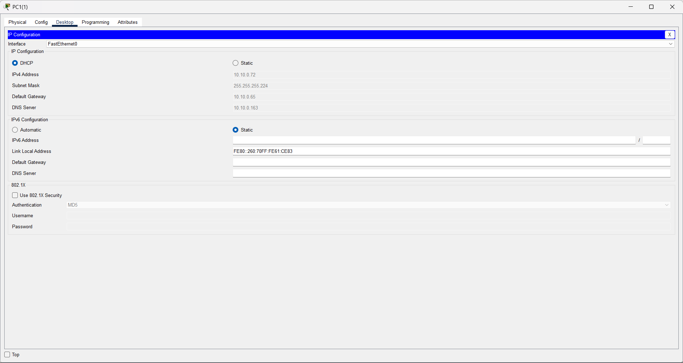
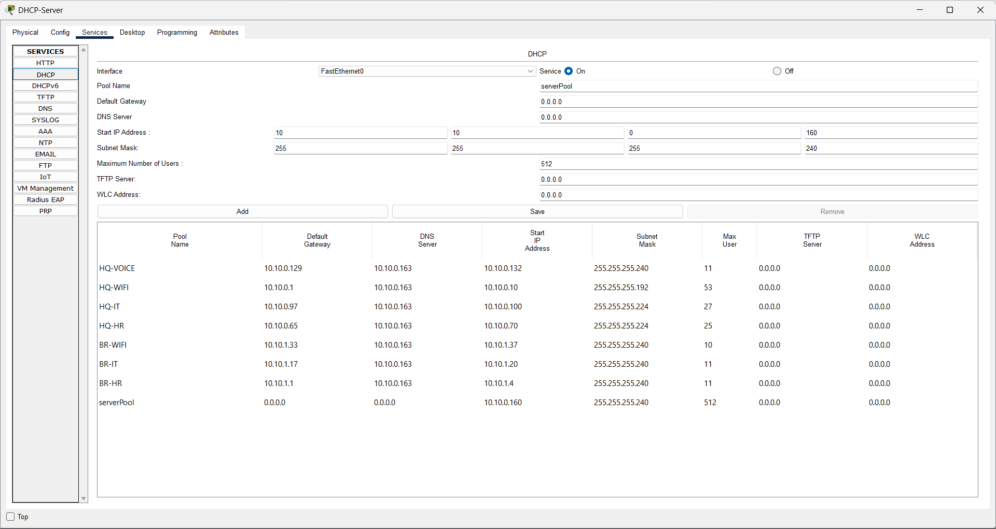

- DNS Server (IP: 10.10.0.163):
Resolves domain names (e.g. enterprise. local) to server IP addresses.
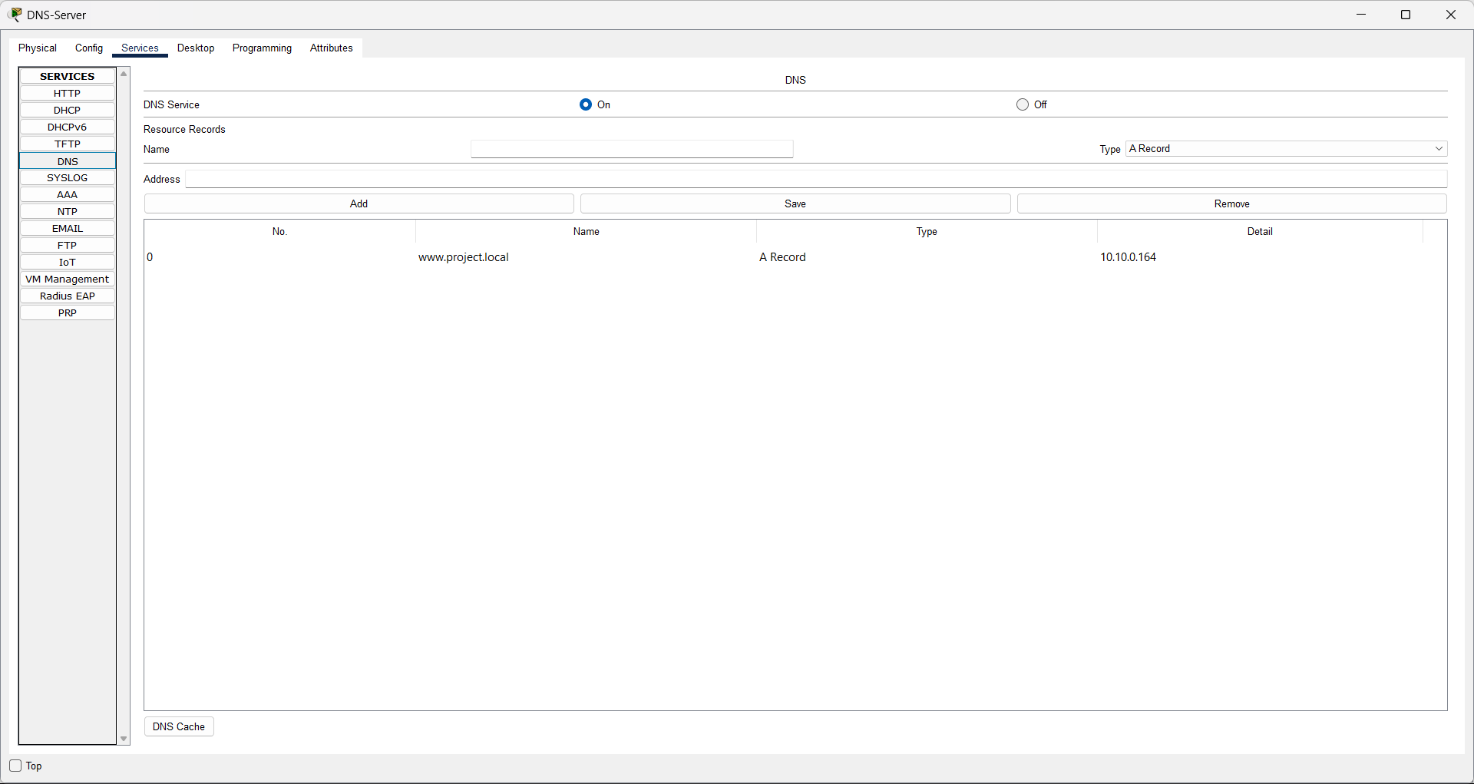

- HTTP Web Server (IP: 10.10.0.164):
Hosts the corporate internal web portal.
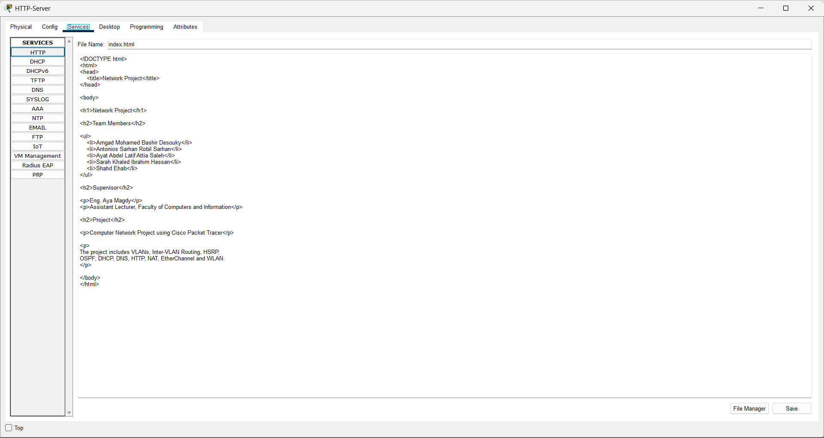
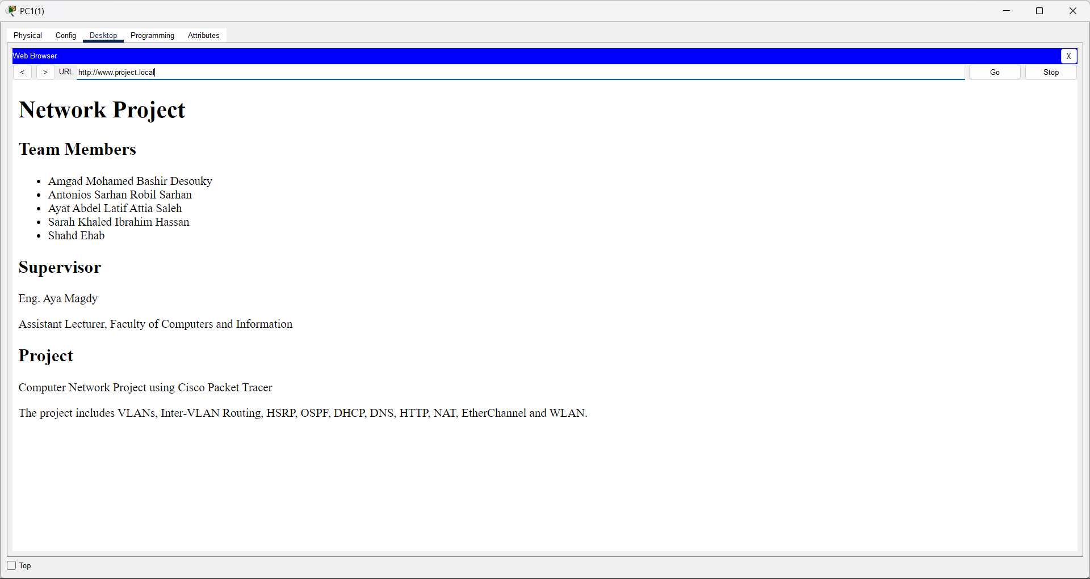

SVI Configuration Example (DHCP Relay):
HQ-MLS1(config)# interface vlan 10
HQ-MLS1(config-if)# ip helper-address 10.10.0.162

9.2 Testing / Verification
1. DHCP Verification: Connected PC clients in VLAN 10 and VLAN 20, set their IP configuration to "DHCP", and verified they automatically received correct IPs, Default Gateways, and DNS addresses.
2. Web/DNS Verification: Opened web browser on user PCs and navigated to "enterprise.local", confirming successful HTTP connection to the web server.

10. EtherChannel

10.1 Design / Configuration
We configured LACP (Link Aggregation Control Protocol - IEEE 802.3ad) to bundle physical links between switches into logical Port-Channels. This doubles bandwidth and provides link redundancy.
- Port-Channel 1 (Between HQ-MLS1 & HQ-MLS2):
Bundles two 1 Gbps links (Gig1/0/4 and Gig1/0/5) into a 2 Gbps link.
- Port-Channel 2 (Between Access Switches):
Bundles FastEthernet links using LACP "active" mode.
Configuration Example (HQ-MLS1):
HQ-MLS1(config)# interface range GigabitEthernet1/2/1 - 2
HQ-MLS1(config-if-range)# channel-group 1 mode active
HQ-MLS1(config-if-range)# exit
HQ-MLS1(config)# interface port-channel 1
HQ-MLS1(config-if)# switchport mode trunk

10.2 Testing / Verification
1. Executed "show etherchannel summary" to confirm Port-Channel status shows "SU" (In Use / Layer 2 Trunk) and member ports show "P" (Bundled in Port-Channel).
2. Physically disconnected one member link during ping testing; traffic continued seamlessly over the second link without packet loss.
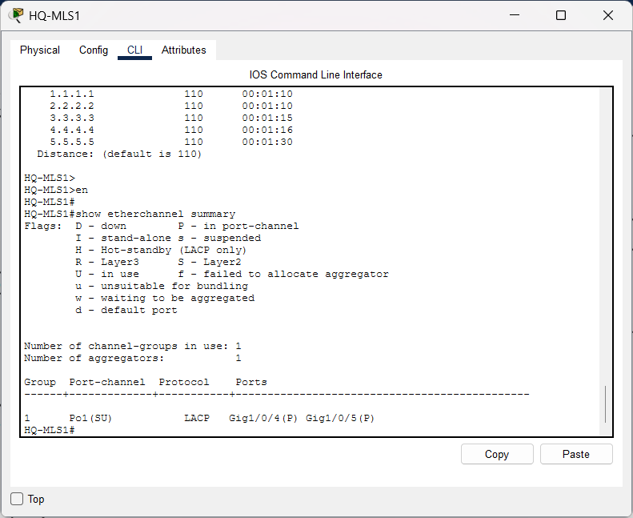
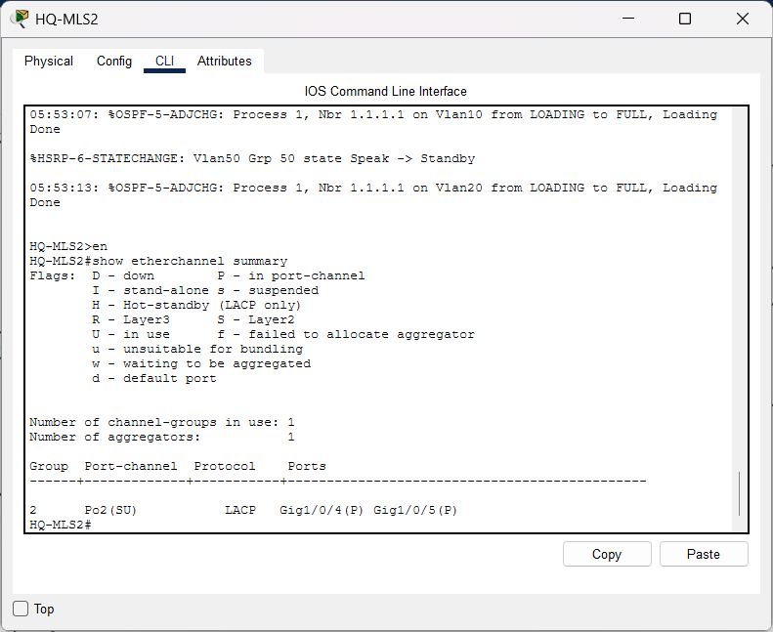

11. HSRP

11.1 Design / Configuration

We implemented Hot Standby Router Protocol (HSRP) between HQ-MLS1 and HQ-MLS2 to provide First-Hop Redundancy. This creates a shared Virtual Gateway IP address so users never lose internet or network access if one Core Switch fails.
- Virtual IP (VIP):
Configured per VLAN (e.g., 10.10.0.65 for VLAN 10).
- HQ-MLS1 (Active):
Priority set to 110 with "preempt" enabled to always serve as the primary gateway when online.
- HQ-MLS2 (Standby):
Priority default set to 100 as the backup gateway.
Configuration Example (VLAN 10 on HQ-MLS1):
HQ-MLS1(config)# interface vlan 10
HQ-MLS1(config-if)# standby 10 ip 10.10.0.65
HQ-MLS1(config-if)# standby 10 priority 110
HQ-MLS1(config-if)# standby 10 preempt

11.2 Testing / Verification
1. Executed "show standby brief" to verify HQ-MLS1 status is "Active" and HQ-MLS2 status is "Standby".
2. Initiated a continuous ping from a VLAN 10 host to an external IP, then manually shut down the active interface on HQ-MLS1.
3. HQ-MLS2 instantly transitioned to "Active" state with sub-second failover, allowing the continuous ping to succeed with zero downtime.

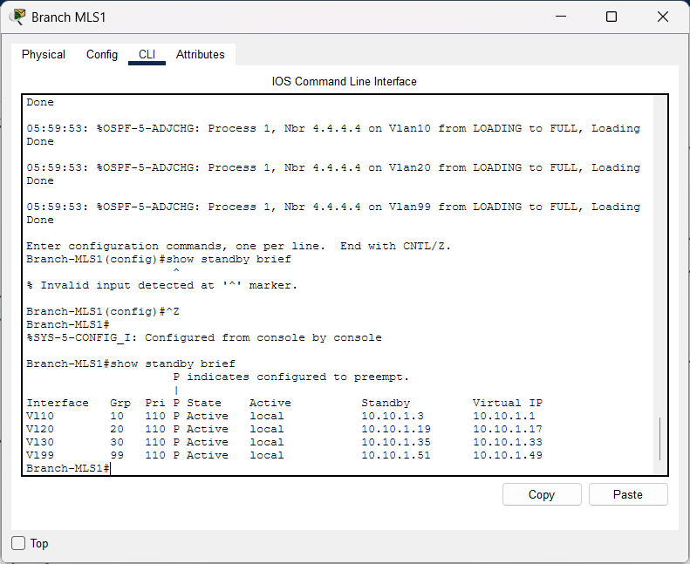
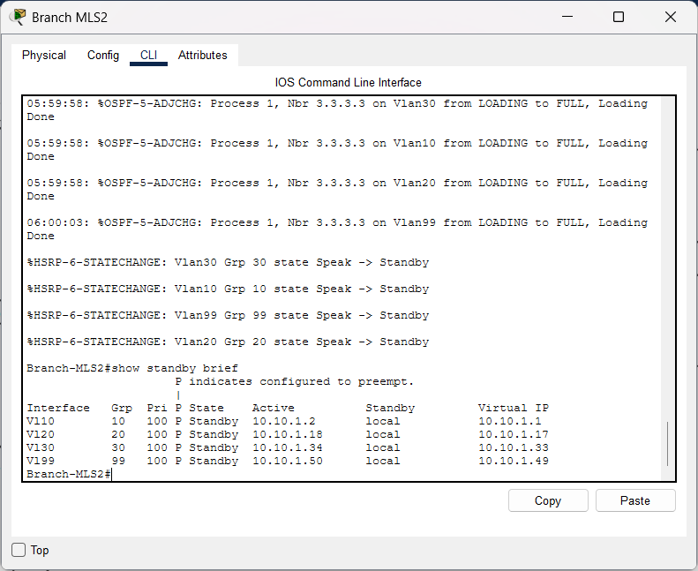

12. WLAN

12.1 Design / Configuration
We extended wireless connectivity to mobile and guest users inside VLAN 30 using Wireless Access Points (APs).
- SSID: Enterprise_WiFi
- Subnet / VLAN: VLAN 30 (10.10.0.0/26)
- Security: WPA2-Personal (AES Encryption) for secure wireless authentication.
- IP Assignment: Wireless clients dynamically receive IP parameters from the central DHCP Server via VLAN 30 SVI.

12.2 Testing / Verification

1. Connected wireless laptop clients to "Enterprise_WiFi" SSID using the pre-shared key.
2. Verified that wireless clients successfully obtained IP addresses in the 10.10.0.1 - 10.10.0.62 range.
3. Executed Ping tests from wireless clients to internal servers (VLAN 40) and external destinations, confirming full connectivity.

13. NAT

13.1 Design / Configuration
We configured Port Address Translation (PAT / NAT Overload) on the Edge Router (EDGE-R). PAT translates all internal private IP addresses (10.10.0.0/16) into a single public IP address when connecting to the Internet, providing IPv4 address conservation and perimeter security.
- Inside Interface: GigabitEthernet0/0/0 (Facing internal LAN)
- Outside Interface: GigabitEthernet0/0/1 (Facing ISP)

Configuration Example (EDGE-R):
EDGE-R(config)# access-list 1 permit 10.10.0.0 0.0.255.255
EDGE-R(config)# ip nat inside source list 1 interface GigabitEthernet0/0/1 overload
EDGE-R(config)# interface GigabitEthernet0/0/0
EDGE-R(config-if)# ip nat inside
EDGE-R(config)# interface GigabitEthernet0/0/2
EDGE-R(config-if)# ip nat outside

13.2 Testing / Verification

1. Initiated HTTP traffic and Ping requests from an internal PC in VLAN 10 toward the external ISP IP address.
2. Executed "show ip nat translations" on EDGE-R to confirm active translations, showing internal private IPs mapped to the router's outside interface port numbers.

14. Testing & Verification

Test ID | Feature | Test Procedure | Expected Result | Actual Result
T01 | End-to-End Connectivity | Ping from VLAN 10 PC to ISP External IP | 100% success rate with active reply | PASS
T02 | Routing | Verify routing table using show ip route | OSPF routes and 0.0.0.0/0 default route visible | PASS
T03 | DHCP / DNS / HTTP | Request dynamic IP on client PC and open web portal | IP assigned automatically & web page loads | PASS
T04 | VLAN / Inter-VLAN | Ping between PC in VLAN 10 and PC in VLAN 20 | Successful inter-subnet communication | PASS
T05 | EtherChannel | Disconnect 1 physical link in Port-Channel 1 | Traffic continues seamlessly over 2nd link | PASS
T06 | HSRP Failover | Shutdown active interface on HQ-MLS1 switch | Standby HQ-MLS2 instantly becomes Active | PASS
T07 | WLAN | Connect Laptop via Wi-Fi SSID with WPA2 | Wireless client gets IP and reaches network | PASS
T08 | NAT | Check translations using show ip nat translations | Internal IPs translated to public interface IP | PASS
T09 | Security | Attempt Telnet connection to Core Switch | Connection refused; only SSH allowed | PASS

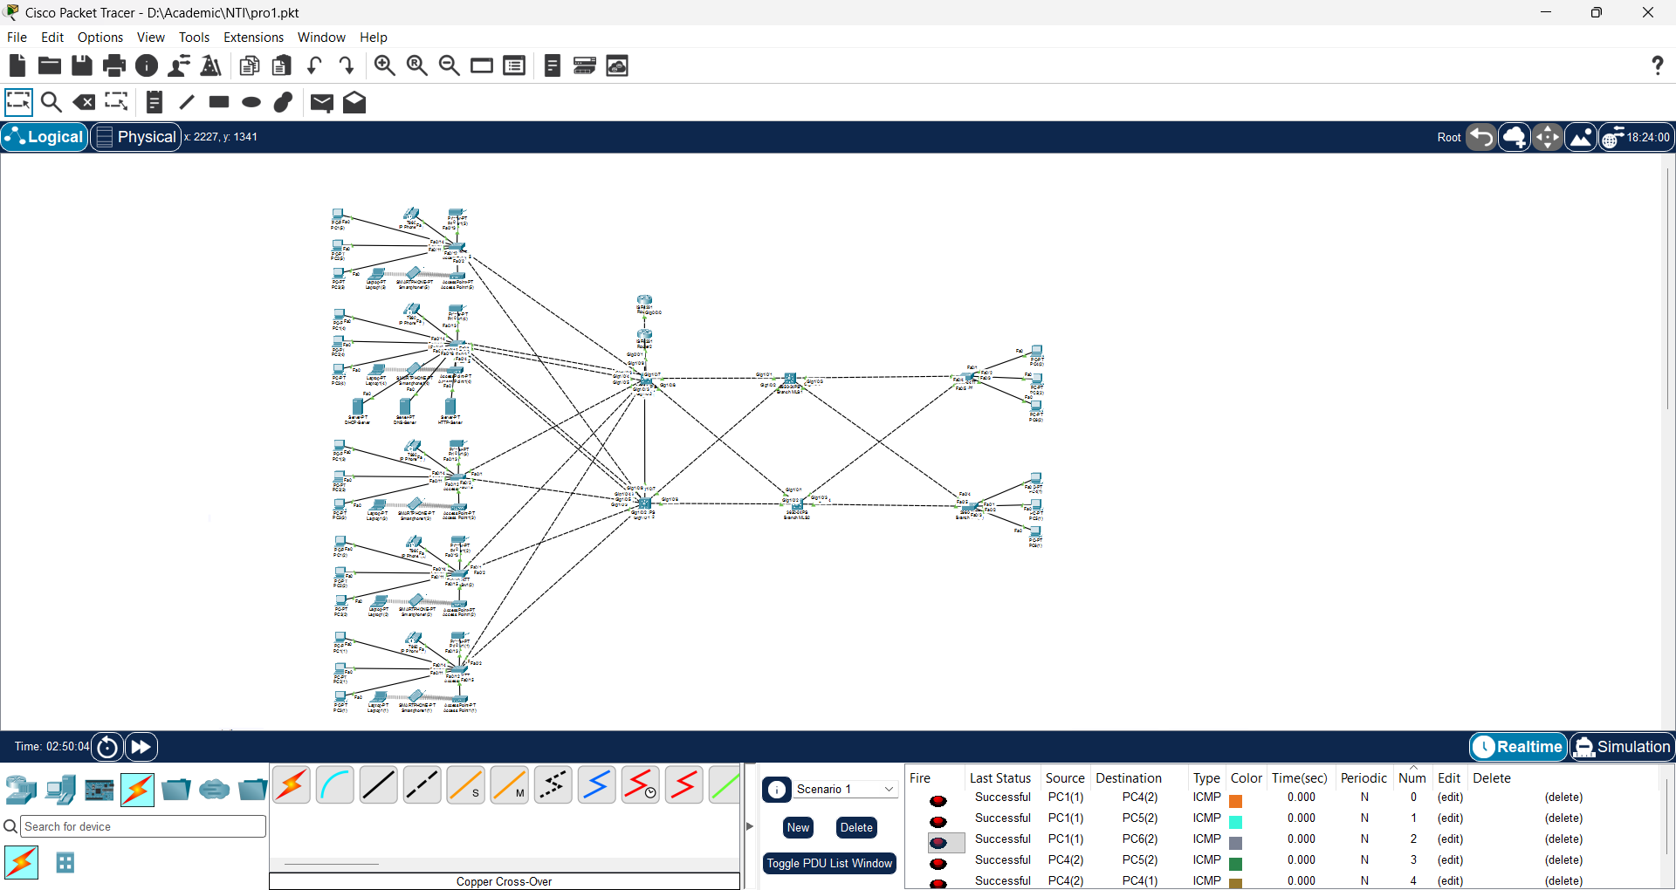
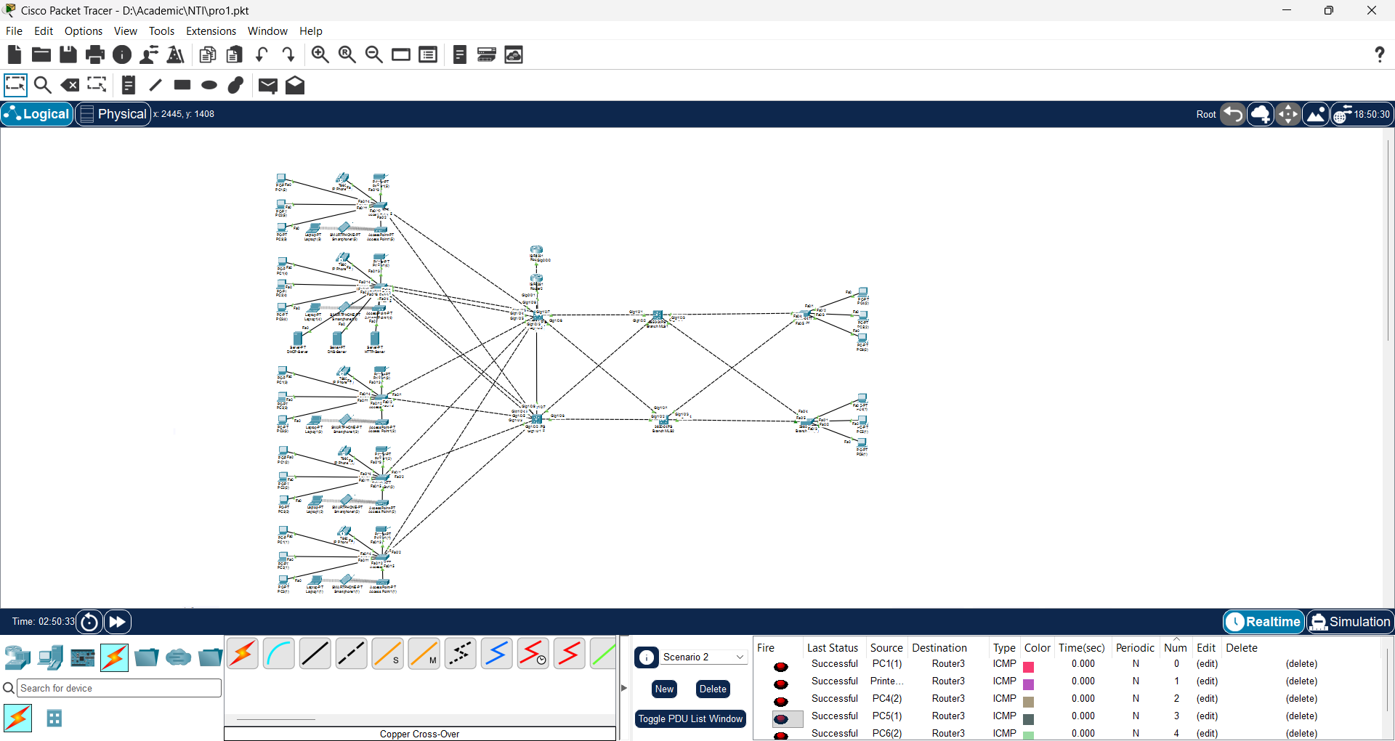
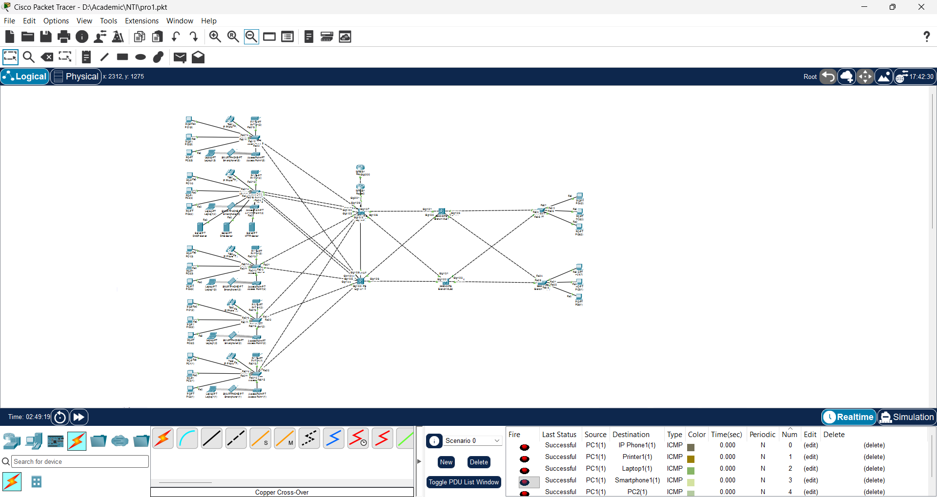

15. Challenges & Solutions

Challenge | Root Cause | Solution
Inter-VLAN DHCP Request Failure | DHCP Relay wasn't forwarding broadcast packets across routers/switches. | Added ip helper-address 10.10.0.162 on all VLAN SVI interfaces.
EtherChannel Mismatch / Discarding | Member ports had inconsistent speed, duplex, or trunking settings. | Standardized port settings before applying channel-group 1 mode active.
HSRP Preemption Flapping | Both Core Switches claimed Active role simultaneously during boot up. | Configured HSRP preempt delay and fine-tuned priority values on HQ-MLS1.
NAT Translation Loss for Wireless Users | Access Control List (ACL) did not include the new WLAN | Updated NAT ACL to permit the whole private address space 10.10.0.0 0.0.255.255.

16. Conclusion
The Enterprise Network Infrastructure project was successfully designed, configured, and tested. By adopting a hierarchical network design combined with VLSM IPv4 addressing, the architecture achieves high scalable capacity, fault tolerance, and security. Key redundancy protocols such as HSRP and EtherChannel ensure zero downtime for critical business operations, while OSPF dynamically manages core routing. The integration of centralized network services (DHCP/DNS/HTTP), secure WLAN access, and PAT for internet traffic complete a robust, reliable, and production-ready enterprise network solution.

17. Appendix

17.1 GitHub Repository
GitHub Link: https://github.com/amgadnassar74/Group3_NTI_project_Network

17.2 Project Files
Google drive link (including packet tracer file, excel sheet, documentation and screenshots):
Project (1) - Google Drive

