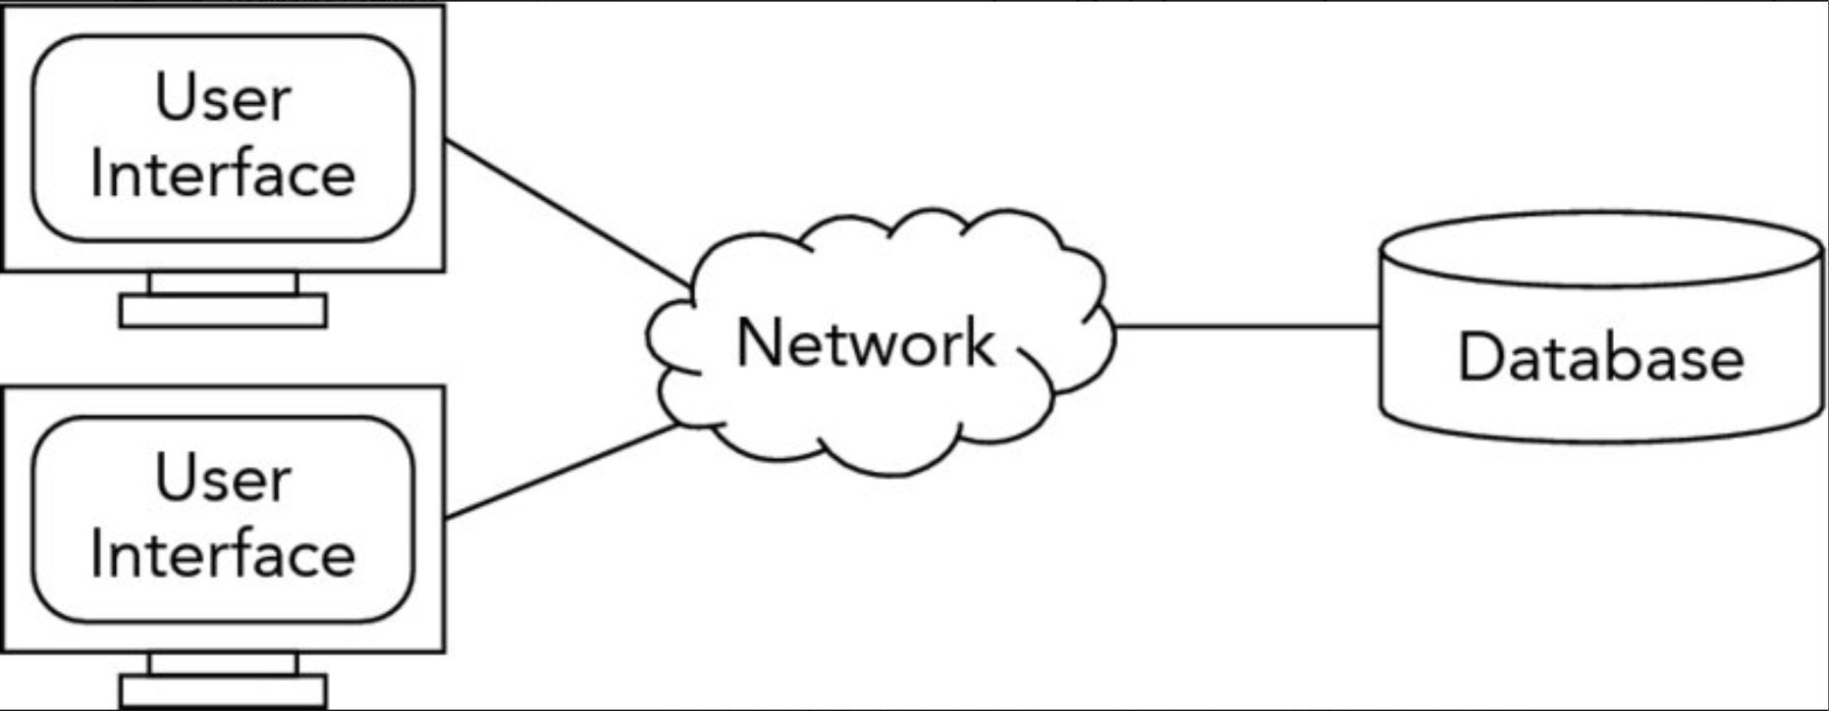

The user interface is the part the user interacts with and could be a phone, laptop, tablet, etc. A relational database will be the server and will contain all the information entered by the user as well as calculations made. The clients will communicate with the server via a LAN. Since there will be multiple users and calculations and we want to keep response time at a good level, we chose the client/server methodology. However, a third tier would probably be overkill for this application, so we went with a simple client/server architecture.