NEW METHOD 3/17/16 – Used **depoytool** in matlab

**Creating a Standalone Executable**

A [*standalone executable*](http://www.mathworks.com/access/helpdesk/help/releases/R2010b/toolbox/compiler/bsmbyn0.html) is a complete program that you can run from the Unix command line or Microsoft Windows DOS command prompt. Standalone executables are a convenient way to provide turn-key MATLAB-based solutions to your colleagues or end users.

Save this MATLAB function as helloworld.m. Before compiling it, test it in MATLAB. It should produce a globe with the continents visible and the view centered on the mid-Atlantic trench.

function helloworld

% HELLOWORLD Display the globe and a welcome message.

% Load the topographical data for the globe

load('topo.mat', 'topo', 'topomap1');

% Create a unit sphere with 50 facets. This sphere is the Earth.

[x,y,z] = sphere(50);

% Establish initial viewing and lighting parameters. Use Phong shading

% and texture mapping to wrap the topo map data around the sphere.

props.FaceColor= 'texture';

props.EdgeColor = 'none';

props.FaceLighting = 'phong';

props.CData = topo;

% Set the viewpoint to look at the Atlantic Ocean.

view(-130, 10);

% Draw the sphere, with the topo data texture mapped to the surface.

s=surface(x,y,z,props);

set(gcf, 'Color', 'white'); % White background

axis square

axis off

axis equal

title('Hello, World.', 'FontSize', 14, 'FontWeight', 'Bold');

end

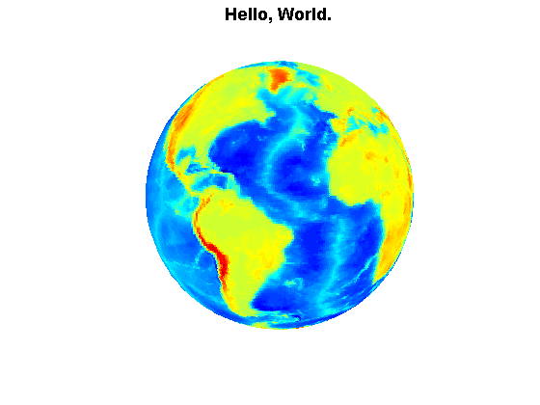

Build this function into a standalone application with the MATLAB Compiler:

mcc -mv helloworld.m -a topo.mat

Here, I've specified three groups of arguments to the [mcc](http://www.mathworks.com/access/helpdesk/help/releases/R2010b/toolbox/compiler/mcc.html) command:

* -mv: -m means create a ''main'' program, a standalone executable. -v requests verbose output.
* helloworld.m: The name of the MATLAB function to compile. The generated executable takes its name from the name of the first MATLAB function specified on the command line.
* -a topo.mat: -a stands for ''additional file''; it is typically used to add data files to the application.

This mcc command will create a standalone executable called helloworld on UNIX systems, helloworld.exe on PCs running Microsoft Windows.

In order to run the executable, the operating system needs to be able to find the MCR. You need to put the MCR's runtime/<architecture>directory on the system's [library search path](http://www.mathworks.com/access/helpdesk/help/releases/R2010b/toolbox/compiler/f12-999353.html#br2jauc-33). On Windows, you add it to the PATH environment variable. On Unix, you add it to LD_LIBRARY_PATH(except on the MacIntosh, which uses DYLD_LIBRARY_PATH). To run the executable locally (on the machine where you created it), use MATLAB'sruntime/<architecture> directory. If the environment variable MATLAB_ROOT indicates the root of your MATLAB installation, add the runtimedirectory to the library search path with one of the following commands

Linux 32-bit:

% setenv LD_LIBRARY_PATH $MATLAB_ROOT/runtime/glnx86

Windows:

c:\Work> set %PATH%;%MATLAB_ROOT%\runtime\win32

Then, run the application:

UNIX:

% helloworld

Windows:

c:\Work> helloworld.exe

You should see a single window displaying a map of the world.

Also read the readme.txt file for the standalone application. It requires installing the runtime compiler on the system

MATLAB Compiler

1. Prerequisites for Deployment

. Verify the MATLAB runtime is installed and ensure you

have installed version 8.5 (R2015a).

. If the MATLAB runtime is not installed, do the following:

(1) enter

>>mcrinstaller

at MATLAB prompt. The MCRINSTALLER command displays the

location of the MATLAB runtime installer.

(2) run the MATLAB runtime installer.

Or download the Windows 64-bit version of the MATLAB runtime for R2015a

from the MathWorks Web site by navigating to

http://www.mathworks.com/products/compiler/mcr/index.html

For more information about the MATLAB runtime and the MATLAB runtime installer, see

Package and Distribute in the MATLAB Compiler documentation

in the MathWorks Documentation Center.

NOTE: You will need administrator rights to run MCRInstaller.

2. Files to Deploy and Package

Files to package for Standalone

================================

-teleBCI.exe

-MCRInstaller.exe

-if end users are unable to download the MATLAB runtime using the above

link, include it when building your component by clicking

the "Runtime downloaded from web" link in the Deployment Tool

-This readme file