Development and Validation of a Two-Input Transfer Function Analysis for Blood Pressure, CO₂, and Cerebral Blood Flow Dynamics
Abstract deferred until the results and interpretation are finalized.

Introduction
Adequate regulation of cerebral blood flow (CBF) is essential for normal brain function. Among the multiple mechanisms involved in CBF regulation, responses to changes in arterial blood pressure and the partial pressure of arterial carbon dioxide (PaCO₂) are particularly important. Cerebral autoregulation (CA) refers to the ability of the cerebral vasculature to buffer the effects of changes in arterial blood pressure on CBF. In response to an increase in blood pressure, cerebrovascular constriction occurs, thereby limiting excessive cerebral perfusion. In contrast, a decrease in blood pressure evokes cerebral vasodilation to protect against cerebral hypoperfusion. Cerebral vasomotor CO₂ reactivity (CVMR) refers to the ability of the cerebral vasculature to adjust vascular tone in response to changes in PaCO₂, thereby modulating CBF and contributing to brain tissue pH homeostasis. An increase in PaCO₂ lowers pH (acidosis), leading to cerebral vasodilation and an increase in CBF. The increased CBF facilitates CO₂ washout and limits the decrease in pH. Conversely, a decrease in PaCO₂ raises pH (alkalosis), leading to cerebral vasoconstriction and a decrease in CBF. The reduced CBF limits CO₂ washout and attenuates the increase in pH. Alterations in CA and CVMR have been reported with aging and in various pathophysiological conditions, raising interest in their quantification as potential markers of cerebrovascular dysfunction. [1,2]
Cerebral autoregulation can be broadly characterized as static or dynamic. Static CA describes the ability of the cerebral vasculature to maintain relatively stable CBF across sustained changes in steady-state blood pressure. Its assessment generally requires the establishment of different steady-state blood pressure levels, often through pharmacological interventions that induce relatively large and sustained changes in blood pressure. In contrast, dynamic cerebral autoregulation (dCA) describes the ability of the cerebral vasculature to buffer transient changes in CBF in response to rapid fluctuations in blood pressure that occur over seconds to minutes. Because dCA can be assessed noninvasively from spontaneous blood pressure and CBF fluctuations under resting conditions, it has been widely quantified in both physiological and clinical research. Single-input, Single-output (SISO) Transfer Function analysis (TFA) is widely used to quantify dCA based on linear system theory, describing the relationship between ABP (input) and CBF (output) in the frequency domain. Using TFA, dCA is quantified with three metrics: gain, phase, and coherence. Gain describes how strongly changes in MAP appear in CBFV (i.e., magnitude relation), while phase describes their timing relationship (i.e., temporal difference) at each frequency. Coherence quantifies the strength of linearity between ABP and CBF fluctuations and ranges from 0 to 1, with a higher coherence value indicating a stronger linear relation and a higher signal-to-noise ratio for estimating TFA gain and phase. Importantly, CBF also responds dynamically to fluctuations in arterial CO₂. Thus, CBF dynamics may be shaped by concurrent cerebrovascular responses to fluctuations in both blood pressure and CO₂. [1–3]

A MAP-only model is useful, but MAP is not the only input that can influence CBFV. In this study, mean arterial pressure (MAP) represents arterial blood pressure (ABP), and cerebral blood flow velocity (CBFV), measured with transcranial Doppler, is used as a surrogate for changes in CBF when the diameter of the insonated artery is sufficiently stable. [1,3] End-tidal CO₂ (PETCO₂) provides a practical breath-to-breath surrogate for changes in arterial carbon dioxide during resting recordings. [2] In a MAP-only SISO model, PETCO₂ is omitted. If MAP and PETCO₂ fluctuate together in a consistent relationship at a given frequency, MAP can carry information about PETCO₂, and part of the PETCO₂-related CBFV response may be attributed to MAP. Having fluctuations in the same frequency range is not sufficient: their relative timing must also be consistent across the segments used to estimate the relationship. The same problem applies to a PETCO₂-only SISO model. Therefore, two separate SISO models describe pairwise relationships, but they do not distinguish the contribution of one measured input from the other. [4,5]
Previous studies have shown the potential value of modeling MAP and PETCO₂ together. Panerai et al. used multivariate finite impulse response filters to estimate the contributions of beat-to-beat MAP and breath-to-breath PETCO₂ fluctuations to resting CBFV variability. MAP explained a substantial portion of the measured CBFV variability, and adding PETCO₂ reduced the model mean squared error, calculated from the differences between measured and model-reconstructed CBFV. These results suggest that spontaneous PETCO₂ fluctuations can help explain resting CBFV variability that is not captured by pressure alone. [4] Peng et al. also examined multivariable system identification for cerebral autoregulation. Including PETCO₂ and end-tidal oxygen increased multiple coherence below 0.05 Hz relative to an arterial-pressure-only model, supporting the contribution of gas-related fluctuations to CBFV variability. [5]
However, lower CBFV prediction error does not necessarily mean that the separate MAP and PETCO₂ transfer functions were estimated correctly. First, MAP, PETCO₂, and CBFV can be measured in human recordings, but the true contribution of each input is not independently known. Second, when the inputs are related, a model may predict total CBFV well while assigning part of the response to the wrong input. Model fit therefore describes how well the output is reproduced, but it does not establish that the individual pathways were recovered correctly. Here, a pathway means the response associated with one input in the model; it is not an independently measured anatomical or causal pathway. Previous multivariable studies provide a basis for two-input modeling. The question addressed here is when joint frequency-domain estimation improves recovery of the individual generating responses across recording and input conditions. [4–6]
A two-input multiple-input, single-output (MISO) TFA model addresses the omission of the second input by estimating the MAP-to-CBFV and PETCO₂-to-CBFV transfer functions together. Each response is estimated while accounting for the other measured input. The coherence measures used with this model answer different questions. Ordinary coherence describes the pairwise relationship between one input and CBFV without accounting for the other input. Partial coherence describes the remaining relationship between one input and CBFV after accounting for the second input. Multiple coherence describes how consistently MAP and PETCO₂ together are related to CBFV. Higher multiple coherence indicates that the two-input model explains the measured output more closely, but it does not show by itself that the individual pathways were estimated accurately. [5,6]

A clear and consistent MISO TFA framework is therefore needed because preprocessing, spectral settings, the joint model solution, and diagnostic criteria can all affect the results. The framework must document these choices, return the MAP- and PETCO₂-related gain and phase estimates, and report the coherence and numerical diagnostics needed to interpret them. The physiological aim is to examine blood-pressure-related CBFV dynamics while accounting for concurrent CO₂ variation, and CO₂-related dynamics while accounting for blood pressure. The computational details of this framework are described in the Methods. [3,5]
Adding a second input does not automatically produce a more accurate model. MISO must estimate two pathway coefficients at each frequency from the same finite recording. If MAP and PETCO₂ become too similar within a frequency region, the model can have difficulty distinguishing their effects. In this situation, small spectral errors can produce large changes in the estimated transfer functions. Some variation unique to each input is needed to distinguish their responses; the inputs do not have to be completely independent. [6] Short recordings, weak PETCO₂ fluctuations, measurement noise, and signal misalignment may also affect this balance. Even when the inputs are independent, including PETCO₂ can account for CBFV variation that remains unexplained in a MAP-only model. This can reduce variation in the MAP estimate across repeated finite recordings, although improvement is not guaranteed. A separate PETCO₂-only fit does not remove that unexplained variation from the MAP-only fit.
The two-input framework is applied to resting baseline recordings from cognitively normal (NC) adults. We compare MISO with a conventional MAP-only SISO model by estimating transfer functions from training blocks and evaluating CBFV prediction in a separate, held-out block. This asks whether including measured PETCO₂ improves prediction of an unseen part of the recording. This application provides physiological relevance, but it cannot establish which model is closer to the underlying pathways because those pathways are not known in subject data. Selected NC input properties also inform the simulated input spectra and operating levels; they do not establish the true human transfer functions or calibrate their recovery accuracy.
Known-truth simulation provides the complementary evaluation. Prespecified MAP-to-output and PETCO₂-to-output transfer functions are defined first. Synthetic input time series are then generated, passed through these model pathways, and combined to create a synthetic output time series. MISO and SISO models are estimated using only the same generated input and output observations, and their gain, phase, and complex transfer functions are compared directly with the prespecified transfer functions. Recording duration, noise, input relationships, pathway strength, and timing alignment are varied to determine how each condition affects pathway recovery. The spectral estimation settings are held fixed so that the comparisons reflect the declared changes in recording and input conditions. Repeated random recordings under each condition assess how consistently each estimator recovers the assigned responses. This follows the general logic of evaluating methods against a known data-generating system; the particular generating rules and parameter values used here are specified study assumptions. [5–8]
The primary objective of this study is to develop and evaluate a reproducible two-input TFA framework for examining blood-pressure- and CO₂-related CBFV dynamics. We use known-truth simulations to compare MISO and SISO pathway-recovery accuracy across relevant recording and input conditions. In a complementary analysis, we assess whether including PETCO₂ improves CBFV prediction in held-out NC recording blocks. Together, these analyses evaluate when jointly considering blood pressure and CO₂ can support interpretation of cerebral blood flow regulation, while distinguishing accurate recovery in a controlled model from predictive performance in human recordings.
Methods

Study design and two accuracy questions
The study contains a known-truth simulation and a held-out analysis of normal-control (NC) recordings. The simulation asks whether SISO or MISO more accurately recovers a transfer function that is known because it generated the data. The NC analysis asks whether transfer functions estimated from one part of a recording predict CBFV in a different part. Human pathway truth is unavailable, so the NC analysis does not determine which estimate is physiologically correct.
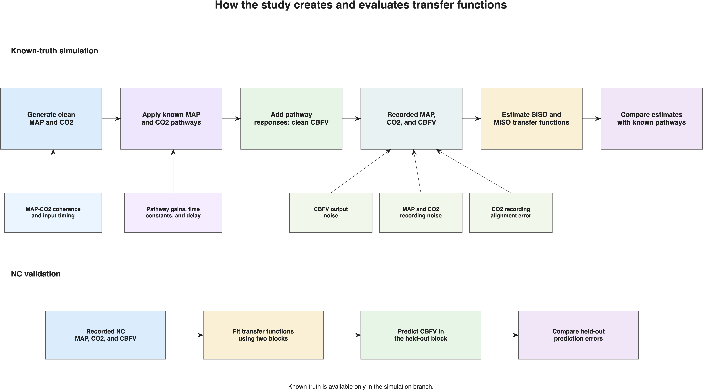
Figure 1. Study design. The known-truth branch generates CBFV from specified MAP and CO₂ responses and compares both estimators with those responses. The NC branch evaluates held-out CBFV prediction with subject-bootstrap uncertainty. Both branches use the same spectral estimators but answer different accuracy questions.
For each simulated replicate and frequency, the estimated complex transfer function was compared with the complex transfer function used to generate the recording. This comparison includes both response size and timing. Squared errors were normalized by the mean squared magnitude of the known pathway across the reporting band, then averaged across paired replicates at each frequency. This uses one reference magnitude for the pathway rather than dividing by a potentially very small gain at each frequency. When the entire generating pathway had zero gain, absolute error was used.
$$E(f) = \frac{meanᵣ |Ĥᵣ(f) - H(f)|²}{meanν∈B |H(ν)|²}$$ | (1)
Here H(f) is the known generating transfer function and Ĥᵣ(f) is its estimate from replicate r. The numerator averages squared error across replicates at a fixed frequency; the denominator averages squared true gain across frequencies in the reporting band. The frequency axis is therefore retained. The primary score is the base-10 logarithm of mean SISO error divided by mean MISO error. Positive values indicate lower mean error for MISO, negative values indicate lower mean error for SISO, and zero means equal error. An advantage of 1 means that the mean SISO error is ten times the mean MISO error.
$$A = \log_{10}(\frac{E_{SISO}}{E_{MISO}})$$ | (2)

Frequency, power, and signal-to-noise ratio
Power describes the average squared size of a signal's fluctuations around its mean. The power spectrum distributes that variation across frequency, so a larger value near a frequency means that more of the signal's fluctuation occurs on that time scale. The signal-to-noise ratio (SNR) compares signal power with measurement noise power: 10 dB means ten times as much signal power as noise power, 0 dB means equal power, and no noise is the ideal reference.
Frequency describes how often a fluctuation repeats: 0.10 Hz corresponds to a 10-second cycle and 0.20 Hz to a 5-second cycle. Phase expresses relative timing as a fraction of that cycle. A one-second timing difference is therefore 36 degrees at 0.10 Hz. The sign depends on which signal is taken as the reference.
$$Pₓ = ⟨(x-x̄)²⟩$$ | (3)
Signals were sampled at 4 Hz, which permits frequencies up to the 2 Hz Nyquist frequency. We report only 0.02–0.35 Hz because that was the prespecified physiological range of interest. Spectra were estimated with 100-second, 400-sample Hann windows, 50% overlap, linear detrending, and three-bin smoothing. Because each window contains 400 samples at 4 Hz, the frequency-bin spacing is 4/400 = 0.01 Hz. The 2 Hz Nyquist limit is therefore much wider than the reported 0.02–0.35 Hz physiological band. SISO and MISO used identical settings. [9]

Known-truth signal generation
The simulator first creates clean MAP and CO₂ recordings. It then passes each input through a known response rule to obtain its CBFV contribution. The two contributions are added to form clean CBFV. The known response rules are the truth for the simulation; the estimators later receive only the resulting observations.
A response rule is represented in two equivalent ways. In the time domain, a kernel is a list of weights that determines how an input value affects the current and later CBFV values. A constant multiplier would create an instantaneous response with the same gain at every frequency. A kernel allows the response to develop over time and therefore allows its gain and phase to differ across frequency.
The MAP response is high-pass-like. It combines an immediate component with a slowly developing component that reduces the response to sustained MAP changes. Its time constant is 3 seconds, its high-frequency gain is 1.5, and one-quarter of that gain is retained for slow changes. The CO₂ response is a delayed low-pass response. It is built from exponentially decreasing weights with a 5-second time constant and a 3-second delay, representing a response that begins after a delay and develops gradually.
These response shapes and time constants are prescribed simulation assumptions, not transfer functions learned from NC data. NC data inform the input-spectrum shape and selected operating levels. The simulator converts each time-domain kernel to its frequency response and saves that response before observation noise or alignment error is applied. For every generated record, stored seeds determine the random realization. The requested SNR sets target noise power to signal power divided by 10^(SNR/10); the generated noise is scaled to that power. Thus a noise condition changes the observation without changing the underlying clean pathway. The cited physiological literature motivates the different pressure and CO₂ response patterns; it does not establish these exact numerical constants. [2,3]
$$Y = HₘM + H꜀C + E$$ | (4)
In this expression, M and C represent the MAP and CO₂ fluctuations at a frequency, Hₘ and H꜀ are their assigned responses, Y is the resulting CBFV fluctuation, and E is the remaining output component. The primary model assumes that this remaining component is not systematically related to either clean input. Otherwise, part of an unmeasured influence could be assigned to an input response. Input recording noise is tested separately by altering what the estimator observes after clean CBFV has been generated.

Signal families and paired realizations
A simulated family represents one fixed underlying system rather than one single recording. The family keeps the input-spectrum shape, the MAP–CO₂ relationship, the response-kernel rules, and the pathway settings fixed. Each realization then uses new random draws to create a different finite recording from that same system. This separates variation that belongs to the assumed physiology from variation that is caused by having only one finite recording.
The simulator first creates a shared input component and an input-specific CO₂ component in the frequency domain. The shared component is scaled to the requested MAP–CO₂ coherence, while the independent component supplies information that can distinguish the two inputs. A requested input lag is applied to the shared CO₂ component before the inverse Fourier transform, so the lag changes the timing of the generated inputs rather than being added later as an arbitrary phase label.
The same family realization is then used for both estimators. SISO and MISO do not receive different signals or different random noise. They receive the same observed MAP, CO₂, and CBFV recording, and their estimates are compared with the same known generating responses. The pairing means that a difference in accuracy is caused by the estimator, not by comparing two unrelated recordings.
Code example 1. MATLAB excerpt from generateKnownTruthRealization.m and createKnownTruthObservation.m
for replicateIndex = 1:numReplicates
seed = familySeeds(replicateIndex);
realization = generateKnownTruthRealization( ...
scenario, settings, seed, durationSeconds);
observation = createKnownTruthObservation( ...
realization, conditionRow);
end
The code shows the separation between a family realization and an observation condition. The random seed controls the particular realization. The condition row then selects the recording duration, input noise, output noise, and alignment setting applied to that realization. Changing one condition value therefore changes one declared recording or analysis property while preserving the same generation rules.
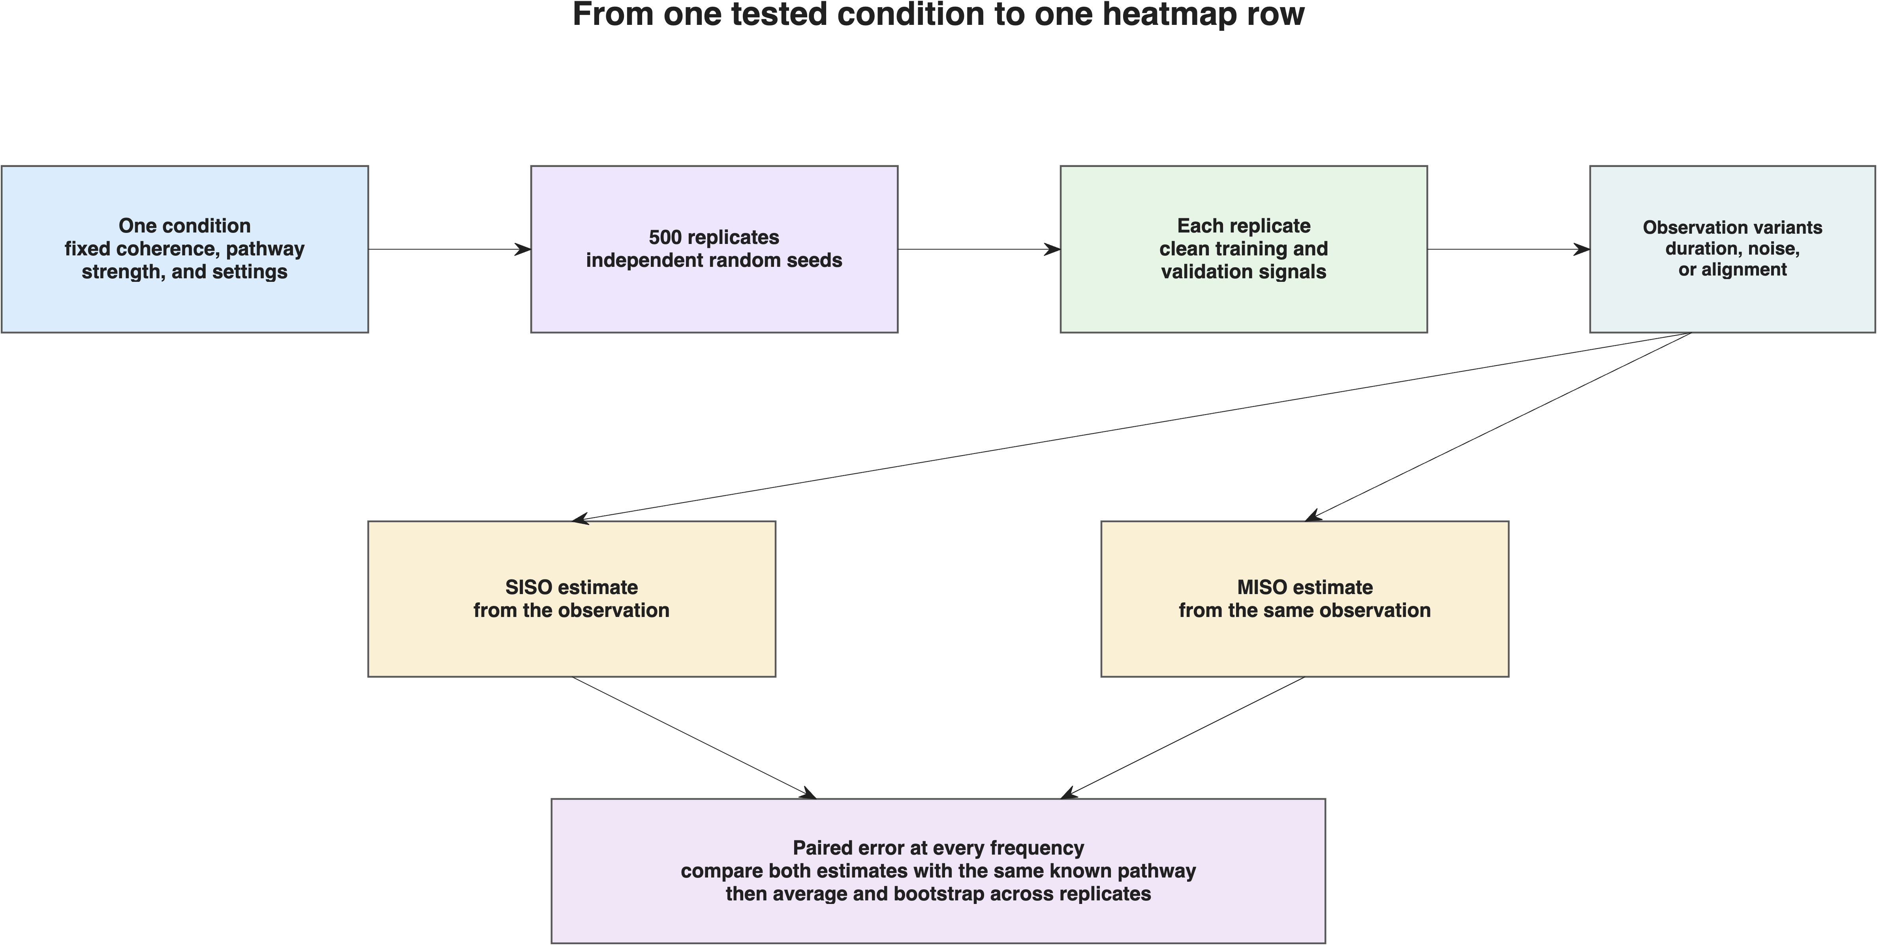
Figure 2. How one fixed simulation condition produces paired family realizations. Each realization is observed once, analyzed by both estimators, and compared with the same known pathway responses.

From kernels to frequency responses
The MAP and CO₂ kernels are not learned from the NC recordings. They are prescribed generating rules chosen to represent two different time courses. The MAP kernel combines an immediate component with a slower component that attenuates sustained changes. The CO₂ kernel is an exponentially developing response with a delay. The simulator converts these time-domain weights into complex frequency responses, which supplies the known gain and phase used as the truth. NC data inform the relative input-spectrum shape and selected operating levels, not the individual transfer functions. [2,3,4]
Code example 2. MATLAB excerpt from generateKnownTruthRealization.m
mapKernel = createMapAutoregulationKernel(settings);
co2Kernel = createPetco2VasoreactivityKernel(settings);
mapContribution = filter(mapKernel, 1, map);
co2Contribution = filter(co2Kernel, 1, co2);
cleanCbv = mapContribution + co2Contribution;

NC-derived input-spectrum shape
We used the NC recordings to choose how much input variation to place at each frequency. For each subject, MAP and CO₂ power spectra were calculated from 90-second windows. The subject-level median curves were averaged in decibels and fit with a smooth decreasing function. Only this relative shape was used; measured amplitudes and clinical units were not copied into the simulation.
$$S(f) = \frac{1}{1 + {\left(\frac{f}{f_{0}}\right)}^{α}}$$ | (5)
The fitted roll-off frequency was 0.0290 Hz and the exponent was 2.5514, with an RMS fitting error of 0.91 dB. MAP and CO₂ were assigned the same shape in the primary simulation so that input coherence could be changed without simultaneously changing their frequency distributions.
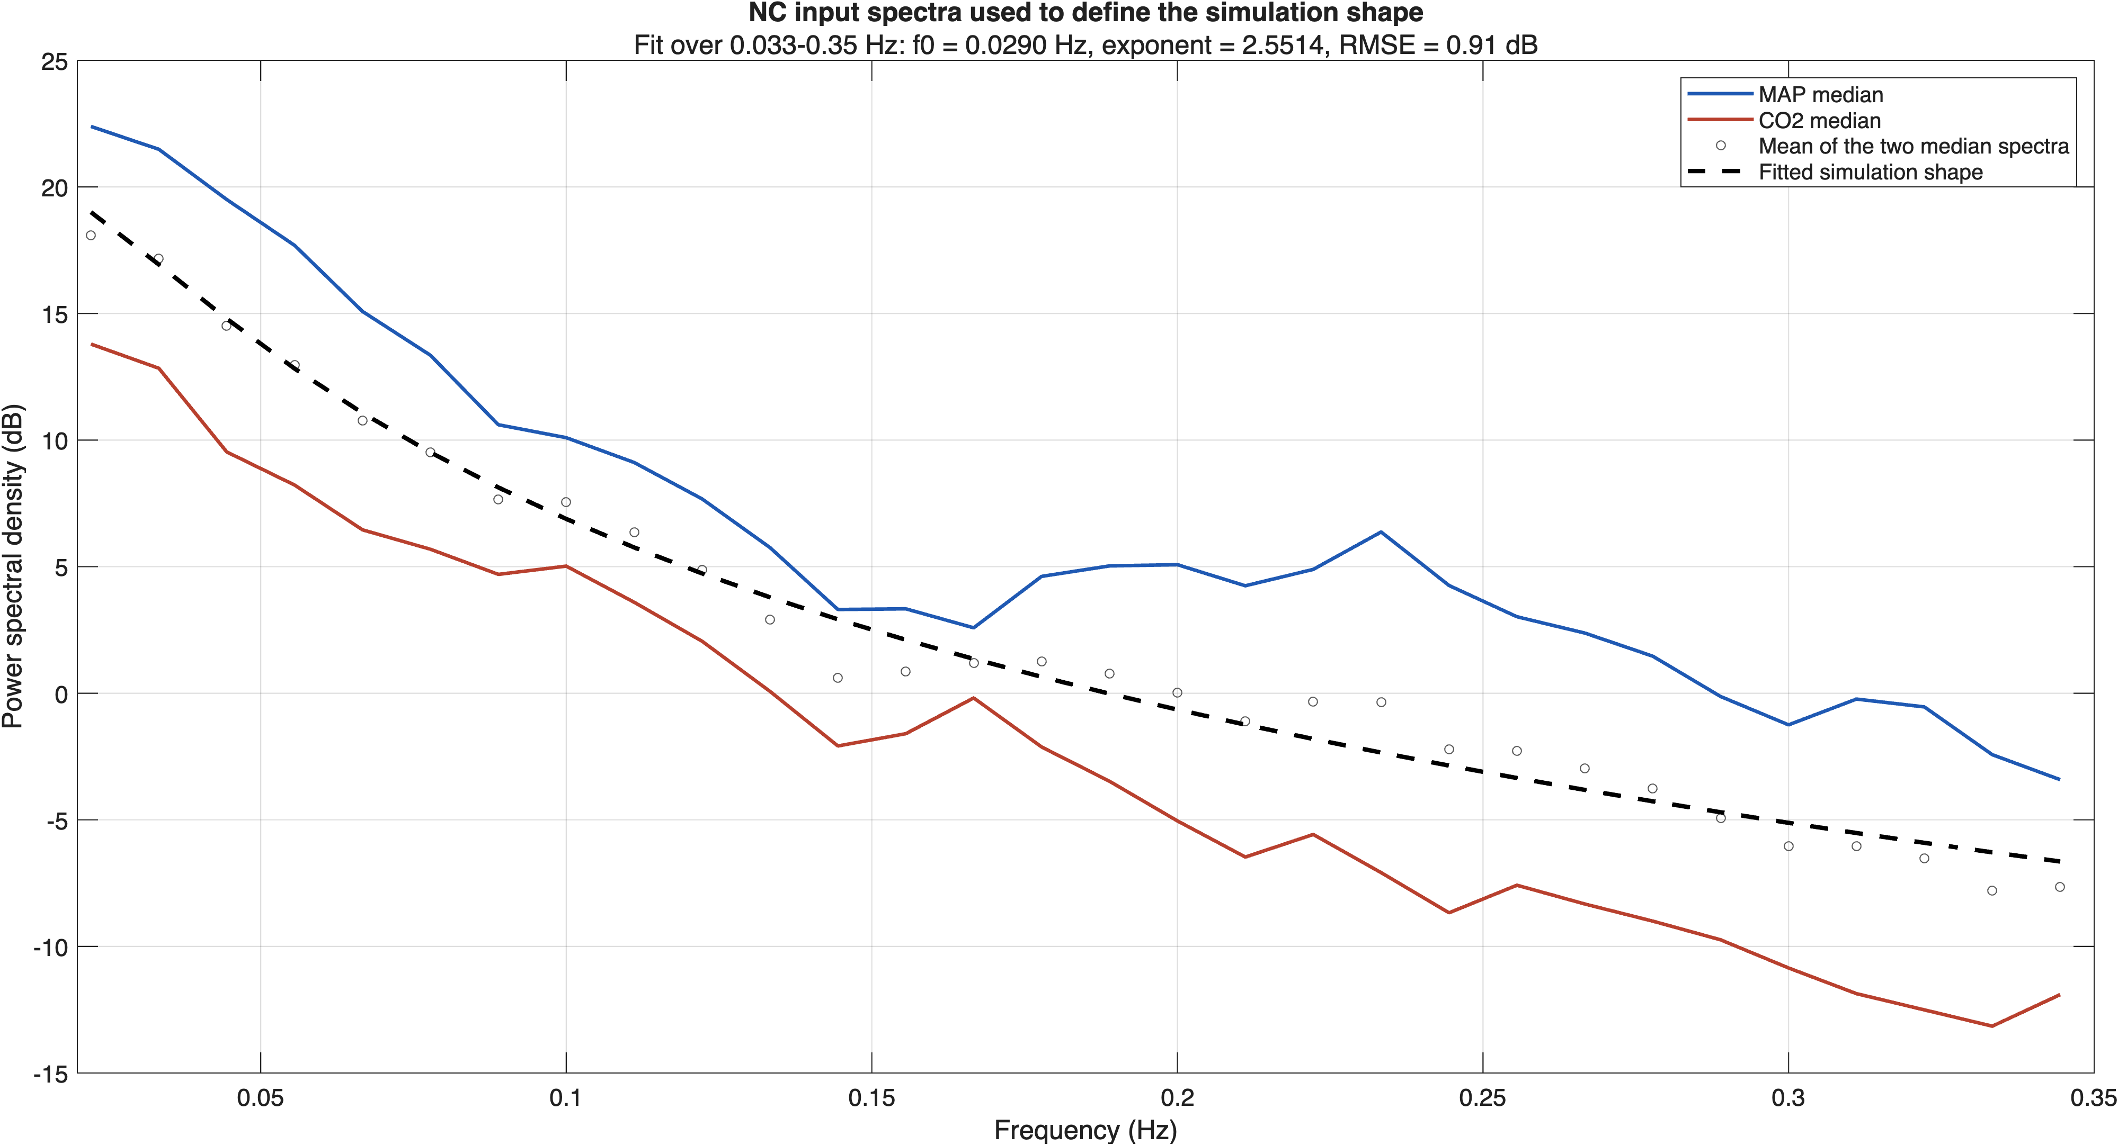
Figure 3. Origin of the simulated input-spectrum shape. Subject-median NC MAP and CO₂ spectra are shown with their fitted monotonic reference shape. The shape controls relative variation across frequency and is not presented as a universal physiological range.

Tested quantities and fixed reference condition
The main heatmaps vary one quantity at a time. Except for the named quantity, primary maps use 300 seconds of data, 10 dB signal-shaped CBFV output noise, MAP–CO₂ input coherence of 0.50, and an assigned CO₂-to-MAP pathway gain ratio of 1. These are declared reference settings, not a claim that they represent universal normal values.
The coherence levels include 0 as an independent-input control, 0.15 as an NC-informed operating level, and 0.50 and 0.95 as stronger dependence tests. The pathway-strength levels are 0, 0.25, and 1. They change the assigned CO₂ response relative to MAP, not the proportion of observed CBFV that must be attributed to CO₂.
The input-lag analysis changes when the shared CO₂ fluctuation occurs relative to MAP before CBFV is generated. It does not independently set MAP–CBFV or CO₂–CBFV phase. The alignment analysis is different: it shifts the recorded CO₂ channel after CBFV has already been generated, representing an acquisition or processing error.
MAP and CO₂ input noise were varied separately, with the other input kept noise-free. CBFV output noise was added to clean CBFV. A white noise check tested whether the primary signal-shaped noise assumption changed the conclusions.
Table 1. Simulation quantities, tested levels, fixed settings, and basis for selecting each level.
Varied quantity | Tested levels | Other settings held fixed | Basis for levels
MAP–CO₂ coherence | 0, 0.15, 0.50, 0.95 | 300 s; 10 dB CBFV SNR; pathway ratio 1 | 0 is an independent-input control; 0.15 is NC-informed; 0.50 and 0.95 are dependence tests
Relative CO₂ pathway strength | 0, 0.25, 1 | 300 s; 10 dB CBFV SNR; coherence 0.50 | Absent, weaker, and equal-gain conditions
Recording duration | 300, 600 s | 10 dB CBFV SNR; coherence 0.50; pathway ratio 1 | Shorter and longer data records
CBFV output SNR | No noise, 10, 0 dB | 300 s; coherence 0.50; pathway ratio 1 | Ideal, moderate, and severe unexplained output variation
MAP–CO₂ input lag | −6, 0, 4 s | 300 s; 10 dB CBFV SNR; pathway ratio 1 | NC-informed timing sensitivity levels
MAP input SNR | No noise, 10, 0 dB | CO₂ clean; 300 s; 10 dB CBFV SNR; coherence 0.50; ratio 1 | MAP recording-quality levels
CO₂ input SNR | No noise, 10, 0 dB | MAP clean; same reference settings | CO₂ recording-quality levels
CO₂ alignment error | −3, 0, 3 s | Both inputs clean; same reference settings | Acquisition and processing robustness check

SISO and MISO estimation
At each frequency, the spectral quantities for MAP and CO₂ play the same role that variances and covariances play in a time-domain regression. The diagonal terms describe input power, the off-diagonal terms describe shared input variation, and the cross terms describe how each input varies with CBFV. These quantities form a 2-by-2 input spectral matrix and a two-entry input–CBFV cross-spectrum.
MISO uses those quantities to estimate both responses at once. It asks how much CBFV is associated with MAP after accounting for CO₂, and how much is associated with CO₂ after accounting for MAP. The matrix equation below is solved separately at each frequency; its two complex coefficients contain both the response size (gain) and the relative timing (phase).
$$\hat{H} = [{S_{xx}}^{-1}] S_{xy}$$ | (6)
For comparison, MAP-only SISO estimates the pairwise MAP–CBFV relationship without conditioning on CO₂. If MAP and CO₂ vary together, the SISO estimate can contain part of the CO₂ response. If they are independent, the population omission term is absent, but finite-record CO₂-driven variation still remains in the MAP-only residual and can make the estimate more variable. In other words, independence removes systematic population mixing, but it does not make the second pathway visible to a model that was never given the second input.
$${\hat{H}}_{m},SISO = H_{m} + H_{c}\frac{S_{cm}}{S_{mm}}$$ | (7)

Coherence diagnostics and paired estimator calls
Ordinary coherence was used for a pairwise check between one input and CBFV. Partial coherence was used to describe the relationship between one input and CBFV after the other input was accounted for. Multiple coherence described the joint relationship between MAP, CO₂, and CBFV. These quantities were reported as diagnostics of the recorded information; none was treated as a substitute for transfer-function recovery accuracy. [3,5]
Code example 3. MATLAB excerpt from analyzeTfaSignals.m
spectra = estimateWelchSpectra( ...
map, co2, cbv, samplingFrequencyHz, pwelchSettings);
misoResults = runMISOTFA( ...
spectra, analysisSettings.phase, analysisSettings.misoSolver);
sisoResults = runSISOTFA( ...
spectra, analysisSettings.phase);

Simulation replicates and uncertainty
A condition is one fixed combination of the assigned coherence, pathway strength, duration, noise, and timing settings. Each condition was repeated with 500 random signal realizations. The exact fluctuations differed between realizations, but the assigned system properties remained the same. SISO and MISO were always paired within the same observed recording. The 500 realizations are therefore repeated samples from one fixed generating system, not 500 different physiological parameter sets.
The paired replicate errors were resampled together 2,000 times. The standard deviation of the resampled advantages estimates the Monte Carlo uncertainty caused by using a finite number of replicates. It is a standard-error estimate for the log ratio of the mean errors at each frequency and factor level. The prespecified target was a maximum standard error of 0.05 advantage units in every finite primary heatmap cell. [8]
The numerical precision audit and the final number of passing heatmap cells will be reported with the simulation results. The Methods protocol therefore states the resampling rule and its target without using the audit as an additional physiological endpoint. [8]
As an implementation check, the expected population SISO mixing error was also calculated directly from the known input spectra and pathways. This verification quantity was not treated as an additional study endpoint.

Held-out NC validation
Each NC recording was divided into three non-overlapping 90-second blocks. Transfer functions were estimated from two blocks and used to predict CBFV in the third. Each block served once as the held-out block. Errors were averaged within each subject, and subjects were resampled 2,000 times to obtain pointwise 95% bootstrap intervals. The NC SISO comparator used MAP alone; MISO used MAP and CO₂. This analysis measures prediction on unseen blocks and does not identify the true human pathways.

Reproducibility
The simulation saved its random seed, settings, exact factor selections, family seeds, source tables, and run manifest. The same settings and seeds regenerate the same input recordings, response kernels, observations, estimates, and figures. The manuscript assets can be rebuilt from the archived numerical outputs without rerunning the full production simulation. [8]
References
[1] Claassen JAHR, Thijssen DHJ, Panerai RB, Faraci FM. Regulation of cerebral blood flow in humans: physiology and clinical implications of autoregulation. Physiol Rev. 2021;101:1487–1559. doi:10.1152/physrev.00022.2020. PMID: 33769101.
[2] Hoiland RL, Fisher JA, Ainslie PN. Regulation of the cerebral circulation by arterial carbon dioxide. Compr Physiol. 2019;9:1101–1154. doi:10.1002/cphy.c180021. PMID: 31187899.
[3] Panerai RB, Brassard P, Burma JS, et al. Transfer function analysis of dynamic cerebral autoregulation: a CARNet white paper 2022 update. J Cereb Blood Flow Metab. 2023;43:3–25. doi:10.1177/0271678X221119760. PMID: 35962478.
[4] Panerai RB, Simpson DM, Deverson ST, Mahony P, Hayes P, Evans DH. Multivariate dynamic analysis of cerebral blood flow regulation in humans. IEEE Trans Biomed Eng. 2000;47:419–423. doi:10.1109/10.827312. PMID: 10743786.
[5] Peng T, Rowley AB, Ainslie PN, Poulin MJ, Payne SJ. Multivariate system identification for cerebral autoregulation. Ann Biomed Eng. 2008;36:308–320. doi:10.1007/s10439-007-9412-9. PMID: 18066666.
[6] Westwick DT, Pohlmeyer EA, Solla SA, et al. Identification of multiple-input systems with highly coupled inputs. Neural Comput. 2006;18:329–355. doi:10.1162/089976606775093855. PMID: 16378517.
[7] Chertoff ME, Billinger SA, Perdomo SJ, et al. A novel nonlinear system identification for cerebral autoregulation in human: computer simulation and validation. Ann Biomed Eng. 2020;48:1207–1217. doi:10.1007/s10439-019-02442-7. PMID: 31873829.
[8] Morris TP, White IR, Crowther MJ. Using simulation studies to evaluate statistical methods. Stat Med. 2019;38:2074–2102. doi:10.1002/sim.8086. PMID: 30652356.
[9] Welch PD. The use of fast Fourier transform for the estimation of power spectra. IEEE Trans Audio Electroacoust. 1967;15:70–73. doi:10.1109/TAU.1967.1161901.
Additional sources retained for later manuscript development
[10] Diehl RR, Linden D, Lücke D, Berlit P. Phase relationship between cerebral blood flow velocity and blood pressure: a clinical test of autoregulation. Stroke. 1995;26:1801–1804. doi:10.1161/01.STR.26.10.1801.
[11] Latka M, Turalska M, Glaubic-Latka M, et al. Phase dynamics in cerebral autoregulation. Am J Physiol Heart Circ Physiol. 2005;289:H2272–H2279. doi:10.1152/ajpheart.01307.2004.
[12] Torrence C, Compo GP. A practical guide to wavelet analysis. Bull Am Meteorol Soc. 1998;79:61–78. doi:10.1175/1520-0477(1998)079<0061:APGWA>2.0.CO;2.
[13] Perreault EJ, Kirsch RF, Acosta AM. Multiple-input, multiple-output system identification for characterization of limb stiffness dynamics. Biol Cybern. 1999;80:327–337.
[14] Marmarelis VZ, Shin DC, Orme ME, Zhang R. Model-based physiomarkers of cerebral hemodynamics in patients with mild cognitive impairment. Med Eng Phys. 2014;36:628–637. doi:10.1016/j.medengphy.2014.02.025.

