CIS 721 - Real-Time Systems Name: _______________________
Quiz #1
Spring 2014

Friday, Feb. 28, 2014

Please show all work on the quiz.

- (30 points) Consider the following set of tasks scheduled using preemptive priority-based scheduling.

Task | Run Time ( e_{i} ) | Period ( p_{i} ) | Deadline ( D_{i} )
A | 8 | 24 | 24
B | 3 | 12 | 12
C | 2 | 8 | 8

- Suppose that the rate monotonic (RM) algorithm is used to assign priorities. In what order would these tasks be prioritized from highest to lowest priority? (Fill in the blanks with A, B, C)

Highest priority: ______, middle priority: ______, lowest priority: ______

- What is the total utilization, U, of all tasks? ___________________________________________. Can Liu and Layland’s Test be used to try to check if the task set is schedulable? ______. If the test can be used, what conclusions, if any, can be made after applying Liu and Layland’s Test? If the test cannot be applied, explain why not. Hint: 3*(2^1/3 – 1) = 0.779763.

- Use Response Time Analysis to determine if the task set is feasible. Show work.

- Draw the Gannt Chart (using the template shown below) showing how the tasks would be scheduled over one hyperperiod.

- (30 points) Consider the following set of tasks scheduled using non-preemptive priority-based scheduling. Assume that the deadline monotonic (DM) algorithm is used to assign priorities.

Task | Run Time ( e_{i} ) | Period ( p_{i} ) | Deadline ( D_{i} )
A | 2 | 5 | 5
B | 2 | 10 | 10
C | 3 | 20 | 9

- In what order would these tasks be prioritized from highest to lowest priority?

Highest priority: ______, middle priority: ______, lowest priority: ______

- What is the worst-case blocking time for each task?

B_{A} = ____________, B_{B} = ____________, B_{C} = ____________

- What conclusions (if any) can be made by applying a Utilization-Based Test to the given task set? Show work.

- Is the task set schedulable based on Response Time (Time-Based) Analysis? Show work.

- (20 points) Preemption Thresholds: Suppose that the task sets shown above in Problems 1 and 2 are scheduled using priority-based scheduling with preemption thresholds.

- What does it mean for a task set to be simply periodic?

Is the task set shown in Problem 1 simply periodic? _______
Is the task set shown in Problem 2 simply periodic? _______

- Is there a particular assignment of priorities and preemption thresholds that makes the task set shown in Problem 1 schedulable using priority-based scheduling? ________ If so, give an assignment using 3=high priority and 1=low priority:

- π_{A} = ________, γ_{A} = ________
- π_{B} = ________, γ_{B} = ________
- π_{C} = ________, γ_{C} = ________

- Is there a particular assignment of priorities and preemption thresholds that makes the task set shown in Problem 2 schedulable using priority-based scheduling? ________ If so, give an assignment using 3=high priority and 1=low priority:

- π_{A} = ________, γ_{A} = ________
- π_{B} = ________, γ_{B} = ________
- π_{C} = ________, γ_{C} = ________

- Briefly describe an optimal algorithm to assign preemption thresholds for a given task set if the priorities are given.

- (20 points) Consider the task set consisting of the following three preemptive, periodic tasks (denoted using the notation τ_{i} = (p_{i}, e_{i}, D_{i})):

τ₁ = (12, 2, 6)
τ₂ = (12, 4, 12)
τ₃ = (24, 5, 12)

The system is to be scheduled and executed using a fixed cyclic schedule.
- Determine an appropriate frame size, and draw a network flow graph that can be used to find a fixed (static) cyclic schedule of the tasks. Hint: Remember to indicate the maximum allowable flows on all edges in the graph. Clearly indicate which nodes represent jobs and which nodes represent frames.

Frame Size = ______

τ₁ = (12, 2, 6)
τ₂ = (12, 4, 12)
τ₃ = (24, 5, 12)

- Suppose that the task set is modified so that τ₁ = (6, 1, 6). Further, suppose that a solution is obtained by using the following input file describing allowable flows in a directed graph, and by passing it as input to the maximum flow algorithm to compute a maximum flow of 17, with the corresponding flow values as shown in the graph:

p max 13 21
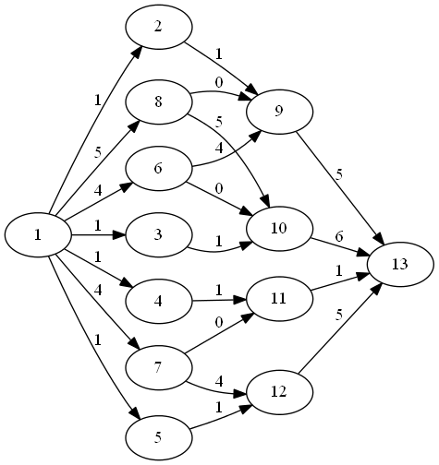
n 1 s
n 13 t
a 1 2 1
a 1 3 1
a 1 4 1
a 1 5 1
a 1 6 4
a 1 7 4
a 1 8 5
a 2 9 6
a 3 10 6
a 4 11 6
a 5 12 6 hi_pr + convert + dot
a 6 9 6
a 6 10 6
a 7 11 6
a 7 12 6
a 8 9 6
a 8 10 6
a 9 13 6
a 10 13 6
a 11 13 6
a 12 13 6

Draw a Gannt Chart showing the corresponding schedule that is represented by these flows.

- Could the same solution be used for part b) if the jobs are non-preemptive? Explain briefly.

