CIS 721 - Real-Time Systems Name: _______________________
Quiz #2 Solution
Spring 2013

Fri., Apr. 26, 2013 (100 points)

- Consider a preemptive, priority-based system consisting of three periodic tasks, A, B, and C, with the following properties:

Task | Run Time ( C_{i} ) | Period (T_{i}) | Deadline (D_{i})
A | 1 | 4 | 4
B | 5 | 12 | 12
C | 9 | 36 | 36

Suppose that tasks are assigned priorities using a rate monotonic priority assignment.

- Is the task set feasible based on a Utilization Based Test? _Yes__. Explain briefly. Hint: 3(2^{1/3} – 1) ≈ 28/36 and 1.0 = 36/36.

The task set is simply periodic, 4 | 36 and 12 | 36, so the schedulable utilization is 1.0.
U = 1/4 + 5/12 + 9/36 = 33/36 <= 1.0, so the task set is feasible.

- Compute the worst-case response time for task B using Response Time Analysis: ______ Show work below.

W_{B}⁰ = 5, W_{B}¹ = 5 + ceil(5/4) * 1 = 7, W_{B}² = 5 + ceil(7/4) * 1 = 7, so WCRT of B = 7.

- Suppose that only task B needs to access a resource X for k time units. What is the maximum value of k that can be used and still ensure that the task set remains feasible if access is controlled using NonPreemptable Critical Sections (NPCS)? _______. Note that k is in the range 0 to 5 because the run-time of task B is 5. Explain briefly.

Using NPCS, task B will block all higher priority tasks when it holds a lock on X for k time units. Since task A can only tolerate up to 3 units of blocking time (it needs one unit to complete its own job), so the maximum value of k is 3.

- Suppose that only task B needs to access a resource X for k time units. What is the maximum value of k that can be used and still ensure that the task set remains feasible if access is controlled using the Original Priority Ceiling Protocol (OPCP)? ________. Explain briefly.

With OPCP, task B will only block tasks that also use the shared resource, so it will have no impact on the other tasks. Thus, task A will be able to preempt task B at any time, and k can be as large as B’s run-time which is 5.

- Consider the following timed automata, Light and User. They communicate via a global channel called tap. Light has a local clock x, User has a local clock y and a location invariant of y<=1000.

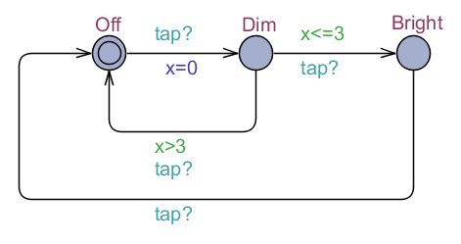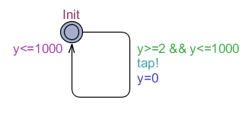
Templates: Light User

// Global Declarations:

chan tap;

// System Declarations

System Light, User;

- Determine which of the following properties are satisfied for the automata shown above; circle all properties that are satisfied, explain briefly why the properties that are not circled are not satisfied: SATISFIED IN RED

- A[] not deadlock
- Light.Off --> Light.Dim
- Light.Dim --> Light.Bright – if the user never clicks within 3 time units, then the light will just go from Off to Dim to Off, etc.
- Light.Bright --> Light.Dim
- E<> (Light.x==1000 and User.y==1000)
- A[](Light.x==2003) imply Light.Off
- E<> (Light.x==2003 and User.y==1000)
- E<> (Light.x==2004) – the max for Light.x is 2003, in Dim for 3, Bright for 1000, and Off for 1000
- A[] (User.y <= Light.x)
- A[] (Light.x <= User.y) – y is reset on each tap, but x is not

- As these automata have two clocks, Light.x and User.y, the reachable state space with respect to the clocks can be viewed as a point in a two-dimensional Cartesian plane, one axis for clock Light.x and one axis for clock User.y. A point (a, b), with non-negative a and b, can be used to denote that clock Light.x equals a and clock User.y equals b. Determine the reachable state space for this automaton; e.g., draw a 2-d graph.

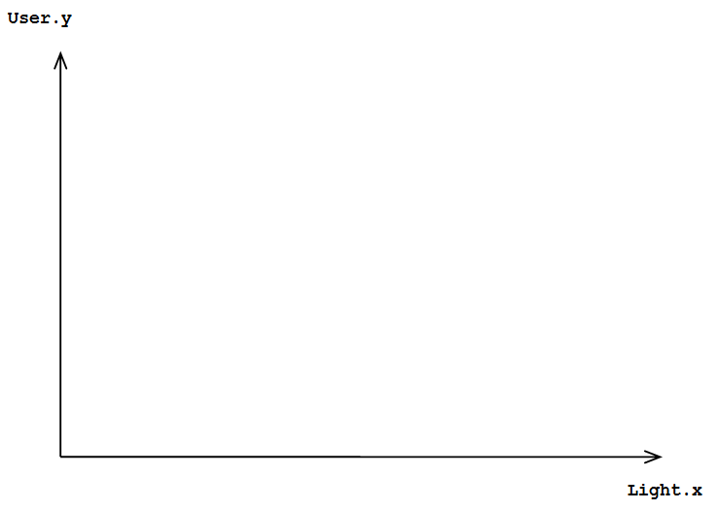
1000
1000
2000
2 3

Fill in the trapezoidal region…

- Consider the following Promela model:

int x,y;

proctype p() {
do
:: (x > y) -> x=x-1; y=y+1;
:: else -> break;
od;
}

proctype q() {
(x == y);
atomic{ x=8; y=2; }
}

init
{
atomic { x=0; y=0; run p(); run q(); }
}

- Proctype p() can be modeled in UPAAL using the following template, draw an equivalent UPAAL template for proctype q(), mark the initial state Init, and the final state Done.
x=8, y=2
Done
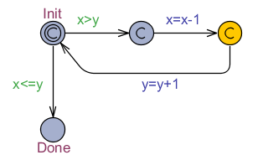
c
x==y

- Will the processes terminate; e.g., is the property A<>(p.Done and q.Done) satisfied? Explain briefly. Yes

- What are the possible final values for x and y? x=5,y=5, or x=8,y=2

- What if the atomic statement is removed around { x=8; y=2; } ? Does your model for proctype q() need to be changed? If so, draw the new model below. Also, in the following list, circle all of the possible final values for x and y: Yes, add another state and transition, the existing transition for x=8, and the new next transition for y=2.
- x=8, y=2
- x=8, y=0
- x=4, y=5
- x=5, y=5
- x=4, y=2
- x=3, y=3

