CIS 721 - Real-Time Systems
Homework #2 Solution
Fall 2015

Due: Friday, September 25, 2015, by 1:20 pm (turn in on paper)

Twenty-five points.

- A system consists of four preemptive, periodic tasks, A, B, C, and D, assigned static priorities using the Rate Monotonic (RM) algorithm, with the following properties:

Task | Run Time ( C_{i} ) | Period ( T_{i} )
A | 1 | 8 (high)
B | 2 | 16
C | 8 | 24
D | 8 | 48 (low)

- What is the total utilization (U) of these four tasks?

U = 1/8 + 2/16 + 8/24 + 8/48 = 1/8 + 1/8 + 1/3 + 1/6 = 3/4 = 0.75

- Does Liu and Layland's Utilization-Based Test ensure that the task set is schedulable? What is the schedulable utilization for these n=4 tasks?

The number of tasks n = 4, so U_{RM} = 4 (2^1/4 – 1) = 0.7568, since U <= U_{RM}, the task set is schedulable.

- What if the run time of task A is increased to 3, is the task set still schedulable? Which test did you use? Show work.

U = 1.0, since U > U_{RM}, Liu and Layland’s Test is inconclusive.

WCRT of task A: R_{A} = 3 <= 8 = D_{A}
WCRT of task B: W_{B}(0) = C_{B} = 2, W_{B}(1) = 2 + ceil(W_{B}(0)/8) * 3 = 5,
W_{B}(2) = 2 + ceil(5/8) * 3 = 5, so R_{B} = 5 <= 16 = D_{B}
WCRT of task C: W_{c}(0) = C_{c} = 8, W_{c}(1) = 8 + ceil(W_{c}(0)/8) * 3 + ceil(W_{c}(0)/16) * 2 = 13,
W_{C}(2) = 8 + ceil(13/8) * 3 + ceil(13/16) * 2 = 16,
W_{C}(3) = 8 + ceil(16/8) * 3 + ceil(16/16) * 2 = 16, so R_{C} = 16 <= 24 = D_{C}
WCRT of task D: W_{D}(0) = C_{D} = 8, W_{D}(1) = 8+ceil(8/8)*3+ceil(8/16)*2+ceil(8/24)*8 = 21,
W_{D}(2) = 8+ceil(21/8)*3+ceil(21/16)*2+ceil(21/24)*8 = 29,
W_{D}(3) = 8+ceil(29/8)*3+ceil(29/16)*2+ceil(29/24)*8 = 40,
W_{D}(4) = 8+ceil(40/8)*3+ceil(40/16)*2+ceil(40/24)*8 = 45,
W_{D}(5) = 8+ceil(45/8)*3+ceil(45/16)*2+ceil(45/24)*8 = 48,
W_{D}(6) = 8+ceil(48/8)*3+ceil(48/16)*2+ceil(48/24)*8 = 48, so R_{D} = 48 <= 48 = D_{D}

- As in (c), if the run time of task A is 3, draw a Gannt Chart to show how these tasks would be scheduled using the rate monotonic scheduling algorithm in the interval [0, 48]. Does checking the tasks over this interval ensure that the task set is feasible? Yes If not, what is the minimum interval length that must be checked to ensure that the task set is schedulable? Explain briefly. Since the tasks all have a common release time of 0, we only need to check over one hyperperiod H = lcm(8, 16, 24, 48) = 48.
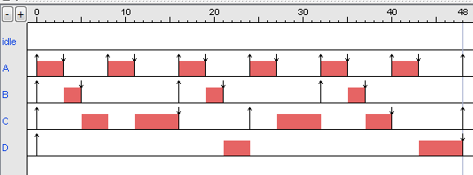
- Which of the following task sets are schedulable if priorities are assigned using the rate-monotonic algorithm? Which of the following task sets are simply periodic? Justify your answer – specify which test(s) you used and show work.

(a) Schedulable, Not Simply Periodic, apply Response Time Analysis, R_{A} = 3, R_{B} = 5, R_{C} = 18, or Leung’s Test over one hyperperiod [0,36]:

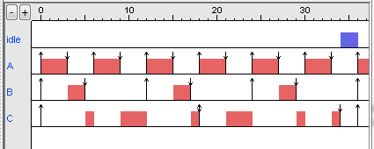
 | Run Time ( C_{i} ) | Period ( T_{i} )
A | 3 | 6
B | 2 | 12
C | 5 | 18

(b) Schedulable, Simply Periodic, U = 2/5 + 3/10 + 6/20 = 1.0 <= 1.0 via Utilization-Based Test.
 | Run Time ( C_{i} ) | Period ( T_{i} )
A | 2 | 5
B | 3 | 10
C | 6 | 20

(c) Not Schedulable, Not Simply Periodic, Utilization-Based Test, U = 4/8 + 2/10 + 3/14 < 1.0, but U > U_{RM} => inconclusive. Apply Response Time Analysis or Leung’s Test:

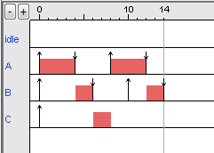
WCRT_{C}: W_{C}(0) = 3, W_{C}(1) = 3 + ceil(3/8) * 4 + ceil(3/10) * 2 = 9,
W_{C}(2) = 3 + ceil(9/8) * 4 + ceil(9/10) * 2 = 13,
W_{C}(3) = 3 + ceil(13/8) * 4 + ceil(13/10) * 2 = 15 > D_{C} => not feasible.

 | Run Time ( C_{i} ) | Period ( T_{i} )
A | 4 | 8
B | 2 | 10
C | 3 | 14

- A set of n independent, preemptable periodic tasks with relative deadlines equal to their respective periods are schedulable rate-monotonically if their utilizations u₁, u₂, ... , u_{n} satisfy the inequality (1 + u₁)(1 + u₂) ... (1 + u_{n}) <= 2.

  - Show that this test is strictly stronger than Liu and Layland's Utilization-Based Test.

First, we need to show that it is as strong as Liu and Layland’s Test, and then we just need a single example that satisfies the new test, but does not satisfy Liu and Layland’s Test to show “strictly” stronger than. Such an example is shown below in 3(b), U = 0.84 > U_{RM} so it doesn’t satisfy Liu and Layland’s Test, but it does satisfy the new test and is consequently feasible.

So, assume that a given task set satisfies Liu and Layland’s Test; e.g., U <= U_{RM}. Then, U = u₁ + u₂ + .. + u_{n} <= n (2 ^{1/n} -1).

We want to show that (1 + u₁)(1 + u₂) ... (1 + u_{n}) <= 2.

Since the sum, u₁ + u₂ + .. + u_{n} equals some constant U, we know that the product
(1 + u₁)(1 + u₂) ... (1 + u_{n}) <= (1+U/n)(1+U/n) .. (1+U/n) = (1+U/n)^{n}; that is, replacing each u_{i} with the average over all i will result in a product that is at least as large as the original.

Since U <= n (2 ^{1/n} -1), (1+U/n) <= (1 + n (2 ^{1/n} -1)/n) = 1 + 2 ^{1/n} - 1 = 2 ^{1/n}

So, (1+U/n)^{n} <= (2 ^{1/n})^{n} = 2. Finally, by the transitive property, we have the desired result
(1 + u₁)(1 + u₂) ... (1 + u_{n}) <= 2.

  - Apply both tests to a task set consisting of five periodic tasks with processor utilizations given by u₁ = 0.8, u₂ = u₃ = u₄ = u₅ = 0.01. What conclusions can be drawn?

U = 0.84, U_{RM} = 5(2^{1/5} – 1) = 0.74349.., so Liu and Layland’s Test is INCONCLUSIVE.
BUT,
(1 + u₁)(1 + u₂) ... (1 + u_{n}) = 1.8*1.01*1.01*1.01*1.01 = 1.873087.. <= 2, so by the new test, the task set is feasible!

NOT REQUIRED: Example feasible task set: (5, 4), (100, 1), (200, 2), (300, 3), (400, 4)

