CIS 721 - Real-Time Systems
Homework #5
Fall 2015

Due: Friday, Nov. 20, by 11:59 pm

Twenty-five points. Please upload your solutions and associated SPIN models via K-State OnLine.

- Construct a Promela model for the following Petri Net. In a Petri Net, a transition (ti) is enabled if all places (pi) immediately preceding the transition contain at least one token. Among all of the enabled transitions, one is non-deterministically selected and fired. When a transition is fired, one token is removed from each place before the transition and a single token is placed in each place after the transition. For example, transition t1 is enabled in the figure shown below. If t1 is fired, a token is removed from p1 and tokens are added to places p3 and p4. Then, t1, t3, and t4 are all enabled. If t4 fires, a token in p4 is removed and a token is added to p6, so then t6 is also enabled. Note that the system is initialized with two tokens in p1, and a single token in places p3 and p4 (as shown below).

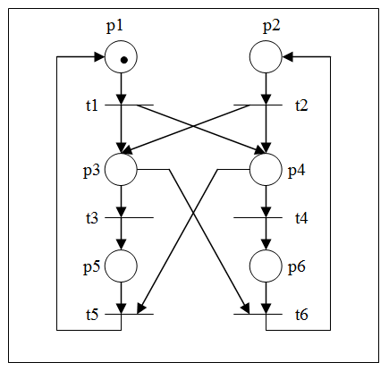

Construct a Promela model of the Petri Net.

  - Describe how you would test the model for deadlock using SPIN. If deadlock is possible, describe how the system could deadlock.

  - Can places p1 and p2 contain a token at the same time? Show how you would verify your conclusion.

  - What is an upper bound on the total number of tokens in the system if the system is initialized as shown above? Show how you would verify your conclusion.

- Translate the above problem into a model using UPPAAL. Complete steps (a) – (c) above using the verifier in UPPAAL. Specify the queries used and the results obtained.

