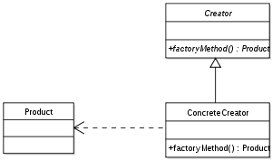
Factory Method
implement the concept of factories and deals with the problem of
creating objects (products) without specifying the exact class of object
that will be created.

Template Method
a behavioral design pattern that defines the program skeleton
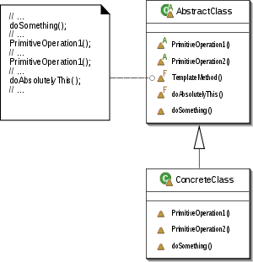
of an algorithm in a method, called template method, which
defers some steps to subclasses. It lets one redefine certain
steps of an algorithm without changing the algorithm's structure

Adaptor
a design pattern that translates one interface for a class into
a compatible interface.[1] An adapter allows classes to work
together that normally could not because of incompatible
interfaces, by providing its interface to clients while using the original interface.
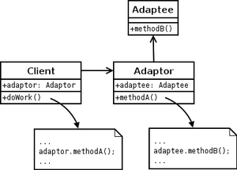

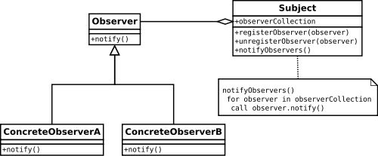
Observer
a software design pattern in which an object,
called the subject, maintains a list of its dependents,
called observers, and notifies them
automatically of any state changes,
usually by calling one of their methods

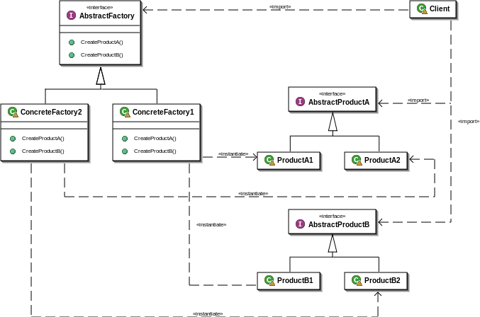
Abstract Factory
provides a way to encapsulate a group of
individual factories that have a common
theme without specifying their
concrete classes

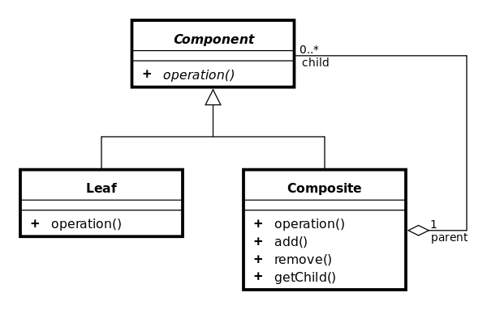
Composite
a partitioning design pattern. The composite pattern
describes that a group of objects are to be treated in the
same way as a single instance of an object. The intent of
a composite is to "compose" objects into tree structures
to represent part-whole hierarchies

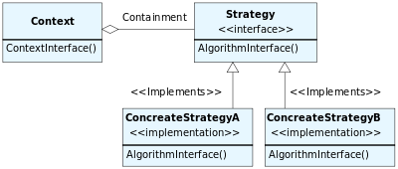
Strategy
a particular software design pattern, where
by an algorithm's behaviour can be selected
at runtime. Formally speaking, the strategy
pattern defines a family of algorithms, encapsulates
each one, and makes them interchangeable

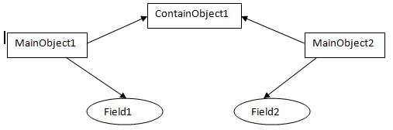
- Shallow Copy
Shallow copy is a bit-wise copy of an object. A new object
is created that has an exact copy of the values in the original
object. If any of the fields of the object are references to other objects, just
the reference addresses are copied i.e., only the memory address is copied.
- Deep Copy
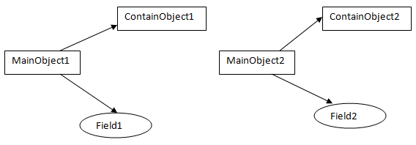
A deep copy copies all fields, and makes copies of dynamically allocated memory pointed to by the fields. A deep copy occurs when an object is copied along with the objects to which it refers.

