COMMUNITY ENGAGEMENT PROJECT
Nutrition and Health Tracking App for Community Use
A Community-Oriented Web Application
Vidya Vardhini Annasaheb Vartak College of Science & Commerce,
Vasai (W) – 401202

Department of Information Technology
Bachelor of Science in Information Technology (B.Sc. IT)
Academic Year: 2026–2027
Submitted by
Anushka Mhatre – Roll No. 113
Under the Guidance of:
Mrs Shital Rode

____________________________

VIDYAVARDHINI’S
ANNASAHEB VARTAK COLLEGE OF ARTS, KEDARNATH MALHOTRA COLLEGE OF COMMERCE,
E. S. ANDRADES COLLEGE OF SCIENCE
(Affiliated to University of Mumbai)
VASAI -MAHARASHTRA
401202
DEPARTMENT OF INFORMATION TECHNOLOGY

CERTIFICATE

This is to certify that Mr./Ms. ________________________________, student of Bachelor of Science in Information Technology (B.Sc. IT), Vidya Vardhini Annasaheb Vartak College of Science & Commerce, Vasai (W) – 401202, has completed the Community Engagement Project titled “Nutrition & Health Tracking App for Community Use” during the academic year 2026–2027. The work presented in this report is submitted as part of the academic requirements of the Community Engagement Project.

Internal Guide: ____________________
Head of Department: ____________________
STUDENT'S DECLARATION
I hereby declare that the Community Engagement Project titled “Nutrition & Health Tracking App for Community Use” has been completed by me as a part of the Community Engagement Project requirements.
The project was developed with the objective of understanding the health tracking, dietary recording, and nutritional awareness challenges faced by members of the local community. The project involved interaction with local residents, health volunteers, and families, understanding their daily food logging habits, and developing a software-based solution tailored to their needs.
The information and observations included in this report are based on the project work and community interactions carried out during the project.
Anushka Bharat Mhatre (Roll No. 113)
Signature: ____________________
Date: __________

ACKNOWLEDGEMENT
I would like to express my sincere gratitude to my college and faculty mentor for providing me with the opportunity to work on this Community Engagement Project.
I am thankful to my mentor, Prof. Shital Rode, for providing guidance, suggestions, and support throughout the project. Their insights helped me understand how classroom software development concepts can be applied to solve real-life health awareness problems.
I would also like to thank the local community members and health volunteers who interacted with us and shared their experiences regarding daily dietary habits, water intake practices, and health monitoring difficulties. Their responses helped us understand the grassroots health challenges and guided us in designing the application.
I am grateful to my classmates and peers who supported me during the development, testing, and demonstration of the software.
Finally, I thank Vidya Vardhini Annasaheb Vartak College of Science & Commerce for offering this practical community-oriented initiative.

ABSTRACT
Many individuals in local communities maintain their daily dietary habits without structured record-keeping or nutritional tracking. Traditional health tracking methods, when practiced at all, rely on manual memory or paper logs, which become difficult to maintain continuously. Commercial health applications often cater to urban populations with complex English-only interfaces, global food databases, and subscription paywalls, excluding many local residents.
The purpose of this Community Engagement Project was to understand such difficulties faced by community members and develop a simplified Nutrition & Health Tracking App for Community Use. The project focuses on providing an accessible digital platform through which community members can record daily meals, track macronutrients, monitor water consumption, and access localized community health announcements.
The developed system provides features such as user registration and profile onboarding with Body Mass Index (BMI) calculations, meal logging across distinct meal types (Breakfast, Lunch, Snacks, Dinner), custom meal additions, a single-tap hydration counter, a 7-day calorie analytics chart powered by Recharts, day-streak gamification, a real-time Community Health Bulletin, and multi-language support in English, Hindi, and Marathi.
The application was built using a full-stack web architecture with React.js for the user interface, Node.js and Express.js for RESTful API orchestration, and SQLite3 for embedded data persistence. Through the community engagement process, the project demonstrated how simple, localized digital health tools can encourage preventive self-care and strengthen community health awareness.

TABLE OF CONTENT

Chapter No. | Particulars / Chapter Name | Page No.
 | ABSTRACT
 | LIST OF FIGURES
 | LIST OF TABLES
Chapter 1 | Introduction
1.1 | Purpose of the Visit
1.2 | Background Information & Problem Statement
1.3 | Scope of the Report
Chapter 2 | Literature Review
2.1 | Preventive Healthcare and Self-Monitoring
2.2 | Digital Health Literacy in Grassroots Communities
2.3 | Evaluation of Existing Commercial Health Applications
2.4 | Need for a Localized and Simple Health Tracking Platform
Chapter 3 | Methodology
3.1 | Community Interaction & Data Collection
3.2 | Software Development Life Cycle (SDLC)
3.3 | Technologies Used
3.4 | Testing and Demonstration
Chapter 4 | Description of Community Interactions, Observations and Analysis
4.1 | Community Interaction
4.2 | Observations
4.3 | System Architecture, Database Schemas & Analysis
Chapter 5 | Conclusion and Recommendations
5.1 | Conclusion
5.2 | Key Findings
5.3 | Recommendations
 | REFERENCES
 | APPENDICES

LIST OF FIGURES
Figure No. | Figure Name | Page No.
Figure 1 | Project Development Approach
Figure 2 | System Architecture Diagram
Figure 3 | User Registration and BMI Onboarding Screen
Figure 4 | User Profile Update Modal
Figure 5 | Multilingual Calorie & Water Tracker Interface
Figure 6 | Custom Food Addition Modal
Figure 7 | 7-Day Calorie Analytics Visualizer (Recharts)
Figure 8 | Community Health Bulletin & Posting Board
Figure 9 | Multi-Language Toggle (English / Hindi / Marathi)
Figure 10 | Community Interaction and Field Demonstration

CHAPTER 1: INTRODUCTION

1.1 Purpose of the Visit
The primary purpose of this Community Engagement Project was to interact directly with local community members, families, and health volunteers to understand their daily habits regarding nutrition tracking, hydration, and general health management.
Many community members execute daily tasks without tracking their calorie consumption or macronutrient intake. While basic health metrics like weight and BMI directly influence long-term wellness, individuals often lack simple tools to calculate or track these metrics regularly.
The project focused on identifying these practical health monitoring gaps and developing a full-stack digital solution tailored to the technical literacy levels of everyday community users.
The main objectives of the project were:
- To observe daily dietary recording habits across local households.
- To evaluate awareness levels regarding daily calorie requirements, protein/carb ratios, and hydration.
- To identify barriers in using existing commercial health tracking mobile applications.
- To design and implement a web application featuring localized dietary presets, water logging, and multi-language support (English, Hindi, Marathi).
- To provide a Community Bulletin board for sharing local health drives and announcements.
- To demonstrate the software to community users and gather feedback regarding ease of use and practical relevance.

1.2 Background Information
Maintaining nutritional awareness is a critical factor in preventive community healthcare. Lifestyle disorders such as diabetes, anemia, unexpected weight gain, and hypertension often arise from unmonitored daily dietary habits.
In local communities across Vasai and Virar, dietary routines are centered around regional Indian meals (e.g., Roti, Dal, Rice, Poha, Sabzi). However, most modern health software features Western meal databases and complex tracking metrics, creating friction for local users.
Problem Statement
The absence of accessible, localized health tracking tools leads to:
- Lack of awareness regarding daily calorie consumption versus expenditure.
- Inability to easily calculate or monitor Body Mass Index (BMI).
- Irregular water intake monitoring.
- Language barriers on health platforms that lack Hindi or Marathi options.
- Disconnect between local health administrators/volunteers and community residents regarding medical drives or awareness campaigns.
Developing a free, simple web application bridges this gap by enabling residents to manage their personal health metrics while staying connected to community health updates.

1.3 Scope of the Report
The Nutrition & Health Tracking App is designed for community adoption across diverse age groups.
The primary functional scope includes:
- User Authentication & BMI Onboarding: Profile setup calculating BMI automatically based on user height and weight.
- Daily Meal & Macro Tracker: Categorized logging for Breakfast, Lunch, Snacks, and Dinner with auto-calculated total calories, carbs, proteins, and fats.
- Custom Food Management: Options to add custom regional dishes directly into the user database.
- Hydration Counter: Single-tap water logging with visual progress tracking toward daily glass targets.
- 7-Day Analytics Visualizer: Interactive weekly bar chart powered by Recharts displaying calorie intake trends over time.
- Community Bulletin: Real-time announcement board allowing health workers to post awareness drives and health notices.
- Multilingual Interface: Toggle support between English, Hindi, and Marathi for all key navigation titles and actions.

CHAPTER 2: LITERATURE REVIEW
2.1 Preventive Healthcare and Self-Monitoring
Preventive healthcare emphasizes early intervention and self-awareness before chronic health conditions develop. Academic studies indicate that routine self-monitoring of daily calorie intake and fluid consumption significantly improves health self-efficacy. When individuals track their intake, they make more informed decisions regarding portion sizes and diet quality.
2.2 Digital Health Literacy in Grassroots Communities
A significant challenge in community health tech adoption is digital health literacy. Complex interfaces with multi-nested menus discourage long-term usage among users who are not tech-savvy. Simplifying data entry to basic dropdowns and single-click buttons improves user retention and daily compliance.
2.3 Evaluation of Existing Commercial Health Applications
Commercial health tools (e.g., MyFitnessPal, HealthifyMe) provide extensive feature sets but suffer from limitations when deployed in localized community contexts:
- Paywalls: Advanced charts, streak logs, and custom macro targets are often restricted behind paid tiers.
- Monolingual Focus: Primary interfaces are in English, excluding non-English speaking demographic segments.
- Database Irrelevance: Default search results frequently prioritize foreign packaged foods over local regional home-cooked meals.
2.4 Need for a Localized and Simple Health Tracking Platform
To maximize grassroots adoption, a community health platform must prioritize:
- Native language translation (English, Hindi, Marathi).
- Local Indian dish presets.
- Clean layout without advertisement clutter or paywalls.
- Integration of community health communications alongside individual tracking.

CHAPTER 3: METHODOLOGY

3.1 Community Interaction & Data Collection

The community interaction phase was conducted to gather real-world requirements from target users in local neighborhoods.

Questions were asked regarding:
- How daily meals and dietary habits are monitored.
- Familiarity with concepts like Body Mass Index (BMI) and calorie goals.
- Willingness to use smartphone/computer interfaces for daily health logging.
- Preferred primary languages for software navigation.
- How local health drives or medical checkup information is currently received.

Community Interaction Details:
- Number of Community Locations Visited: 4
- Date(s) of Interaction: 05/10/2026 & 0/10/2026
- Location: Nallasopara
- Target Audience: Local households, community centers, and health volunteers
- Number of Individuals Interviewed: 4

3.2 Software Development Method

The project followed an iterative software engineering approach:

Stage 1 – Requirement Identification & Surveys
The problem and requirements of the intended users were studied.

Stage 2 – Architecture & Database Schema Design
The major modules of the application were identified.

Stage 3 –Full-Stack Development (React + Express)
The backend, frontend and database components were developed.

Stage 4 – Integration & Unit/System Testing
Different functions such as adding products, billing and stock management were tested.

Stage 5 – Field Demonstration & Community Feedback
The application was demonstrated to users to understand whether the system was simple and useful.
Feedback was collected and observations were recorded for future improvements

3.3 Technologies Used
Technology | Purpose
React.js | Single Page Application (SPA) frontend interface
Node.js | JavaScript runtime environment for server-side logic
Express.js | Web framework for REST API endpoints
SQLite3 | Embedded relational database engine (nutrition.db)
Recharts | Interactive chart visualization library for weekly calorie trends
Lucide React | Scalable UI icon components
Bcrypt.js | Password hashing for secure user storage
JSON Web Token (JWT) | Secure session authentication

3.4 Testing and Demonstration

Testing was conducted across all core modules prior to community demonstration:
- User account registration, login, and JWT validation.
- Automated BMI recalculation upon updating height/weight in user profile.
- Meal logging, quantity multiplication, and macro summation.
- Custom dish creation and backend synchronization.
- Hydration counter increment/reset functions.
- 7-day analytics chart aggregation logic.
- Bulletin board announcement posting and feed updates.
- Instant language switching across English, Hindi, and Marathi.

CHAPTER 4: DESCRIPTION OF COMMUNITY INTERACTIONS, OBSERVATIONS AND ANALYSIS
4.1 Community Interaction
Field interactions were conducted in local community settings in Vasai-Virar. The target audience included local residents and health volunteers.
During these sessions, participants were interviewed about their current diet logging methods, awareness of daily calorie needs, and preference for digital tools. The live Nutrition & Health Tracking App was demonstrated on a portable laptop setup, walking users through account creation, logging breakfast items (e.g., Poha, Chapati), updating water intake, viewing weekly calorie trends, and reading community announcements.

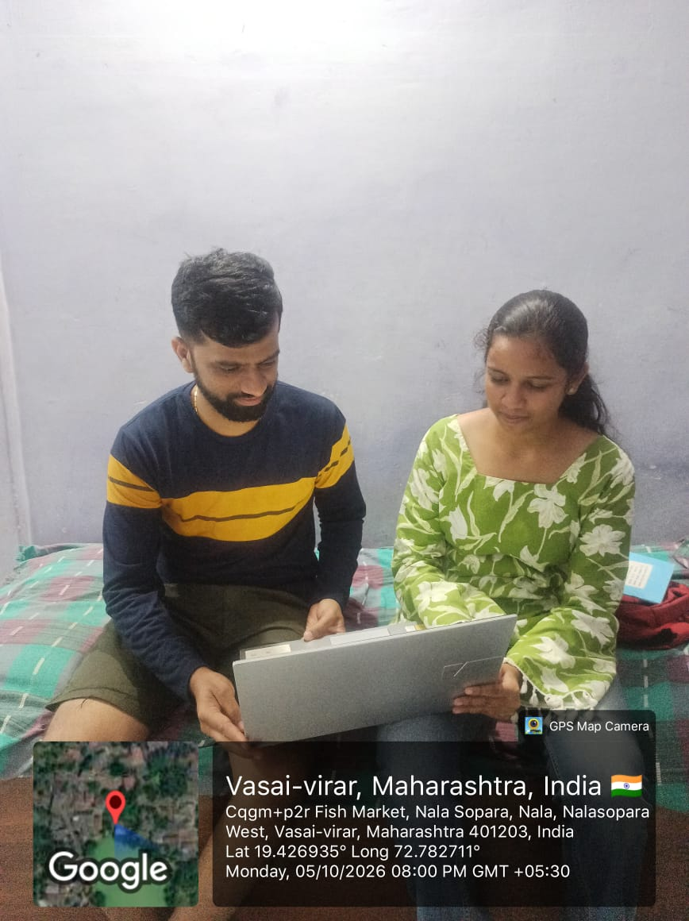
Figure 4.1: Demonstration of the Nutrition & Health Tracking App to local community members in Nallasopara
4.2 Observations
The following observations should be completed using your actual community interaction.
Observation Area | Manual / Existing Method | Observed Finding / Feedback on Proposed System
Dietary Logging | No logging or informal memory | App simplifies entry via preset dropdowns in local language.
BMI Awareness | Unaware or manual formula lookup | App calculates BMI instantly on registration and profile updates.
Water Tracking | Unmonitored | Single-tap glass counter makes hydration tracking effortless.
Community Notices | Paper flyers or word of mouth | Digital bulletin allows immediate access to health camp notices
Language Accessibility | English-only mobile apps | Hindi and Marathi translations make navigation natural.
System Usability | N/A | Interface rated simple and intuitive by non-technical users.
4.3 System Architecture & Database Schemas
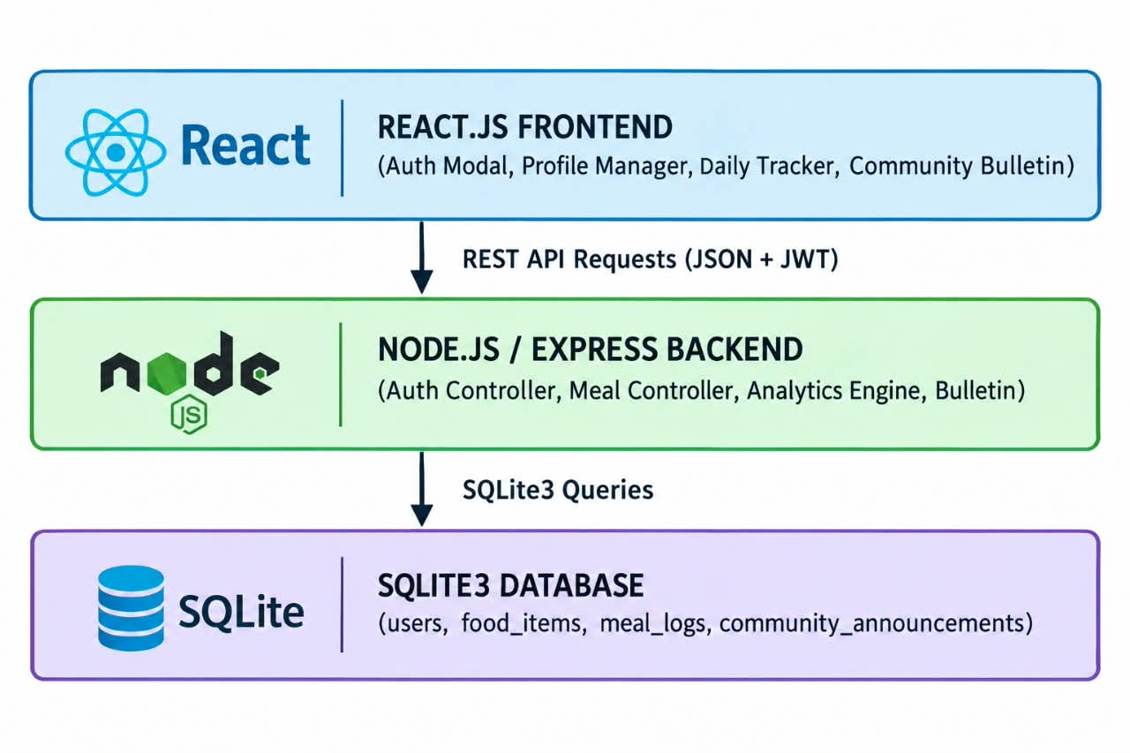

CHAPTER 5: CONCLUSION AND RECOMMENDATIONS
5.1 Conclusion
The Community Engagement Project provided an opportunity to connect software development skills with a real-world community health challenge.
The developed Nutrition & Health Tracking App for Community Use delivers a simple, accessible digital platform for daily dietary monitoring, water intake tracking, BMI management, and community health notice sharing.
By eliminating paywalls, prioritizing regional language options, and organizing features logically, the project demonstrates how localized software solutions can promote preventive self-care at the grassroots level.

5.2 Key Findings
The major findings of the project were:
  - Simple digital interfaces significantly reduce technical friction for non-tech-savvy users.
  - Multilingual support (Hindi/Marathi) is essential for broad community adoption.
  - Preset regional food databases streamline daily meal logging.
  - Automated BMI calculation helps users monitor basic health parameters effortlessly.
  - Combining health tracking with a Community Bulletin creates a unified channel for health workers and residents.

5.3 Recommendations
1. Regular Data Updates: Maintain and expand the food database with additional regional dish presets.
2. Mobile Application Build: Package the React web client into a mobile app (PWA/React Native) for offline tracking.
3. Micro-Nutrient Extension: Add tracking options for essential vitamins and minerals (e.g., Iron, Calcium).
4. Health Worker Roles: Implement dedicated administrative roles for verified community health volunteers to publish official health notices

REFERENCES

- World Health Organization (WHO), "Preventative Community Health and Nutrition Guidelines," WHO Technical Report Series, 2023.
- React Documentation, "Building Interactive Single Page Applications," Meta Open Source, 2025.
- Express.js API Reference, "Routing and Middleware Architecture in Node.js," OpenJS Foundation, 2025.
- SQLite Architecture Documentation, "In-Process Relational Database Management," SQLite Development Team, 2024.
- MDN Web Docs, "JavaScript and Modern Web Application Concepts," Mozilla Developer Network, 2025.
- Community Fieldwork Notes & Survey Responses, Nallasopara Community Interactions, October 2026.

APPENDICES
Appendix A – Community Interaction Photographs
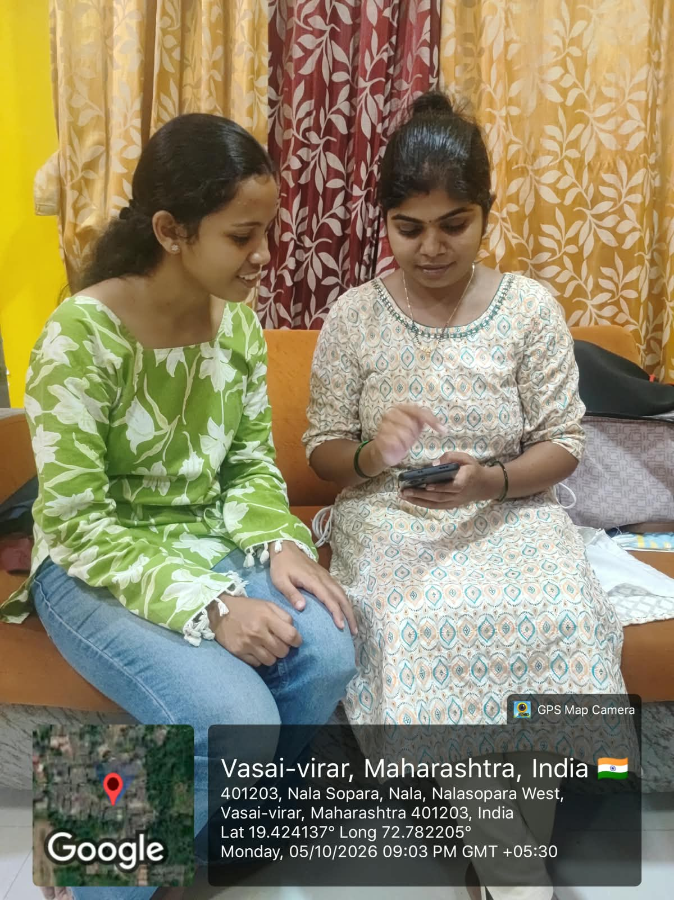
Figure 1: Interaction with community
Appendix B – Application Pages