Test one: menuChoices()

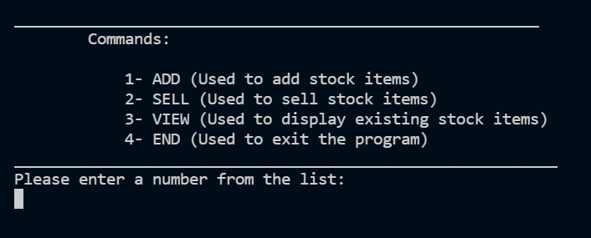

|  |  |  |
| --- | --- | --- |
| Test Case | Purpose | Result |
| hhhh | Test if program can handle string input instead of integer | Error message and new prompt |
| 5 | Test if program can distinguish invalid integers from valid ones | Error message and new prompt |
| 1 | Test if program carries on to ADD() when 1 is input | Program carries on to ADD() |
| 2 | Test if program carries on to SELL() when 2 is input | Program carries on to SELL() |
| 4 | Test if program ends when 4 is input | Program ended |

Test two: Item Code

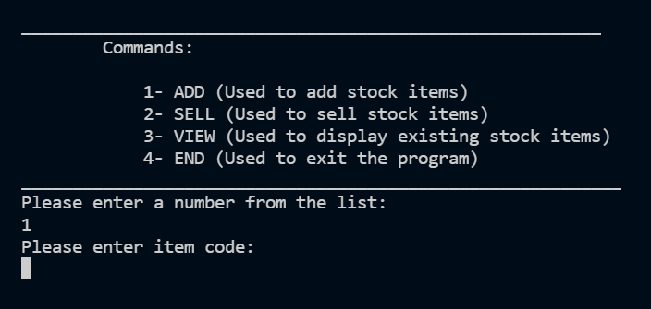

|  |  |  |
| --- | --- | --- |
| Test Case | Purpose | Result |
| computer | Test if program accepts string | Program carries on |
| huh,, | Test if program will accept an entry with a comma, which can ruin the .txt file | Error message and new prompt |
| 1 | Test if program accepts singular numbers | Program carries on |
| 12345678910 | Test upper bound for max length (10) | Error message and new prompt |
| 12345567891 | Test upper bound for max length (10) | Program carries on |
|  | Test if program will accept null for code | Error message and new prompt |
| MG6677 | Test a code which is a mix of letters and numbers, just like real codes | Program carries on |

Test Three: Item Name

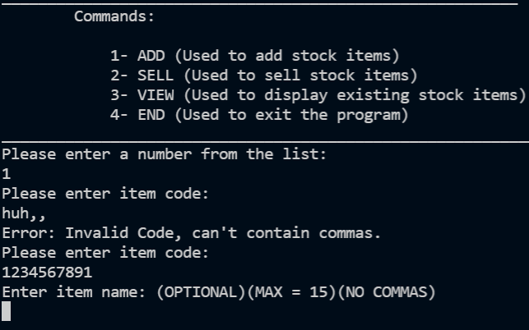

|  |  |  |
| --- | --- | --- |
| Test Case | Purpose | Result |
| Air Freshner | Test if program accepts string | Program carries on |
| Nice,, | Test if program will accept an entry with a comma, which can ruin the .txt file | Error message and new prompt |
| 1 | Test if program accepts singular numbers | Program carries on |
| AAAAAAAAAAAAAAAA | Test upper bound for max length (15) | Error message and new prompt |
| AAAAAAAAAAAAAAA | Test upper bound for max length (15) | Program carries on |
|  | Test if program will accept null for code | Program carries on |

Test Four: Item Description

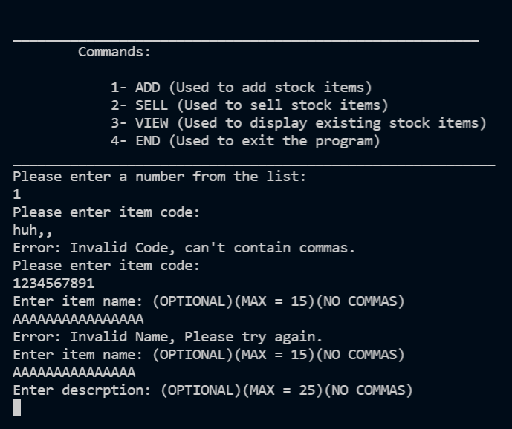

|  |  |  |
| --- | --- | --- |
| Test Case | Purpose | Result |
| It freshens air | Test if program accepts string | Program carries on |
| It’s pretty good, have a try | Test if program will accept an entry with a comma, which can ruin the .txt file | Error message and new prompt |
| 1 | Test if program accepts singular numbers | Program carries on |
| AAAAAAAAAAAAAAAAAAAAAAAAA | Test upper bound for max length (25) | Error message and new prompt |
| AAAAAAAAAAAAAAAAAAAAAAAA | Test upper bound for max length (25) | Program carries on |
|  | Test if program will accept null for code | Program carries on |

Test Five: Item Type Input

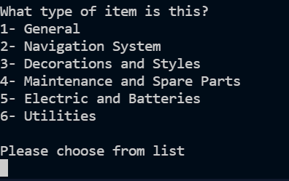

|  |  |  |
| --- | --- | --- |
| Test Case | Purpose | Result |
| 1 | Test if program accepts number on the list | Program carries on |
| 2 | Test if program will identify another number on the list | Program carries on and instance of NavSys is created |
| red | Test if program accepts string | Error message and new prompt |
| 7 | Test if an incorrect integer will be rejected | Error message and new prompt |

Test Six: Item Price input

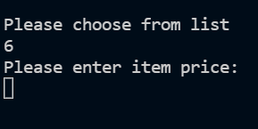

|  |  |  |
| --- | --- | --- |
| Test Case | Purpose | Result |
| bristol | Test if program accepts string | Error message and new prompt |
| 0 | Test if program will accept 0 | Error message and new prompt |
| -2 | Test if program will accept negative number | Error message and new prompt |
| 7 | Test if an integer is accepted | Program carries on |

Test Seven: Quantity

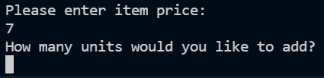

|  |  |  |
| --- | --- | --- |
| Test Case | Purpose | Result |
| bristol | Test if program accepts string | Error message and new prompt |
| 0 | Test if program will accept 0 | Error message and new prompt |
| -2 | Test if program will accept negative number | Error message and new prompt |
| 7 | Test if an integer is accepted | Program carries on |

Test Eight: Identifying Existing Items

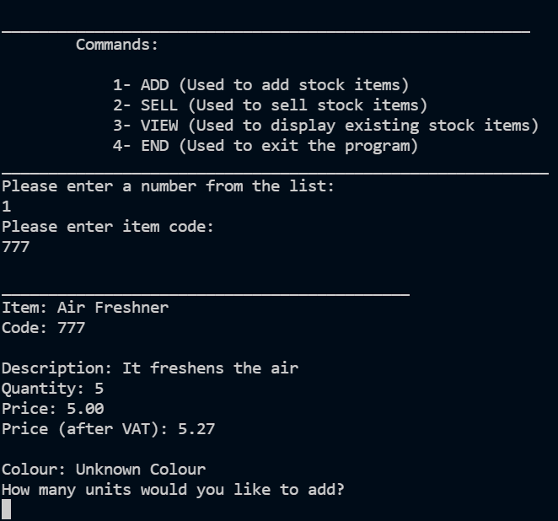

|  |  |  |
| --- | --- | --- |
| Test Case | Purpose | Result |
| 222222 | Test if program identifies that said item isn’t in the data | Program asks user to input more data about item 222222 |
| 888 | Test if program identifies that 888 already exists | Program asks user how many units to be added to 888 |
| 777 | Test if program identifies that 777 already exists | Program asks user how many units to be added to 888 |

Test Nine: Adding to a stock level above 100:

|  |  |  |
| --- | --- | --- |
| Test Case | Purpose | Result |
| 9 | Test if program rejects adding 9 to 112 | No more units added |

Test Ten: Selling more than stock

|  |  |  |
| --- | --- | --- |
| Test Case | Purpose | Result |
| 113 | Test if program rejects selling more than current units in stock | Error message |
| 111 | Test if program sells unis less than stock | Units are sold |
| 112 | Test if program accepts selling all of stock | Units are sold |

Test Eleven: Selling an item that doesn’t exist

|  |  |  |
| --- | --- | --- |
| Test Case | Purpose | Result |
| 1010 | Test if program rejects selling none existent item | Error message |
| 888 | Test if program sells normal item | Units are sold |

Test Twelve: Two Choice Prompts



|  |  |  |
| --- | --- | --- |
| Test Case | Purpose | Result |
| 1 | Test if program identifies 1 | Program goes on to edit page |
| 2 | Test if program identifies 2 | Program goes on to main menu |
| 3 | Test if program knows 3 isn’t an option | Error message |
| yellow | Test if program accepts string | Error message |

Test Thirteen: password

|  |  |  |
| --- | --- | --- |
| Test Case | Purpose | Result |
| password | Test if program accepts correct password | Program goes on to edit page |
| passwordd | Test if program rejects wrong password | Error message |

Test Fourteen: Changing data

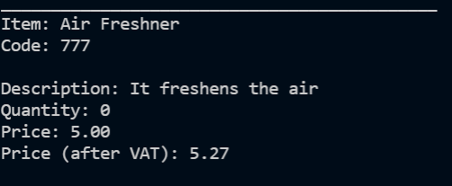 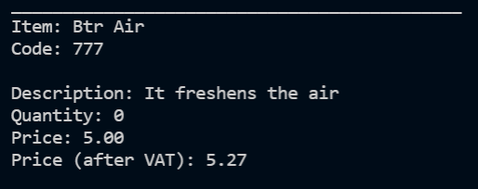

Test Fifteen: Changing Code

|  |  |  |
| --- | --- | --- |
| Test Case | Purpose | Result |
| 777 | Test if program accepts changing 778 to 777 | Error message |
| 779 | Test if program accepts changing 778 to 779 | Error message |

Test Sixteen Delete Item

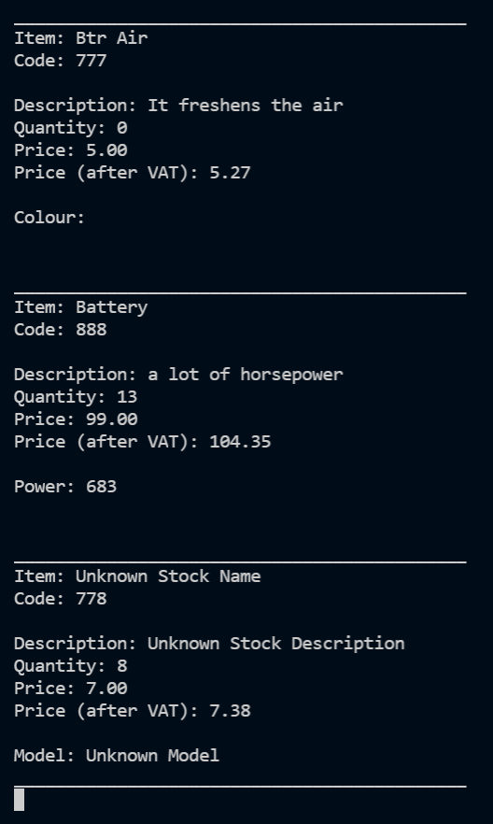 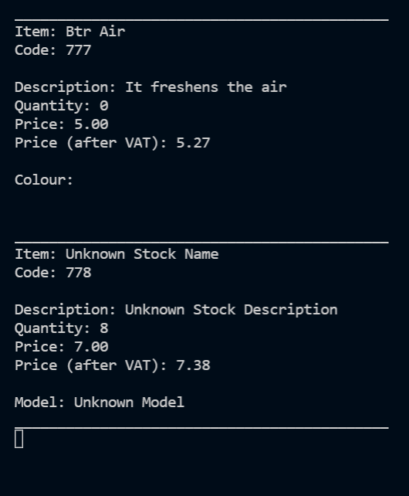

Test Seventeen: Advanced

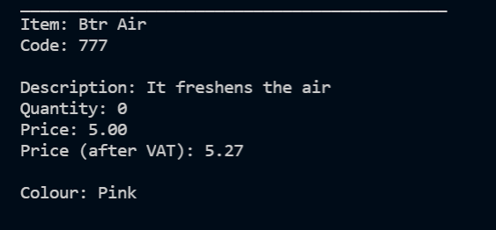

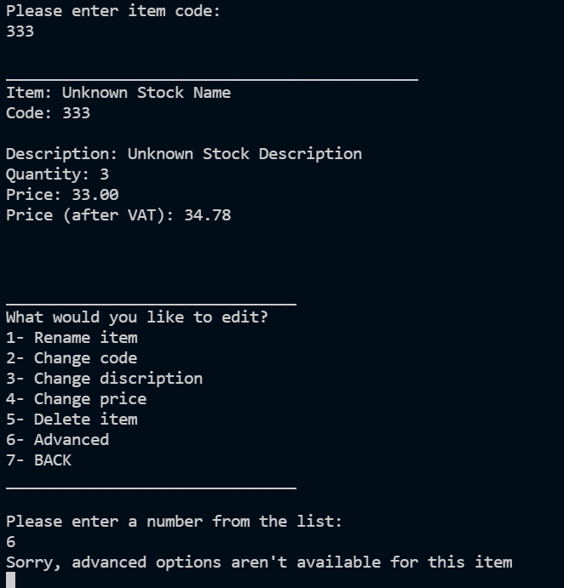

Test Eighteen: Data saving

