**LABORATORY MANUAL**



**OBJECT ORIENTED PROGRAMMING (OOP)**

Submitted by

**AADARSH MEHDI | 00314965**

Instructor

Sir. Rozi Khan

Lab Engineer, Department of Computer Science,  
National University of Sciences & Technology,   
Balochistan Campus (NBC), Quetta.

**LAB 03:**

**TASK 1:**

Hierarchy for the Super STUDENT Class:



Note : To magnify the Chart : Double Click the above graph. MS Visio File automatically will be opened.

Description about the Relation:

Above is just the rough diagram to indicate the hierarchy of the students pursuing education from the university at different levels. I have added the student as the main super class of this hierarchy which is categorized into two main streams, Undergraduate and Graduate Students. These are further categorized into their minor levels like Undergraduate students are divided into their Titles in the university distinguished by their year of the education while in Graduate students are divided into further educational streams like Masters or Doctorial. We know that there are two semesters conducted in almost all universities thus , we divided Undergraduate and masters pursuers into two further streams , Fall and Spring(Semester wise).Whereas, Doctorial students are divided into their education categories. And that is how this hierarchy will keep going. There is no end.

**TASK 2:**

**INPUT:**

* Class : “Accounts”:

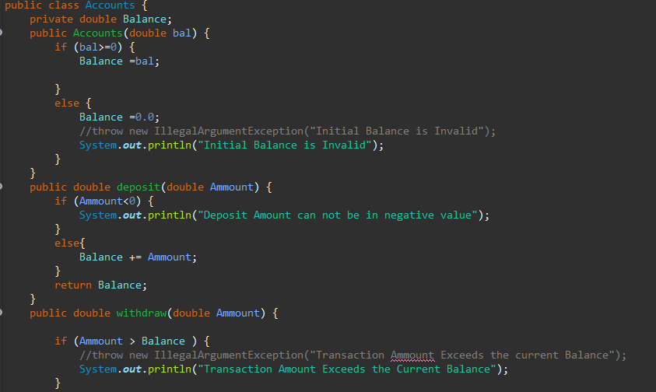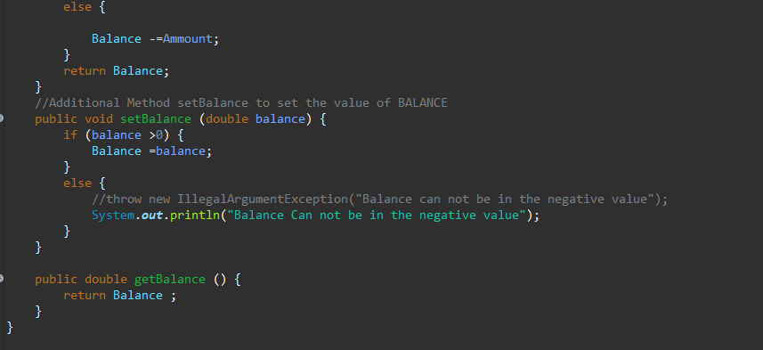

* Class : “SavingAccounts”:

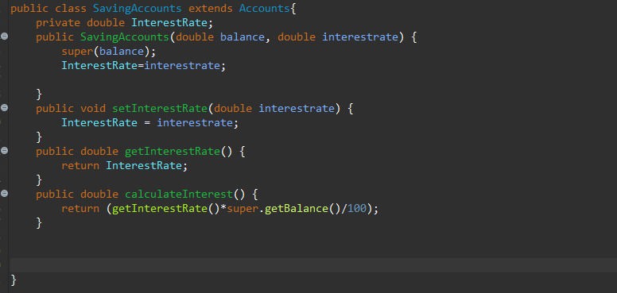

* Class : “CheckingAccount”:

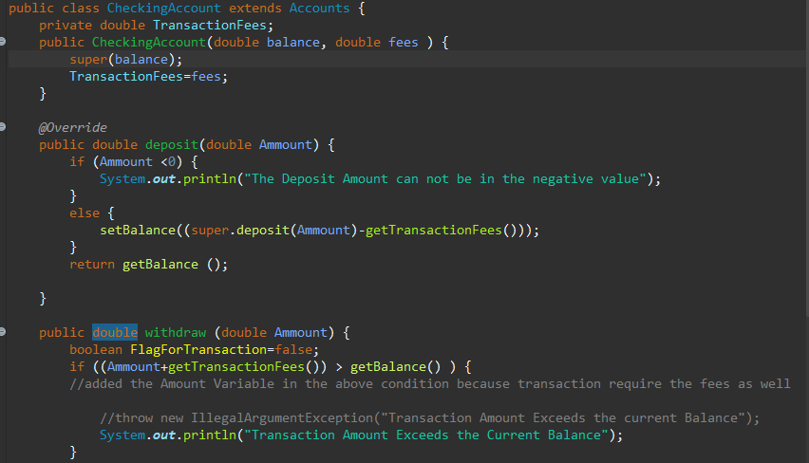 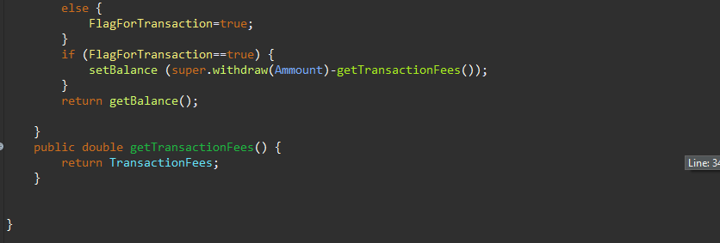

* Class : “AccountTest” :

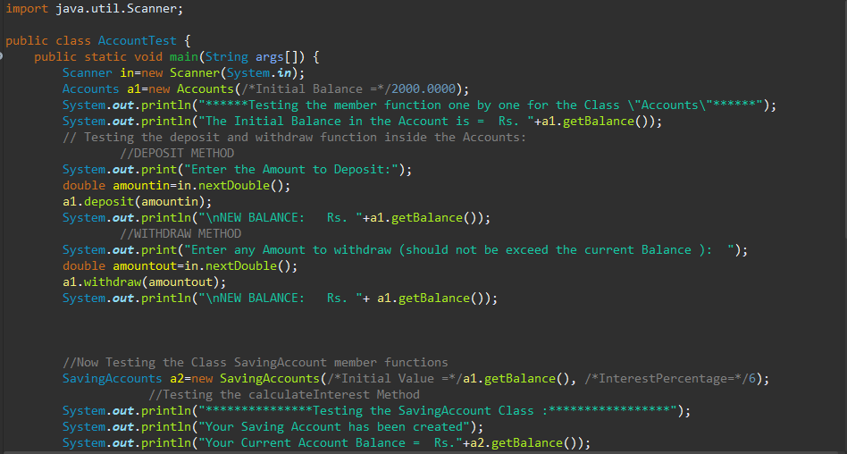 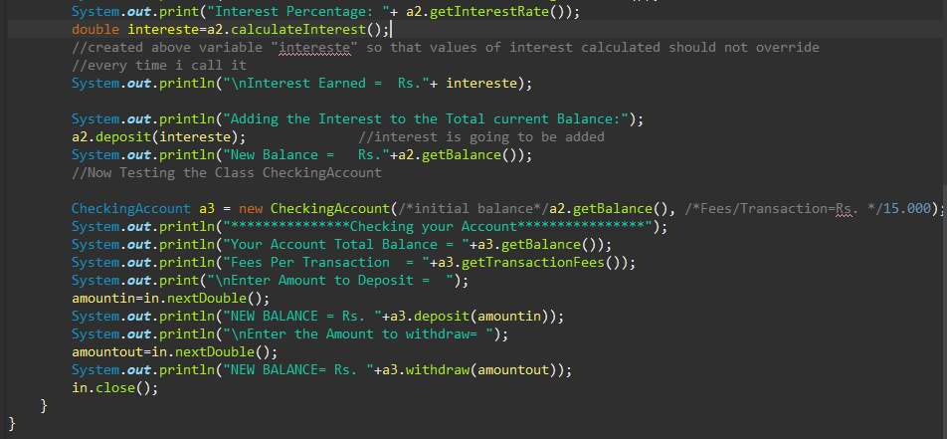

**OUTPUT:**

* Smooth Run

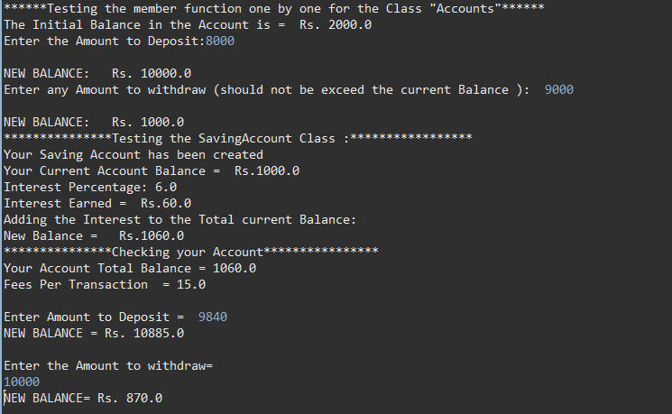

* Input Validation Example:

